Walker Evans
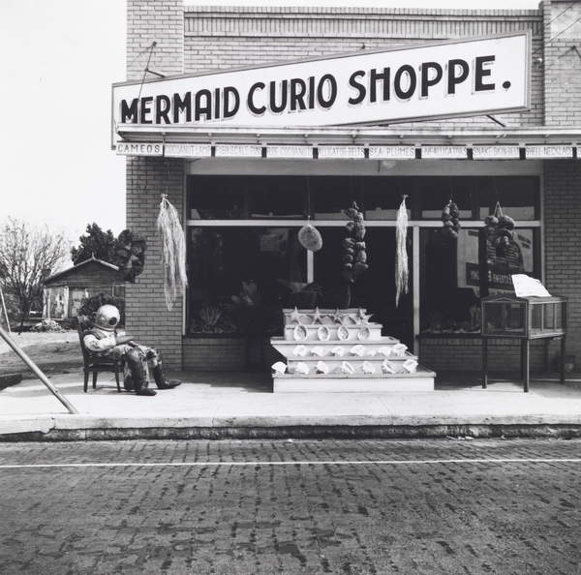
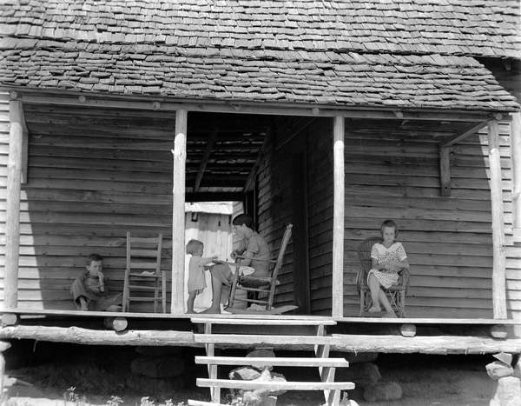
Fig. 21. Mermaid Curio Shoppe (Sponge Diver's Suit), 1941 (gelatin silver print) (1941)
Fig. 20. The Burroughs Home, Hale County, Alabama, 1935 (b/w photo) (1935)
Again, this image has been taken head on with the subject of the photo. This one is of a shop, with some interesting features outside. In the foreground is a road, and the midground is the shop window and the merchandise and the background is the shop sign and the sky. Like the first annotation, the main focus is captured in the midground. There is also no colour as well, making you examine the subject of the image closer. Pattern in this photograph is small and detailed, such as the bricks on the road, and building and the merchandise. It is very hard to specifically focus on the shop as just to the left is a man in a vintage diving costume, which you wouldn’t expect to see outside a shop, just sat on a chair. You can also see around the corner in this image too down to another building set behind the shop. The composition of this picture is strange because of what it contains as you wouldn’t necessarily place the objects together.
This photograph is of a family sat enjoying the weather outside of their home. The midground is the main focus for this picture as the background is the roof and the foreground is the foundations of the building. In the middle is where the main focus is, which in this case is the family. As this image was taken a long time ago it is black and white. I feel that this makes the photograph stronger in a sense because there is no colour to take you away from the focus of the family. Say for example, the roof was red, this would lead your eye away from them. It has a deeper meaning without the colour when looking at the posture of the people in the image. The angle of the image has been taken head on, like the majority of his images. This makes sense here as we are focusing on the family, not so much the building itself. Stairs, wooden planks as walls, and roof tiles, all contribute to pattern in the image and also the chair on the left-hand side of the image, and the beams holding the roof up. The stairs at the bottom of the image help lead your eye to the person sat in the rocking chair, and the roof stops you from looking up any further, the only other way you can look is both ways across at the other people sat out on the decking. The two people on each side of the people in the middle, help frame them and so does the door way and beams as they’re dead centre to all of them and the centre of the image itself.

