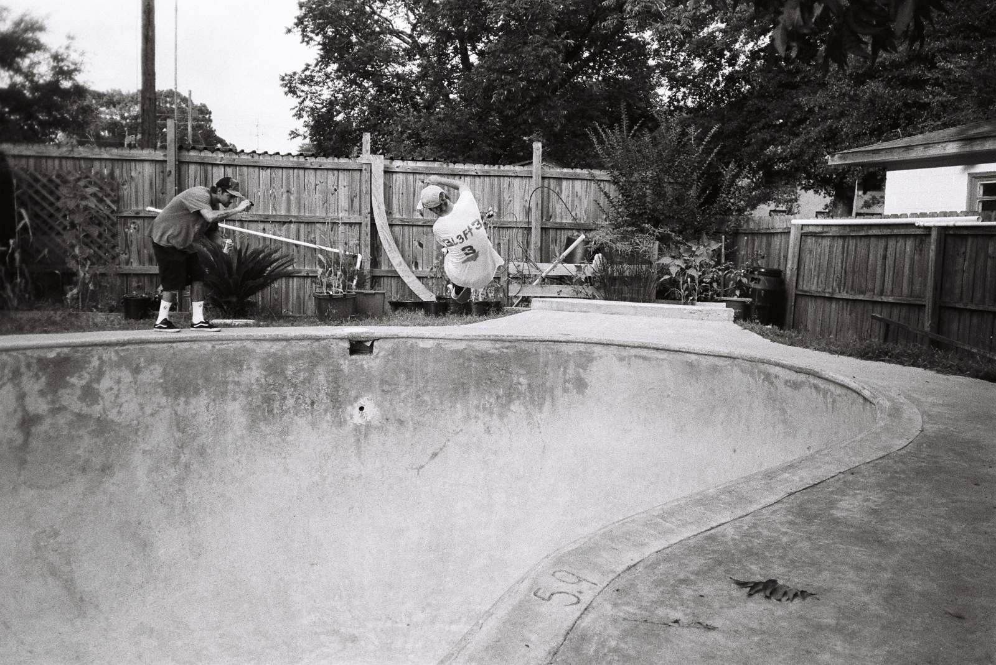
Robin Pailler
Fig.13. Photography (s.d.)
In this image, you can see one camera man, and one man doing a stunt, his body shape looks odd because he is twisting and turning in the air. But it is as if he does not know the other photographer is there and he is just doing his thing. He is up at quite a height. A height, that he could seriously injure himself at if he was not to land. It is that chance he has to land it after he has committed himself to whatever trick he is doing. This is decisive because he will never get the same exact height etc., and be able recreate this exact image. Skateboarding is unique and I feel that shows decisive moments again and again. You cannot ‘stage’ a skateboard decisive moment, because there is always an element of risk to the sport, and you never know the outcome, whereas when people were using ‘the decisive moment’ as a cliché, they were staging simple images and calling it a decisive moment, skateboarding will always continue to be decisive, and for all we know after this image he could have fallen and broken his leg. Therefore, each moment, is a decisive one.
In the foreground, you can see the depth of the pool and how deep it is and how high up he is. In the background you can see that it looks like a normal garden, maybe they drained the water out so they can skate it. I like how the image has been made black and white, this makes it seem more meaningful, and makes you focus more on the action and other aspects rather than the colour, and almost makes it more of an old school type of image. The bowl looks rather strange and a cross between 2D and 3D and makes the eye feel uneasy because of its strange shape.

