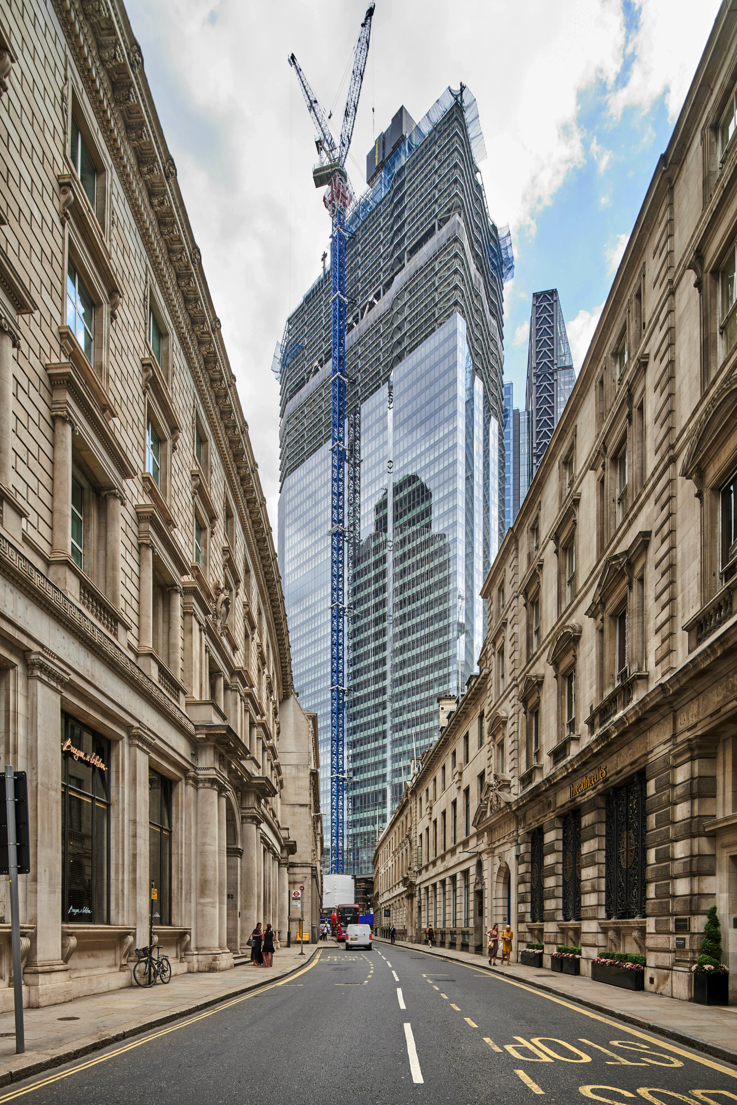
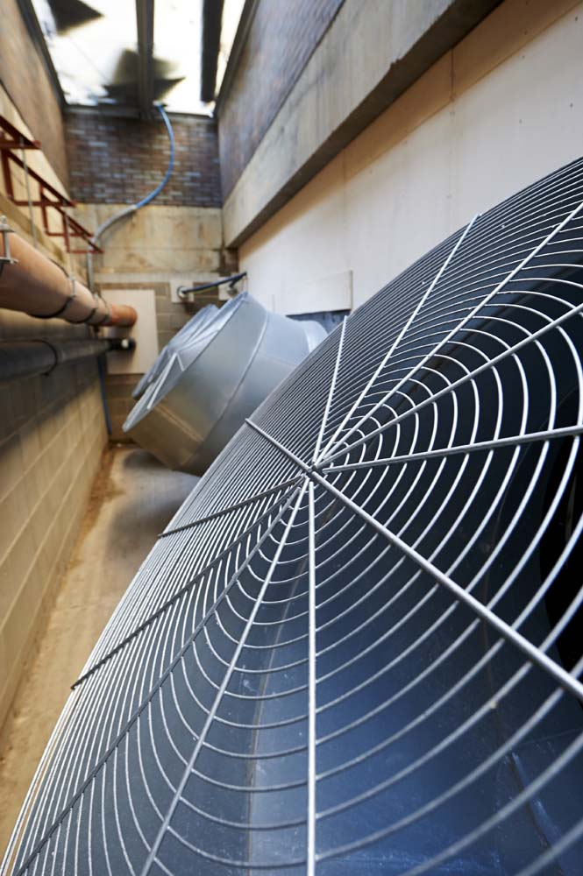
Paul White
Fig. 29. Box & Charnock - Ventilation Plant (s.d.)
Fig. 30. City Of London Development For Freeform (s.d.)
This image looks like it was taken in London. It is a very strong and propelling image as there is a huge difference in the buildings. This makes the image seem surreal. The buildings either side of the street are old, rich buildings and the sky scraper in the background is modern and slick. It is almost as if someone has photoshopped the building into the image as it looks so out of place. The texture of the sky scraper seems delicate and fragile, whereas the other buildings seem tough and sustainable. Your eye is instantly lead to the sky scraper from the bottom of the photo, leading your eye down the centre of the image to the building. This is helped by the road and the fact you cannot view anything other than the buildings either side of the image. This makes it seem symmetrical. The colours of the buildings are fairly opposite also, one a fresh green, blue and the other a creamier more old-fashioned colour. All the buildings within the picture seem to be 3D. There are lots of lines and patterns in the image, making it seem complex and strong.
This image seems to be of some kind of fans. The texture seems sharp because of the colour of the fans as it is so striking. The foreground and background seem to be slightly out of focus which makes you focus on the narrow bit in focus. The colour of the fans is a silver because of the metal which makes them stand out amongst their surroundings. This angle is a strange one because he has taken it close up to the fan in the foreground so much that you cannot see the whole of the fan, and can only see one side of the fan in the background. The shape of the fan in the foreground is flat because of the angle we are at and is 2D. Although the object is actually 3D. There are many patterns in this photo from the fans themselves to the spokes of the fans. Also, there is many lines in this image too, some which are highly noticeable like the spokes, to the bricks of the wall which are not so noticeable.

