Laszlo Moholy-Nagy
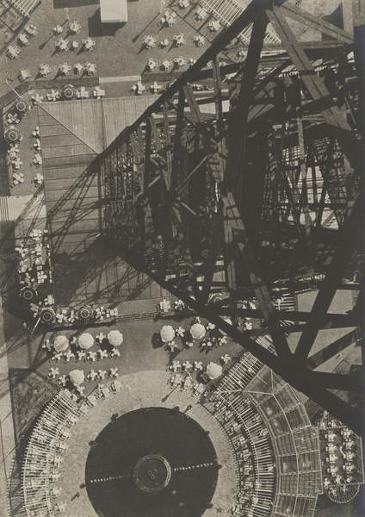
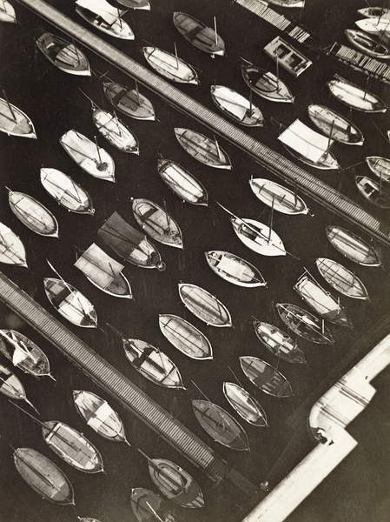
Fig. 18. Boats, Marseille, 1927 (gelatin silver print)
Creator (1927)

Fig. 19. Berlin Radio Tower, 1928 (gelatin silver print) (1928)
This is another picture taken by Maholy-Nagy looking down. The image has been taken from an incredibly high vantage point and almost looks like he has taken it out in the middle of the sky. If you don’t know much about his style of photography, you may not know at first glance, that this image has been taken from such a height. These types of images give abstract photography its name and really makes it what it is. There are many different patterns in this image and the structure leads your eye down to the ground towards the centre of the image. It seems like the structure has smashed out of the ground which makes it seem powerful. Because the image is black and white, it makes you focus on the shadow on the ground from the structure, giving the image more pattern and makes it seem more industrial.
This is a photograph of a boat doc by Maholy-Nagy. It doesn’t look like boats from the angle he has taken it at, in fact it just looks like small odd shapes which form a pattern. This picture is very interesting because of the boats and how the lines form. When you first look at the picture, there is lots to contain, but then you soon realise that it is just repetitive. The way he has made the boats seem flat is quite interesting and gives the audience a different perspective of the image to what it really is. It makes the world seem flat, which seems odd. You cannot really tell that he is high up in this either. Because it is black and white the water is completely black, meaning that you cannot tell it is a boat doc. I think if there was colour, you would be able to tell what it is more easily, but without colour it makes you focus on the other aspects of the image.

