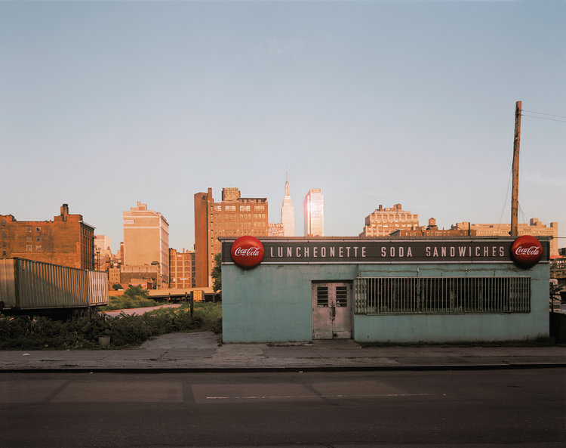
Joel Meyerowitz
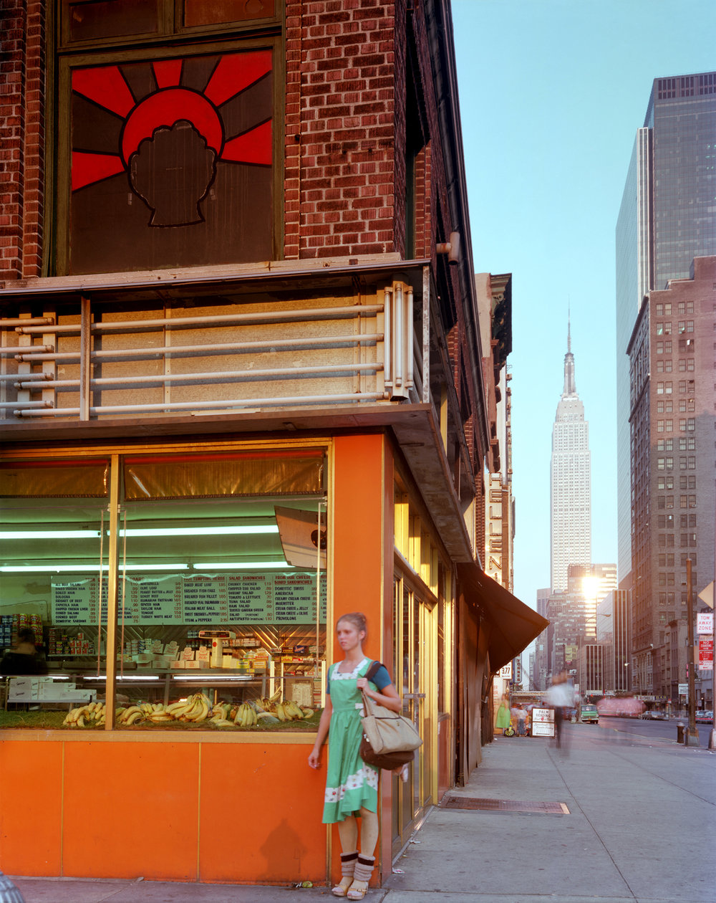
Fig. 26. Empire State (s.d.)
This is the Empire State from a different viewpoint. Here he is closer in to the building, but still a fair bit away. This location seems slightly more upbeat with the orange corner shop bursting to life with some juicy bananas in the window and a well-dressed lady outside. Looking down the street you can see that there is no overgrown grass like the image on the left and that it is more of a main street with sky scrapers near. The Empire State building doesn’t seem to be the tallest tower in this image as there is the one on the right which looks taller, only because it is closer to where he is stood. If this was taken from a different viewpoint then it would look smaller. Your eye is lead off from the left of the image to the right and down the street to the Empire State building which compositionally is excellent. As mentioned earlier, the colour seems to be vibrant and gives out a positive feel to the image. Again, like the image to the left, (Coca Cola building) the main focus here seems to be the lady as that is the most central closest thing to him, although it is not, it’s the Empire State building. There are dozens of patterns in this image from windows, to bricks and the bananas which helps complete the image.
Fig. 25. Empire State (s.d.)
This image is from Joel Meyerowitz’s series Empire State. In which he takes numerous shots surrounding the famous piece of architecture. This shows different viewpoints in which you can see different areas surrounding the main subject. Here, although it doesn’t seem like the main focus, is the Empire State building which is pretty much central in the background of the image. It is very far away in this image but still easily noticeable. As you can tell from this image, the location in which he has taken the image is not particularly wealthy, or busy. In fact, it looks pretty run down. The shop isn’t open and the space within the foreground seems abandoned and dull. The sunset makes the sky scrapers in the background shimmer with a gold/bronze colour which suggests power. Whereas it is shady in the foreground, therefore making it seem less rich and powerless. He has captured the Coca -Cola building over to the right-hand side of the picture, giving you a chance to glimpse at the buildings over the back left. I feel that all the colours within the image complement each other through the fact that there is a lot of colour in each section of the image. For instance, the grey of the road and pavement in the foreground, the bronze/gold of the buildings in the midground/background and the blue of the sky in the background. He has taken this viewpoint head on with the subject without trying to portray the location in a particular way by focusing on something in particular, to make the location seem horrible, or really nice, he has just taken it how it is. The image seems flat with most of the building’s 2D because of the angle.

