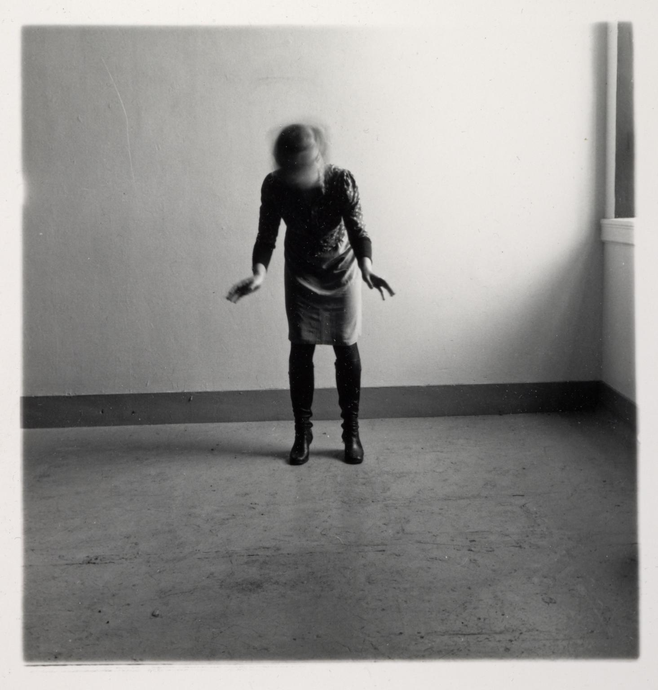
Francesca Woodman

Fig. 35. Space², Providence, Rhode Island 1976 (1976)

Woodman’s work is a very good example for the ‘Traces of Time’ exercise. She uses very simple backdrops and very simple movement with slow shutter, creating a blur within the image, of the moving subject. Here you can see that there is a figure in the centre of the frame, standing very still whilst the shutter is open, but shaking their head very fast so that they cannot be identified. The background is still so this is not blurred from movement, making you focus solely on the figure. This image is black and white, which makes you focus on other aspects of the image, such as her figure, rather than the colour of her clothes etc. The black and white also helps with the tone of the image, as the light source coming in from the right casts a noticeable shadow on the wall. I like how the image is presented with movement, combined with still life and how the movement is small, and does not take up the majority of the image.

