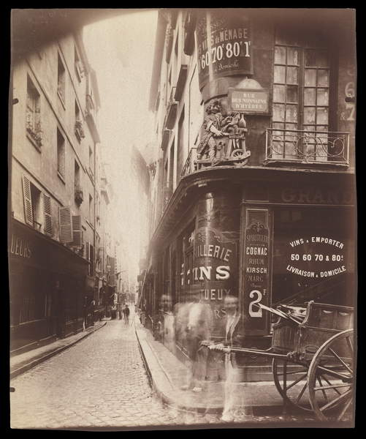
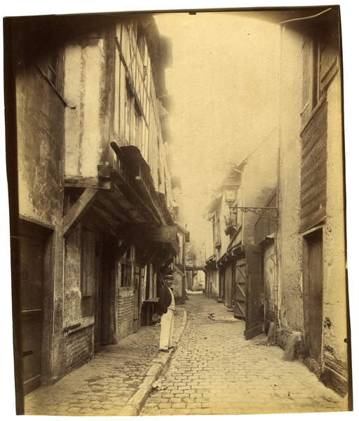
Eugene Atget
Fig. 16. Beauvais - Impasse Beauregard, 1904 (gelatin silver print) (1904)
Fig. 17. Rue des Nonnains, 1900 (silver print) (1900)
In this image, Eugene has taken it of a man stood on the curb in this small quite street. The further you look down the street the narrower it gets, leading your eye to the centre of the image. He has taken the image very central to the street but slightly aiming his camera to the left, towards the man. I can see that there is a variety of pattern in this image from the curb and road to the doors and buildings. The image makes me feel empty because there is only one person there and the image is not jumping to life with lots going on. Everything seems calm and I feel without colour this adds to the sense of calmness. Not only do the walls of the buildings help lead your eye down the road, but also the pavement itself, which also helps lead you to the man.
Like the first image, this image leads your eye down the street. With help from the curb. It seems that the exposure in this image may have created the men in the foreground to have been made blurry, which gives a feel of a ghost, which seems creepy. The shop on the corner gives the image a 3D shape to it and gives the viewer the opportunity to look around the corner down the street. It is almost like you start from the right-hand side of the image and you work your way across the image and your eye leads down the street. There is a lot of pattern in the image, coming from the window frames to the spokes on the wheels of the barrow. Because this image has no colour, it gives a bronze edge to the image which gives off a rich sense.

