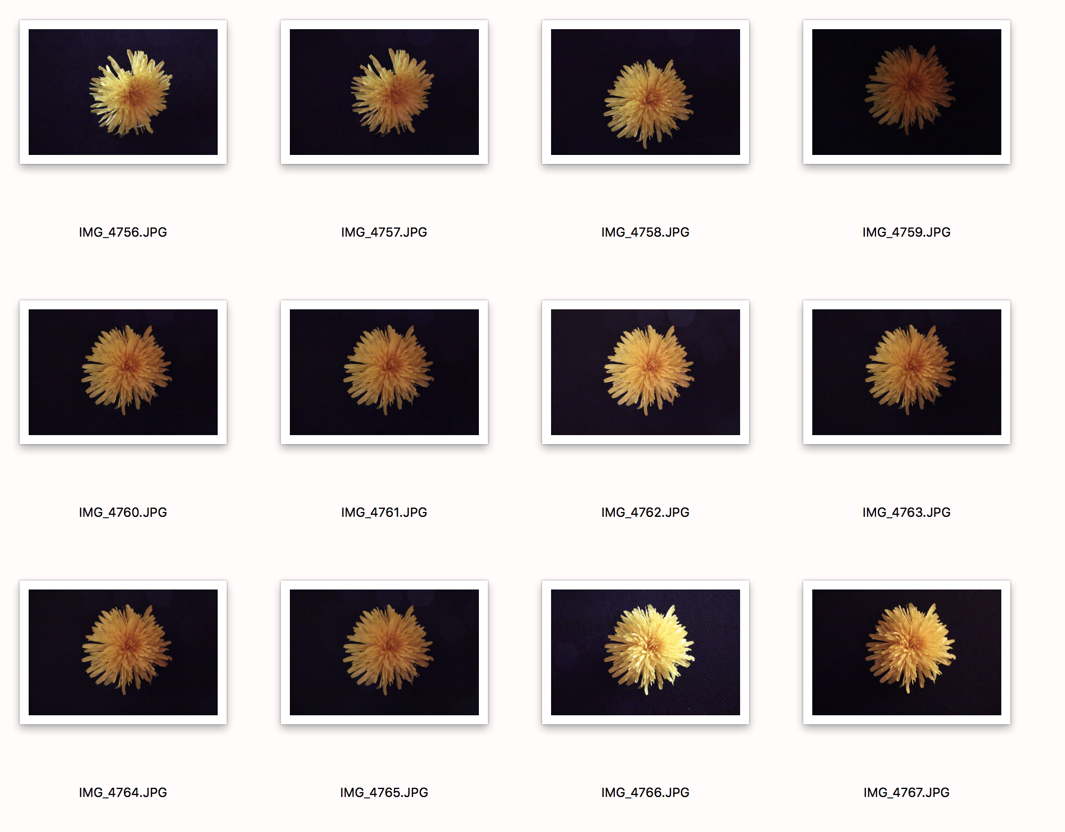
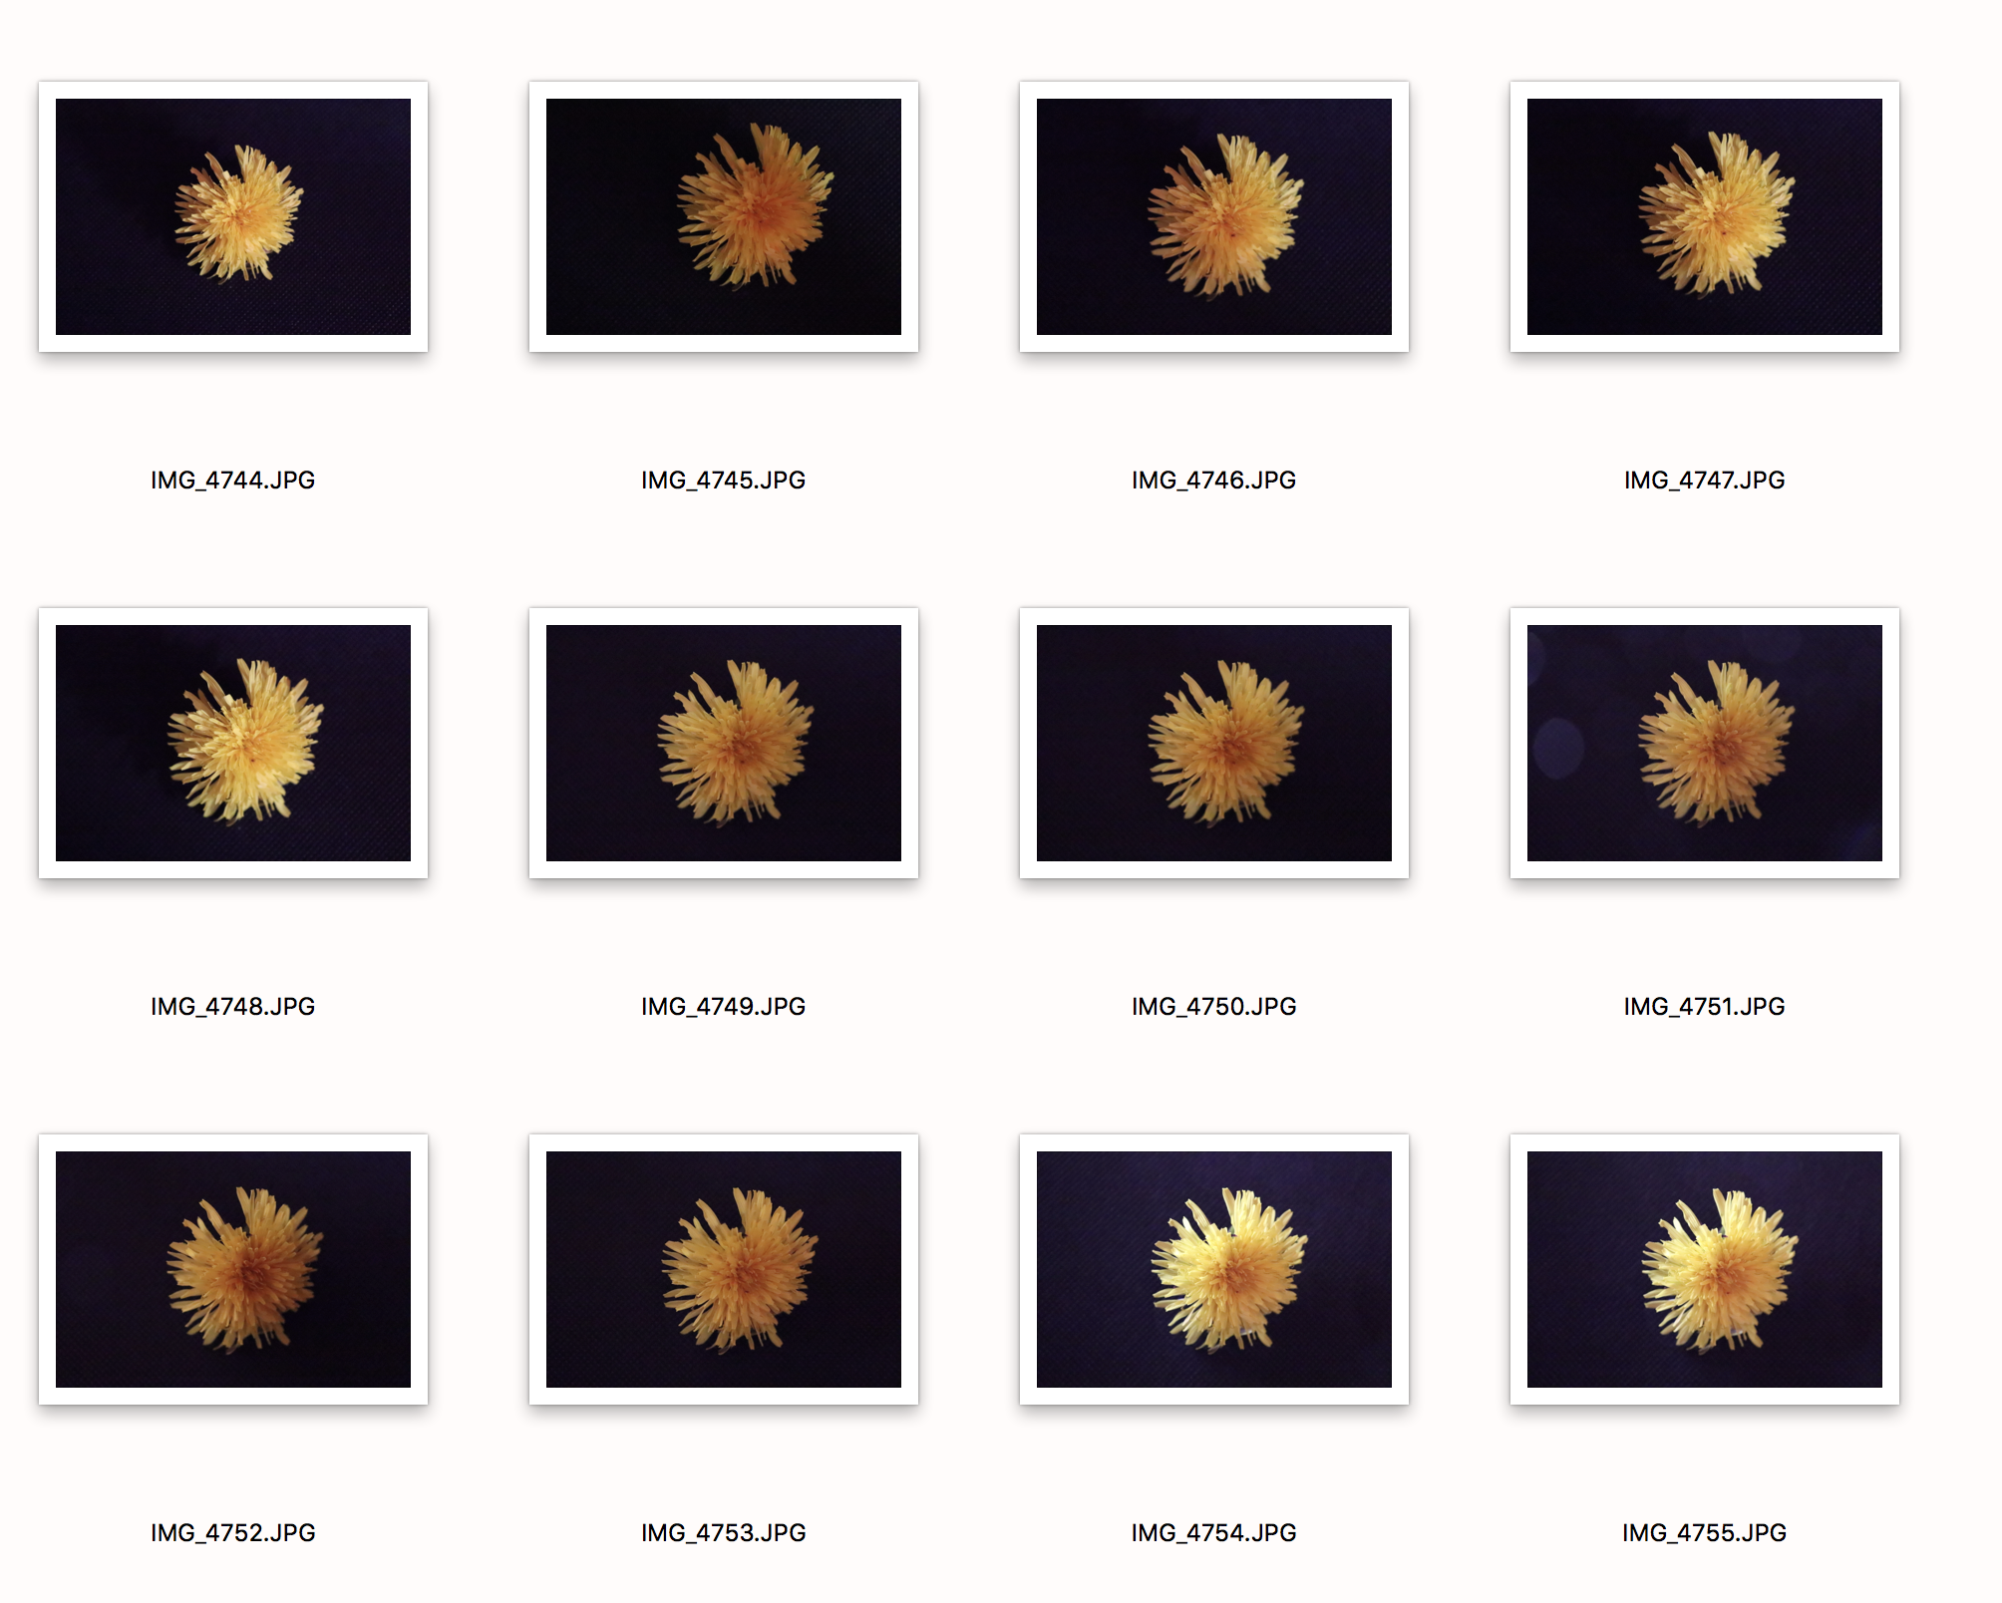

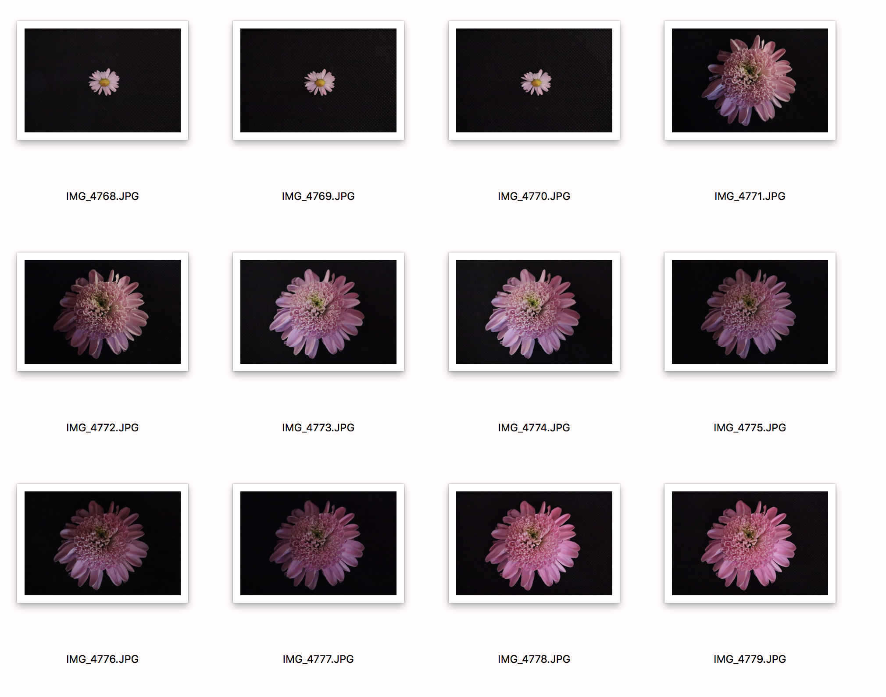
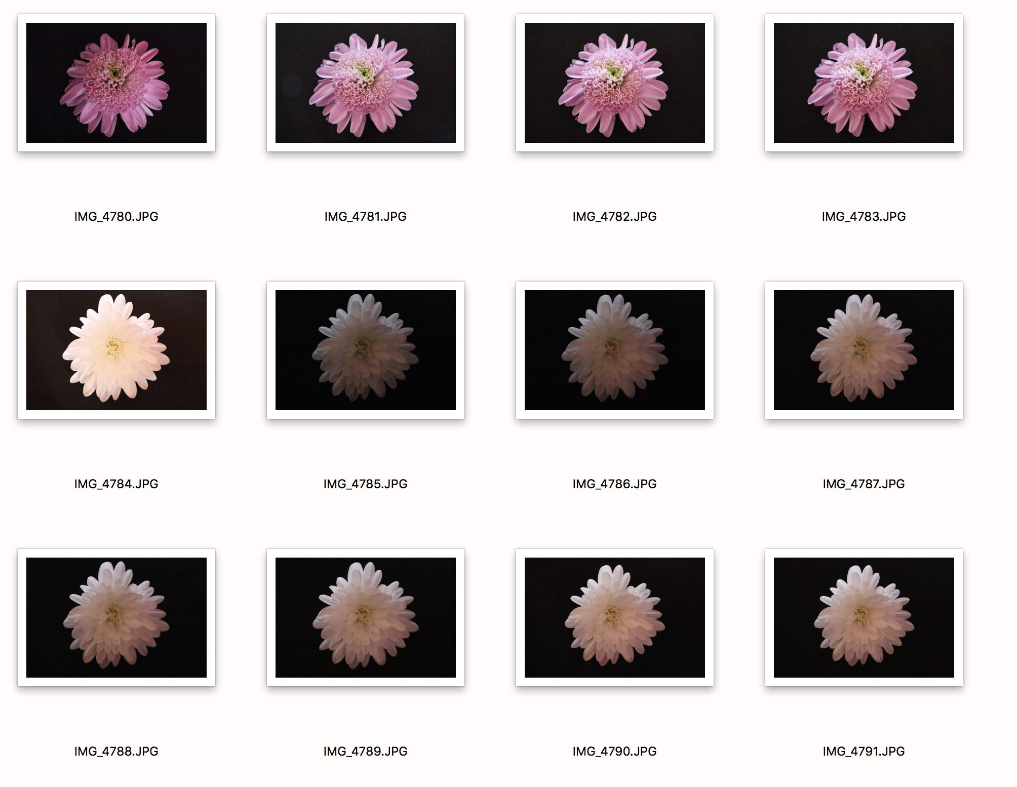
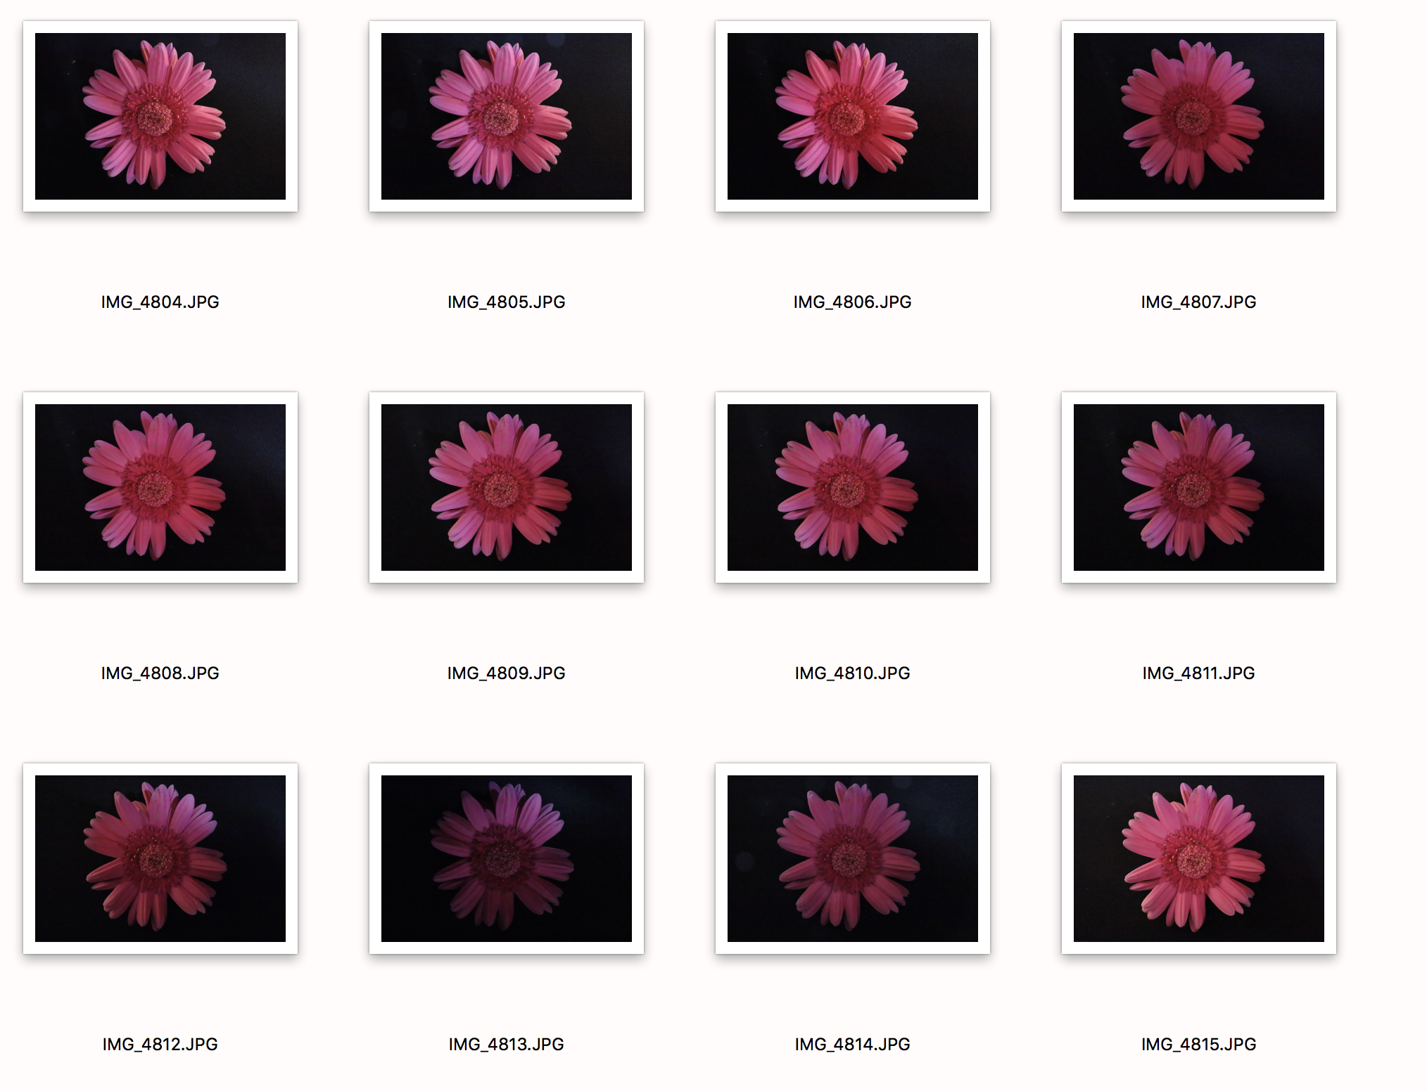
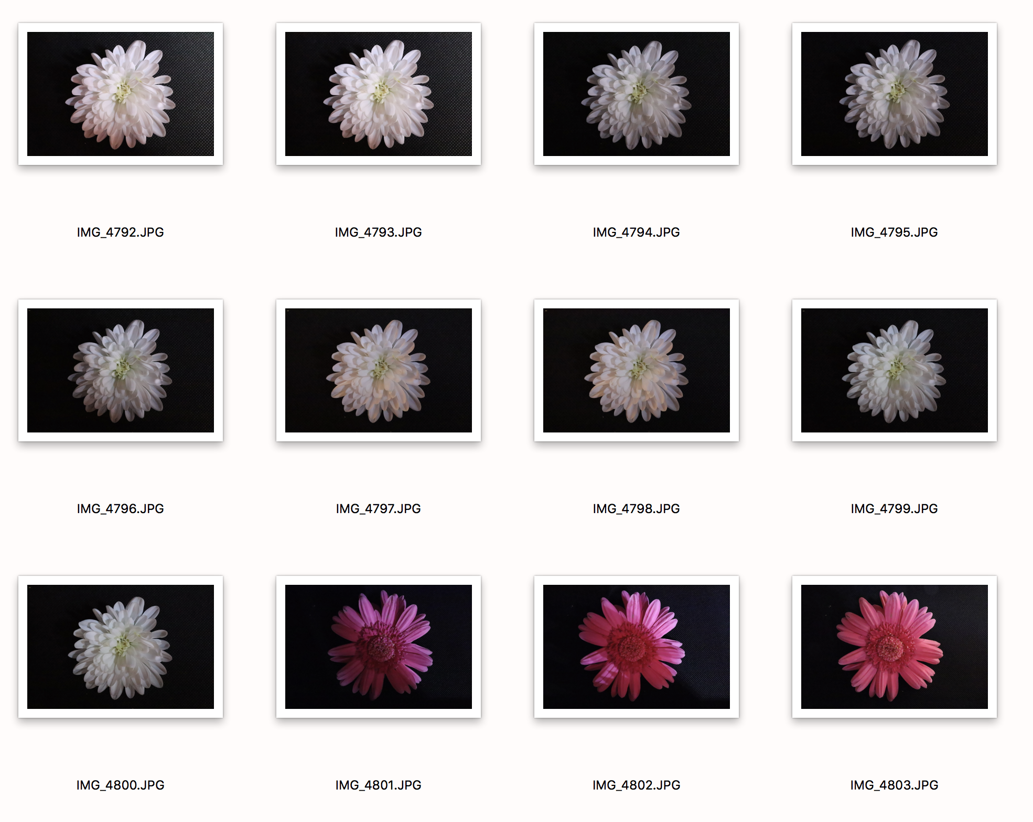

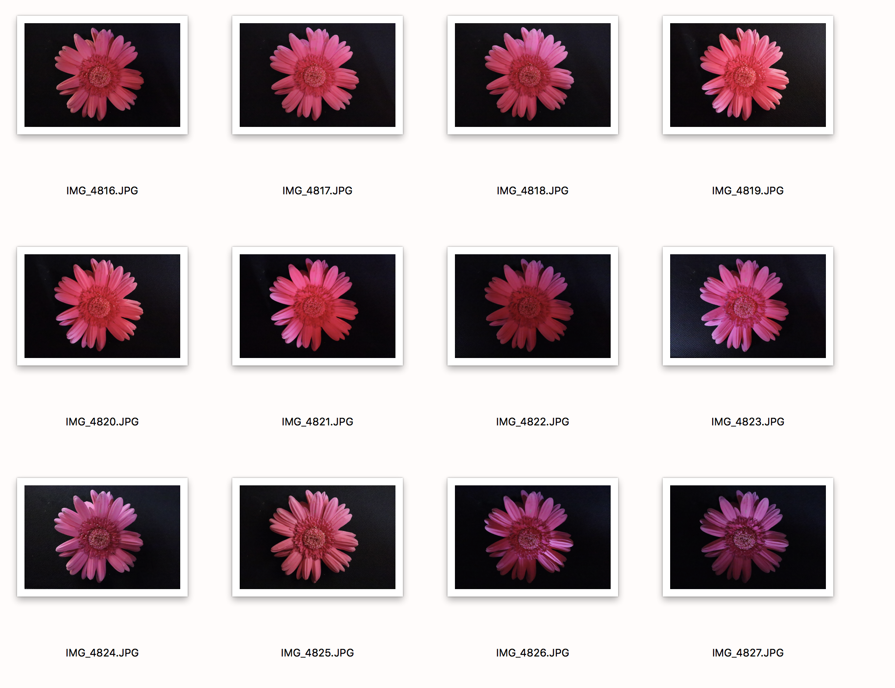
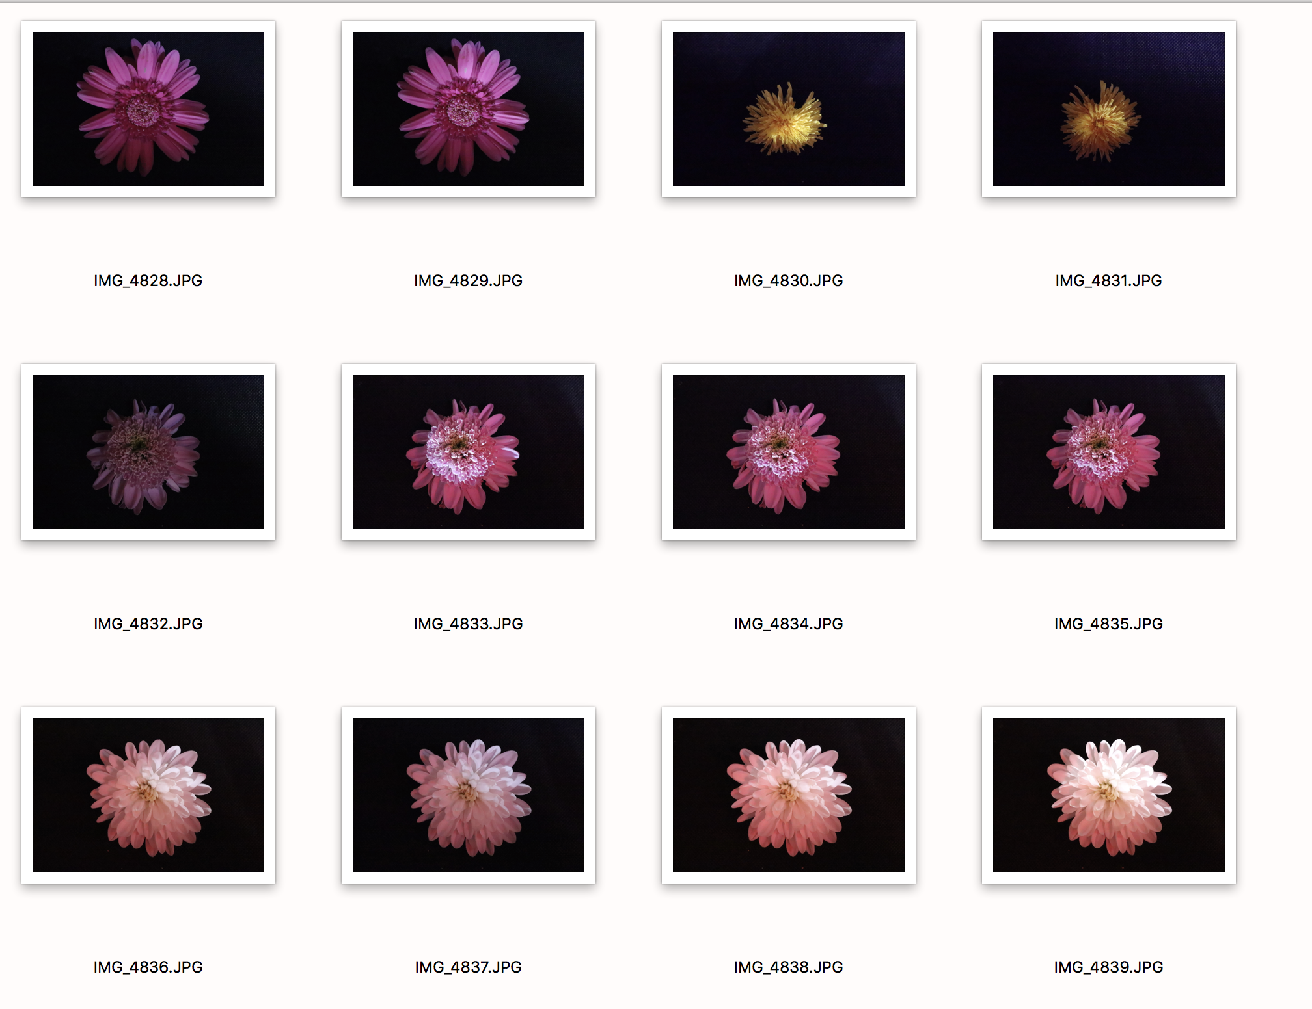
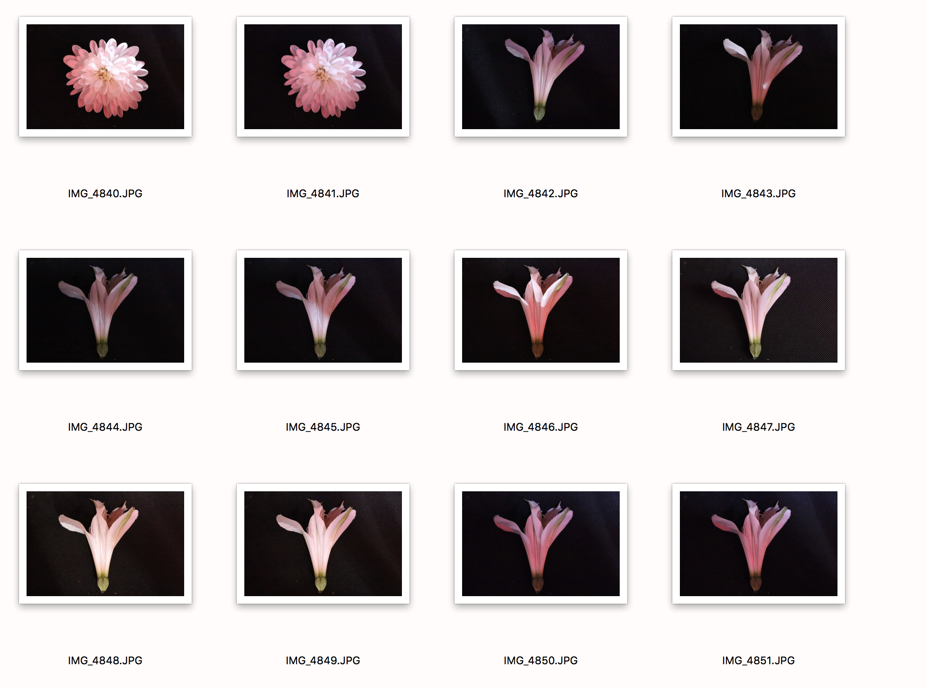

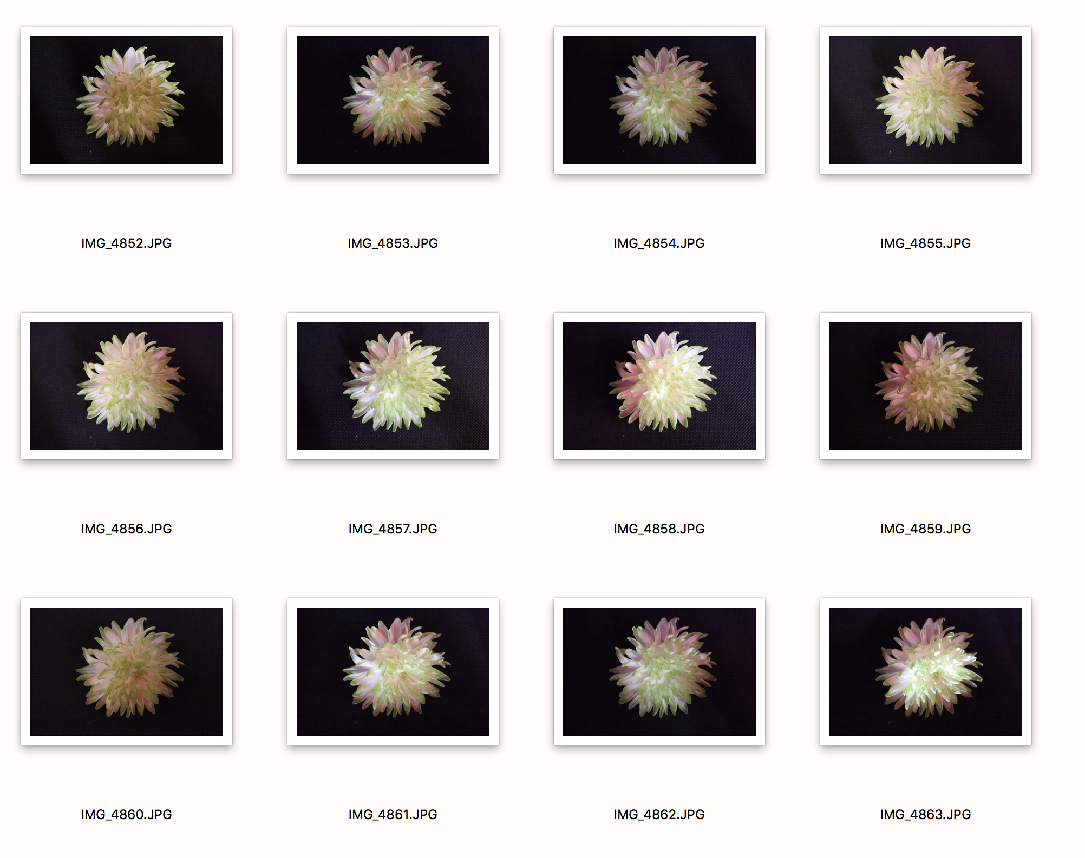

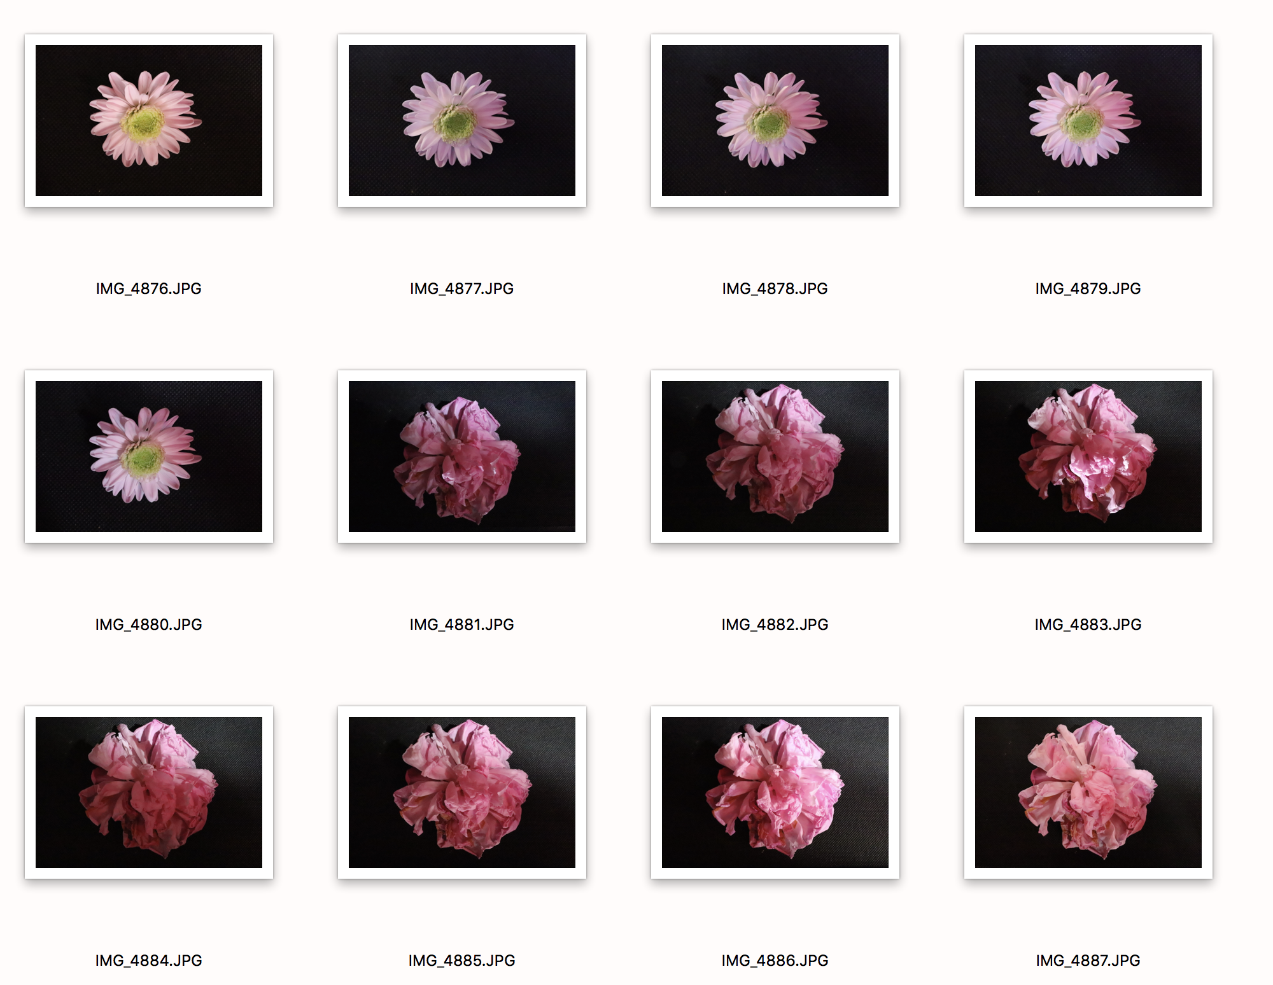
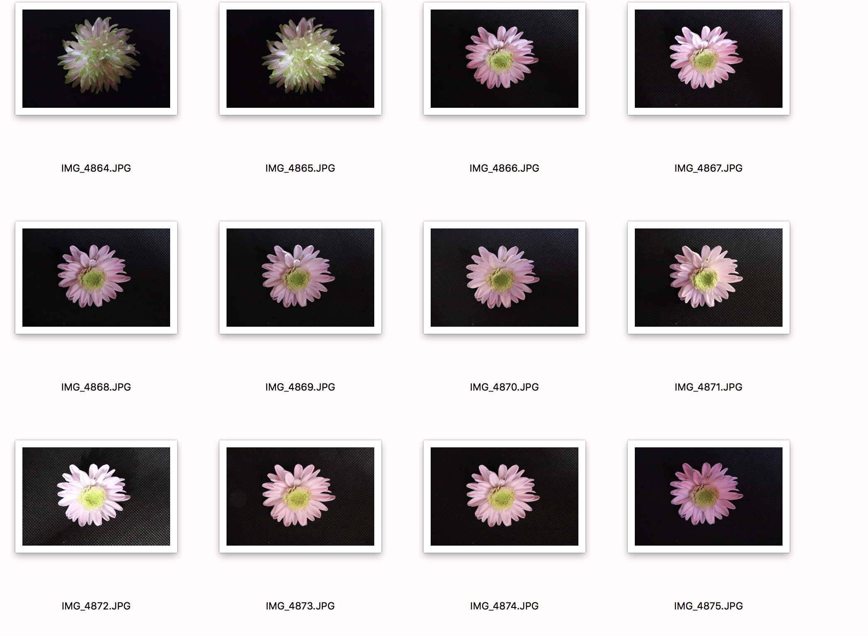

The selection process was fairly simple for this shoot. I needed at least six images for the shoot, and took nine flowers in total. I feel three didn’t work very well being the one I had to lay on its side because of its shape, it wouldn’t stand up. I felt that if I included this image in the finals it wouldn’t be uniform and sit together as a set because all the other images would have looked much different with all the flowers tops and that one’s side. I then thought the big pink one at the bottom of the contact sheet looked weird. I don’t think it looked right with the rest of the flowers as It didn’t look pretty and I felt it didn’t represent form very well. All the others had petals and looked really cool and interesting and felt this one just looked like a scrunched-up piece of tissue paper. Nothing special. I tried another small flower but I didn’t think it looked very interesting, so decided not to continue shooting it after a few shots. This flower was too small. The way I narrowed down the rest was easy. I simply looked at the ones that were most central, best lit and the flowers that had the best focus because I used small aperture. I chose one of each subject to fulfil the brief. I decided not to do plants in the end because I felt flowers made the shoot more uniform as they were the same subject.

