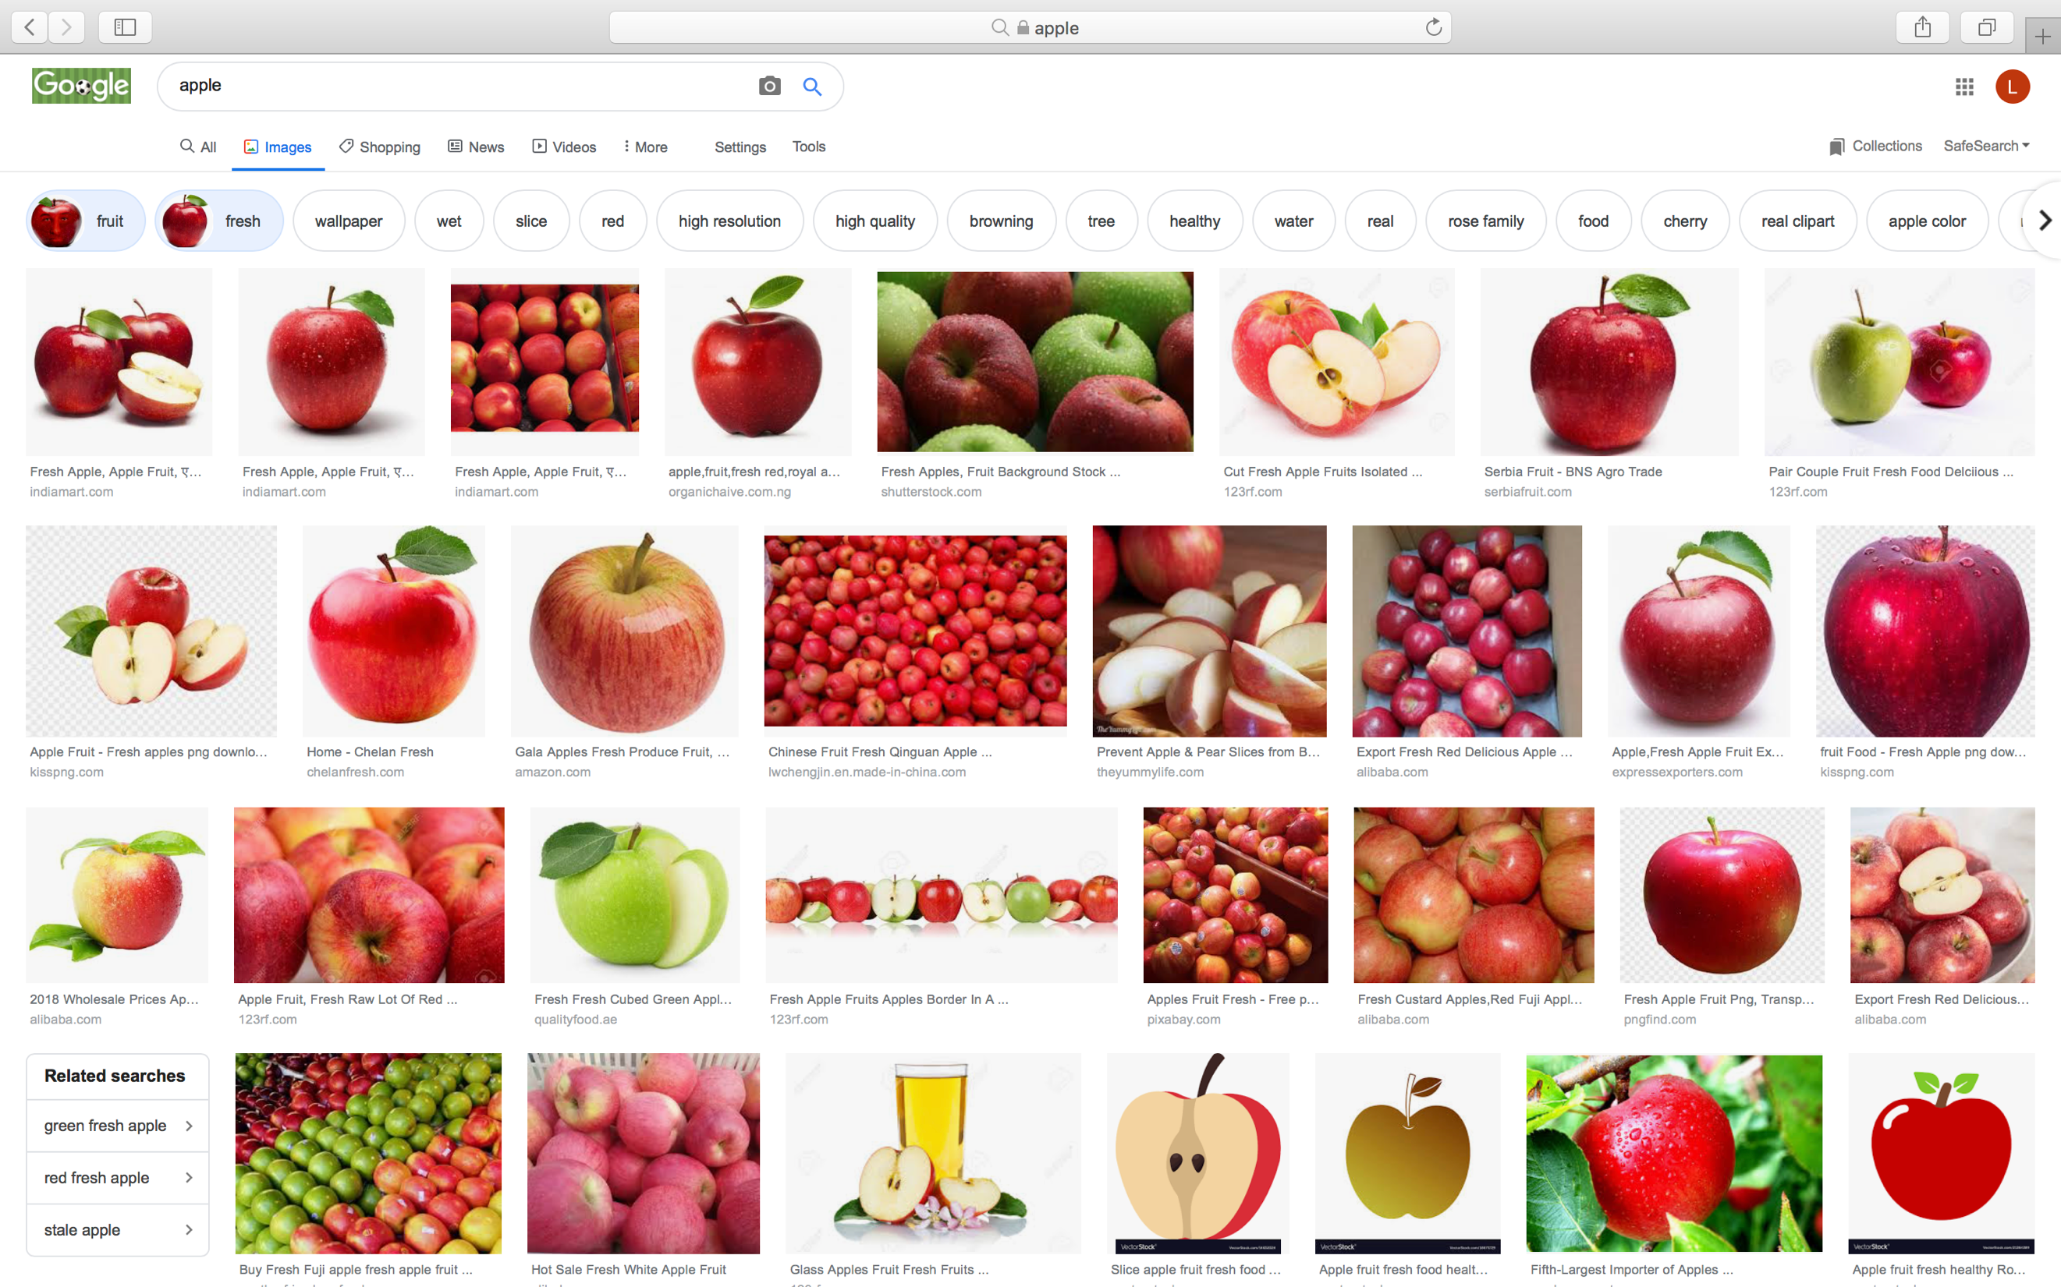

Fig. 36. ‘Apple’ (s.d.)
When doing the search, I had to put in that it was a fruit, because it kept coming up with the company and also had to put fresh as like in the bottom right there were photoshop and all sorts. Although I cannot specifically get the perfect search, this is what typically arrives top of the engine when searching for apple the food and fresh. As stated in my shoot plan, other than the vectors and cartoons, they are all presented, with a white backdrop like a studio shoot, or they are in a fruit bowl, on sale at a market, in a tree, or boxed ready to be sold. Basically, typically where you would find an apple. They are all presented in a manner which suggests they are fresh, yummy and ready to eat. There are no bugs crawling through them and they’re not in some really yuk, antihygienic place. They have all been suited to look attractive, and the aim of my shoot is the opposite. To make you not want to eat it. There is nothing creative about these photos, just like I would have thought, I mean I did guess it in the shoot plan. But what else would you expect when viewing an image of an apple. Also, they all tend to be very vibrant, which helps them looks delicious.

