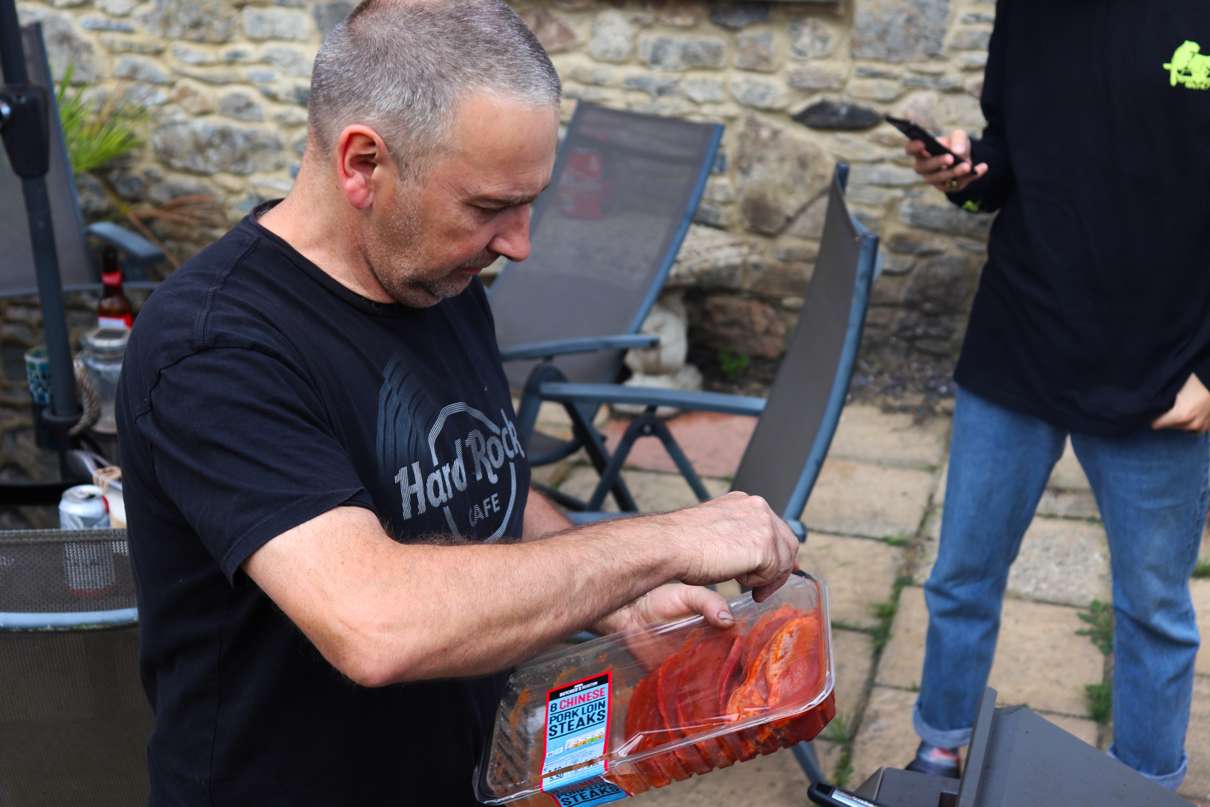
This image is of my family BBQ. Here you can see in this image my dad preparing the BBQ food. The texture of the food looks very slimy and hot because of the colouring of the meat. As you can see I have used a small aperture to blur the background out. It is not fully blurred but it makes you focus on what is in focus in the foreground of the image. The angle this has been captured from is slightly above my dad as you can see. This gives the viewer the opportunity to look down on the food, to see what it is clearly. I think if I did this from another angle you would not be able to see the contents of the package very well, here you can clearly see them and read the label also. The general vibe of the image is very vibrant, because of the meat colour but also the surroundings are partially dark but the wall and patio are more of a beige colour which levels out the image. For this image I used Manuel Mode. The framing of the image is interesting because I am not worried about what surrounds him, as if I was I would have taken a step back. But also, there is a slight bit of head chop and the bottom of the packaging too. This is because I have pointed a shot the image, trying to capture a unique image in time of an unusual viewpoint of him preparing the food. As you can see he is concentrating very hard on the task at hand. In this image you can only just see the top of the BBQ.
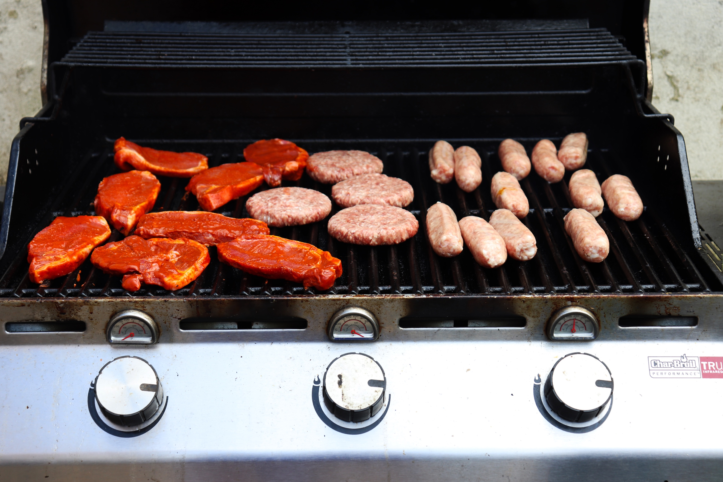
Now the food is all loaded onto the BBQ itself, you can see how bland a lot of the colouring is of the meat, because it is not cooked. However, the colour of the meat contrasts against the black of the grill really well. The texture of the meat in general looks squishy and rubbery. The angle I have taken this from means that I get part of the BBQ in on the foreground which shows you the knobs to operate it. These are all spaced equally apart making them look like a pattern and with the little screen things behind them too. The shape of the food is 3D because of the level I am at. Almost level with the BBQ itself instead of from above. Although this shows the steaks like the first image, these are out the packaging now and on to the BBQ ready to be cooked. Also, the grill bars themselves also make for a pattern on the BBQ.
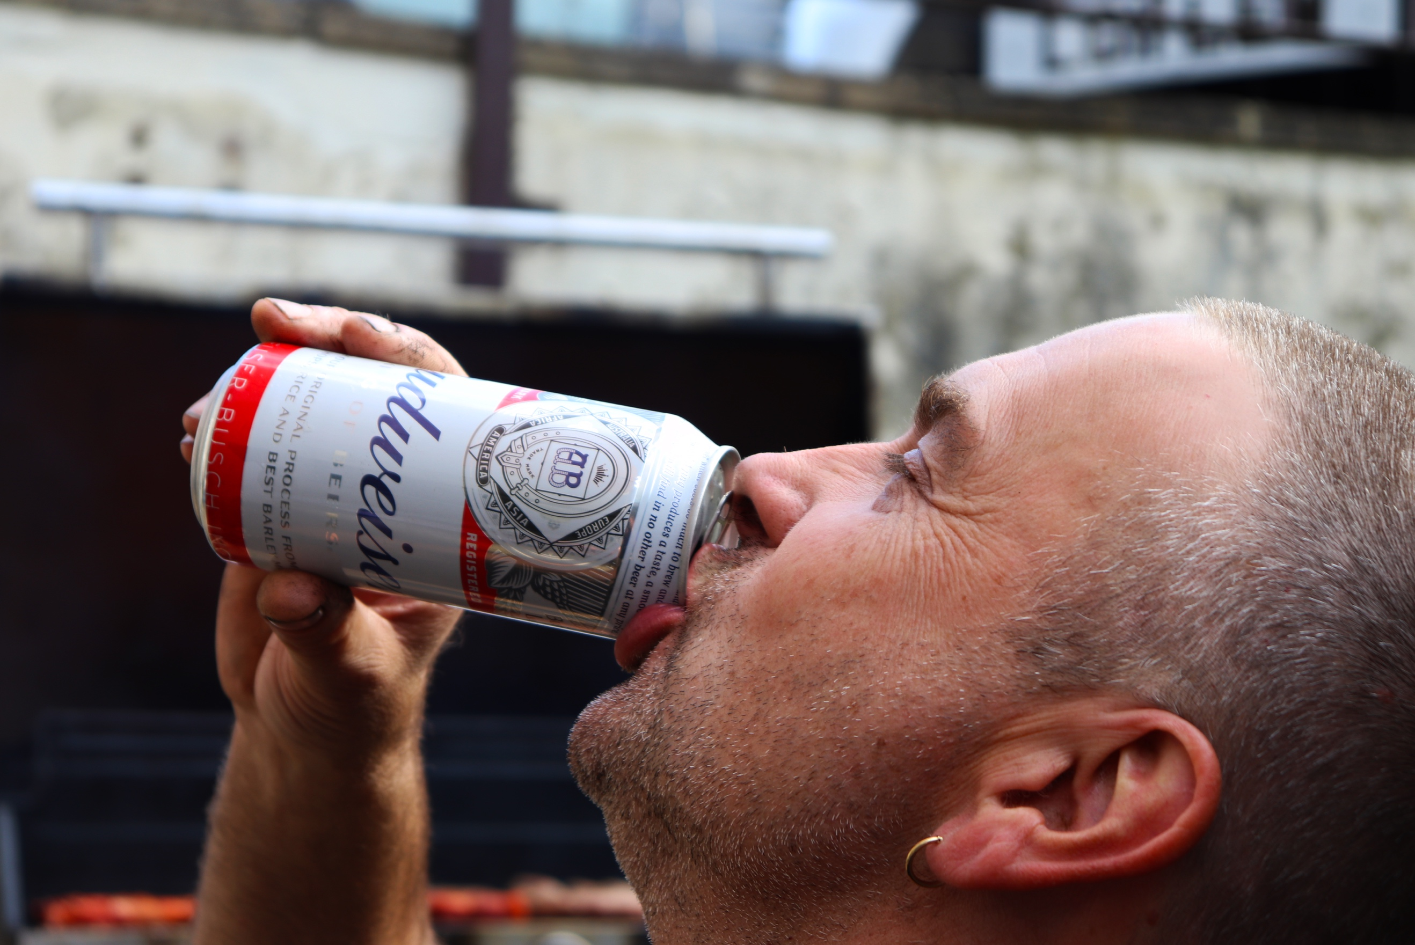
For this image, I am up very close with him. Here, he has taken a break and is drinking his beer. I have shot this so close in because you can really see his facial expression. I have used a small aperture because it focuses in on what he is doing easier, without the background being a distraction. You can see the texture of his hair, and his stubble too because it is so close within the frame. It looks very spikey. The colour and framing of this image was taken from inspiration from Martin Parr. Like Martin Parr, I am not too worried about the framing, just getting a viewpoint and moment which captures the image the way I want it to, not necessarily in the most attractive way. The colouring of the can and his face are very bright and has good colouring. His eyes are closed which means that he is really enjoying the beer as it trickles down his throat, nice and cold on a warm summer’s day. His head is tilted back and the cap of the can is pressed against his nose which means he must be near the bottom or he is drinking a lot at once.
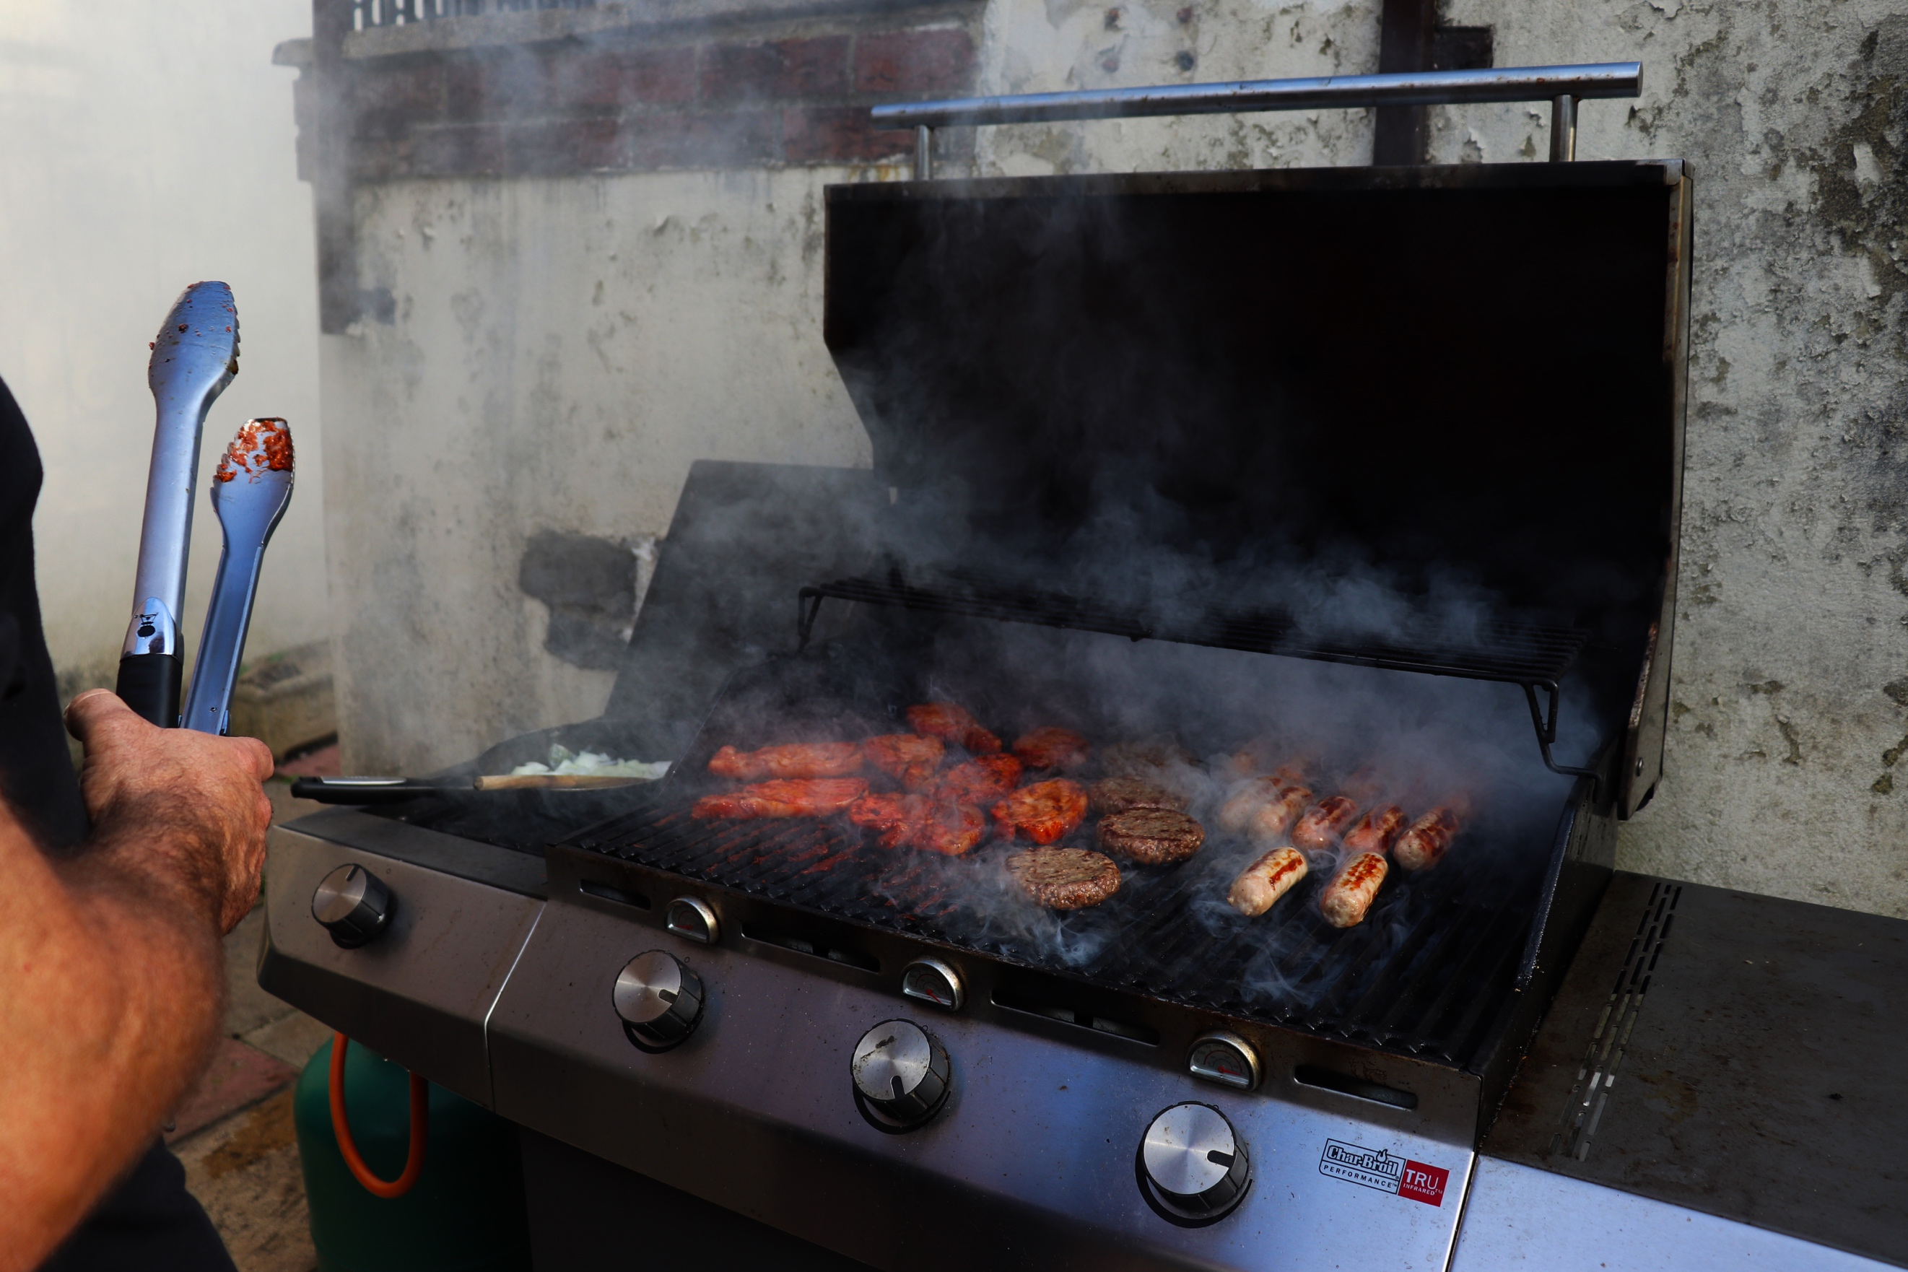
In this image we are back to the BBQ. It is much further along now so the meat has changed colour because it is being cooked. This shows different representation of information because they have transformed. There is a lot of smoke coming off of the BBQ in this image. Like the rest, I have not really bothered with the framing, keeping the same style as Martian Parr. I have just looked for the viewpoint and clicked the shutter. That is why the framing is not perfect. As you can see to the left my dad’s arm and his tongs are in the way of the frame. This time, unlike the other BBQ image, you can see more of the BBQ, including another knob and a pan of onions and a gas cylinder underneath powering the BBQ. The texture of the burger especially looks different in this image because of the colour they now are, they look much more durable. The smoke in the image seems to be very thick that you cannot see the food at the back, making it look like a dark fog that you cannot see beyond.
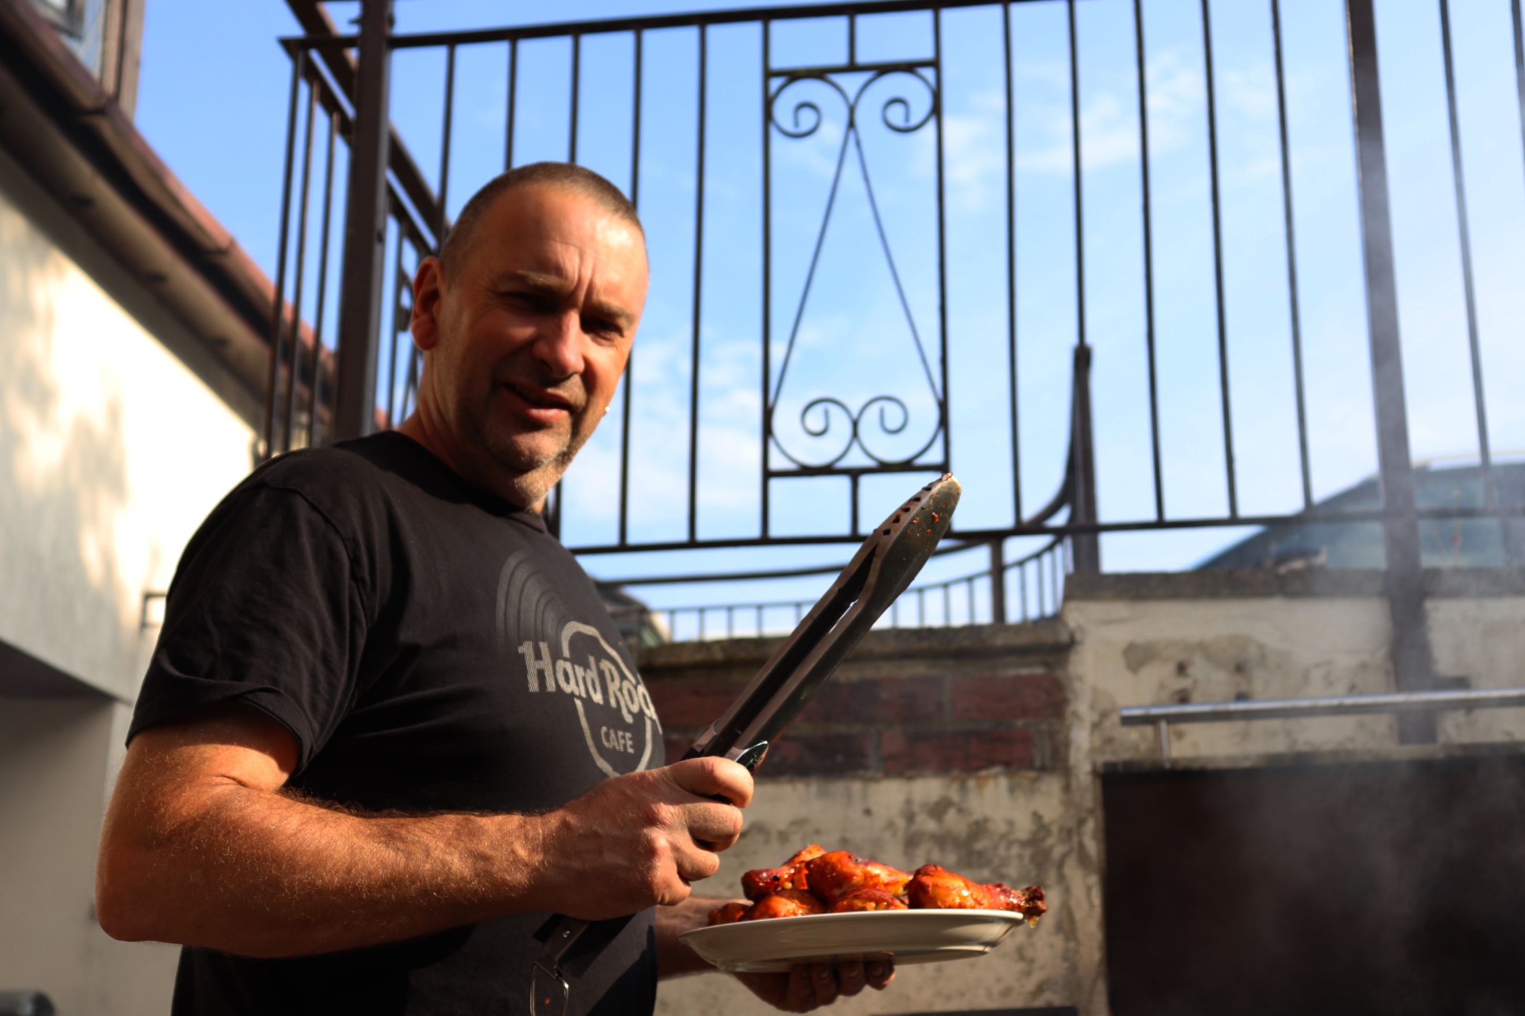
Although he is looking at the camera in this image, he is off guard. He looks like he is posing for this one, just because of the time I have captured it. In one hand he has his tongs and in the other he has his chicken which he is just about to add to the BBQ. He looks very built in the image because of the angle I am at, I am down below so he looks much bigger because I’m lower down, this generally makes things seem bigger from that angle. The background has been blurred again making him the main figure in the image with a good outline from him being in focus to out. You cannot see much else in this image other than some railings and some smoke coming from the BBQ on the right-hand side. Because of the warm glow of the sun, this has made him very brown/gold coloured skin and the chicken looks like hot wings because of how explosive the colouring is of them. A really bright orange/red. Going back to the light, you can also see what direction it is coming from as it is shining off of his forehead, which I have observed.
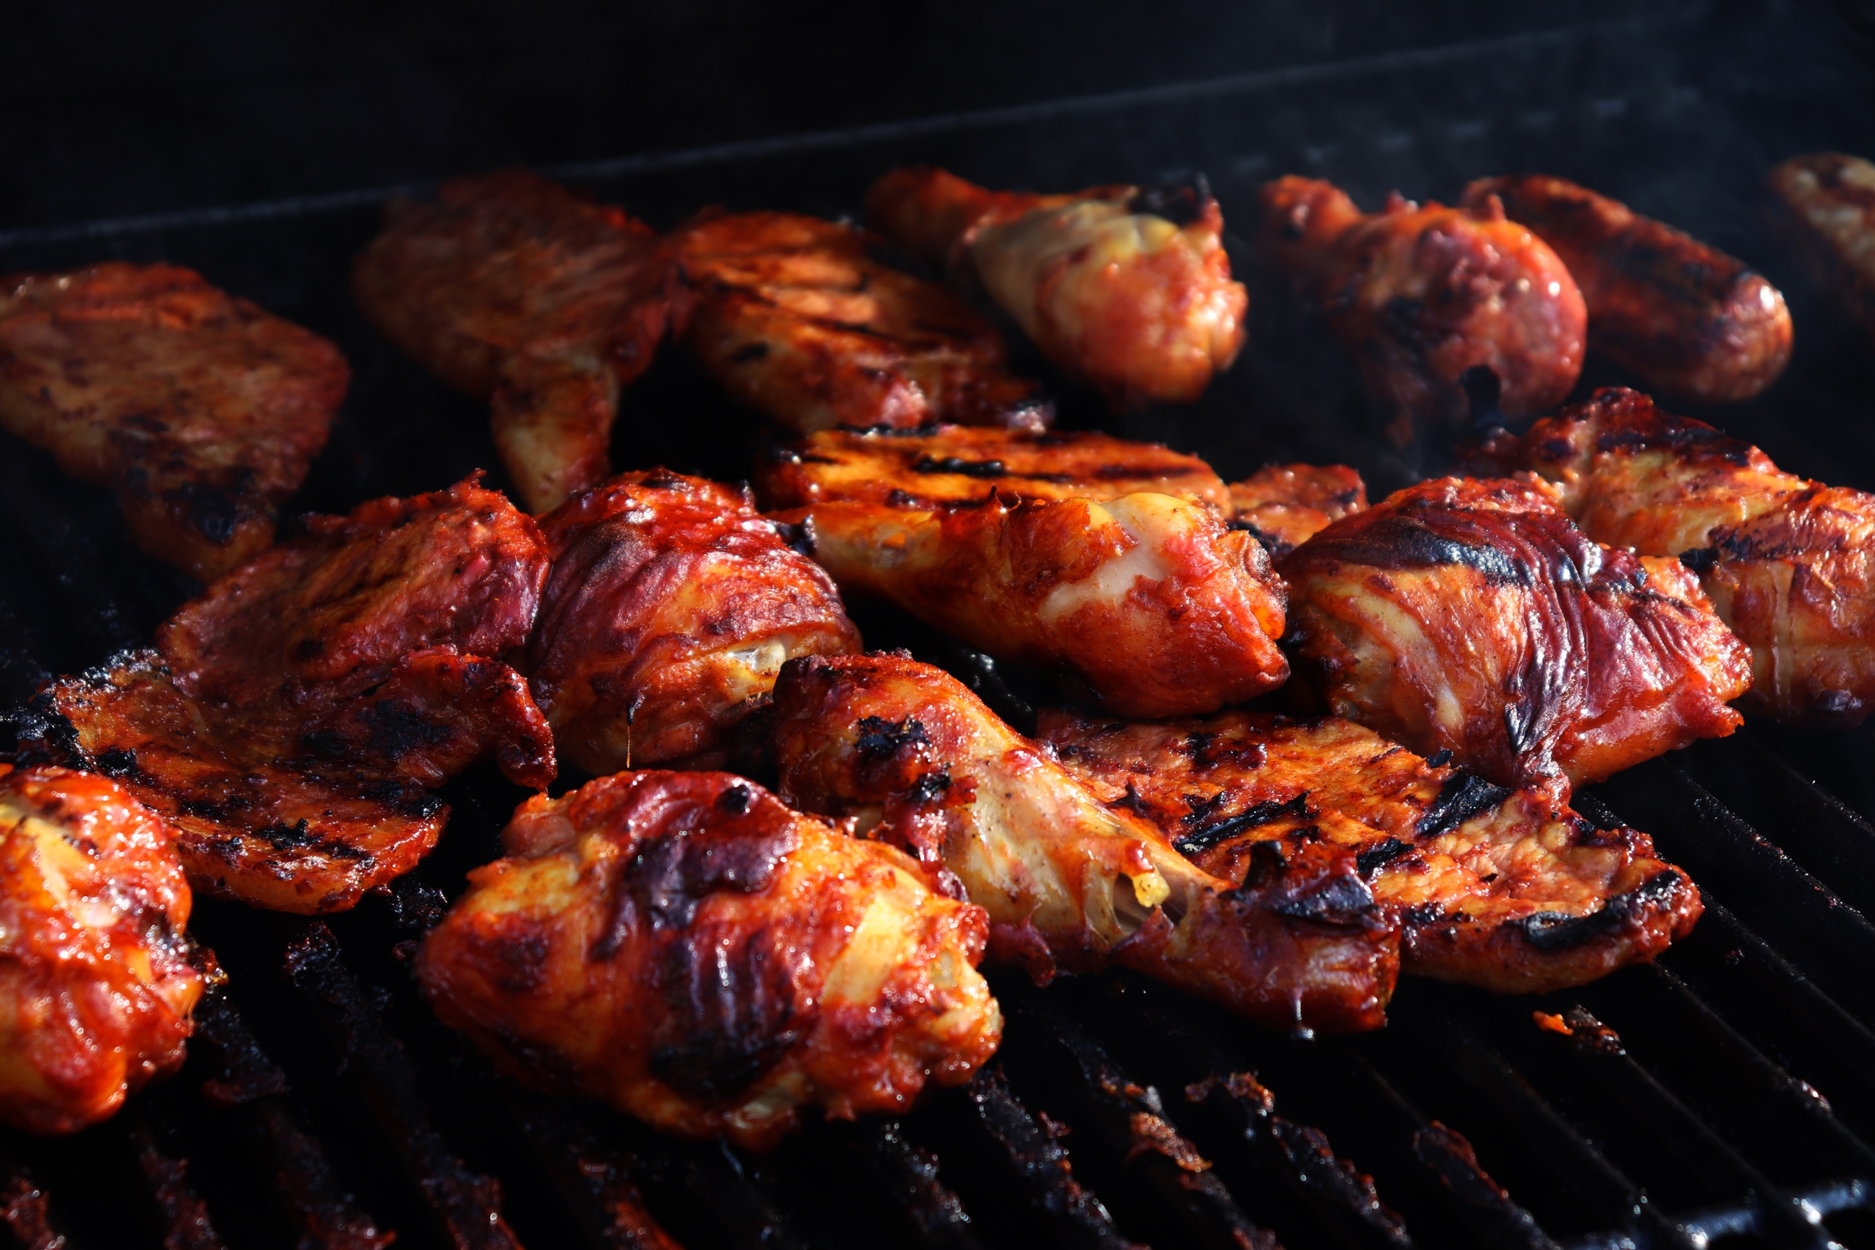
The chicken and steaks are nearly done here. I have got very close in with this shot, as the brief asks for unique view. I could have stood back and have had this shot taken, but I felt if I was really close in this would show the chicken and how succulent it looks and appealing. I have not tried to fit them all in the frame, nor have I focused on any particular one, but just took the picture as it is as they are cooking and nearly ready to eat. The texture of the food seems very juicy and exotic, with a very strong but good taste to them. I feel the colour of them influences the thought of the taste, and I think they look spicy! The ones in the background are slightly blurred out, although unlike previous images in this shoot, you cannot really tell because the food is all together it just blends more, but then gets blurrier the further you look back. This makes the image seem very soft which brings out the texture of the chicken in the foreground.
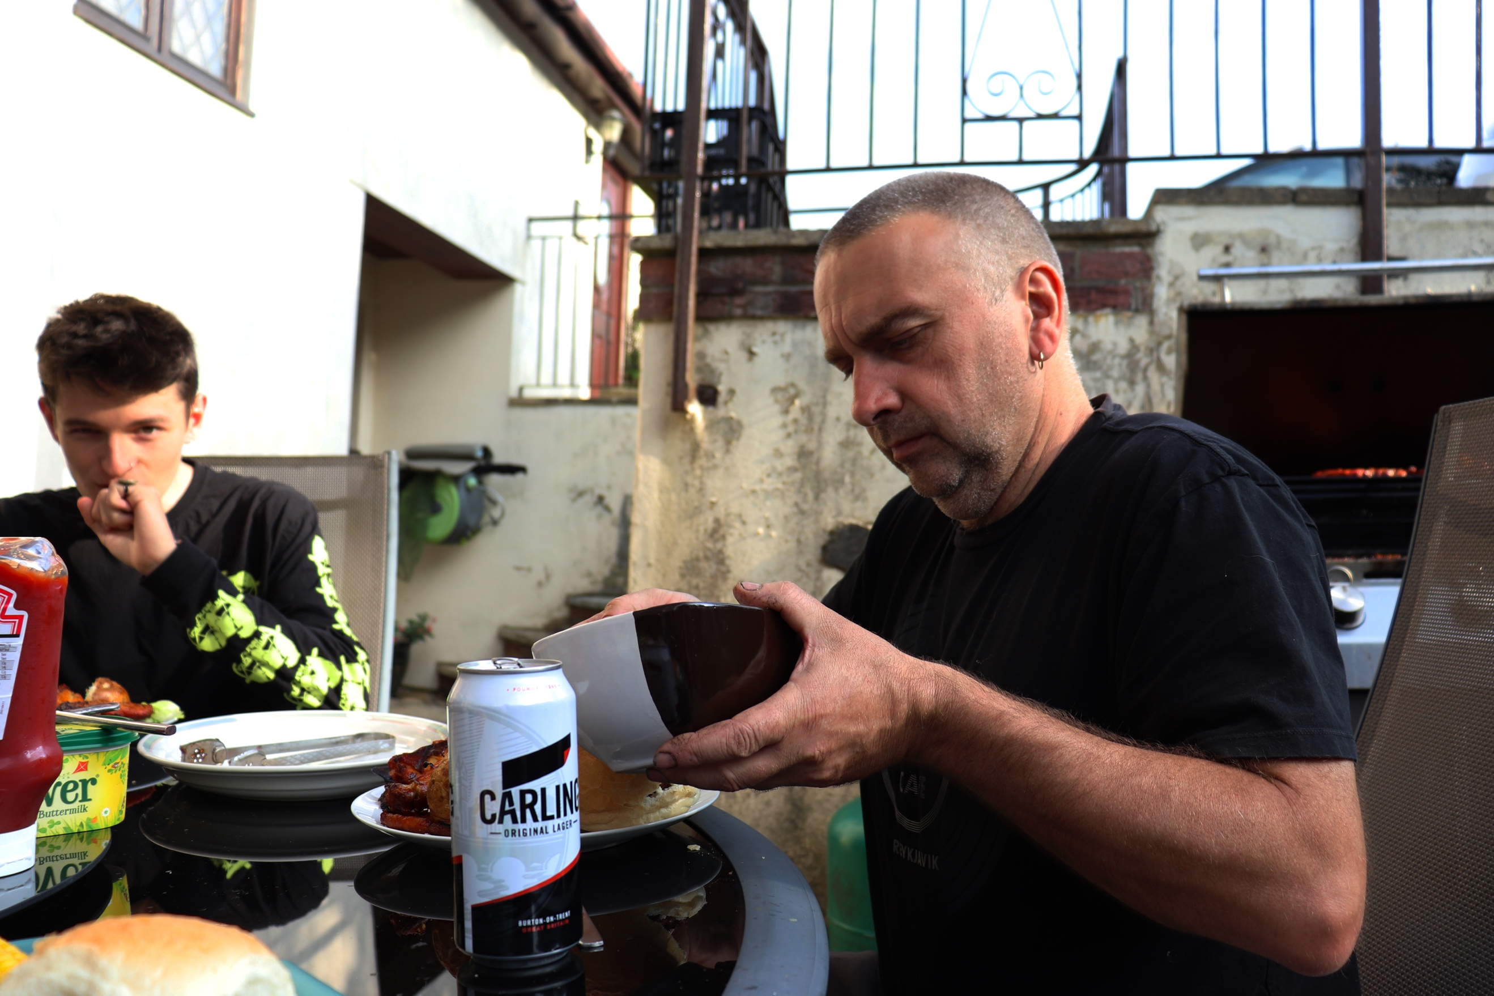
Now the food has been dished up. I have taken this one from next to him as he is finishing putting food onto his plate. As you can see he is not concerned with me but with what he is doing. In terms of the framing, I am not too worried about it again, as long as I am getting my subject in and the moment by pointing my camera in the general direction. You can see on the table various household brands for food and beverages such as Carling, Clover and Heinz ketchup. Although you cannot fully see the label, but you recognise the packaging because of its popularity as a product. This adds to the scene, making it a typical British summer time image. His beer in this image is blocking his food, so you cannot see what is on his plate, this is also partially blocked by the bowl too. There is a lot going on within the frame, but that is because there are lots of small objects. But once you see them, there is nothing but him to focus on, finishing off dishing up. My only concern about this image is that it is slightly over exposed in the top from the sun. If this was darker it would make the image look more complete. This image reminds me of a style similar to Michele Groskopf’s work, where the subject is caught off guard and are occupied with a simple and boring task, and their emotions and the motion of the task has been captured by the photographer and the camera.
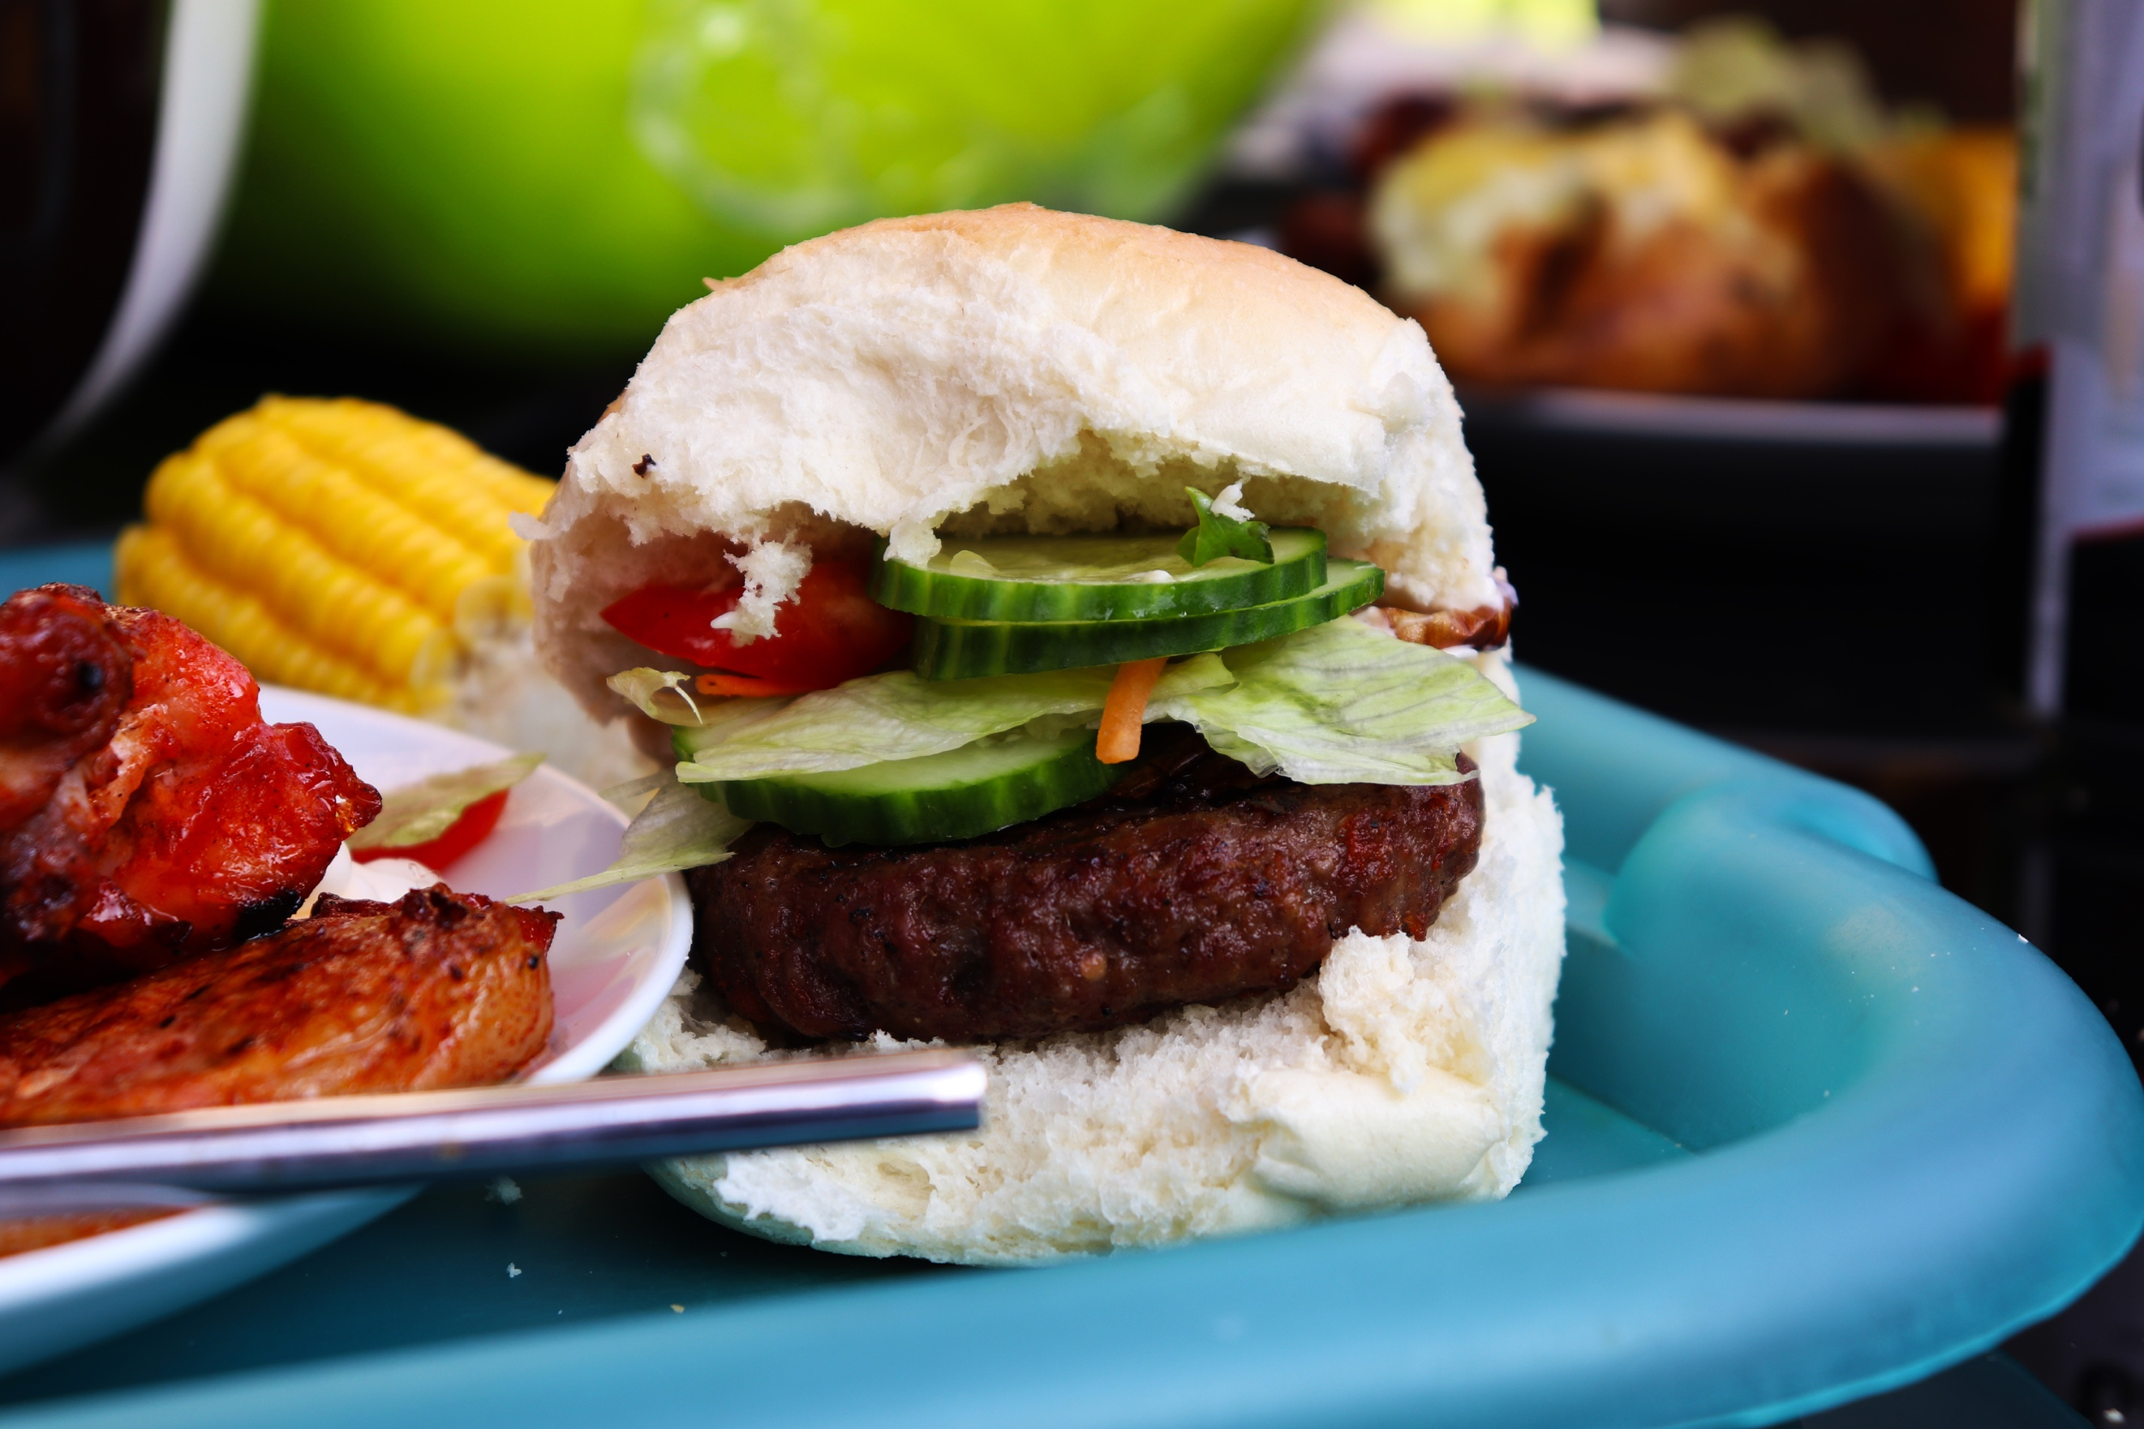
The end product! Finally. Here I have captured my mini burger, the end product. I have captured it, not on the plate but on the tray, I have presented it in a way that looks tasty, but not the tastiest burger ever. I have not really thought about the framing of the image, that is why the plate is pushed up against the roll with other food surrounding it and cutlery blurred out going across the burger in the foreground, ruining the perfect shot. As you can clearly see this is not set up to look like the tastiest burger every created, but showing the typical British family BBQ burger, cooked for the evening grub. The roll itself looks very fluffy and the salad looks fresh and vibrant. As does the surrounding food. The background is blurred using a small aperture which makes you focus in on the main subject. The foreground is also partially out of focus for this shot too. This image is different from the rest because it is the first one in the bun, ready on the plate, presented as the end product. I do not feel that any of these images are necessarily ‘strong’ but show a variety of viewpoints and moments. With this one especially, it does not always show the greatest of images, of angles, but then also I am partially emulating my artists from my research as influences on this shoot as a basis for my photography for this shoot, in order to trial a variety of techniques throughout.
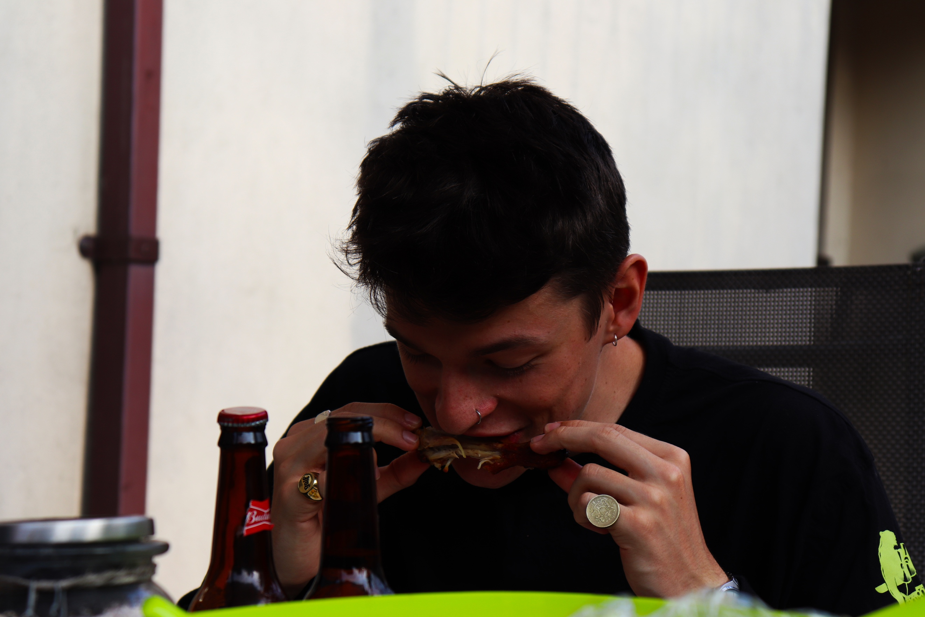
Enjoyment of the food. From across the table, I captured this shot using my 18-55mm and used Manuel Mode to calculate the exposure. I then decided that framing isn’t key in this shot, as long as I am representing the British summer time style BBQ in full swing, showing different viewpoints and moments of the process in which, I can capture a variety. Here in the foreground you have a green line, which is actually the top of the salad bowl, which has been blurred out along with the jar in the foreground, but have managed to retain the Budweiser bottles in focus. I like how the background is fairly plain, and not too much going on in the foreground, meaning that I can capture him really well without too much distraction. This is kind of an action shot which shows him just about to take a bite, so I have taken this at the right time in order to capture that moment as he is enjoying his food, as you can see from his facial expression that he is happy (although he is also taking a bite at the same time, but by his cheekbones).
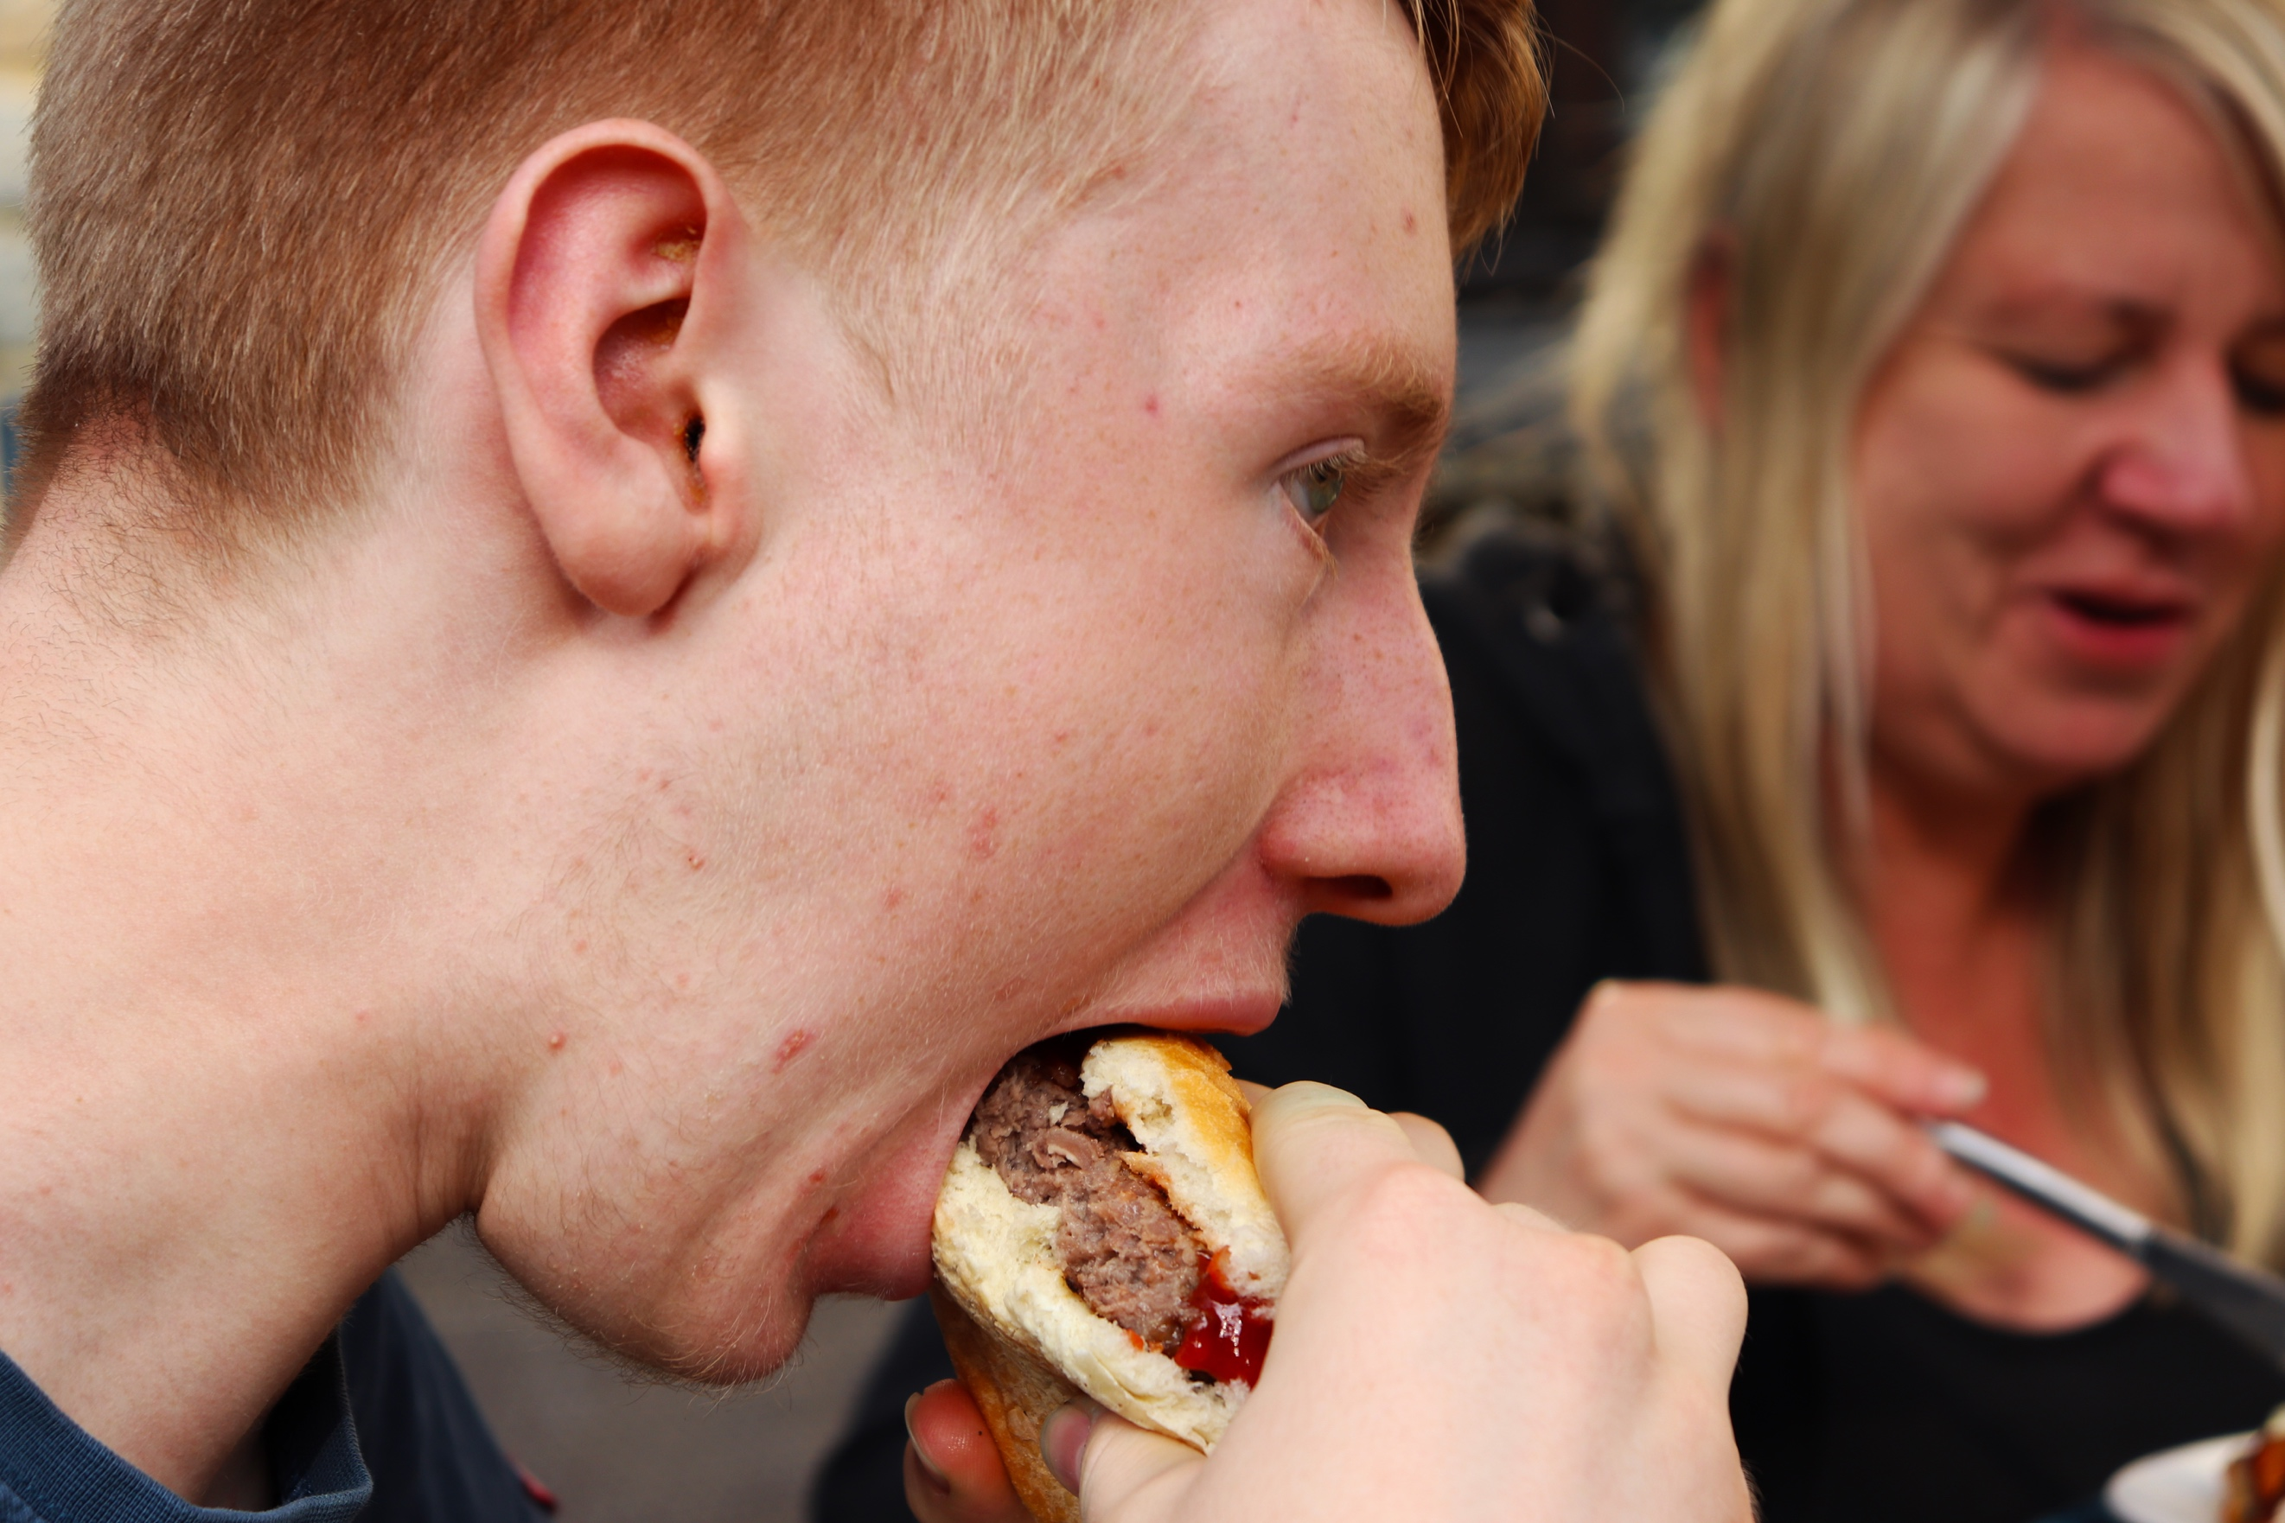
For me this is the most styled image representing my artist research. It reminds me of the grotty food images by Martin Parr. I am very close in, with a character we have not seen before. As you can see he is taking a massive bite of his burger which is oozing with ketchup. His eyes are focused ahead of him on something and he is using both of his hands to hold the food. I feel I have captured this at the perfect moment as you can see the burger entering his mouth and the bun firmly pressed against the bottom of his lip and not against the top, suggesting he is about to bite down on the burger. The texture of the burger looks much different than previous images. This is because he has taken a bite out of it and now it looks like pulled pork, but also does not look as yummy as when I presented the burger in the other images. In the background you can see someone else, my mum. As you can see she is also enjoying her food, laughing. She is blurred out which makes you focus on him easier. As the background is blurred out, this gives you the opportunity to focus on the texture of his skin, and as you observe you can see the hairs on his chin. The angle, shows primary him taking the bite and not worrying about the rest of him or his other food but because we are so close in this makes you observe that area really well.

