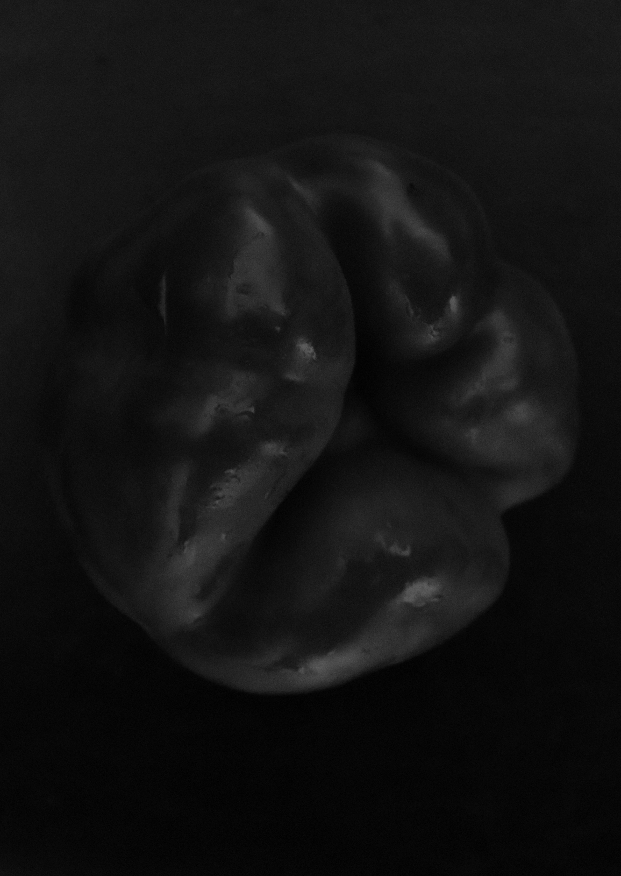
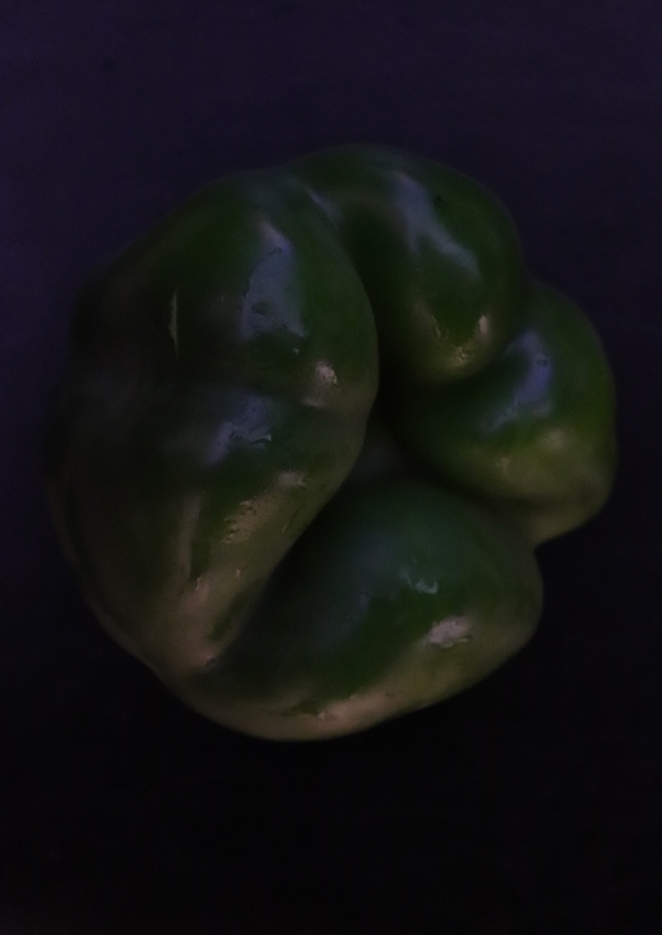

Taken from inspiration from Weston’s pepper, after I found I couldn’t do chillies such as Habanero etc. I had to alter my shoot slightly. I picked up a variety of veg and used this as my object for my shoot. My background I used was black from a seat and used natural and artificial light alternatively throughout the shoot. I used a small aperture and long shutter speeds to ensure the image was correctly exposed. I also used my light meter to check this. This image is of a pepper. My intention was to show the form of the pepper and how it is presented in such a way. I feel this image looks strange, not necessarily looking like your average pepper. That’s why each piece of grown veg is unique because they come in all different sizes and shapes. The texture of the pepper is very damp as you can see from the coloured version, it seems moist and fresh, this gives it a shiny effect to it, I feel this is also contributed by the light source reflecting off of the water. In the B&W image, it looks like a darker shade in the area it is most damp. The background helps you focus on the pepper and its form, as there is nothing in the surroundings to take your attention away from it. I have taken this image from above, not that you can tell this anyway because of how close in I am. The shape of the pepper looks really fat on the outside and then draws into a hole in the middle of the pepper. I feel overall, the image is very dark, and is borderline to being nearly on the darker side, but you can still concentrate on the main part of the image being the form of it. For this I used a standard 18-55mm. I used Manuel mode for this shot. I chose to convert it to black and white so you can see the tones within the image, and I must say there is a good variety of tones throughout the pepper, with some light and some dark, mixed. The dark pepper especially looks very hard, almost like a rock because of how the tones are presented with different shades.

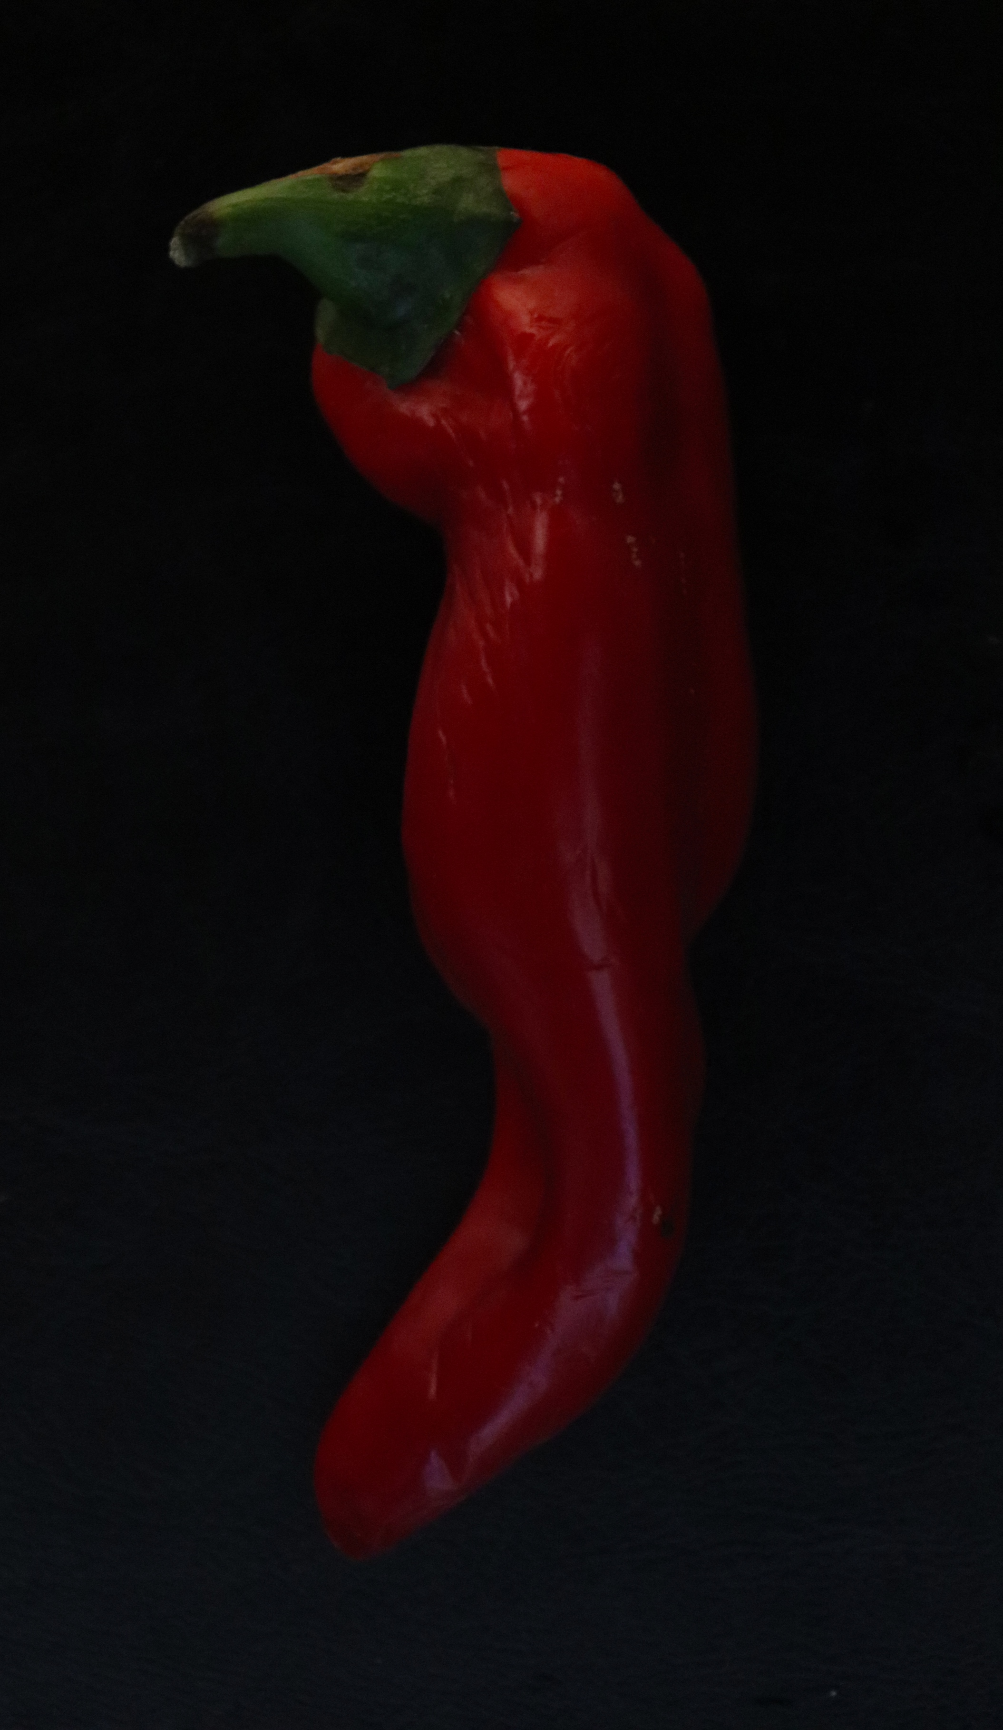
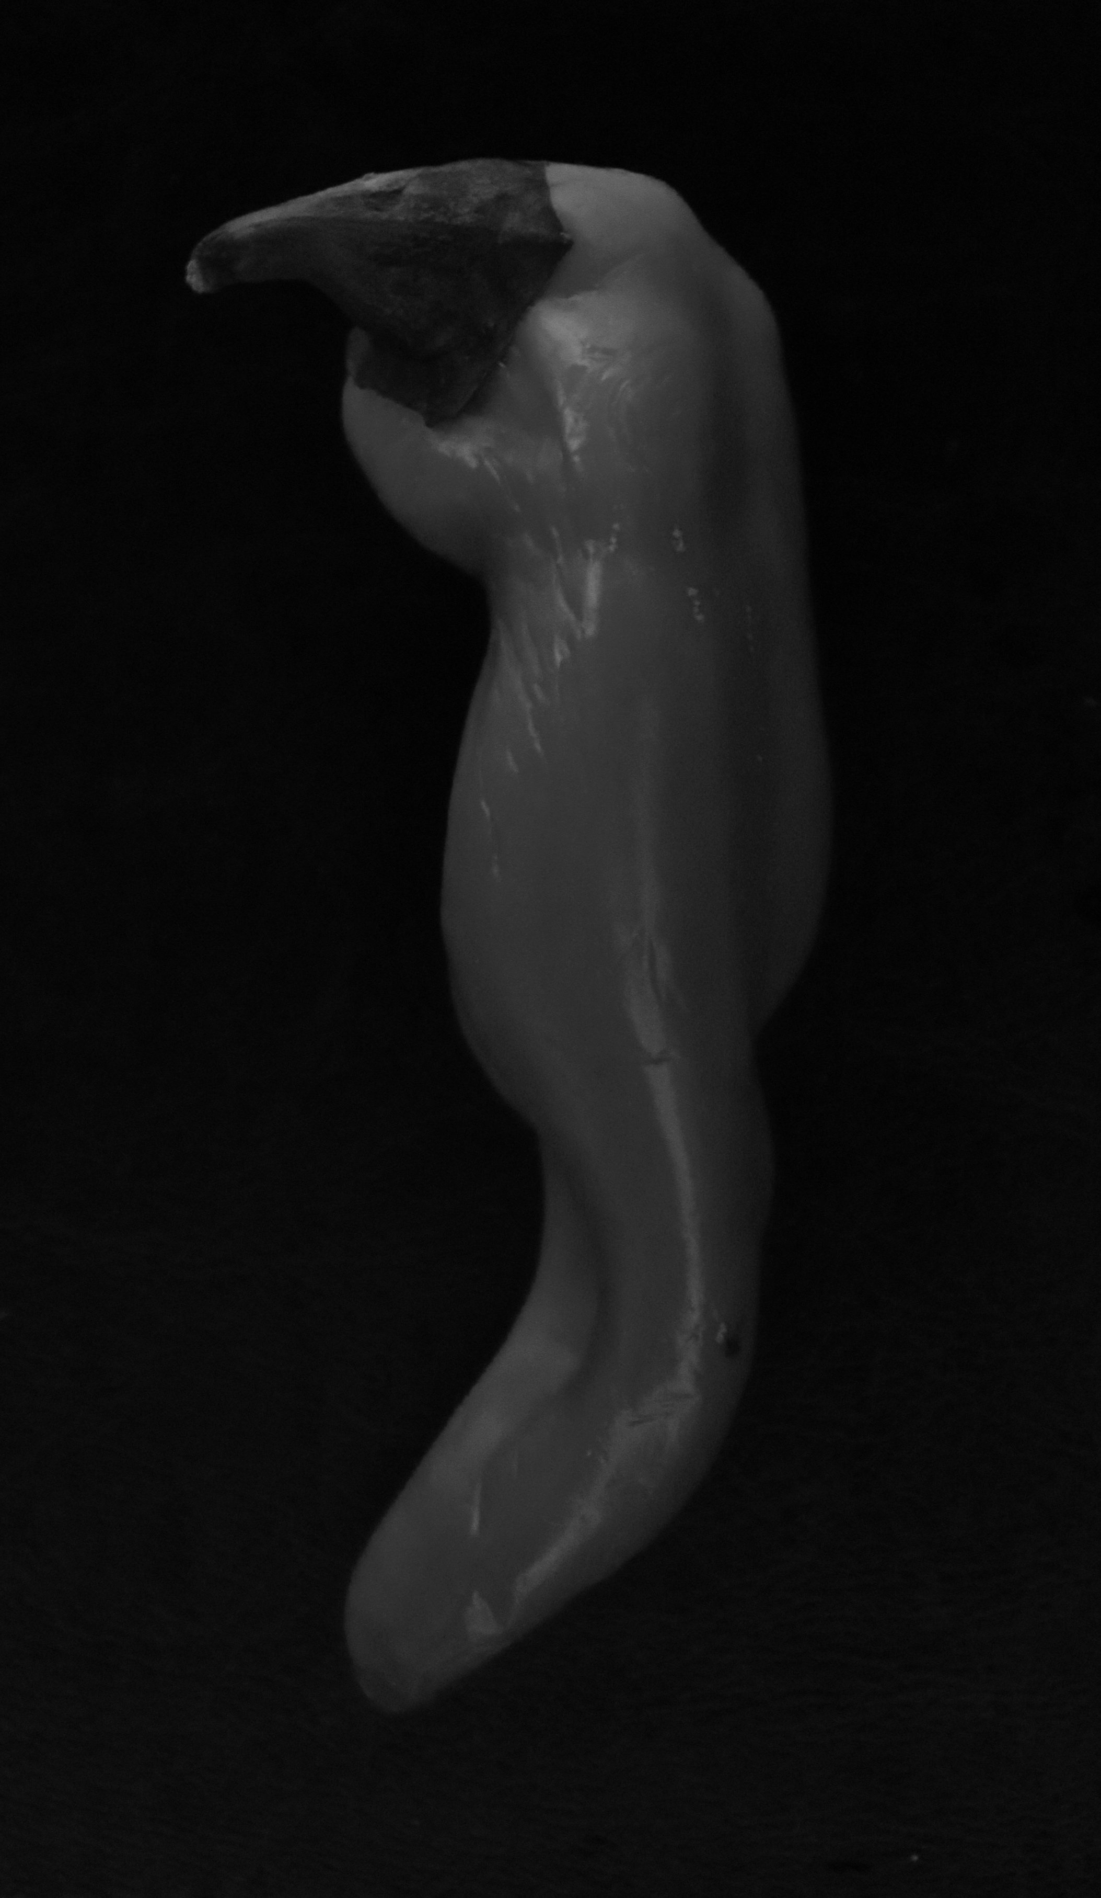

This is of a red Chilli pepper. The texture of this looks very hot, because of the red colour, and how red and chillies are normally perceived. It looks very smooth and fresh, and has a nice shine to it from the light source. The toned image looks very hard, like the first toned image and doesn’t even look like food to a certain degree because of its form. The red repels very well against the black because they are vastly different. This makes the form of the pepper stand out a lot. The angle I have taken this from, was again from above, like the light source. The shape is very unusual and the pepper twists as you look down it and looks dented nearer the bottom, some parts seem stretched and other parts seem very smooth. The top starts very thick and then gets thinner and turns when you approach the bottom of the pepper. I think this gives the form a very interesting feature. The pepper almost looks like it is trying to walk along strutting its stuff. I used the same camera settings throughout, being Manuel mode.
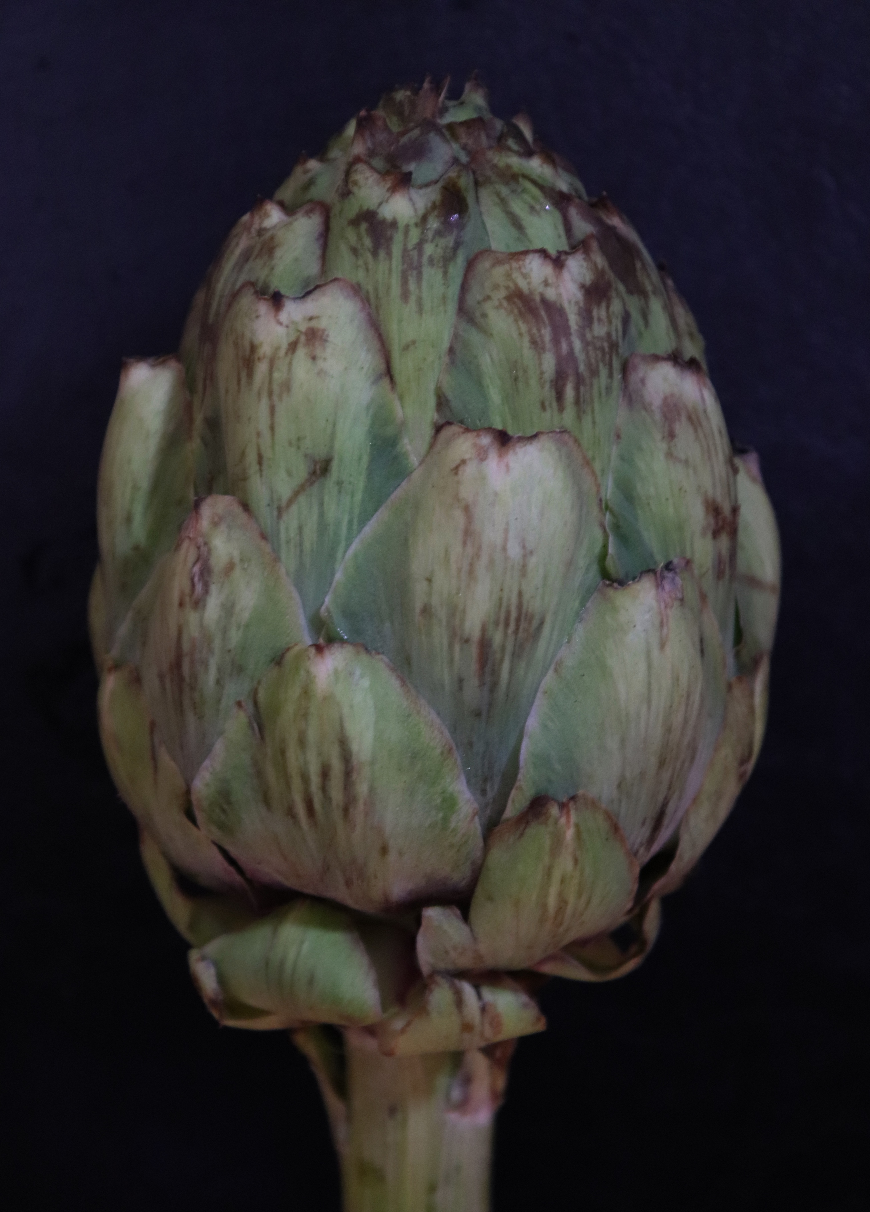
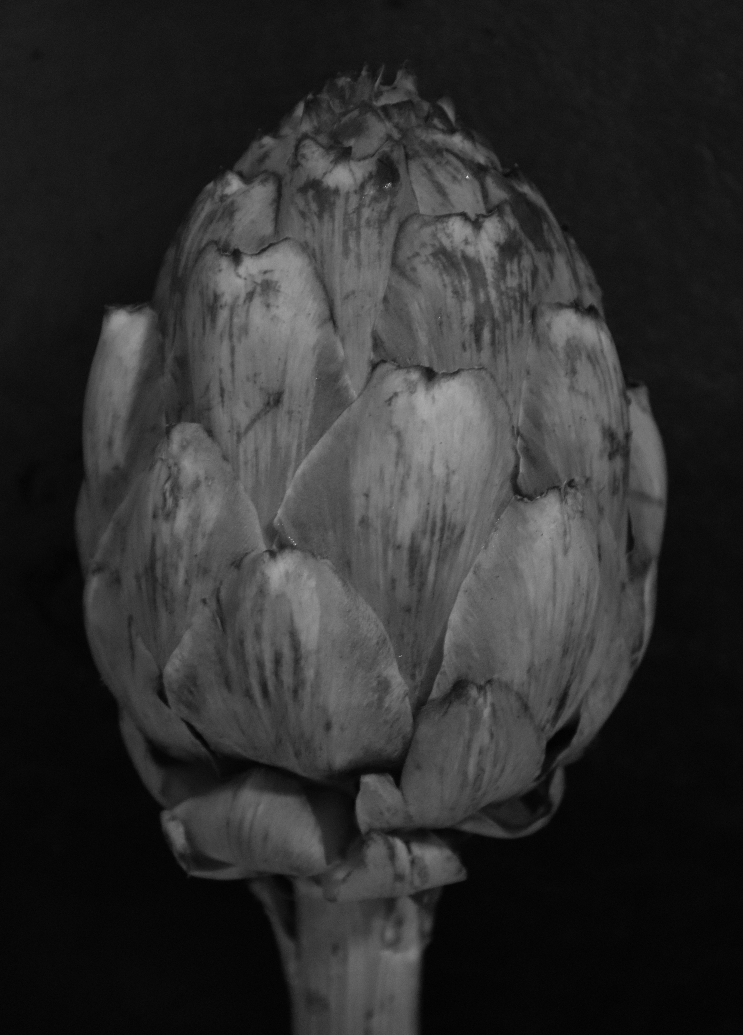

In this image we have an Artichoke. My aperture was slightly annoying in this image, but I selected this as it was my favourite in all other aspects of the image, I feel it blurred the edges slightly too much but the majority of it looks still in focus. The texture seems rough, because some parts look stretched and the colouring makes it seems like it wouldn’t feel smooth, because some parts are darker than others. The colouring is really amazing because a large proportion of it is green, but then a lot of purple starts appearing in the centre of the leaves and at the top. The angle I took this from was from above, like the rest with the settings on Manuel mode. The shape of the object looks like it is of an enclosed flower just about to burst open and spring to life, it seems very clamped up. I like how the leaves overlap one another all the way up to the top. After the stem, it starts off thin and gets thick in the middle and then thins out at the top again. The black and white image makes the tones really stand out from the various colours that are in the image. It looks like it is all meant to be one shade of grey and someone has started scribbling on it with a pen and makes it look scruffy.
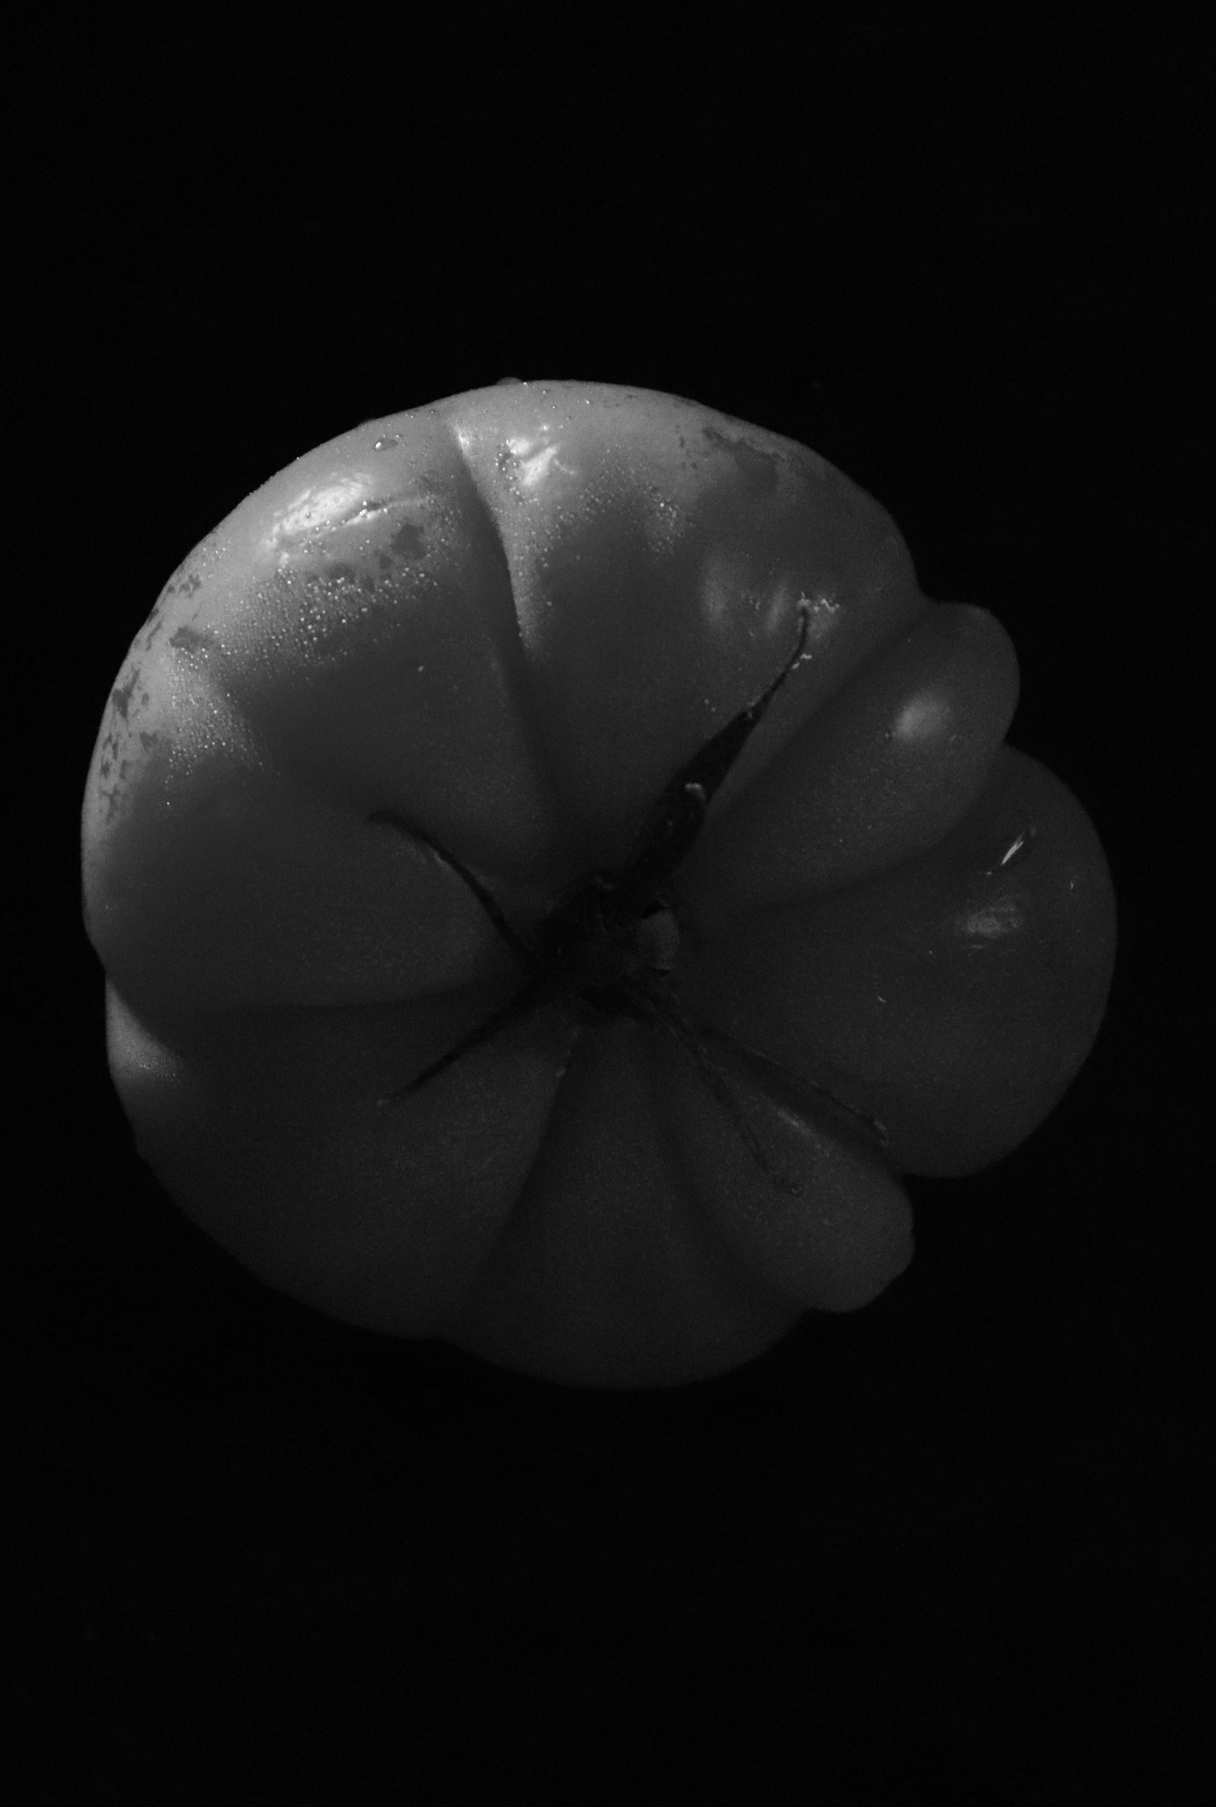
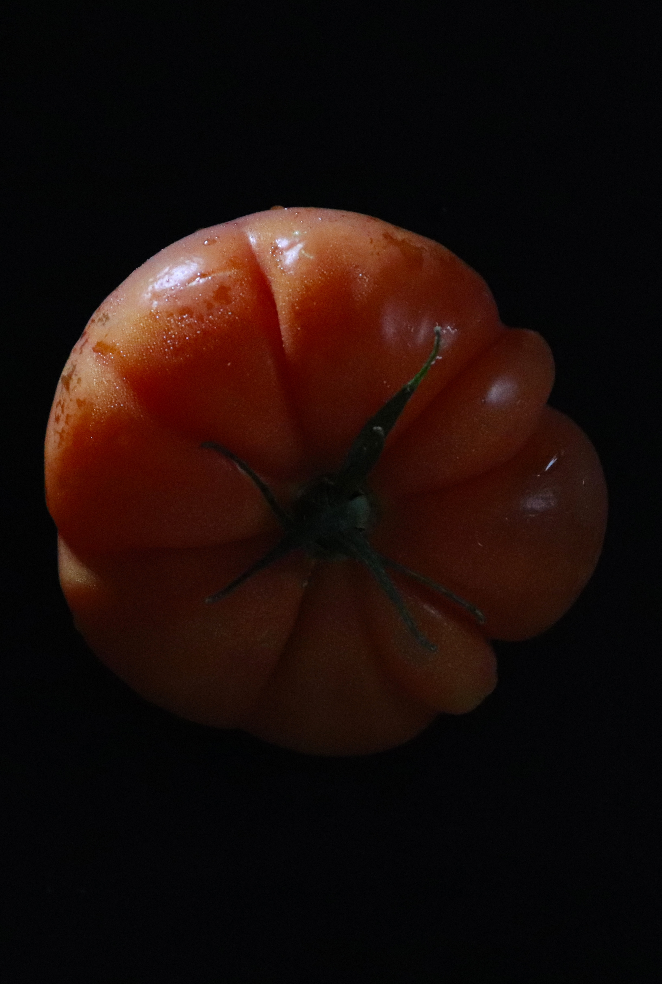

Here we have a beef tomato. This tomato is a very big and juicy one. I have taken this from above, on Manuel mode. As you can see there is one part on the right which sticks out way more than the rest of the tomato, where it is so juicy. You can see that all the lines lead to the centre of the tomato and kind of reminds me of an orange once you peal it, and looks like you can peal it into different segments. The tomato looks fresh as in both variations of the image, it looks moist from the water specs in the top left, highlighted well from the light source. The tomato looks like it is just about to burst because it already looks slightly deformed. It looks like someone has wrapped string around it and it is just about to burst open as it is getting too tight. The colour of the tomatoes is a nice warm orange colour, which helps the texture in the left image, to be more of a warm and squishy feel. Whereas on the right it seems hard because the colours have been taken away. Surprisingly, even though this is from above, it still looks 3D rather than the typical 2D you would expect from a shot above. The one aspect of this image which I really rate is how the black and white image goes from really light to really dark when you travel around the tomato and how it changes tones.
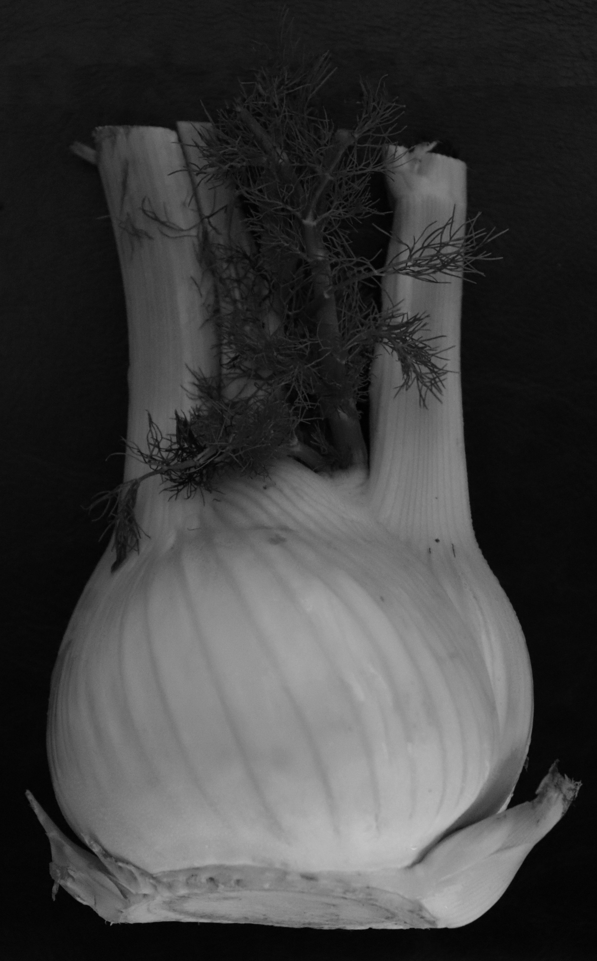
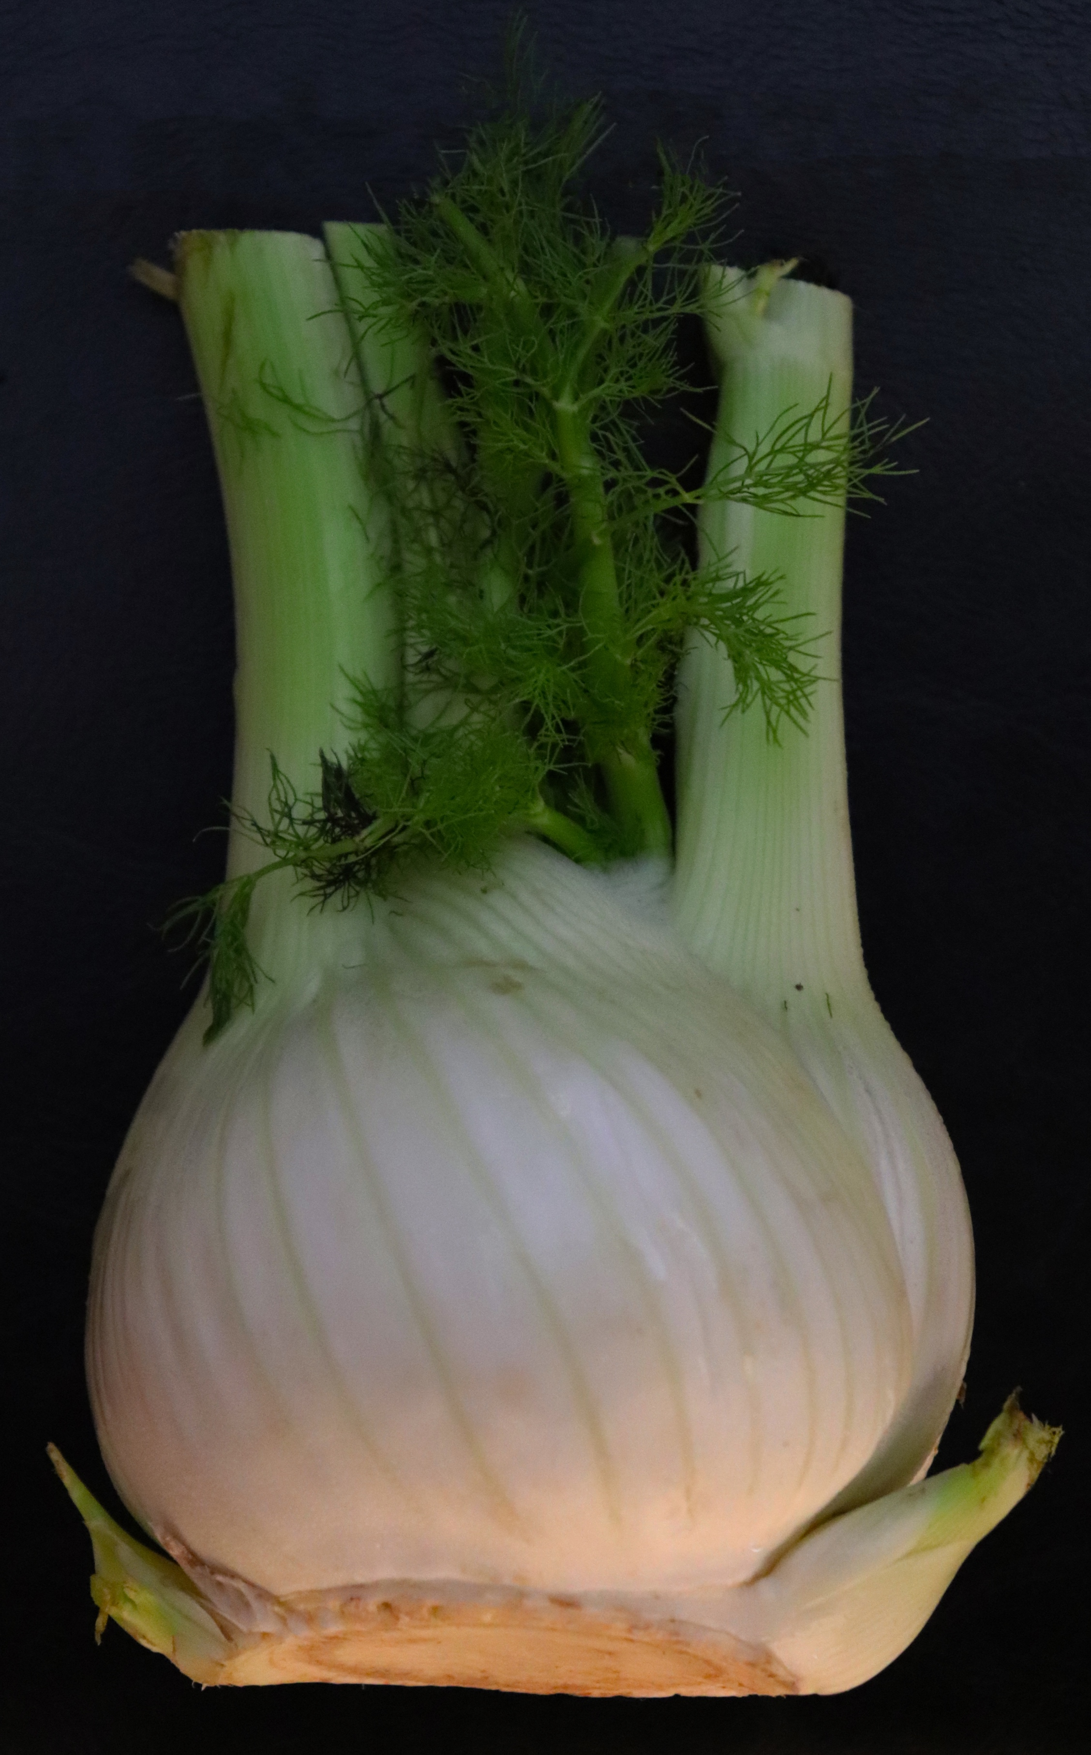

This is a Fennel. I had never even heard of one until I purchased it in a shop to use for my shoot! The texture of it seems hard, in both the colour and the black and white image and the little leaves look prickly. The colour of the coloured image I feel is really well lit. With the lighting coming in from the bottom of the image, gives a warm glow at the bottom of the Fennel. Further up it starts to turn green which blends really nicely and the transition between colours are very fascinating. The black and white image doesn’t have an array of tones as such as I thought it would do, but looks more consistent to one. Although the top gets slightly darker. The angle I took this from, was from above, looking down on the subject. I did try standing this up, but didn’t feel it was worth photographing as you couldn’t see it as well. But with the black background the subject looks like it is stood up anyway! The subject to me at the bottom looks like an onion and the lines going across it diagonally, looks like a really interesting pattern. The shapes of the subject is strange, I don’t know what is really going on at the bottom and then the middle is round and looks like an onion and the top then forms into this outrageous shape with these tubes that just looks so weird and doesn’t look like it should be part of the same thing. The leaves I am not even sure what they’re all about, but if we are solely talking about form, I would have to say that this is one very weird object.

