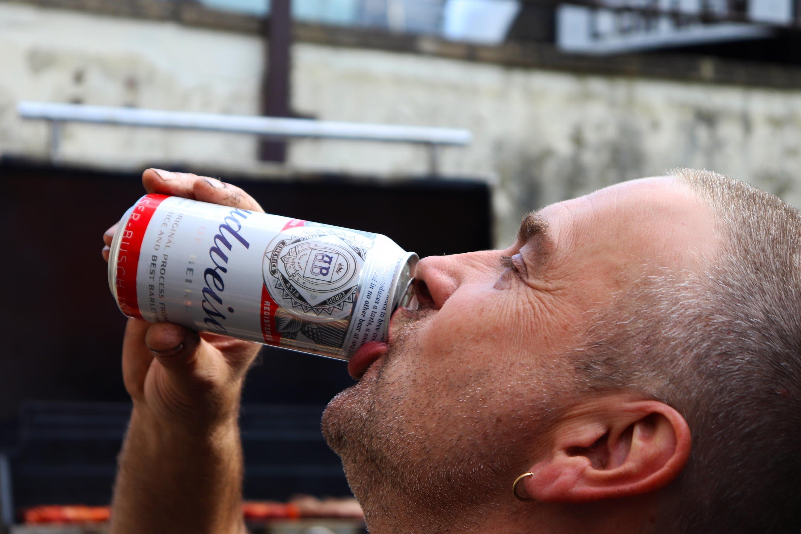
The purpose of this image was to capture my dad enjoying the event of the British summer time BBQ that we were having. I have used a small aperture to ensure he is in focus and the background blurred so that you can clearly see him. The image is of him drinking his beverage and the interaction of him in relation to this and his connection to it. As you can see he is squinting and his facial expression is a happy and joyful one. Budweiser amongst other alcohol is normally associated with events, socialism and family time in the summer. A typical BBQ would normally involve alcohol as a standard drink to drink at such an event. This photograph is about him enjoying the small, sweet things in life which give him pleasure such as his drink. This kind of drink is seen as a luxury, in which is purchased as a gift to himself to enjoy. He is enjoying the moment. The can is very vibrant, reflective and powerful within the image as it is in focus and looks very expensive because of this. What I like about this image is the way that it has been snapped when he is halfway through his sip, capturing the moment in its peak. What could be worked on here is the framing, or angle, to see what would work better, or what wouldn’t. I feel from a different angle you could see his facial expression better, but this might take it away from the can itself and being able to identify the branding of it.

