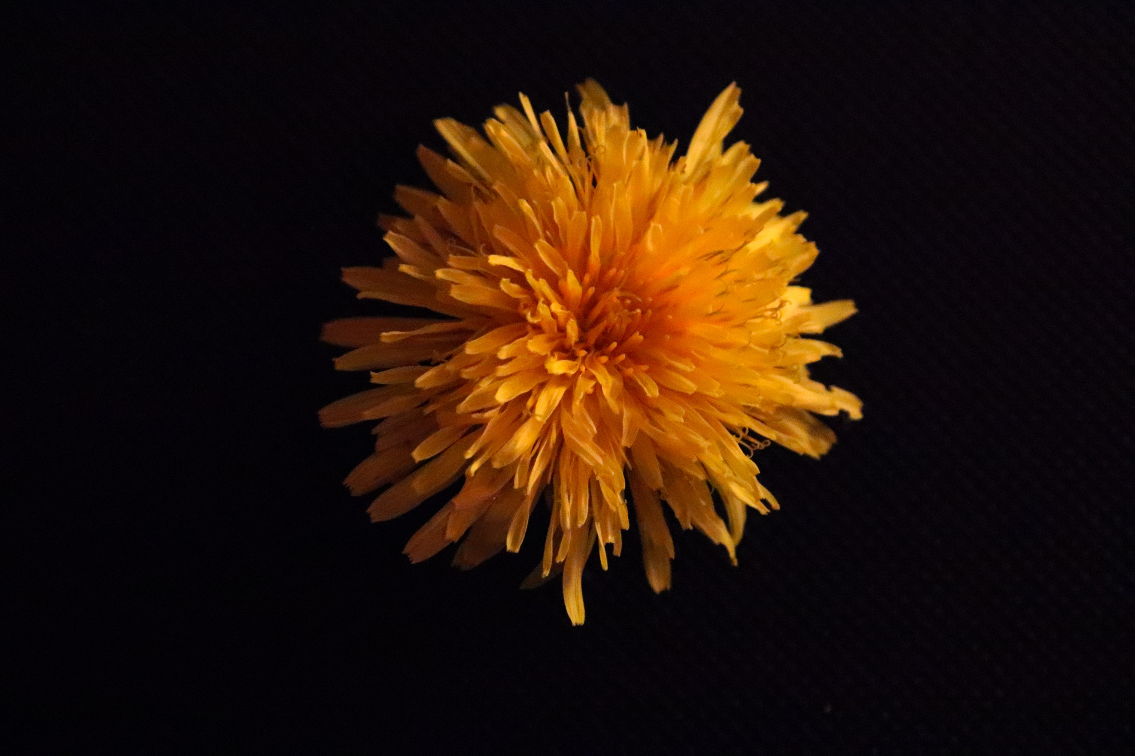
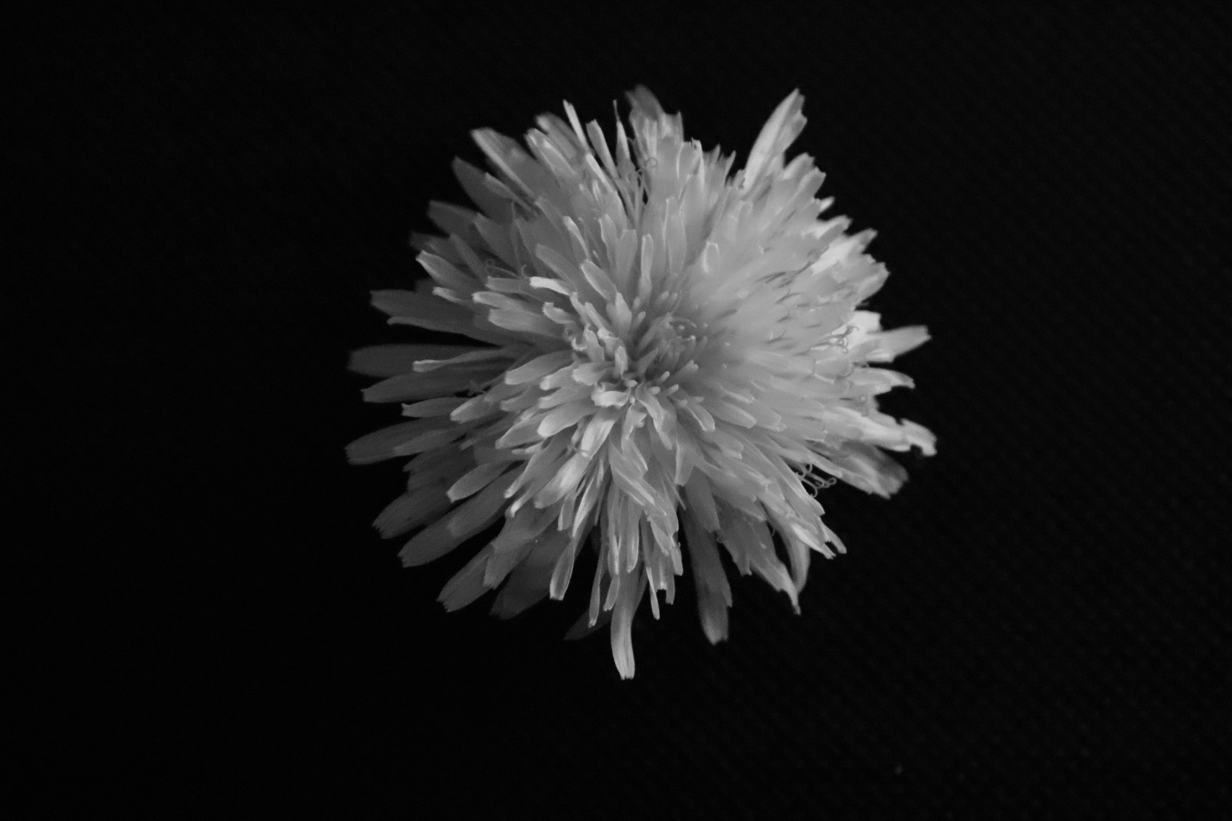

This is the first image for the shoot which I selected, of a small Dandelion. I chose this flower as it is a very bright flower and one that really expands outwards. The texture in both the colour and black and white image is very soft I feel, maybe this is because of the small aperture that I used, but I feel that it does look very soft and bouncy. The background is black, which is very strong, and makes the subject stand out and the form of the subject stand out. I think it repels against the background better with black than if I was to use white, simply because I think it contrasts better. The colour is very vibrant and warm, when the colour is taken away it looks very strange, and looks like something has just exploded and I have managed to capture it with a very fast shutter speed as all the shards fly out. The angle I have taken this from is above, like the previous shoot, as it makes sense as you want to see the top of the flower, not the side. The shape is very unusual and is very spikey, and you can clearly see where the outline is against the background in both images. The flower looks 3D but also looks 2D at the same time which is unusual. It looks 3D at the front because it looks like it is coming at you when exploding but the fainter petals at the back look 2D because they look flat and you can see how they’re not 3D. I think the lighting in the image is very well done, with the light coming in from the right and being very dominant over the surface of the flower. Bringing out the tones really well as you can see through both variations of the image. For this shoot I shot on Manuel mode, I used a high ISO to compensate for the shutter speed and the aperture I used in order to capture this flower the way I have.

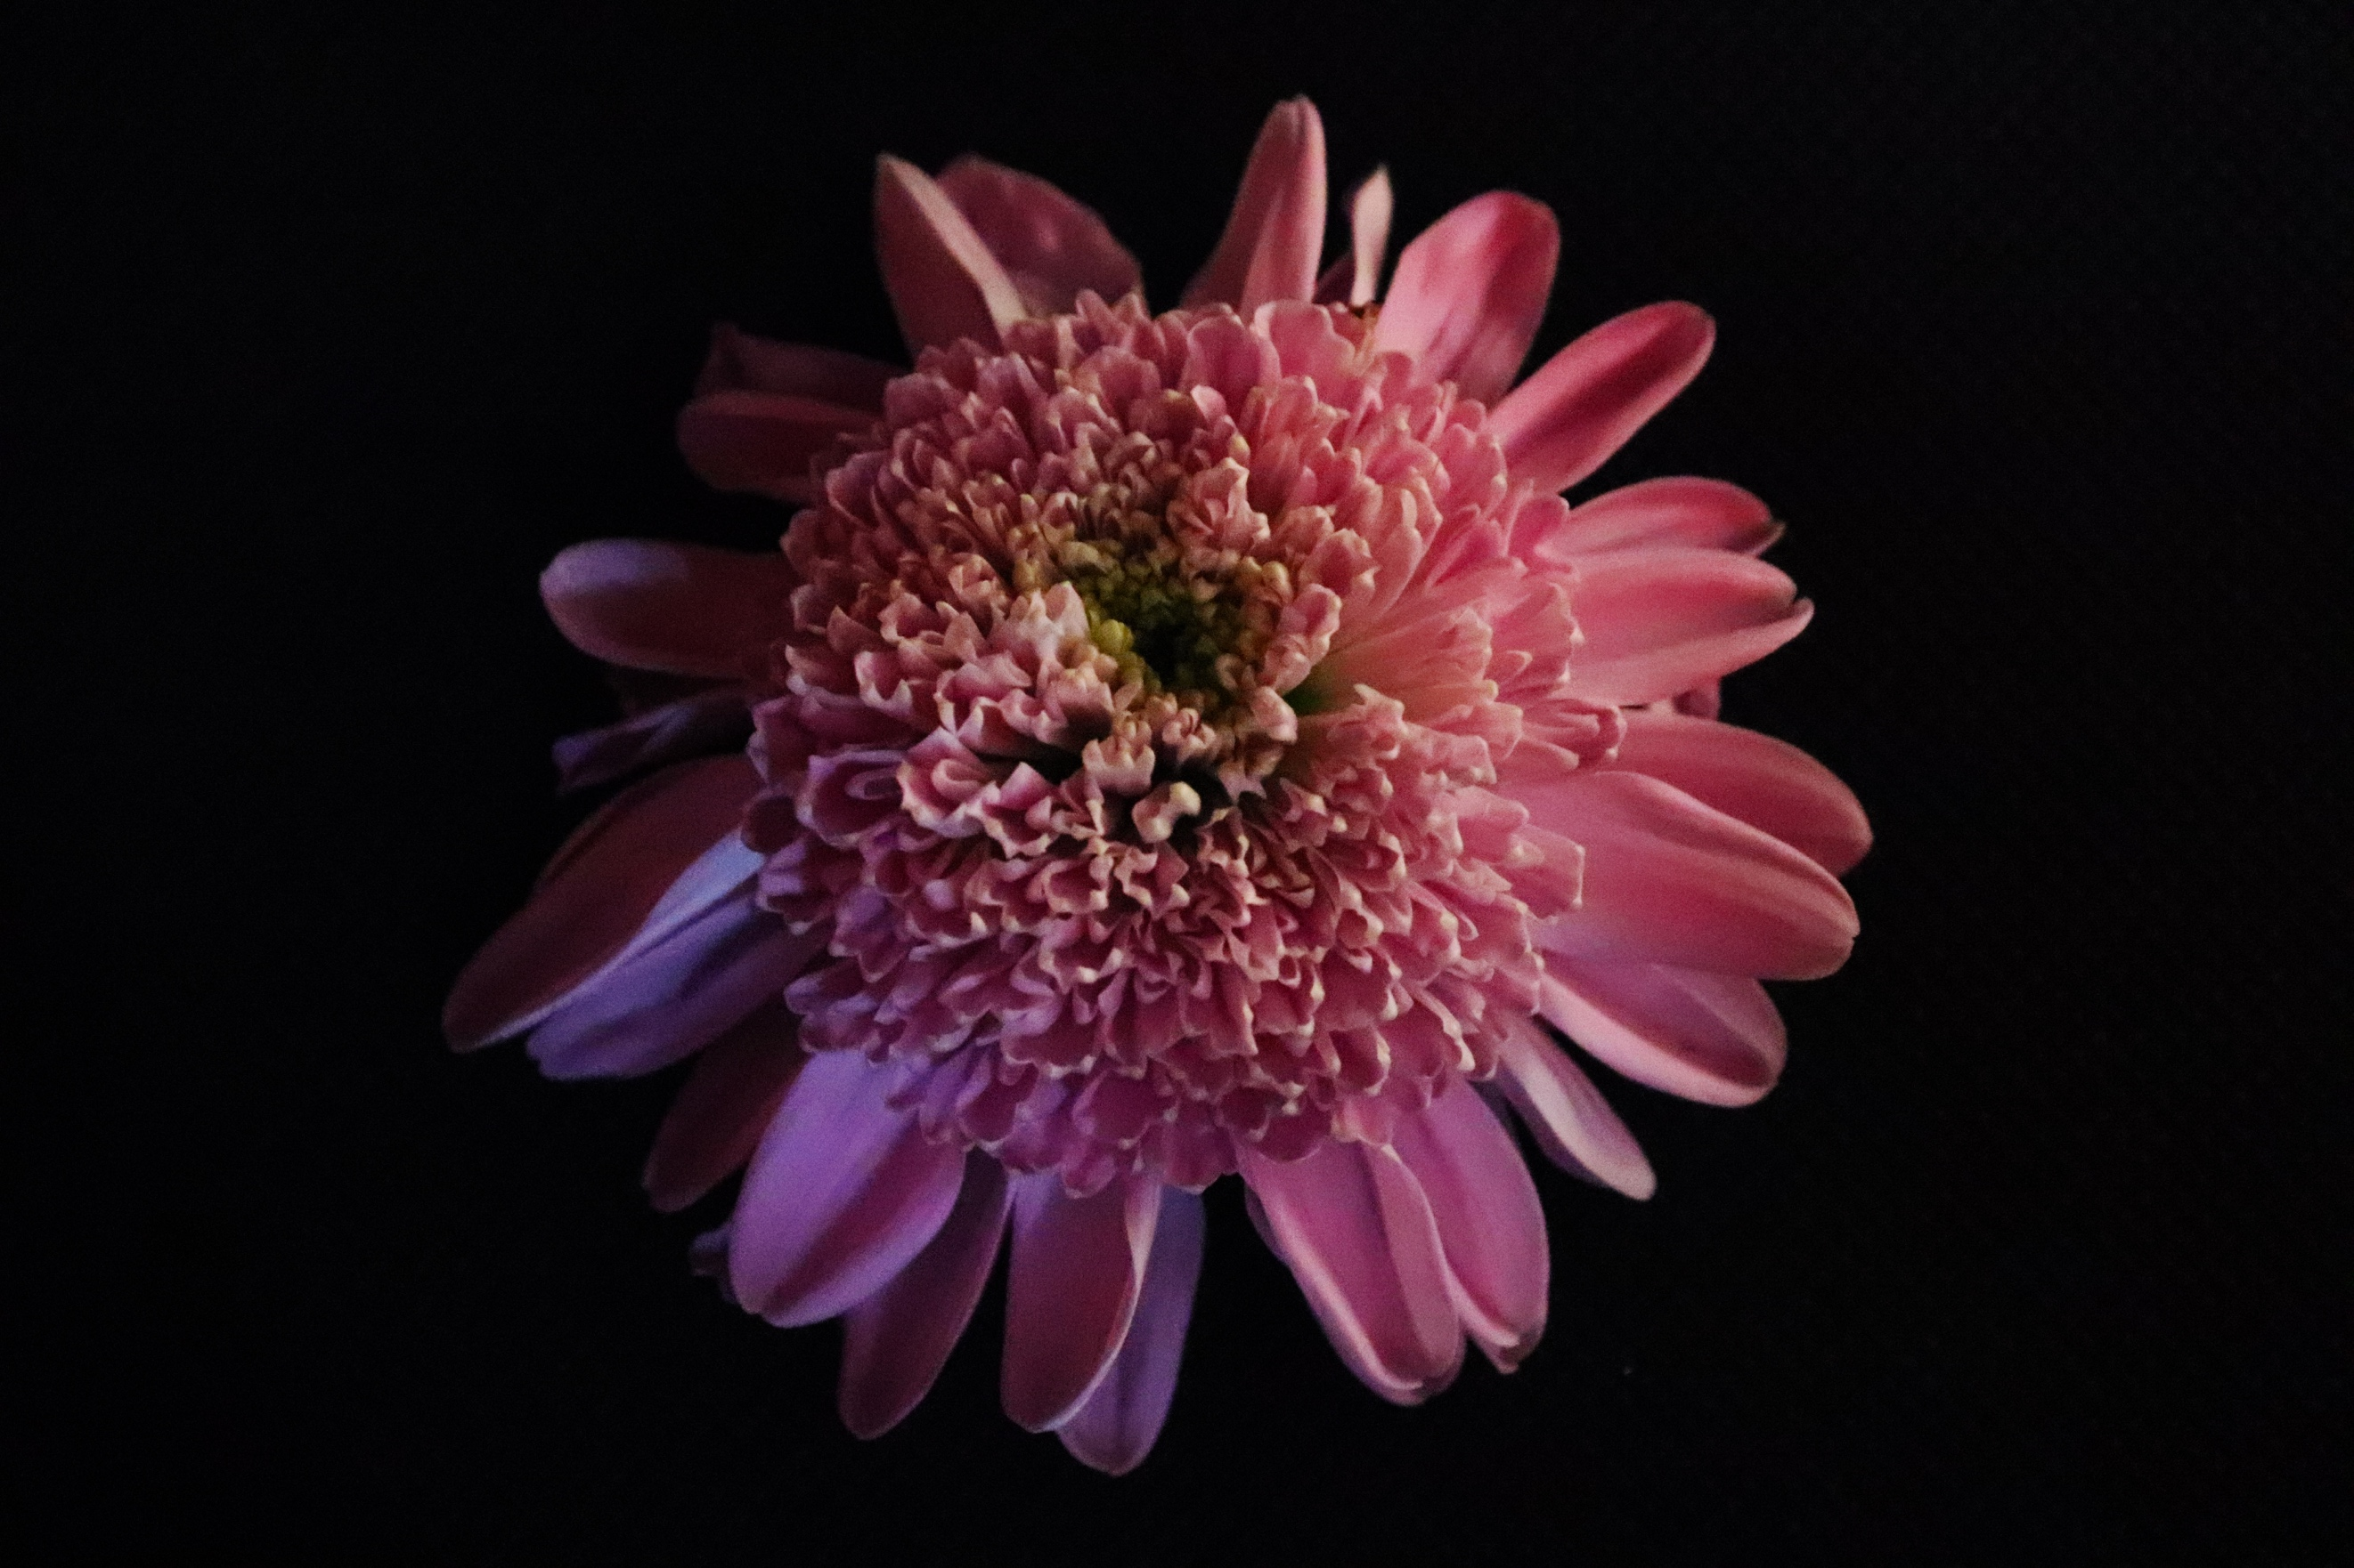
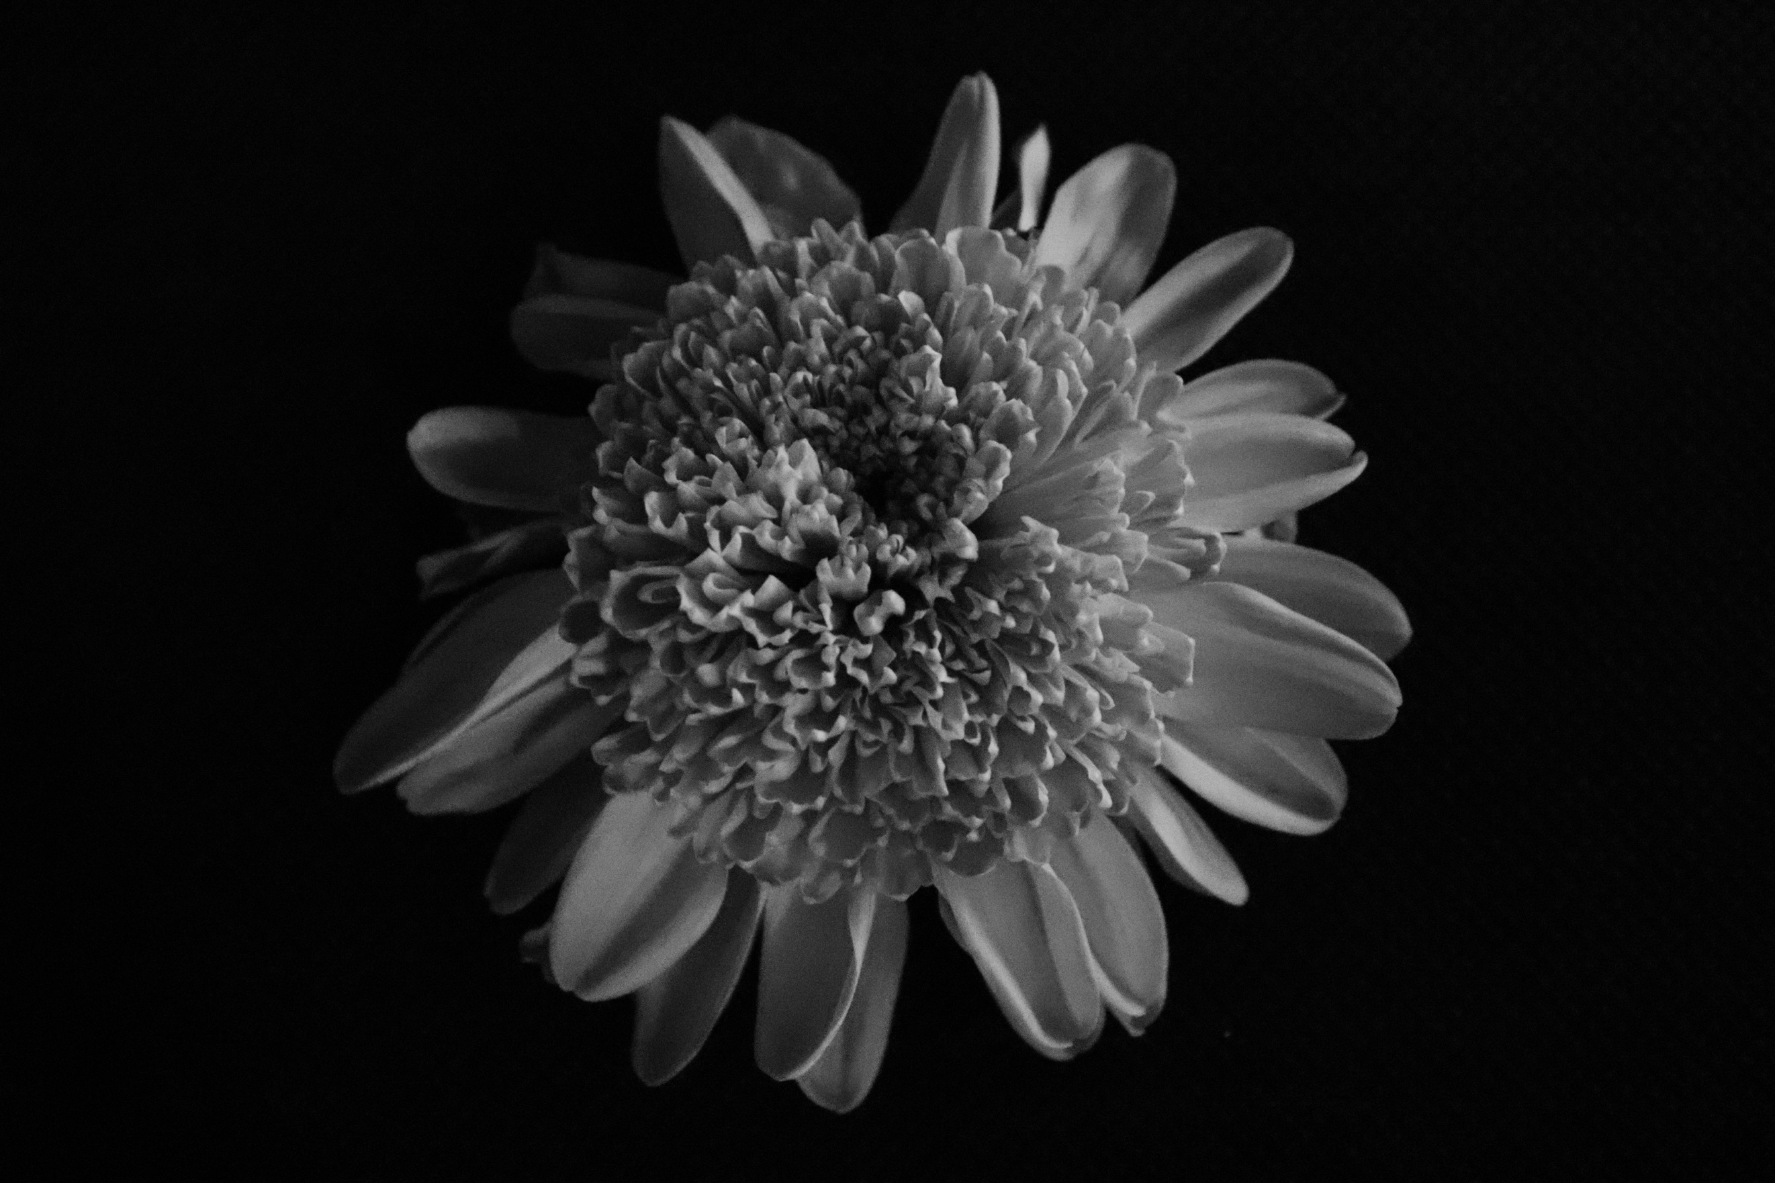

This is the second flower in my series of images. Like most of the flowers, I do not know the specific name for it. I am not really sure how this flower would feel, it looks kind of rough, but at the same time soft too. The background used, is black, and works really well both with the toned image and the coloured image, which clearly shows the outline of the subject. The colour is very vibrant, like most flowers and is rich, which purple can be associated with. The angle I have taken this from is above, looking down on the subject. The subject is very symmetrical and has an unusual shape to it with a big round centre that is 3D with almost flat like petals surrounding it. The light has been used on the right-hand side again for this shot, and I really like how warm it comes on the flower from that side and how it gradually gets darker the further around the flower you look. I think it is very well lit as you can see the variation in colour and tone and how it gets lighter and darker around the perimeter.
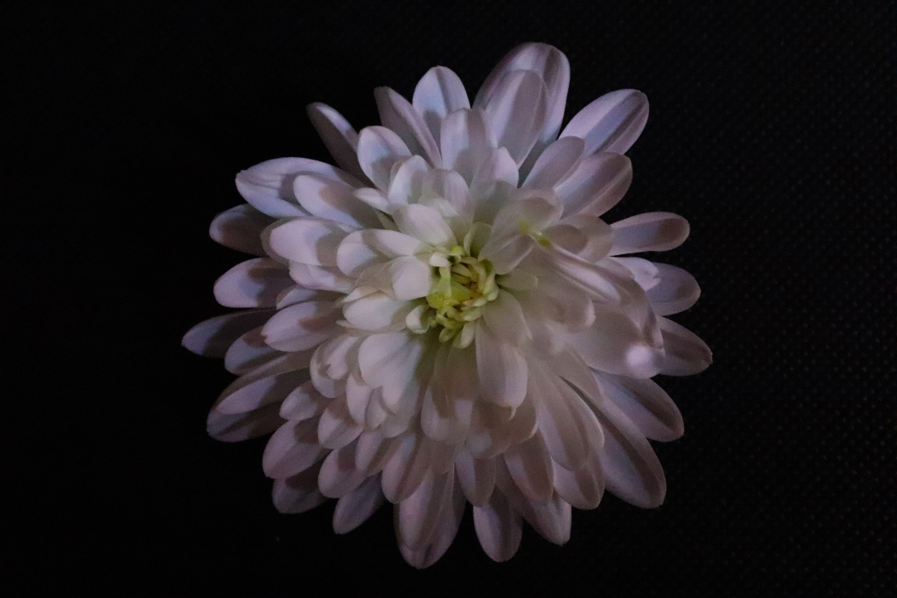
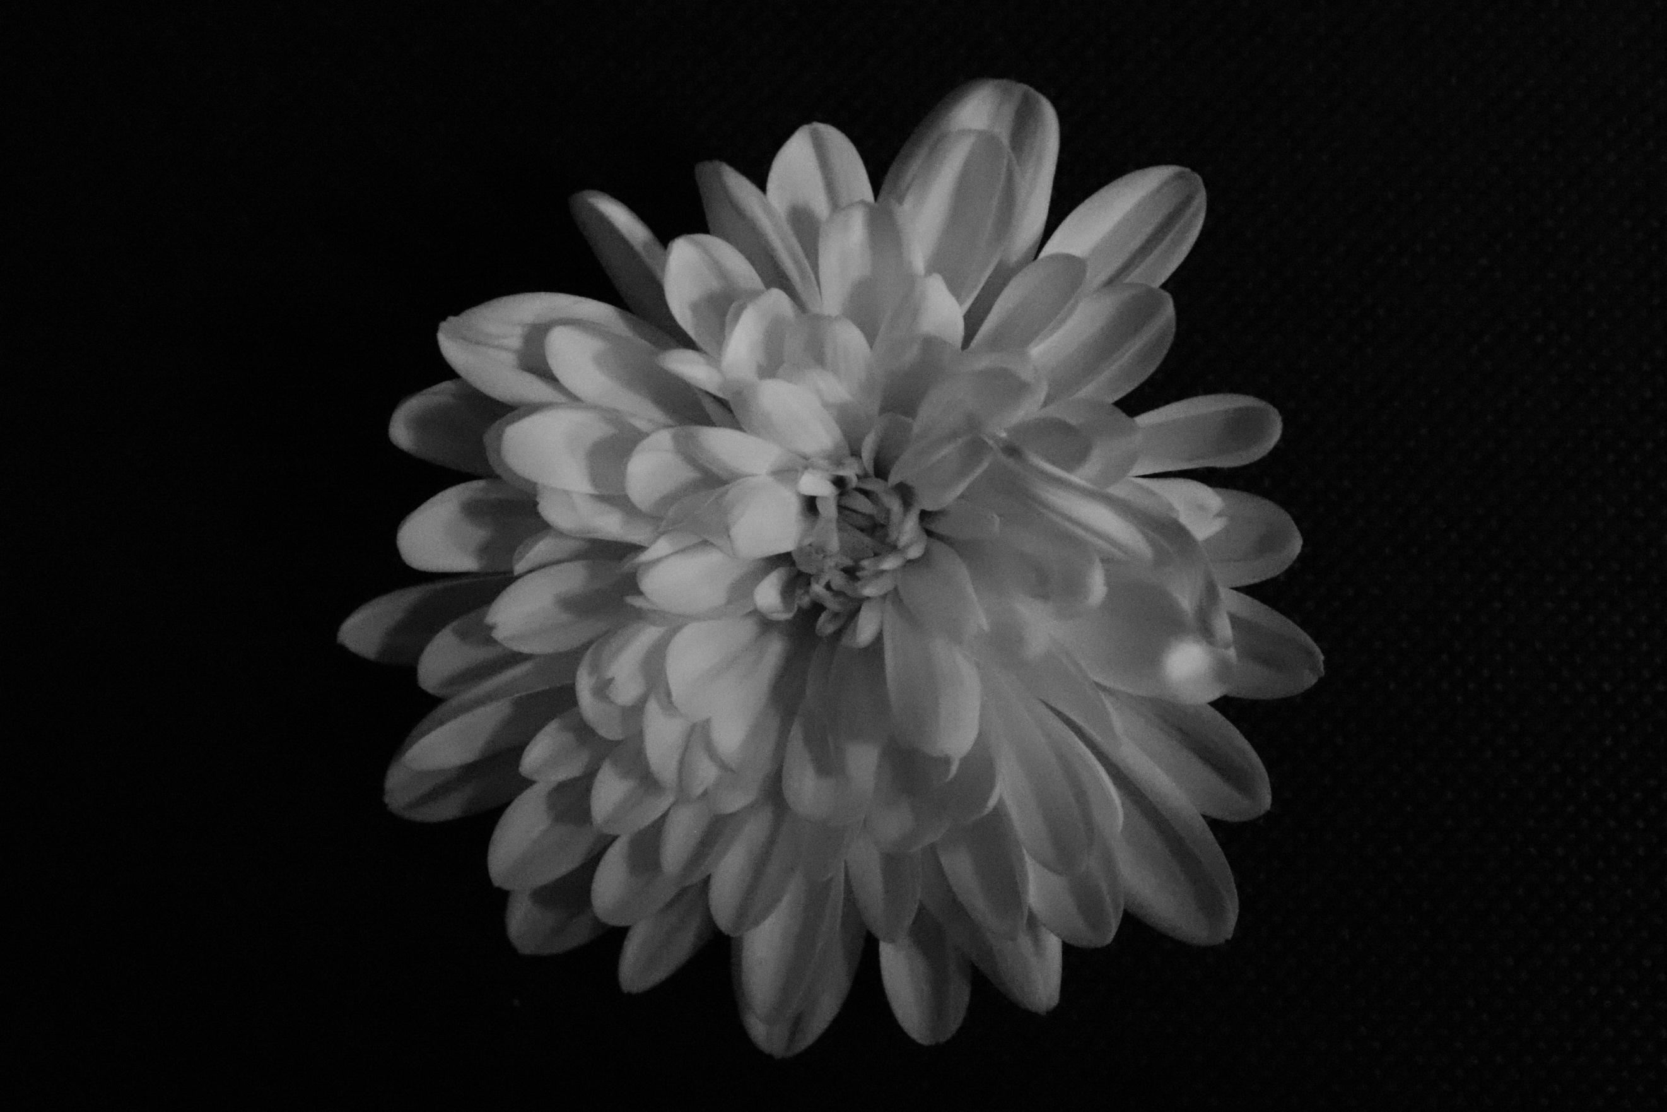

Here we have a white flower, which is a fairly big flower, with an unusual shape to it. The petals all seem to be overlapping and coming away from the centre of the flower. The white of the flower makes it look very soft, and also in the toned image too. This stands out really well against the black and is easy to see between the subject and the background. The angle is from above, and this shot was on Manuel mode, like the rest of the shots. The petals are various in size, with some tiny and some huge. This makes the flower an unusual shape around the edges as some stick out way further than others making the flower seem 3D from all the overlaps. The lighting has worked really well in this shoot and the shadows created on the petals make for a really decent effect, like adding an extra colour to the flower. In the toned image especially, you can see this and how it effects how you see the image overall. You cannot really tell where the light source is coming from in this image, as not like the rest, where one part of the flower is more lit than the rest and it is noticeable where it is coming from. In this image it is rather discrete and it is strange how it manages to cast shadow. The light I used was a handheld LED and was very bright, and in some images, I bounced the light off of walls etc. to get various effects.
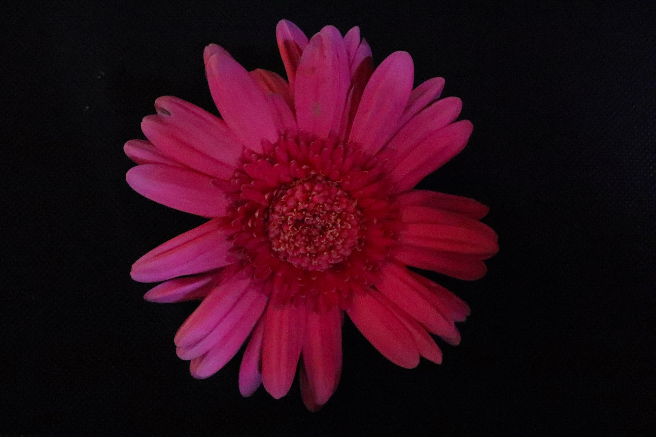
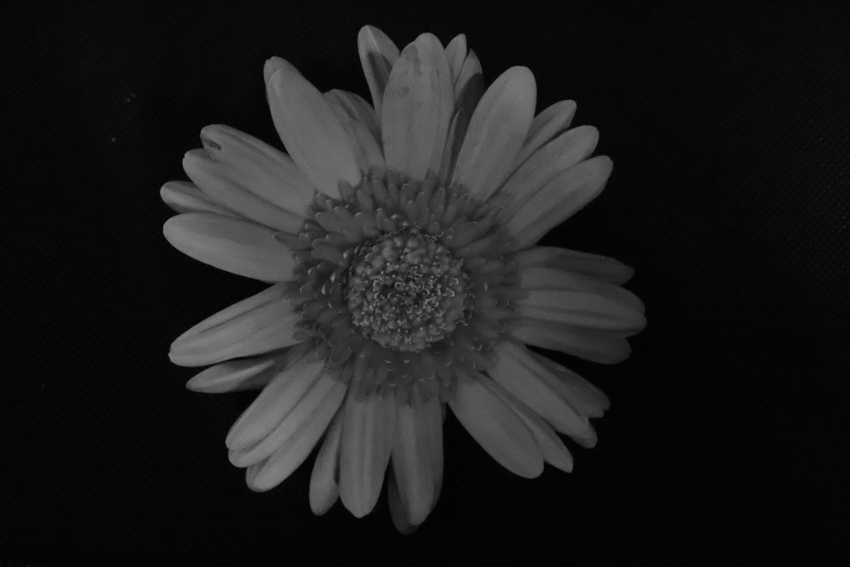
This is the fourth flower in the series, and one of the biggest and brightest. The texture of the flower seems very warm, in the coloured image and dry in the toned. I feel the texture is altered because of the colour. The colour and the toned image both stand out well amongst the background. The angle I have taken this from was above. The shape, looks as if someone has spent significant time creating the flower. The centre of the flower looks very neat, and very beautiful, and the outer layer also looks the same, and almost looks like it is framing the centre. The petals are all around the edge, but there are gaps in some places and some parts are slightly over lapped making it look 3D as some of the petals are faint, it looks like it has moved, and gives a weird vibration effect. Especially on the right. In the toned image the whole flower looks lit and it doesn’t look like there is a specific light source coming from anywhere lighting up a particular area, the plant itself just looks well rounded and lit and the background dark.

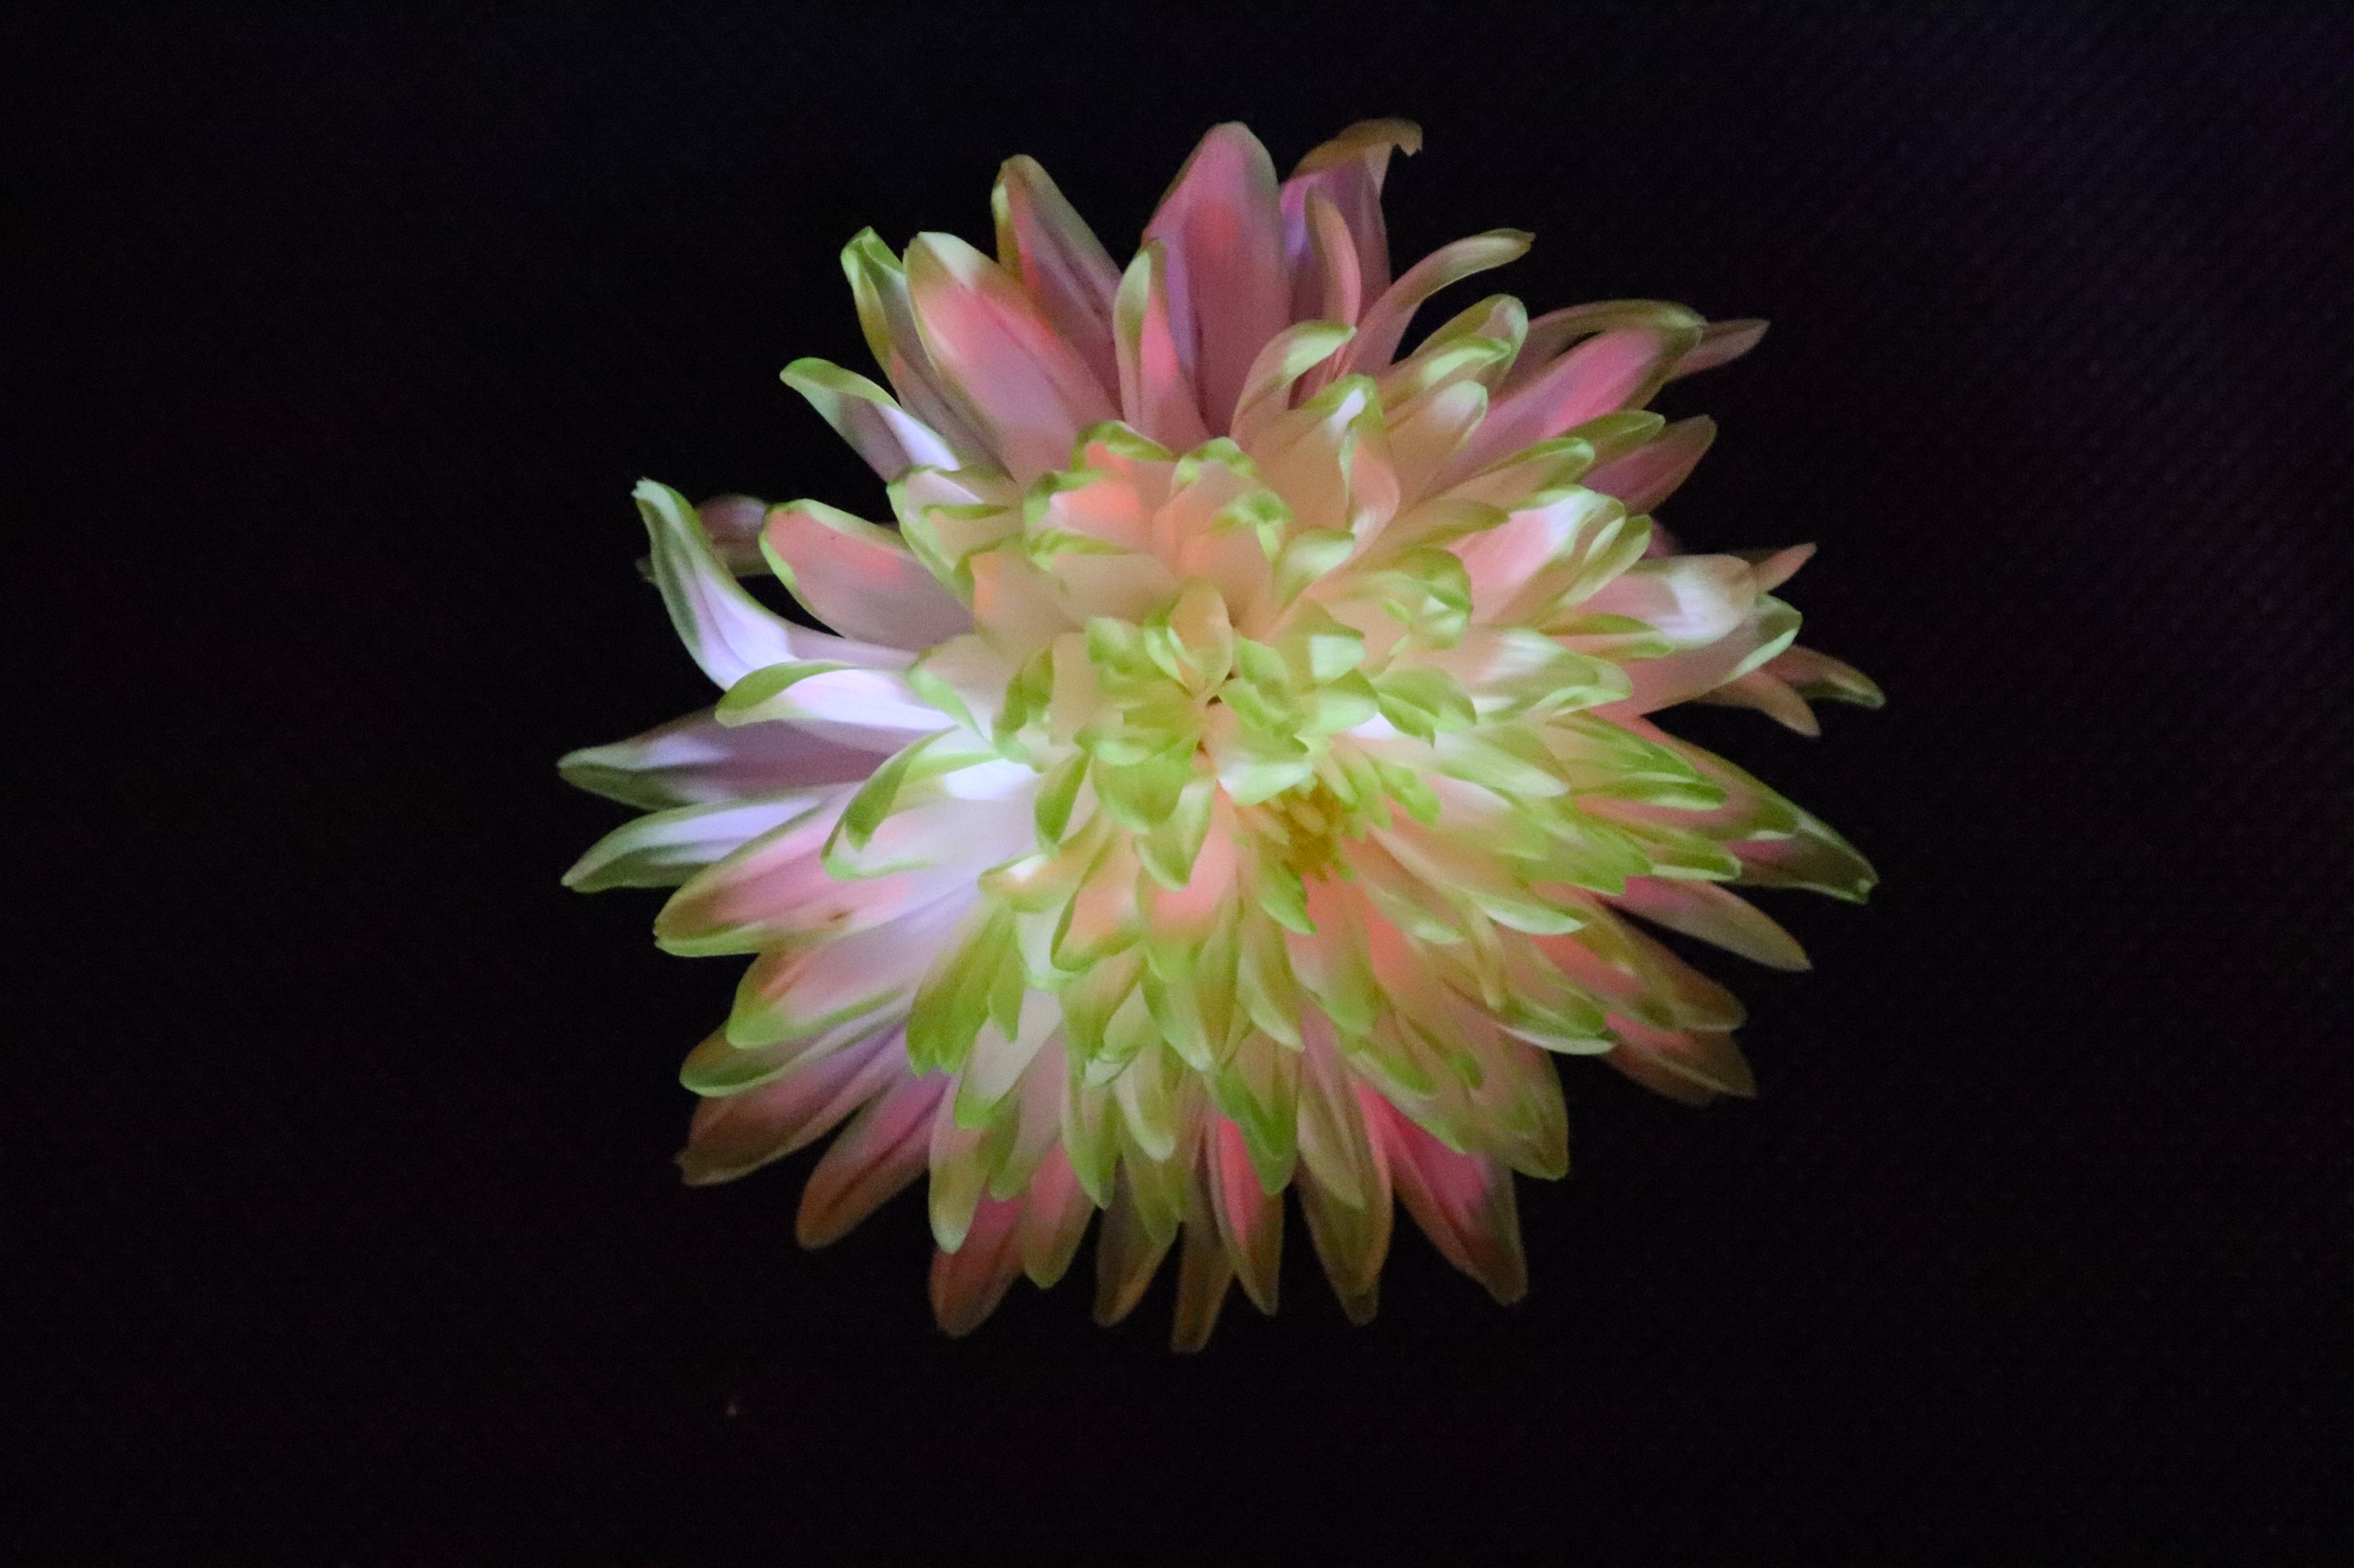
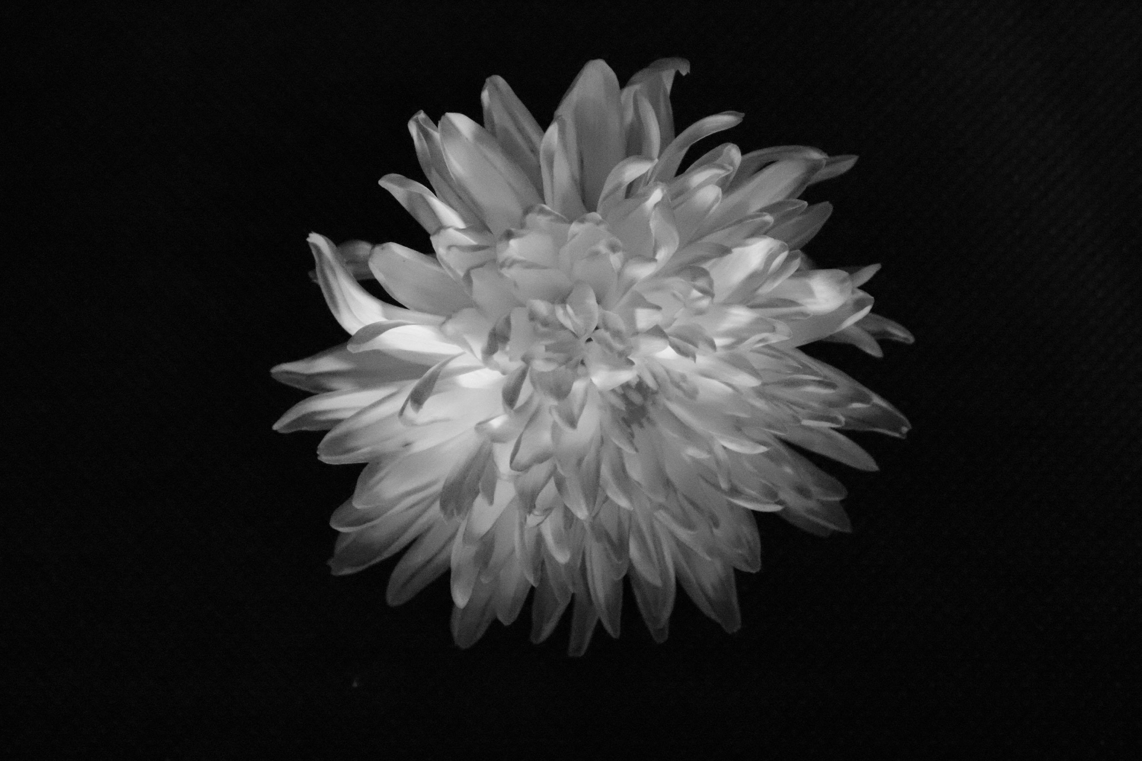
This is one of my favourite images from the shoot. The form and colour of this flower is really amazing. Firstly, the colour is very vibrant and there is a good mix within, and it almost has the effect of needing 3D glasses as it looks like that is what you would need for it! I also think the shape is really amazing too. It doesn’t really look like a flower because of the shape, it looks more like a sea plant. The shape of the flower looks 3D and looks out of control with all the wild petals just oozing out from the centre of the flower. The lighting is coming in from above on the left and really lights up the whole of the flower really well. There is no part of it that is shaded or not booming to life. The toned image also looks very strong and has a really slick grey/ silver to it which makes it look really sharp. This image reminds me of the one I annotated in the build-up to the shoot by Emma Davies, and how the petals are very overrun and colourful, making the flower look very wild and exotic.

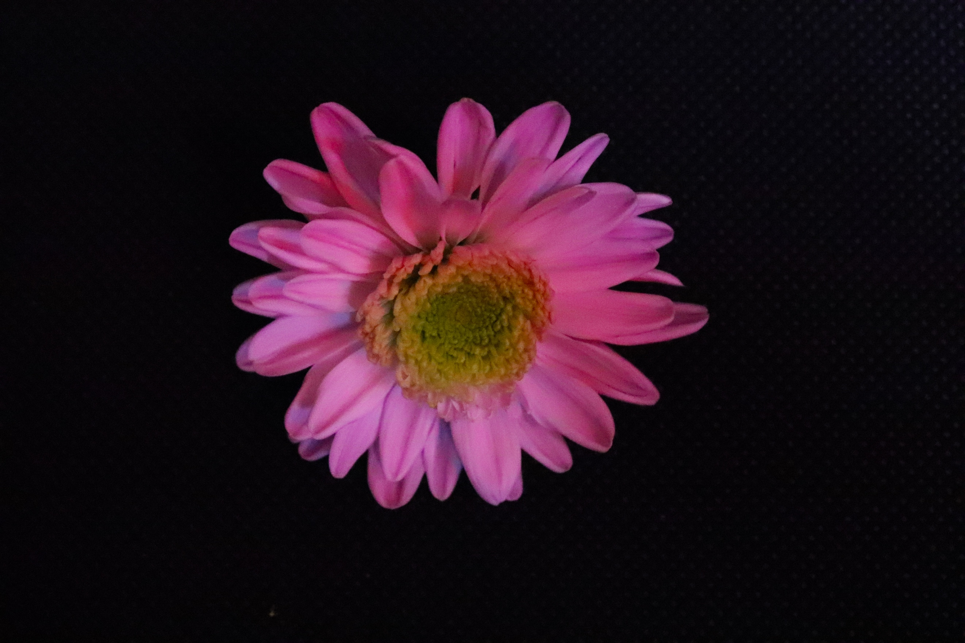
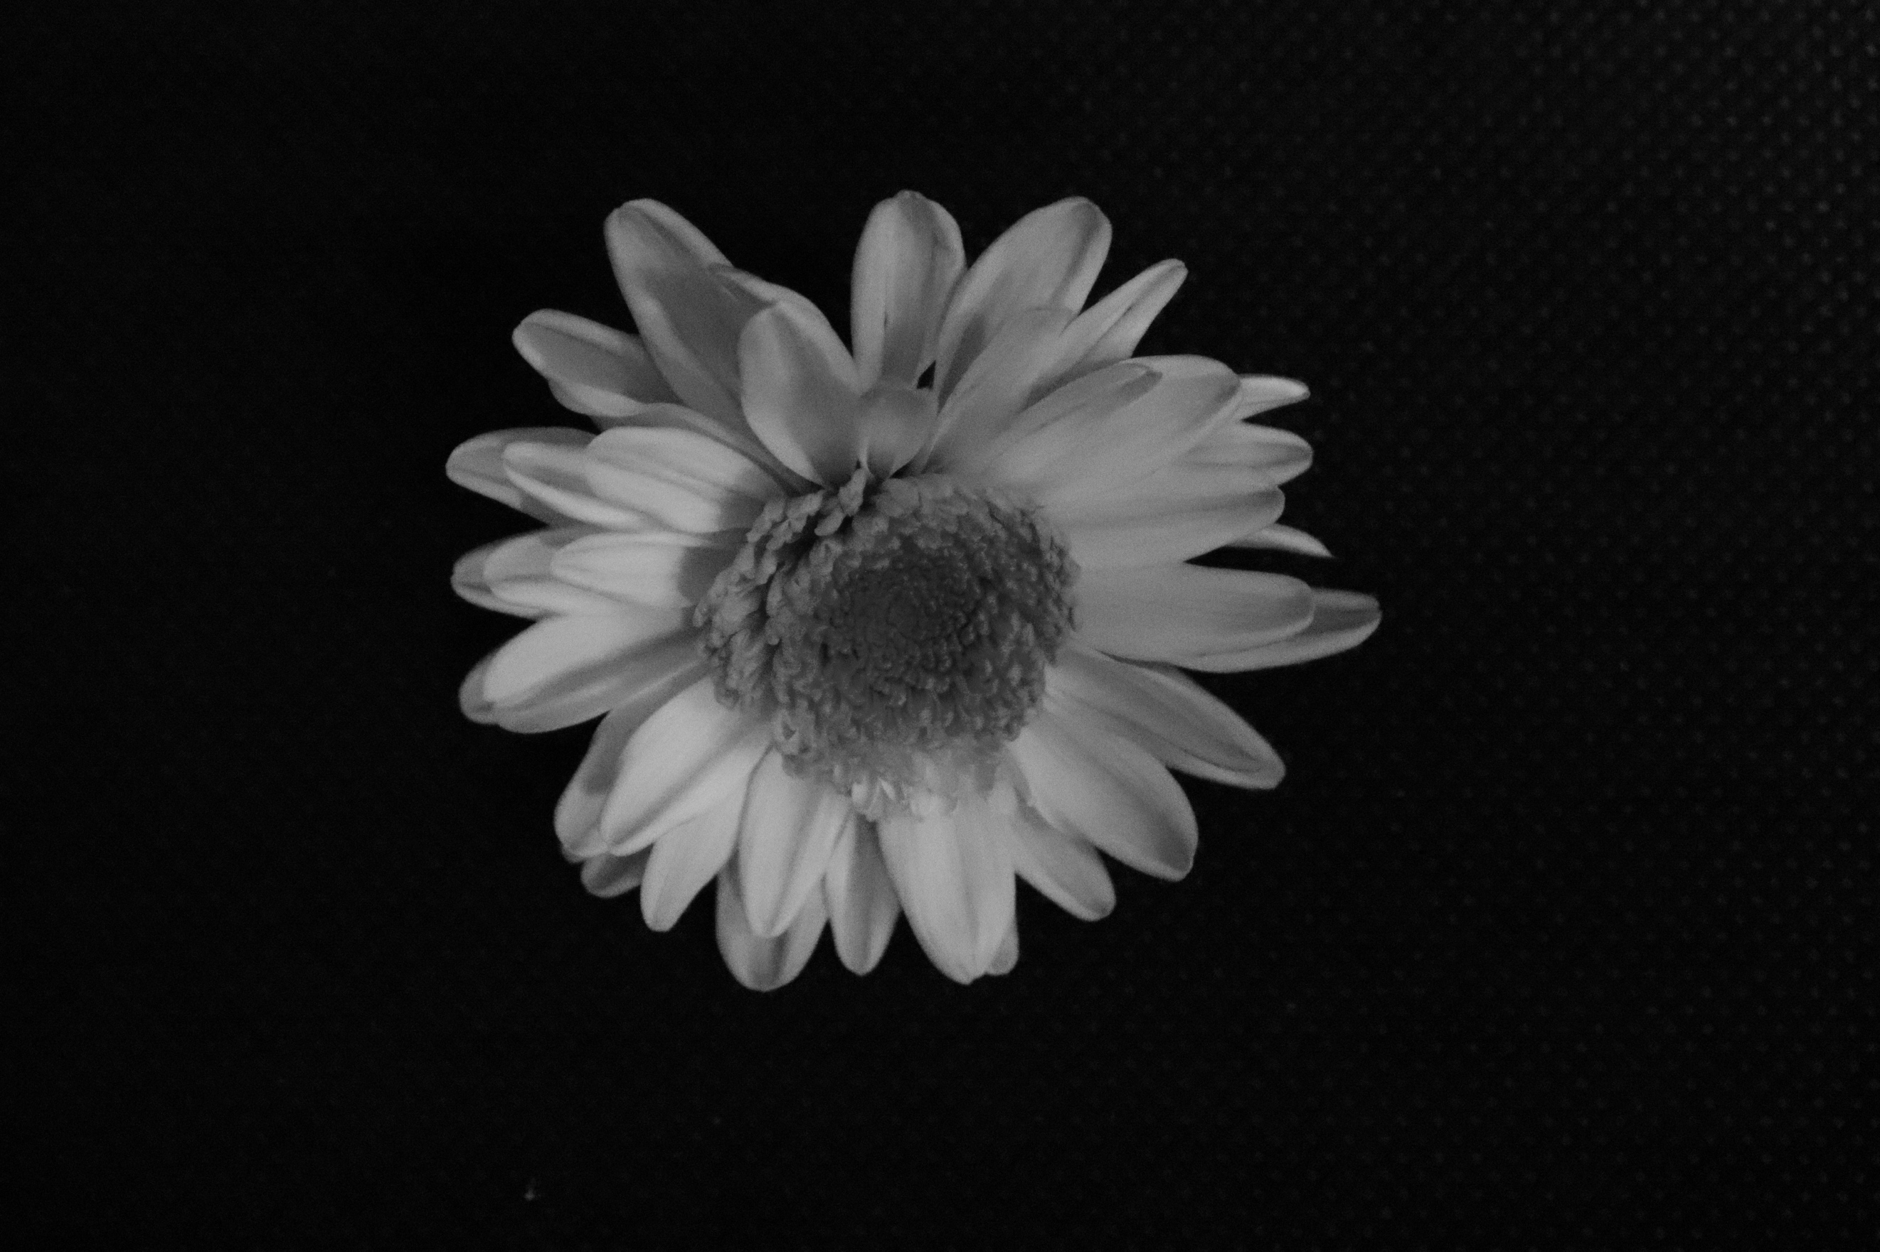
This is the last flower of the series, and a simpler one in terms of shape, your average flower shape, when you think of a flower. Still, the flower really stands out and the lighting creates a little bit of shadow up top left. As the petals overlap the other petals this causes the shadow, meaning the light is most likely coming in from the right. The same layout applies to this image like all the rest with the background being black and Manuel mode used. The aperture like the rest very small to bring the subject out, and the shutter speed slow to allow the correct exposure for the image. This flower was very small so I am impressed that I managed to get it as good as I did. Because of the colouring in this image, it does really stand out from the background, and when changed to black and white, you can tell the outline of the petals really well. The lighting helps this by lighting up the colourful flower.

