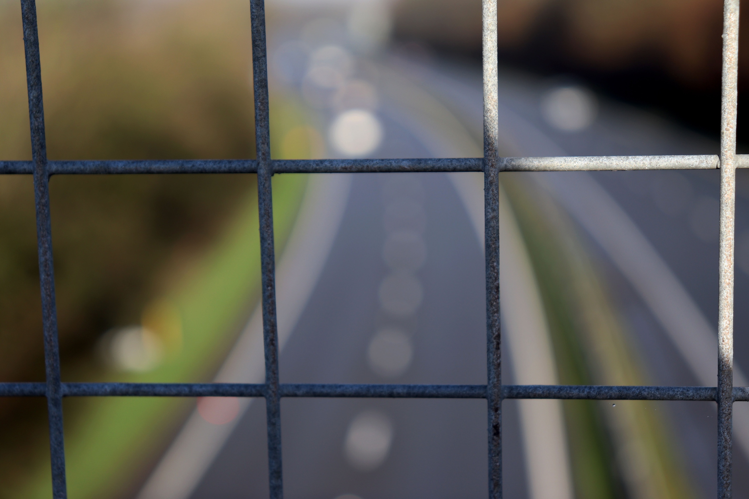
This photo was taken looking towards the duel carriageway from a viewpoint on a bridge going across the carriageway. This was taken through the rails, like the rest of the images in this collection. I attempted to do this shoot about a week beforehand but the weather was so bad when I got there I had to postpone it. This bridge is situated just outside of Ashburton, between Ashburton and Buckfastleigh, in Devon. The texture in this image is strange, because of the depth of field, the background seems really soft and the foreground seems sharp from the metal and dangerous, because of the colouring. I have purposely taken this image with the intent to blur the background out as the brief asks you to. This leaves the metal bars in the foreground in focus, which draws your eye to them first before exploring the background and then quickly coming back to the bars as they are the only aspect of the image in focus. The reason your eye doesn’t like looking at the background is because it is blurred, meaning it is hard to focus on. The colours in this image, although are not bright colours, are seen as bright as the sun is coming in from behind and shining on them, although the further over to the left the darker they get. The green in the background helps bring a softer, calmer colour to the image. The angle I have taken this image from has been a head on one. For this, I have used my 18-55mm lens and have shot on a tripod. Paul White, the photographer I used for research, focuses head on in many of his images, and sometimes uses depth of field within his work, although not as close in as this image. There is a lot of pattern within the image. Although the background is blurred, you can still see the road markings slightly, and the most obvious pattern being the metal bars. I like the tone in this image as some parts are lighter than others and makes a change in the way you see the image as light plays a big part in how you perceive it. For large parts of the shoot I was using aperture priority, but used manual mode also to try and help with different aspects of the image. I zoomed the full 55mm’s to get close to the subject as well. The lines within the image come from a variety of different angles which makes it hard for your eye to focus on a particular point within the image.
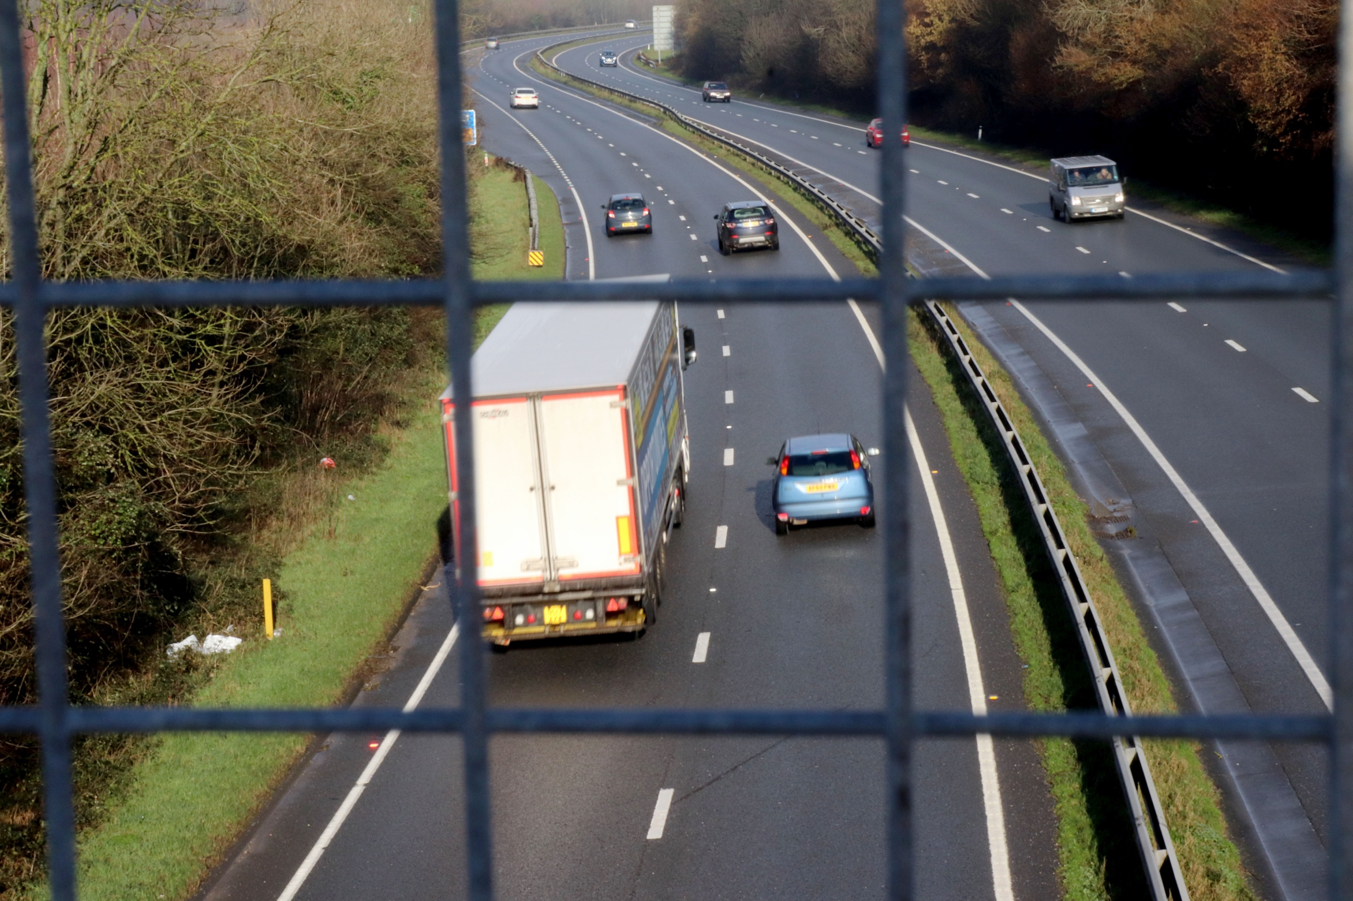
Here is the opposite to the first image, this time with the bars out of focus and the background in focus. The same angle, and framing, and focal length has been used in this shot. The only difference is the main focus and the technical aspects of this image. Now it seems to be the reverse with the bars now seeming soft and the background, other than the grass, hard, especially the tarmac because of the dark colour it is. The ground seems damp also, because it has been raining. The foreground almost looks like it has been segmented up into little squares within the image, almost like it is a physical rule of thirds grid! The pattern in the background is far more noticeable now and can clearly be seen throughout the image and also some symmetry within the image coming from the road markings and the divide in the carriageway. The carriageway helps your eye and draws it into the image until you follow it around the corner. When trying to focus on the metal bars it is a lot harder, like focusing on the background in the previous image, this is because it is out of focus.
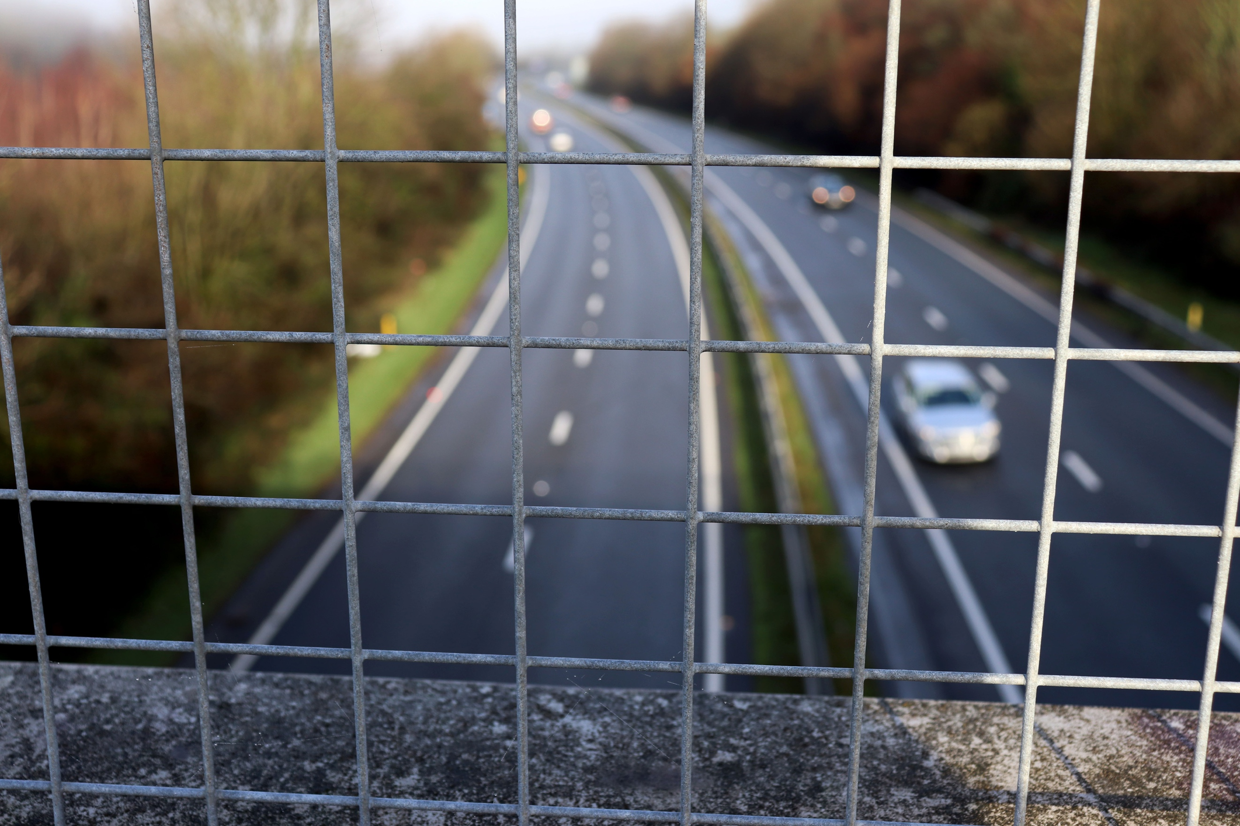
I have taken this picture further out from the first two, but only slightly, the tripod in the same place, but the lens slightly further out. Here, the bars are the main focus, with the background blurred. The background isn’t as soft as the first image, but still makes the bars seem sharp. This image still retains the different shades of colour throughout and brings in the ledge into the frame at the bottom of the image which looks like it would have a strange texture to it. Because the frame is wider in the image, this means there is more pattern within it. The shape of this picture looks 2D in the foreground but 3D in the background because of the depth of field. In some of Paul White’s images, he uses a lot of line pattern to help draw an image and symmetry in it. The composition of this image makes the subject in the foreground seem larger than the background because it is closer to the lens. If you look at the blurred car to the right it fits within one square!
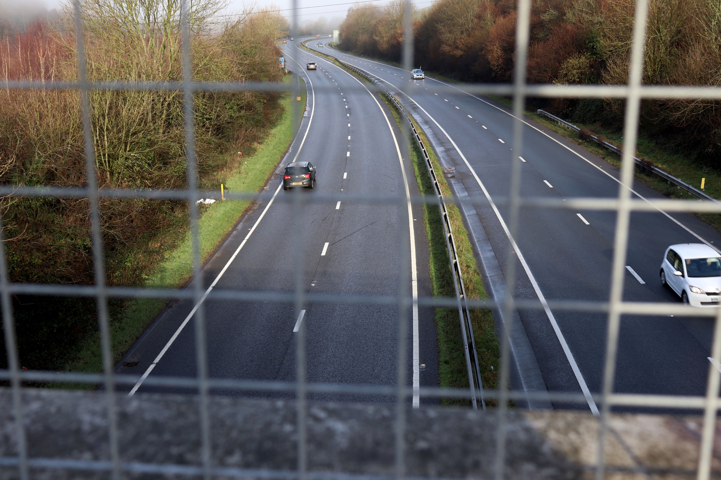
The background here is in focus, again with the bars out of focus. It contains all the same ingredients just different framing. The change in framing means that there is more to take in, in this photo and contains more symmetry. The cars seem 3D, but when trying to focus on them the bars seem to be a nuisance and, in the way, even though they are blurred out. Personally, I feel this image would be better without the bars in the foreground if it was just based on how good the image looks, but it really helps with the depth of the field in this photograph as this is the main focus for the image and the main point of the exercise. Because this is slightly further out, for the first time it gives you the viewer a sense of being high up as there is more to contain within the frame. Lines again, in the image range all across the picture shooting off various ways which makes your eye hard to focus on a certain part of the image.
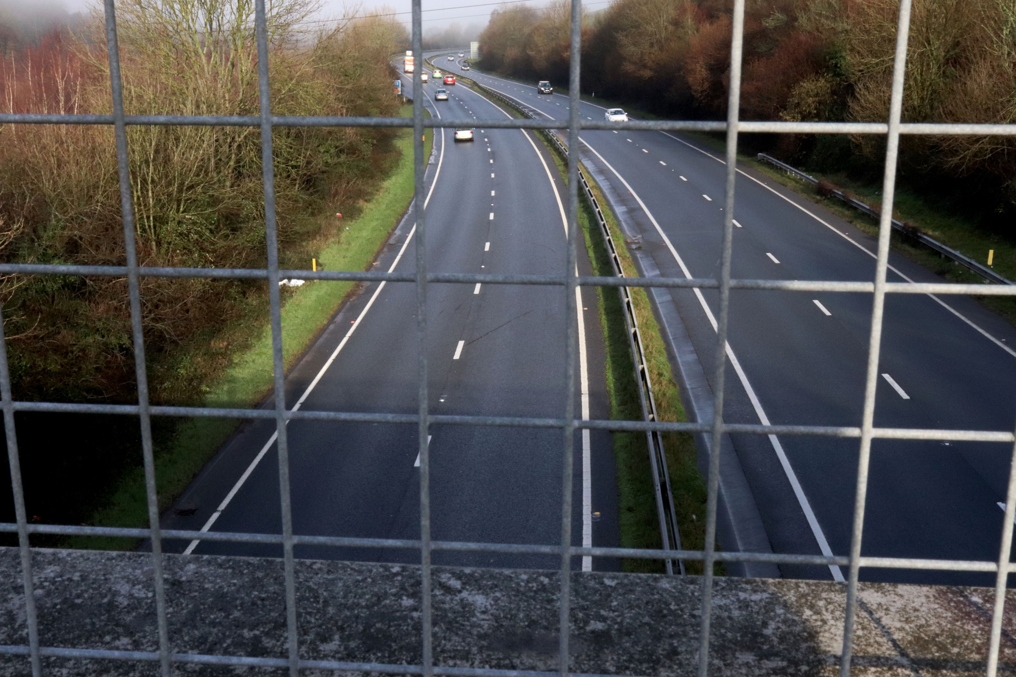
This is the first image of the collection that has all of the depth of field in focus. I found this very hard to get this as close in as I was in the first couple of images. But from this positioning you can clearly see I was able to get that third image with everything in focus. For me this image is the least effective of the lot, mainly because it is so rammed with lines, patterns and colours. I feel that it is a busy picture and doesn’t lead your eye in anyway or focus on a particular part of it. The bars seem in the way and ruin the shot of the duel carriageway. As it is the same as the previous images, in terms of lines etc. it is the same, but this time, whereas one image focused on it more and the other more on another aspect of the image, because it was blurred, it didn’t seem as congested. Here it is. For me, depth of field is really good in photography, and how we can use it to our advantage as a tool to help focus more specifically on a certain area, when applied like the images above and focusing on that foreground or background it is great. It is much more of a pleasure to look at than this image where the whole field is in focus. Don’t get me wrong, some images would look great with all three techniques used, but in this image itself, I feel it doesn’t work with it all being in focus and ruins the shot.

