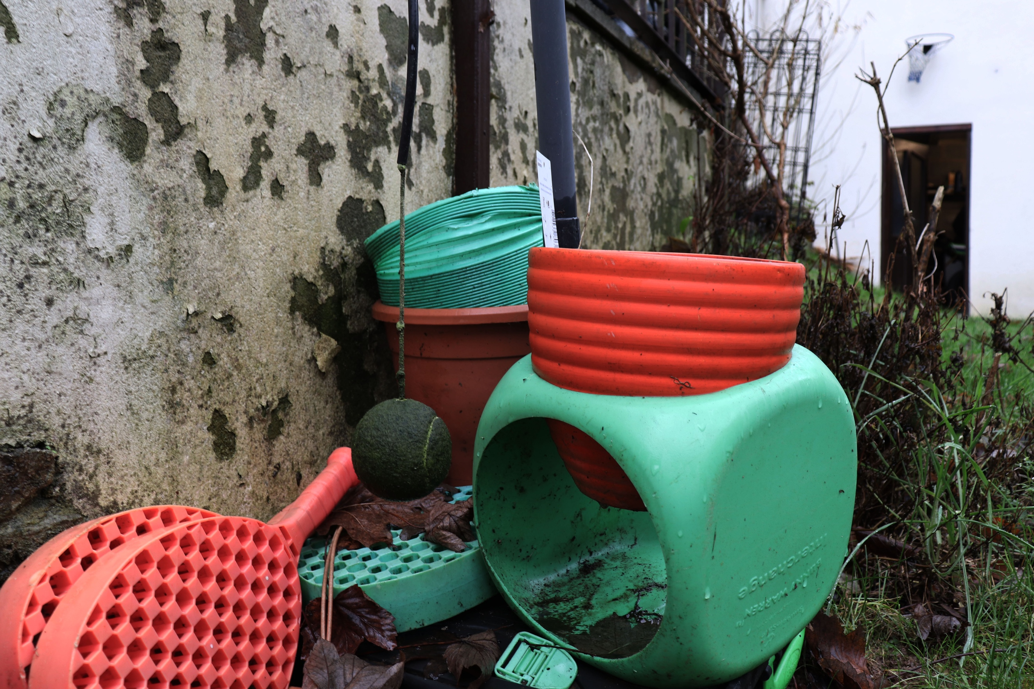
This is the first photograph I picked out as one of my 6 finals for this shoot. Here I have followed the brief and have applied the grid on my camera and have used it to take this picture. I have placed the tennis ball in the lower section of the grid, near to the centre. This was taken in my garden on a wet and rainy day. You can tell what time of year it is because of all the leaves on the ground surrounding the main focus of the image. You can also see them on top of one of the rackets, behind the tennis ball and this seems to be smothering it, in which you can only see a small part of it. Although this picture looks like it is bursting to life with the colour of the green cube and the orange rackets, to me it actually looks abandoned and in fact not bursting to life. The rundown wall which covers a huge percentage of the image is discoloured and the plants behind the cube overgrown. The cube and the tennis ball itself looks dirty and wet. In one way the image is strong and vibrant, and then if you study it more closely its damp and dark, and grimy. The texture of this image seems wet and unforgiving. The foreground and midground seem really busy and there is lots going on and you’re not really sure where to look, whereas the background is dull and not much going on. As I have stated at the beginning of this annotation, I have taken the image at this particular angle as I was using the viewfinder grid on my camera. The main focus being the tennis ball, I guess in a way worked well as the framing of the tennis ball isn’t too close to the edge of the frame, neither too central. In terms of not working, as in the brief it says not to worry about the rest of the frame, which I didn’t, this led to what I believe as the rest of the image being over busy, meaning that you cannot clearly distinguish the main focus of this image being the tennis ball. There is a lot of pattern, from the holes in the tennis rackets to the orange bowl. Some of the patterns are more noticeable than others. 3D shapes are used well in this image, especially the cube, but there are also many 2D shapes, like the tennis ball and wall.
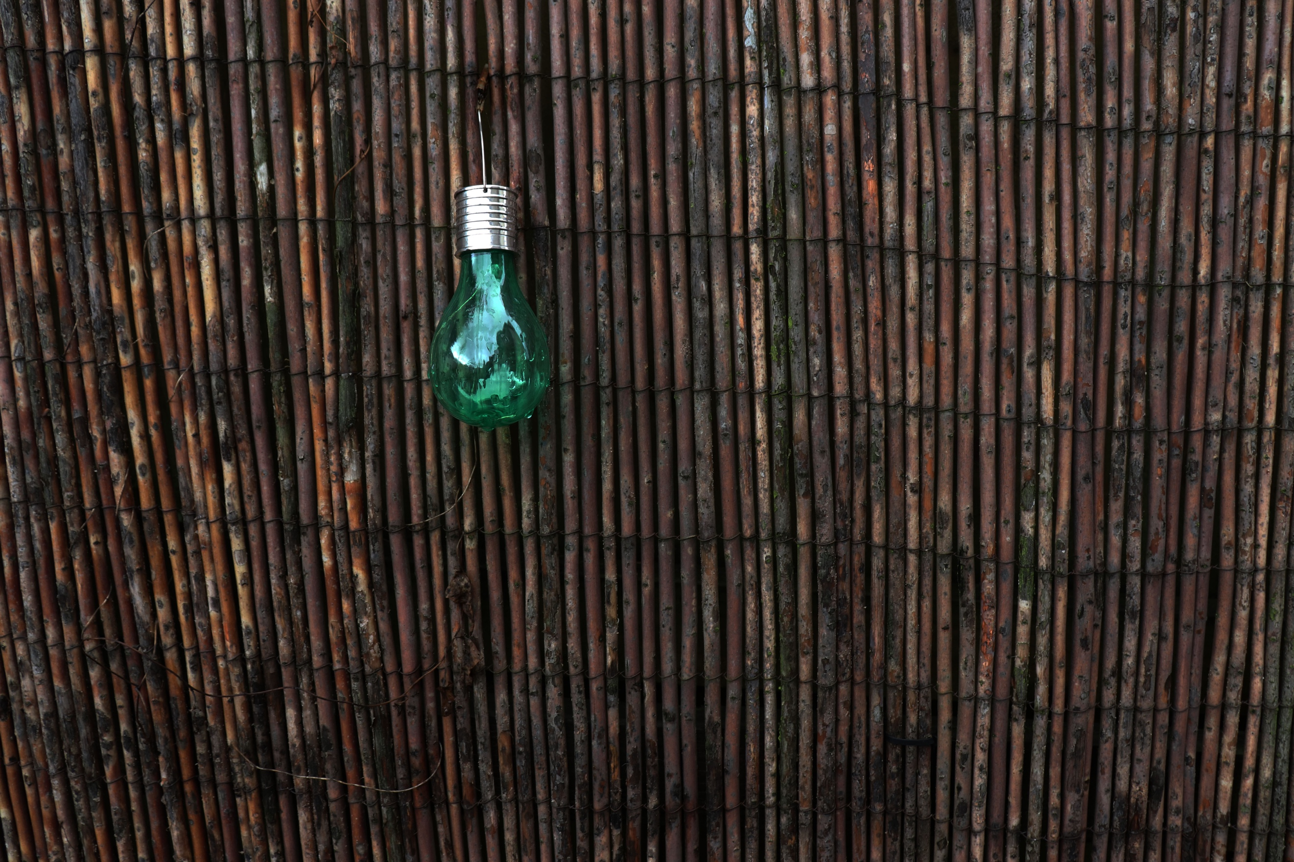
There are only really two objects in this image, the bulb and the bamboo. The picture is really simple and actually clearly demonstrates the viewfinder grid in action really well. As you can tell, the main focus being the bulb. It has been positioned at the near top of the grid just off to the left. The colours in this are compelling. One very bright, the other not so much. The dampness of the bamboo and the colouring differentiates from the colour of the bulb. The texture is very demanding from the bamboo from the harshness of the colour and would almost feel horrible if you were to touch it. If you didn’t know what it was, you wouldn’t touch it. The bulb has a shine to it, in which I can see my house in the reflection. It is almost like the bulb is showing an image, within the image. When you couldn’t really tell that at first glance, so the image itself contains more to what you originally see. The picture seems very flat and there isn’t a lot of shape in the photograph, but there is a variety of pattern from the bamboo going vertically and horizontally. The top of the bulb also uses horizontal line. Walker Evans uses a similar style like I have, taking it head on, which leads your eye straight to a certain point in the image.
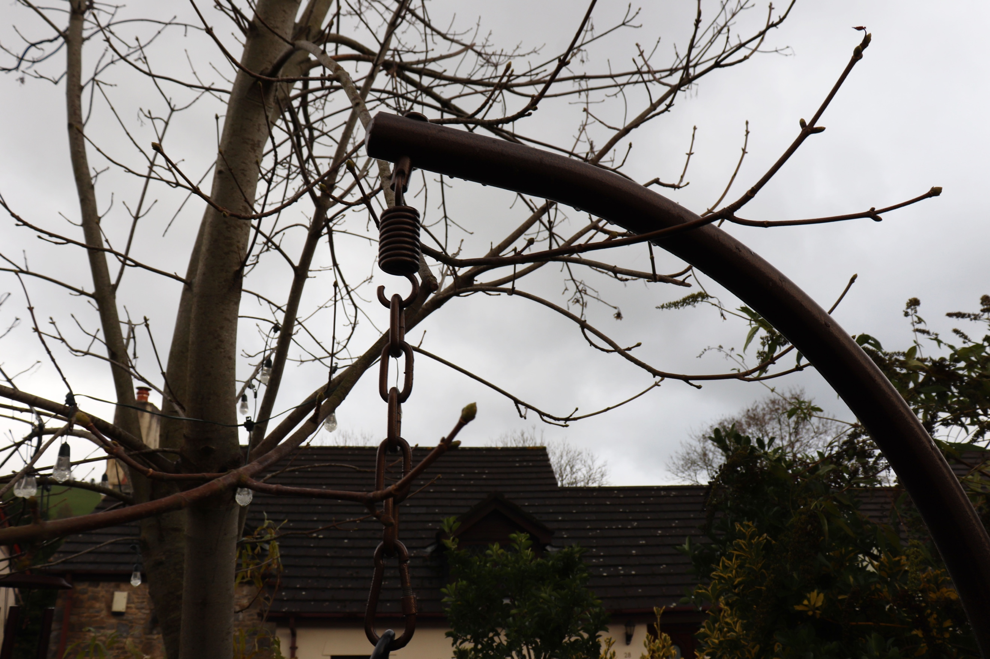
From the first annotation, which was taken head on and the second, this one focuses on a slightly different angle, looking up. The main focus, like the other images is an object hanging down. Here I have taken it of a seat in my garden. From the viewfinder grid, this one has been made more central than the previous two. I feel that the image doesn’t look horrific but I prefer it slightly off to the side of the frame as I feel this pans out the rest of the background better. Whereas here it seems to be more awkward as I am more central, and looking up. You could argue that this leaves to too much sky and not enough going on in the midground. The colours of the image are bland and this compliments the weather. The branches of the tree make it harder to focus on the chain itself because there is so much going on behind it. Like all annotated images, this contains a lot of pattern, from the roof of the house, chain and hook. I like how part of the seat comes in from the bottom right, allowing your eye to follow it to just above the centre of the image and then the chain leads your eye out of the photo, or the other way around. This gives a sense of mystery as to what the rest of the object looks like. There isn’t many 3D shapes present and everything seems fairly flat. The overall tone of the image is dark. I feel that the framing of this photo is messy and doesn’t necessarily work effectively when using the viewfinder grid.
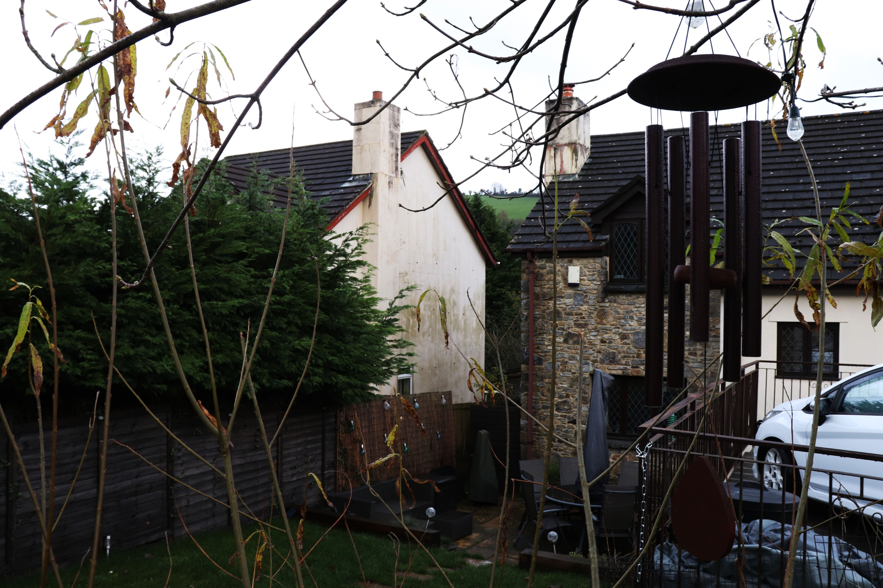
Here I have gotten amongst the trees to get this snap. The main focus is the chime in the bottom right hand side of the image. This is the first image of the set that uses the right-hand side of the viewfinder. Because it is so far over to the bottom right, it gives you the option of exploring the background without the main focus being too central. Although I like the idea of the chimes positioning in this image, it is hard to see as it is a dark colour, which blends with the background more. The rest of the colouring of the picture also fits with this as it is a rather dull day. I like how the wall of next doors house is very centrally positioned in this image and is very dirty matching the same vibe as the rest of the objects in the photograph. As I am in the tree, all the branches are surrounding me and you can see them in the foreground, midground and the background of the image. They’re shooting from all sorts of different angles, which for me disrupts the image slightly. But as stated in the brief, the only focus was what was captured in a specific section of the viewfinder grid. The railings, chimes, brick walls, lights all contribute to the many patterns contained in the picture itself, making it a very busy one. There are a number of 2D and 3D shapes in the image and so many different colours, even though the image is genuinely dim. As with the many objects in this image, comes many textures from what looks soft, like the grass and the car to the hard texture like objects such as the walls and patio slabs. Here I am on a slight mound which gives me the opportunity to overlook the garden as a whole and to see all different kinds of terrain from where I am positioned. If the branches were not in the way, I feel that this would make it clearer to see beyond and would free up the chimes more which would make for a better image. Although the image could be worse, there could be leaves.
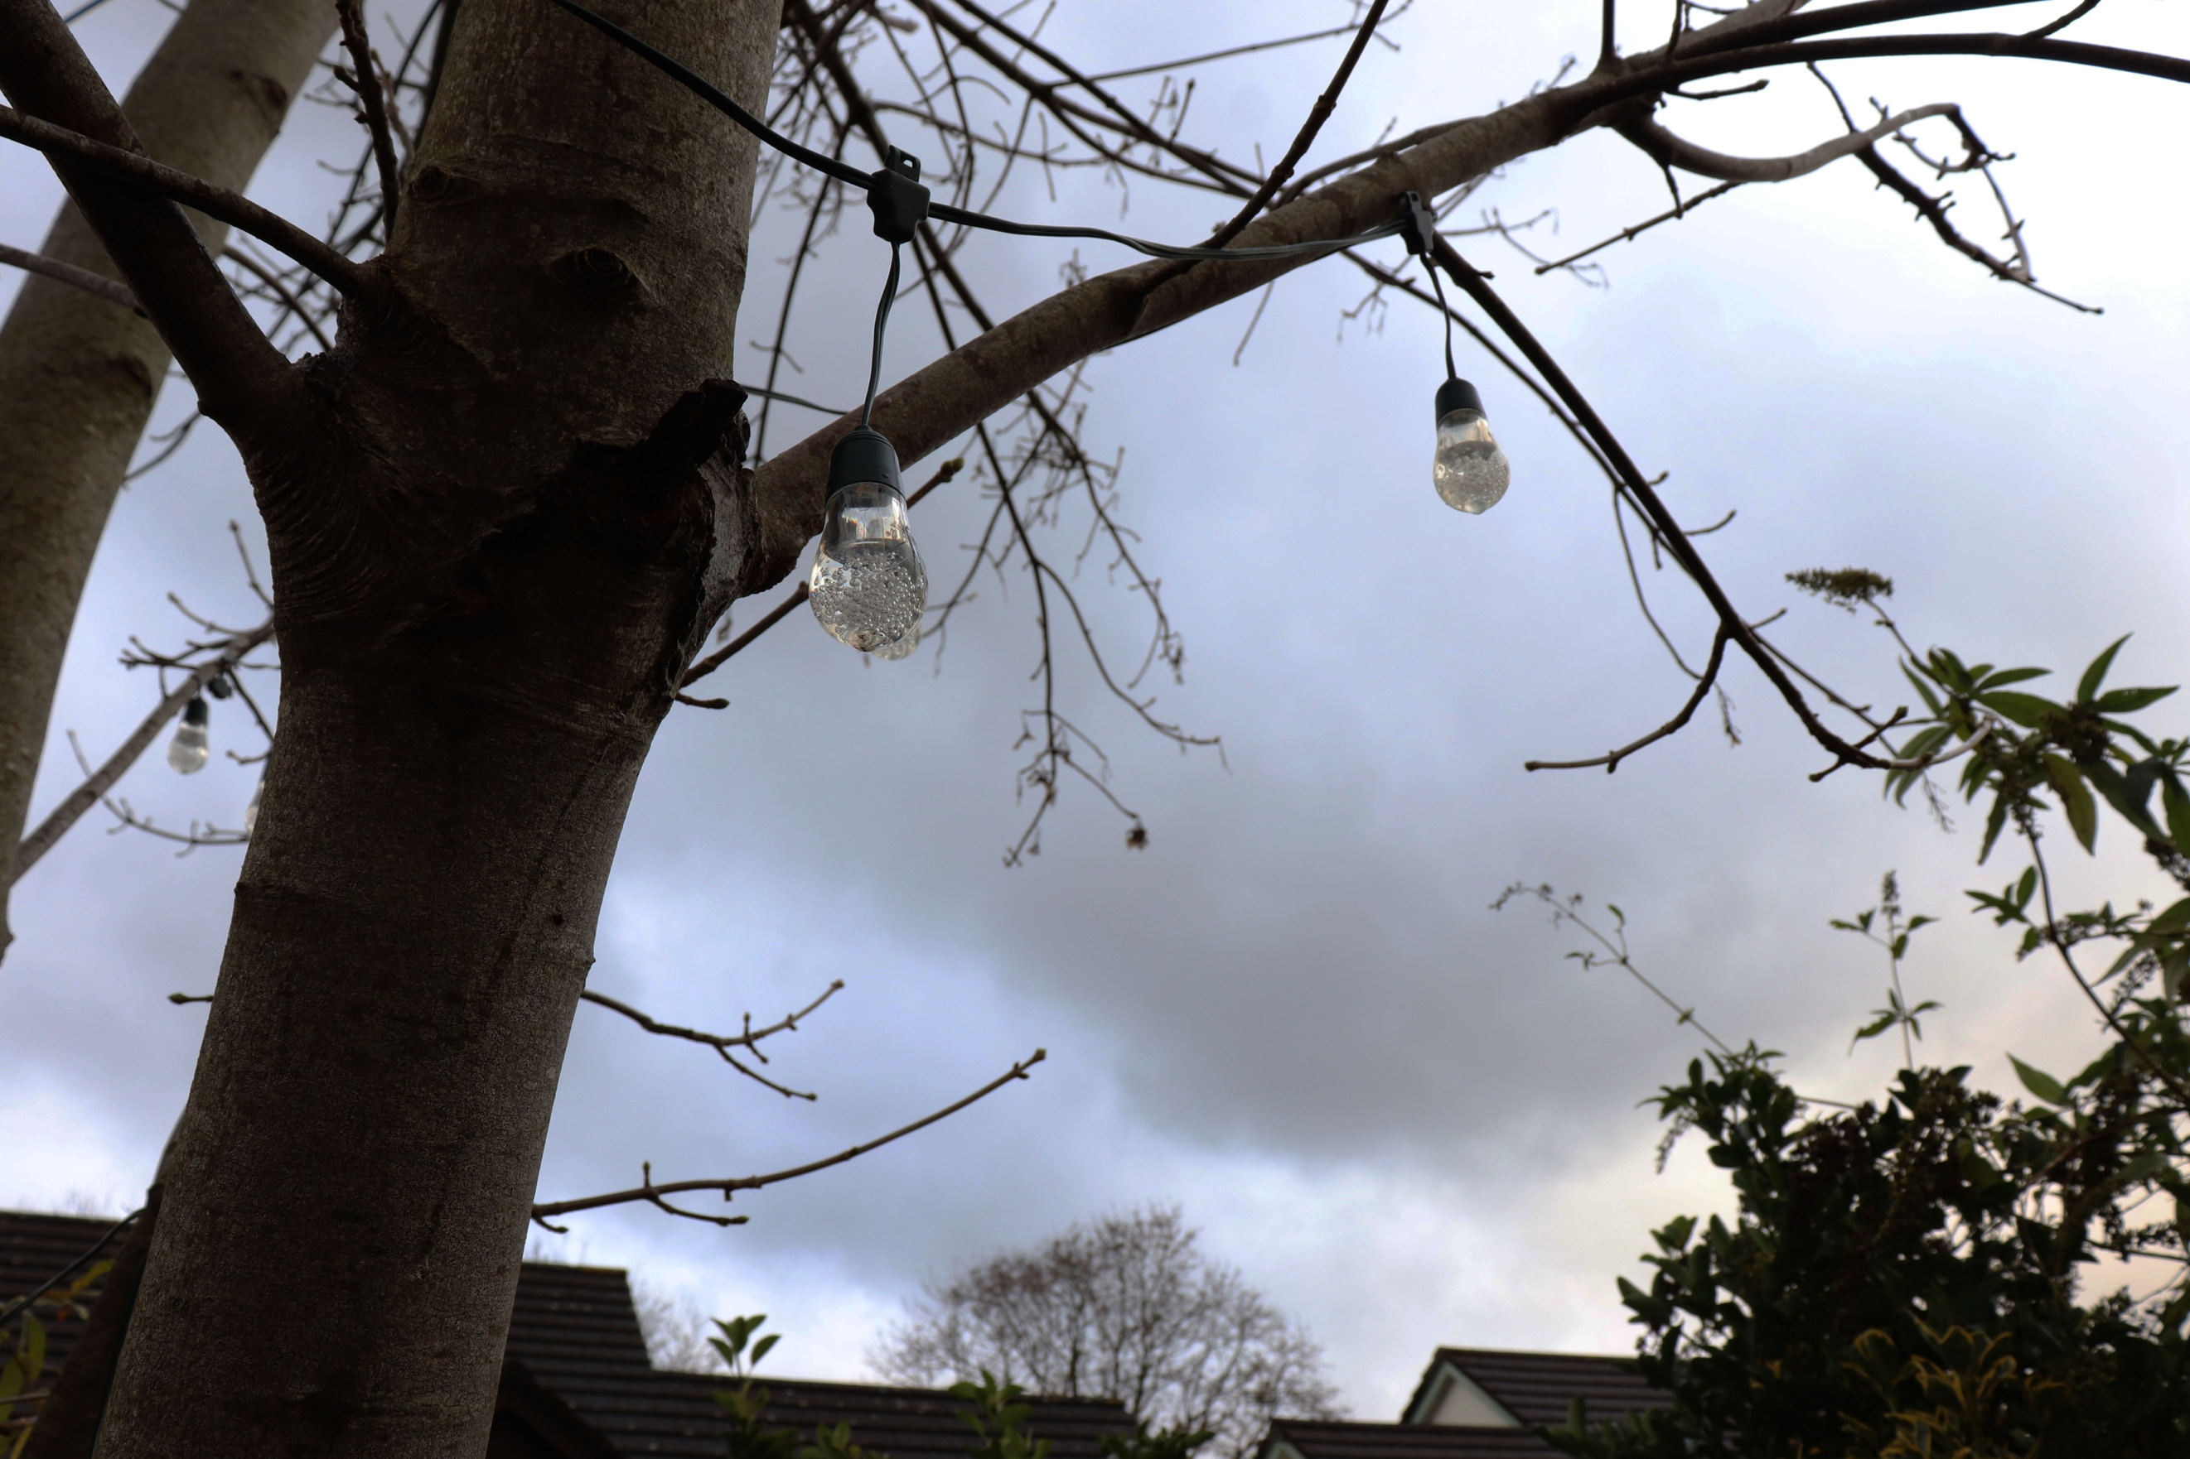
The angle of this image has been taken looking up. There is a lot of sky in the photo, maybe too much. I feel that the positioning of the tree was more effective than the main focus itself in little fairy lights. In fact, they are fairly hard to see because they are slightly transparent making it cool, but hard to see against the colour of the sky. There isn’t much else to focus on in the image as the tree branches are dotted around but are blurred out and are not effective as such in the image, same for the roof and bush. Only one of the bulbs and tree are in focus, which helps you to focus on them more, but doesn’t make the image effective as a whole. The texture of the bulbs seem delicate as of their colour and the little bubbles in the bulb, and the fact they are glass. Although the layout of the image isn’t ideal as I feel the aspects of the image do not gel, I still think that the colours are calm and that it is a pretty light. The photograph is mostly 2d and is not jumping to life with lots going on. If I was to re shoot this image, I think I would try from a more effective angle if I was to take the background into consideration, along with on a brighter and sunnier day.
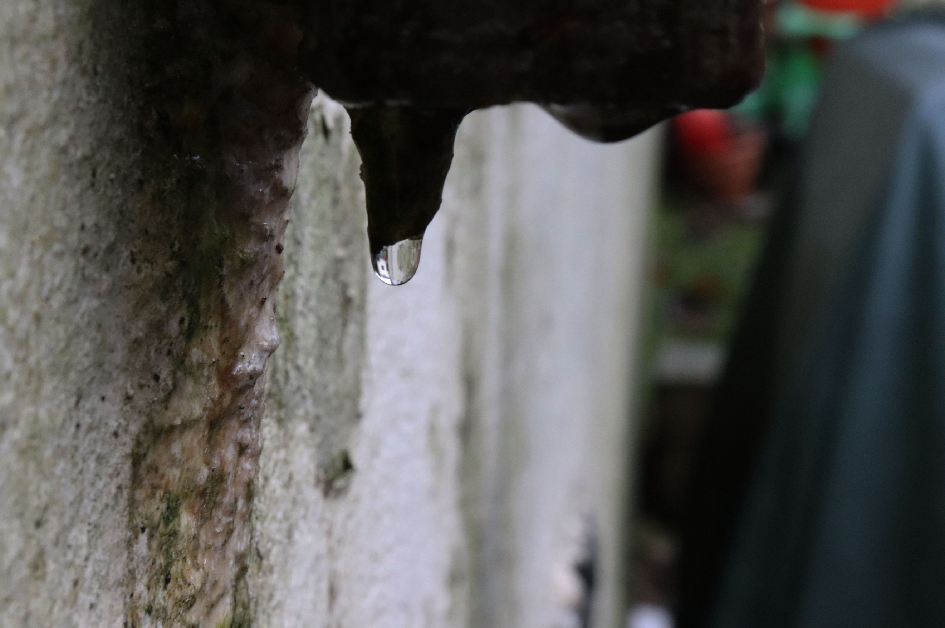
In this last annotation, I have chosen to take it completely different from the rest of the images, but still feel that it is uniform because every single image focuses on something hanging. Here it is a droplet of water. In this close up I have specifically focused it on the one drip in focus. The rest of the background and most of the foreground is blurred out which really helps you specifically focus on that one little aspect of the image. Unlike the pervious image, this is easier to see, even though it is transparent like the last image. If you look into the water droplet itself you can clearly see a flipped image in the water droplet which is really amazing. I have focused the viewfinder in this image similar to some of the previous images in the top centre, to make the top 6 this section of the grid it worked fairly well. To the left of the image is some grime. It has an amazing mixture of colour and looks almost of a slimy texture! The water droplet itself looks rich and expensive and almost like glass as it is so clear. The angle I have used here, is head on just like Walker Evans’s images. I don’t think you could take this image from any other angle as no matter where you try from it is always going to look head on with the droplet. The image looks 2D and is captured at a really good time as it hasn’t fallen yet and it is weird to think that you cannot snap this shot over and over again like some shots you can and that this is only contemporary.

