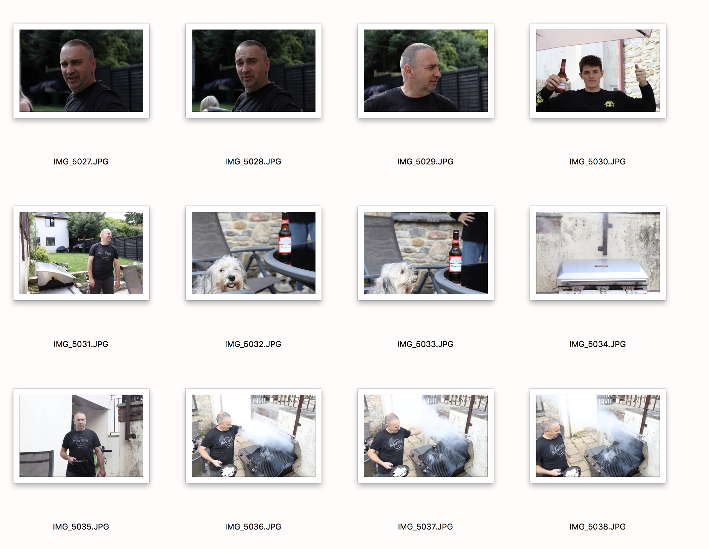
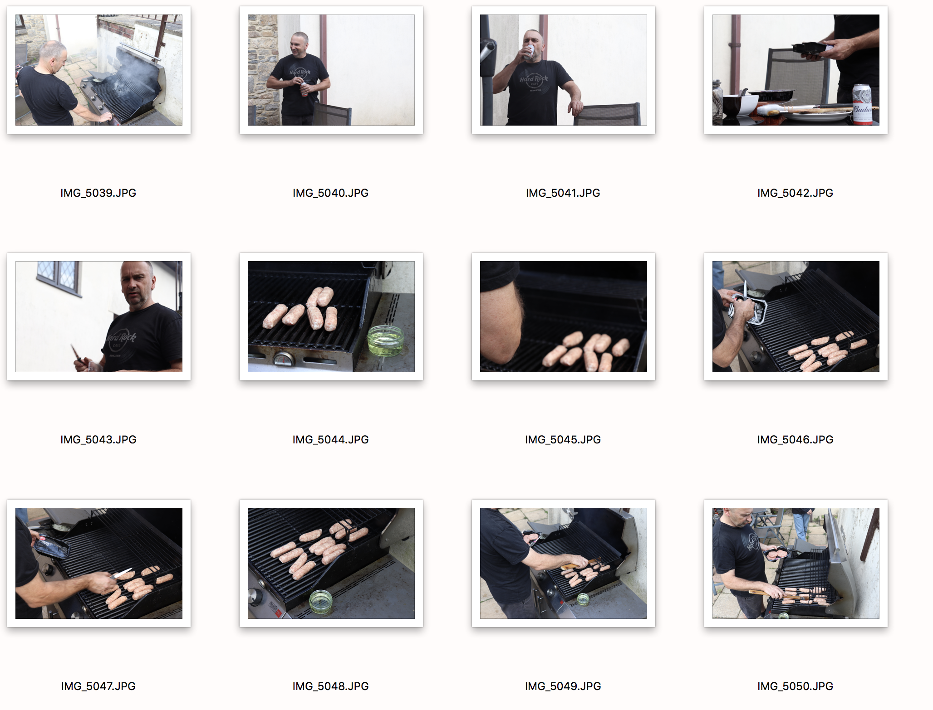
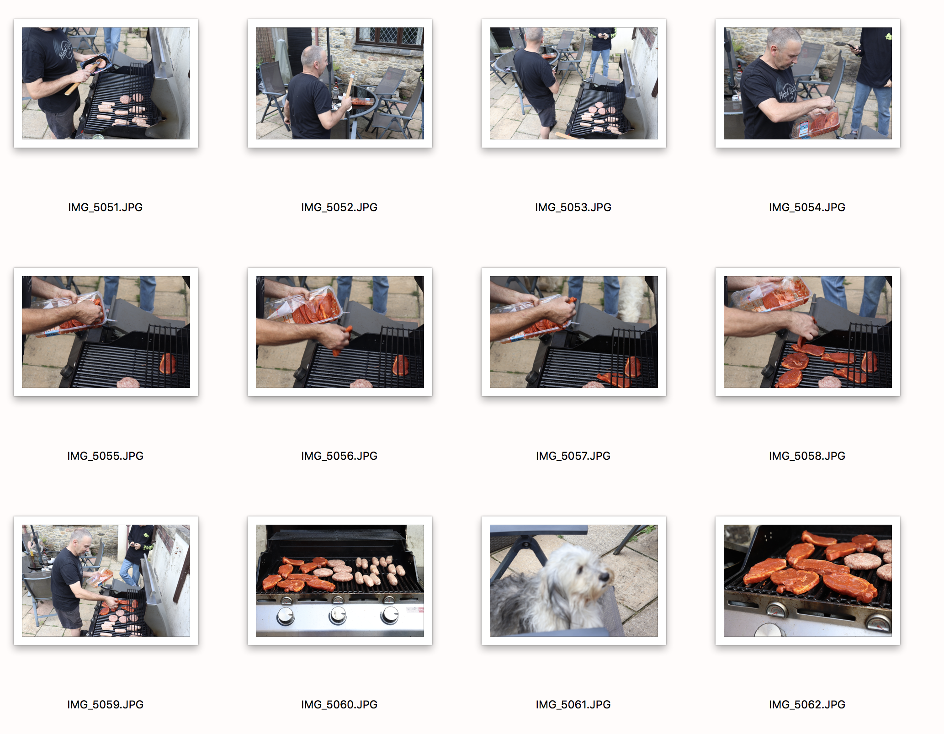
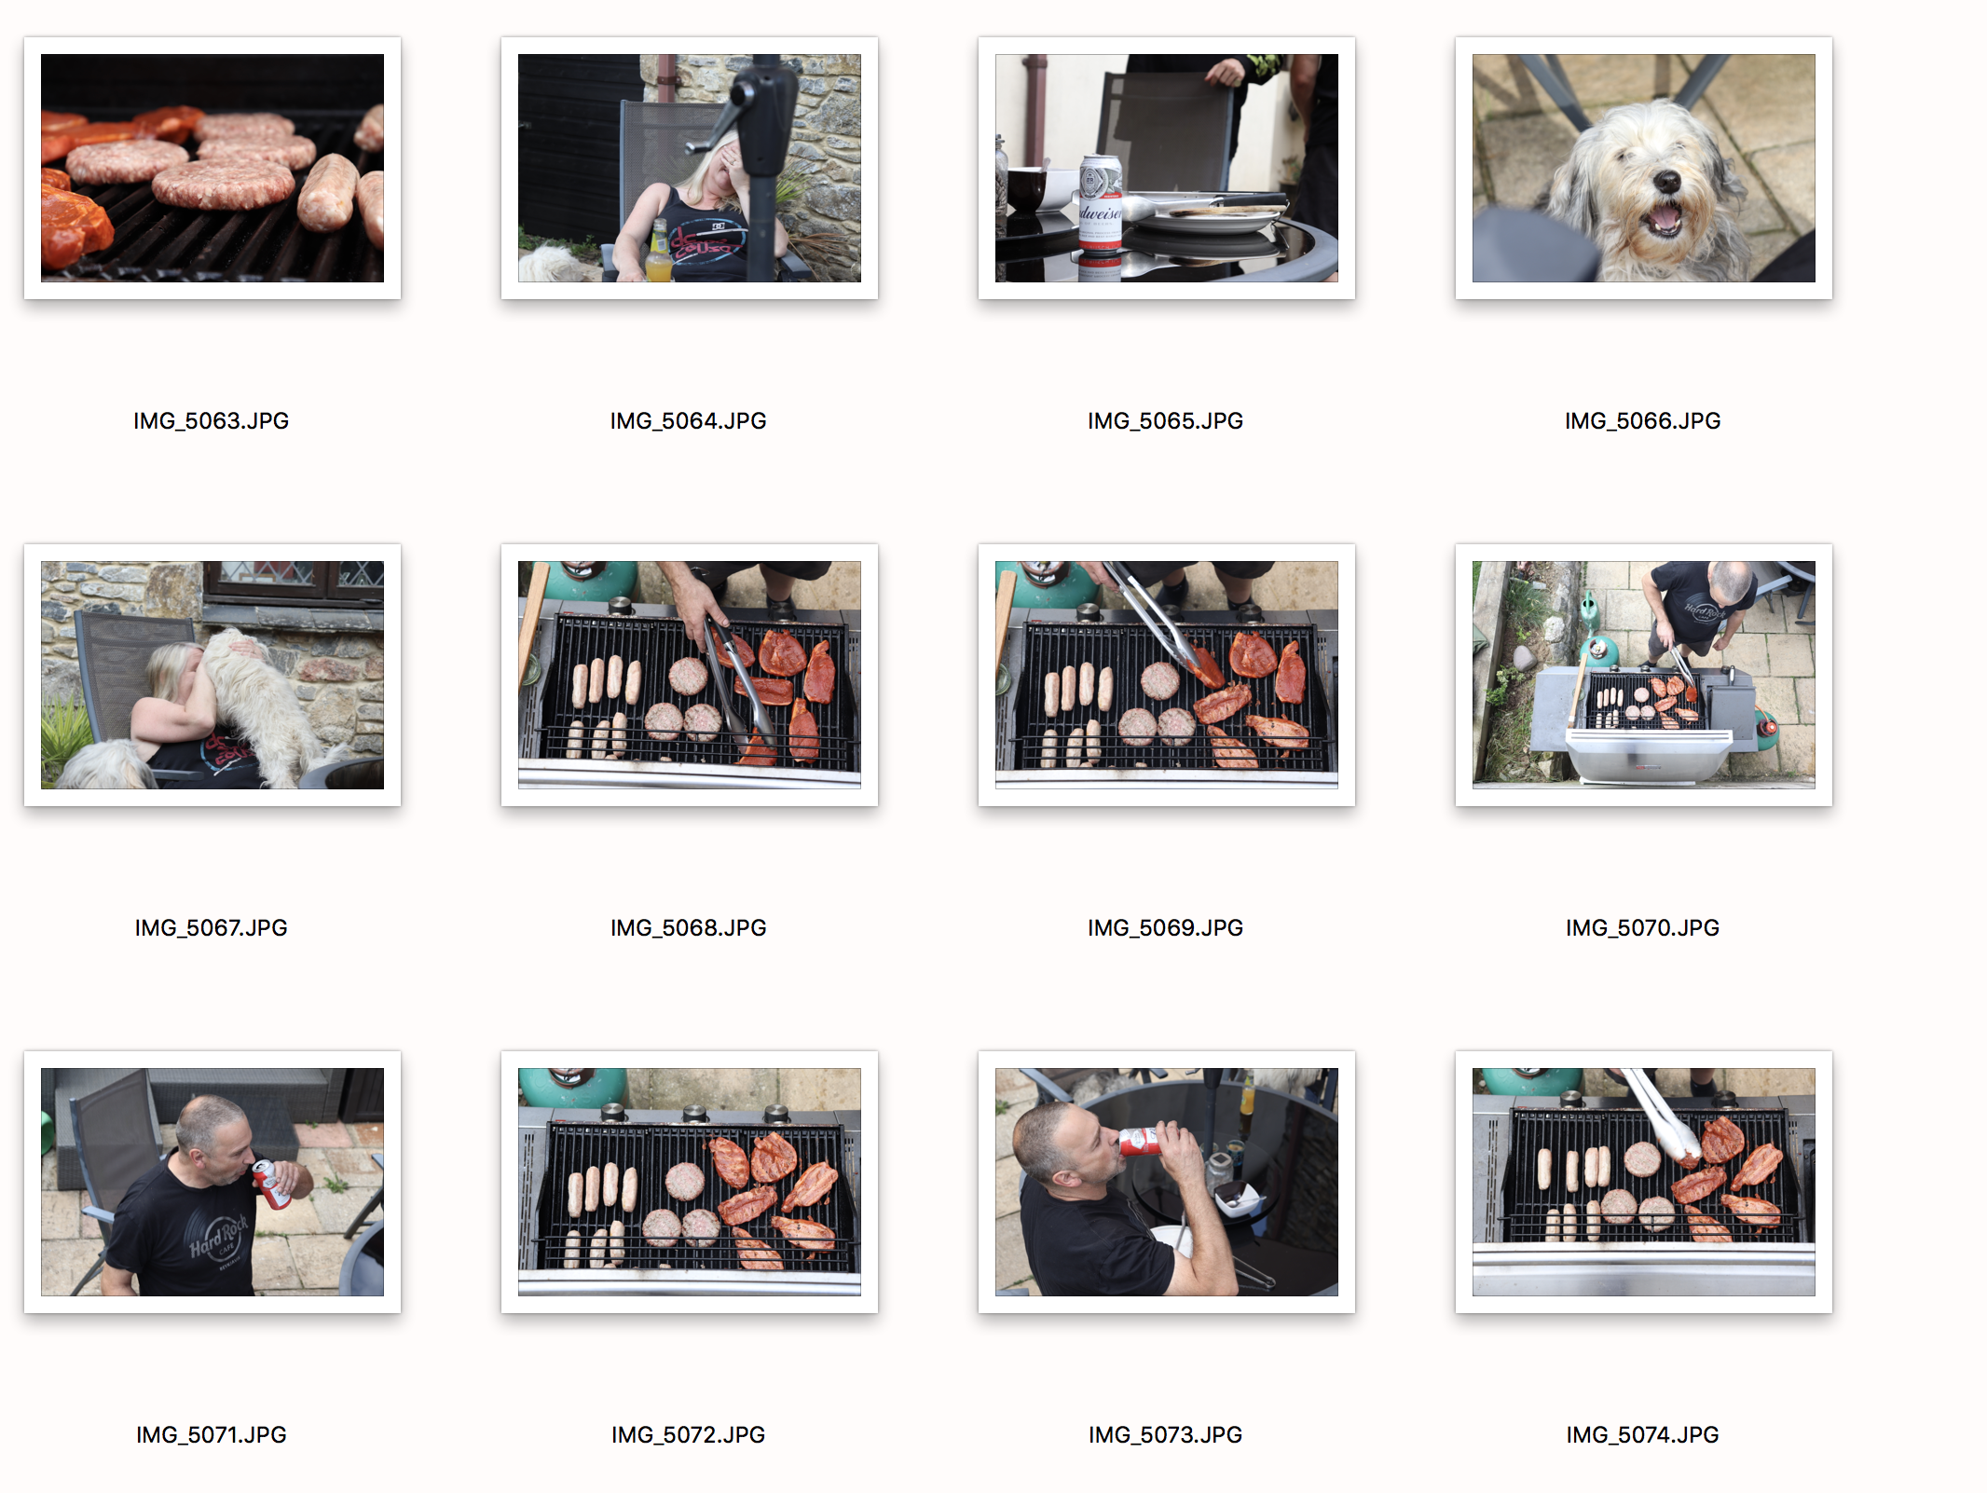
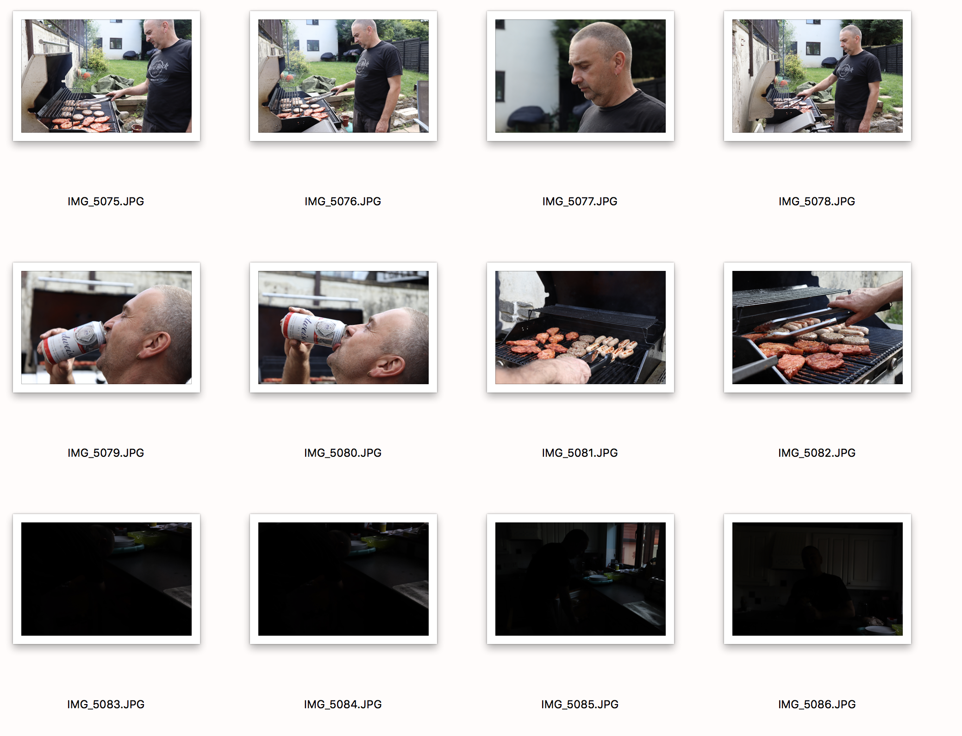
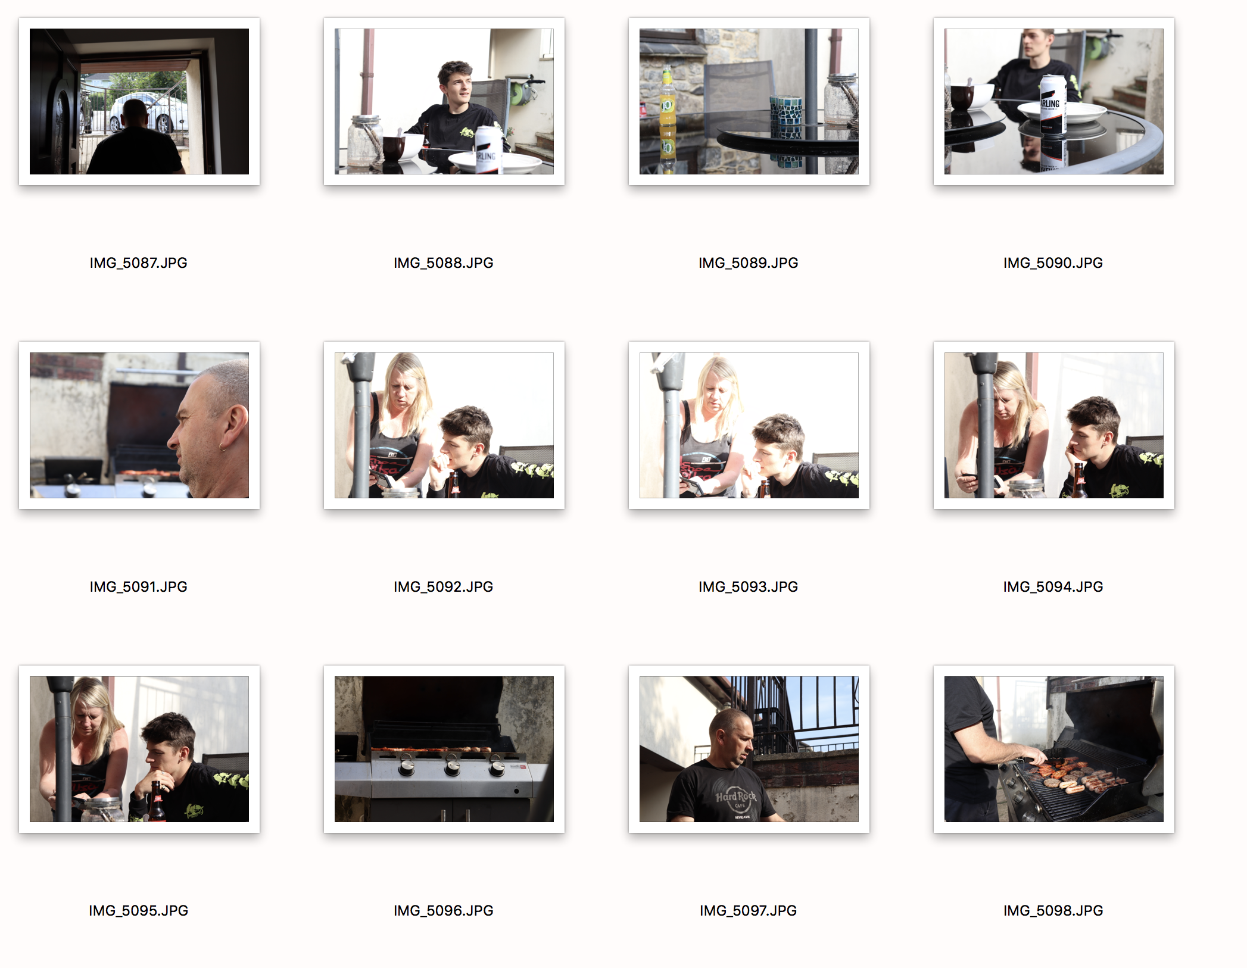
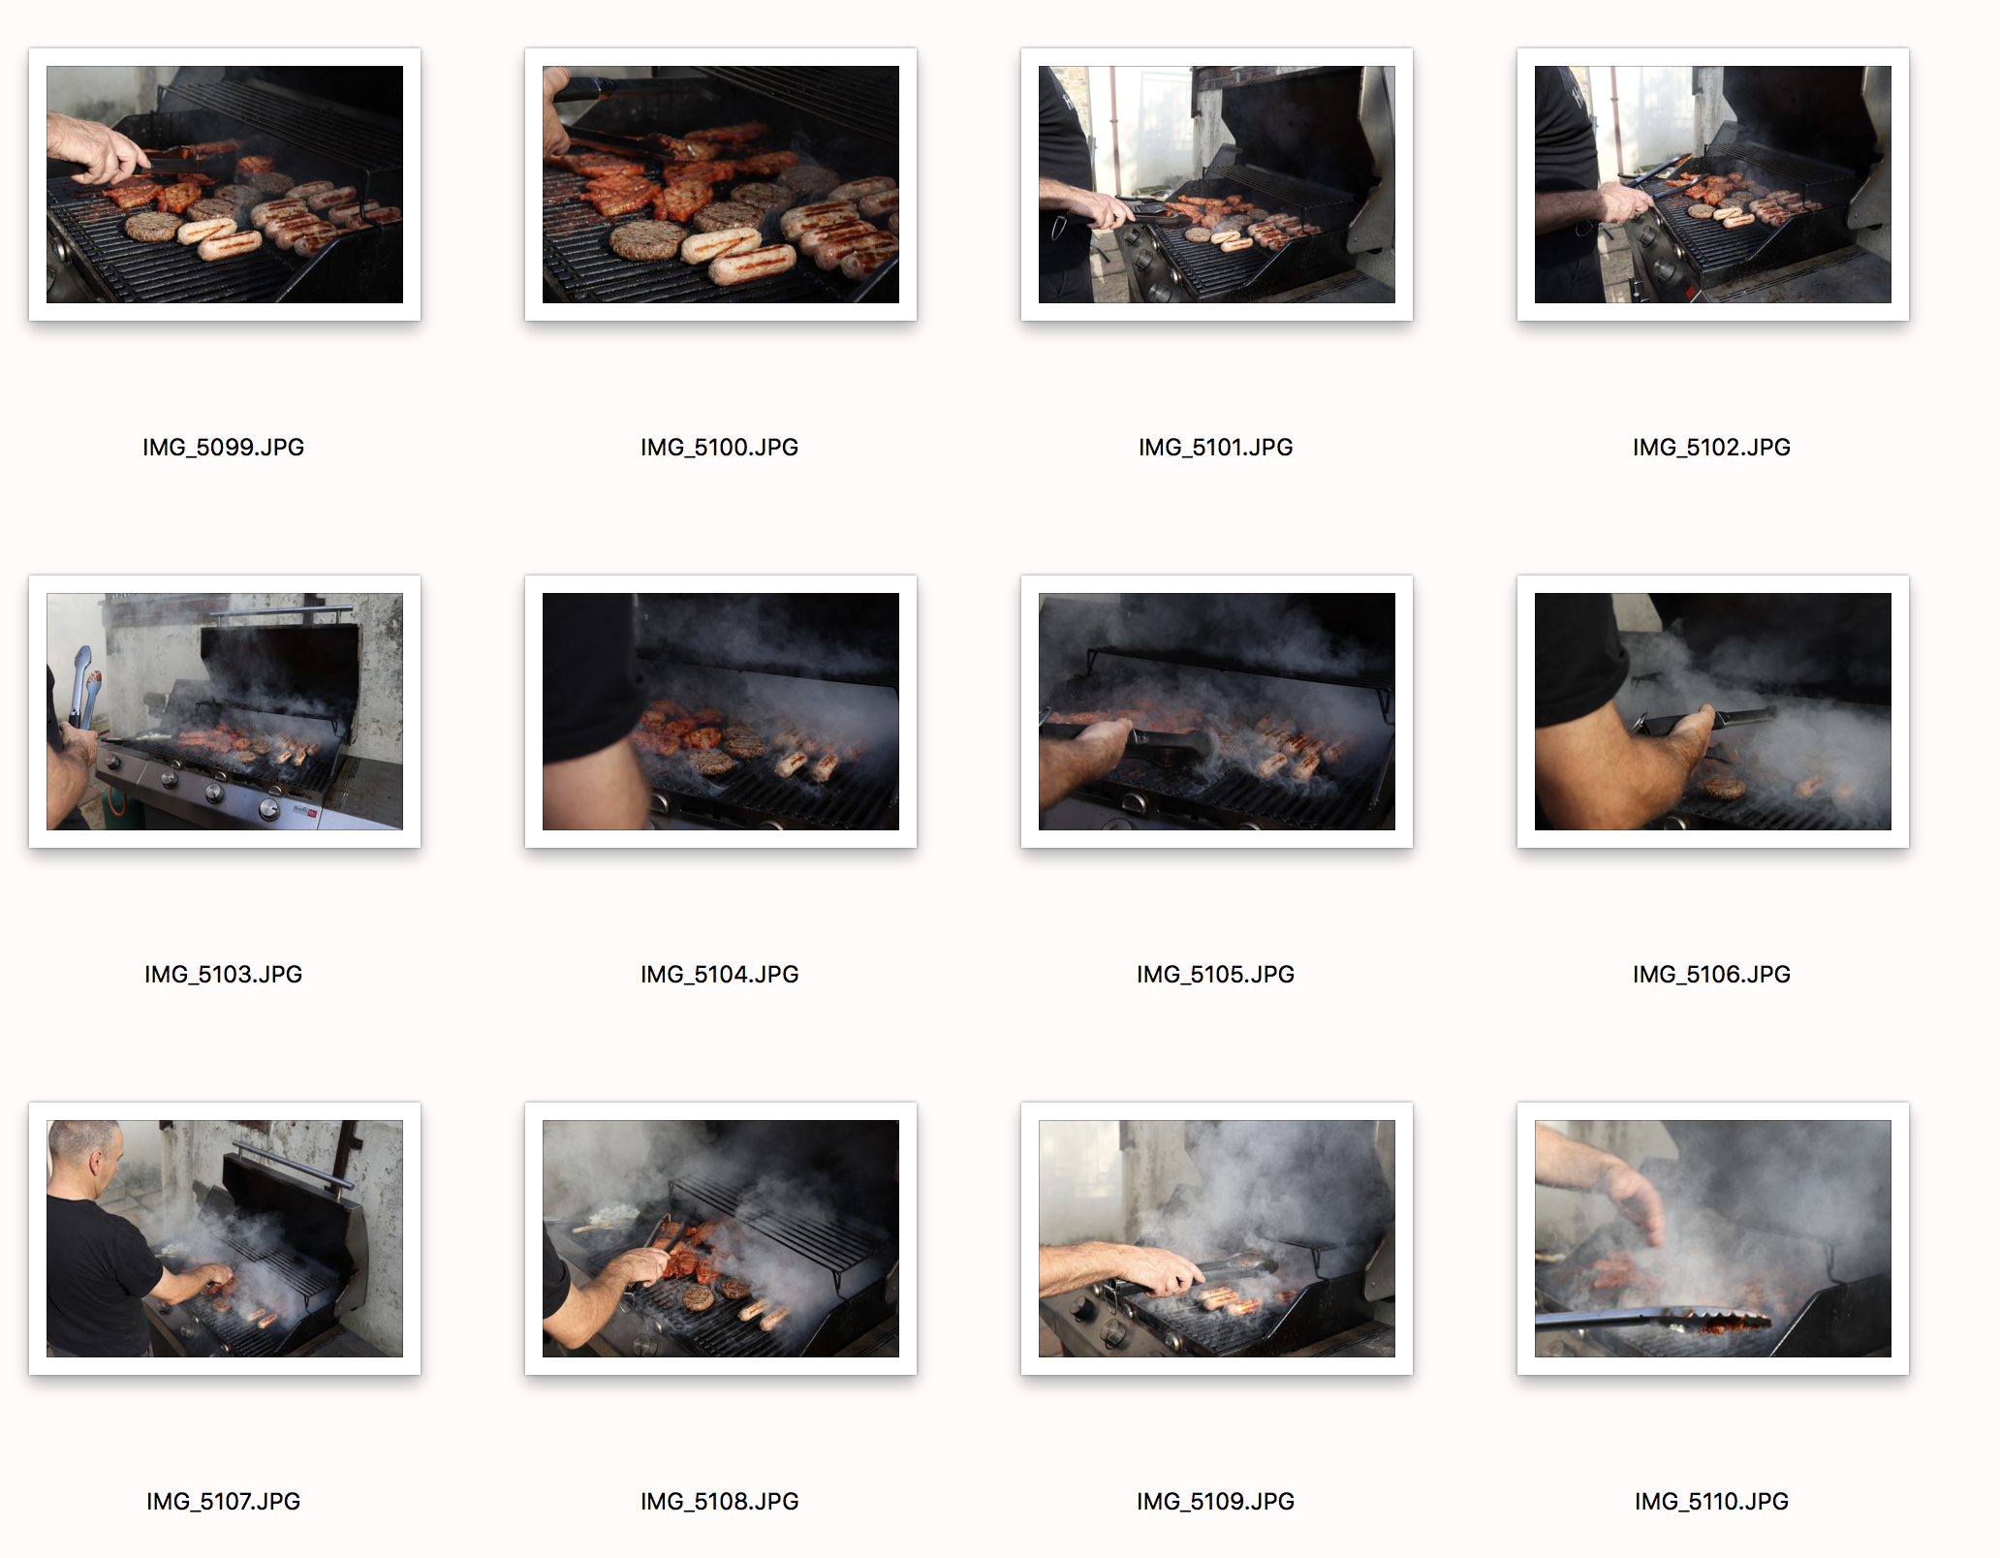
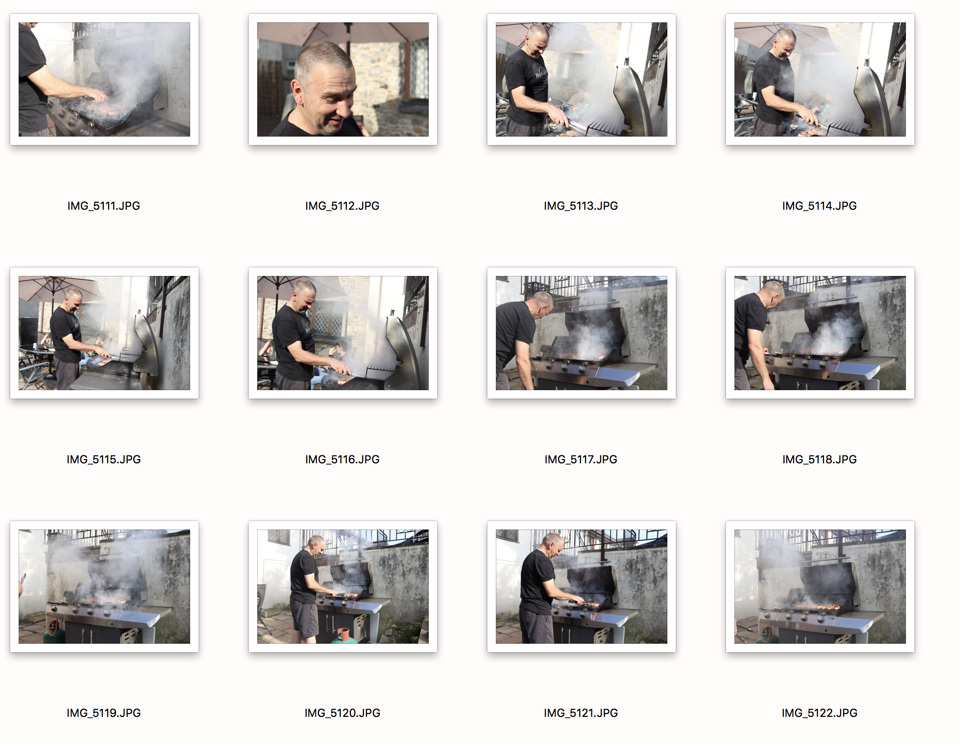
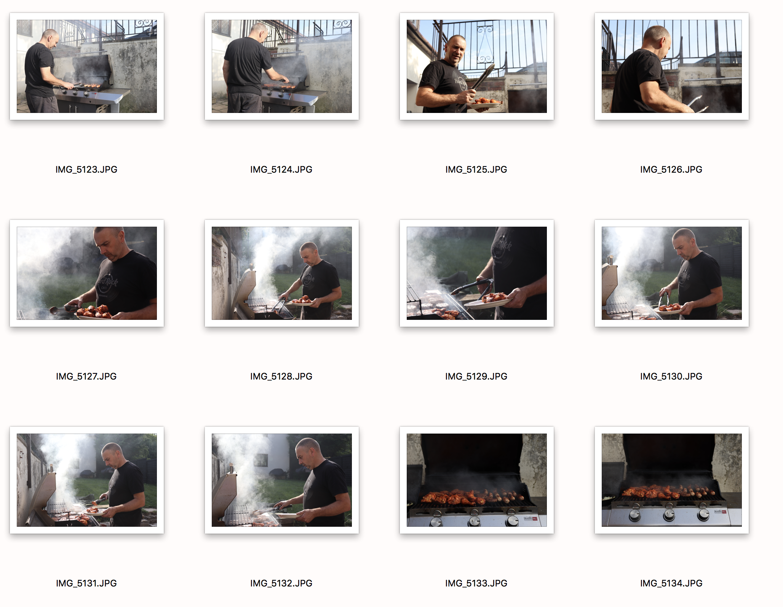
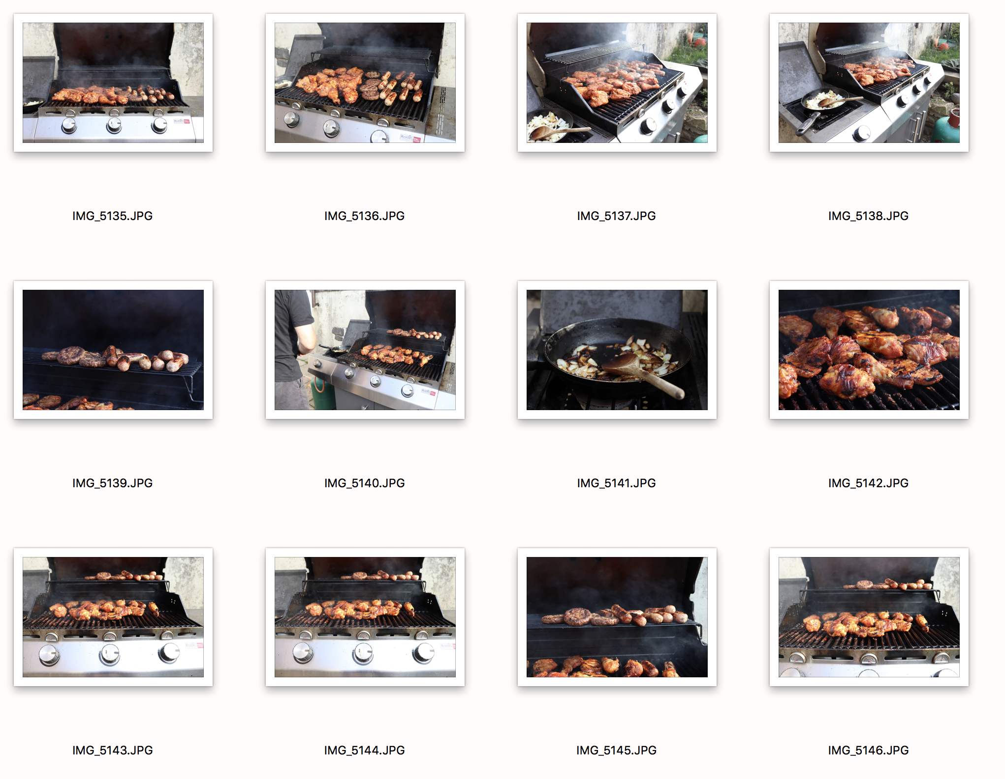
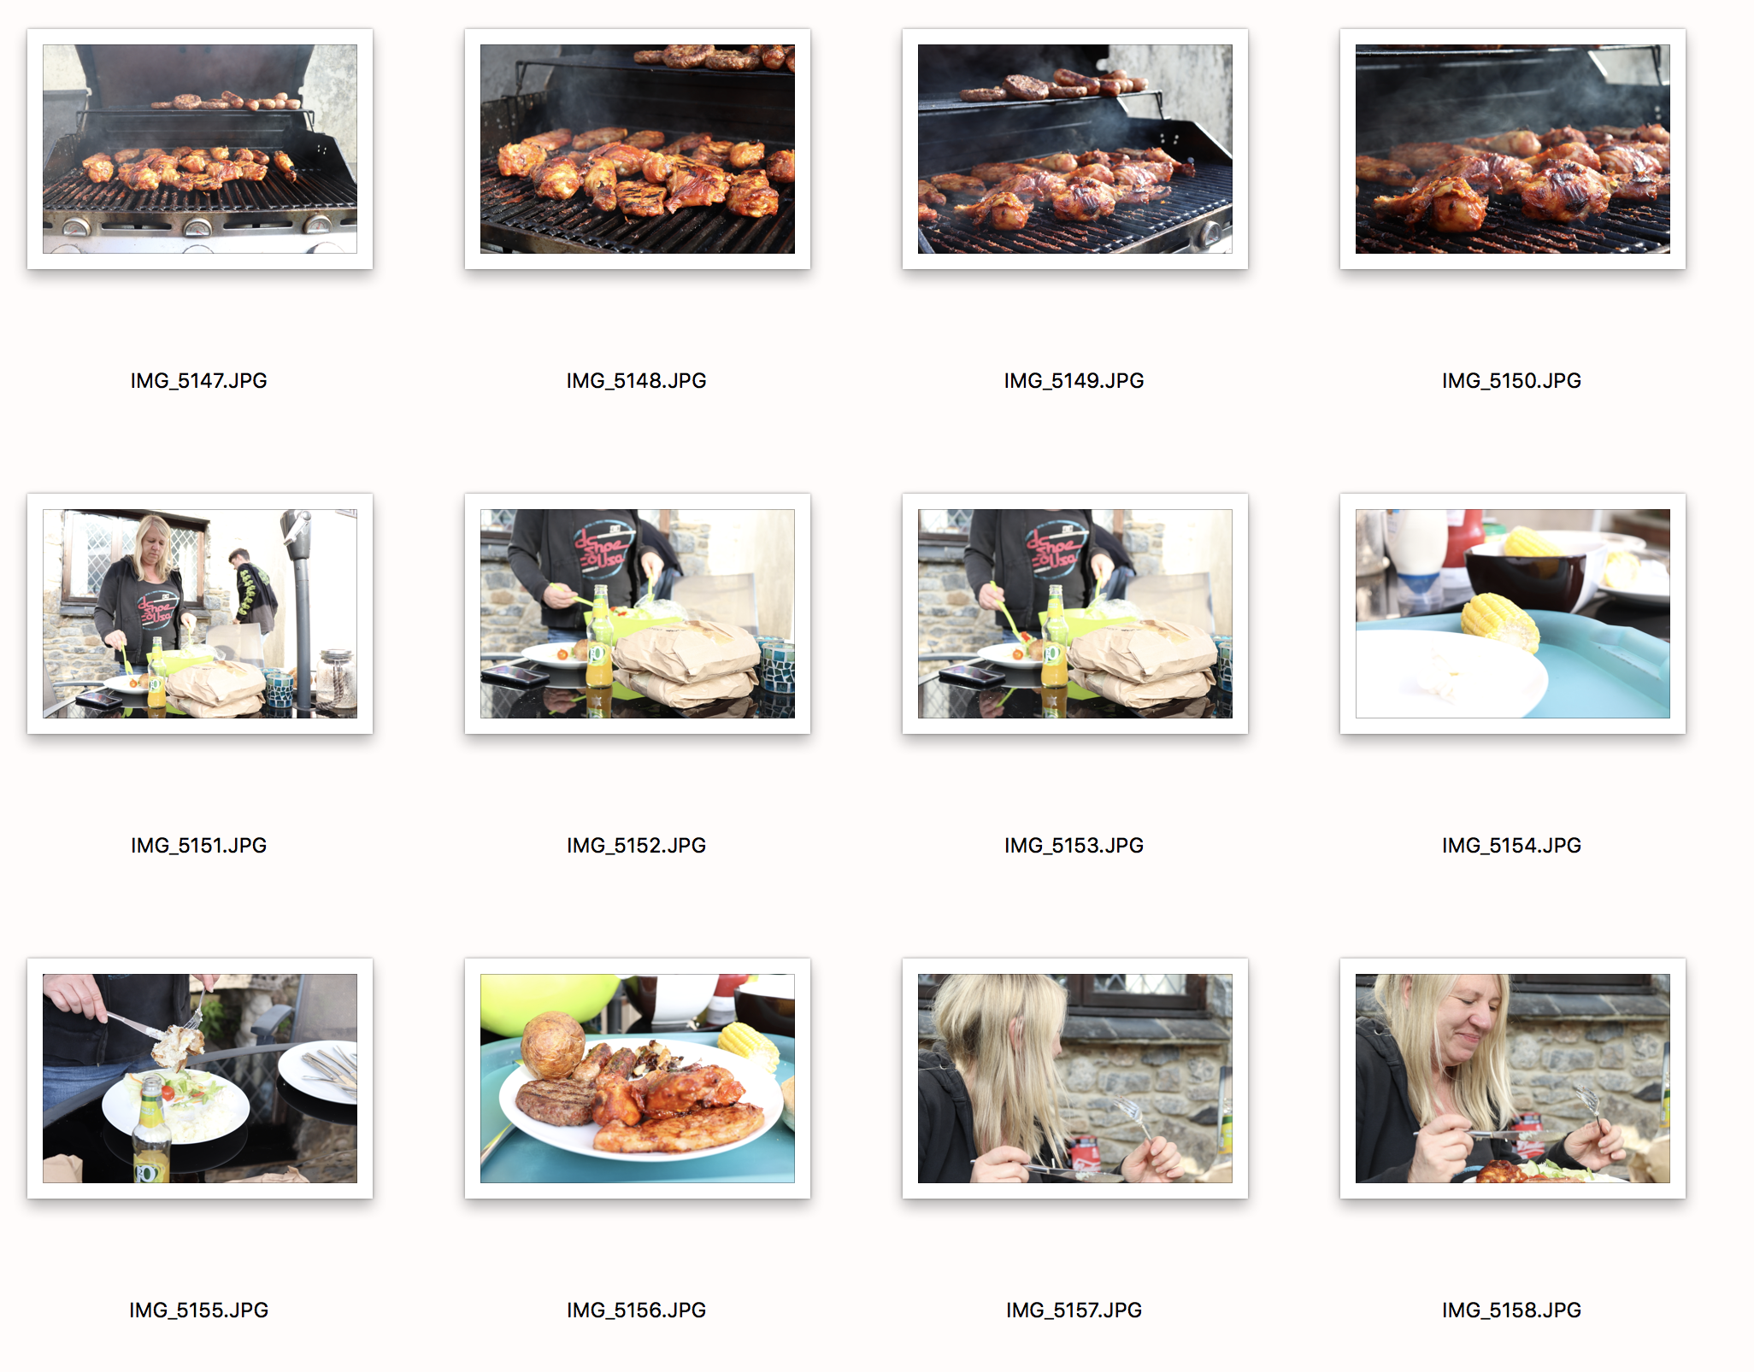
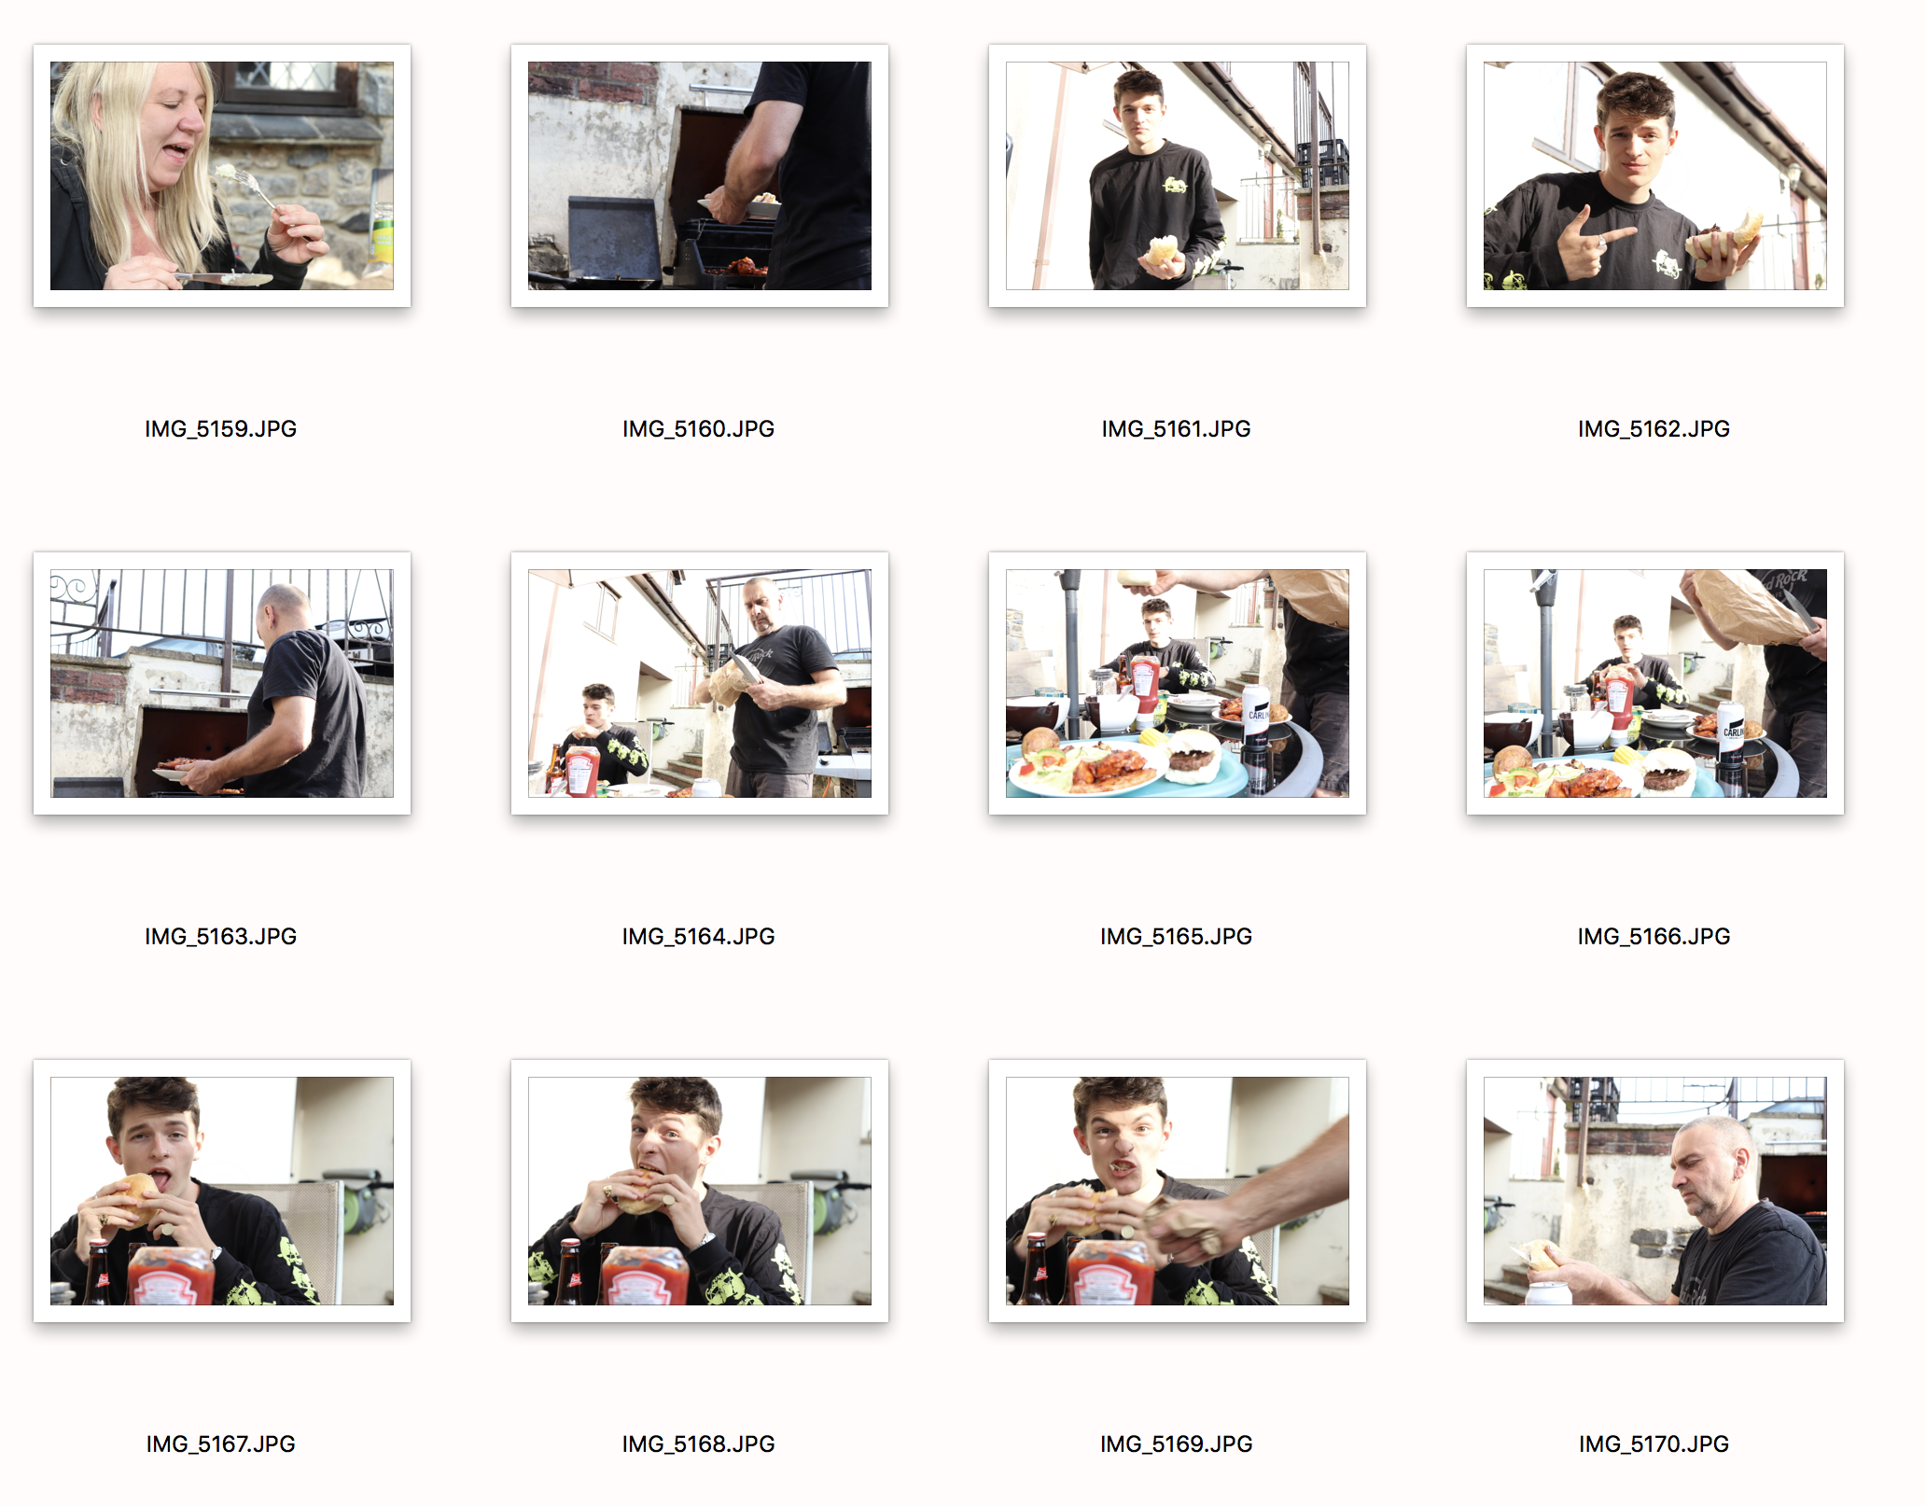
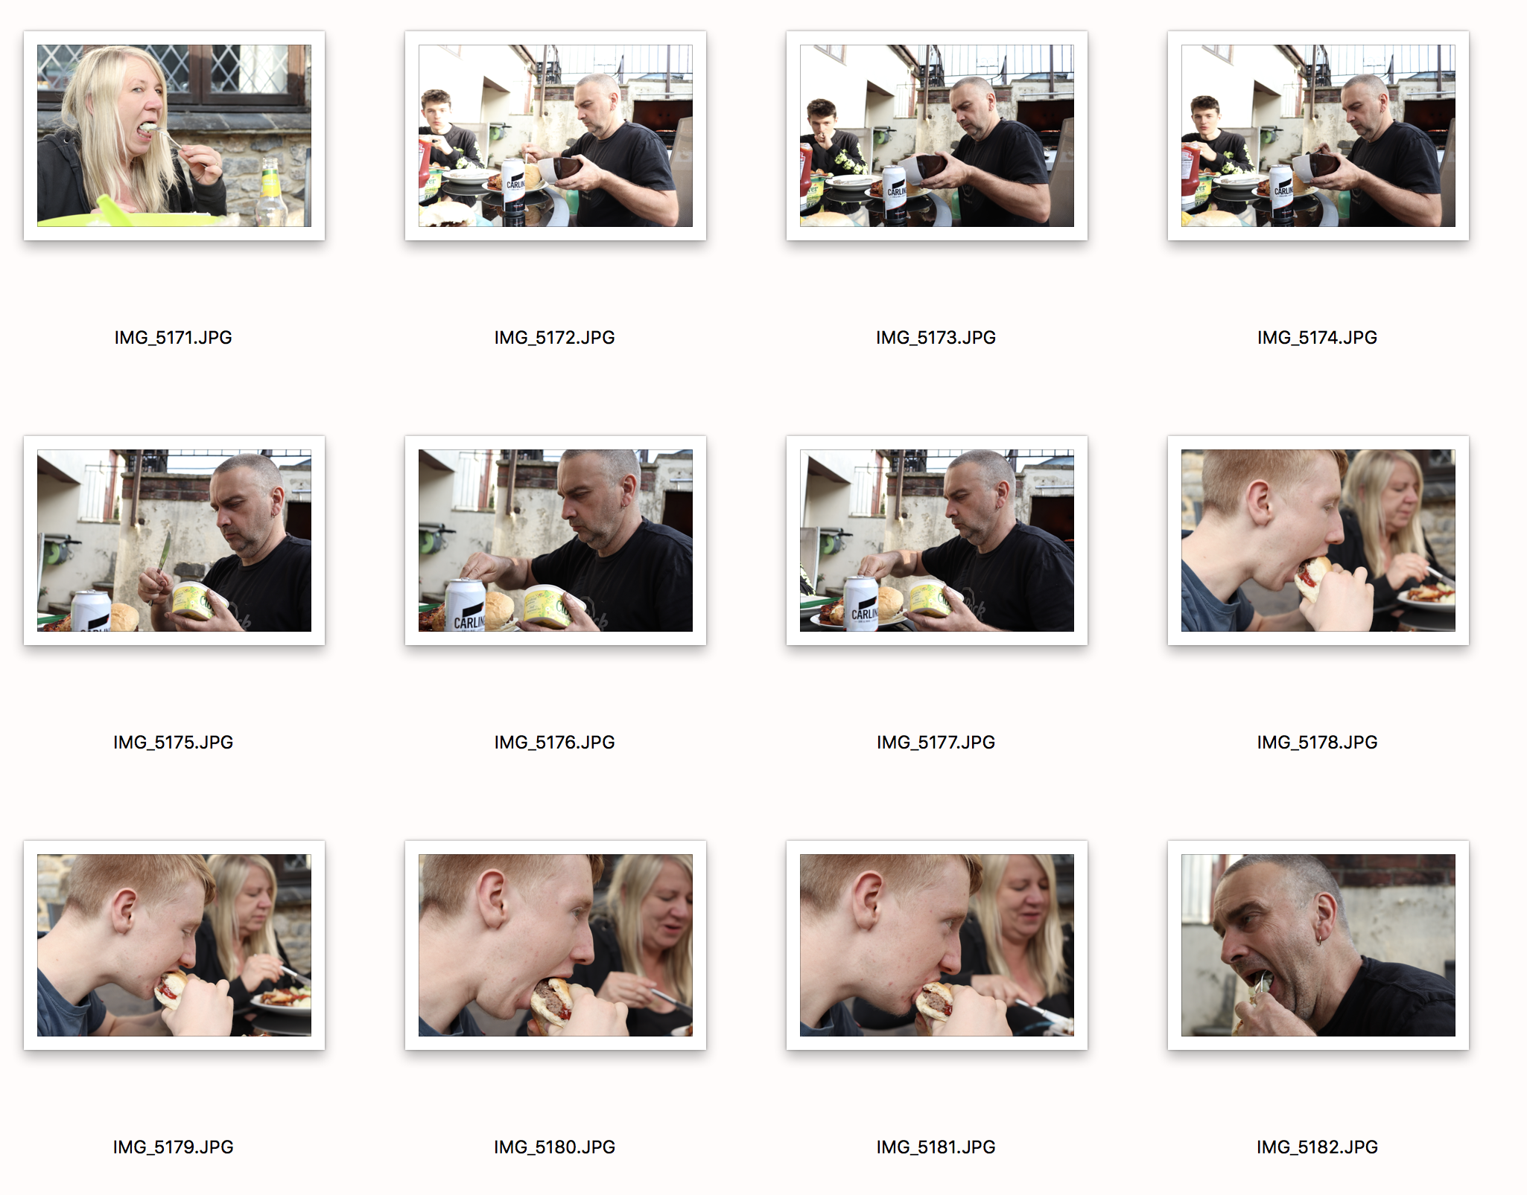
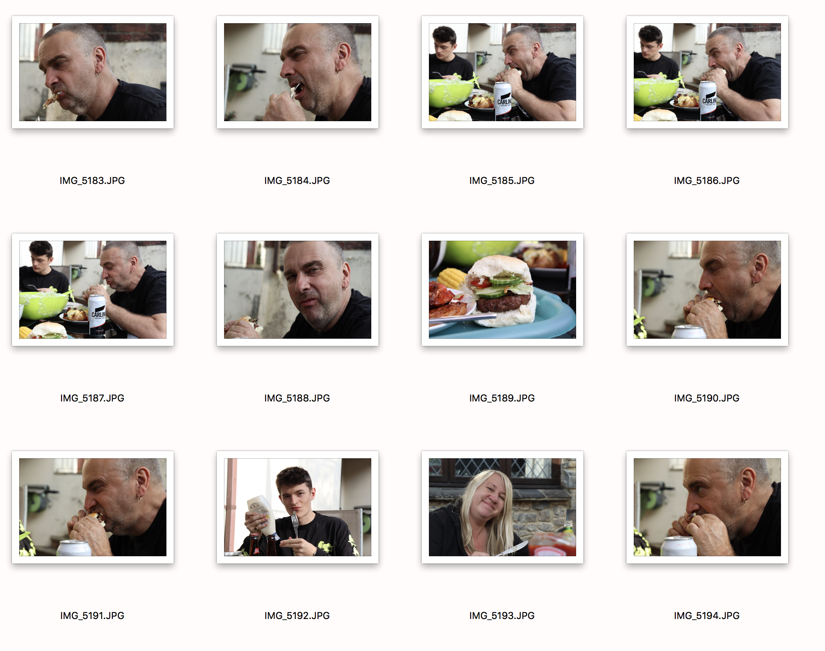
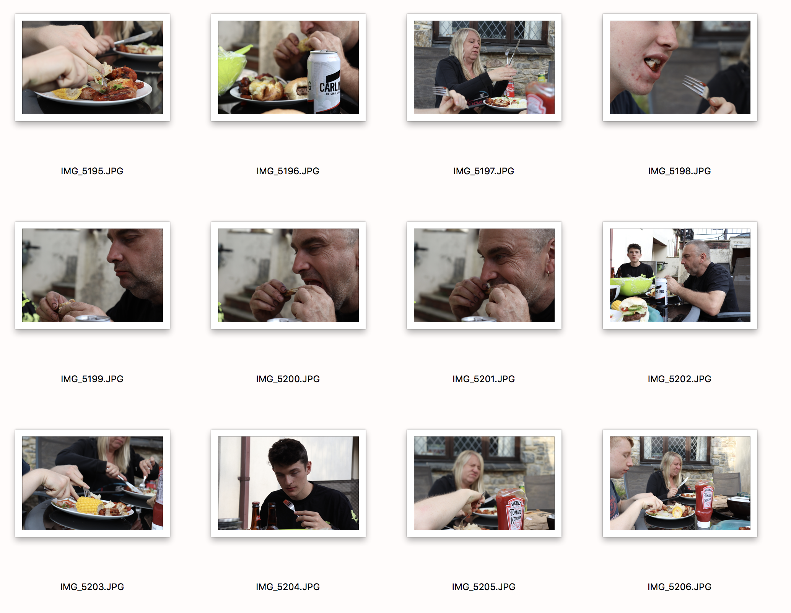
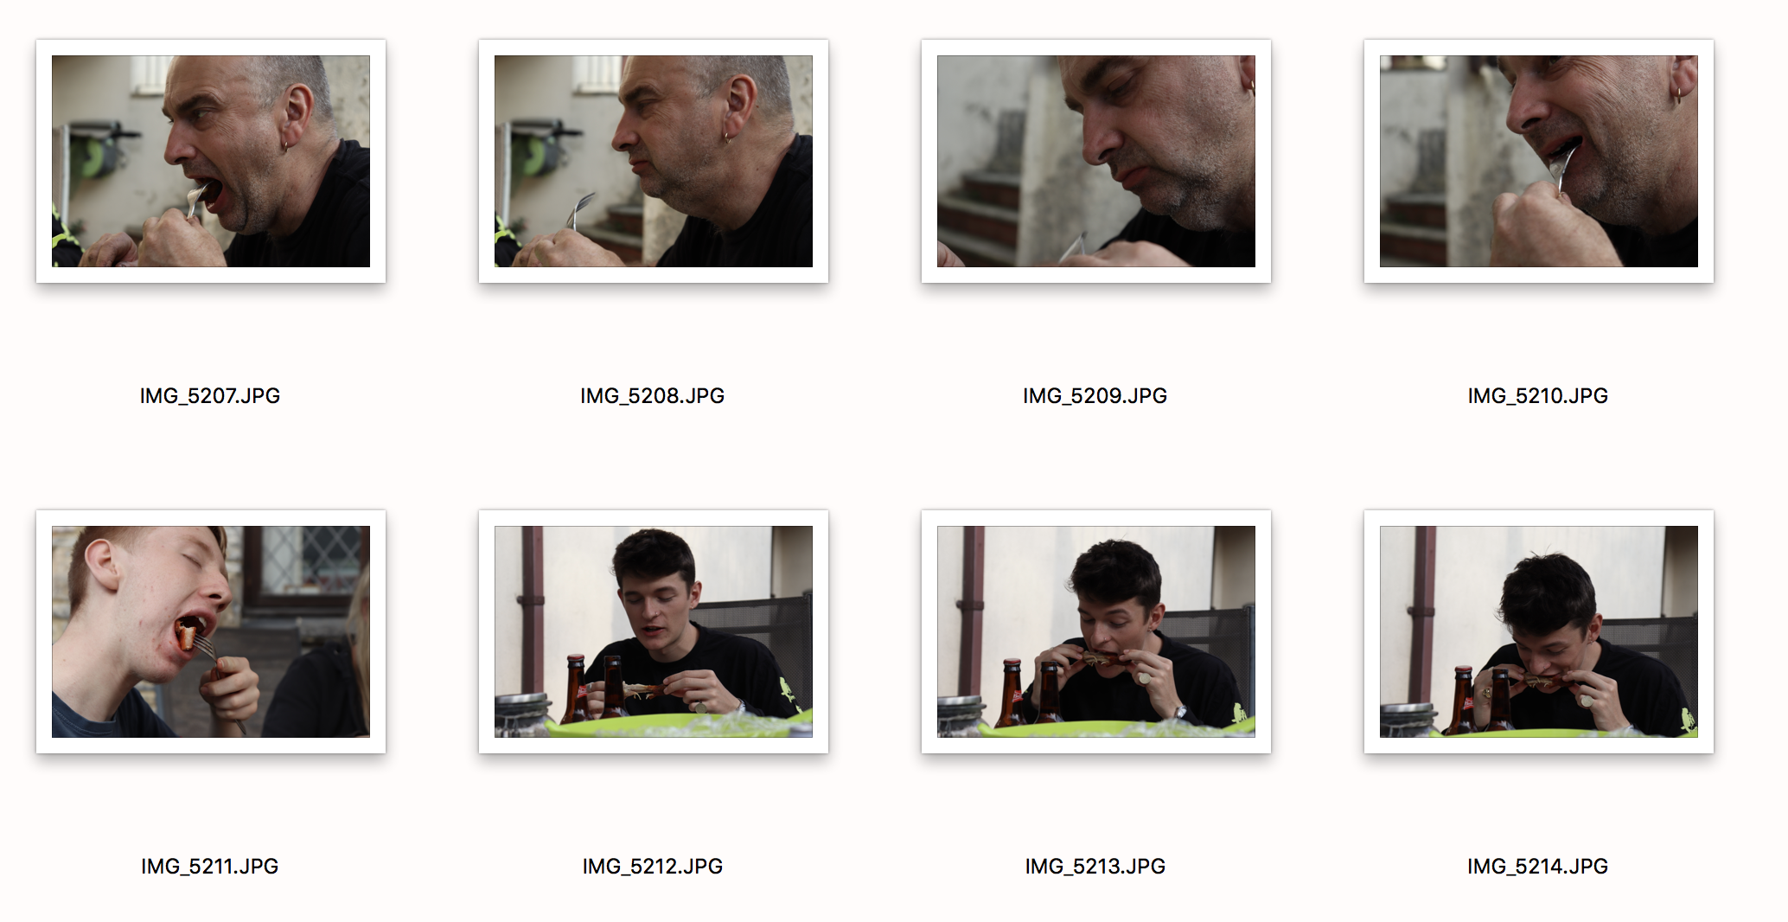
As usual, my selection process first starts by eliminating the poorly exposed shots. Once they’re out the way, I start to look against the relevant criteria of the shoot, and what suits the brief best. Along with what images I personally prefer over others in terms of framing, contents etc. that make the image. The reason I have selected the ten I have circled above is because I feel that these fit the criteria. They are all unique, all in various ways. They all contain different moments and viewpoints throughout the BBQ. I selected something that I enjoy which is spending time with the family, having a laugh and eating good BBQ food. Of course, not every image is going to be totally different, but they are in the sense that they focus on different subjects throughout. What I mean is, more than one image contains the chicken, but the other ingredients that make up the image are totally different. No matter what I shoot, it would be same scenario. If I shot landscape, there would be most likely be trees throughout the images. But the difference in the images also, is one is before it has been cooked, looking raw and vibrant, and then the other is nearly cooked looking very delicious. Each image I feel gives new information and shows a different stage of the BBQ.

