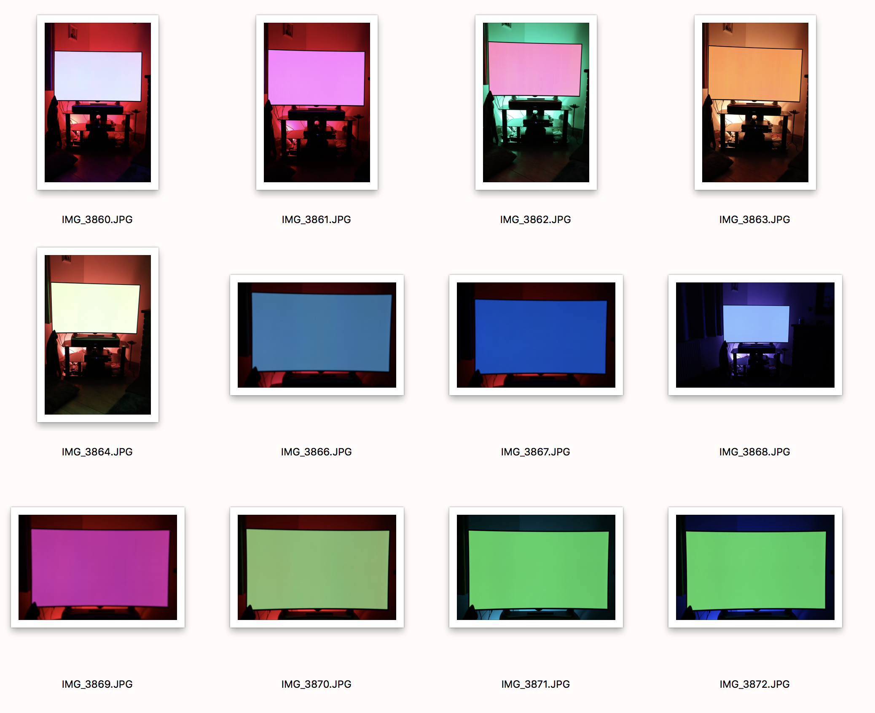
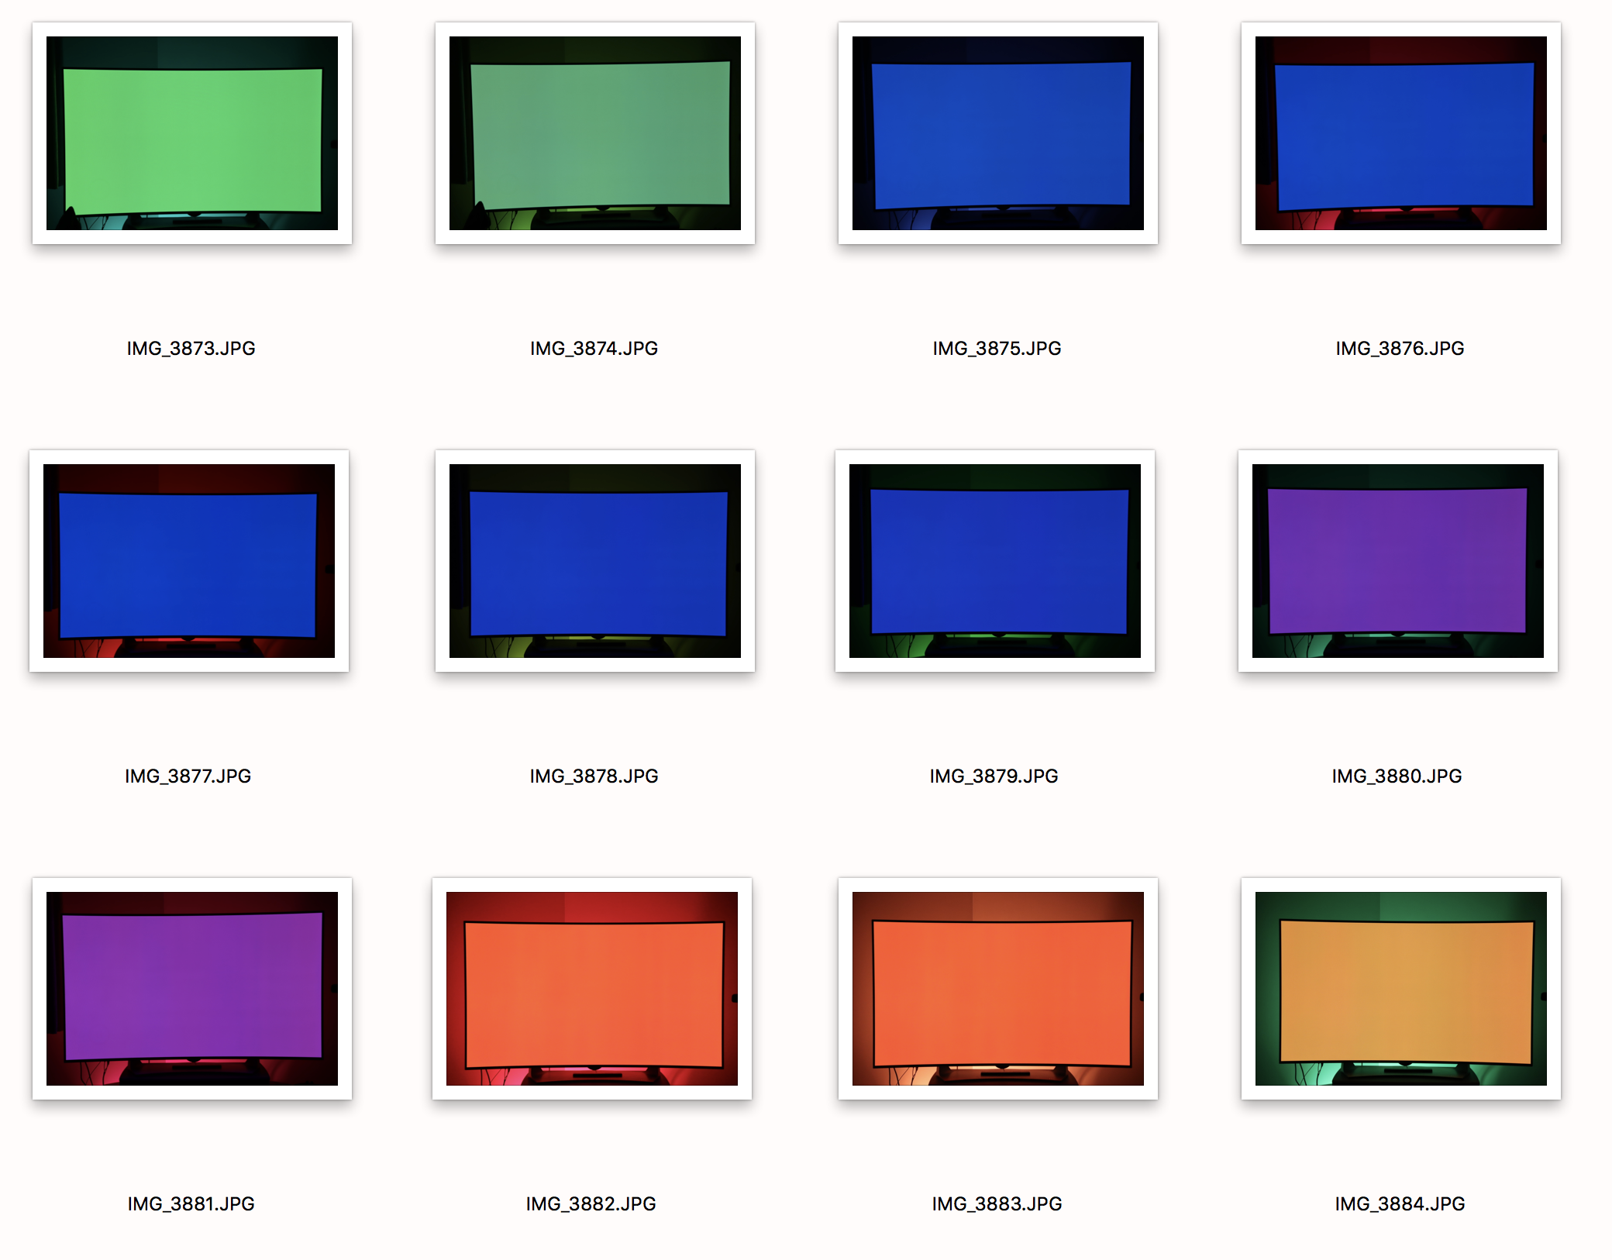
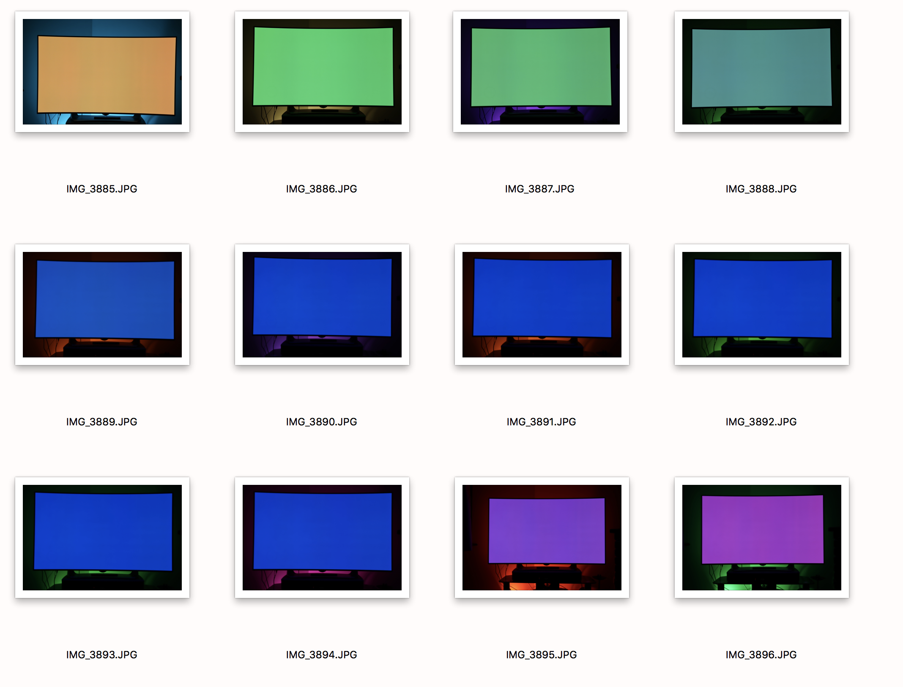
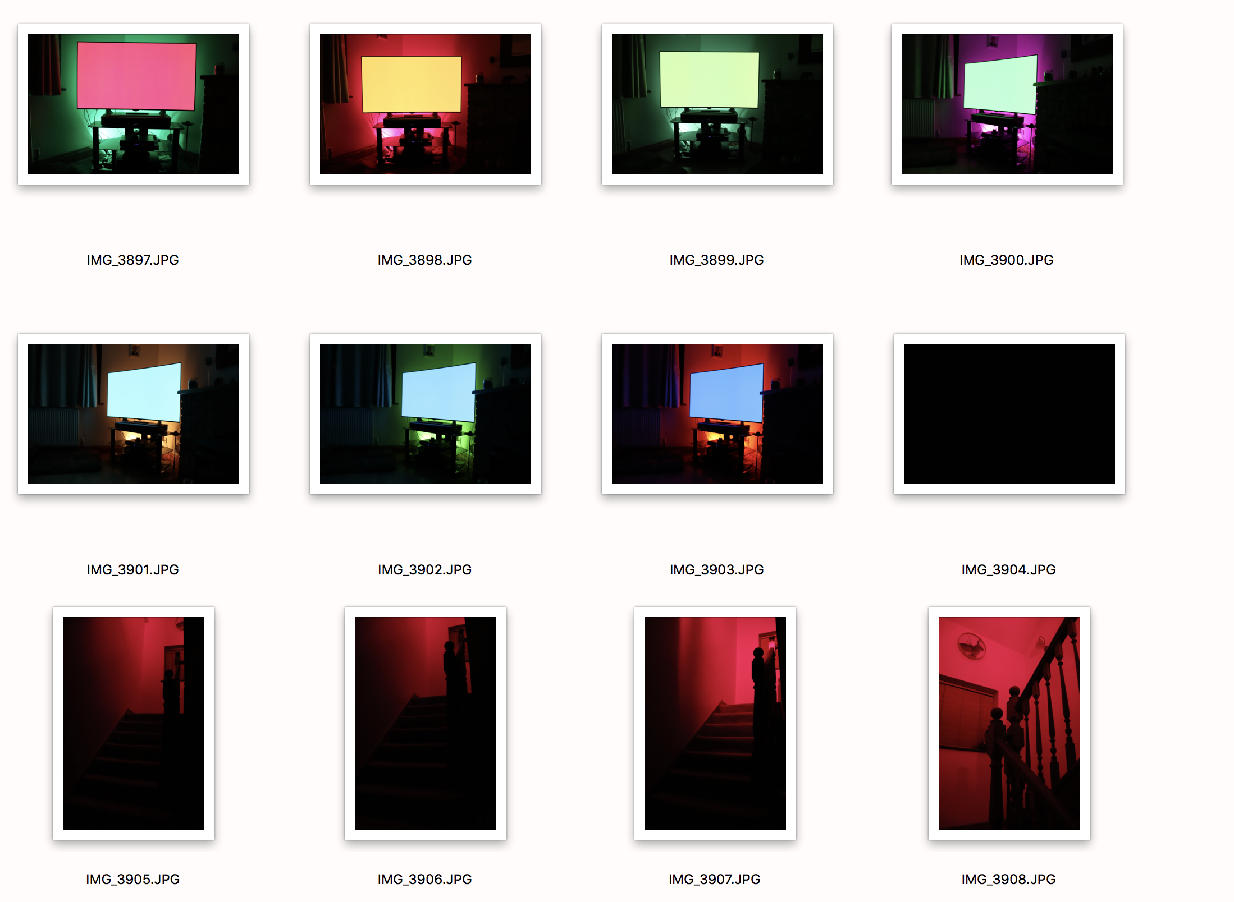
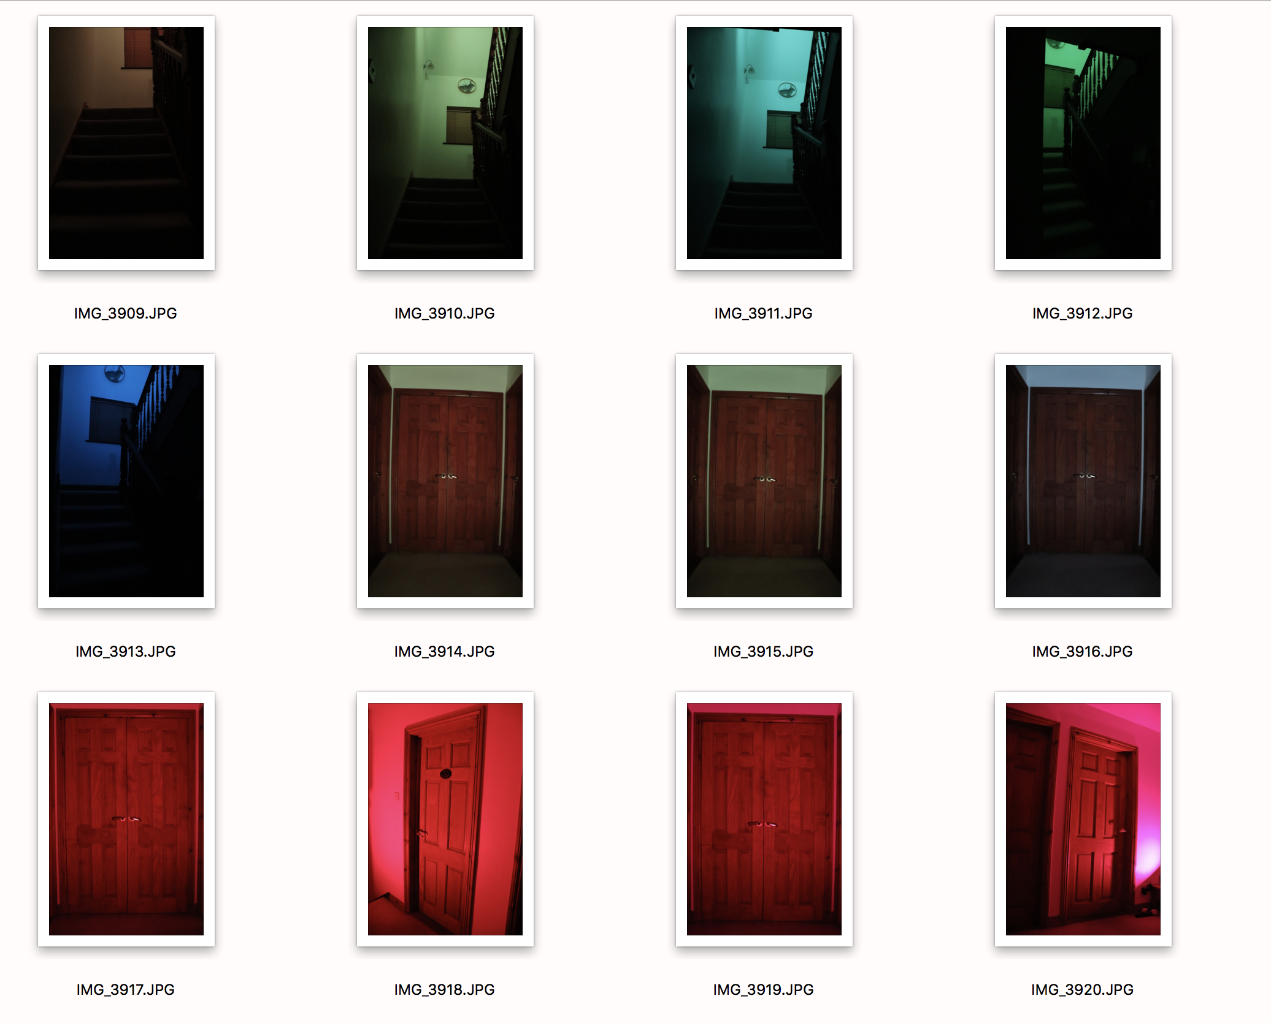
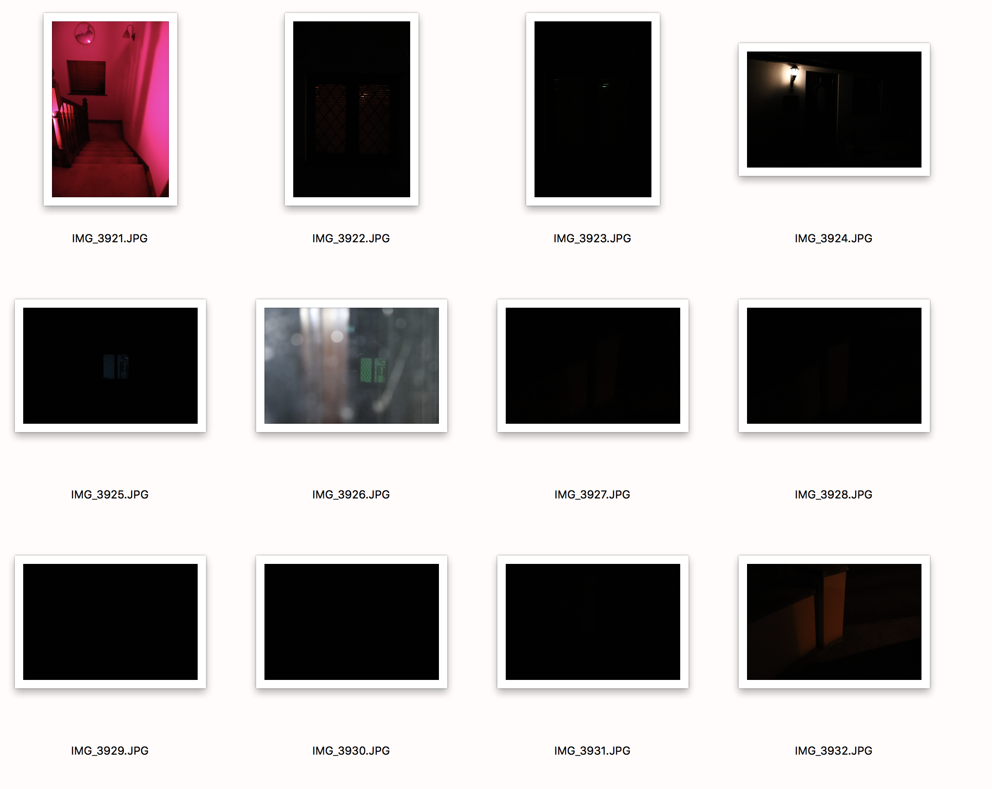
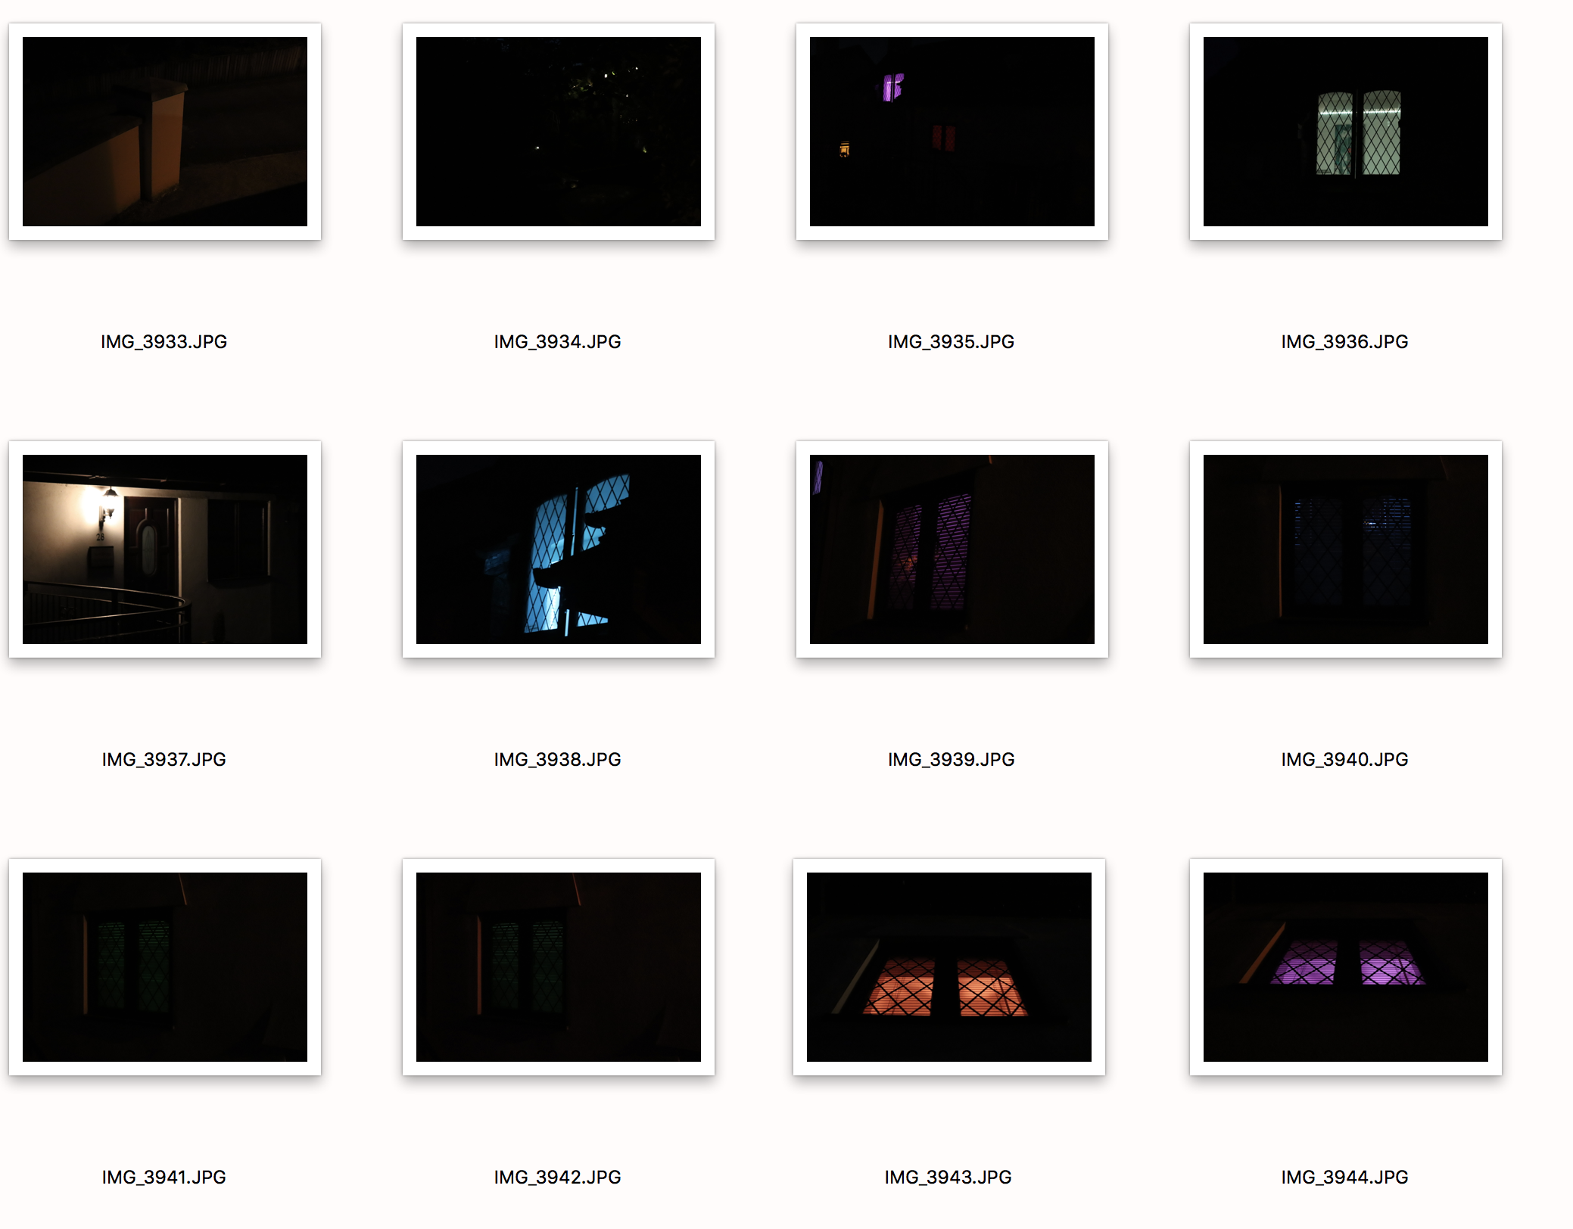
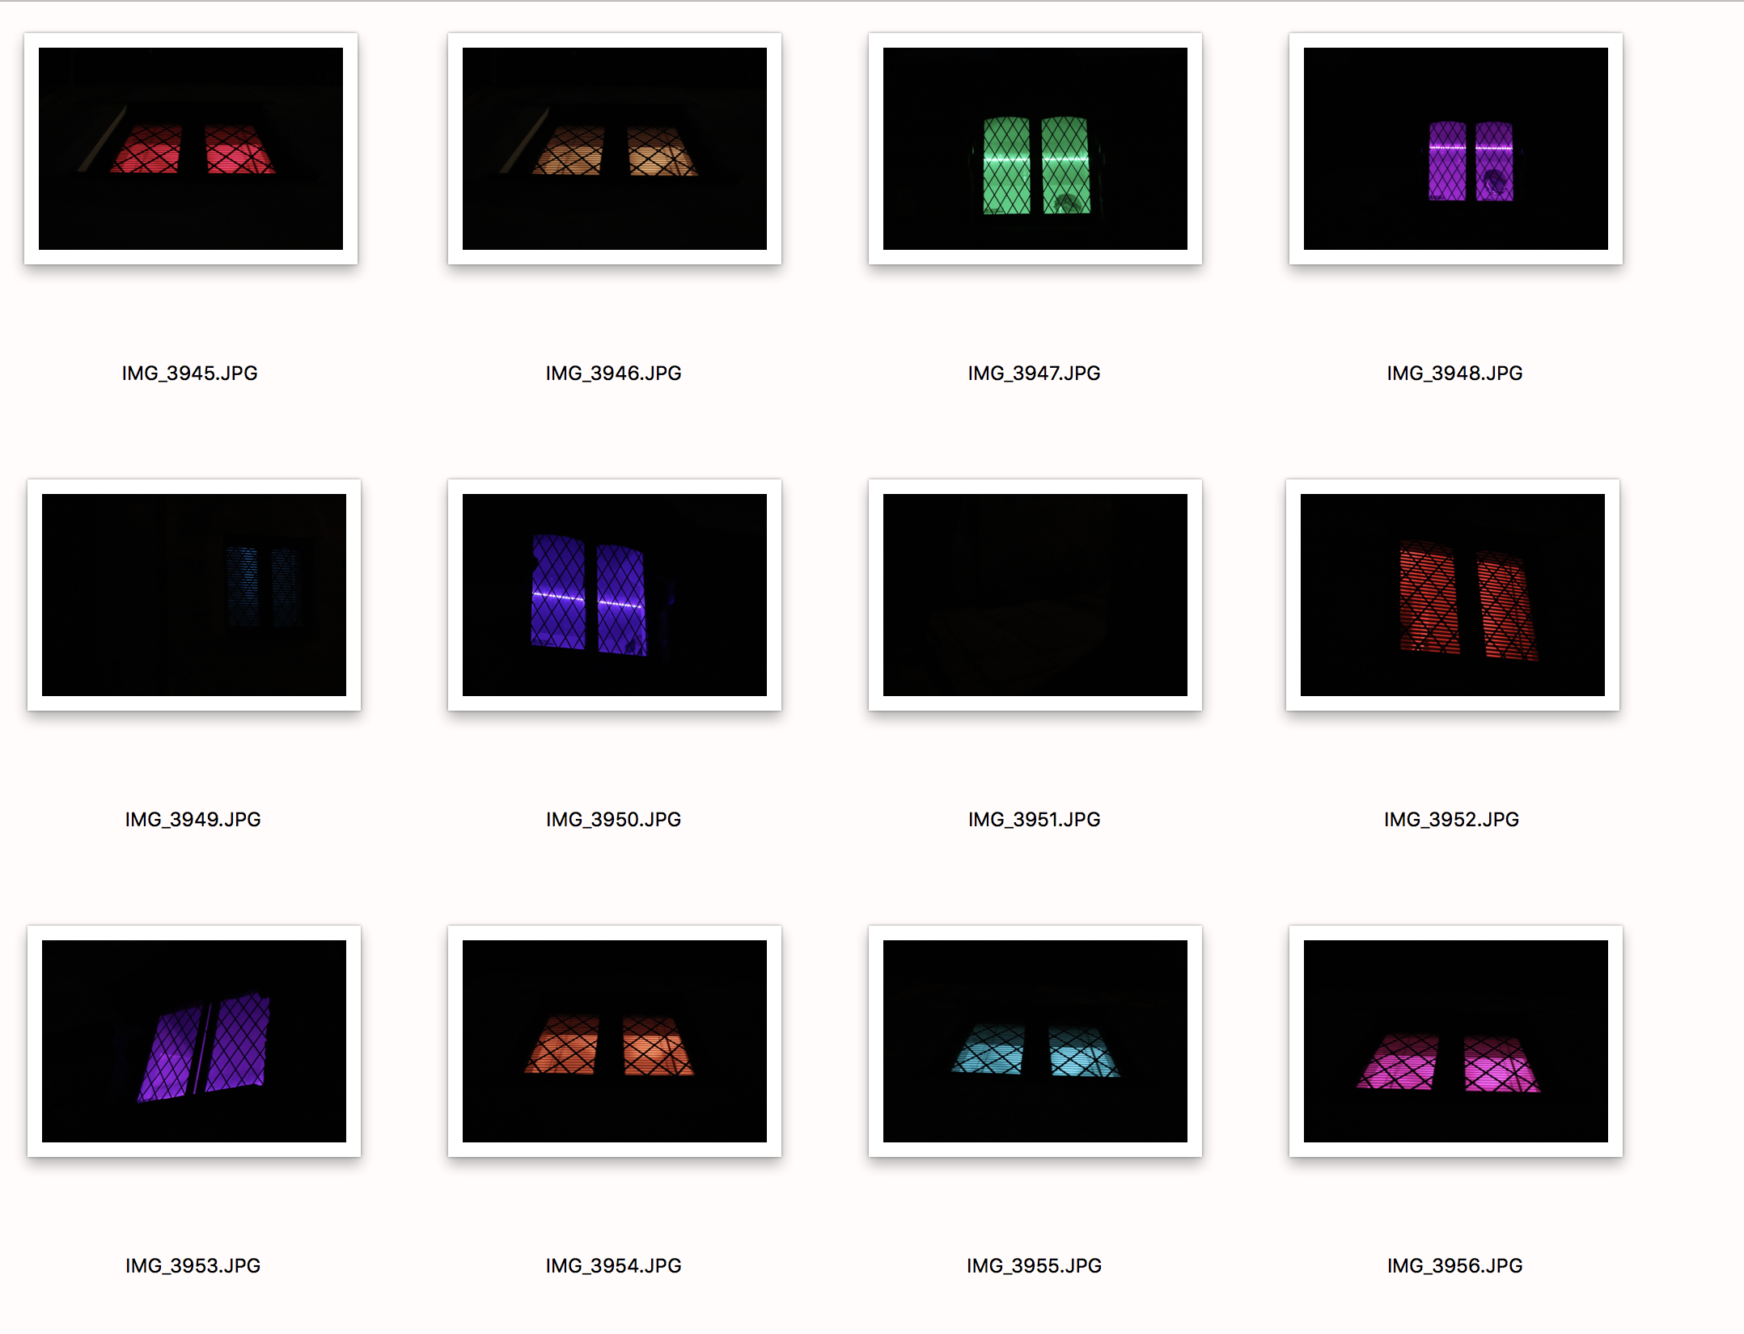
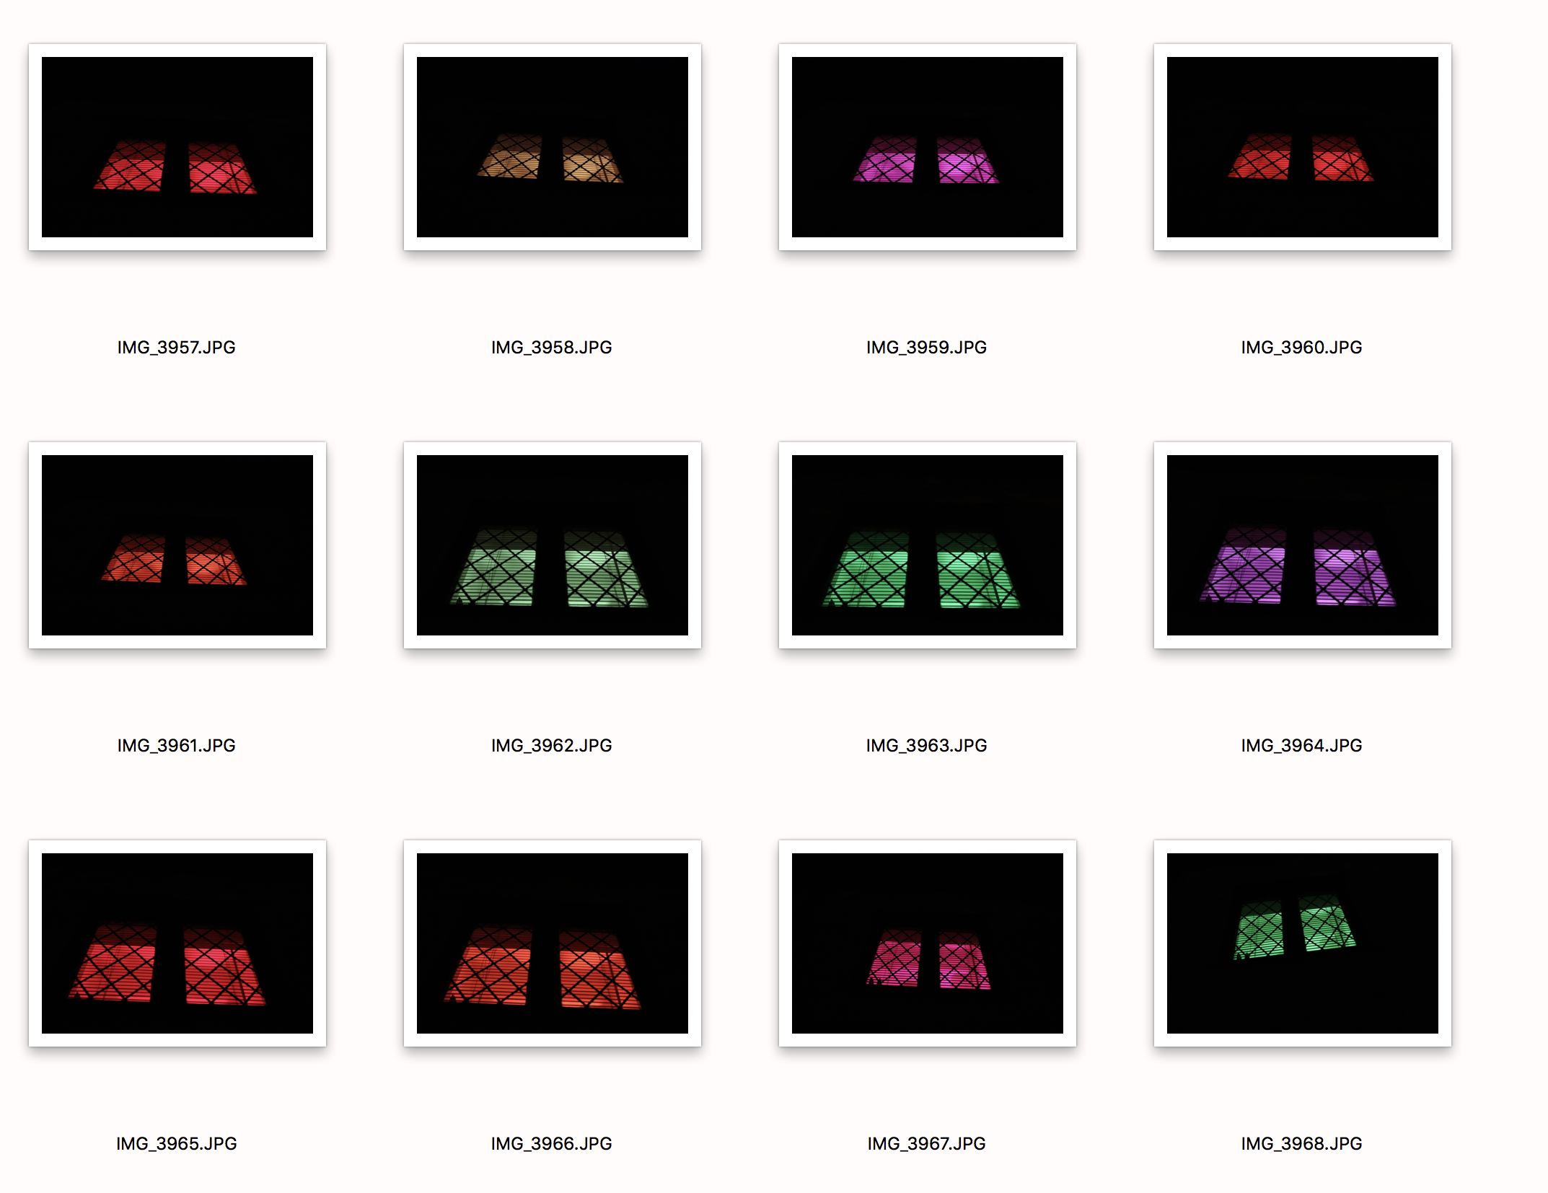
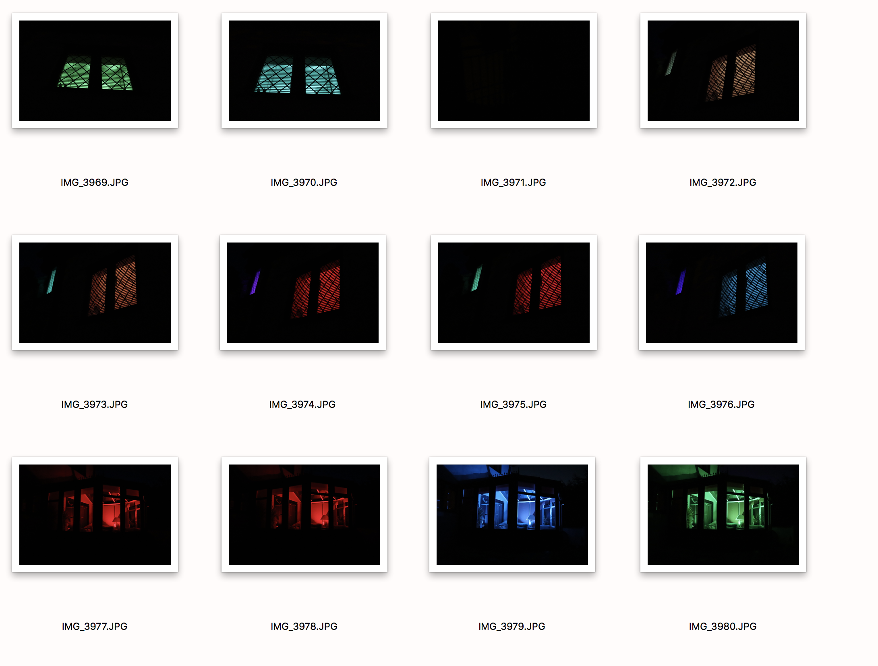
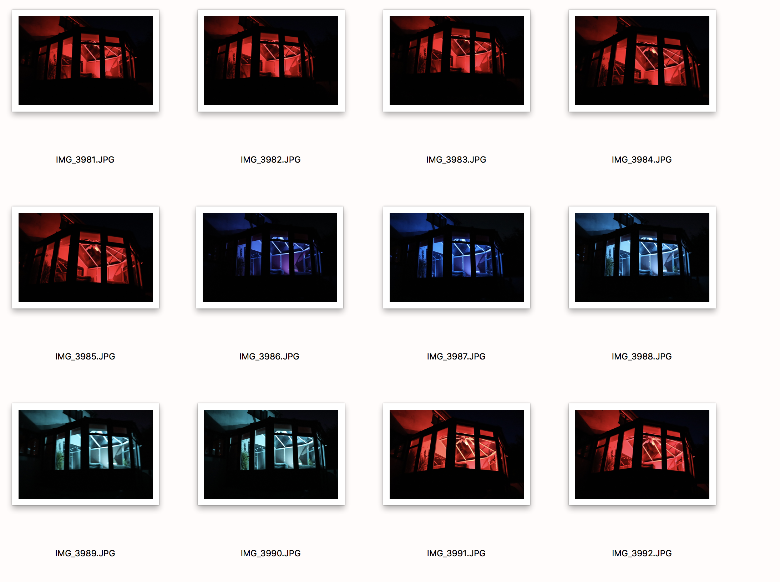
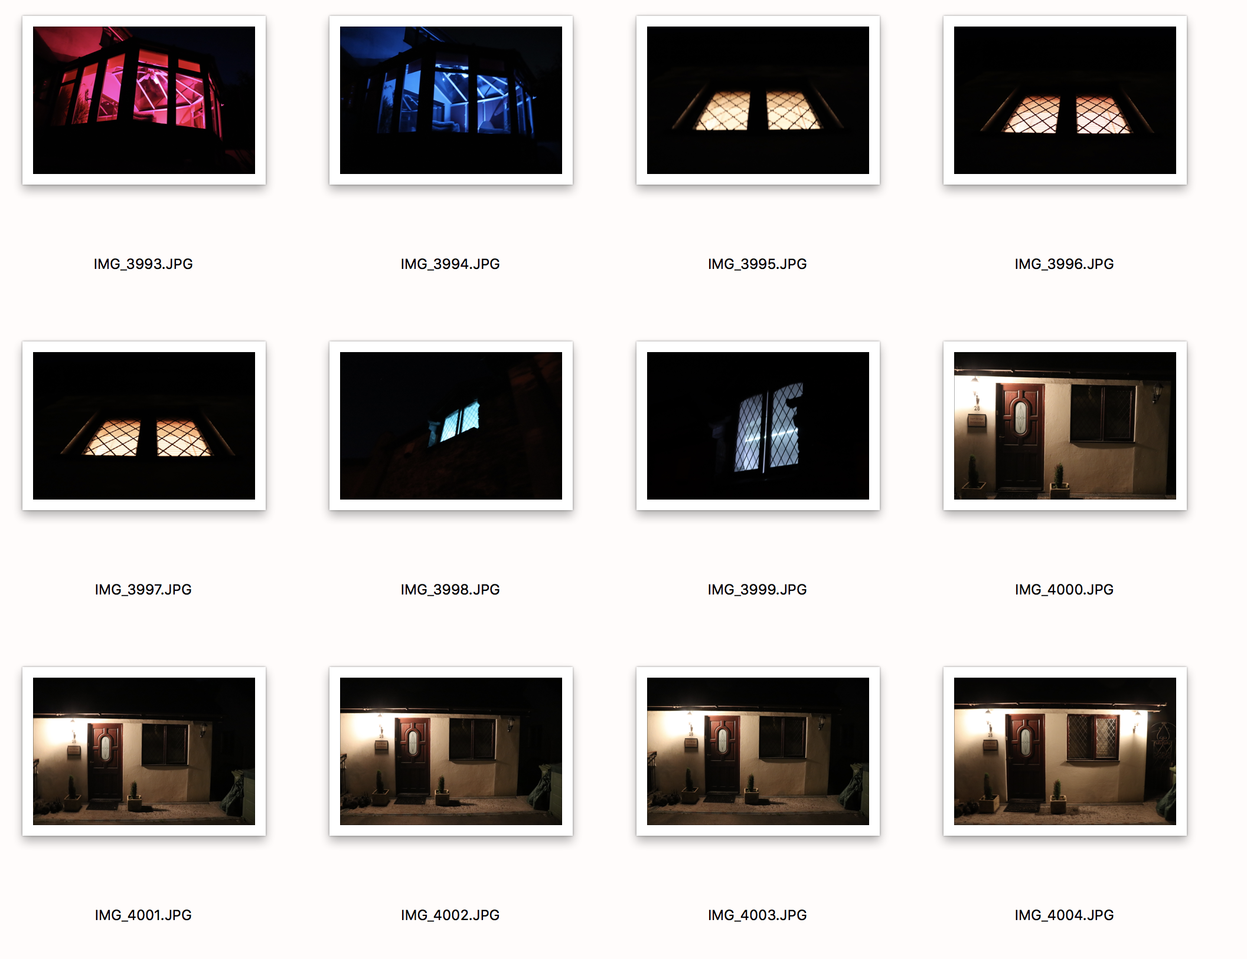
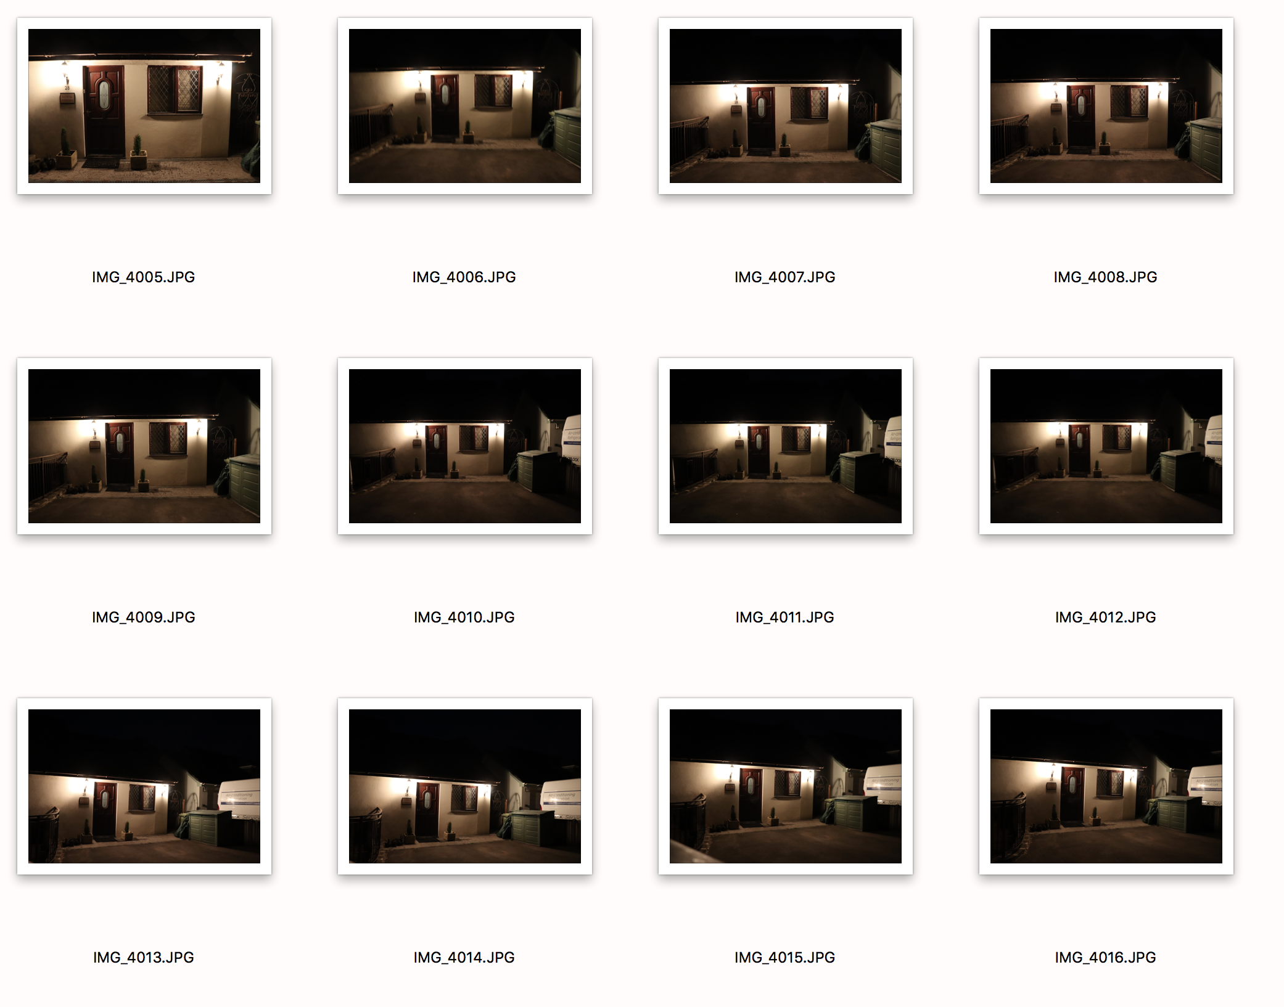
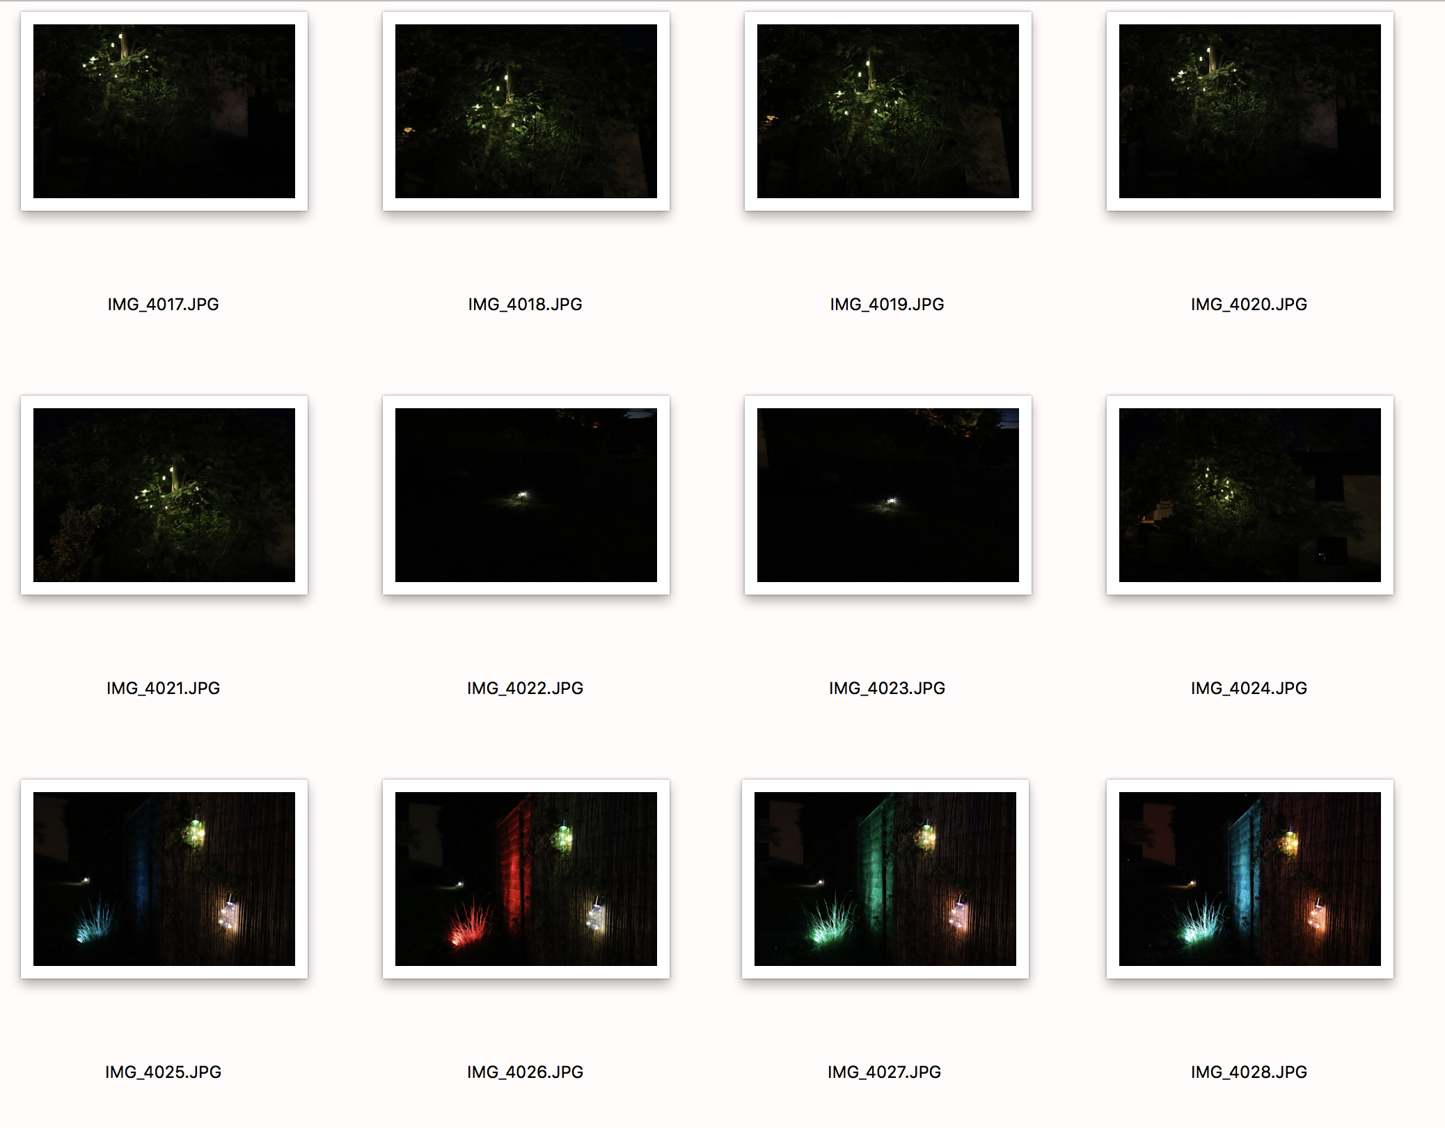
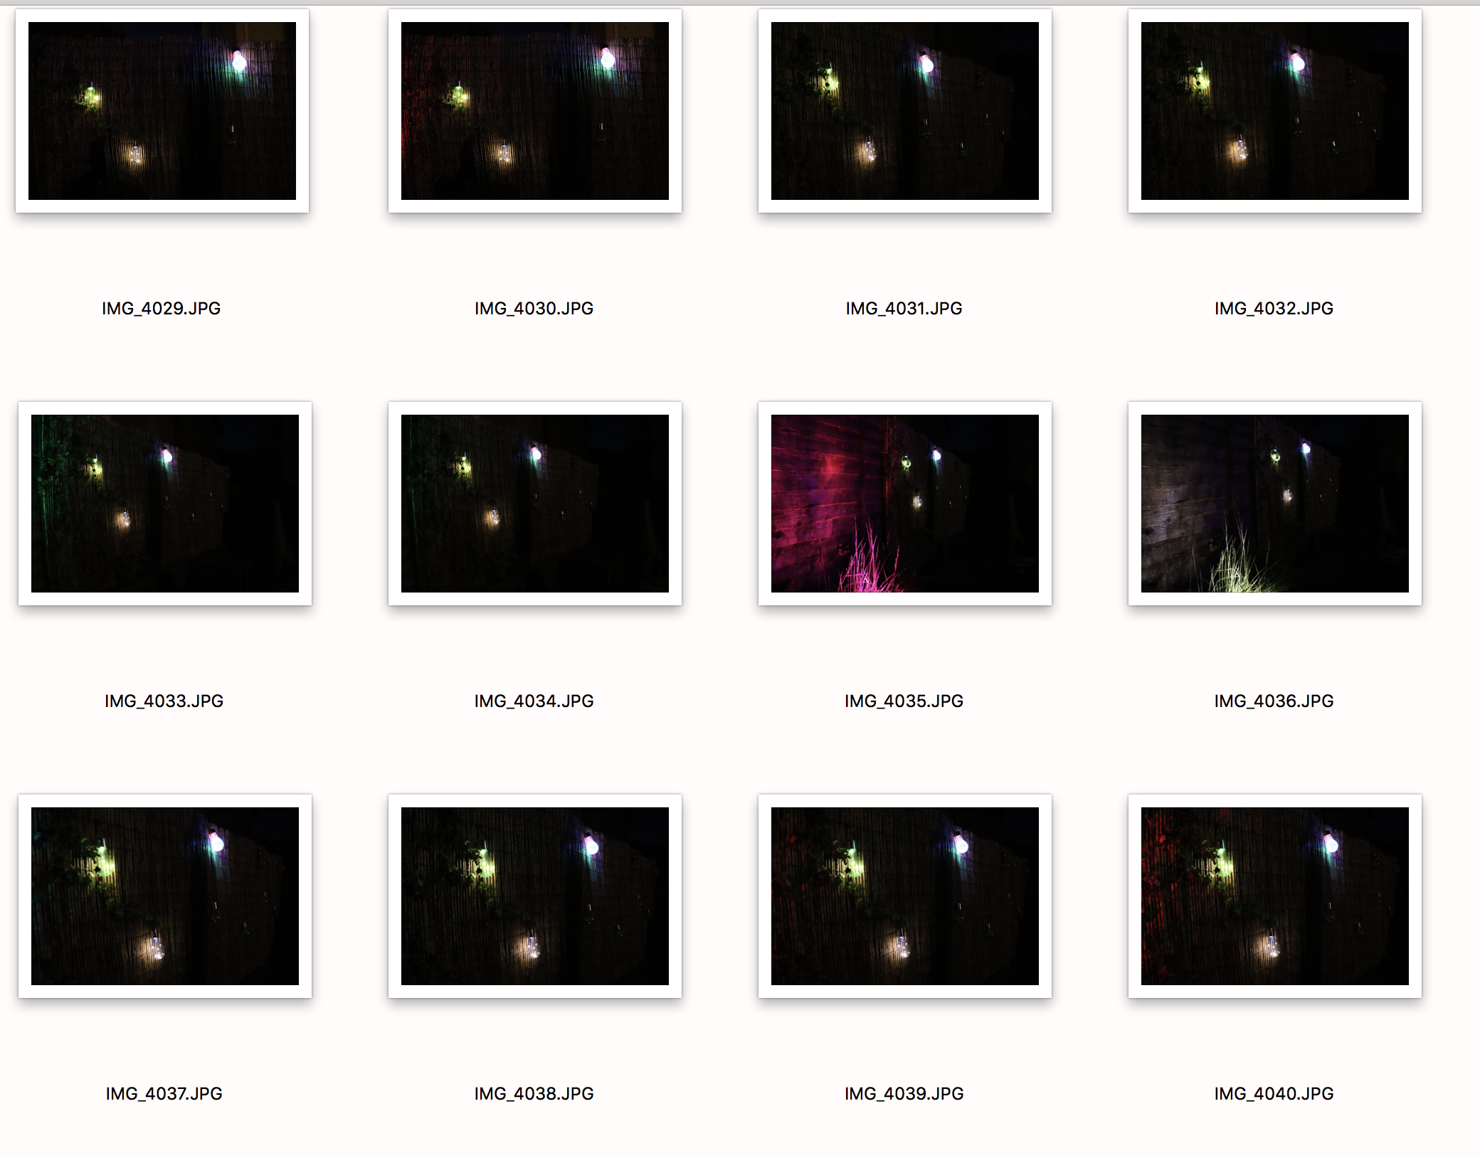
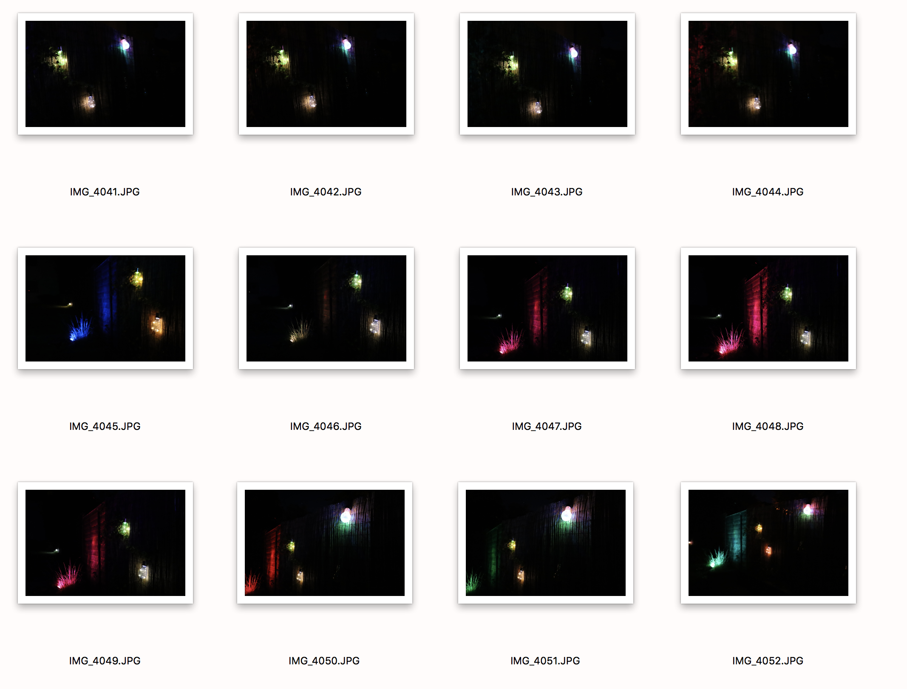
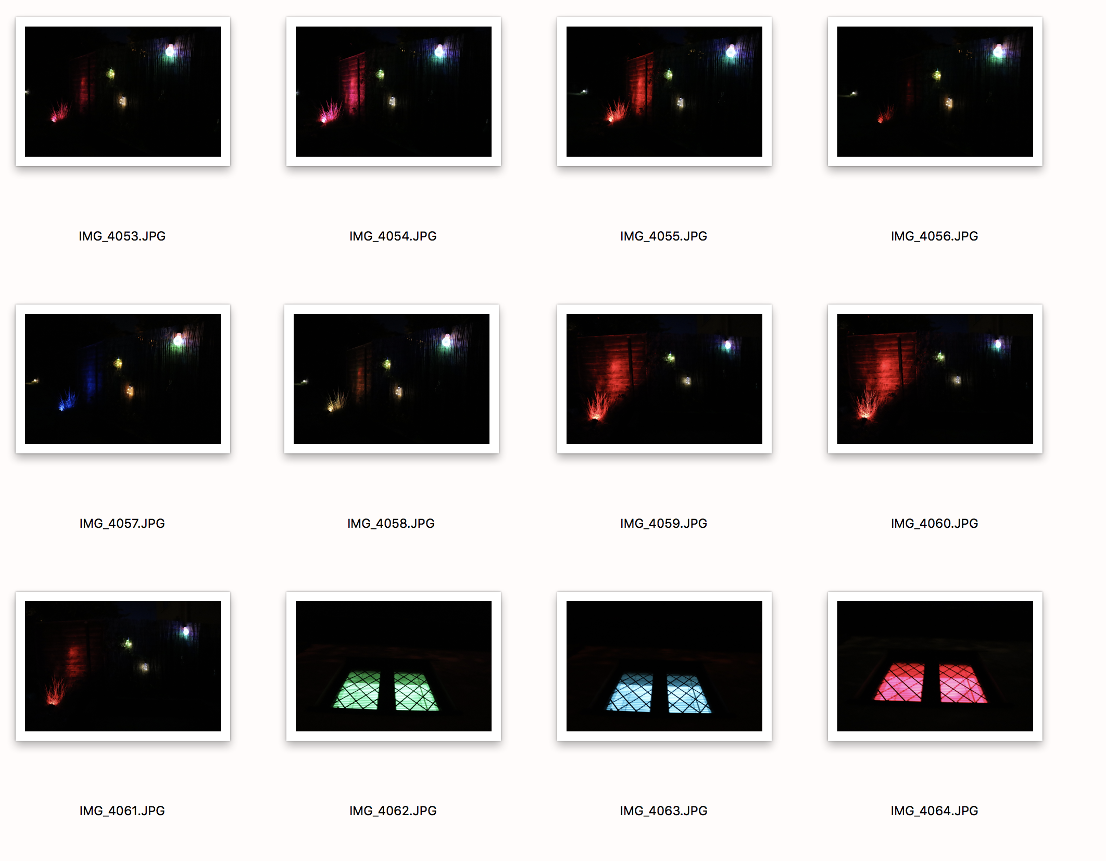
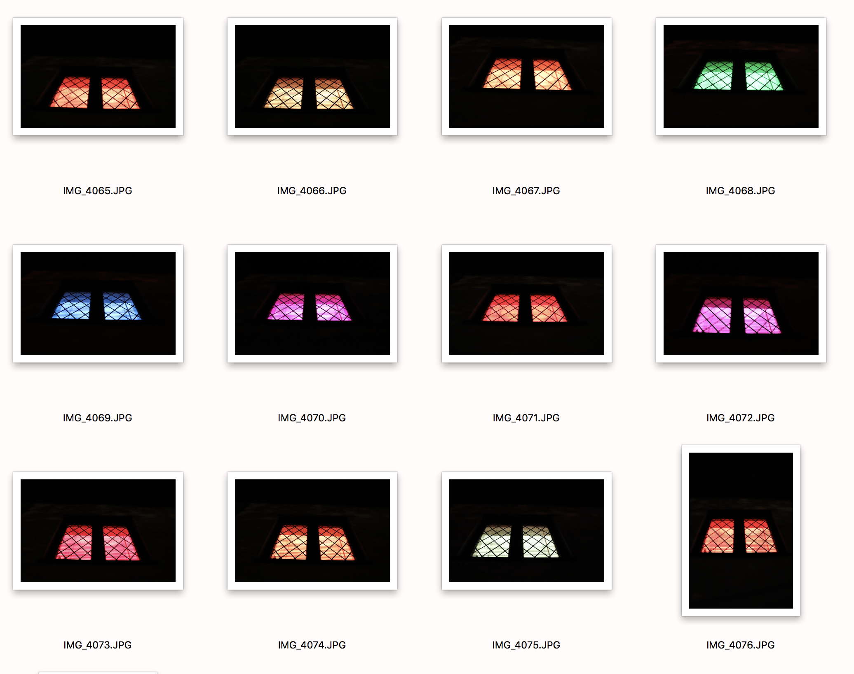
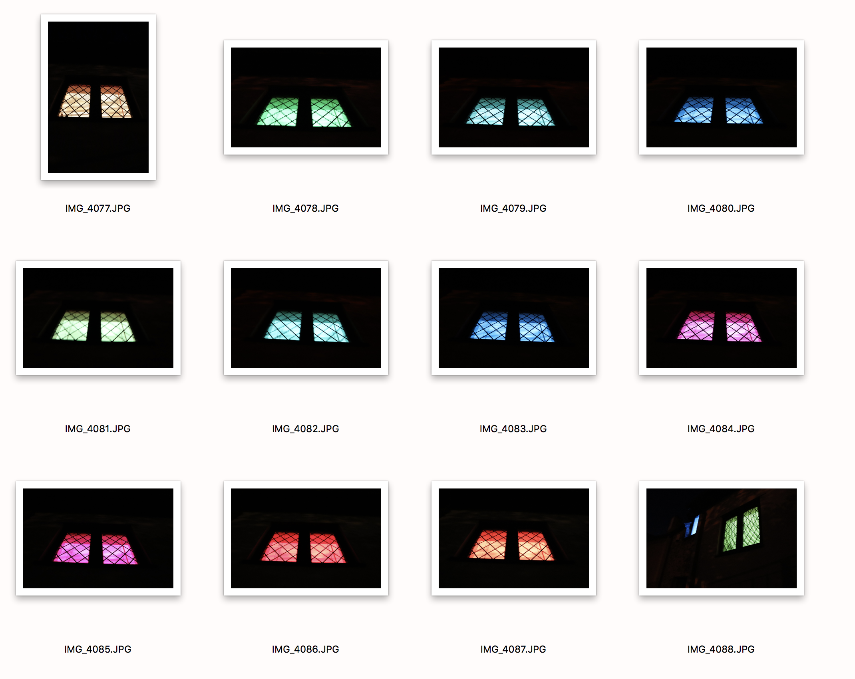
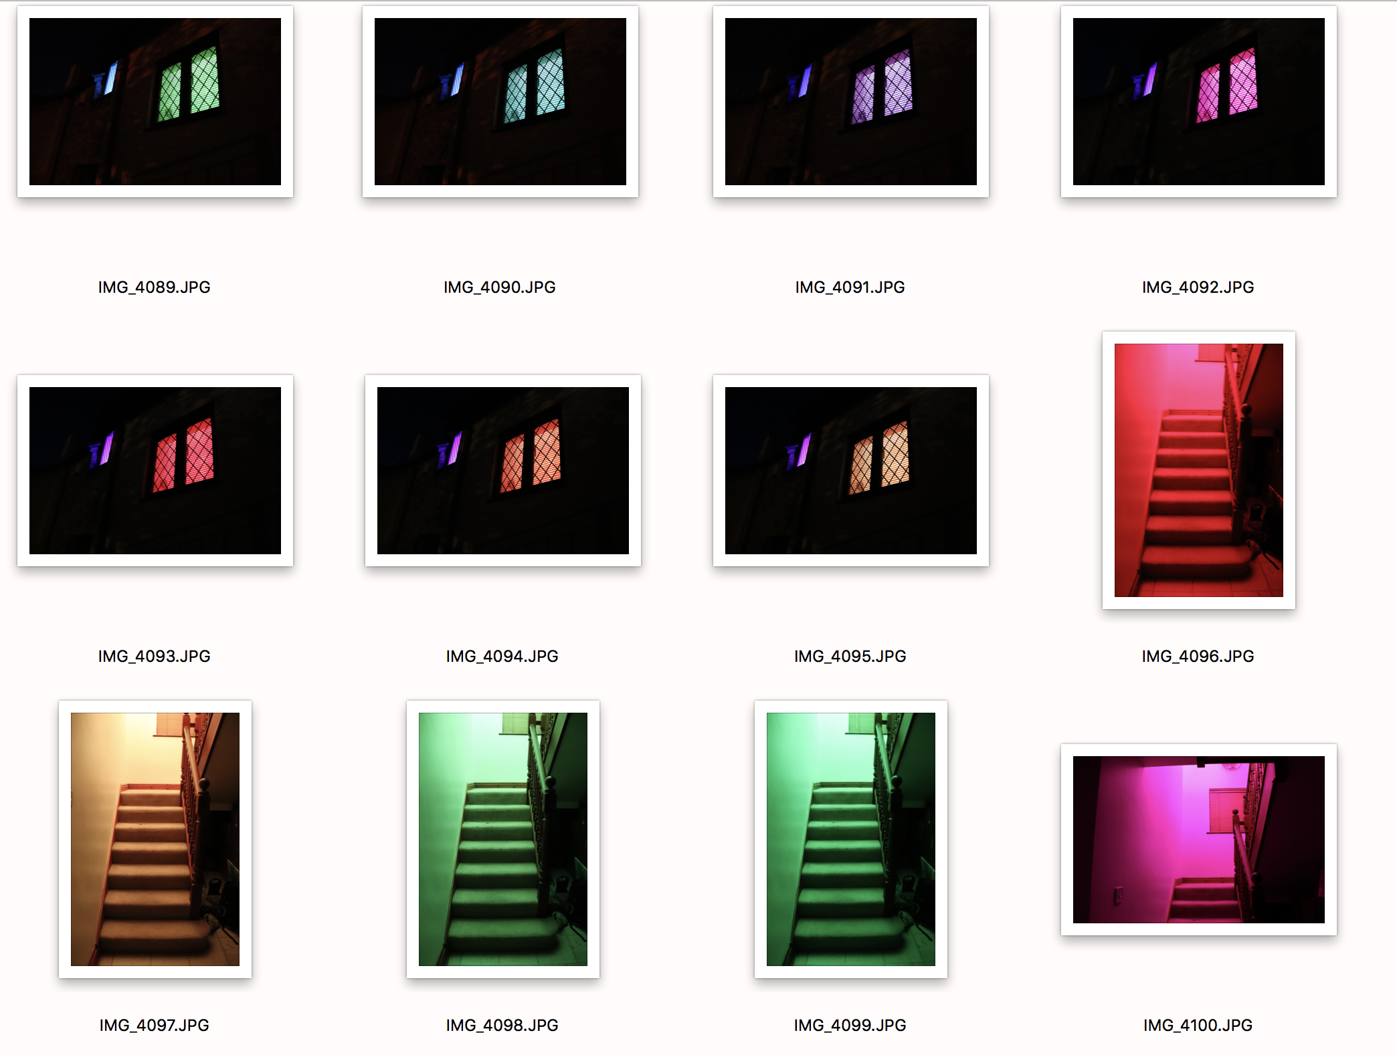
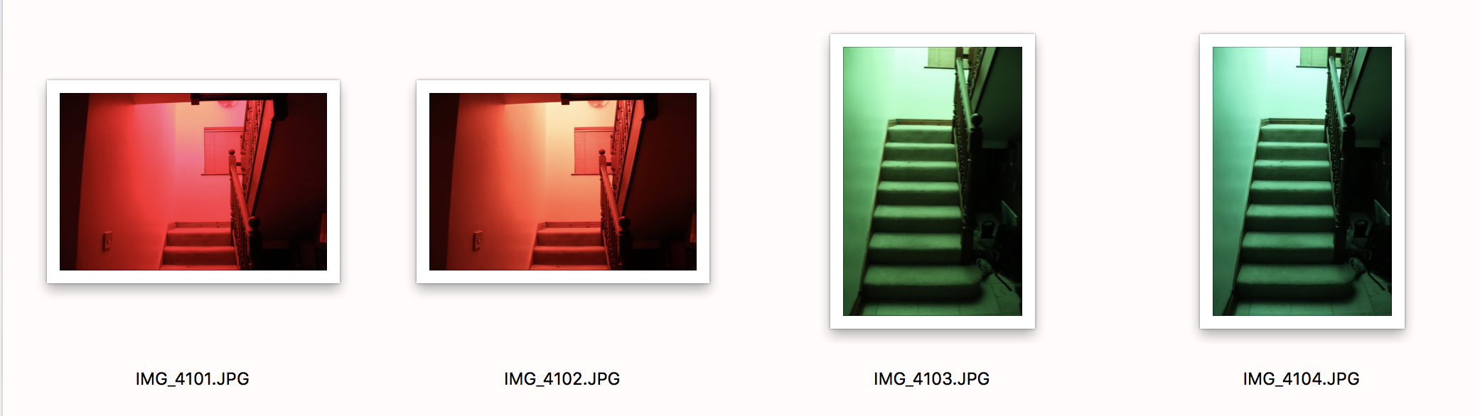
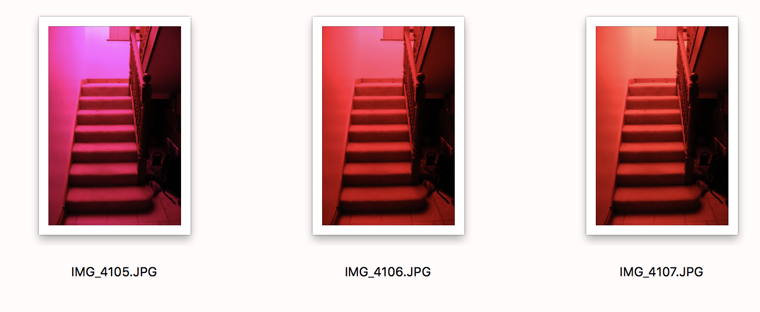
The process to narrow down to the selected few was very easy at first because I was using Manuel mode and some of my exposures did not come out well and I was left with some rather rubbish images. Then, because of long exposure, some images came out a little blurry. I should have used the tripod for this, but because of the angle I was at, I didn’t think the tripod would be compatible for the image I was trying to capture. Then, some images seemed too bland, too repetitive and some did not work because they did not have the desired effect. My main aim other than capturing artificial light, was to show the mood, that can be created by the light source and how it is very much lighting up only where it is pointing and producing light, creating shadows, and in the darkness very strange unfamiliar patterns, that would be much different to natural light. The images were not to show something lit, but to create an image that looked unique, with the light creating the image itself. The locations I used, and the light made it look like something different to what the object actually is. I then decided I do not want repetitive images, so I had to select from different areas which I had explored. Once that was all done, it came down to more of a personal preference, with the colours and how the image has produced itself with the lighting. The ones that I feel best suit each other as a body of work, and complement each other via the colouring.

