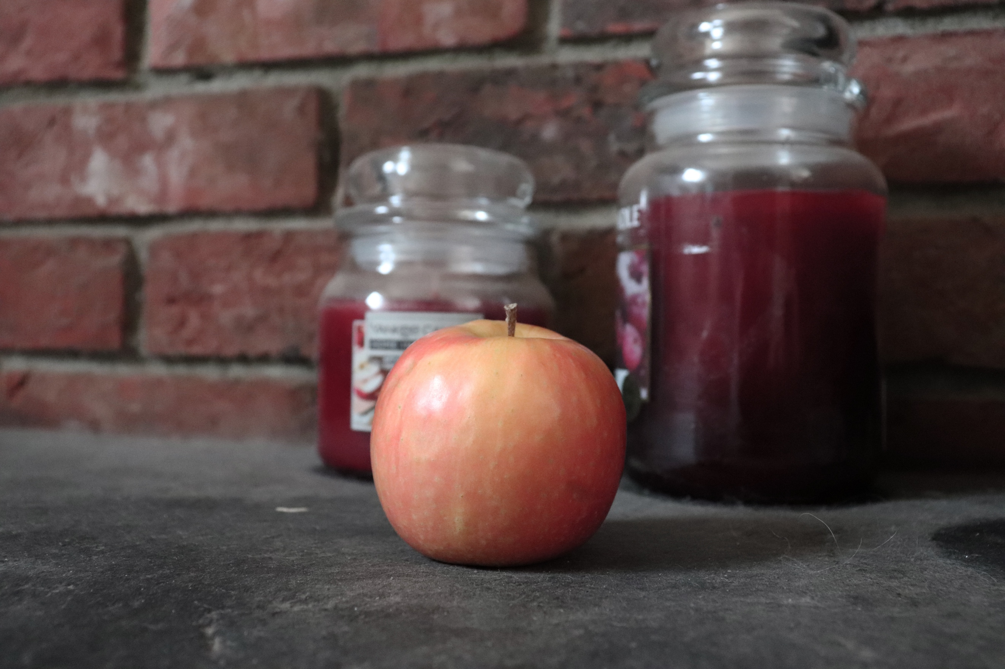
As you can see this image or ‘representation’ of an apple, is vastly different to the screengrab I posted of apples from the web. One of the main and most recognisable differences is the backdrop of the image. The ones on the web were typically places you would see an apple, and they were made to make the apple seem appetizing. But with this image, it is on a surface that is very dirty and dusty, the background is random, with candles and a stone wall. Although the apple doesn’t look horrible here, it certainly has an effect on whether you would eat it, depending on the location. Because the location is typically dirty, and you wouldn’t associate dirt with food. The apple would not be used in a location like this to make it yummy and to be viewed on as that. My creativity shows that a change in location can impact the whole image. Not just the subject. The colours in this image also help to make the image seem very bland, as the colours have not really got the wow factor and are fairly dark and boring because they are not vibrant, and the hue and saturation typically seems dull. So, in comparison with the screengrab, the location is very much the forefront of the differences. The way the apple is presented is also different, as some looked very fresh with water running off them. Here, I haven’t pampered the apple, I have just stood it up, I also haven’t made it very vibrant and really juicy either. The general texture of the image seems very hard, most likely because of the shading of the colour and how the background bricks and the floor is slate. Generally, you would think that using a small aperture would make the background and foreground soft, which it has, but it would also make the subject soft, and in this case, I do not think it has because of other aspects of the image. The angle I have taken this from has been head on with the apple, because this is how most shots of apples would appear. Not from really high up or far away or below. The shape of the apple almost looks 2D but then the top is just about easy enough to see making it look slightly 3D. For this shoot I used Manuel Mode, and made sure that my light meter was working and was on the 0 so that the image was exposed correctly. For this shoot I used inspiration from John Davies and Chris Steele Perkins’s shoots on Fuji. I explained my reasoning in the contact sheet for why.

