Three Images using Rules
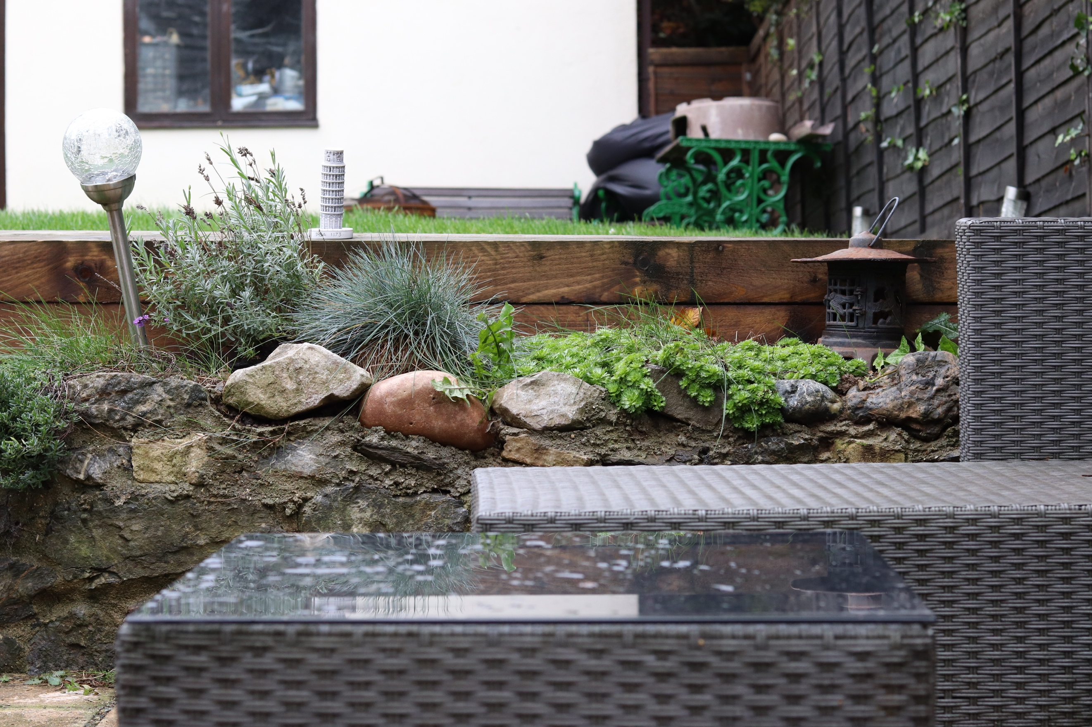
This is the first photo I took for Exercise 1.2. For this shoot, I am using the Leaning Tower of Pisa as the object for the point in the photo. Here I have applied the grid on my camera so I can use the rule of thirds as directed in the brief. There is a lot going on in this image and you cannot necessarily tell that the ornament is the main focus in this image. Although this image does make good use of a variety of colour, and is very well divided up between the foreground, midground and the background because of the furniture and the wall. The image gives a damp vibe as the wood is wet from the rain.

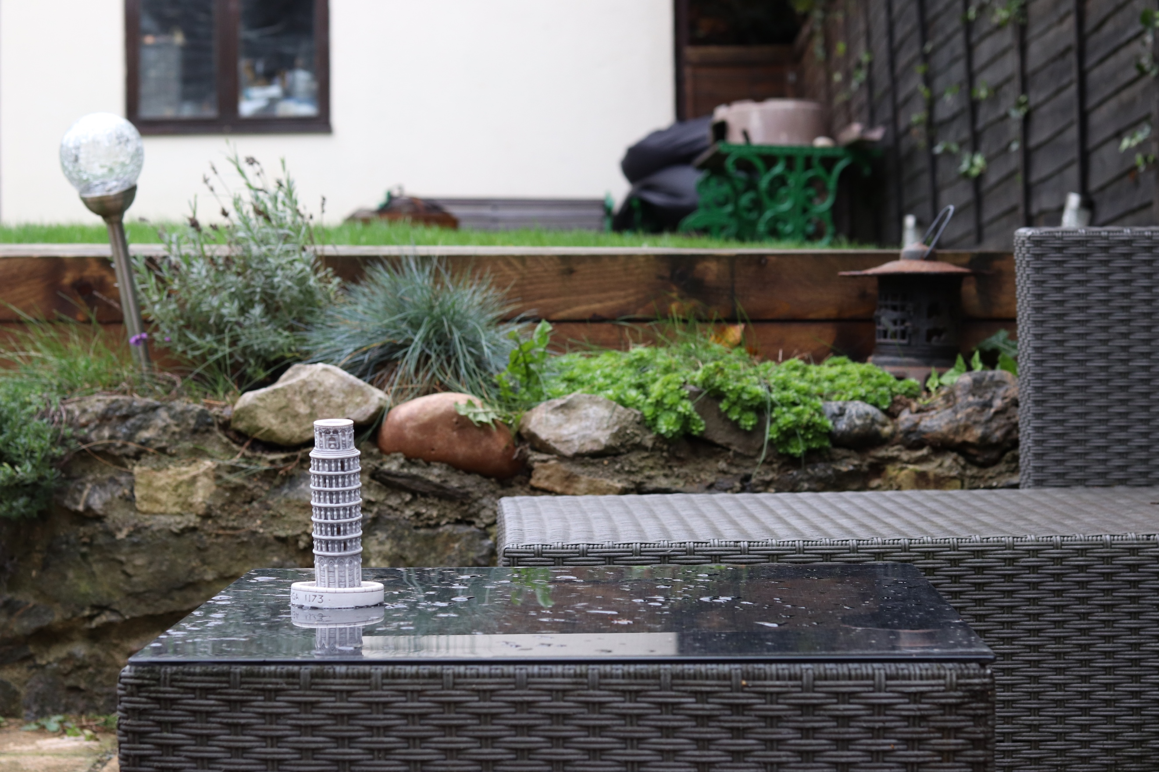
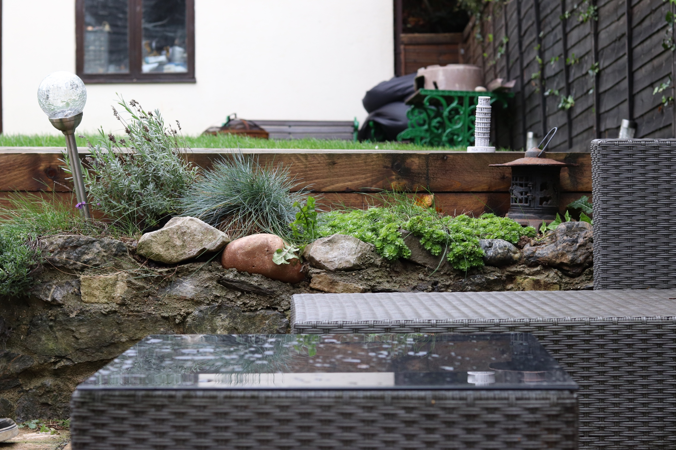
In the third photo for this shoot, I have placed the ornament back on the wood, but on the other side this time. You can see that there is still a reflection from the table but also it seems to be more noticeable than the first image, possibly because there is less going on, on the right-hand side of this image. Again, like the first two I have used the rule of thirds and have tried to make it not too obvious.
In this photo I have moved the ornament towards the camera. My reason for this is because I wanted a picture where there was a reflection off the table. I feel that the ornament is more noticeable, but without being ridiculous, because there are lots of other plants and furniture in the midground and background which helps draw your eye away from the main point.

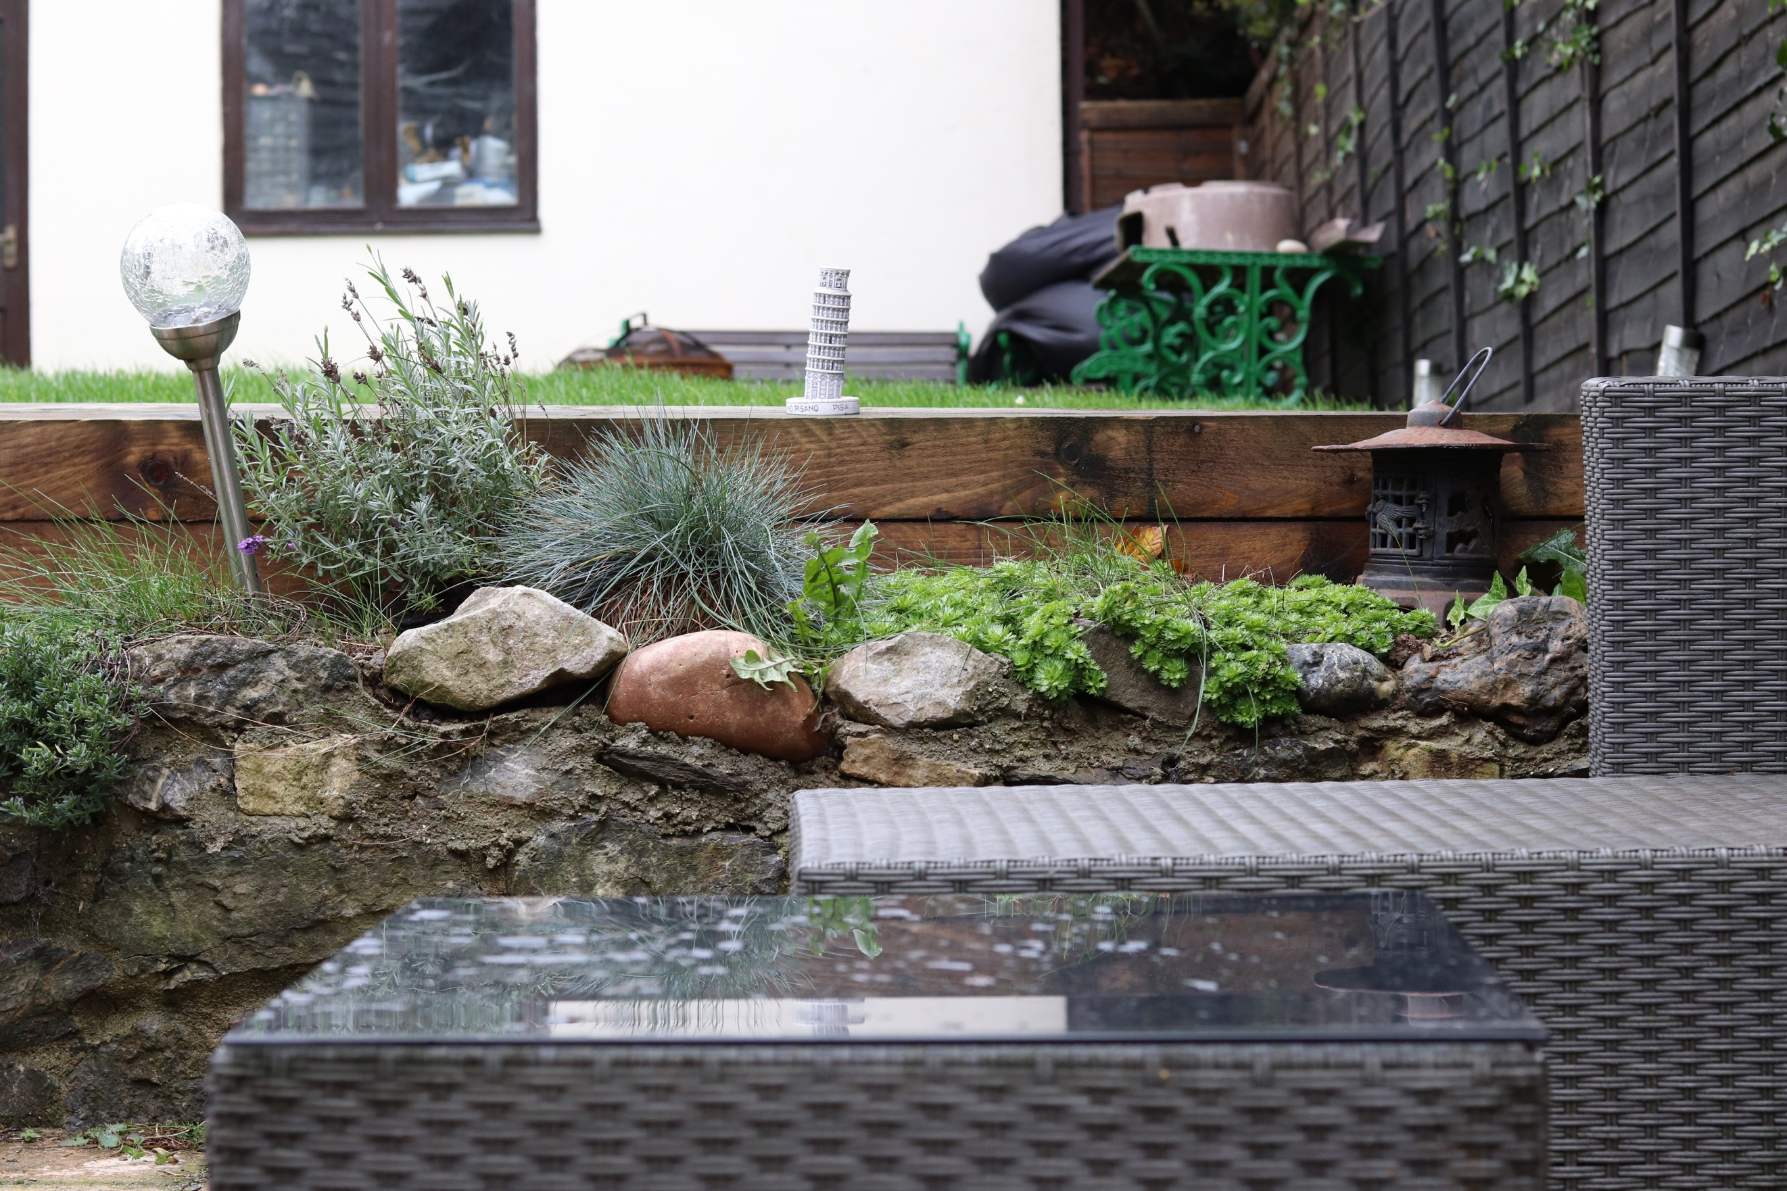
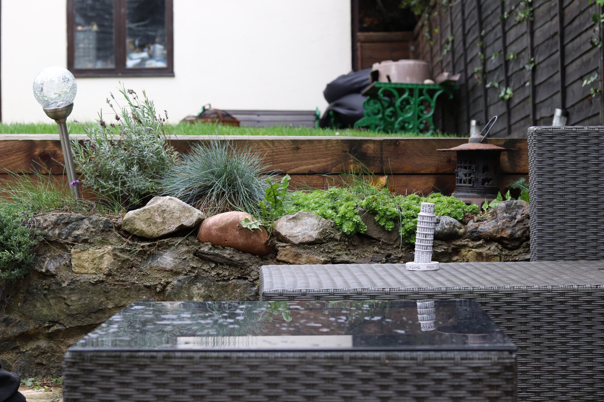
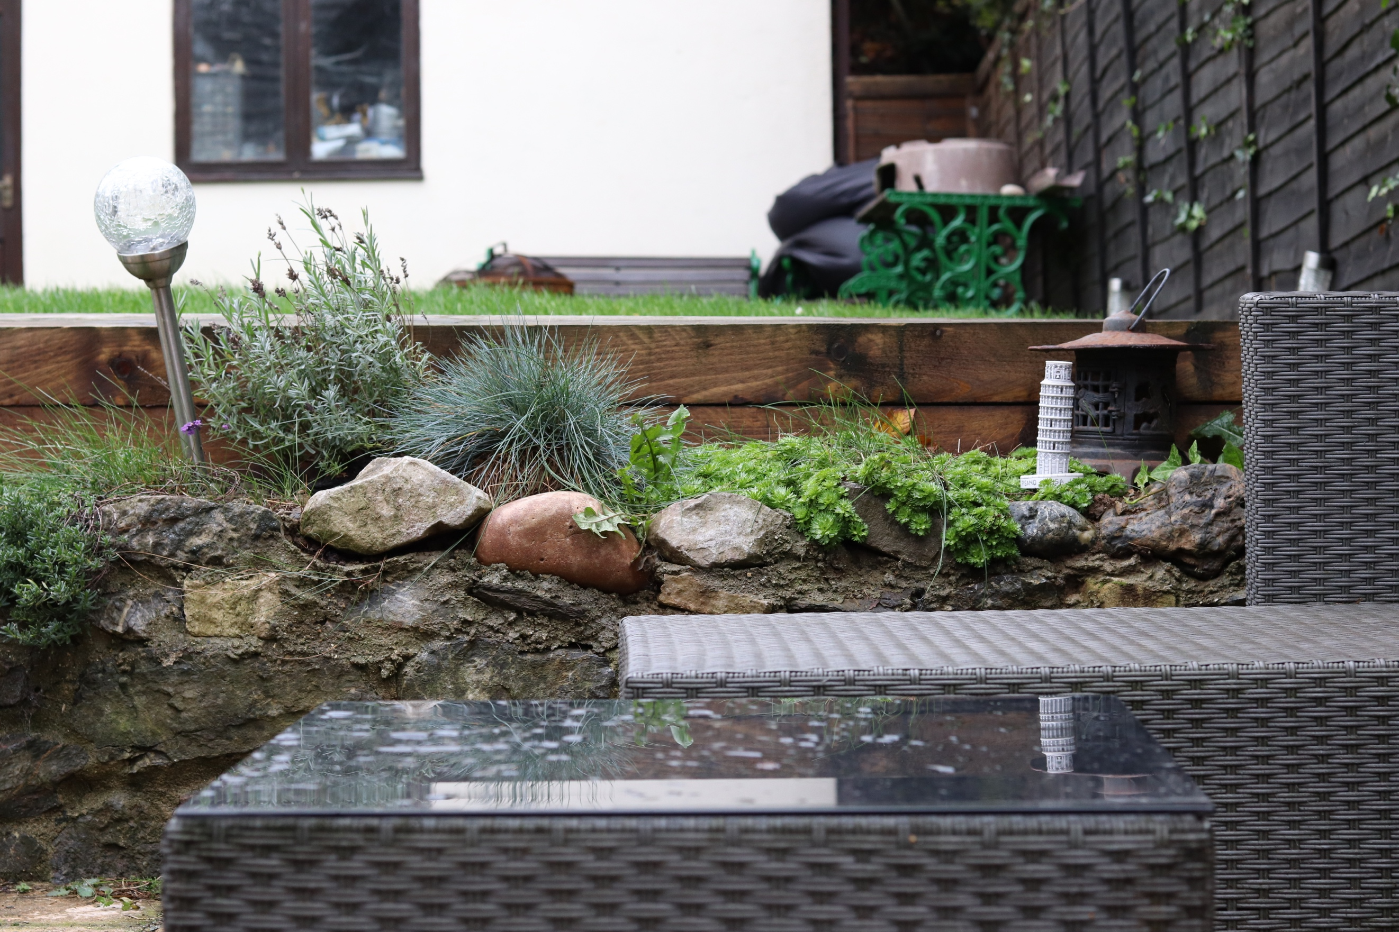
Three Images using no Rules
Here I have used no rules. Just being aware of the object. I have decided to place it in the centre of the wood so it is rather noticeable. I feel that this doesn’t look as good as using the rule of thirds because when I used this rule with the images on the wood, they seemed to be grouped with the light and the lantern as part of a scene. Whereas now the ornament is on its own in the centre, I feel that the image is not as powerful.
In this last image, I have positioned the ornament in an unusual place. For me, it doesn’t make the image flow and seems to be awkward, like the annotation above. In this one, the object is centre of the image and just off to the side, making in my opinion the worst image of the shoot because of the positioning. It seems to have no relation to anything else in the image and looks out of place.
The ornament has now been placed amongst the plants. I Instantly noticed the reflection on the table again, which I stated in the previous photos, but this time there seems to be more of the ornament reflecting off the table and I feel that the gap in between breaks this up and makes the image better as there is furniture between it. It is almost like the ornament is looking down on its reflection into the glass, even though the glass is not directly below it and is in the foreground. I don’t like that in this image the ornament is dead centre in the midground, whereas in previous images it sat just above or below. I don’t like this because it is in an unconfutable place for the eye and doesn’t make the picture flow.

