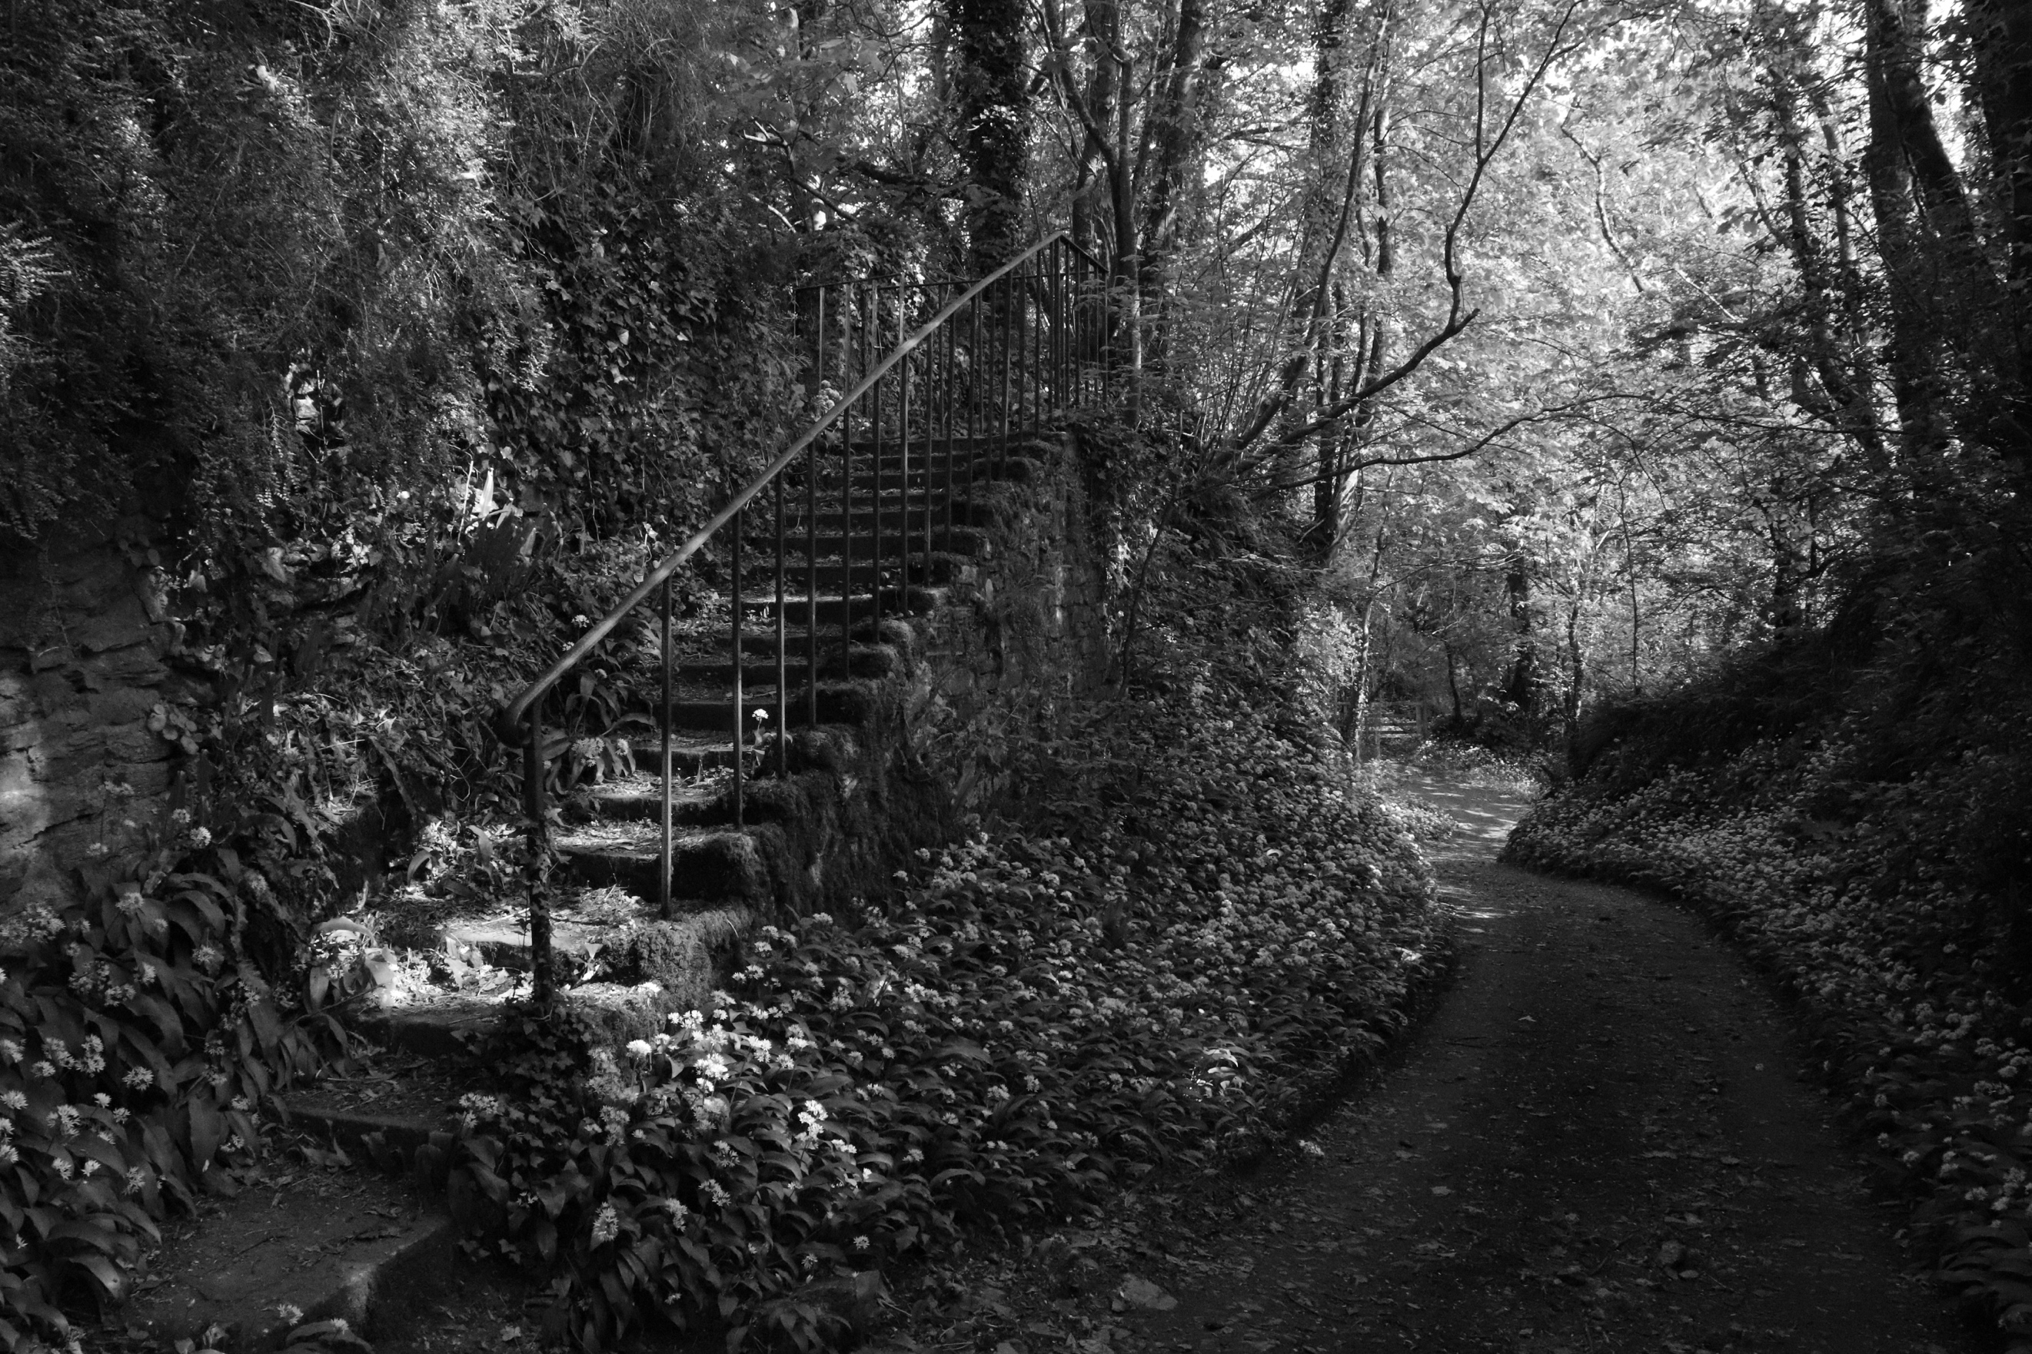
This image was taken on my walk for my shoot up a hill near my house. The location is very pretty with loads of flowers. This makes them look soft in the images because there is so many of them sat together. I have made the image black and white so that the light can stand out more as you can see the different tones, and this has a big impact on the image because the lighting makes it look rather bright in certain areas. For example, the lane looks dark because it is in the shade, and the natural light isn’t so strong there, but on the stairs, there is a glimpse making it brighter, and drawing your eye to that area of the image. The same goes for the tops of the trees. They are also rather bright because more natural light is getting to them. I have taken this from an angle where you can see down the lane but also see up the stairs. The two come together at the bottom of the image. There is some pattern, from the flowers to the stairs and the railings. The shape of the stairs is 3D as you can see on top and also the side of them. The majority of the image seems dark, because the trees have so much to do with blocking the light, and obviously where the sun was situated when I took this. For this image I used manual mode, and tried various shutter speeds and aperture to ensure that my shots came out good. There are a variety of lines in this image which helps lead your eye around the image.
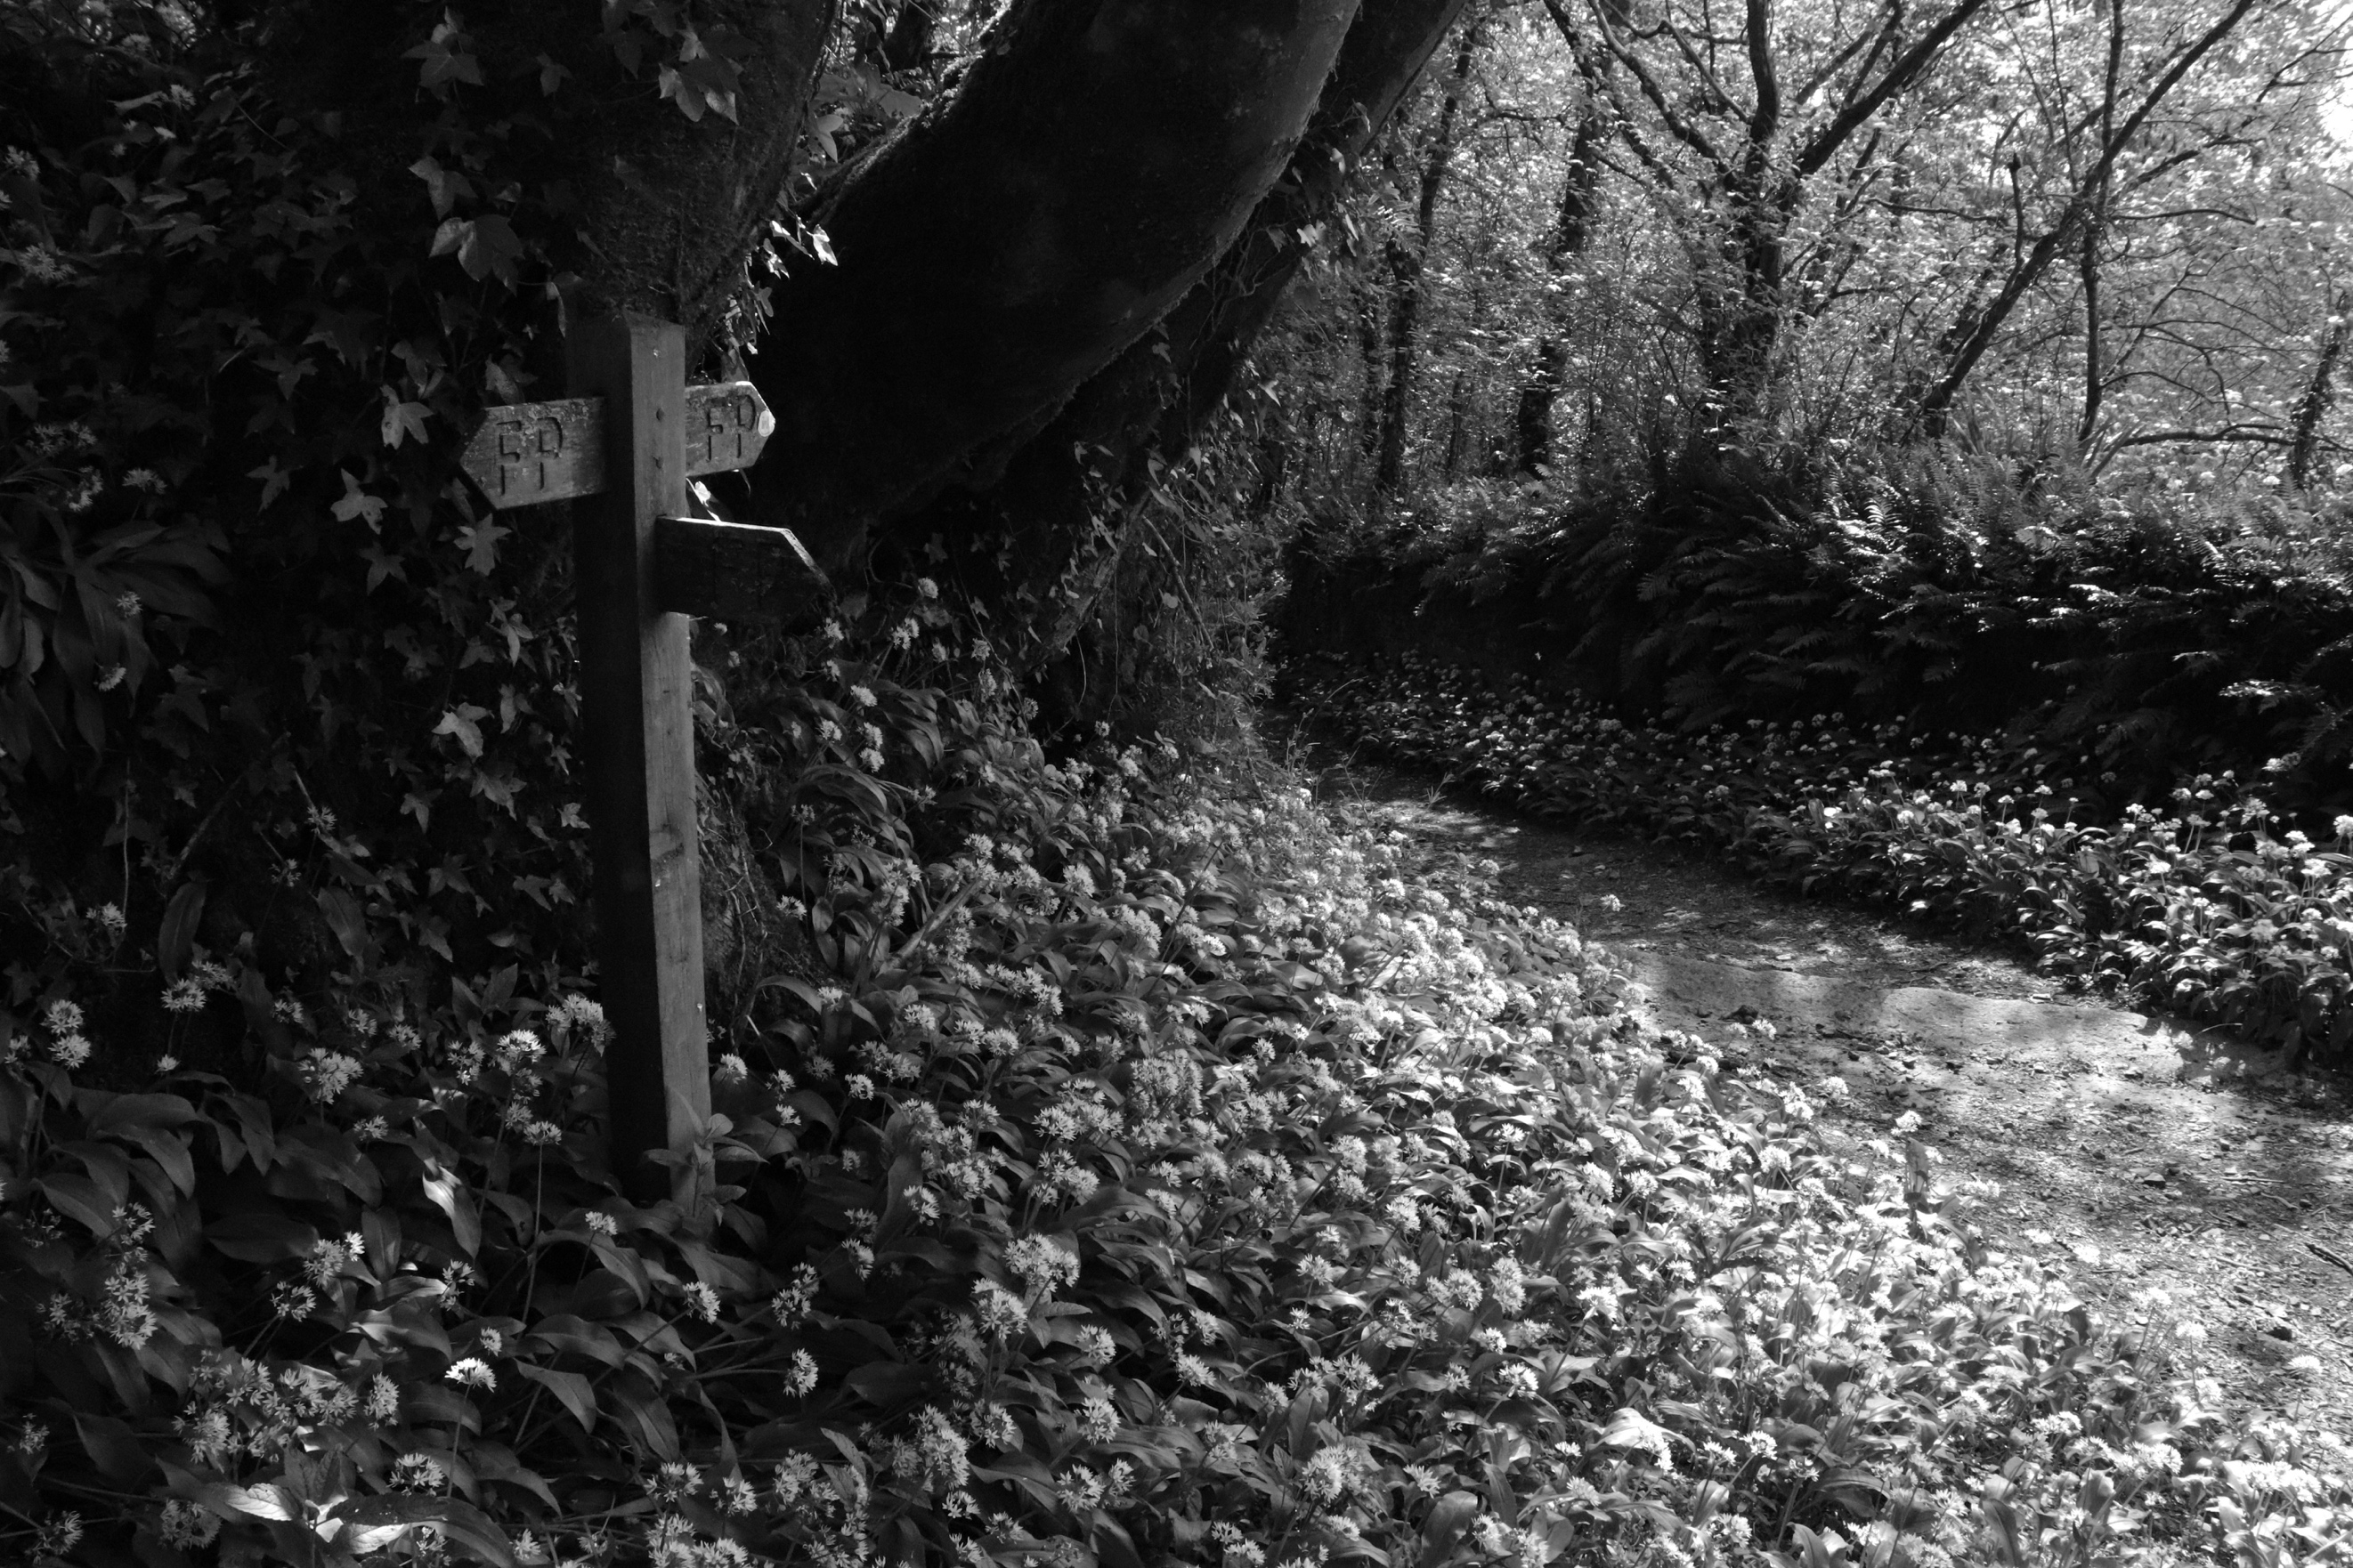
Here is another image that I captured on my walk. The texture of the image looks rather soft as there are so many flowers within the picture. In the foreground it is just flowers, with the sign post on the left coming out from the overgrown flowers. As you can see over to the right there is the path you walk on, with flowers again over the other side. The top of the image seems very dark because of the tree which is partially blocking the leaves on the top left as the light is coming in from the right. Again, I have made this image black and white to help bring the tones out. The flowers start lighter and get darker the more left of the image you look. Which means that the sun was coming in from that direction. The sign doesn’t seem to be affected by the sun. I feel this is because it is being shielded by the tree. There is a lot of variation of the tones, within this image. I also used manual mode for this, as instructed by the brief. The feel of this image to me, is very peaceful. Everything was very calm when this shot was taken.
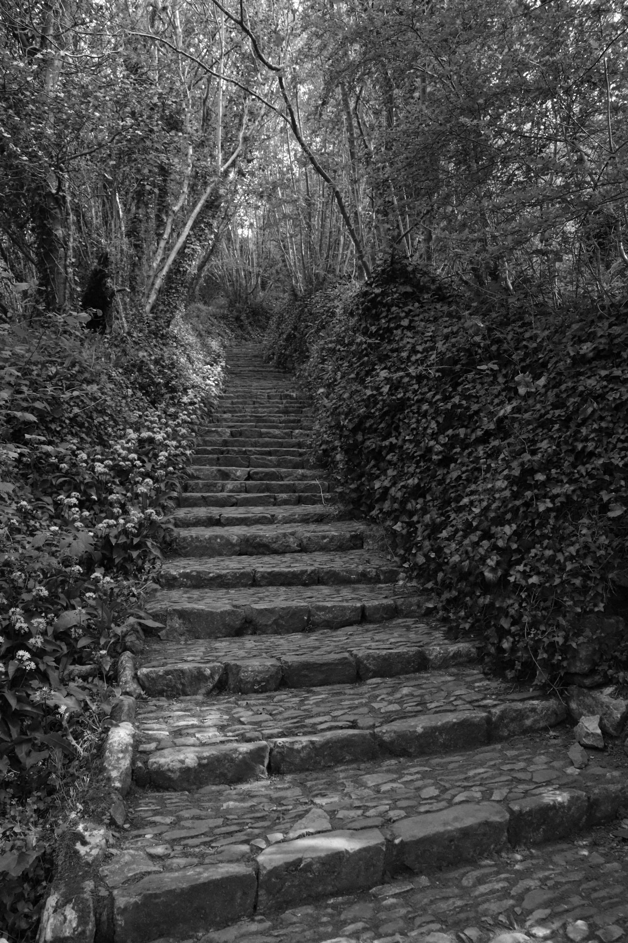
To me, this image seems to be brighter than the first two, simply because I was in a location further away from where the first two were. Here I took the picture facing up the steps that lead up the hill. The texture of the stairs seems hard, with the bushes and trees surrounding it making it look rather cosy, with the bushes looking very soft along with the flowers. The colour has been made black and white to bring out the tones. As you can see at the bottom of the pictures, there is a little bit of sun light which is just shining through on a couple of steps. You cannot really tell this though because it just looks like the stones are that colour. Further up on the left, you can also see where it is brighter because of the natural light. This makes the image seem brighter in general. The angle I have taken this at gives the viewer the chance to look up the stairs from a pretty straight angle, whereas if I stood in the centre of the stairs you wouldn’t be able to see up that well. There is a lot of pattern throughout the image and you can see this from the stairs, as they are all similar with the four bricks and the front and the same kind of size.

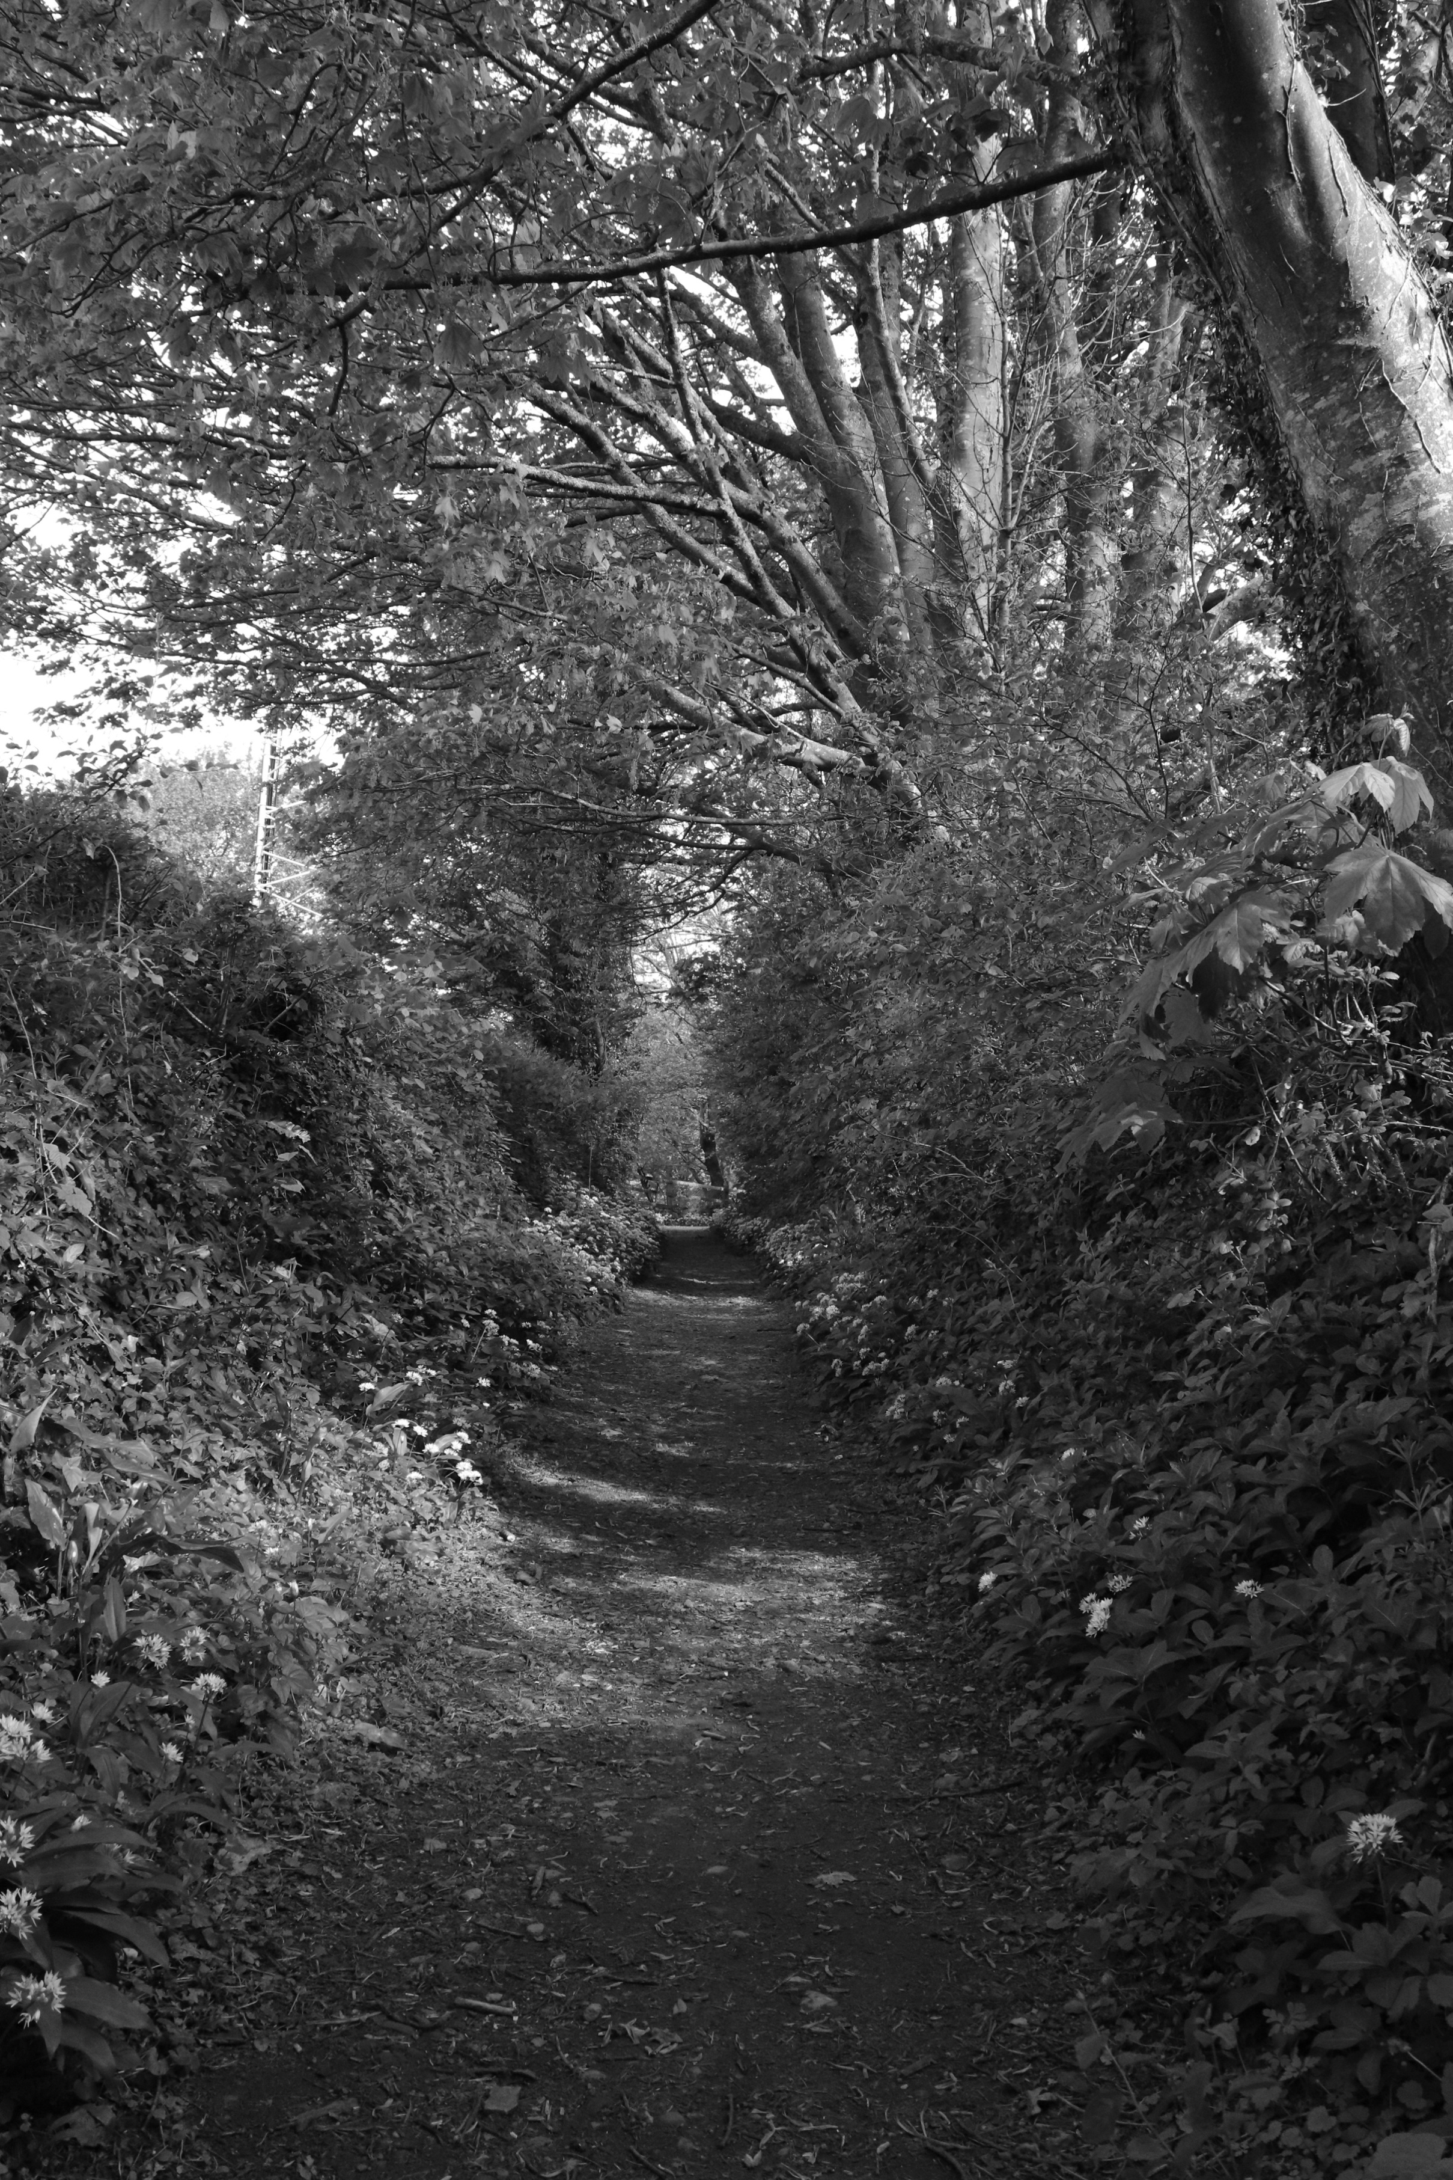
In this last image, I have taken it on top of the hill, looking down the path, this is where it is most likely the best lit place. But because when I took this, it was morning, the sun wasn’t at its peak. As you can see though, the light still got through the gaps in the trees. The light in the foreground creeps up the bushes on the left which means that the light is coming in from the right. The foreground and background are very similar throughout but as there is more distance between the camera, the smaller and thinner the pathway gets. Your eye is instantly drawn into the centre of the image. The trees overshadow the path which makes a great effect to the image making it seem more like a roof.

