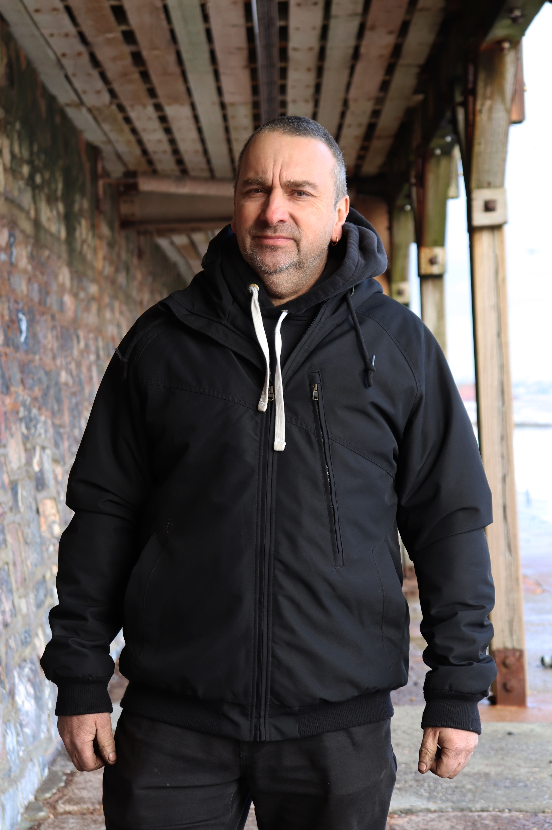
This is the first image from 2.2 Viewpoint. Here is my dad, who volunteered to be a model for this shoot. Like the brief, I have taken it in a similar way, taking into consideration my surroundings. I felt that this was a very good place to do the shoot as it had a lot going on around him. This image shows 3 pillars over his right shoulder with only the very front one being mostly visible, whereas the ones further back are mostly blocked by his arm. This image was taken from further out but zoomed in. The background has been made fairly soft as a result of small aperture. The wall is still visible and the roof. The metal beam behind him is mostly blocked by his head, but you can still see it either side of him. I have used a tripod for my shoot so all images will be of the same height. Whilst being zoomed in but further out, this only leaves enough space to get the top of his legs within the frame and good height above him. I have placed him in a natural position with his arms by his side and just told him to look towards the camera. I feel that over his right shoulder it seems to be slightly over exposed but not horrendous as it is not the main focus and the sky was grey anyway. The colours are very mixed in the image, and he is wearing all black which compels against the colours of the background well and helps clearly outline him against the background. In terms of angles, I have just shot this head on as in similar style to my artist and the brief, no fancy angles. There are a few patterns in this image, like the wooden planks, and the wooden beams. Also, my dad seems to be rather symmetrical because of his clothes. He looks 2D in this shot, as he is head on of course.

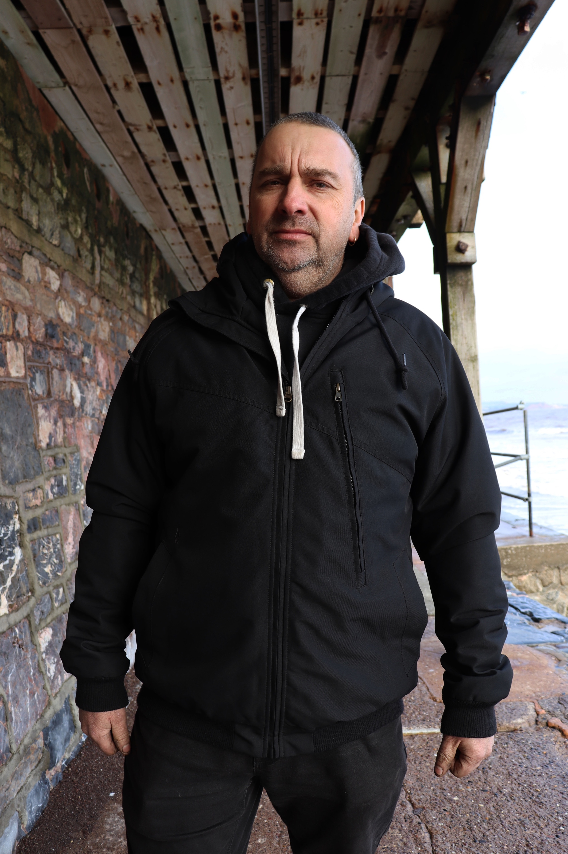
This image has a slight change in viewpoint and has been moved towards him whilst I have zoomed out. As you compare both images, they still contain similar surroundings as it is the same place but the surroundings are in fact slightly different. This is because of a change in viewpoint, unlike the first one, the wall and the roof have moved, the positioning of the beams have moved also, only one is visible now compared to a previous three and is only part visible. The metal beam behind his head has completely vanished and now on the right of him is a metal hand rail, not visible in the first image. Also, whilst keeping a similar space above his head, more of his legs are now in the image as a result to the change of viewpoint. As you can see, he has kept the same posture and has not moved from his original positioning. The background in this image doesn’t seem to be soft and more in focus too. The image gives off a feel that I am higher up when comparing the floor in both images, but in fact the same height when you look at him. He seems intimidating in the second one because of the change in view point and feels slightly more in your face.

