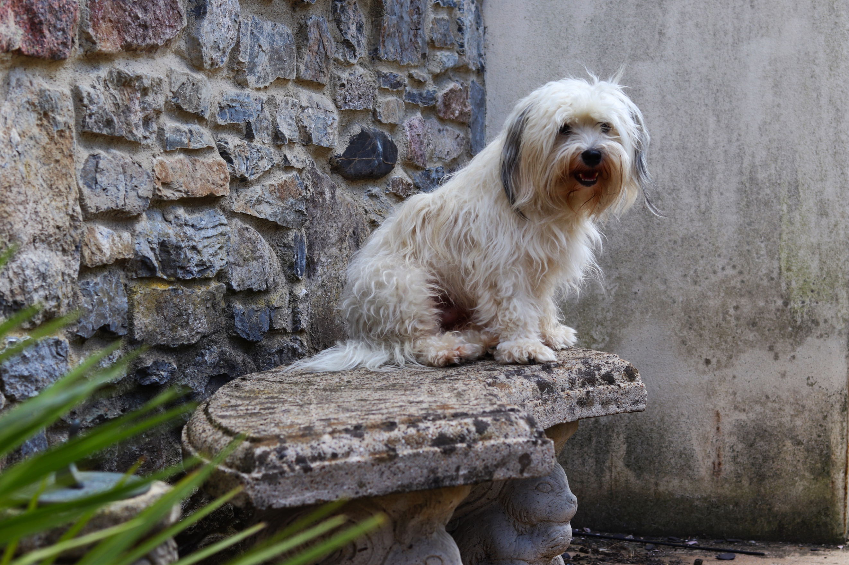
Here is my final image from the shoot. This is of my dog, Jax. There is a strong variety of texture throughout the image from the two walls and the bench and the subject itself. The wall on the left looks hard and wall in the background looks damp and slimy. The bench also looks like this. Whereas the subject looks very fluffy. In the foreground I have managed to capture a plant that was in my way. The plant has been blurred out in this instance so it doesn’t interfere with the main subject and ruin the image. It makes you focus better on the subject. The colour throughout is vibrant, but seems very bland as it is mostly the same colour and there is not a great deal of variety apart from the wall on the left. The angle I have taken this from was bent down, level with my subject in a position where it is possible to see him within the frame. The shape of the bench is 3D and so is the dog, the plant in the foreground and the walls are flat. For this shoot I used my 50mm and shot on Manuel mode.
For this shoot, the framing was not intentional, the main focus was the distance between me (the photographer) and my subject. This is a good distance because he is not too close to the camera, and he is not too far away that you cannot see him. He is in a position where you can see the location he is in and some of his surroundings. The surroundings, which were not intentional are very interesting if you look closely. The first thing I noticed is the sculpture at the bottom of the image, under the bench. When I was taking the shot, I didn’t even realise the face! Then, the plant in the foreground, creeping its way into the image, also with an ornament behind it which I also, didn’t see originally. Over in the background near the wall is some kind of black stick, which is lying amongst some rubble. The walls help frame the dog well and doesn’t give you anything to look past them. One wall is particularly dirty, which contrasts well against the bright green plant and the dog in front of it, and the change in textures. My intention was to capture the dog sitting there, but I did not take into consideration any of his surroundings and how this could affect the frame and the image as a whole. I think if I was further out, the subject may have got lost within the image as there would be too much going on, and if I was closer in, I feel there would be nothing to talk about in relation to the frame as it would be too close. Although, I did not consider the frame, I do like how it has been captured and help makes the image with the various objects within, to fill around Jax. When I selected this from the contact sheet, I really enjoyed looking at the image and found it comforting. The surroundings really brought the image in as a whole and made it the best image, despite not caring about framing when taking the initial shot.

