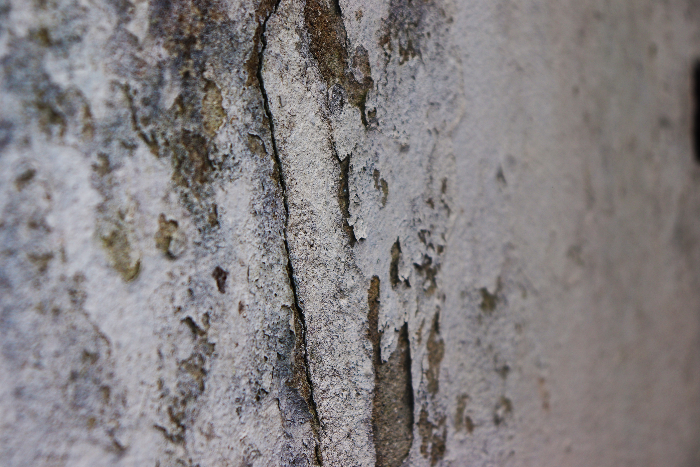
Context is such an important part of the assessment criteria because it is always important to reflect and to put things into perspective so that people can understand your work through critical thinking and research. It is important so people can learn and adjust with you the creator to make the work the way it is supposed to be seen. In this image, I have used texture as the main point of interest. Taken from my artist research, I have studied texture, as a photograph, and how it feels. This is included in each textured image. Texture within an image is important, as when thinking about texture, it gives you more of a feel, a sensation which gives an extra edge to the image, and this is what I wanted to incorporate into my work. As you can see, the wall is very hard and warn, it even looks damp. The softness of either side of the image makes the crack even more brutal, tearing through the image from top to bottom, dividing it in half. Although there is only a small part in focus, this part of the image stands out particularly because it is more in your face because it is in focus. It shows the roughness of the wall by the cracks and bubbliness. You can see also by the colour, it is not as if the wall is a really positive and attractive colour, but a cream, that has been left for a while, in all weathers, battered, into this dirty cream that isn’t attractive, or shinny. The blurred edges make you focus on the crack and the surroundings in the middle of the image because each time you have to look away because your eyes cannot focus on where it is blurred, because it is not clear. In relation to context, this image uses all three variations. Internal context is evident within the image, as of the subject, being this ruined wall, looking at how it could feel to the viewer, and it ‘looks to feel’. Whether the title falls into this category or external, I’m not sure, but if it is this then the title contributes well, and has meaning to the image and makes it seem distant in a way. ‘The Divide’ with the crack tearing down through the image, seems like an okay caption at first, but could it have a deeper significance than just dividing the wall? Also, the image is presented on a blog, to do with photography, which is relevant. Although, not evident, there is obviously a date and a creator of the image which presents this snap shot in time showing this image. The information that is evident within this image, is that it is a wall, with a crack and has been ruined over time to create this crack and damage due to the weather. The information that surrounds the image is the title, which gives a slight touch on the image which gives it more meaning, although the meaning of the image is not evident, but to be desired. Information that is regarded as the making is both physically and physiologically present by finding the crack in the wall, and how the crack has appeared and presented itself and how I have discovered this. Physiologically I thought about the wall, and the way it looks and how this can help relate to my original idea of textures and how I wanted the wall to be presented in this way to show the texture. In all it includes all three to an extent. With the image contents, and how it was created and the information surrounding it all playing a part ultimately providing context for the image, making it unique, with meaning.

