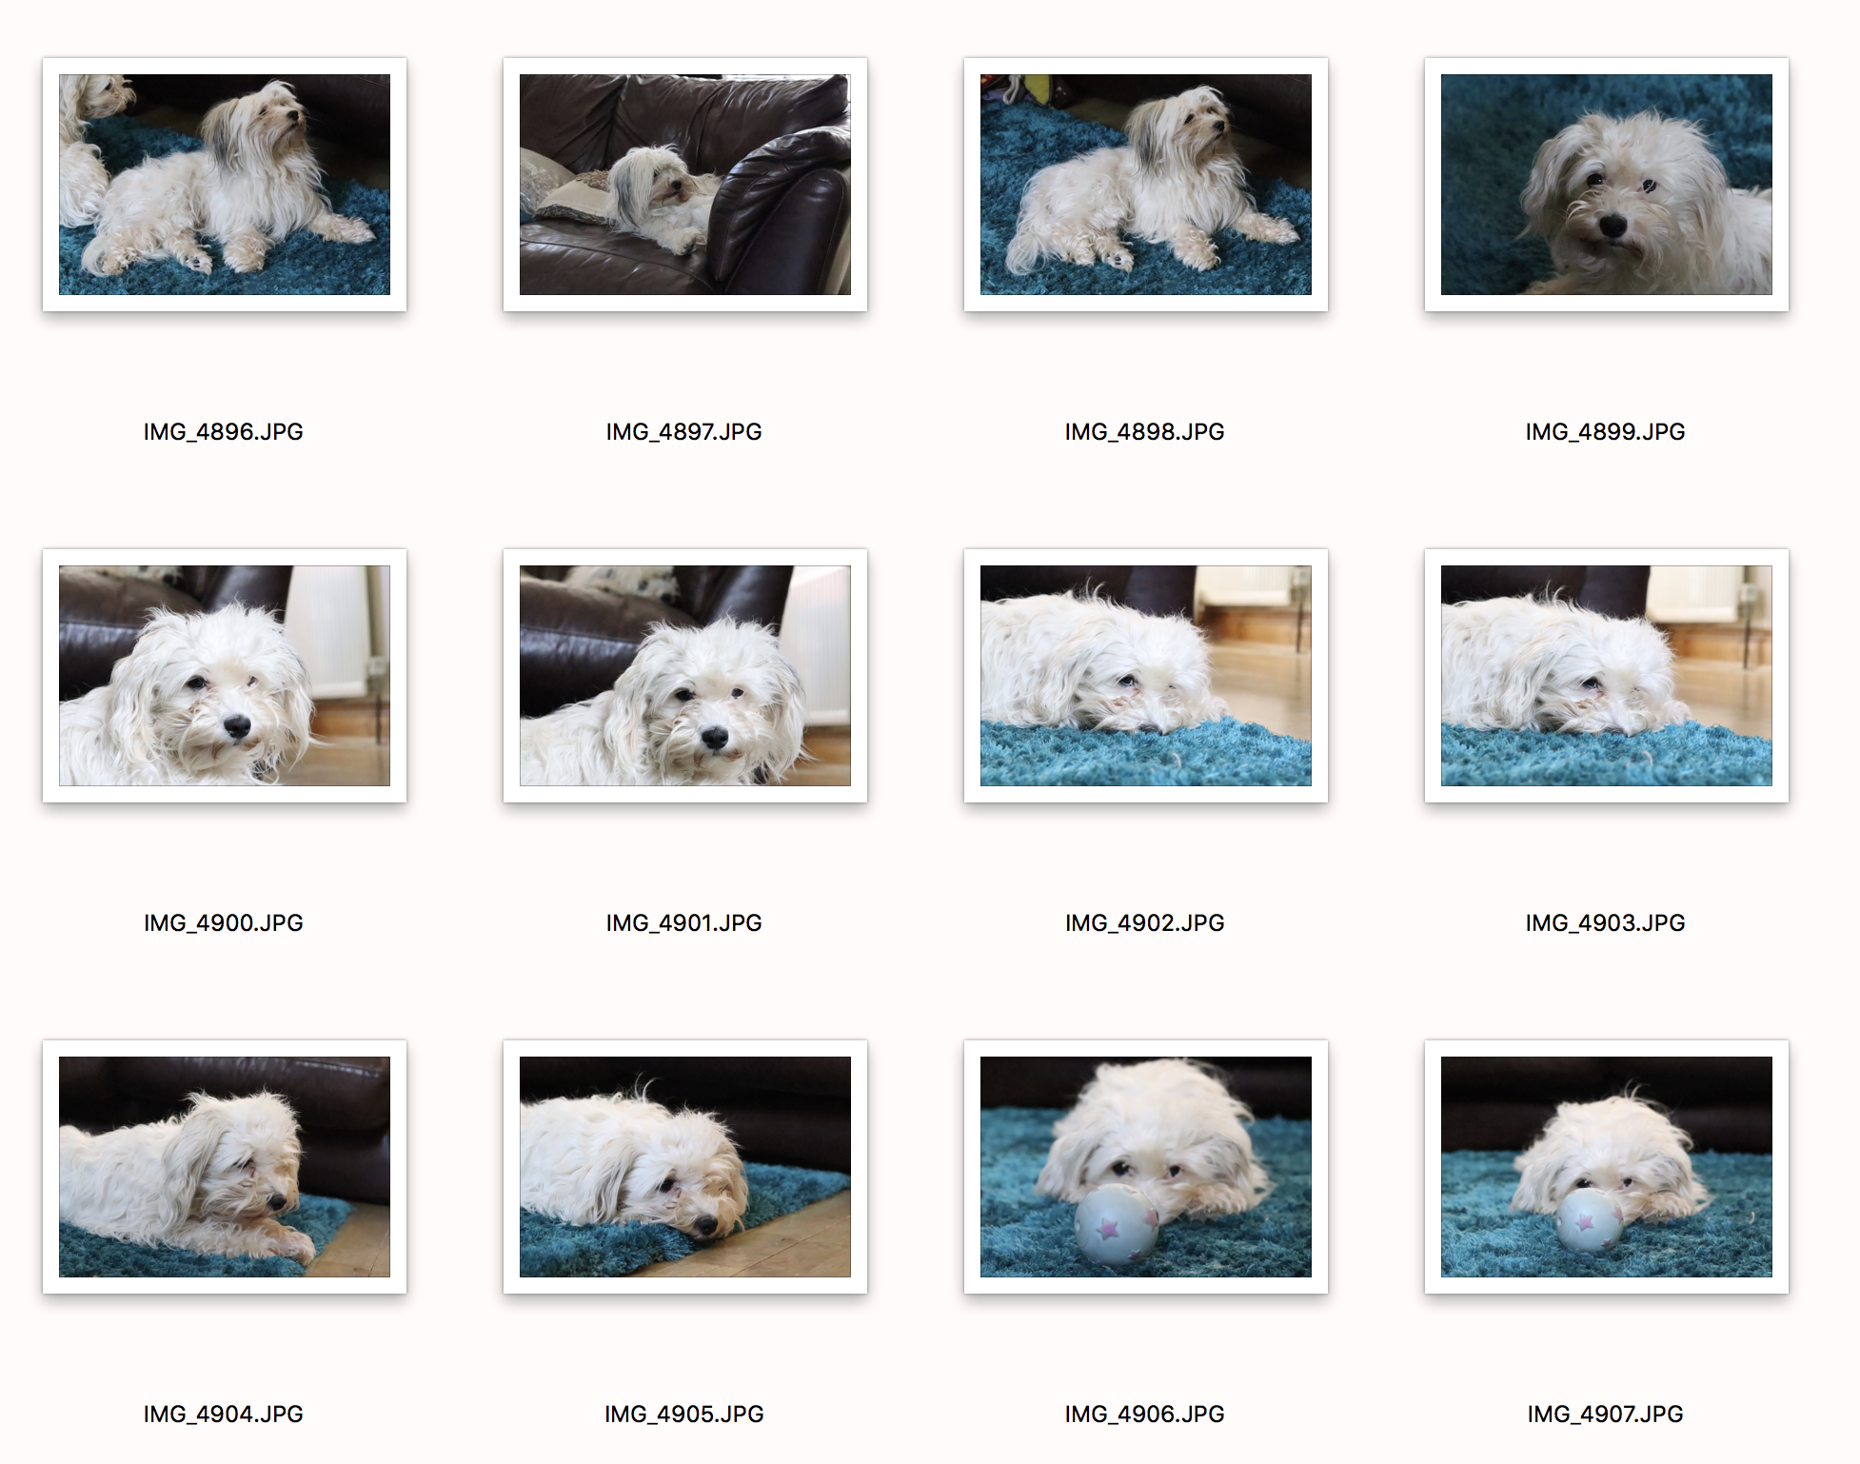
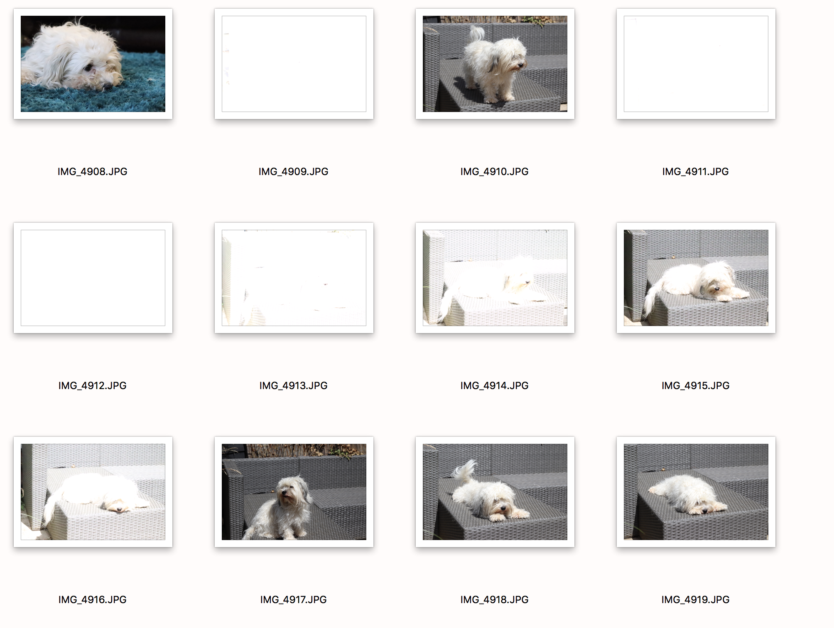
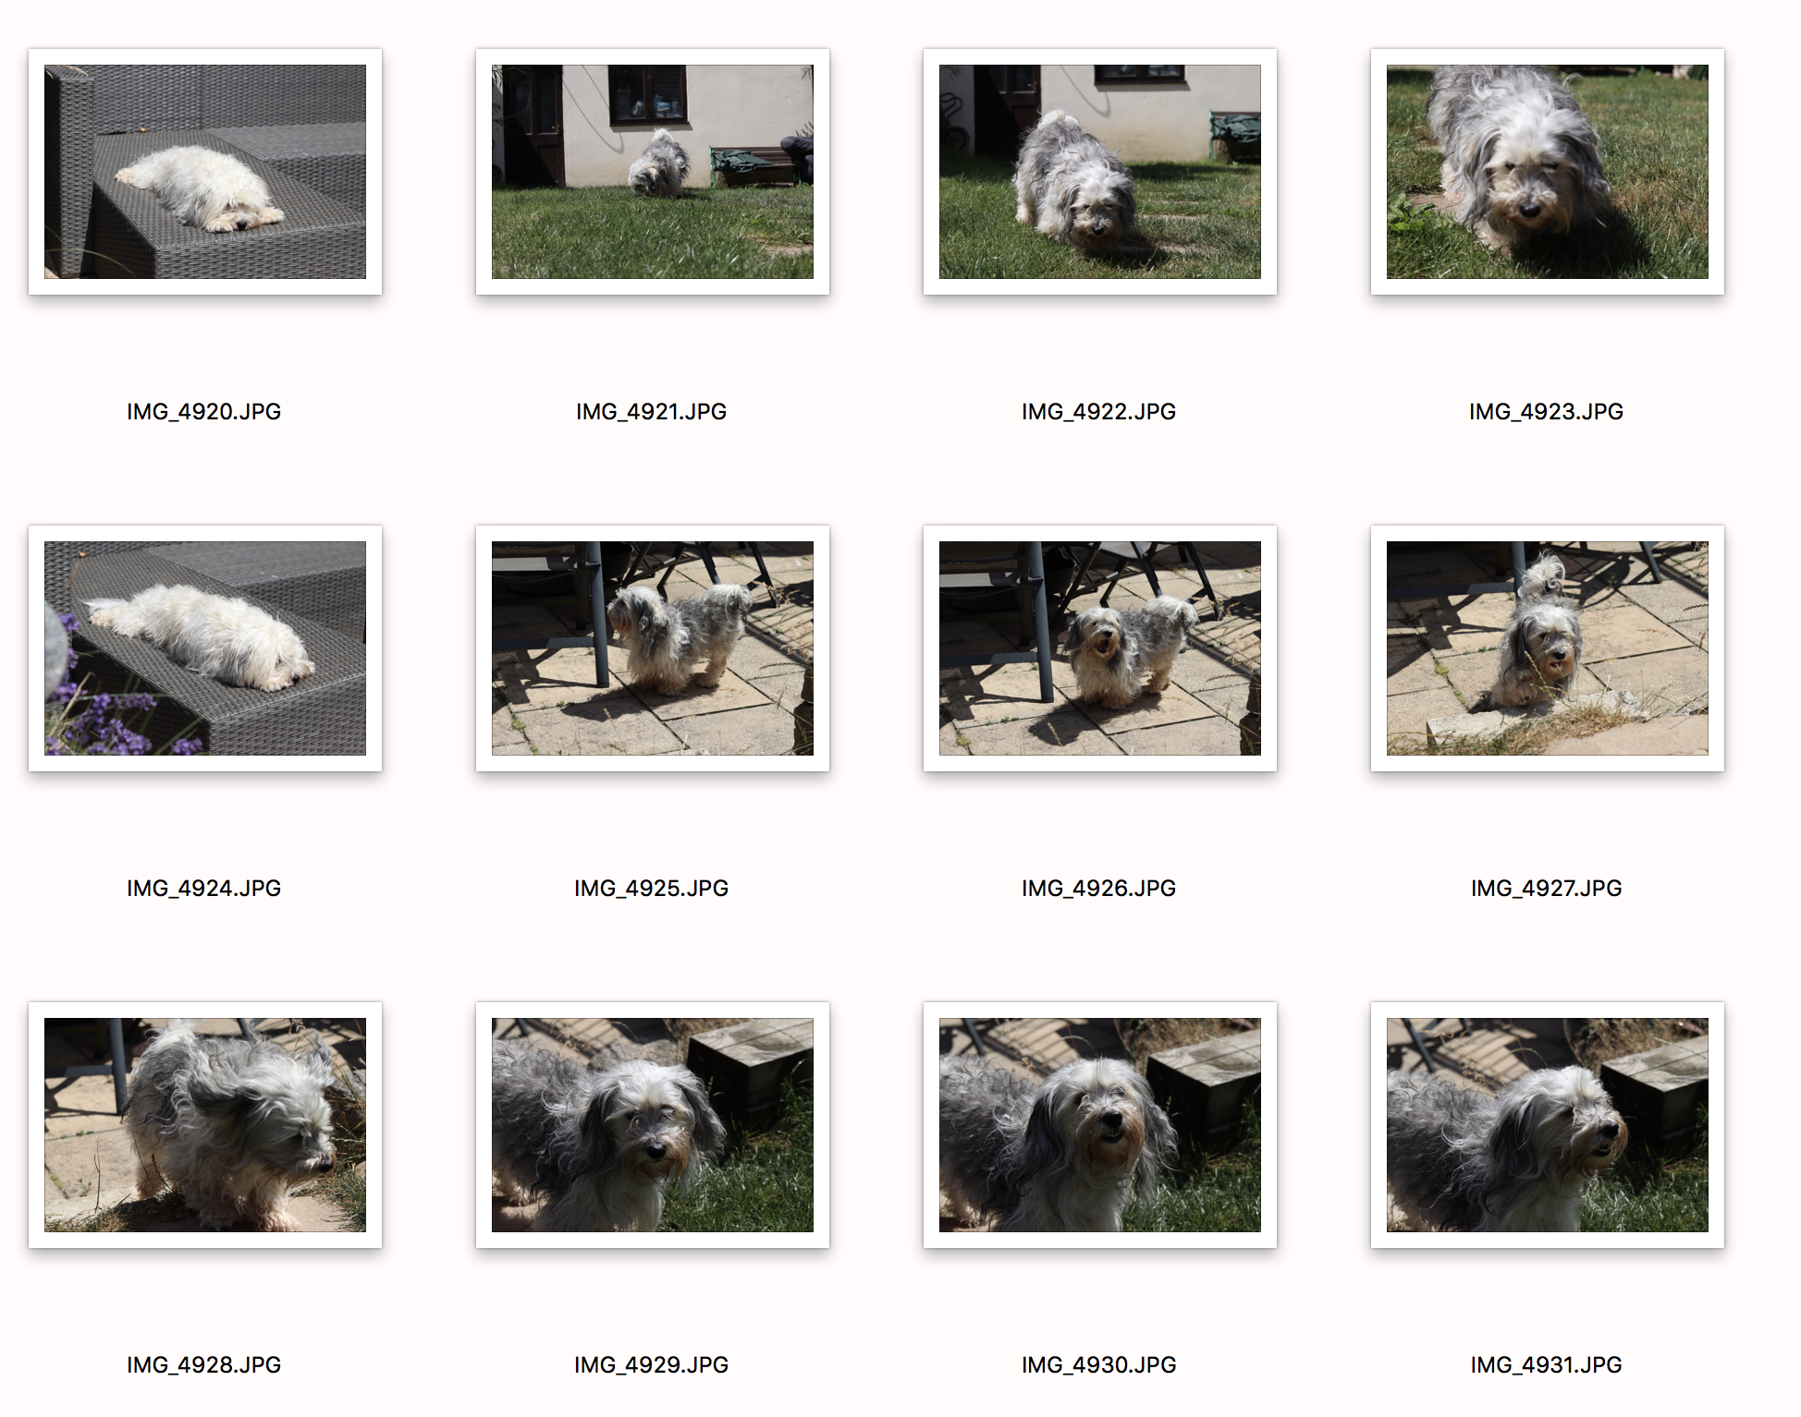
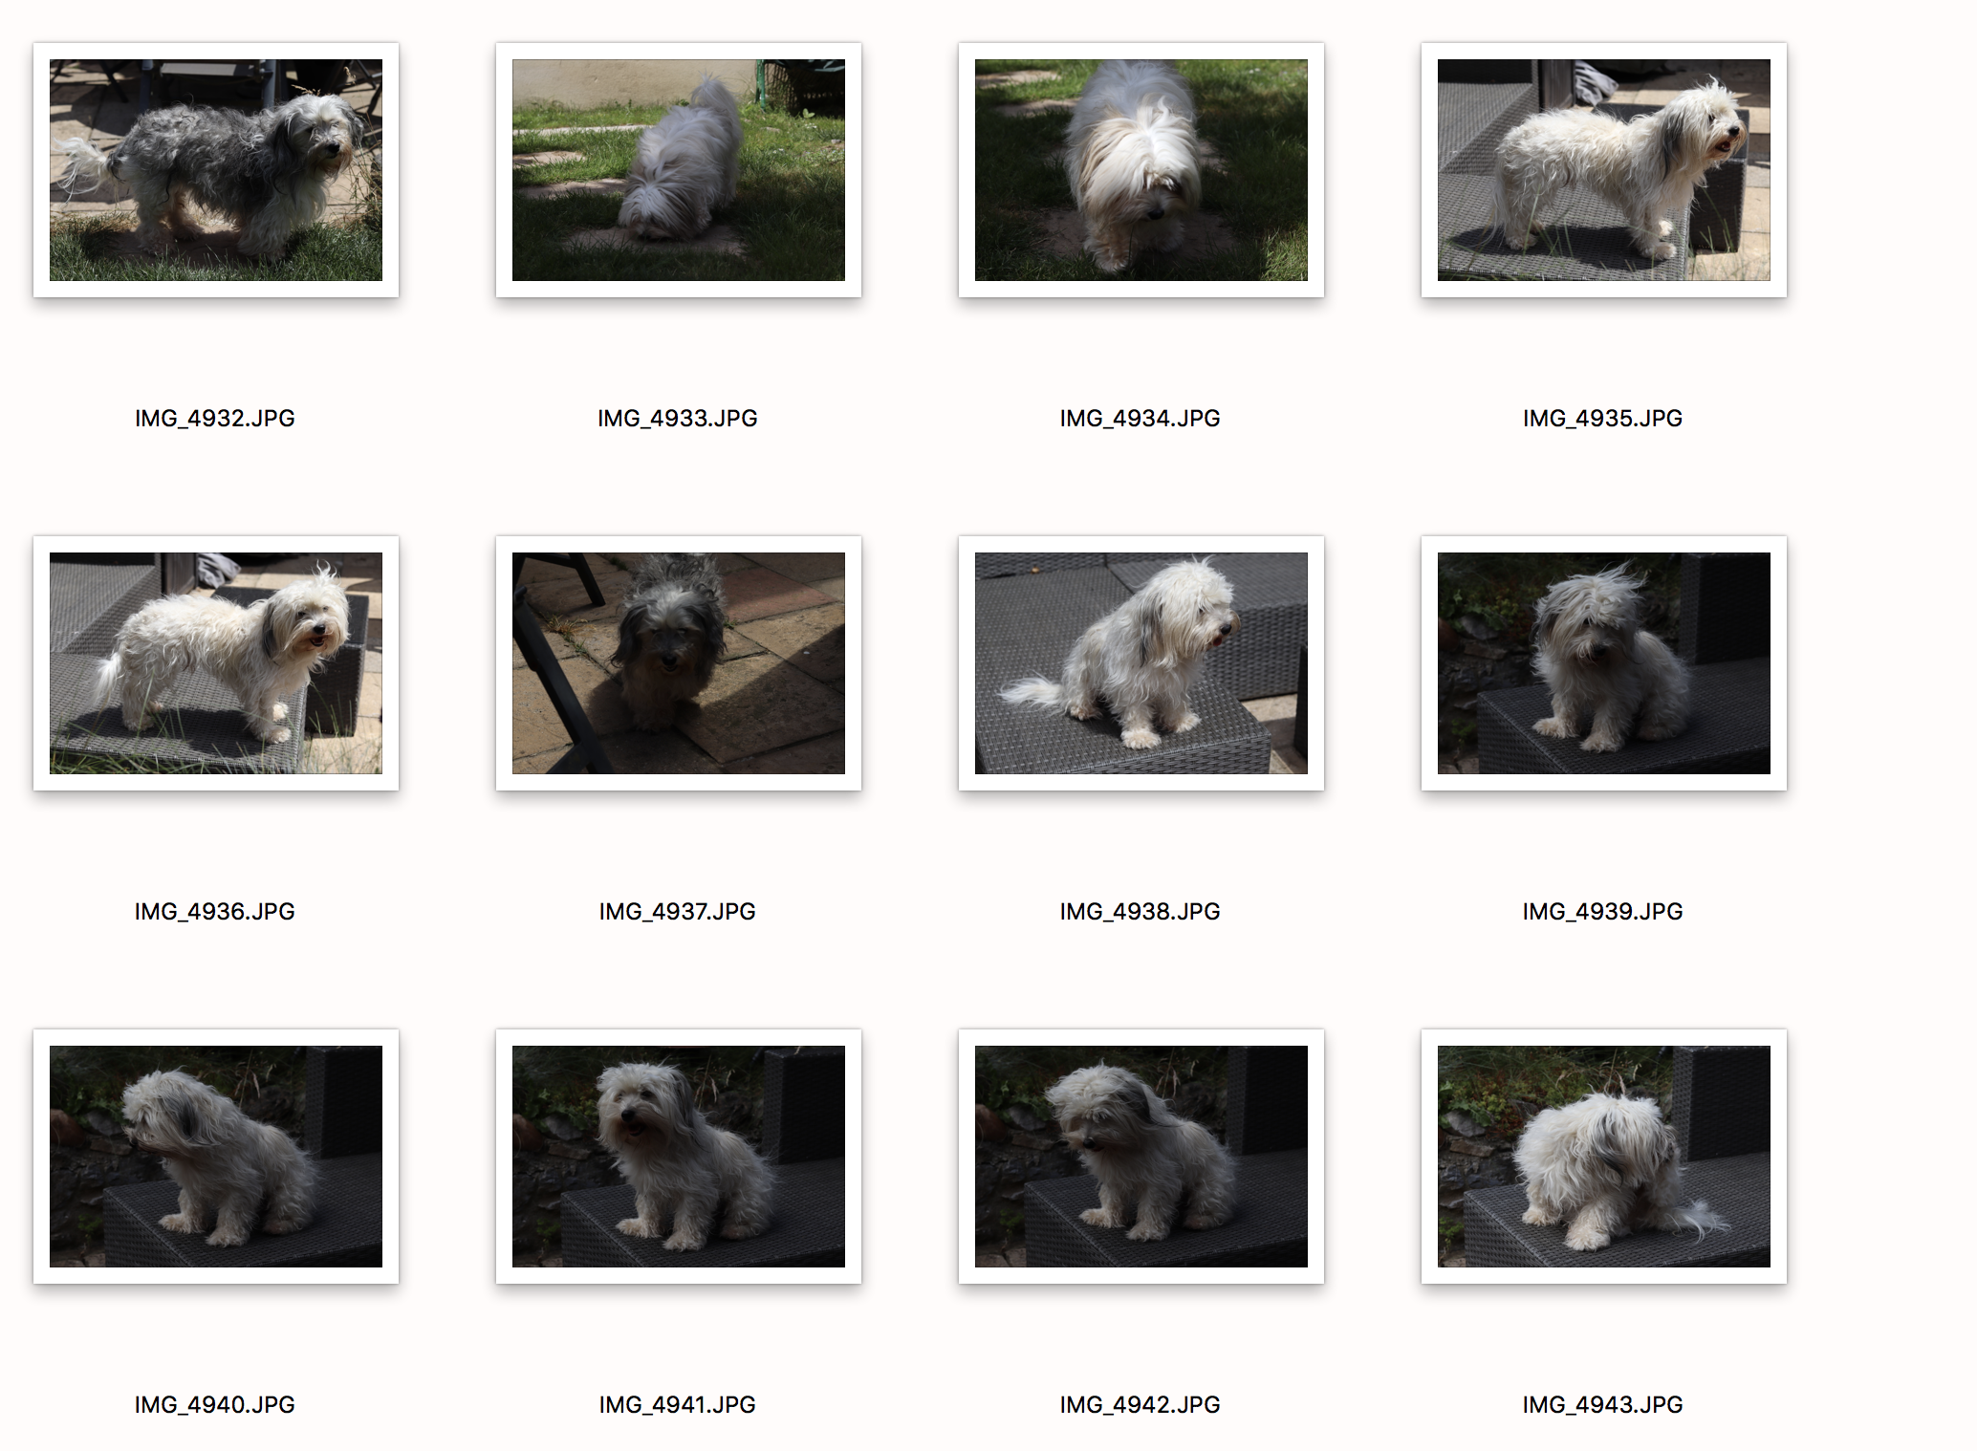
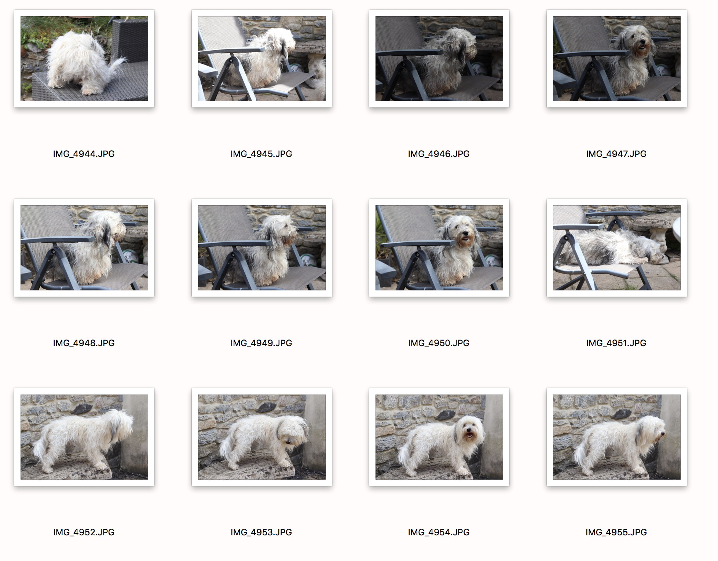
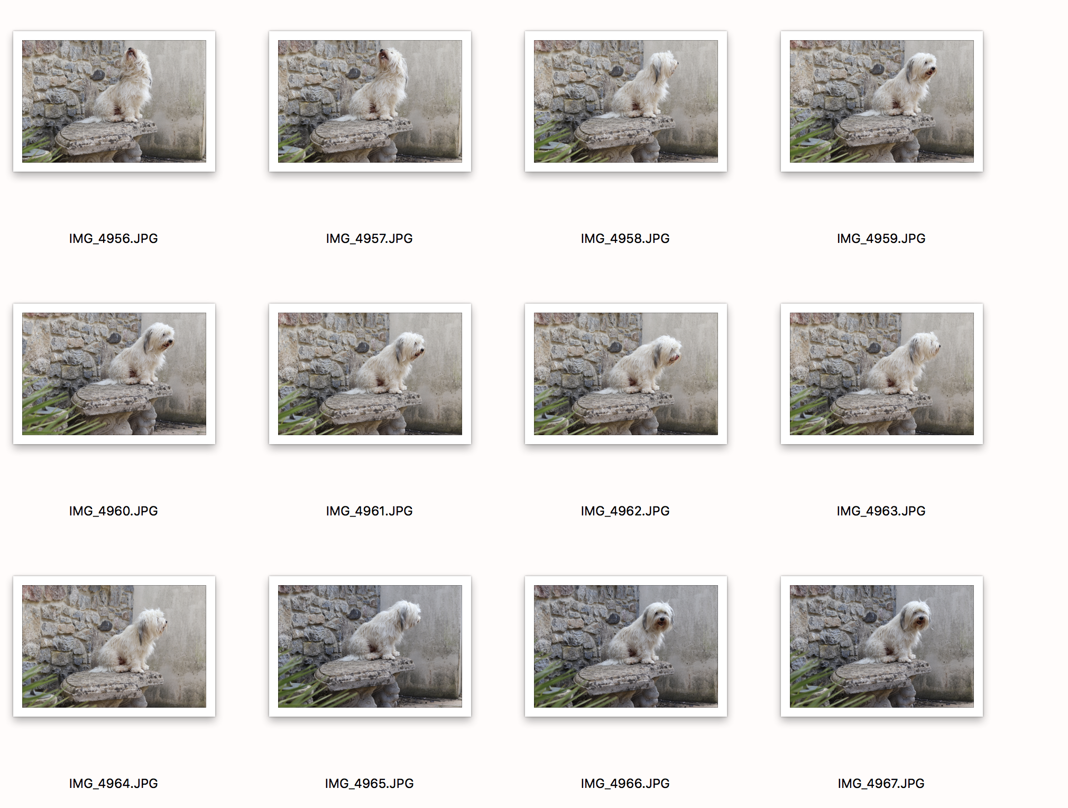
For this shoot, the idea was to capture the distance between you and the subject, and not worry too much about framing and the surroundings. For this shoot I used my dogs and tried exactly that. I will explain in more depth about the image in my shoot write up. But as for the selection process it was fairly simple. My images inside, I feel were not as strong as there was not too much going on in them and they were very bland and boring and didn’t represent the subject how I wanted my subject to look. Then I had some images that seemed to be incorrectly exposed which meant they were obviously not good enough. When exploring the distance between me and the subject, sometimes the subject would come in too close and it would be too hard for me to get a good shot of the subject. Overall, it led me to the circled shot because I really like his posture and how he is positioned. I thought it was really cute how he managed to jump on there and started chilling in the sun. So, I crouched down and took some snaps. As you can see I couldn’t have position myself behind or the other side of him because the walls are in the way and in front of him there is a table, so this is the place where I could easily enough get the shot. I also only made one selected as stated to in the breif.

