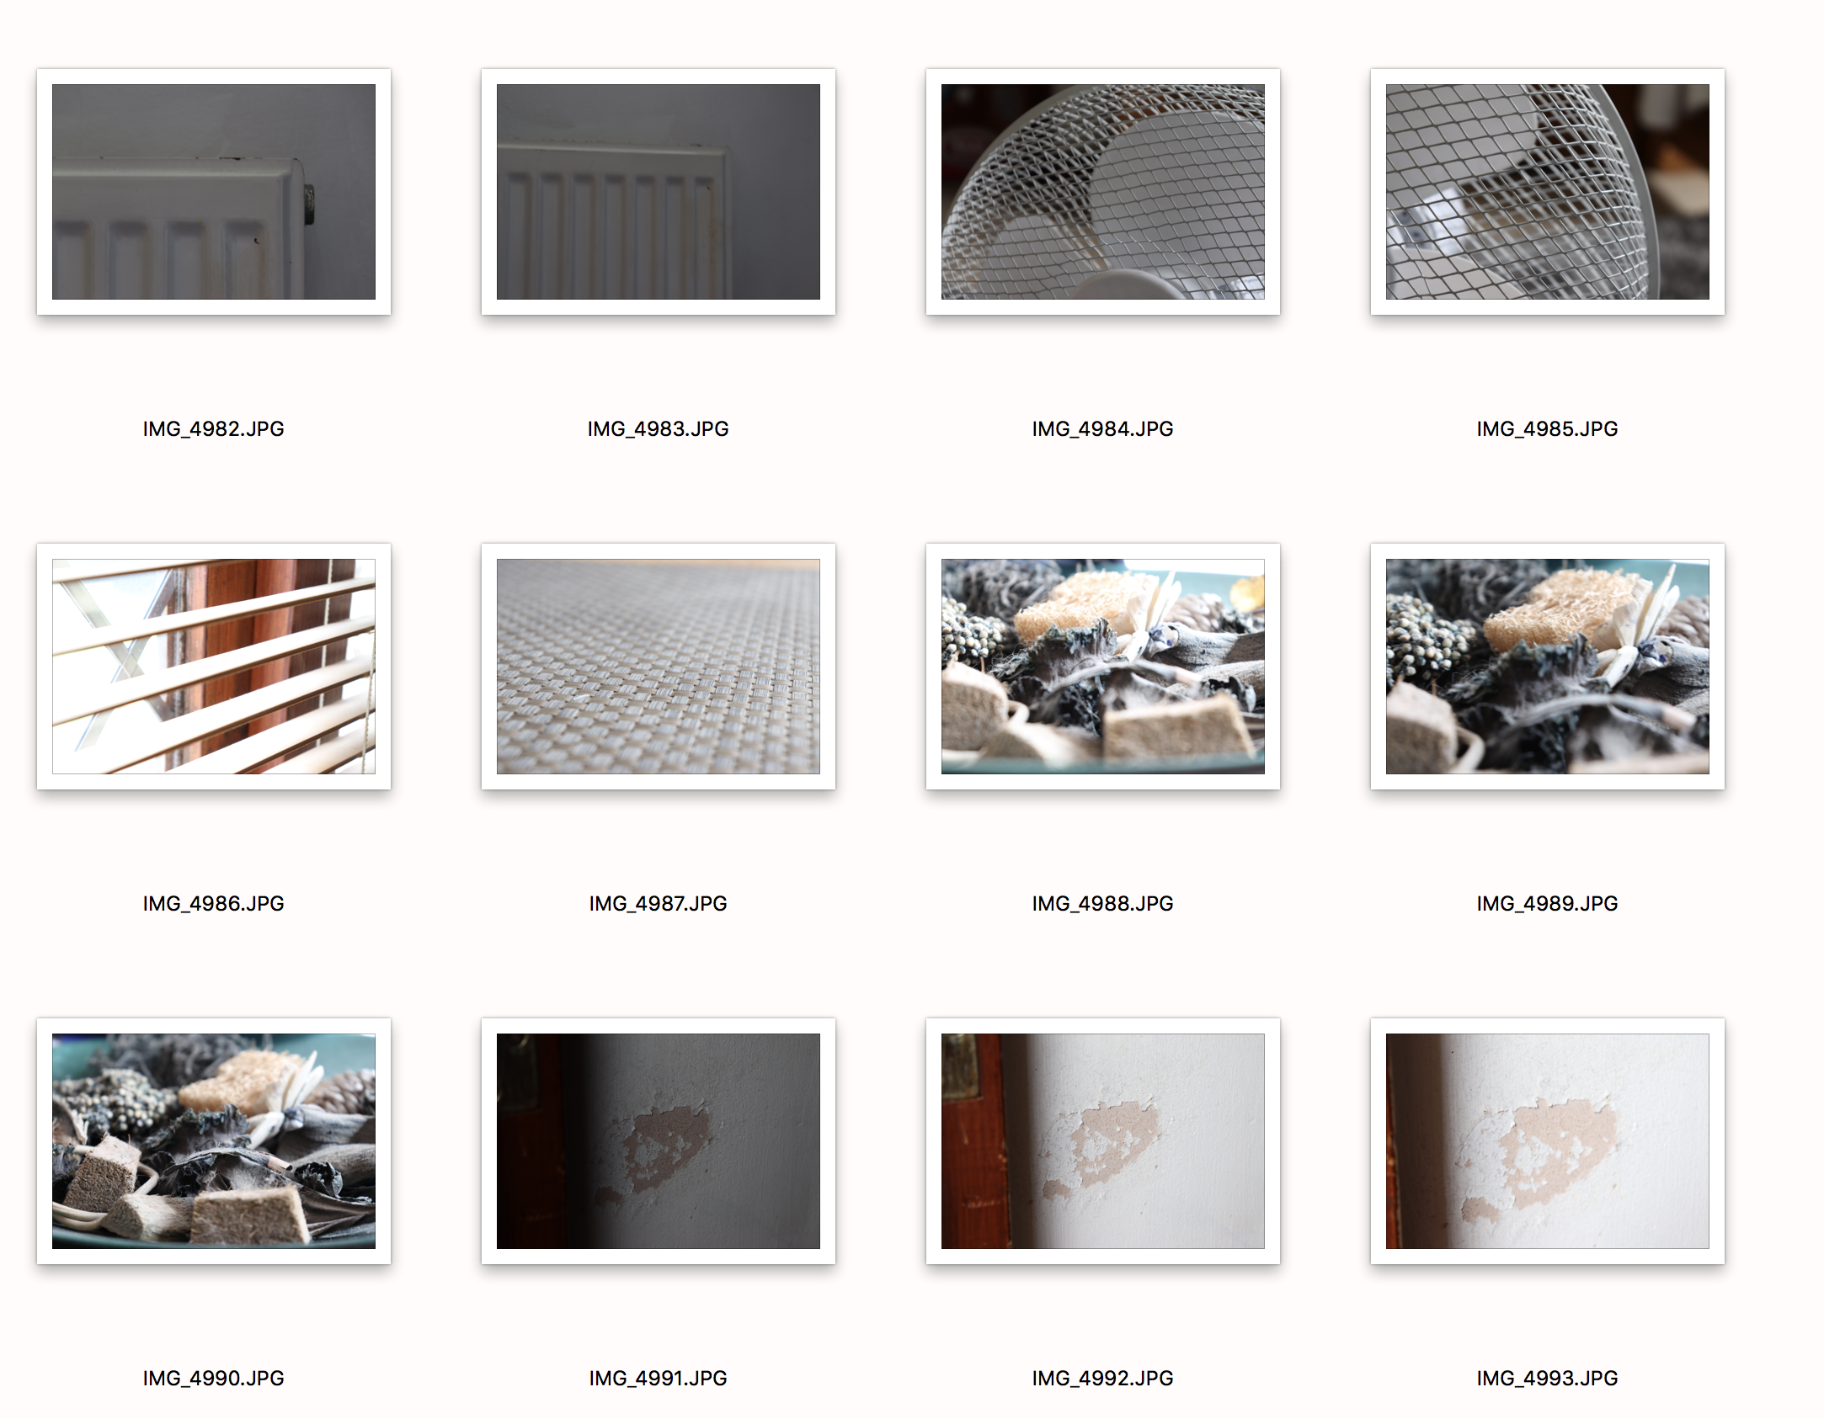
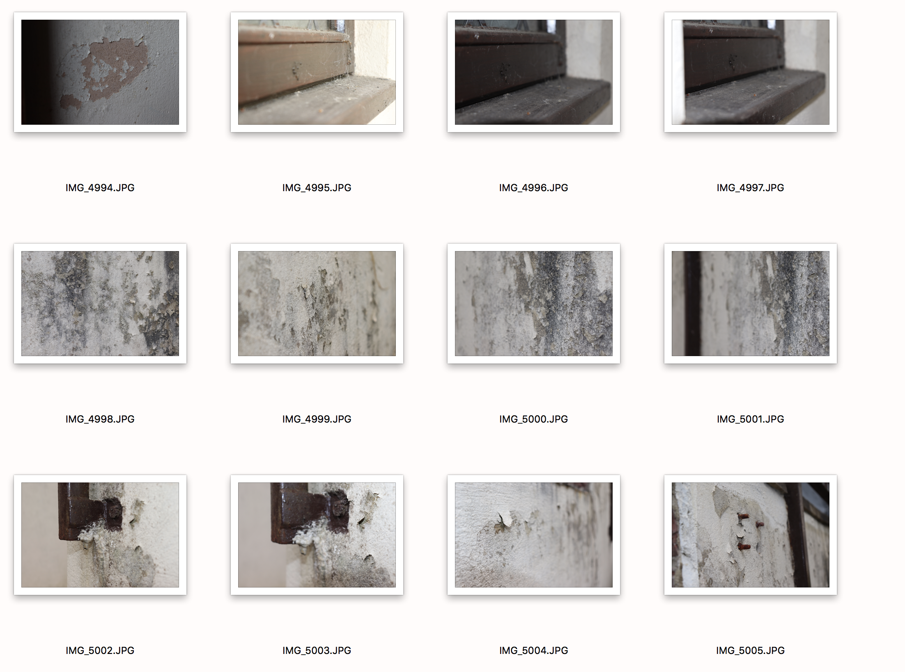
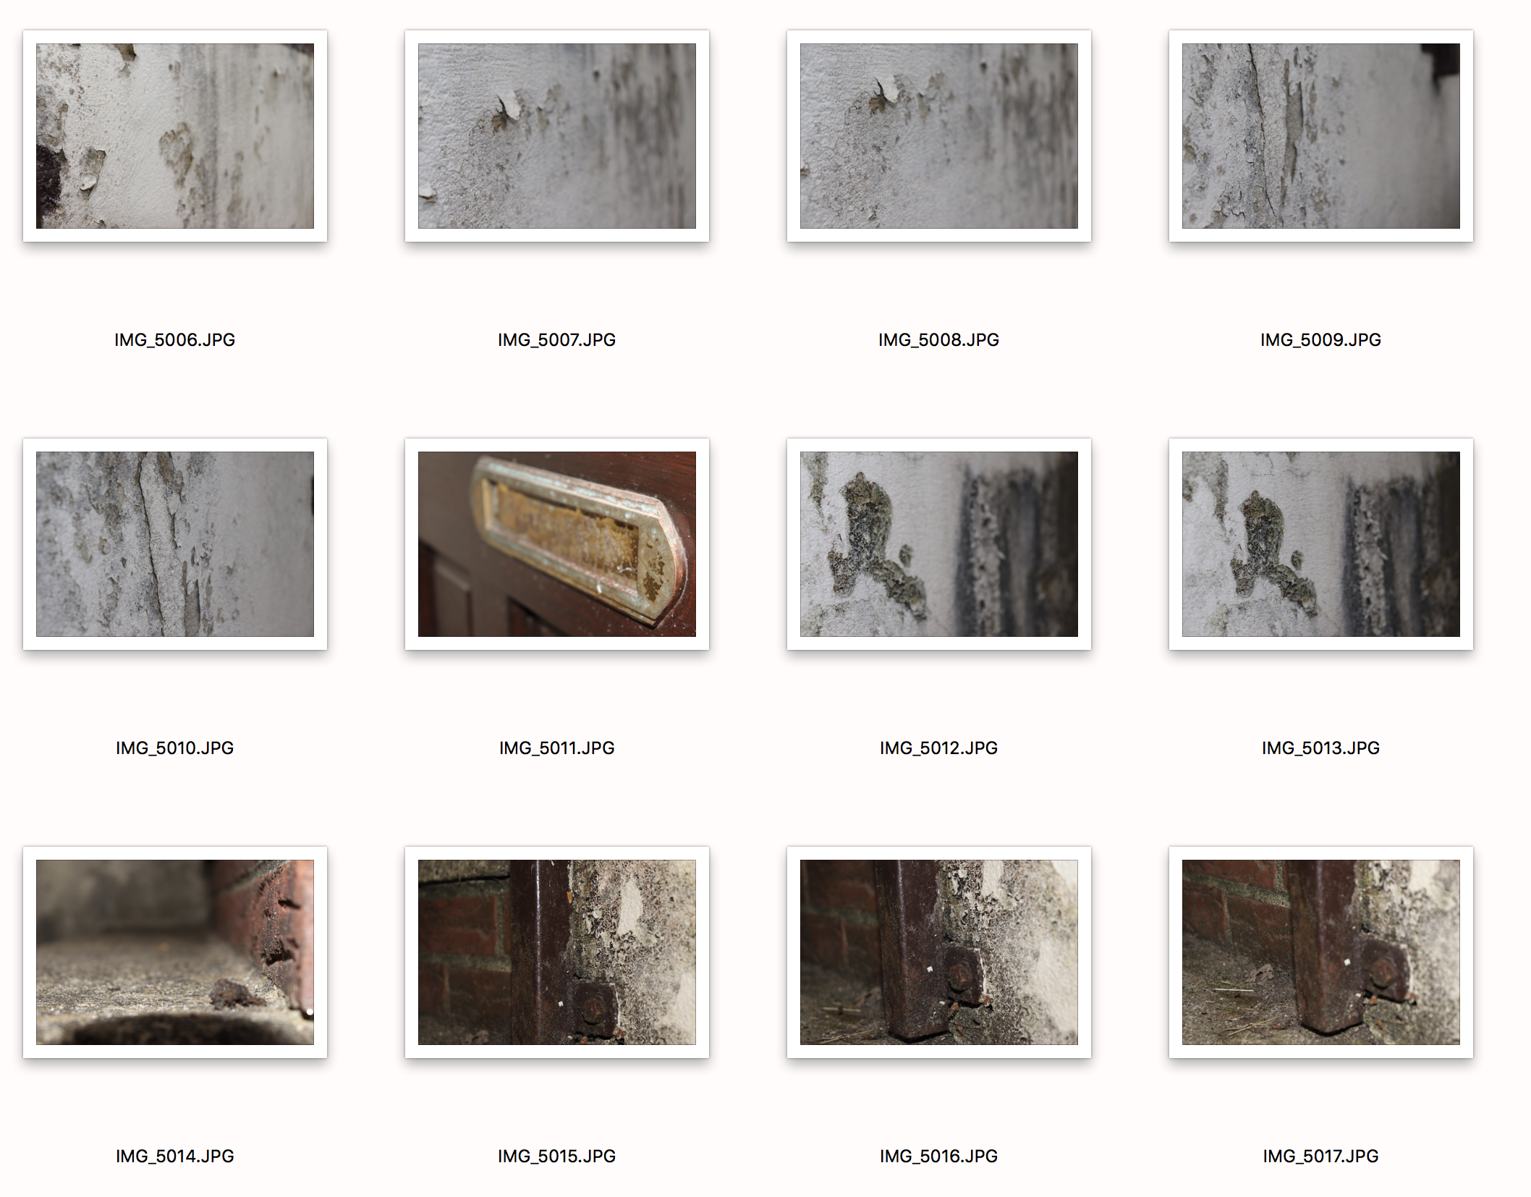
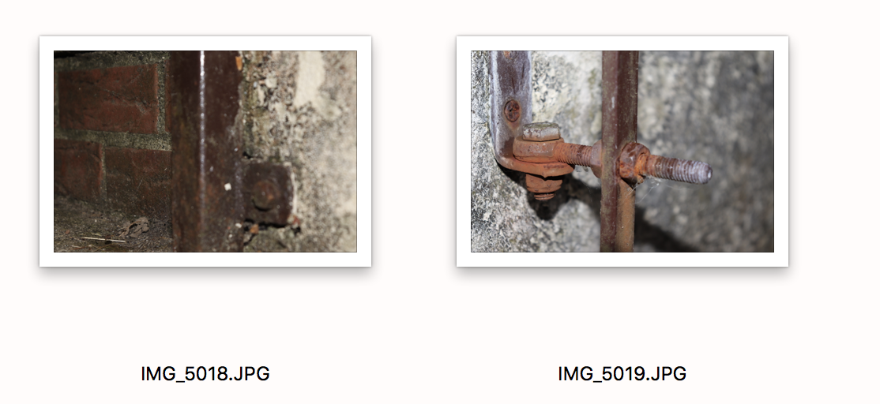
For this shoot, I only did around 40 images. I feel if they are over around 35, that is enough to select from, although you do not specifically need a certain number of images. Usually I go over the top, but for this shoot I did slightly less. I have shot around my house, but also decided to extend the shoot outside which I am glad I did as this made for some really great textures. I used Manuel mode for this shoot, and some images were not exposed correctly. Once I managed to adjust my settings to fill my needs I managed to get some very interesting shots. The idea of the shoot was to capture an image which included texture to a great deal. As I wanted to explore this kind of photography so I responded to an artist which shoots in that field. My reasoning behind the select is because I thought I could include a caption for it and felt it was the most powerful image and fulfilled my needs. I will explain more in my write up to the shoot which will also include about the context of the image.

