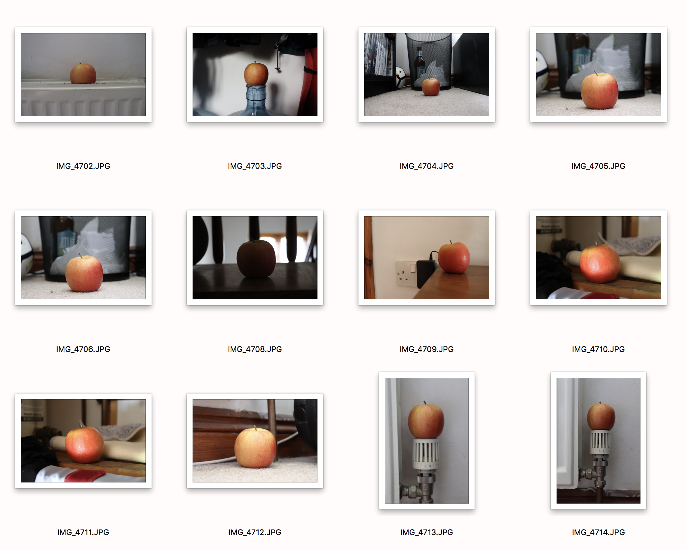
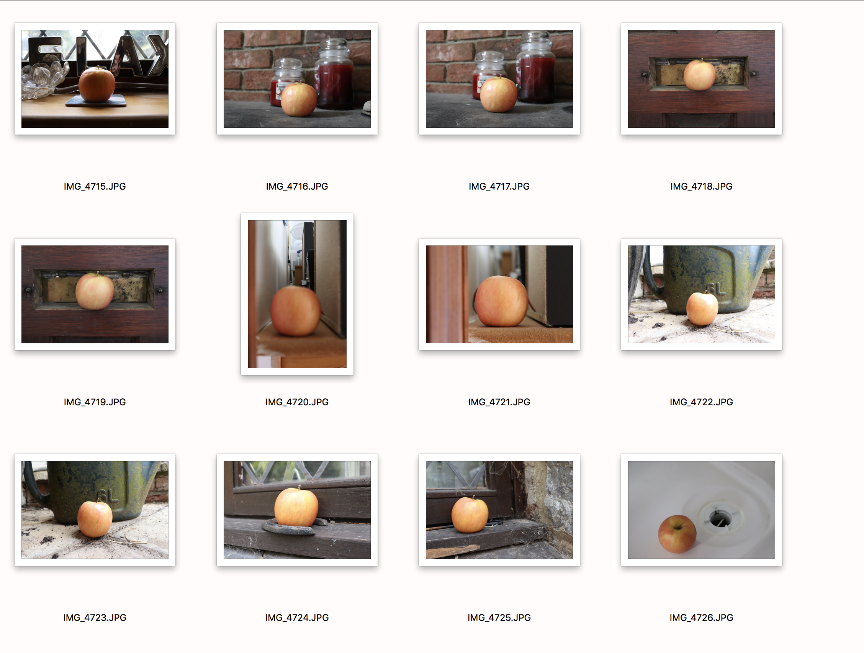
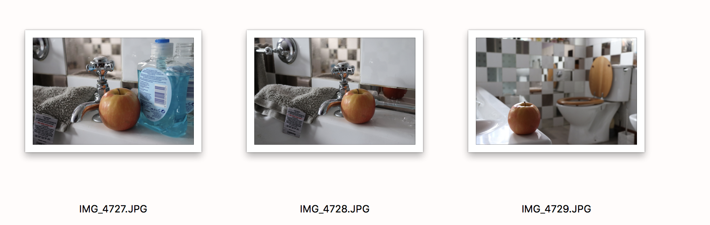
I didn’t take loads of photos for this shoot, as I felt I accomplished the shoot with some really decent shots. I placed the apple in various places around my house where it would look less attractive and would be seen as strange. From the locations I have chosen, I wouldn’t personally eat the apple because where it is situated. I see this shoot as creative as you wouldn’t really go out of your way to shoot this kind of photography. My shoot mainly comes from inspiration from John Davies and Chris Steele Perkins and their photography surrounding Mount Fuji. Mount Fuji, being the subject and the surroundings making a huge difference creatively to the outcome of the image. On a different scale, I see this as having similar attributes, as I am changing the surroundings of the subject having a different influence of what is perceived as ‘the norm’. When selecting my images, I felt the one I selected was correctly exposed and was in a location that was fairly dirty and I feel the colours helped contribute to this matter. Overall, I feel this image is the strongest because of this, and I feel the location works well too.

