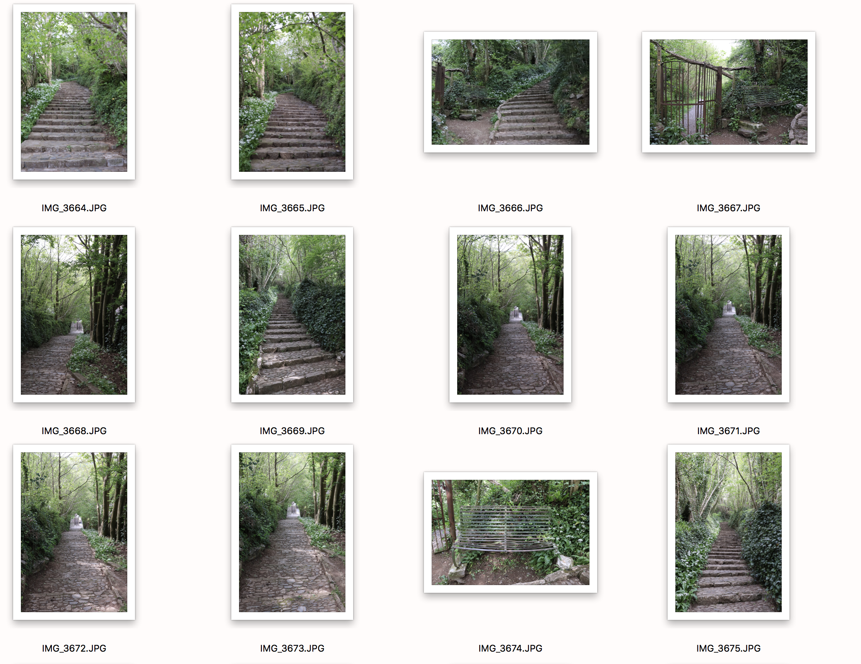

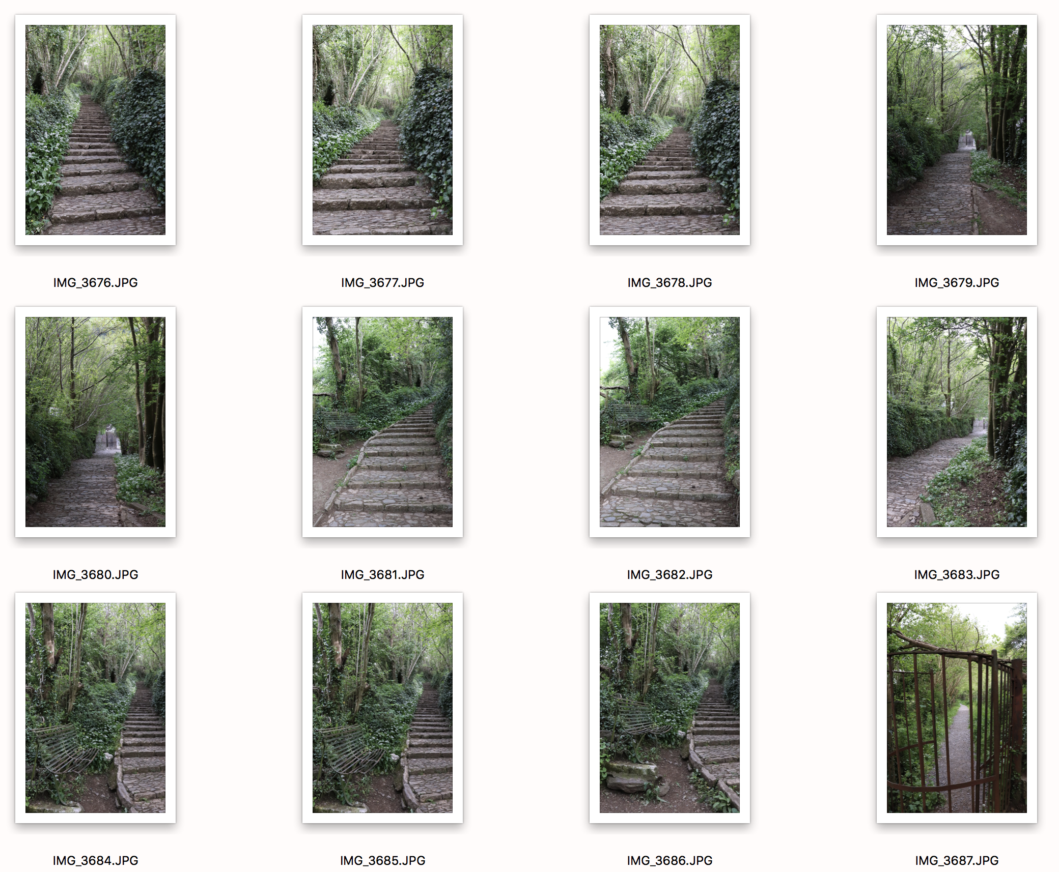

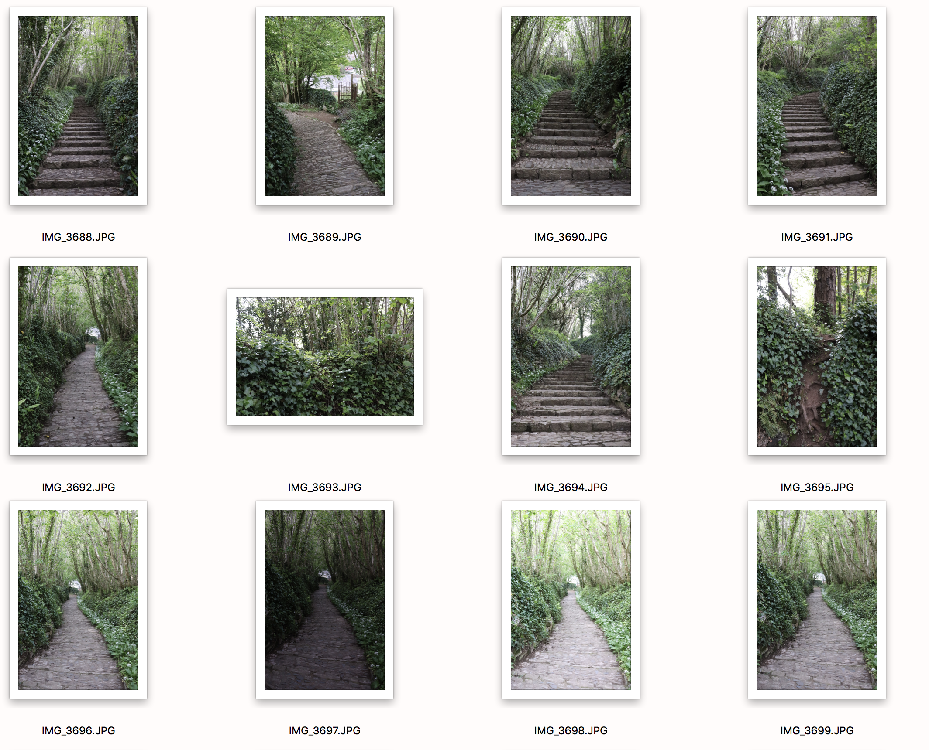
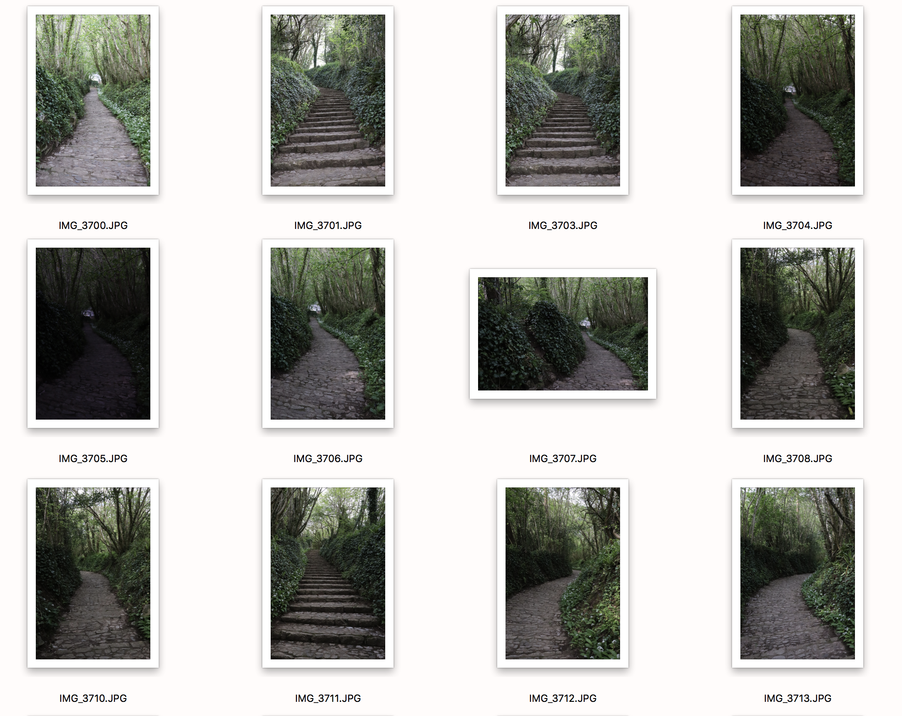
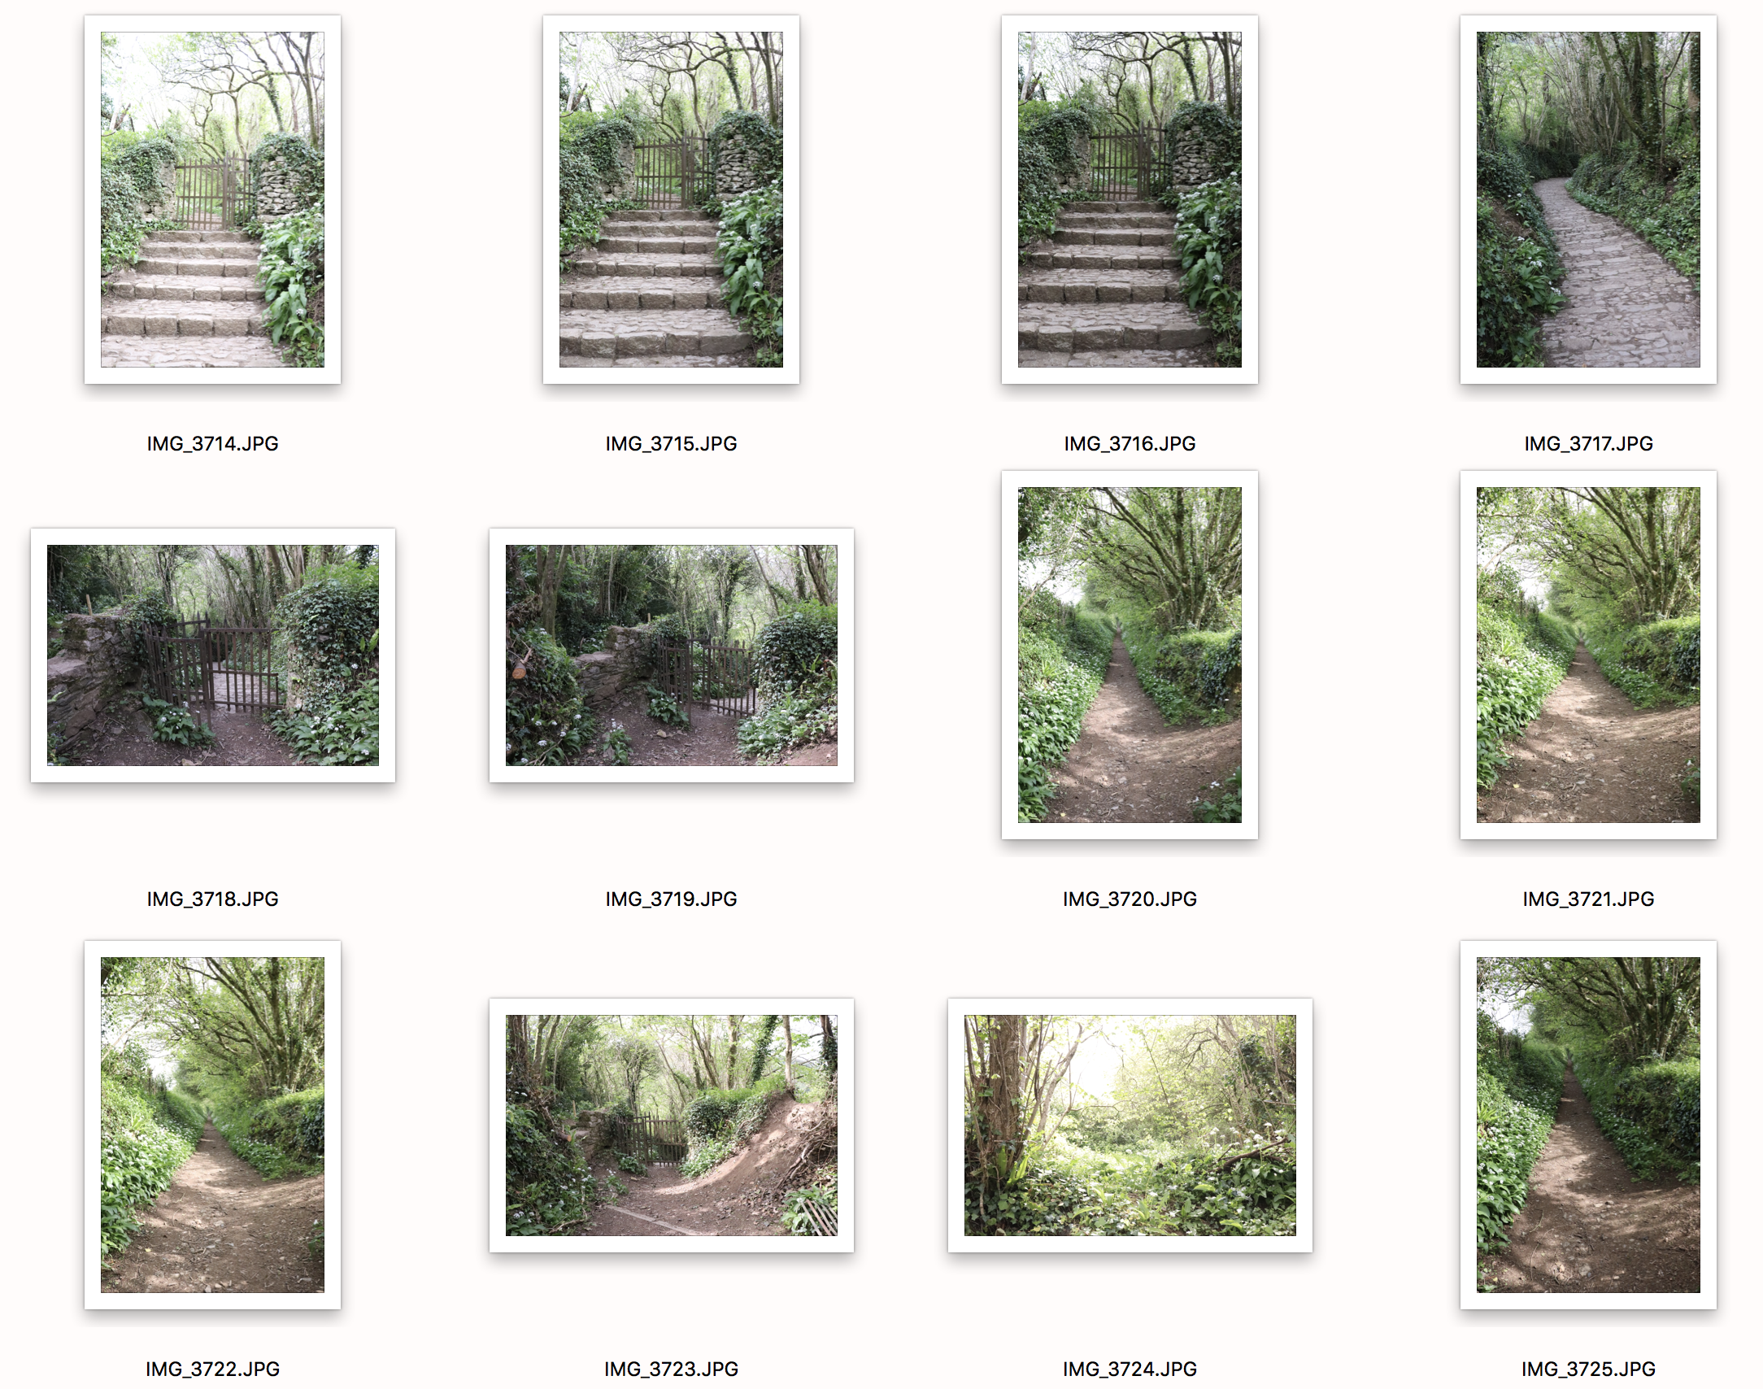
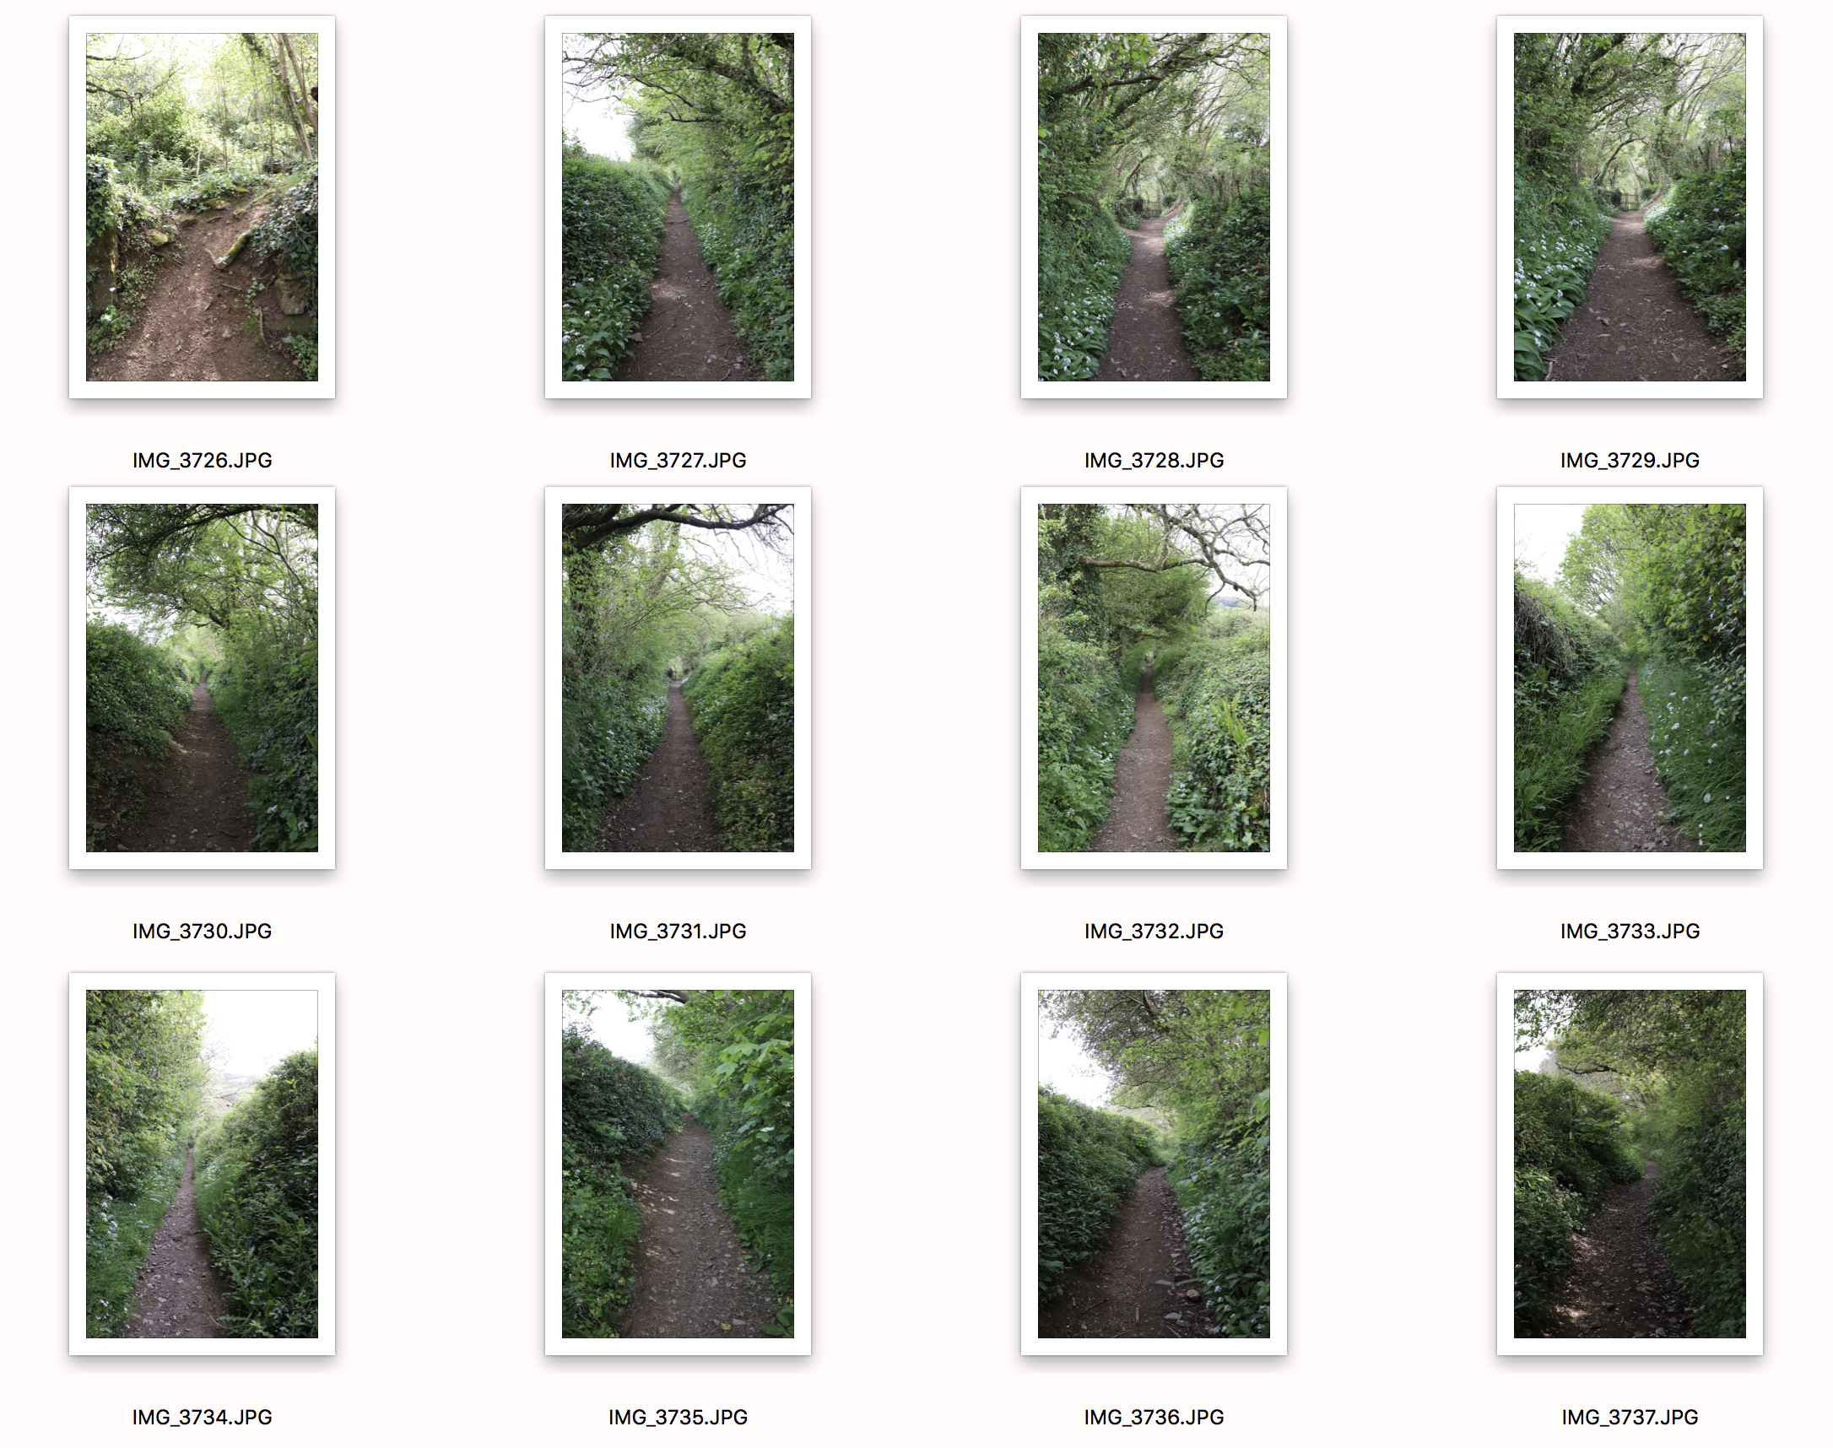
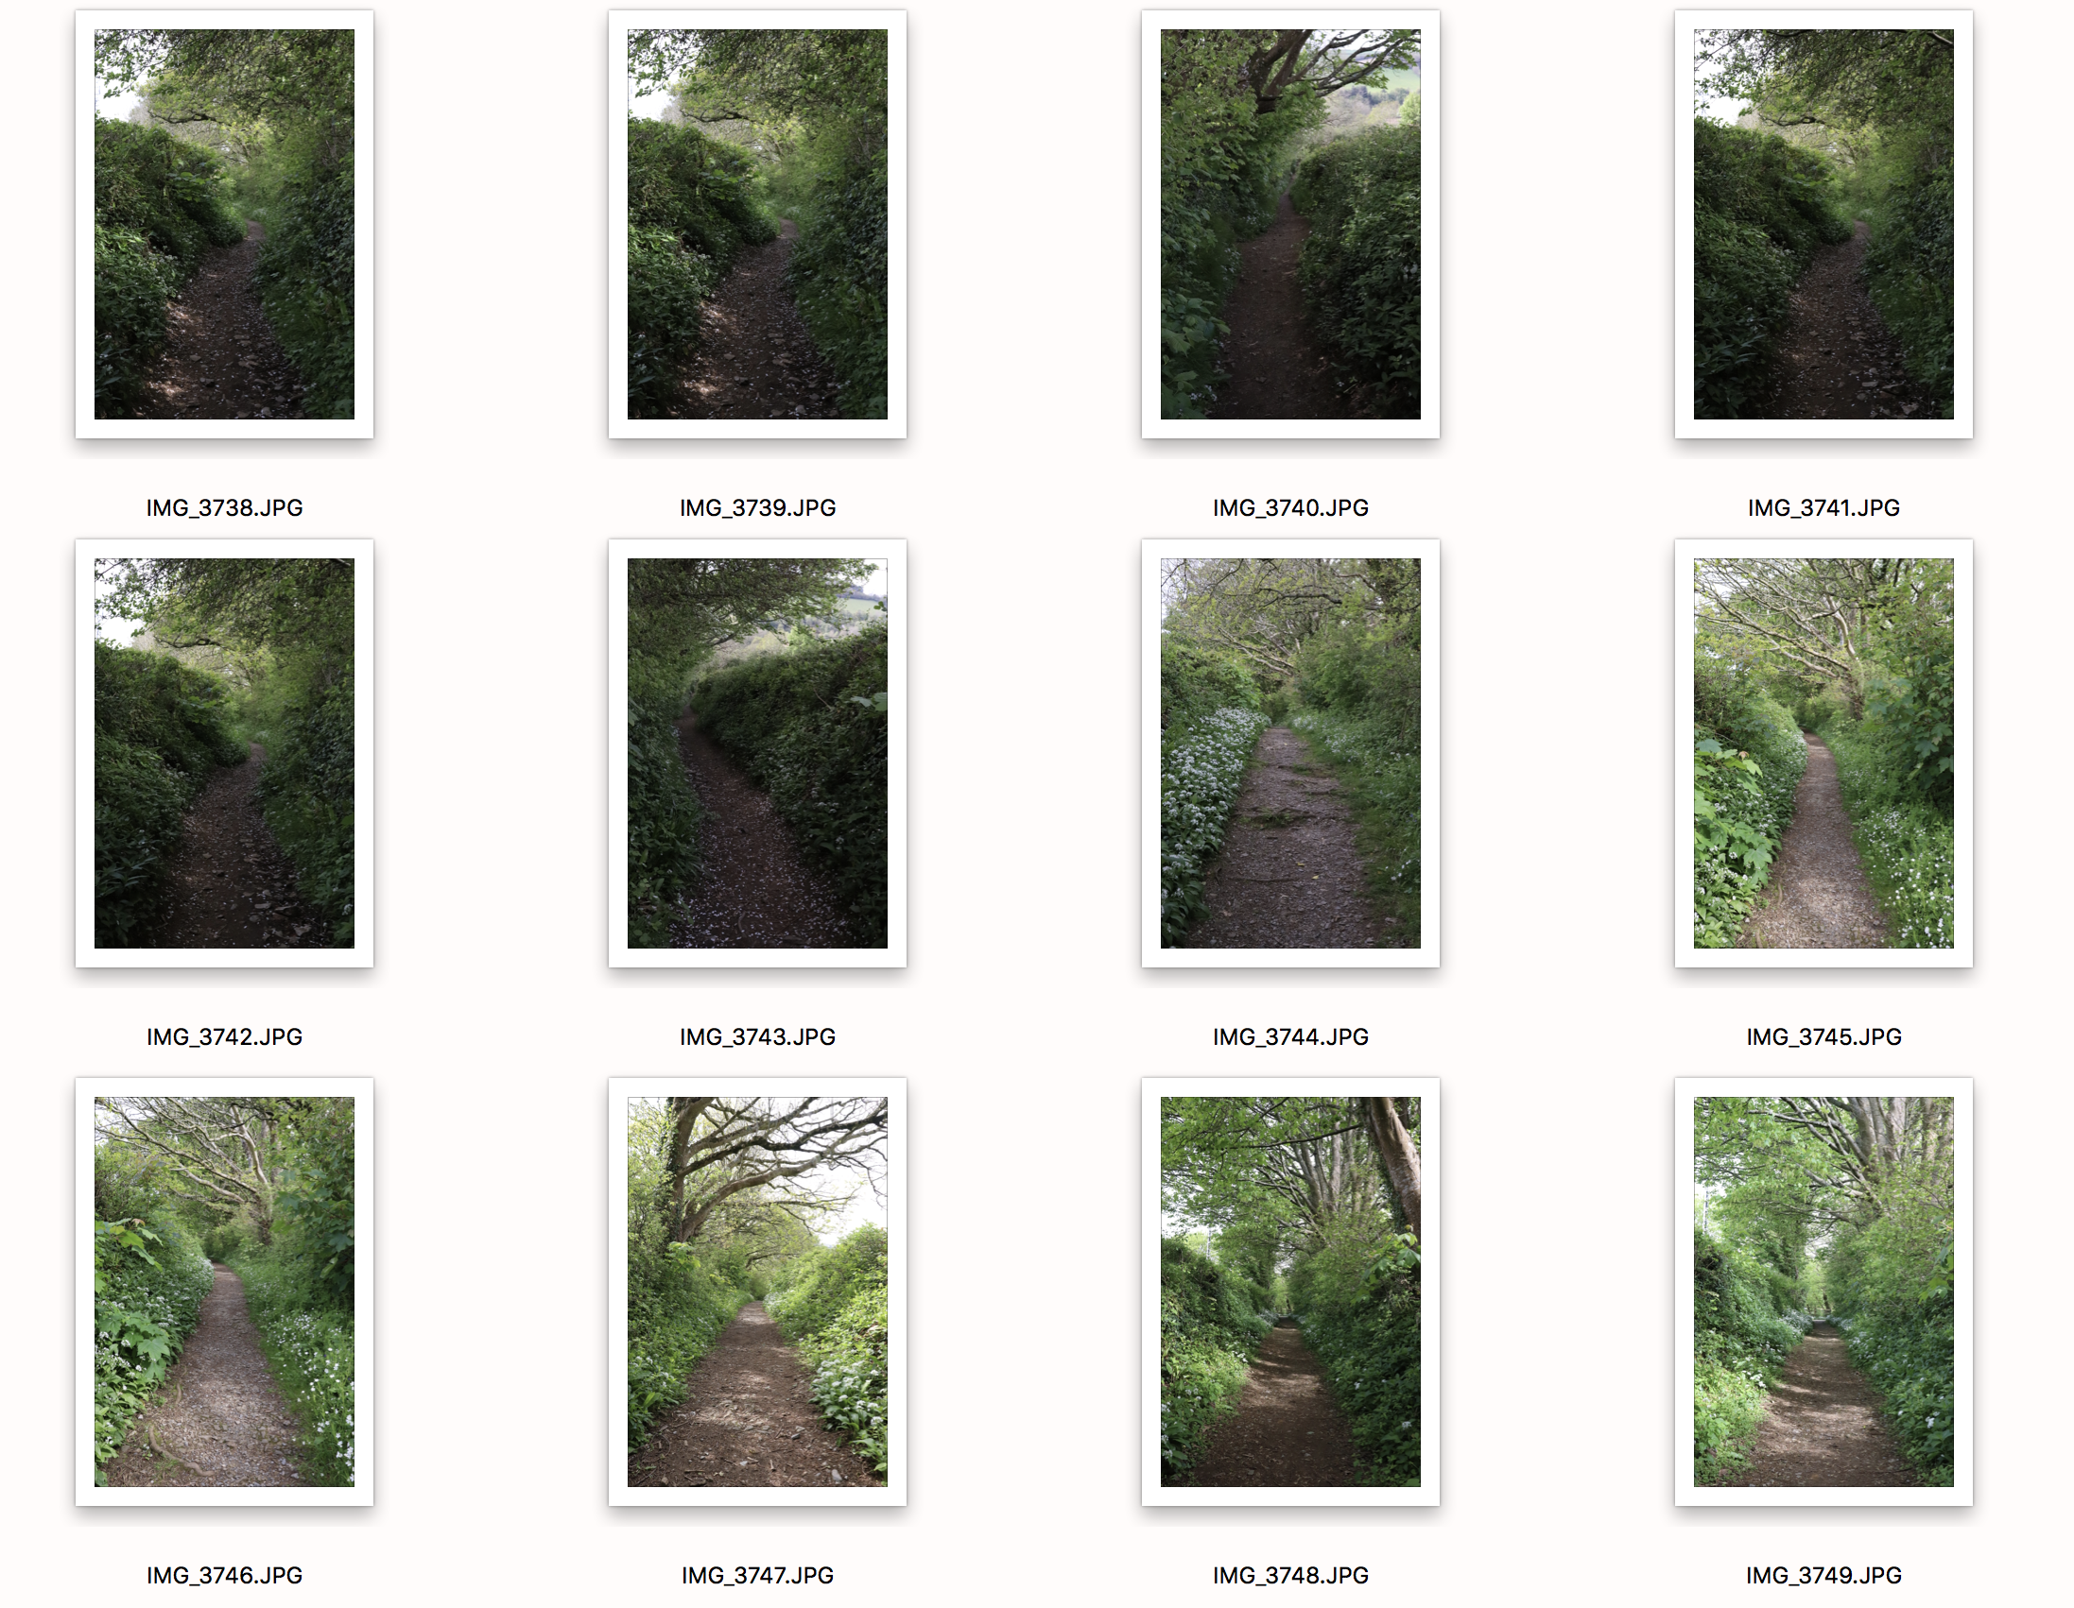
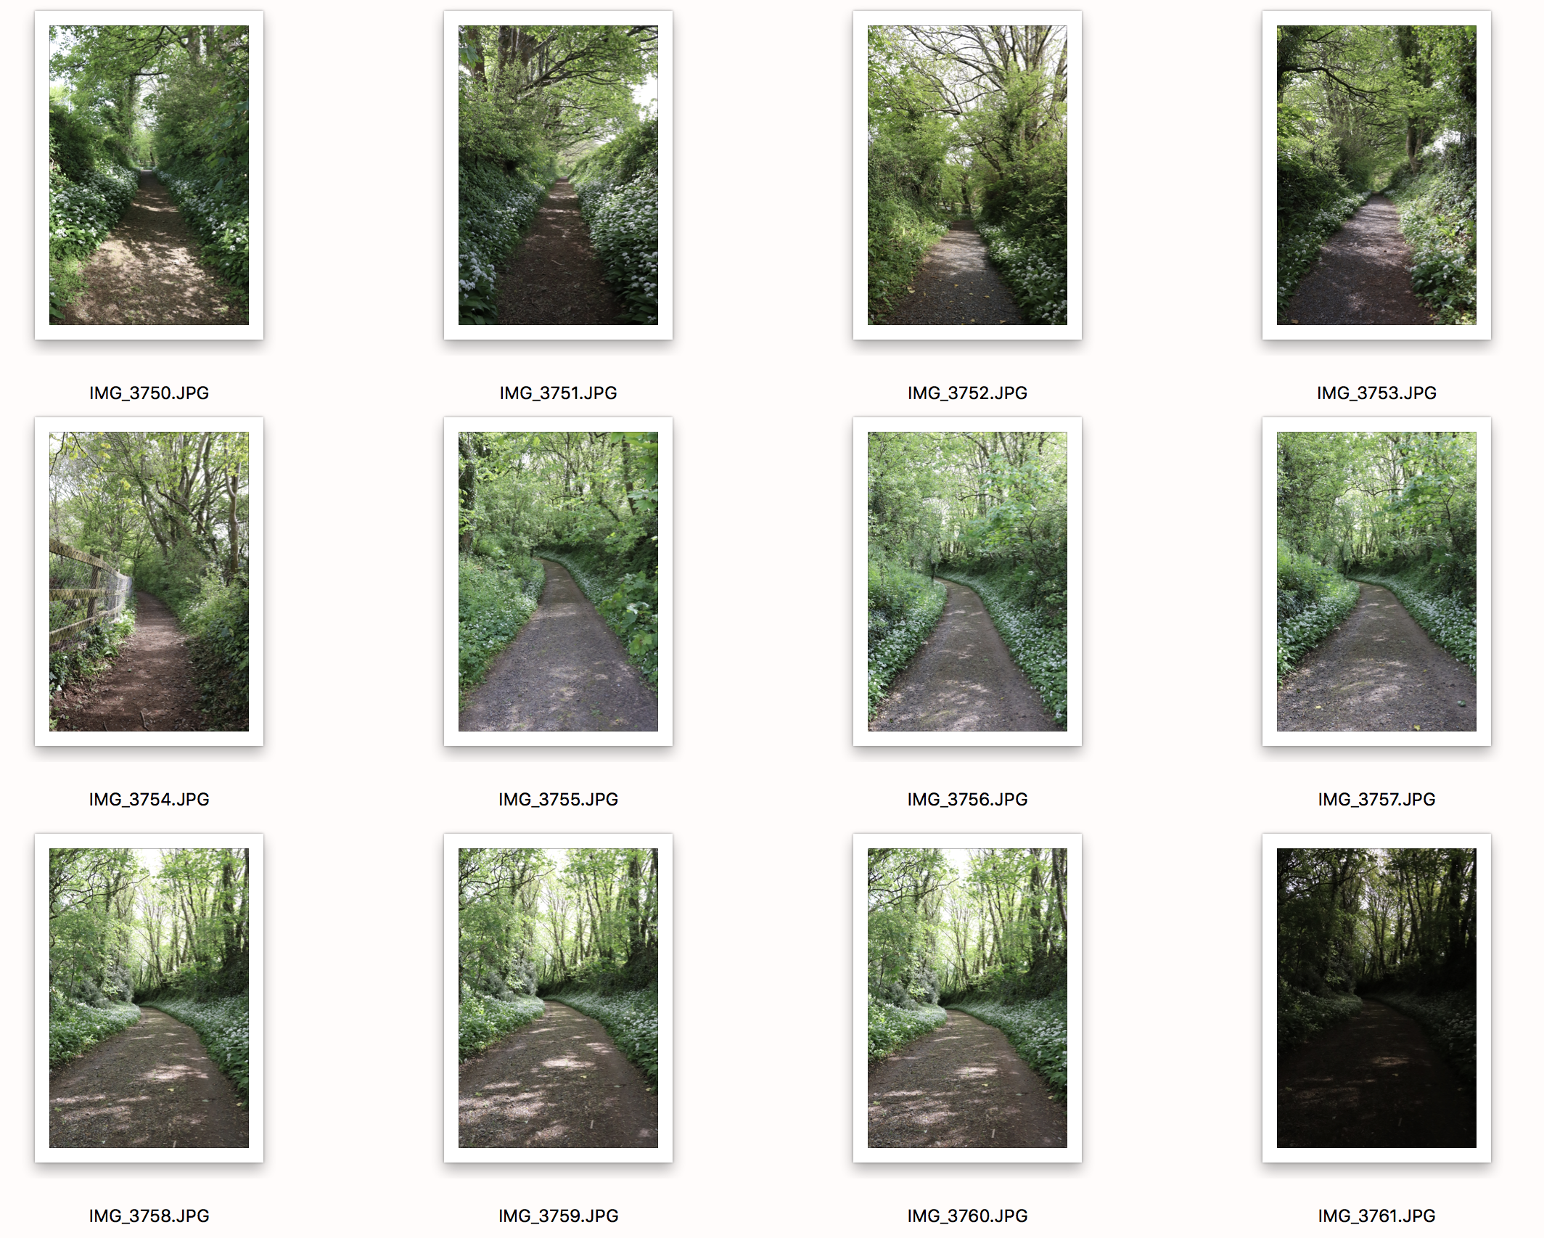
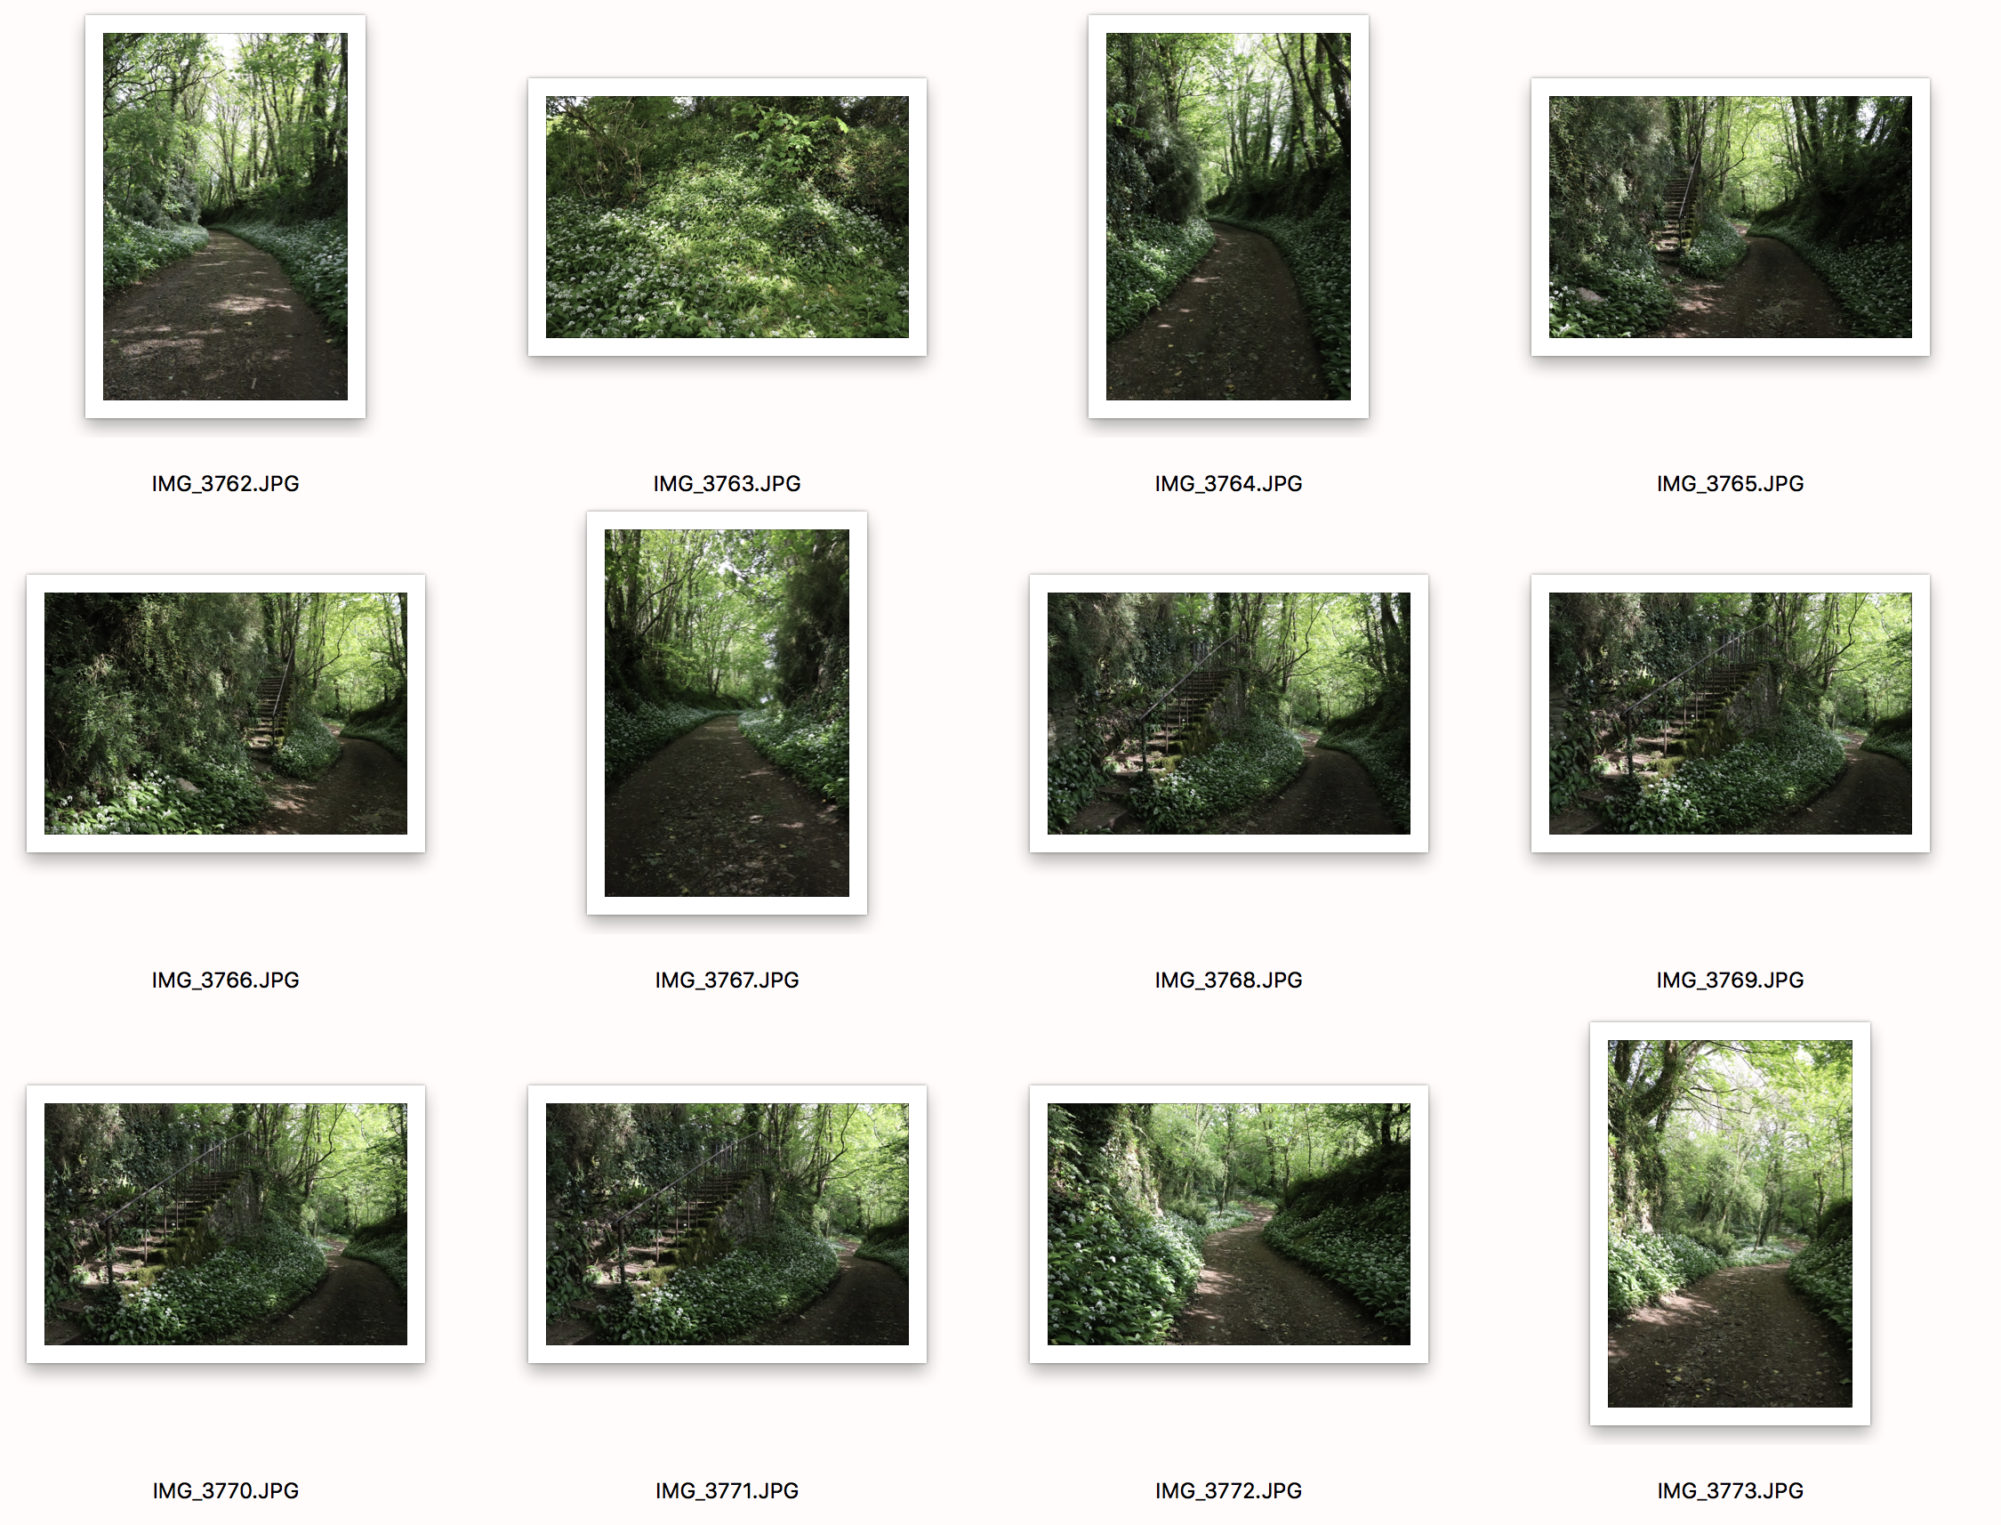
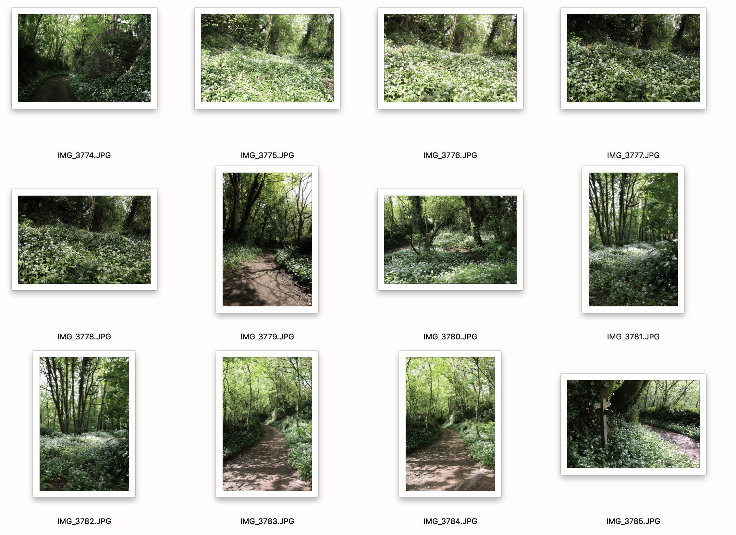
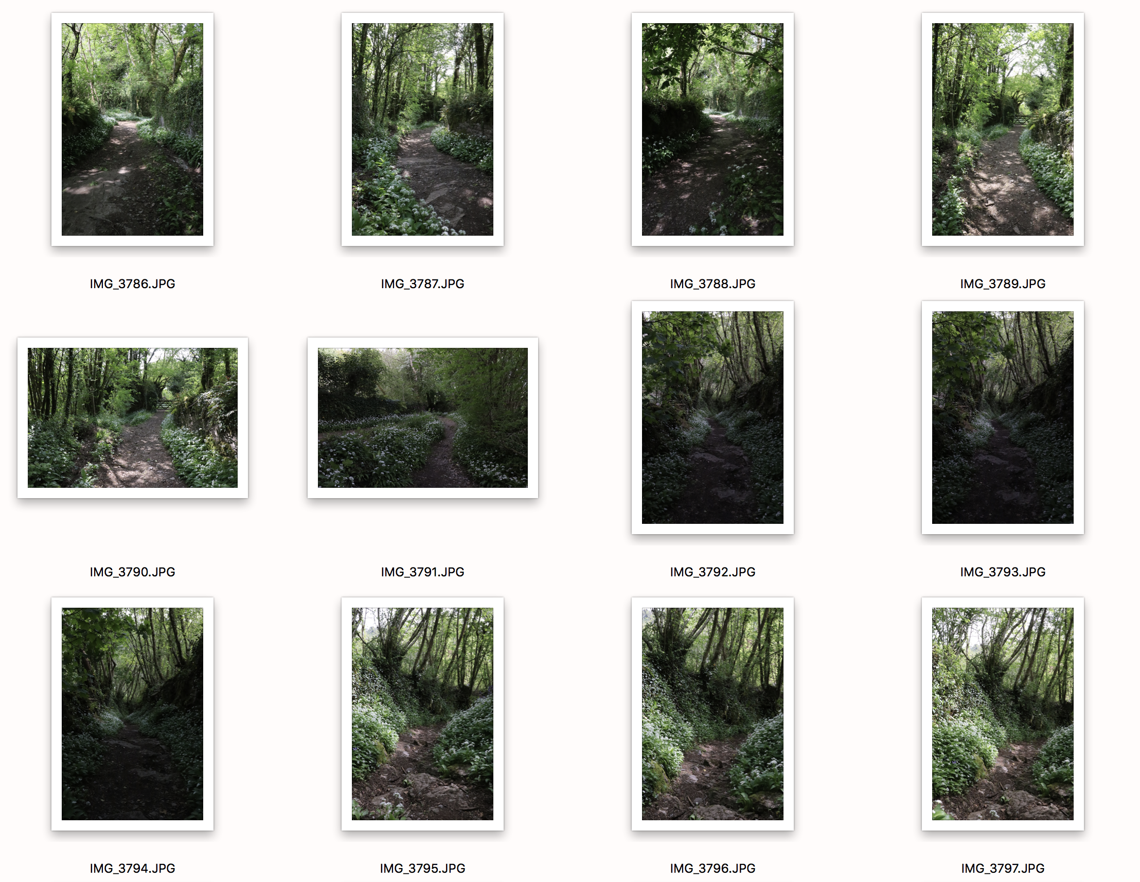
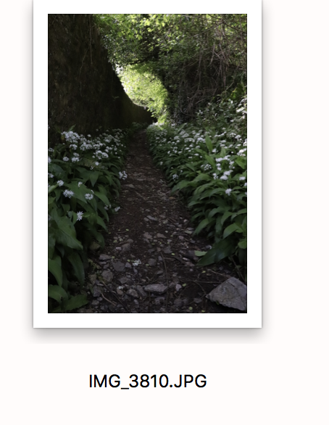
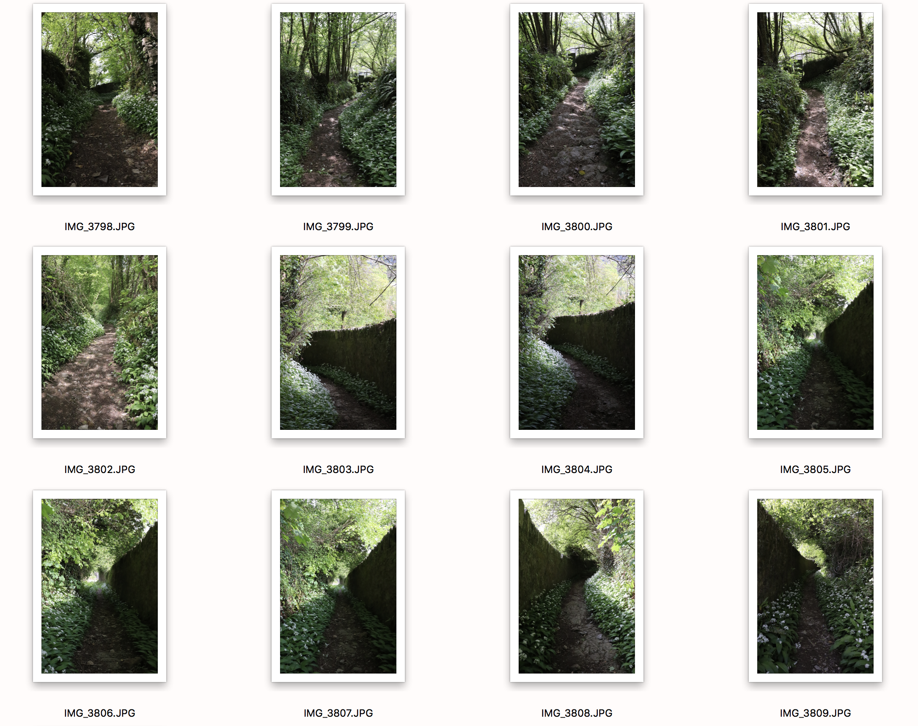
For this shoot, I went to a walking route in the hills near my home. I felt this was an interesting place to visit, as the sun finds it hard to shine through with all the plants and trees around. I also thought it would show where the natural light is strongest and where it is dark and not so good. I chose my selection very quickly. This is because there were a few angles I didn’t like, because they did not make the light stand out, and a few either over or under exposed, because I was experimenting with manual mode. Also, I think that some didn’t have much natural light in them at all, and were quite dull. I took a variety of images, both portrait and landscape, depending on what path I was on and what I thought looked best. I chose 2 landscape, and 2 of the best portraiture as this makes my finals look more uniform, and were genuinely my favourite images, fortunately.

