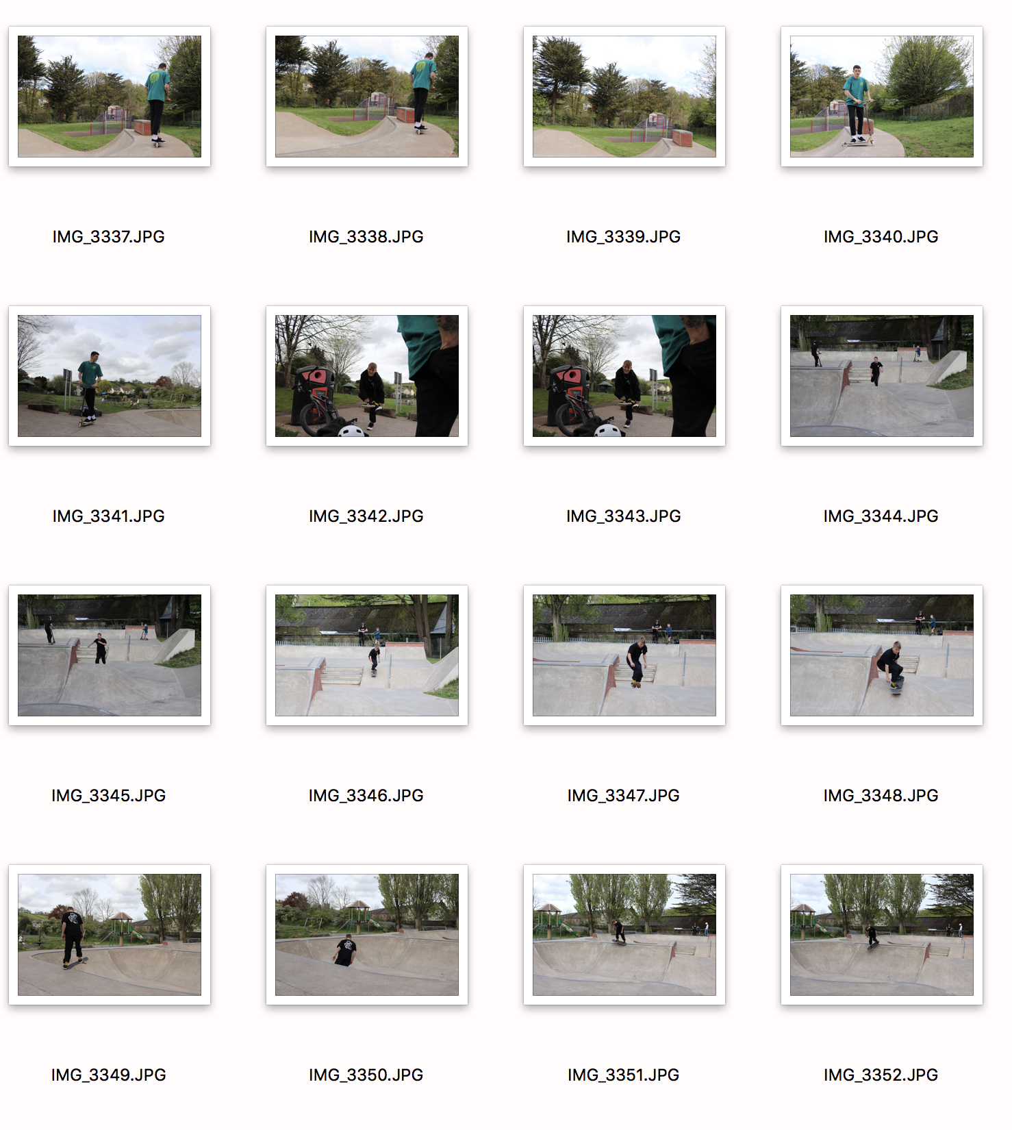

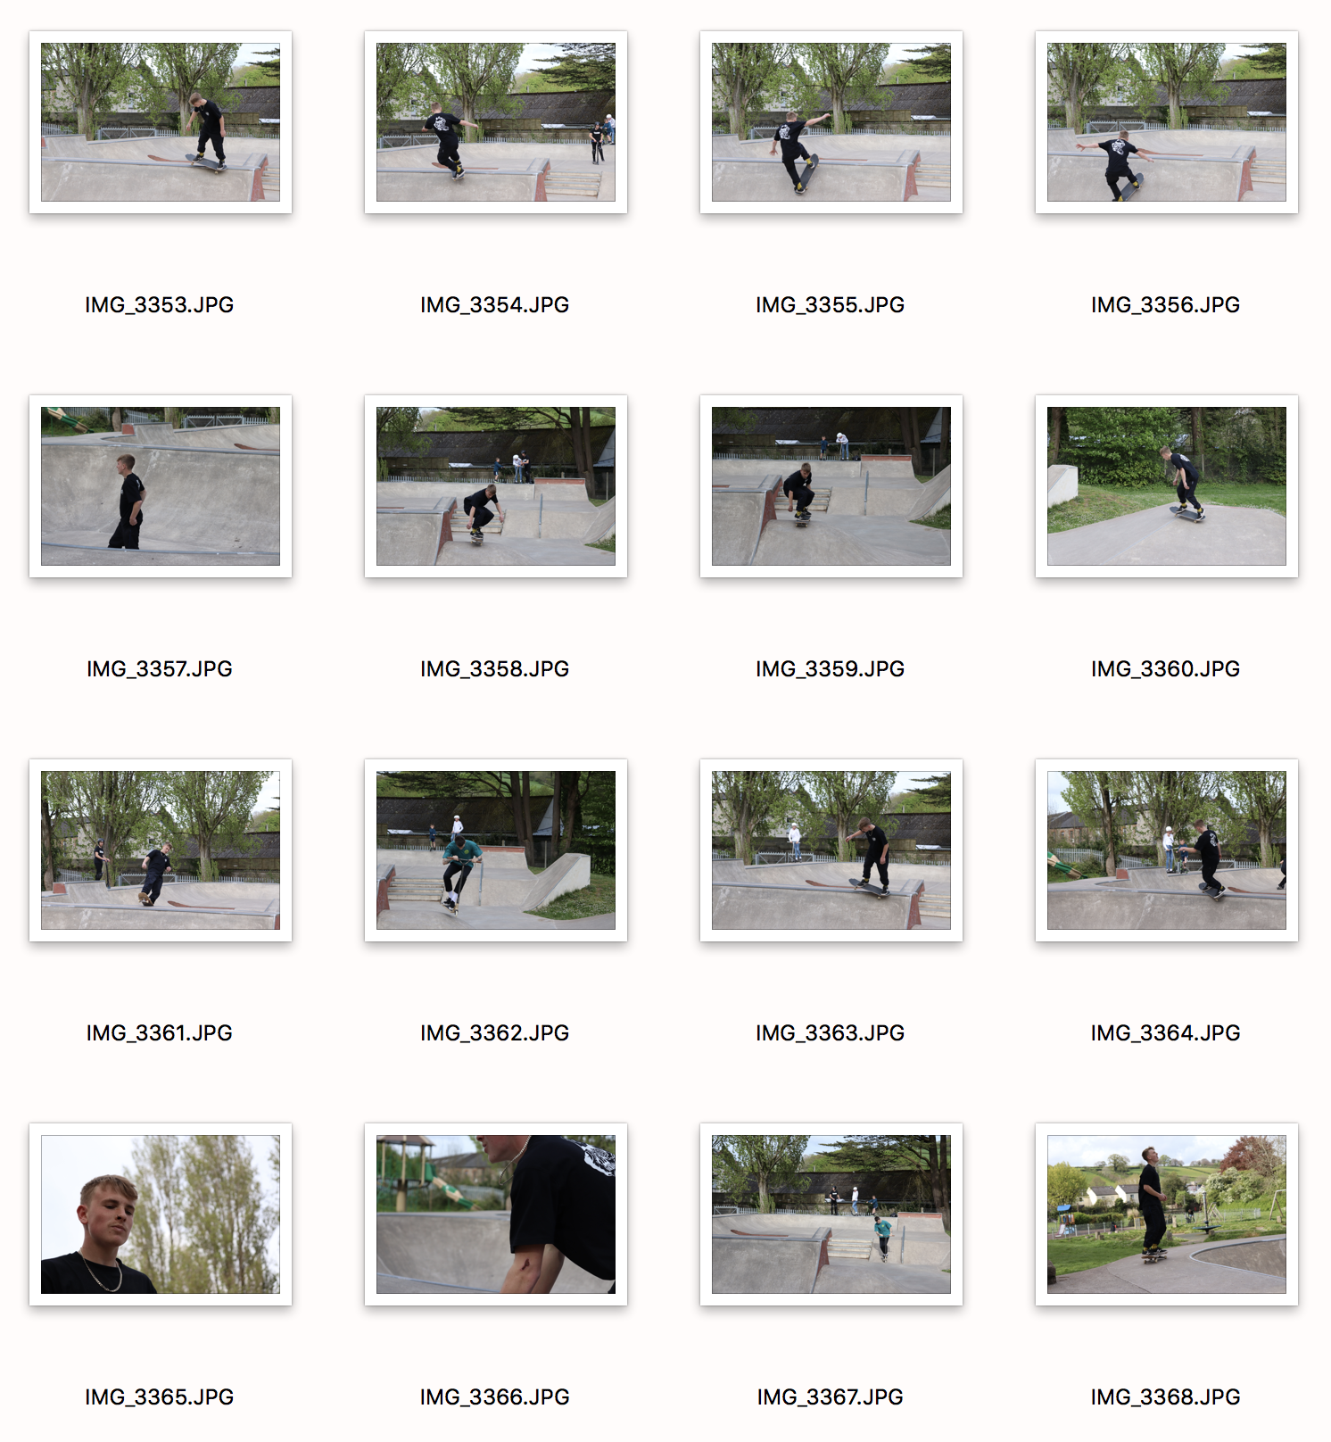

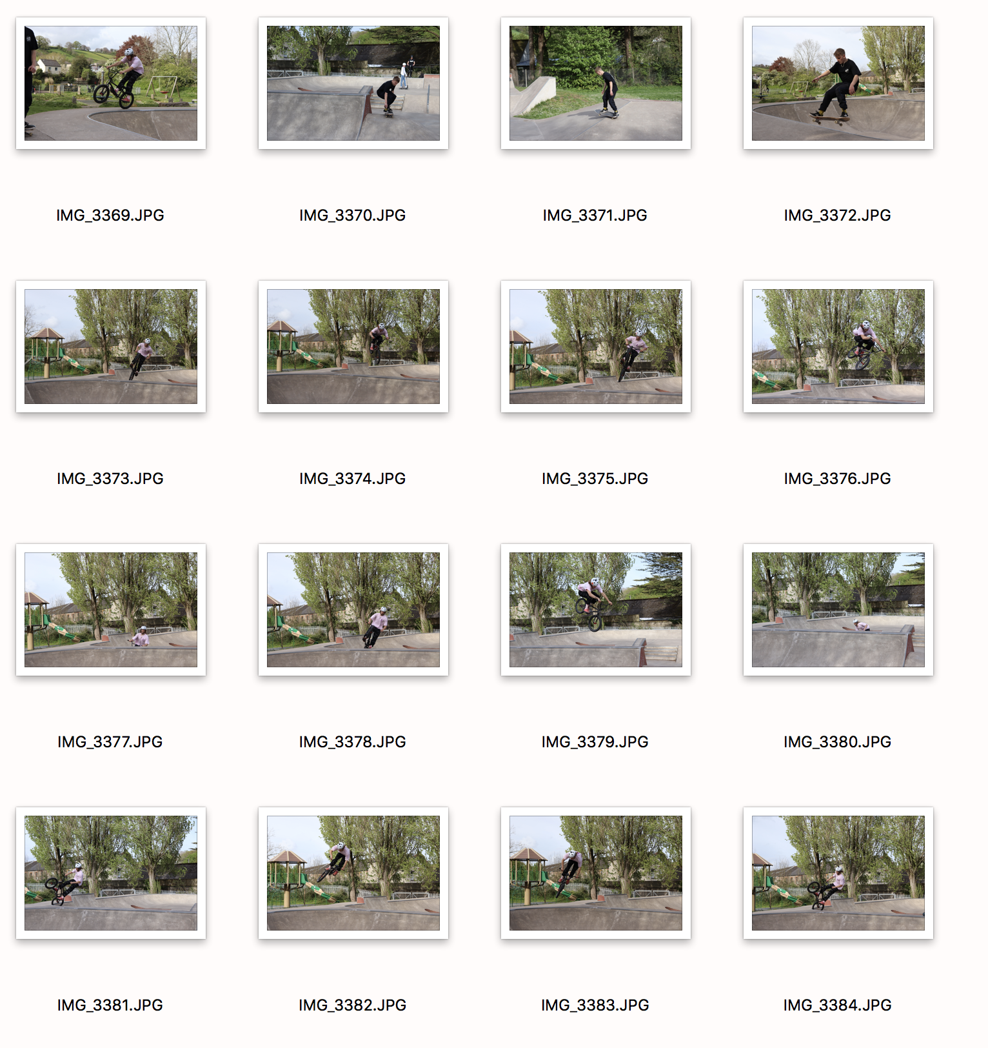

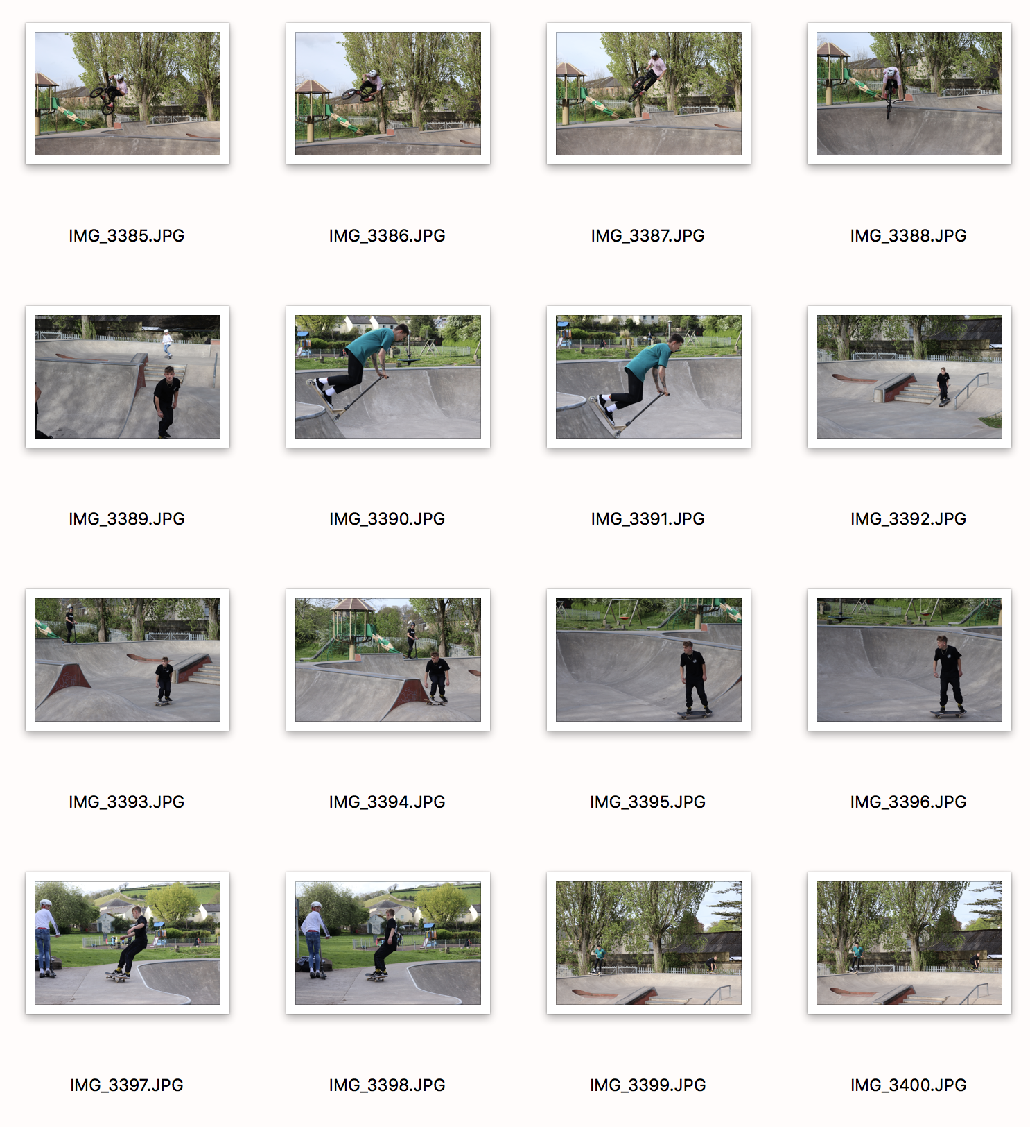

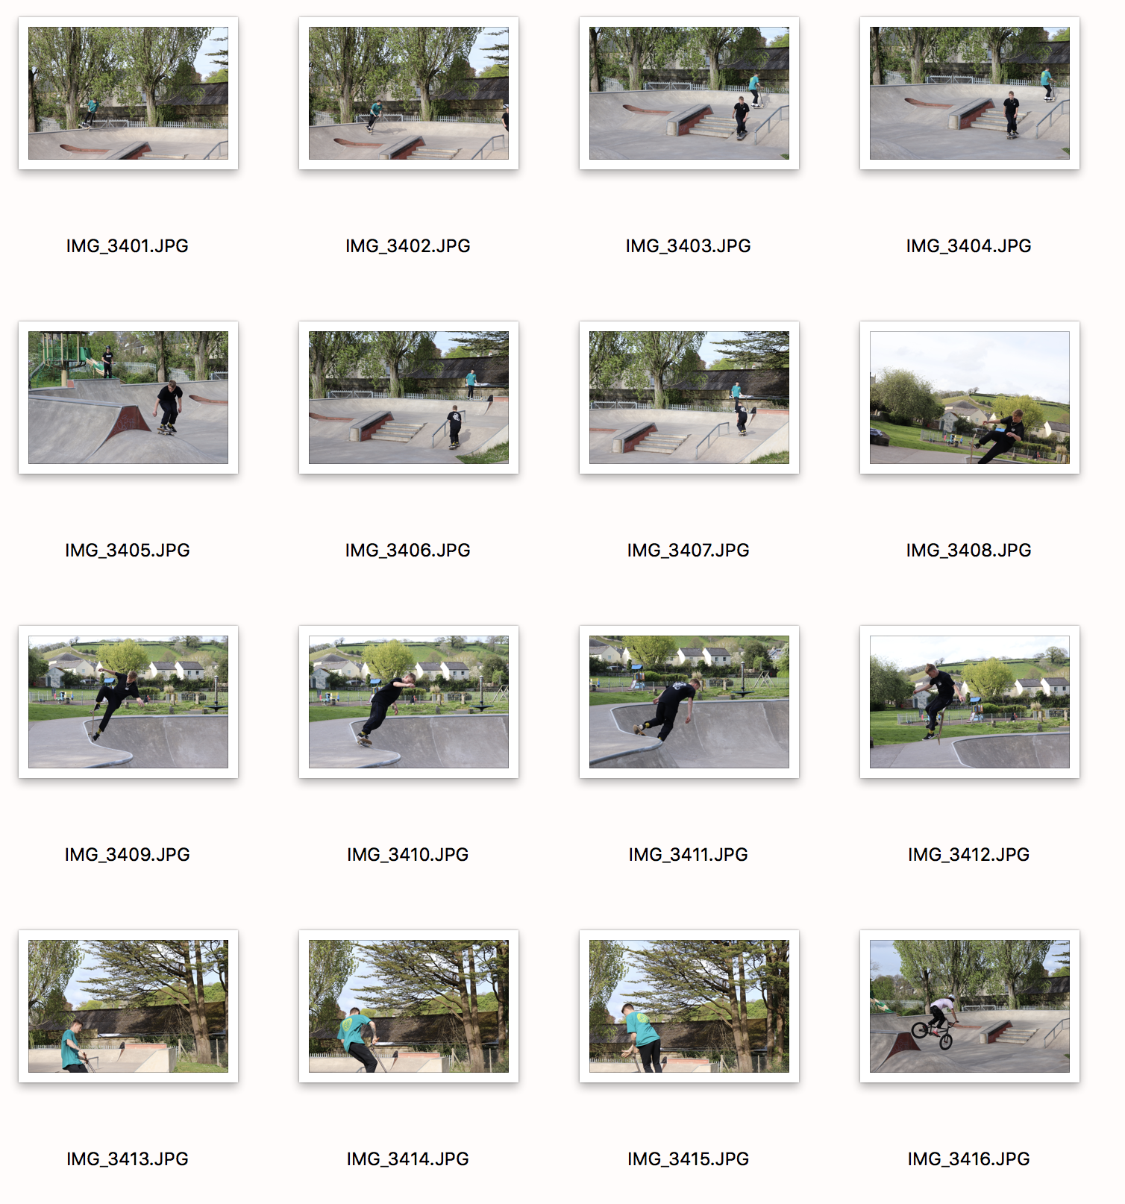

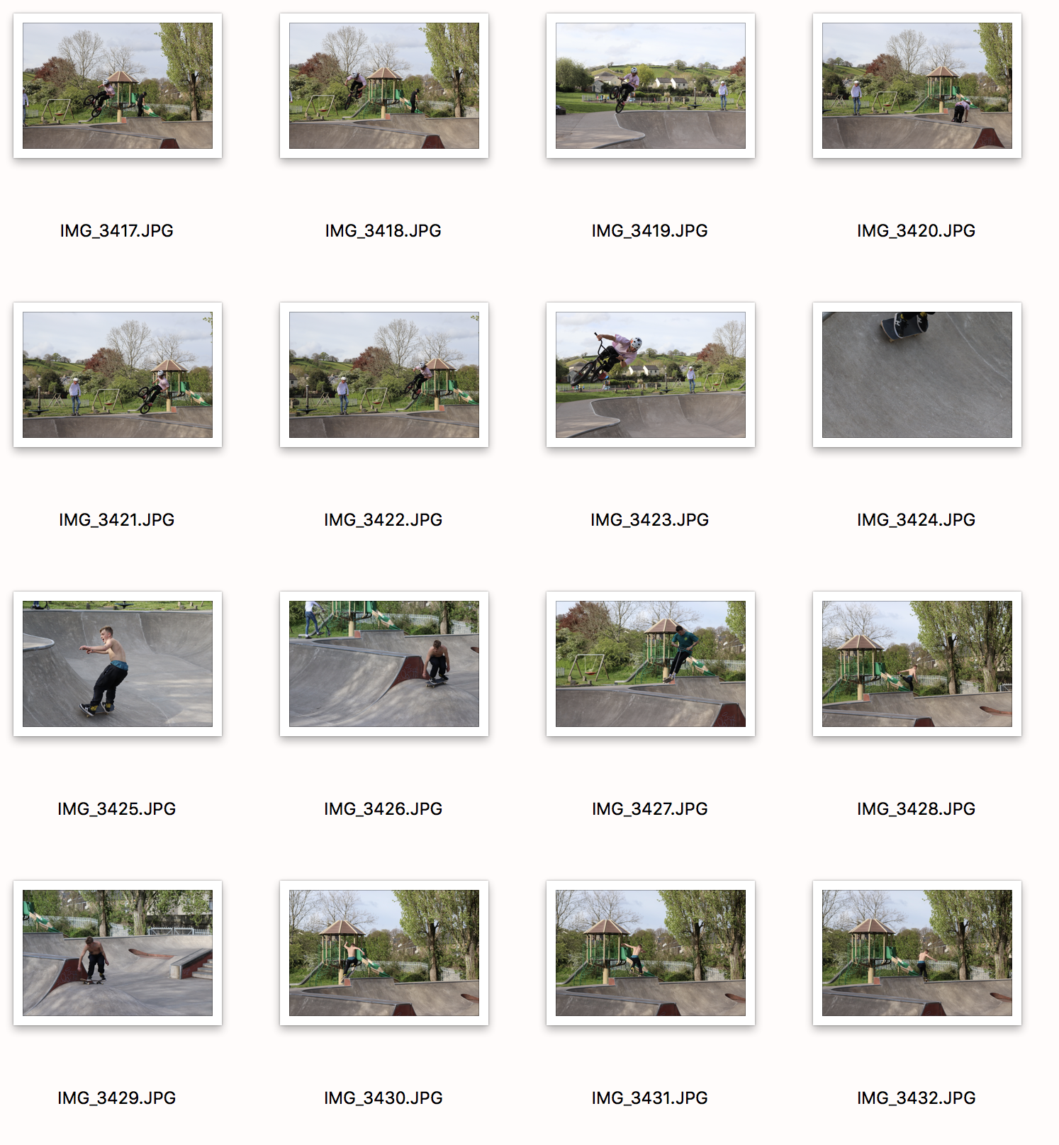

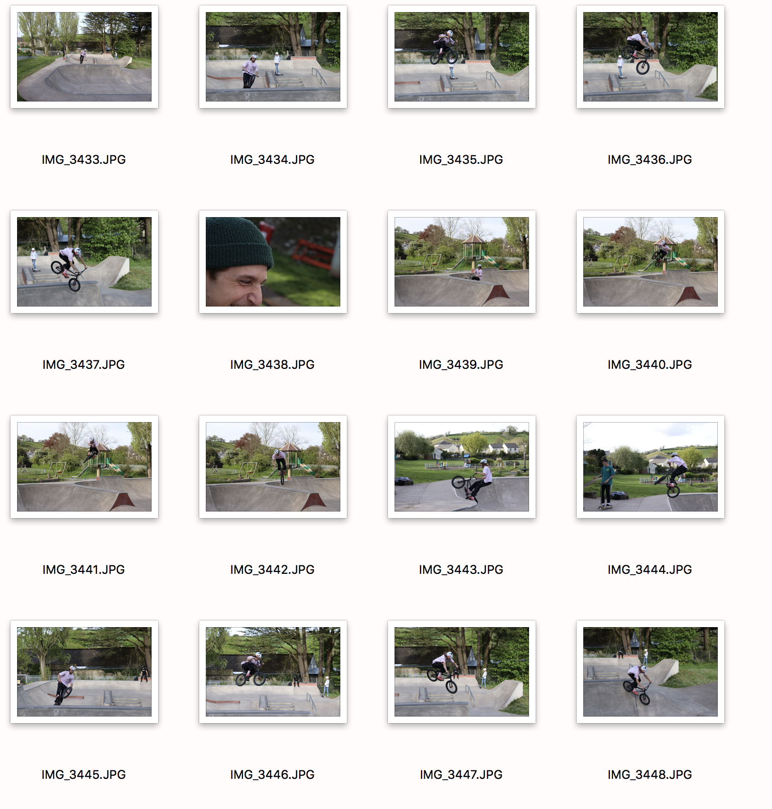

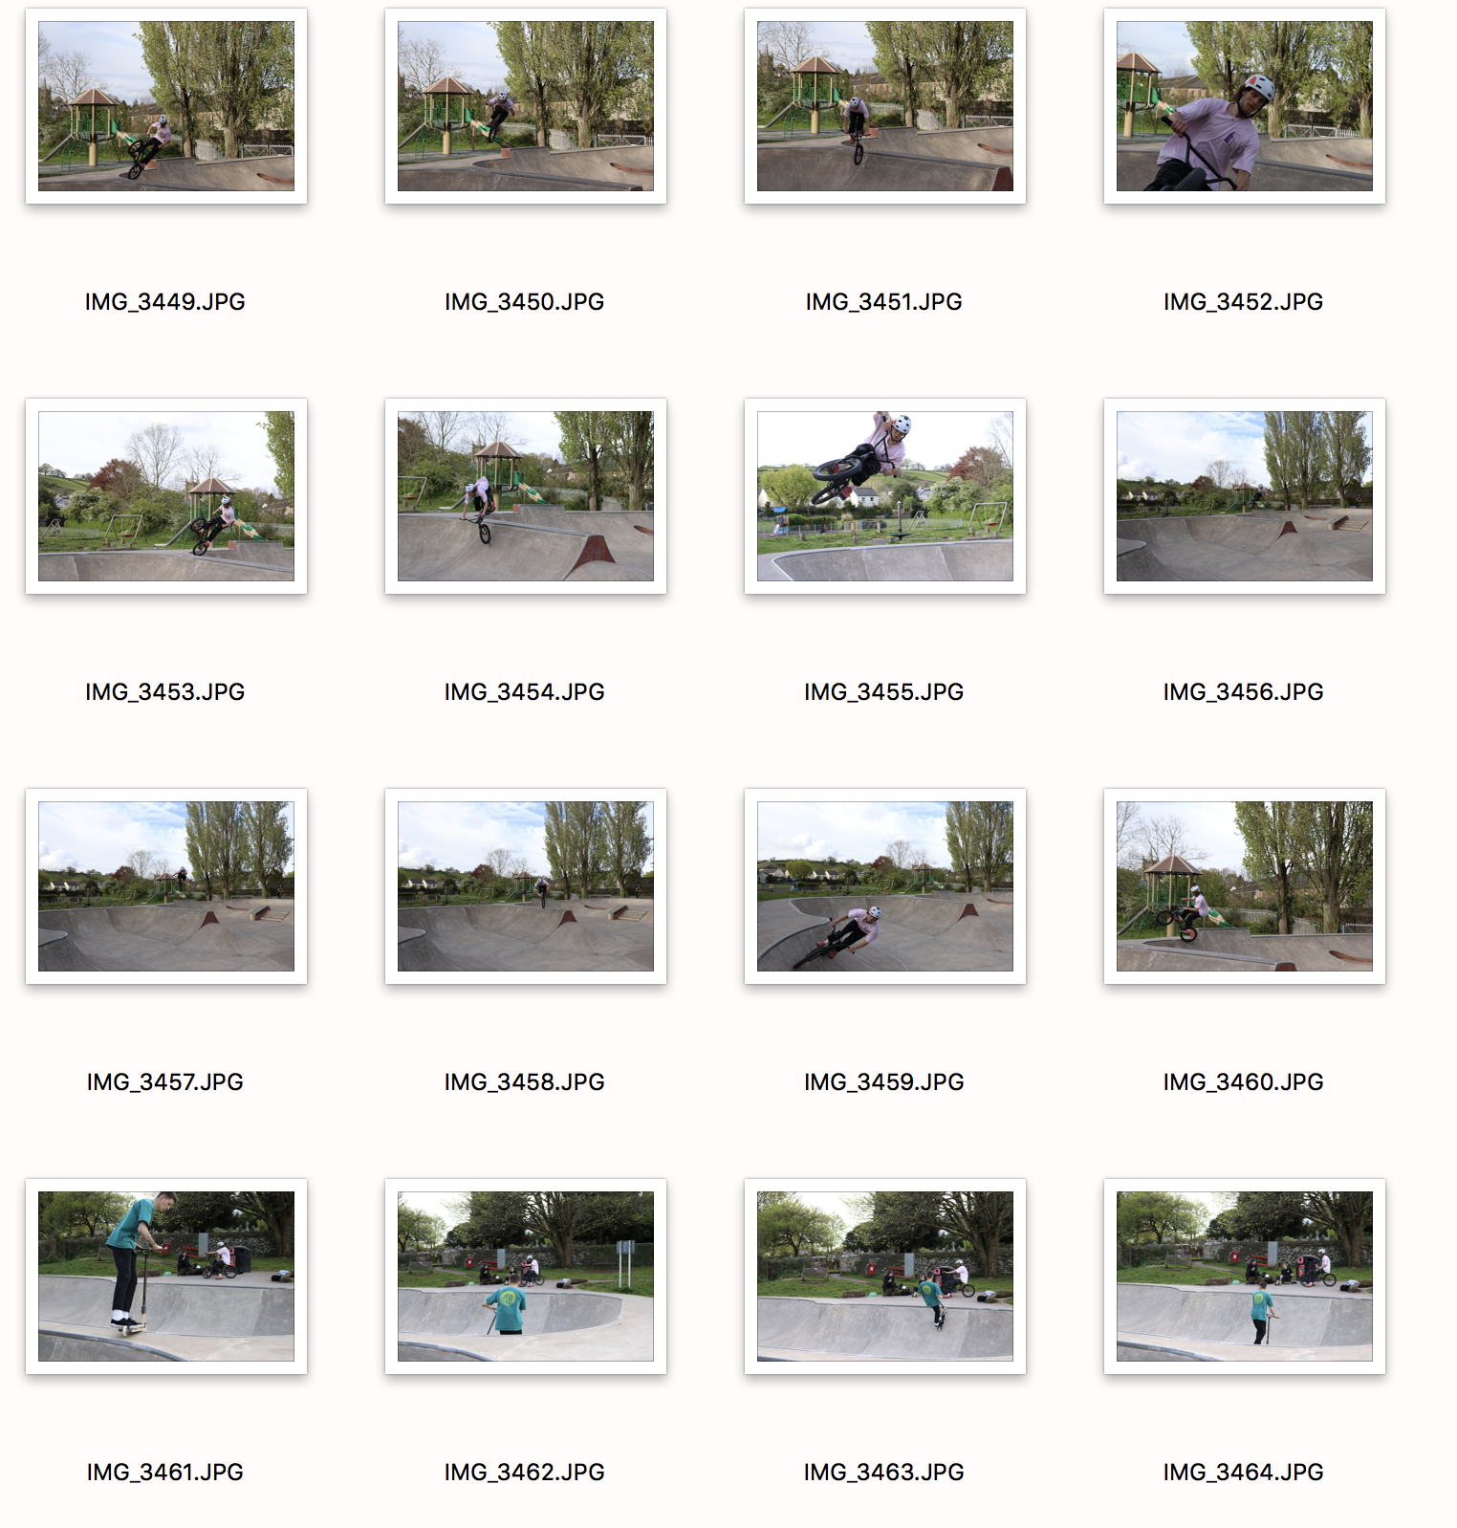

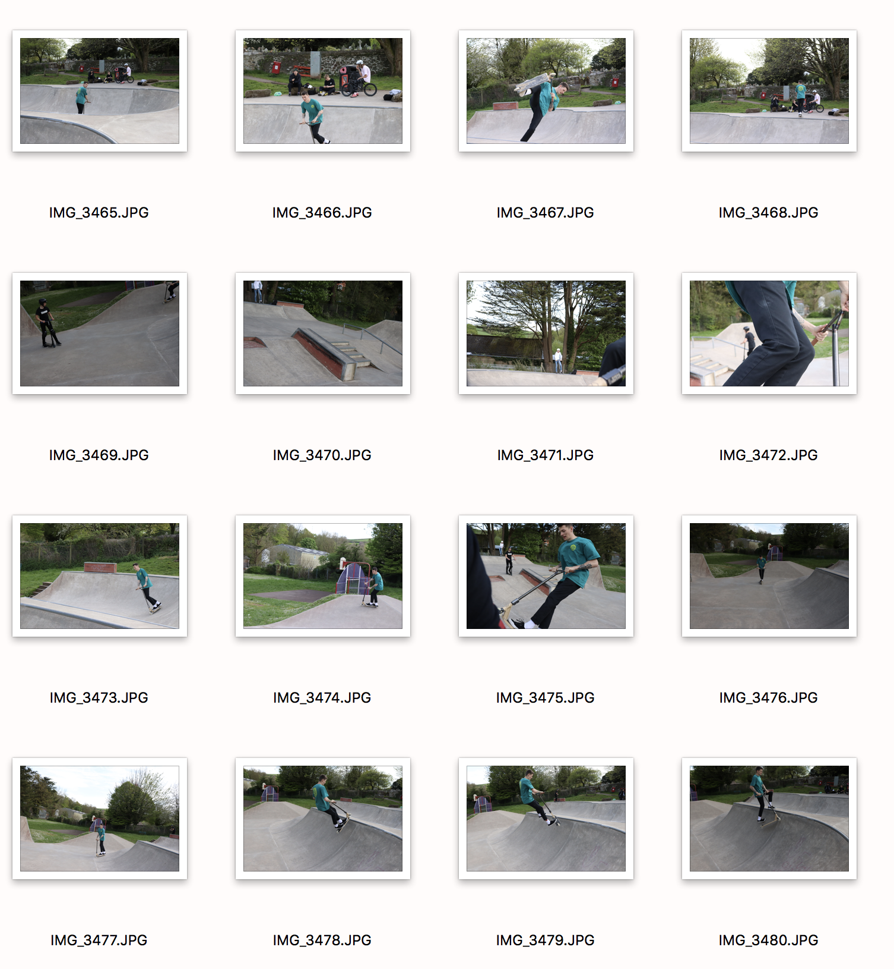

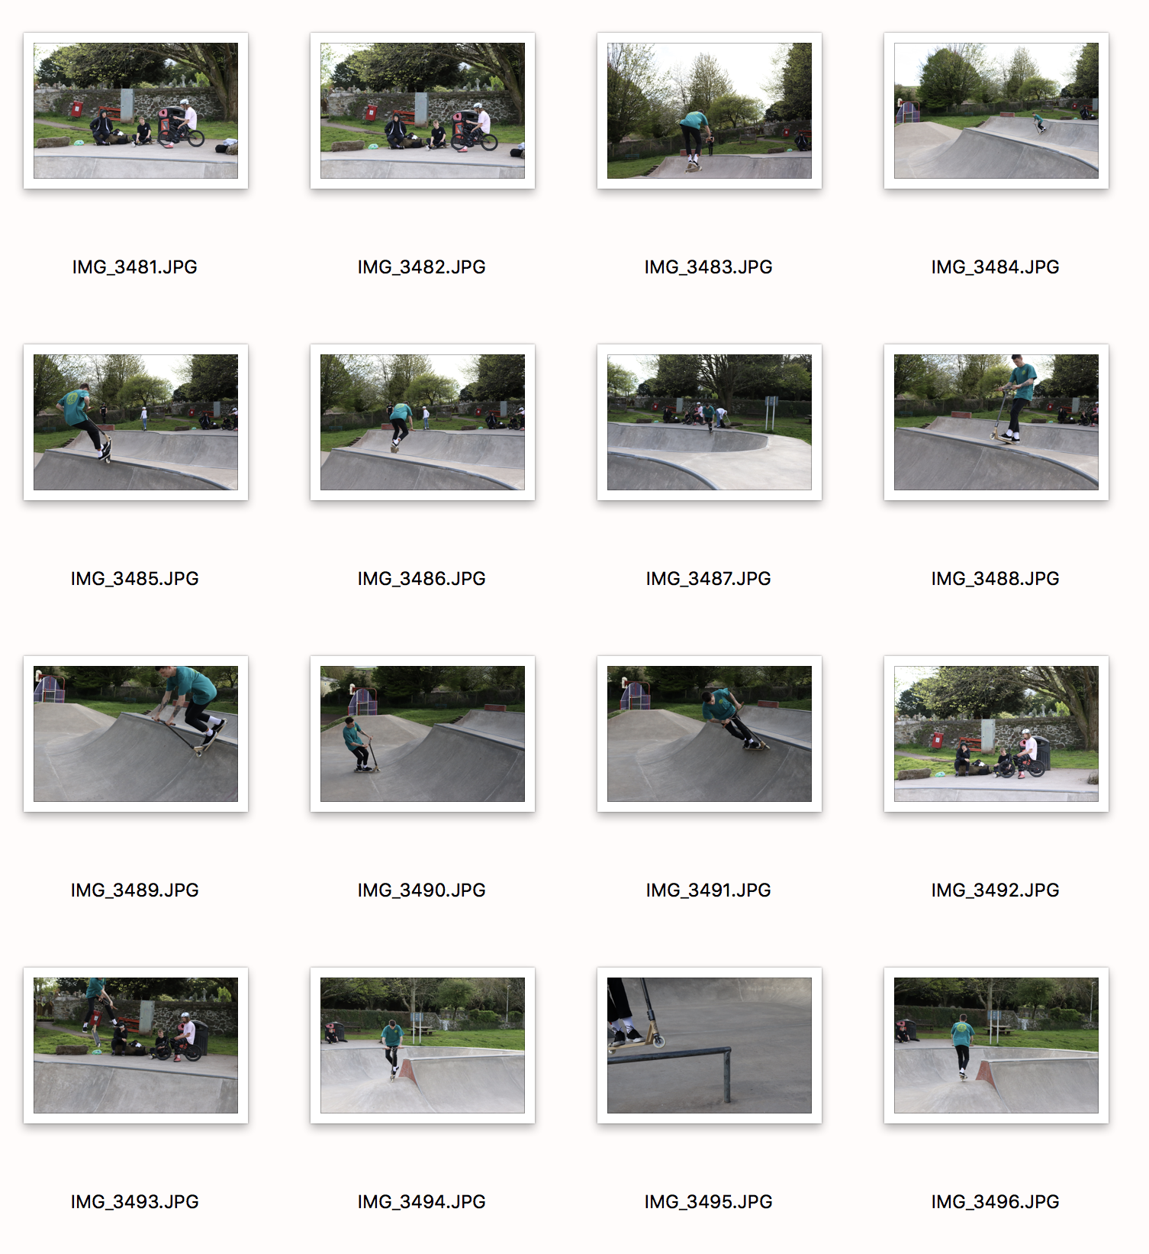

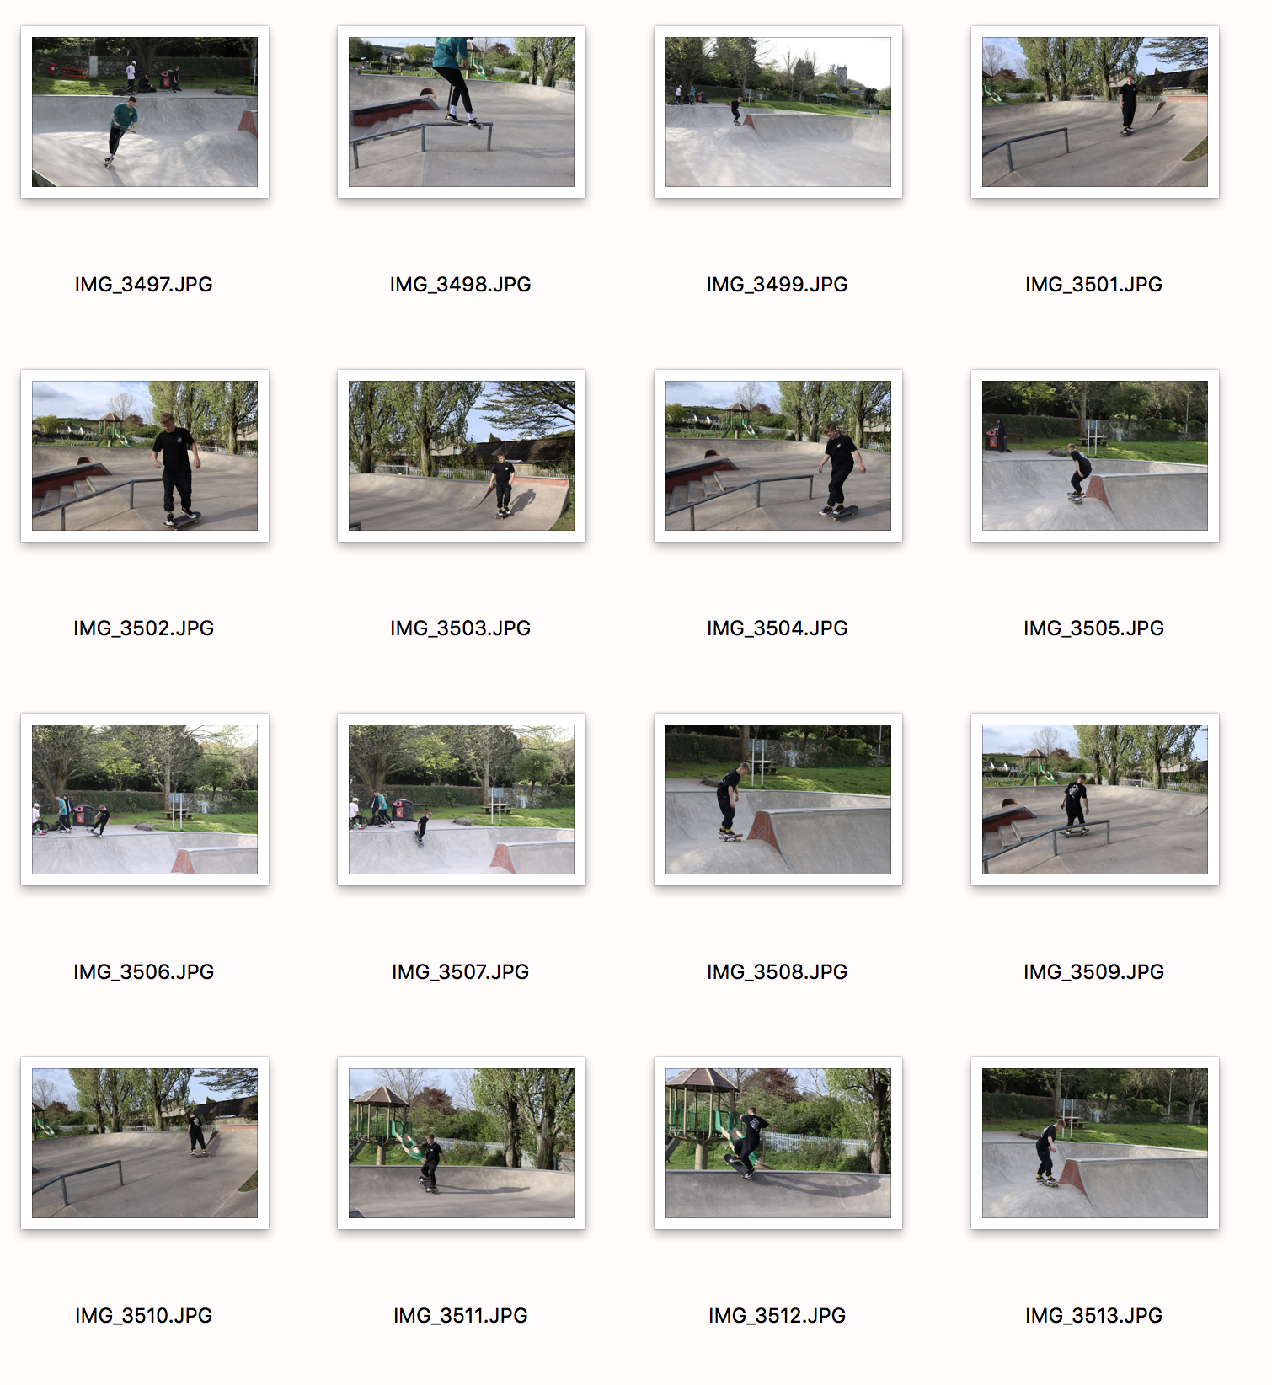

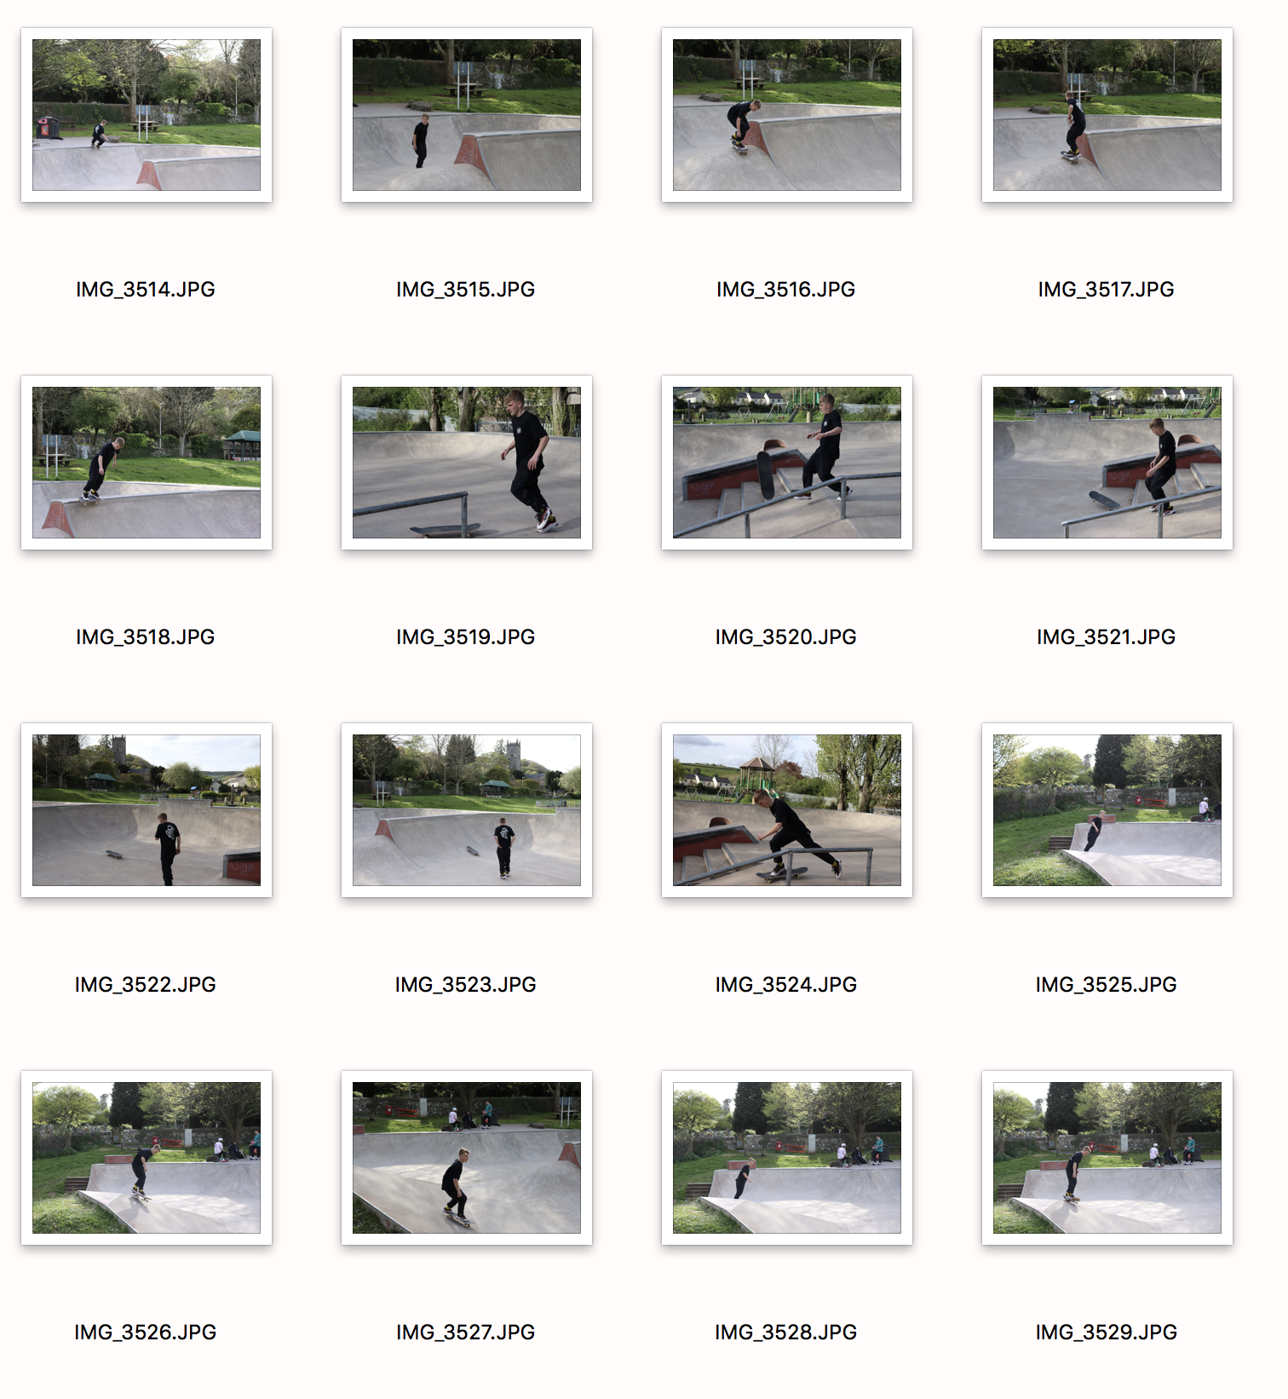

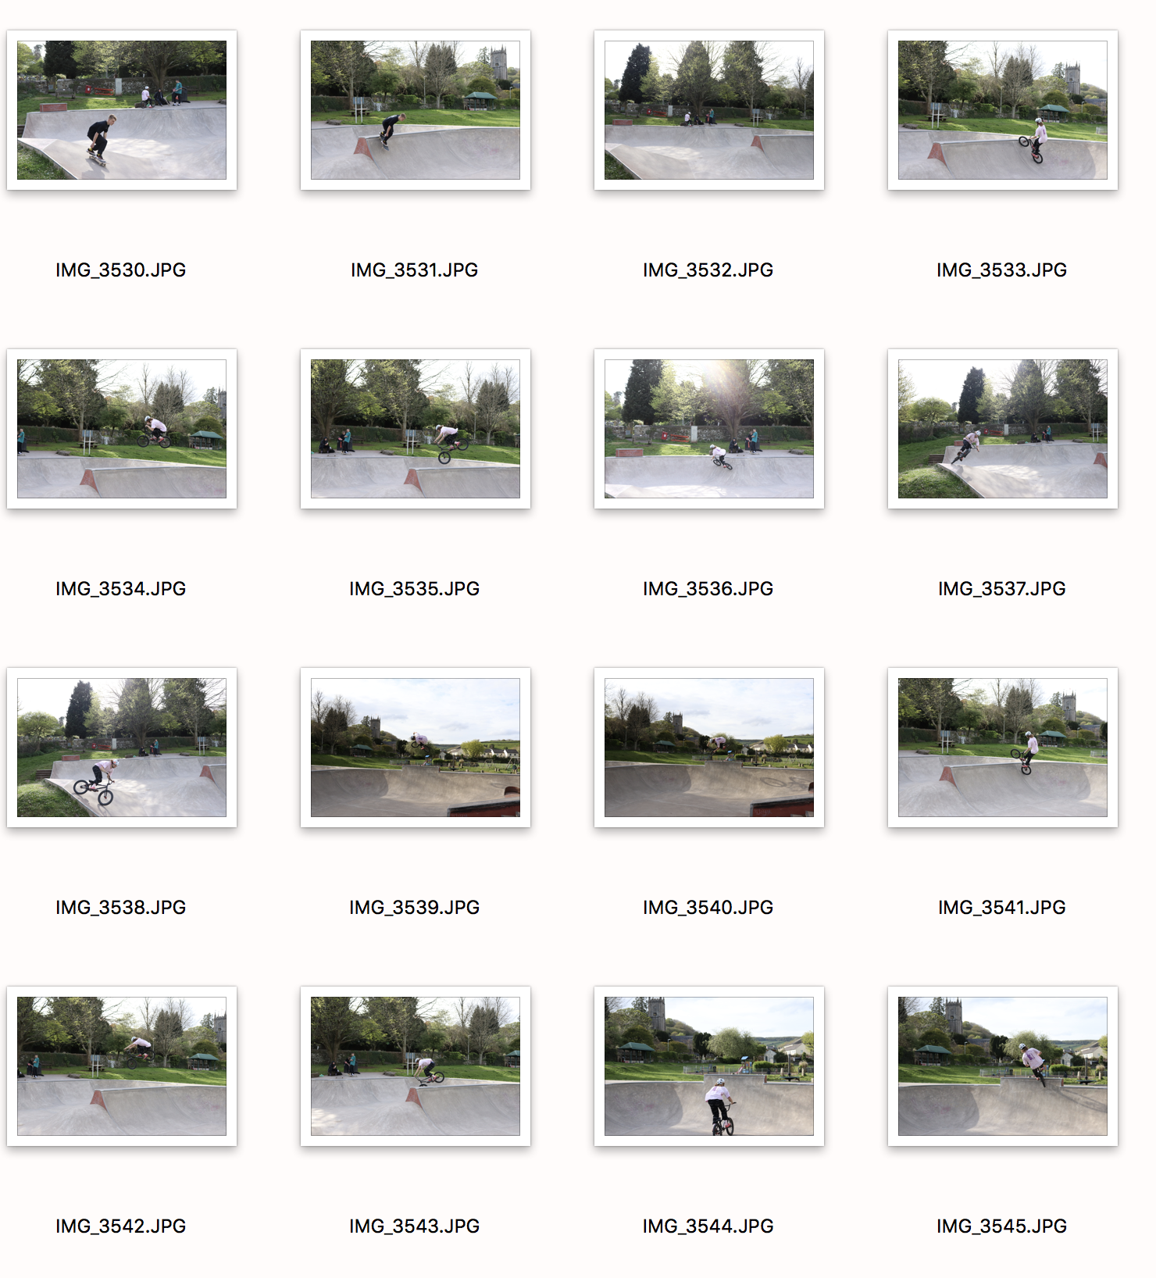

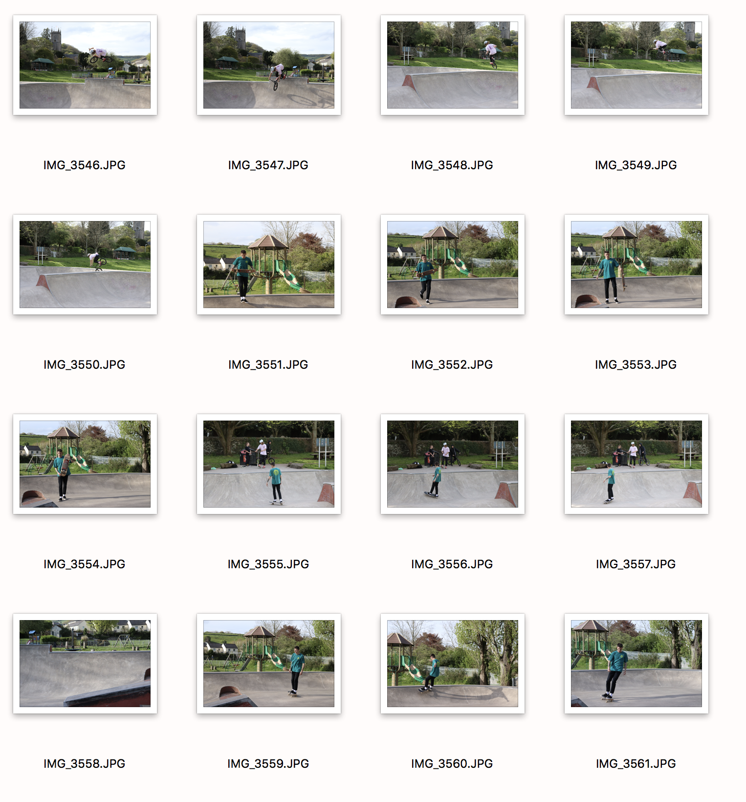

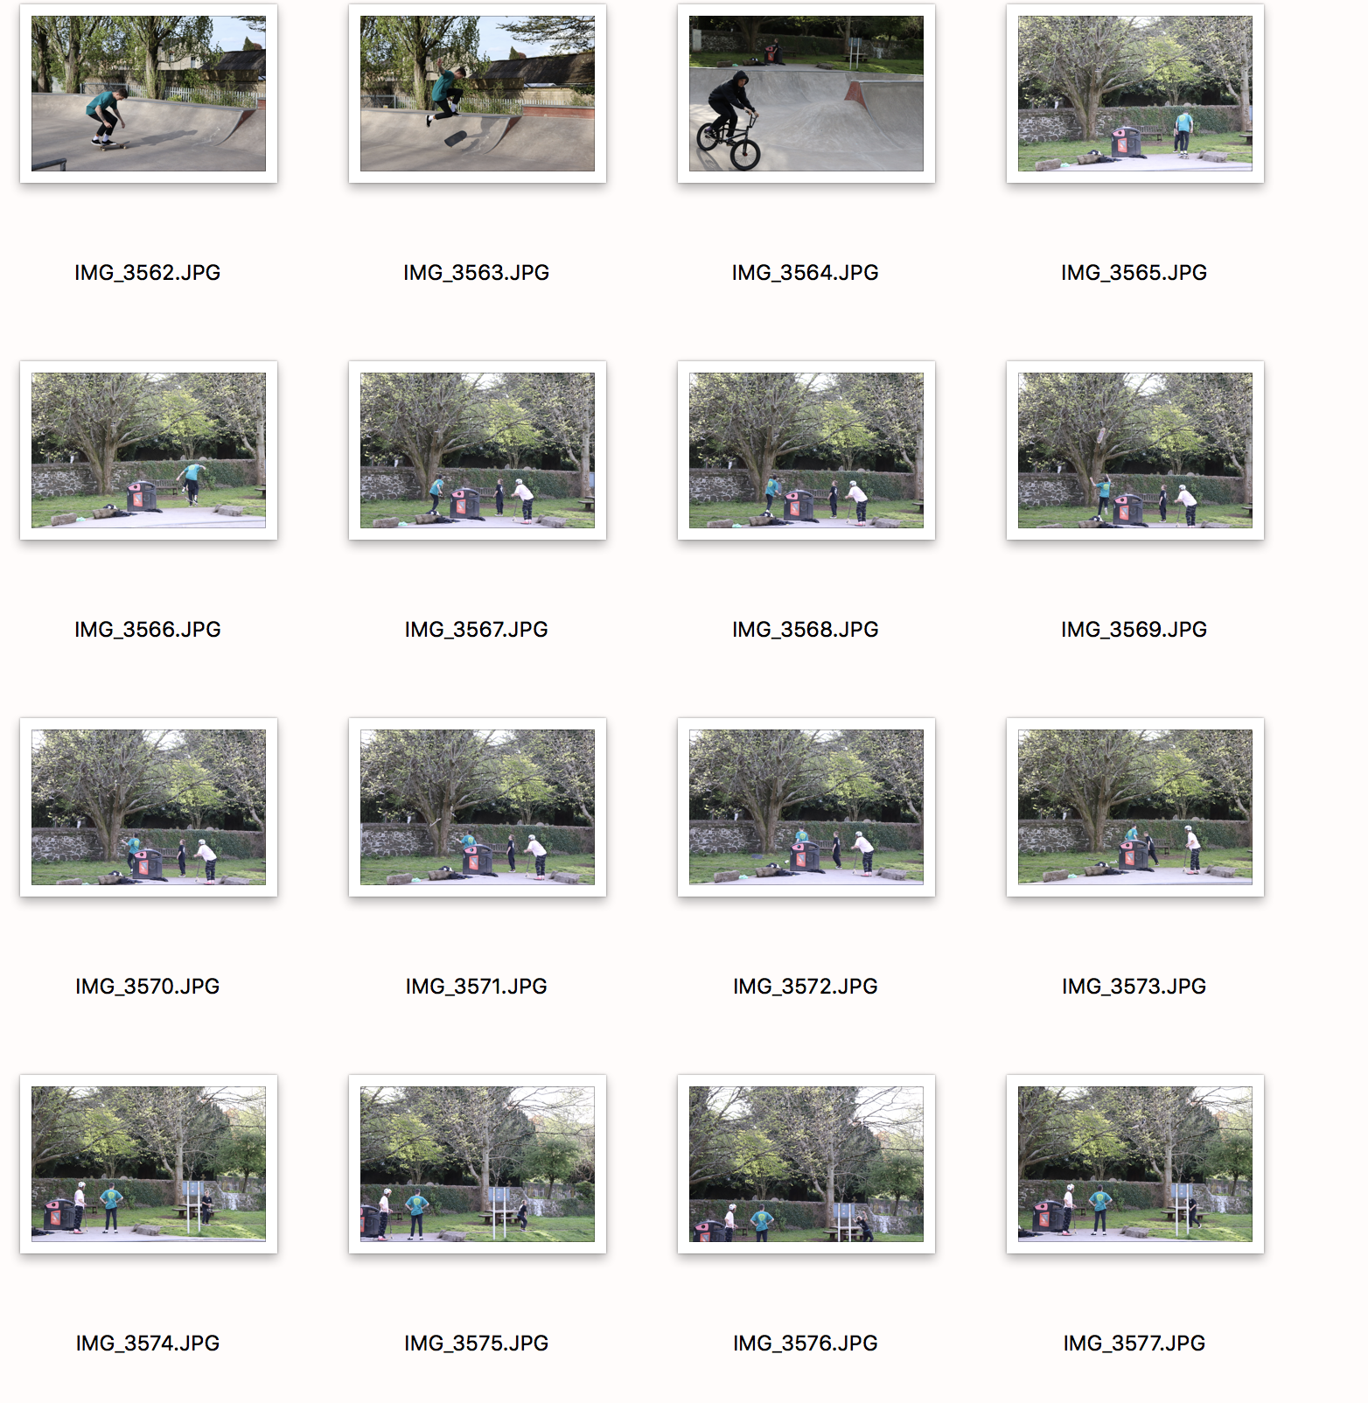

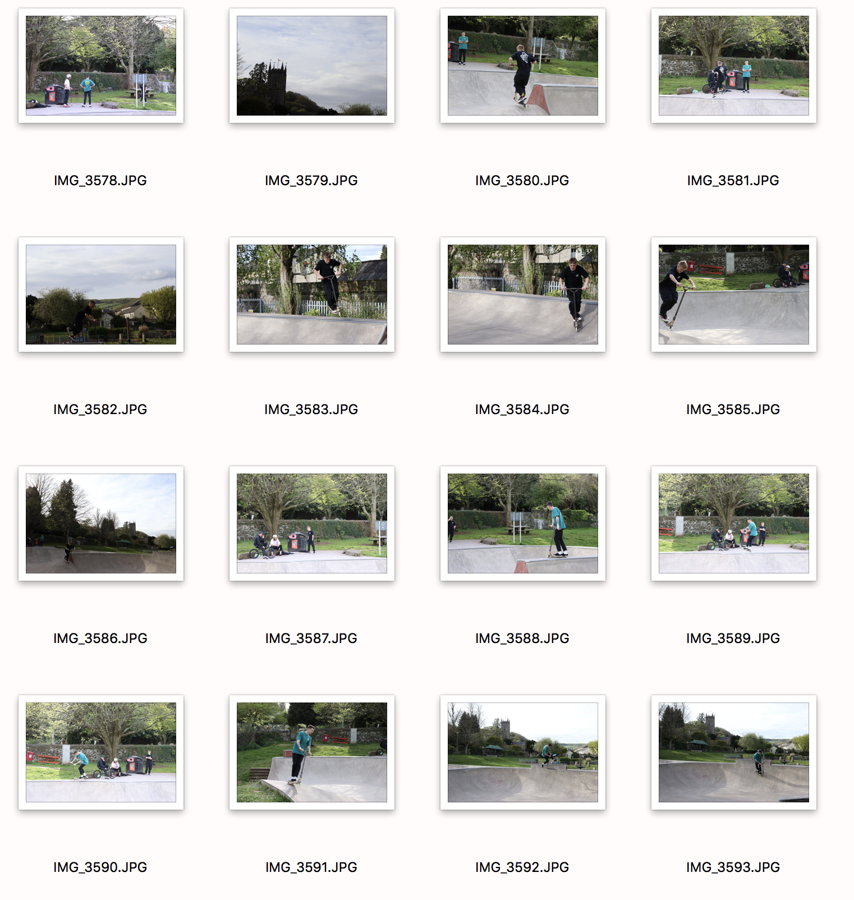

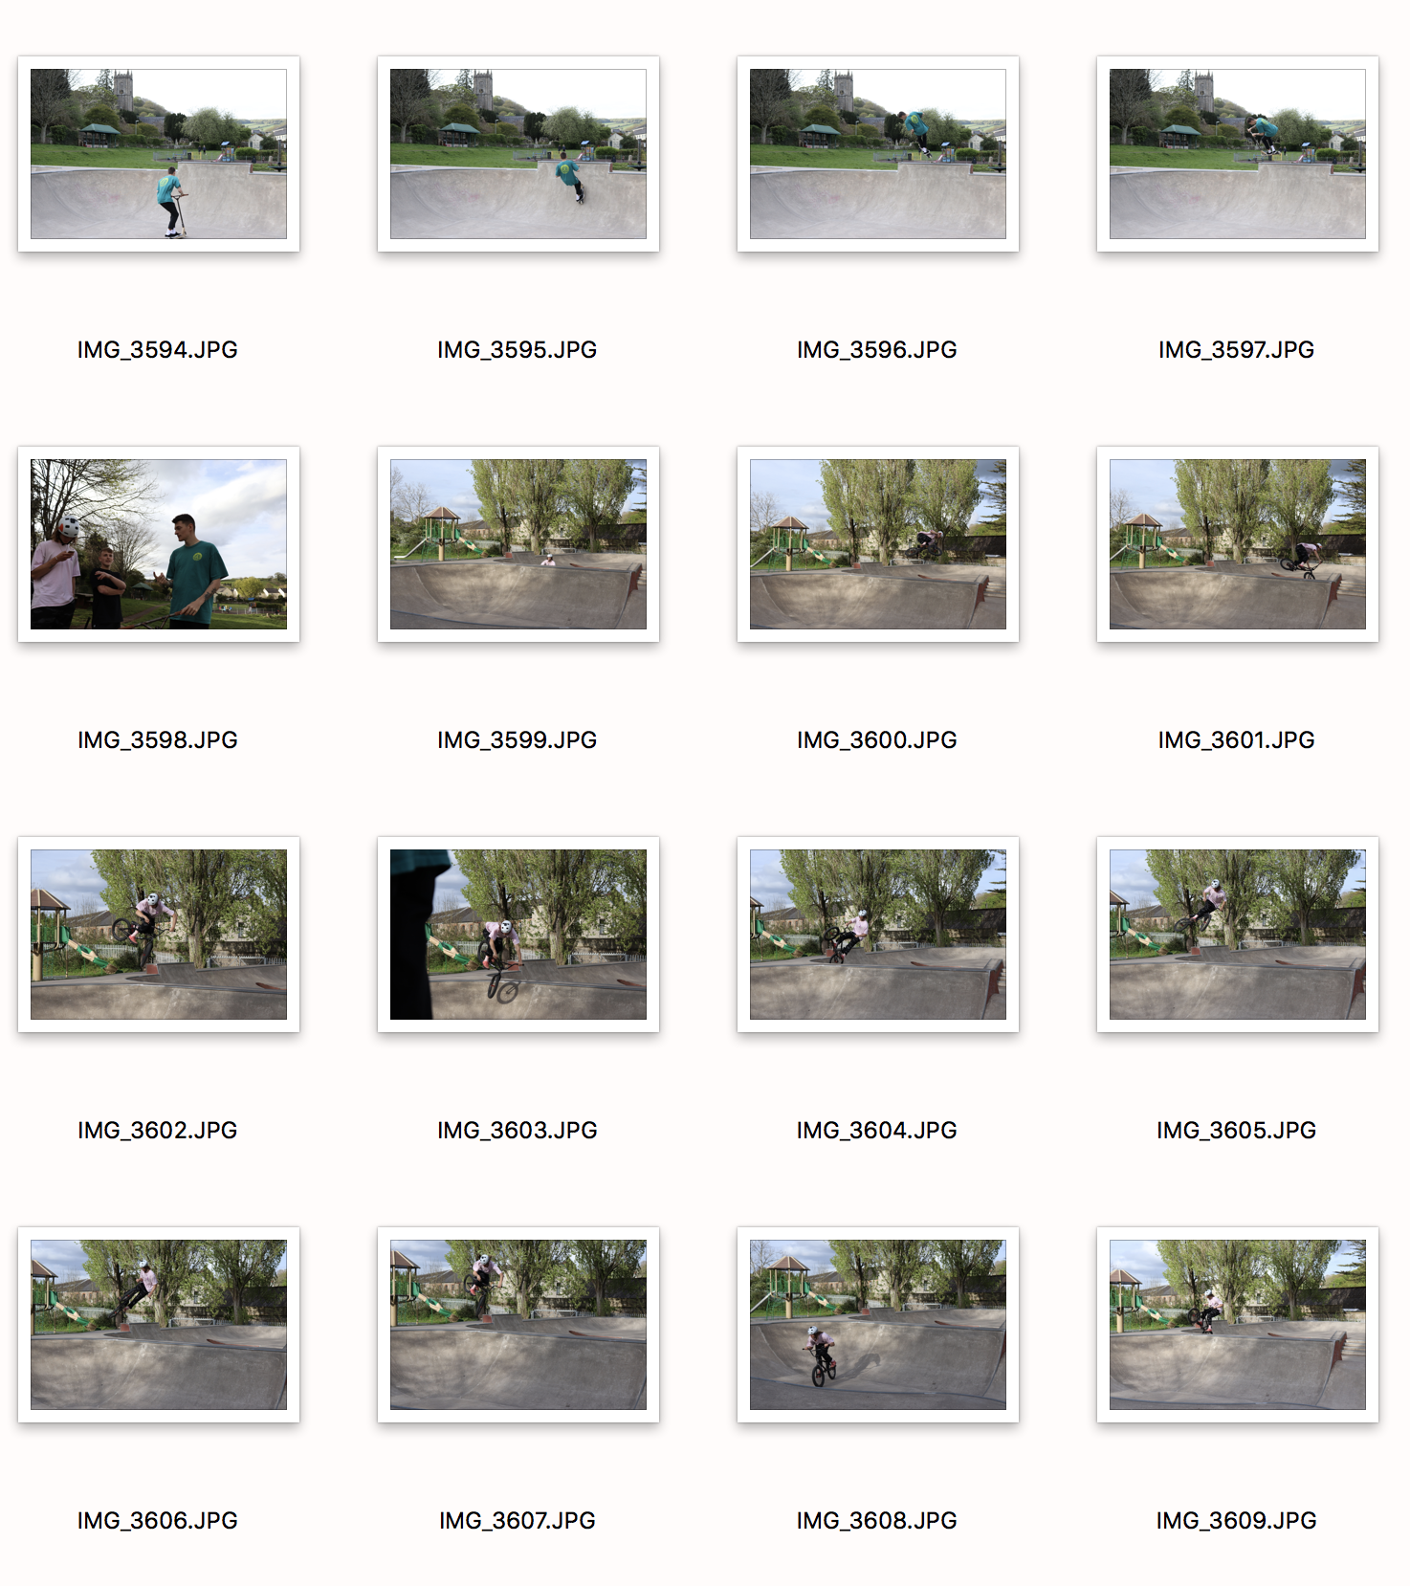

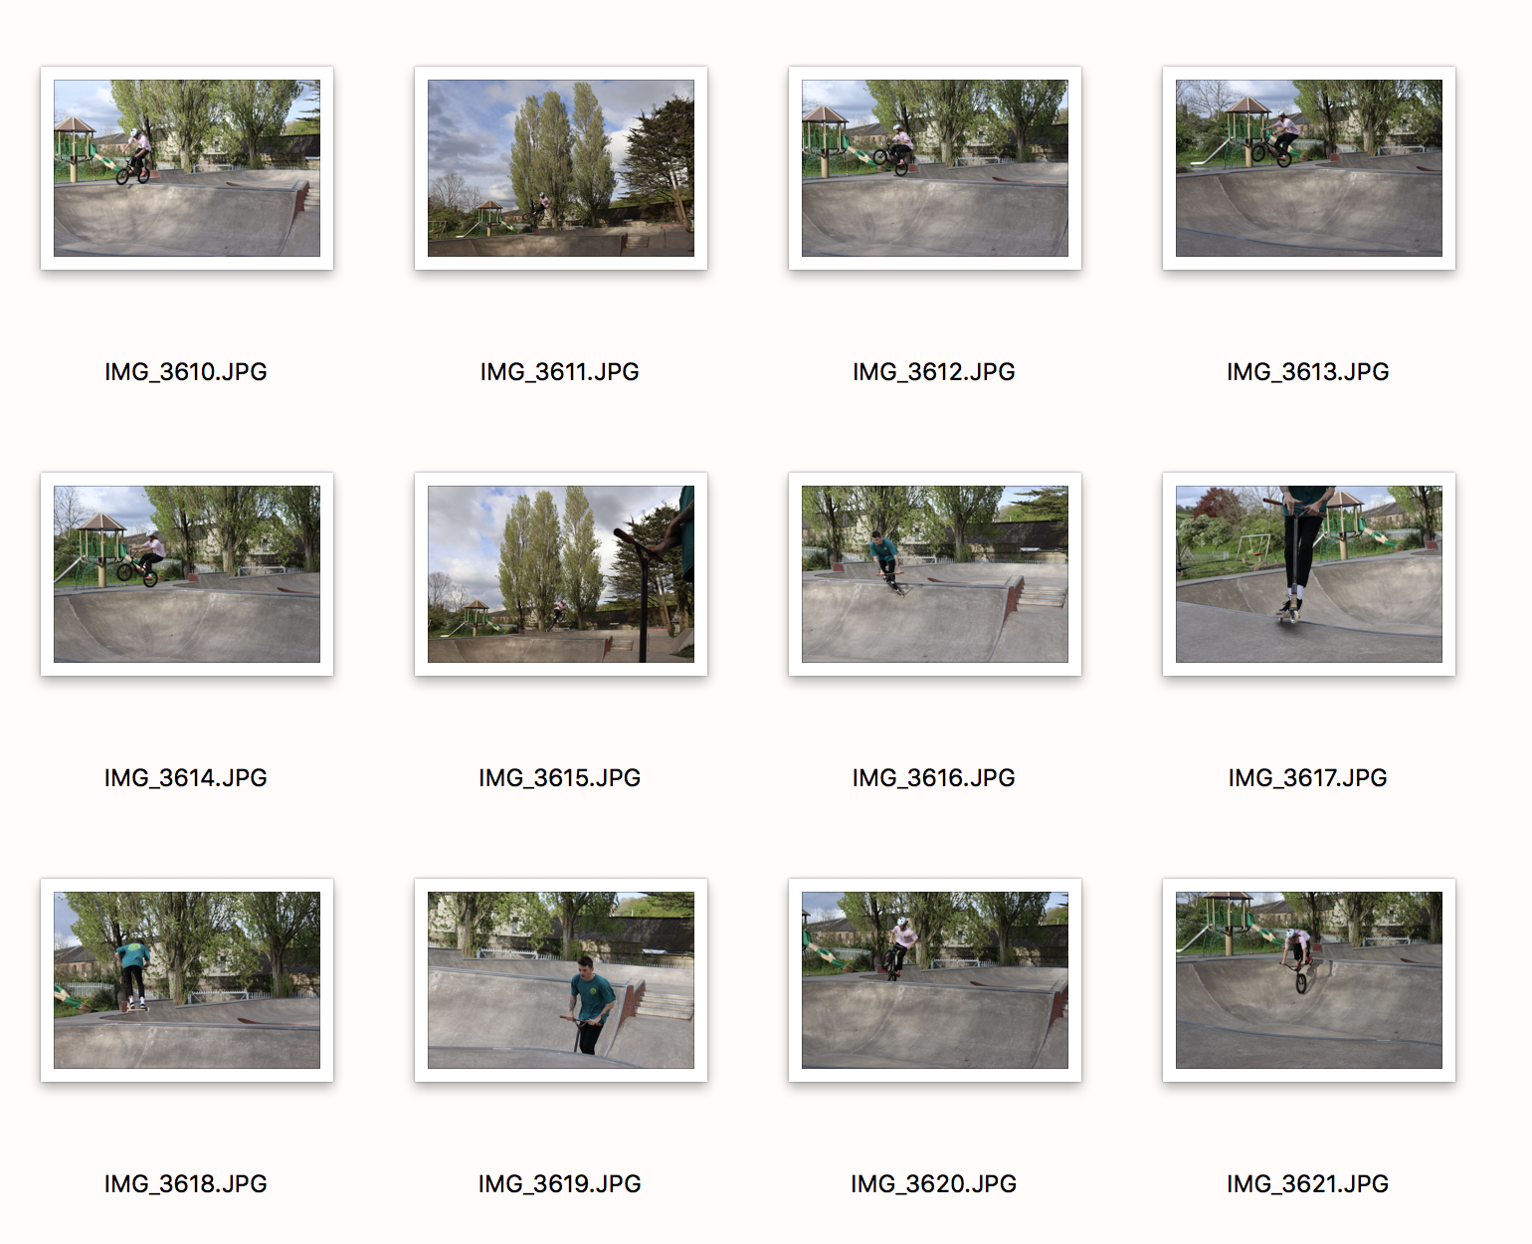
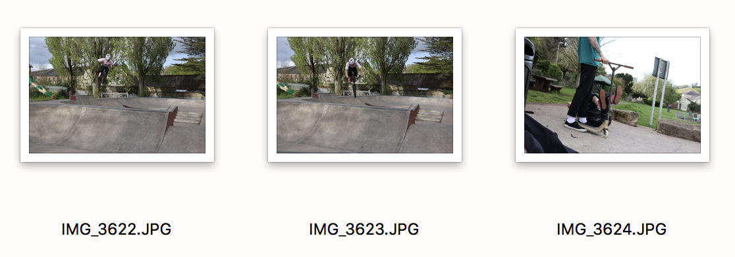
There are a lot of images from this shoot because I just went to the skatepark with one thing in mind and that was capturing ‘the decisive moment’. I asked permission to shoot and shot a variety of riders and what they used. Originally, I was going to go for just skateboards but once I saw what they were capable of I just decided to go all out. Some of the images are terrible, mainly because I was just messing around, trying to get quick point and shoot opportunities because they were always moving so fast, sometimes too close. Other shots I did accidently because of how fast the shutter was. I narrowed it down to the circled ones because I felt these were not blurry, easy to see what the moment is and also, they are proper action shots. I like the positioning and although not used the rule of thirds necessarily within all images, my framing clearly shows the subject, and with a small aperture making the background blurry in a few of the images to really bring out the subject. I feel that all in all I have tried my best to isolate the subject within ‘the decisive moment’ and feel that the images portray this idea.

