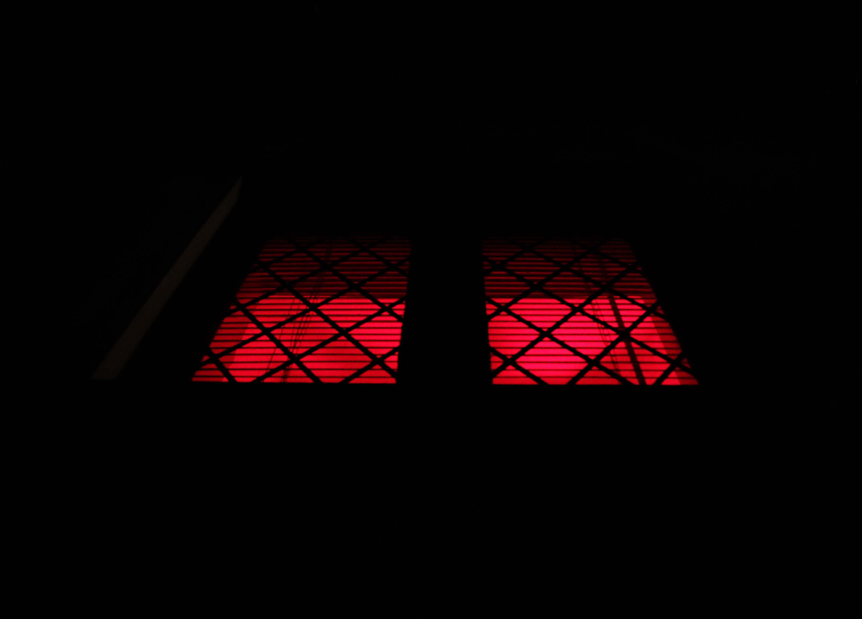
This is the first image, of my short sequence of artificial light. Although there are only three images, there were only four in natural. Within this shoot, my attempt was to capture strong rays of artificial light, especially vibrant colours. My aim was to give a mood to the image, to create a unique set of images which give an almost sense of an illusion. In this image, it has been taken looking up of a window, outside my house. This could easily be perceived as the floor and an underground room. Because the surroundings of the light are so dark. You cannot see around the image. The main focus, is the coloured area. Because of the lines of the window, and of the blind, and the colour of the image gives off a warm but evil sense. The red is very strong, but shades towards the top of the image. Although, the image is simple, there is a lot of pattern within the image, from the blind, to the window markings, to each panel being symmetrical. The window seems very flat, because of the lighting. For this shoot I used Manuel Mode, and a fairly long exposure to ensure the light was captured well on my light meter, rather than over or under exposing the image. The artificial light in this image, gives off a mood, a negative mood, a ‘keep away’ an evil, dark mood. Red is usually associated with blood, the devil, lava etc. The artificial light is very striking and stands out well from the darkness that surrounds the small window of light. Natural light would not be as powerful, nor give off the same kind of mood. With natural light, you are looking out, and the light is coming in, here I am on the outside, looking in on the projected light which is warming the outside, almost like a toaster. The artificial light sits well within the image, and is strong, but does not affect the image in anyway with the relation to the exposure, such as being too bright. The light is such a vibrant red, that if you were to touch the window, it looks as if it would most certainly burn you. The fact that the light can give off a false sense is very interesting. Lighting, in particular artificial light can create an effect on the image in which can alter the meaning and the representation of certain aspects within.
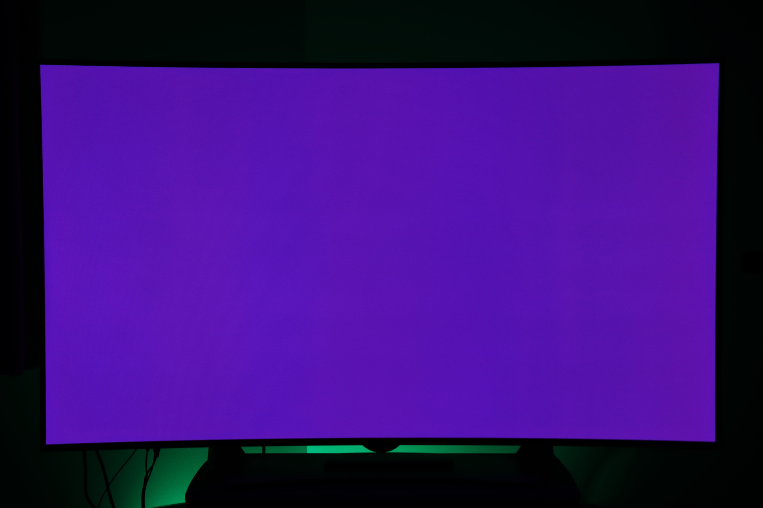
Visually, this image may not look like it sits with the other two, because they use windows, and different focal length etc. But they all use artificial lights, and they all give off certain moods, and illusions. In this image, I have taken it of my TV with another light behind the TV. This doesn’t necessarily look like a tv, just a purple rectangle. But in fact, it is a TV. When your eyes focus for more than a few seconds on the purple, it starts to get unconfutable, it is oddly annoying and the artificial light is bold, big and plain. The green light behind shades nicely with the black and creates a cool effect away from the purple. The purple rectangle almost gives the idea of a portal, just a large piece of artificial light centred within the image. The mood of the image is calm, because of the mix of colours, but frustrating as you cannot get passed the purple and see elsewhere other than the majority of black surrounding it. Although the TV is in the foreground and the black behind, everything looks very flat and the purple compels well against the black. Visually this image shows the natural darkness behind with this strong forceful purple of an artificial kind fighting back against the darkness, with a hint of green to take away from it all. Based on artificial light, this image looks very futuristic and looks far different if natural light was used, because it would give a different mood, and would not seem as intense nor beautiful with the strong purple compelling with the black and the green pushing its way into the image.
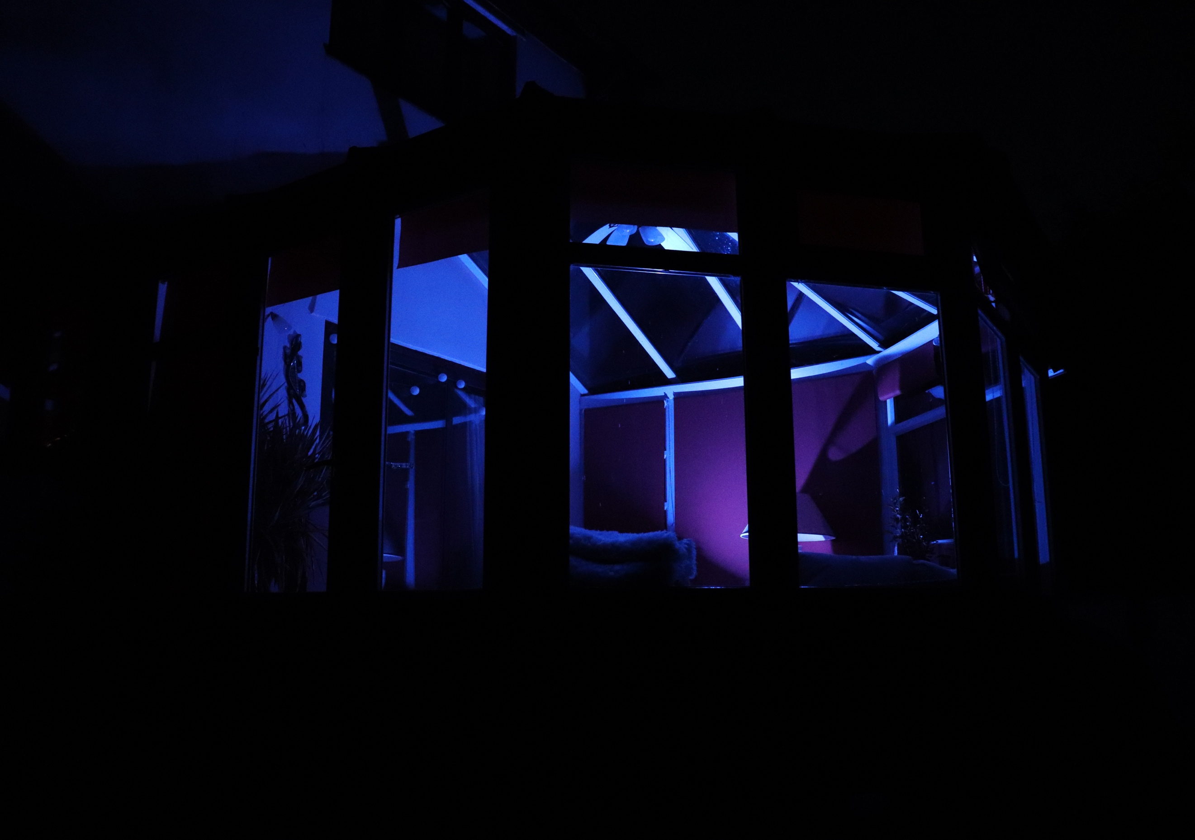
In this last image, it has been taken on the outside looking in again. It is of my conservatory. Not that you can really tell because of the darkness which looms around the artificial light which is safe within the glass panels. In each image, the darkness looks and compels against the artificial light, and it tries to push it back at every bit possible, but the artificial light is so strong it produces a strong powerful, vibrant colour which matches up with the darkness. The colour within this image is a crystal blue. It looks like you are looking into a fish tank. The blue on the far left is very dark where it gets lighter over where the main source of light is coming from. Again, the darkness surrounds the frame of the image, and you cannot physically see aspects of the image because the artificial light is not fulfilling those parts because they cannot be reached. For example, the outside of the conservatory is black so the darkness travels and looks like it splits the artificial lighting. The lighting looks surreal. It almost looks like it is a physical object, but it isn’t. It gives the illusion that there is something there, but not physically, only from the light source itself which we cannot see. The blue makes the image look cold, frozen and empty. Within this image, the colour stands out, but ultimately in a different way to the first two, it is less in your face, but still fills the darkness with its presents. Not only just in this image, but in the other two, the quality of light compared to the natural shoot is much more. Much stronger and more vibrant, and whereas in the natural light shoot, natural light was trying to come in and break through the tree’s etc. The artificial light is trying to break out, break out of the windows, of the TV and try and fulfil the image and the surroundings.

