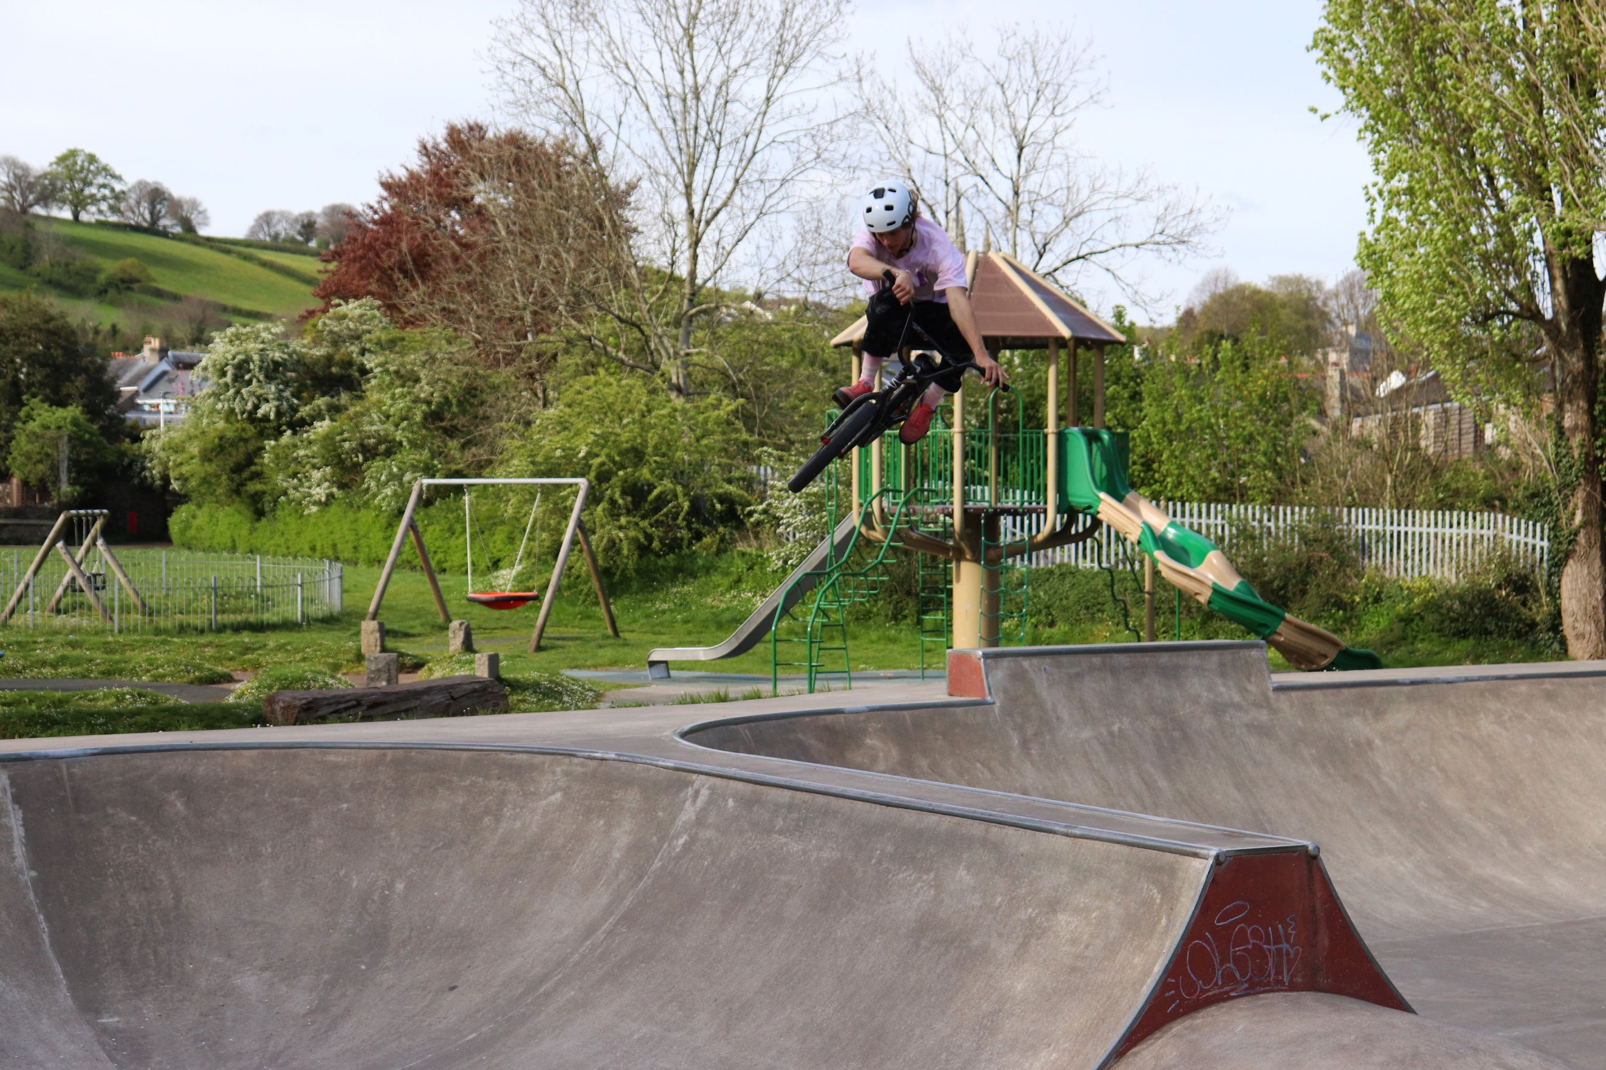
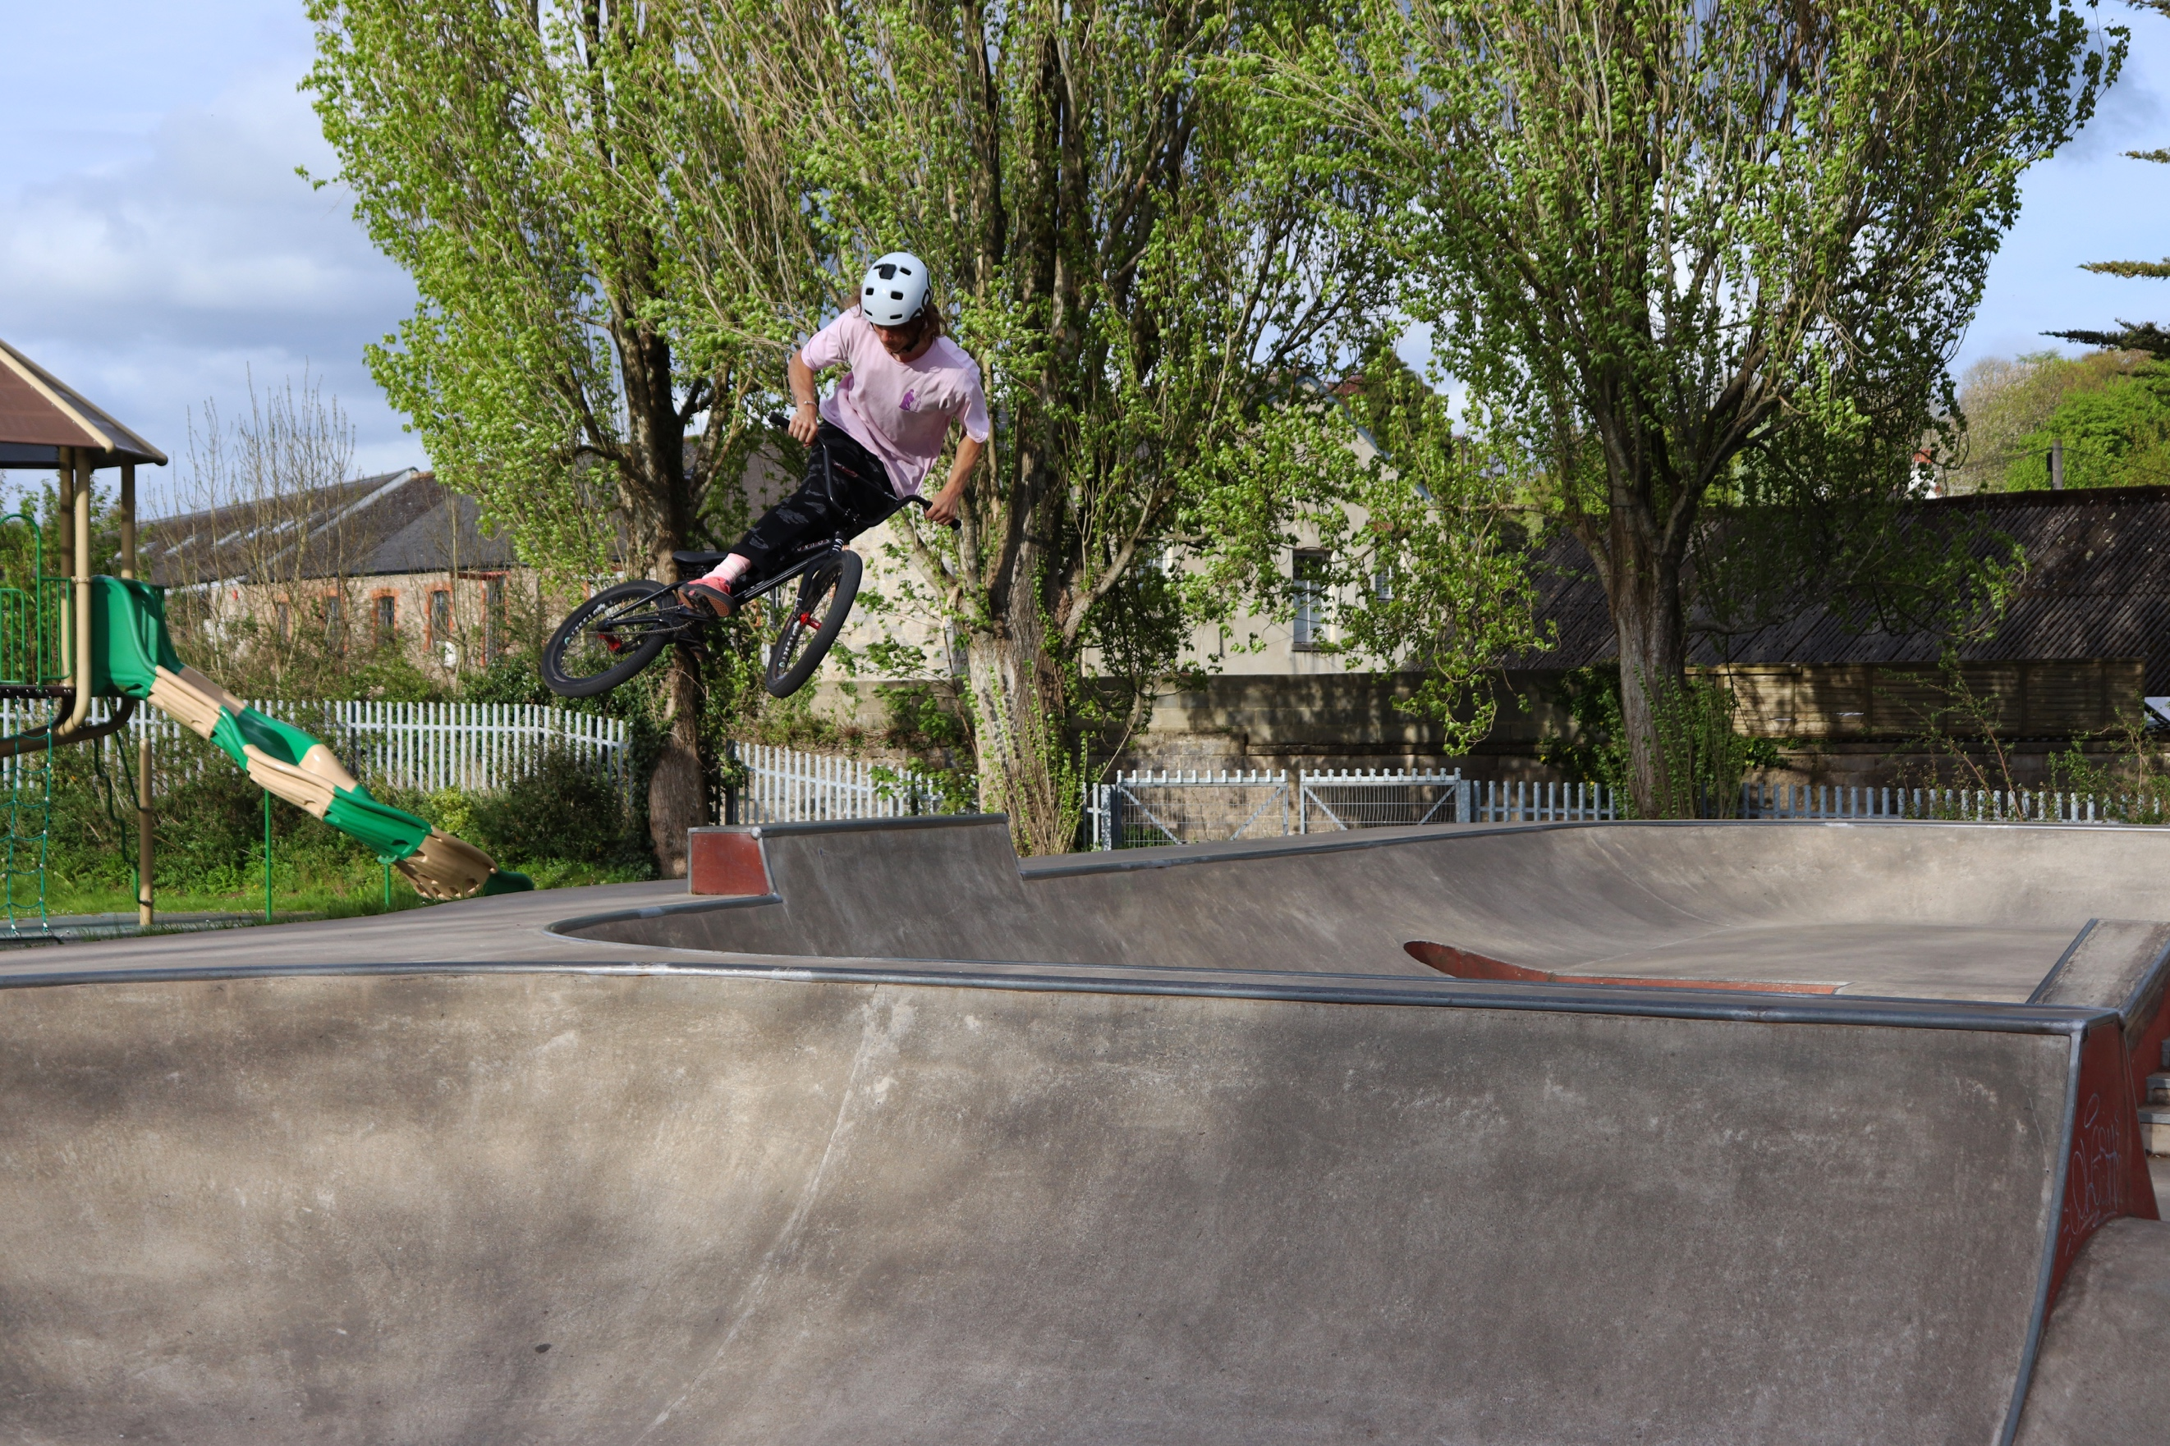
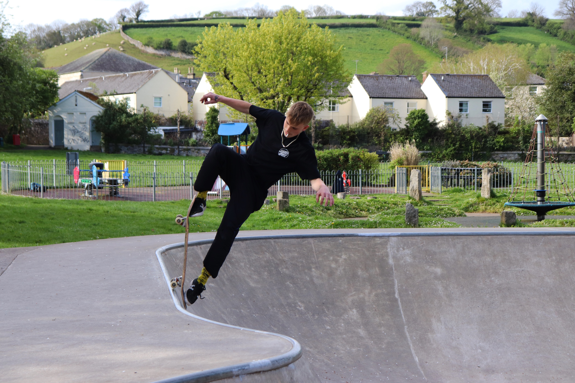
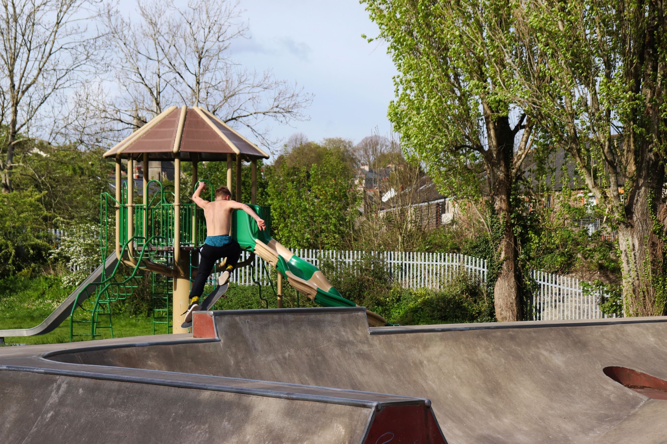
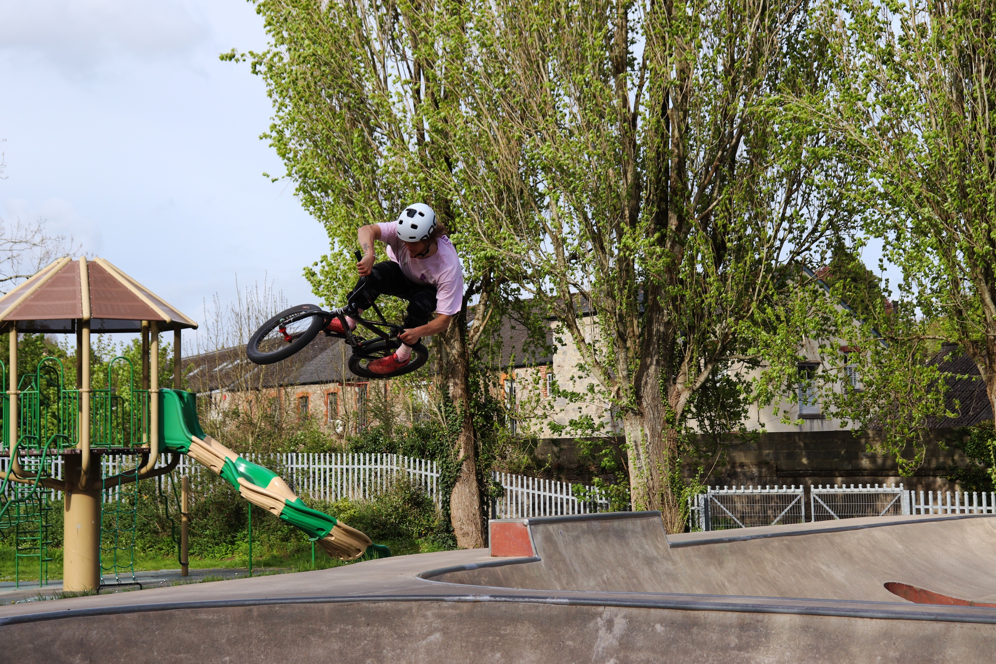
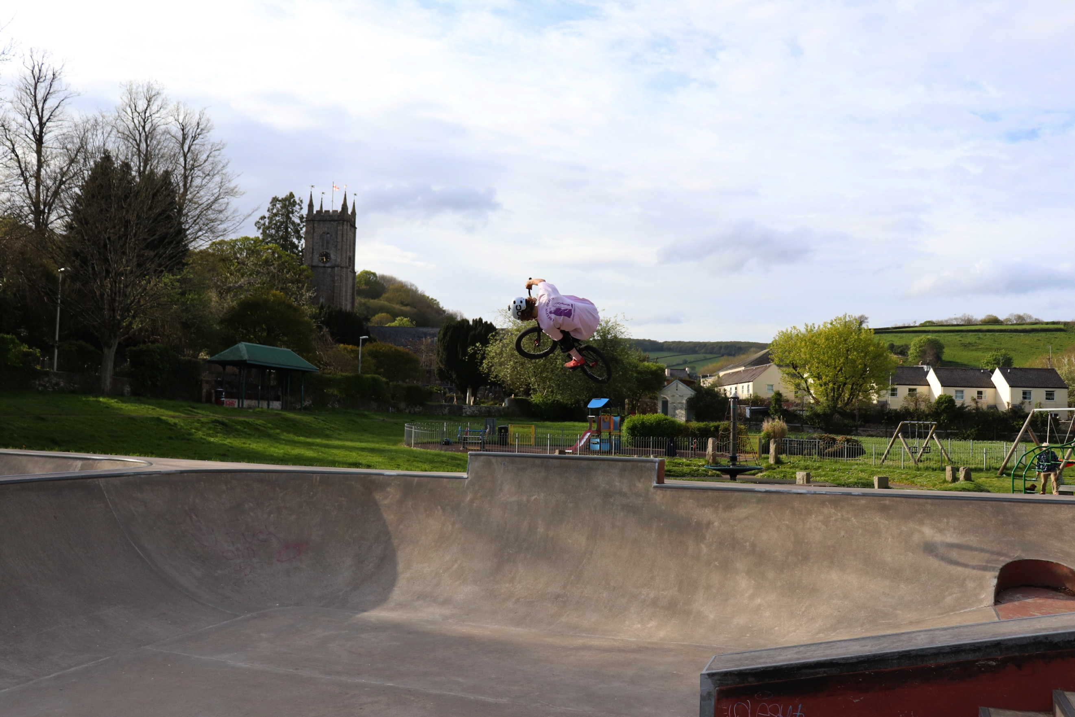
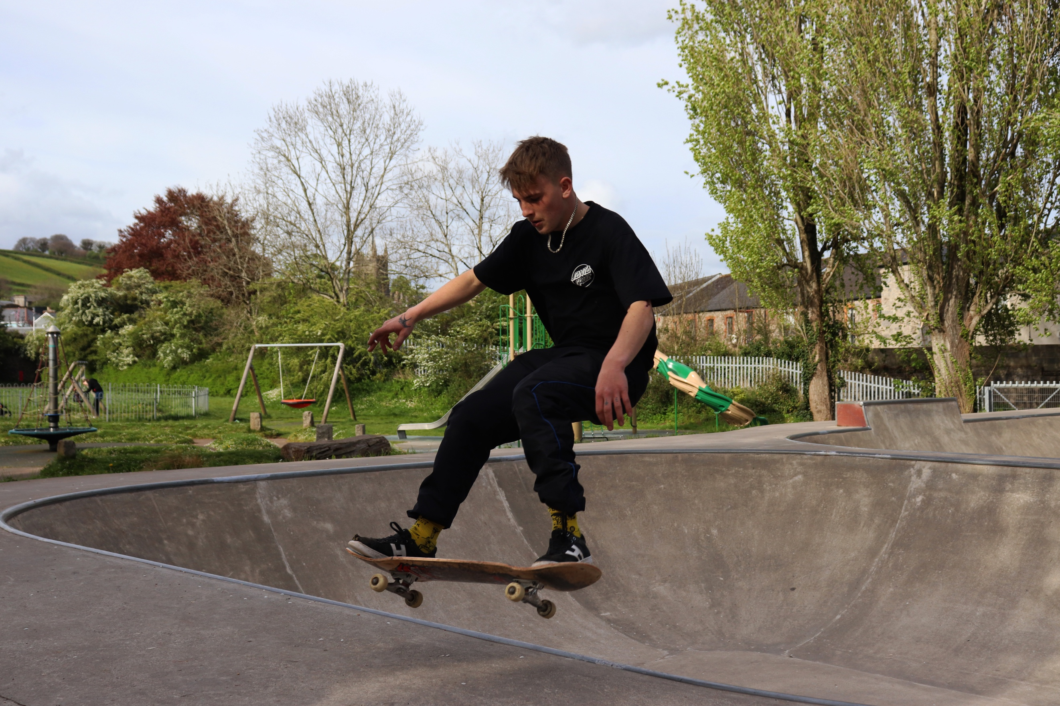
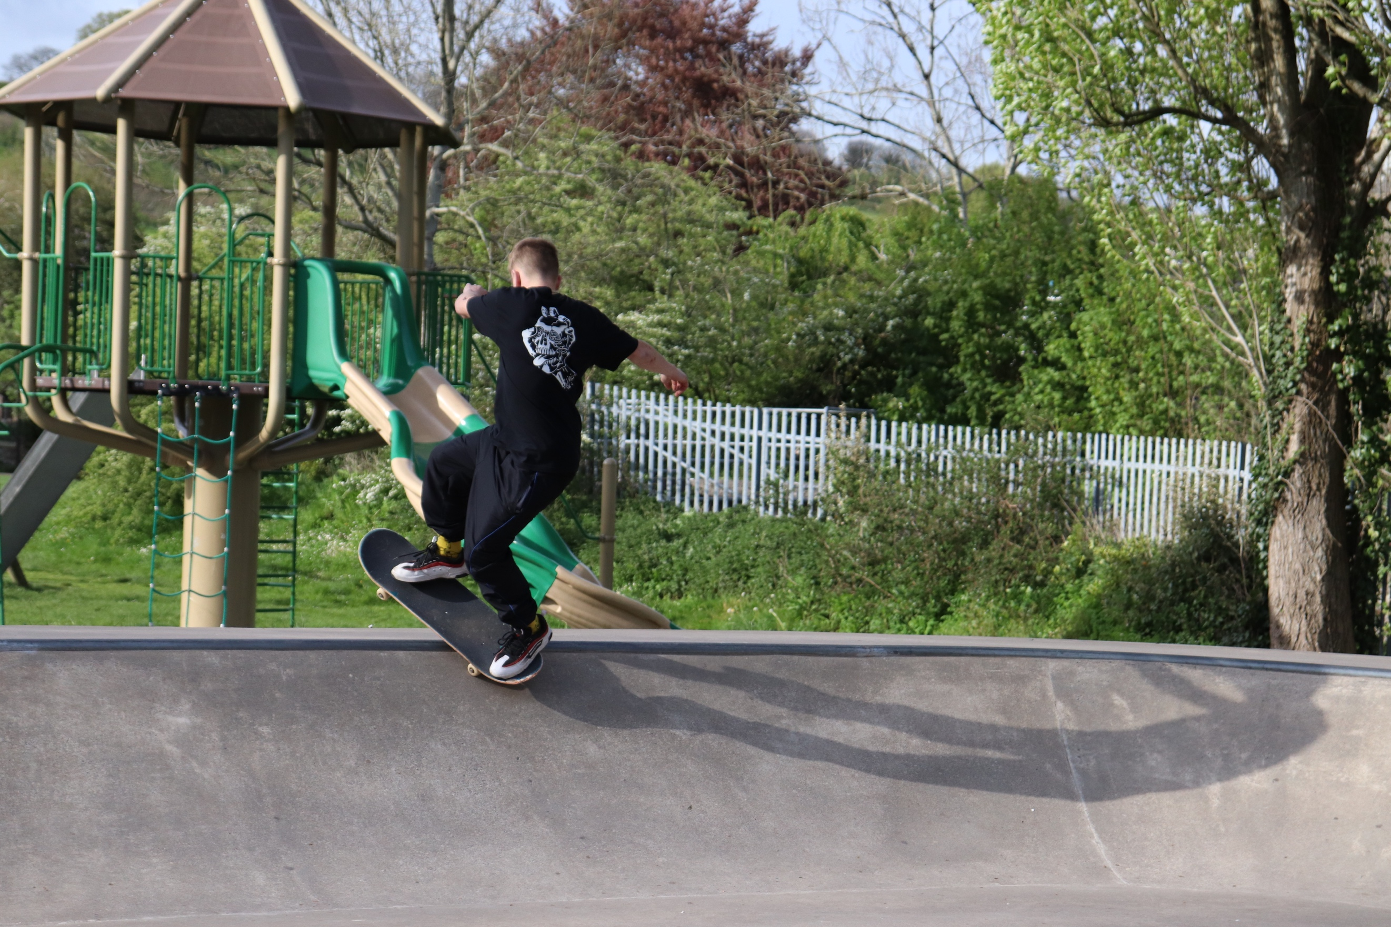
I could sit here and annotate the eight images individually, but that would take far too long. So, I thought because they are all various decisive moments at the skatepark, I would write about key features of each photograph and summaries the shoot as a whole as it would be better. These selected images are of the skater and BMX rider at the skate park. When I was there they did various tricks all across the selection of ramps there. The texture of the skatepark seems rough, mainly because of the material used to create the park, which is concreate. I feel the colour contributes to this also. The surroundings such as the tree’s make a soft look to the image, compelling against the hardness of the concreate. In the majority of the images, the skatepark seems to be in the foreground with the play park over in the background. In all the images I have included and excluded various ramps, and bits of the park depending on my location within the park as you can see throughout. I have made sure that at least the top of the ramp is in the shot because this shows the height in which he is travelling at. Although I do not feel it should be compulsory to get the whole ramp in, because the main subject may be too close to the top of the image or even cropped out. Of course, I could always take a step back and shoot at 18mm but sometimes it is better to be closer in with the subject so you can see them more clearly. Else I feel they get lost within the background sometimes. The colour of the images is vibrant, despite the colours of the ramps. Each image has a lot of colour and one of the riders is very colourful himself! There are many 2d and 3d shapes in the park because of the obstacles which makes the park really come to life. Some of my framing within the images, especially the subjects could be improved upon if I’m honest. Although I really like each individual shot, I think that it would have been better if I did better with the framing by making it less central. But when you are shooting extreme sports that is fast flowing, you are not always going to get perfect framing. For this series of shots, I used a Canon 77D with a standard 18-55mm lens. I used various camera settings throughout the shoot, but majority of the time I kept with a small aperture to bring out the subject from their surroundings and also with a fast shutter because of the nature of the shoot, to prevent blur. My main focus, was the riders and their equipment, and their performance. I knew that by being at the skatepark at that moment when there were people there I was bound to capture a decisive moment. You can predict a decisive moment, that one could happen, but you do not fully know what is going to happen, and what will happen is something unique, that cannot be captured twice. A fast moment in time where all elements come together to create a moment. Skateboarding, bikes and this shoot, demonstrate a series of decisive moments, at the park. I like the height within the images and how high they have got, it looks spectacular. The images link really well to the connection of my artist research and how their images look with mine. Although mine are not in black and white, but contain similar outcomes, being dangerous and decisive. Each moment, uses a different part of the park, and shows different heights and angles. I like how the people look like they are hovering in mid-air, that looks really cool! Some of the bike ones look similar, but he is doing a different move in each image, it is hard to do moves on a bike, but even by the way he angles the bike is a different trick.

