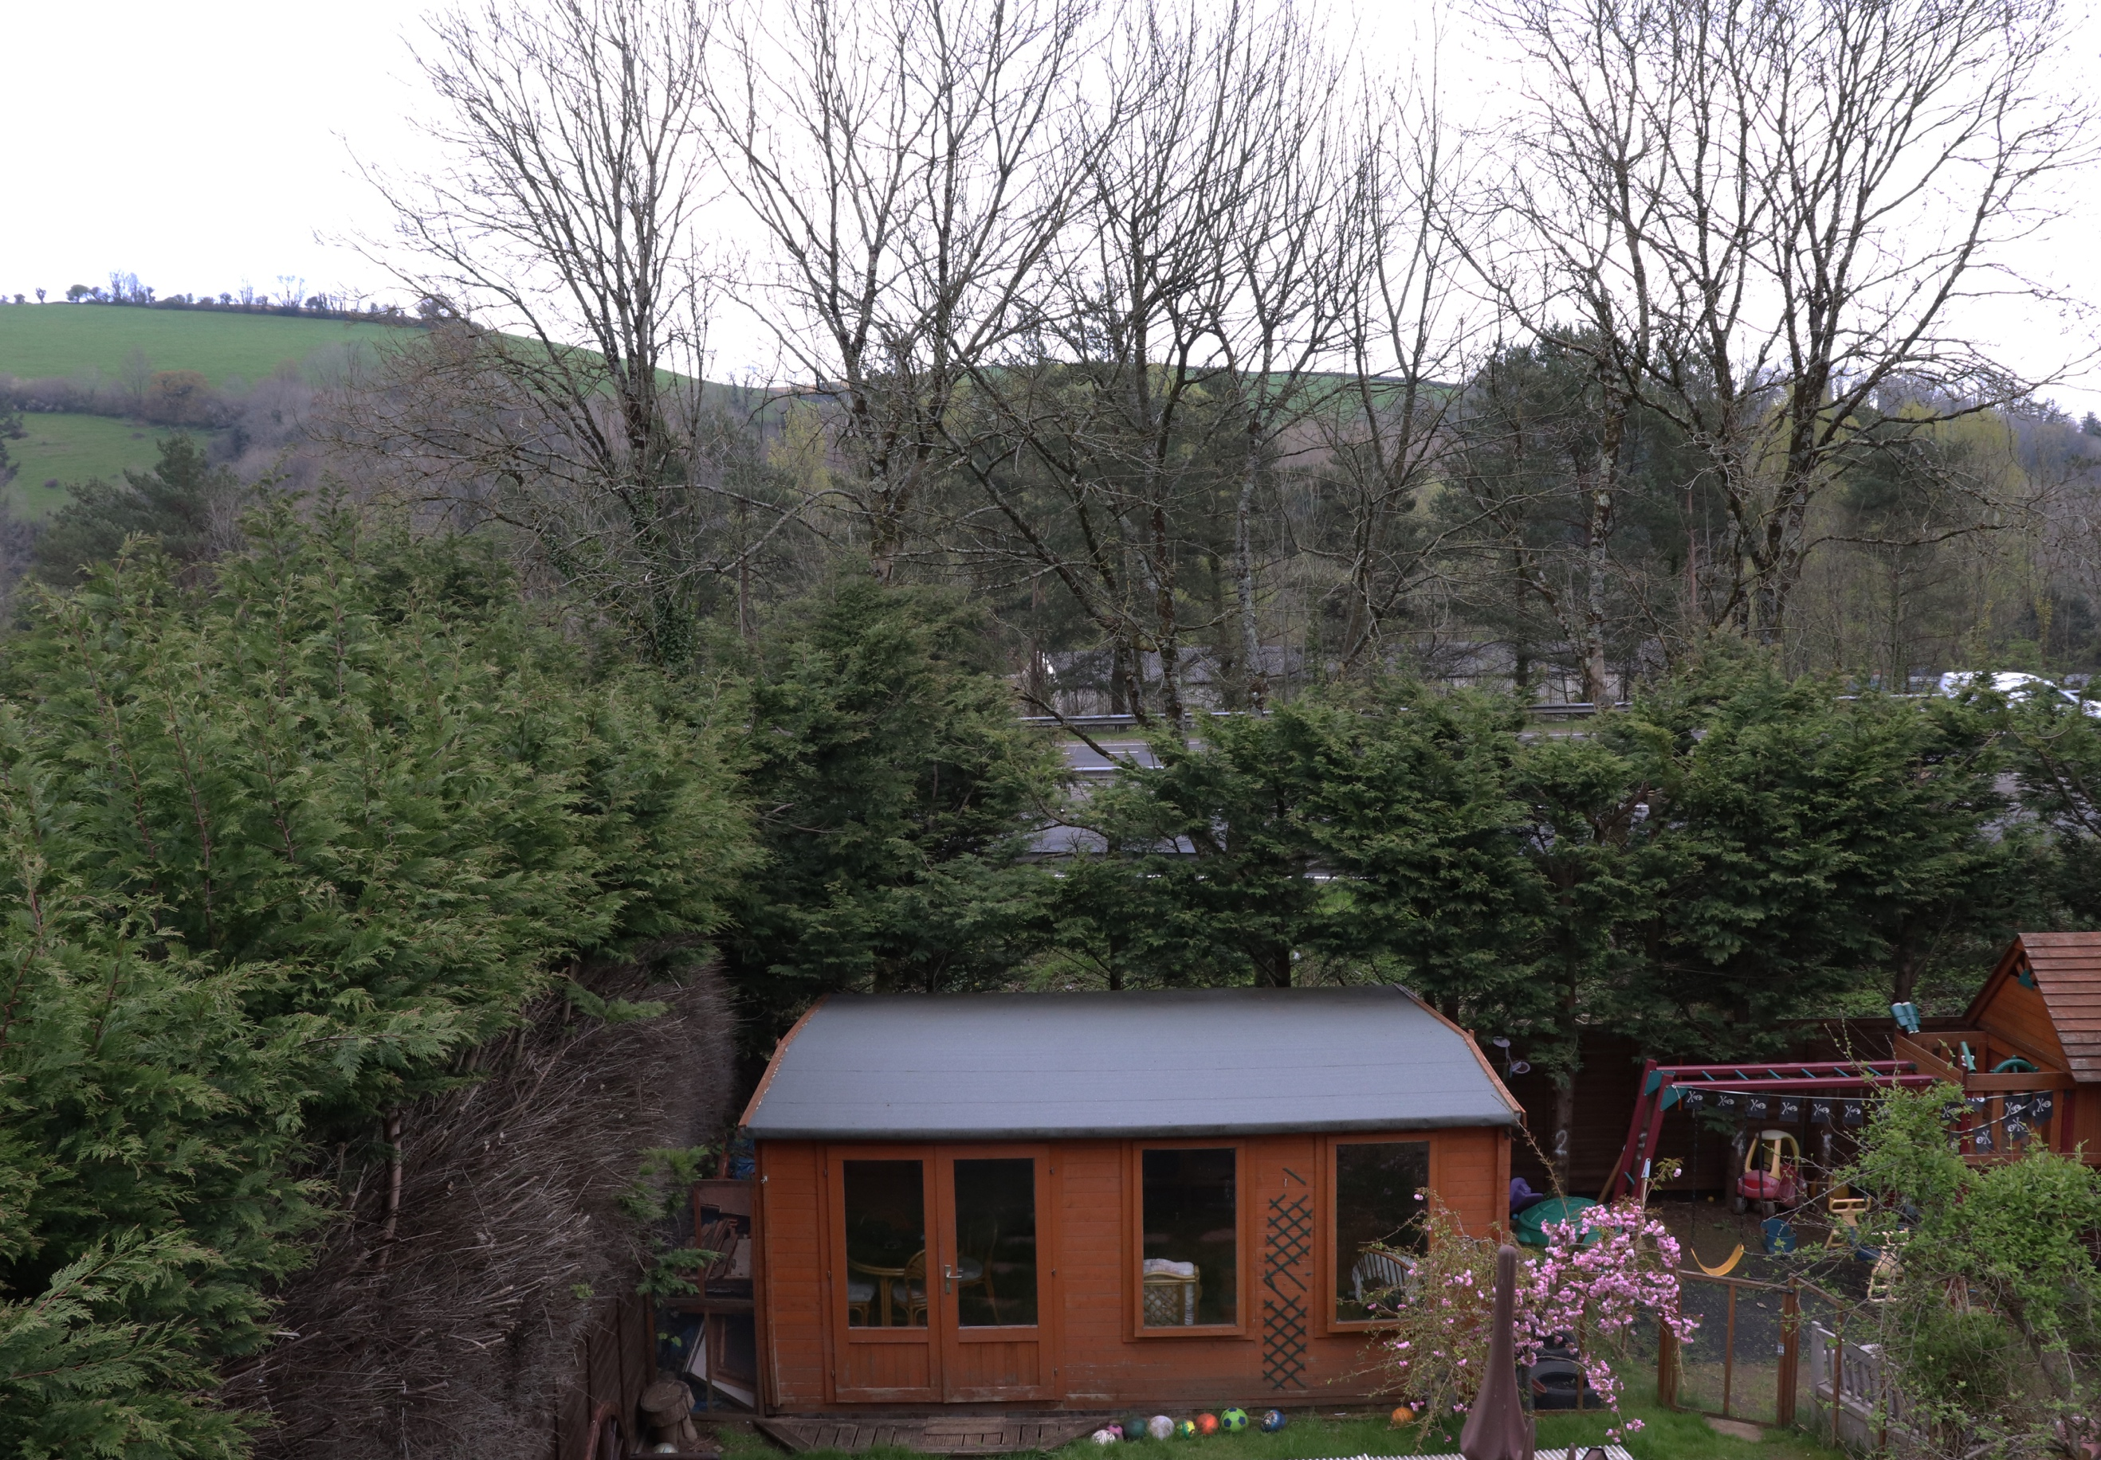
Here I took an image looking out a window of my house. As you can see in the foreground is a play area, tree’s and footballs, and a hut. In the mid ground you can see tree’s and the duel carriageway and at the top of the image you can see the hills/fields and sky and the tops of the trees which work their way up through the image. The bottom of the image seems busy, and the top not so much. I feel this is because there is more likely to be more going on, on the ground rather than the sky. There are many different textures in this image because of how busy it is, some solid like the roof of the hut, and then some soft and fluffy like the conifers to my left. The colours are various throughout the image, with most of the colours appearing at the bottom of the image. I feel this image is not very well balanced or has anything really going for it as it is just out of a window of a garden. Like Alberto Giacometti’s drawings, I feel that this image is messy but can see logic behind it. I intended to leave all elements of the image untouched and did not move anything in the image, and left it all natural. I chose this location as I feel it had the most to offer in terms of various objects in the image, and more going on. I thought that there was a lot of detail to take in, in the three parts of the field, all showing something slightly different, from the ground to the sky. I have tried not to get any of the window or anything in the way of the foreground, so you can see out, like you were just hovering in mid-air. Various parts of this image, pull your eye to and from different aspects. There is no real flow to the image, nothing that signifies the meaning of the image, the point in which the focus is, and has no real specific relation to any of the components with in it. This image may have been better if it was taken portrait to show the hut in the foreground, more broad across the foreground with more of a narrow mid and background, showing that as the main focus rather than with all the conifers and play equipment within the image also.

