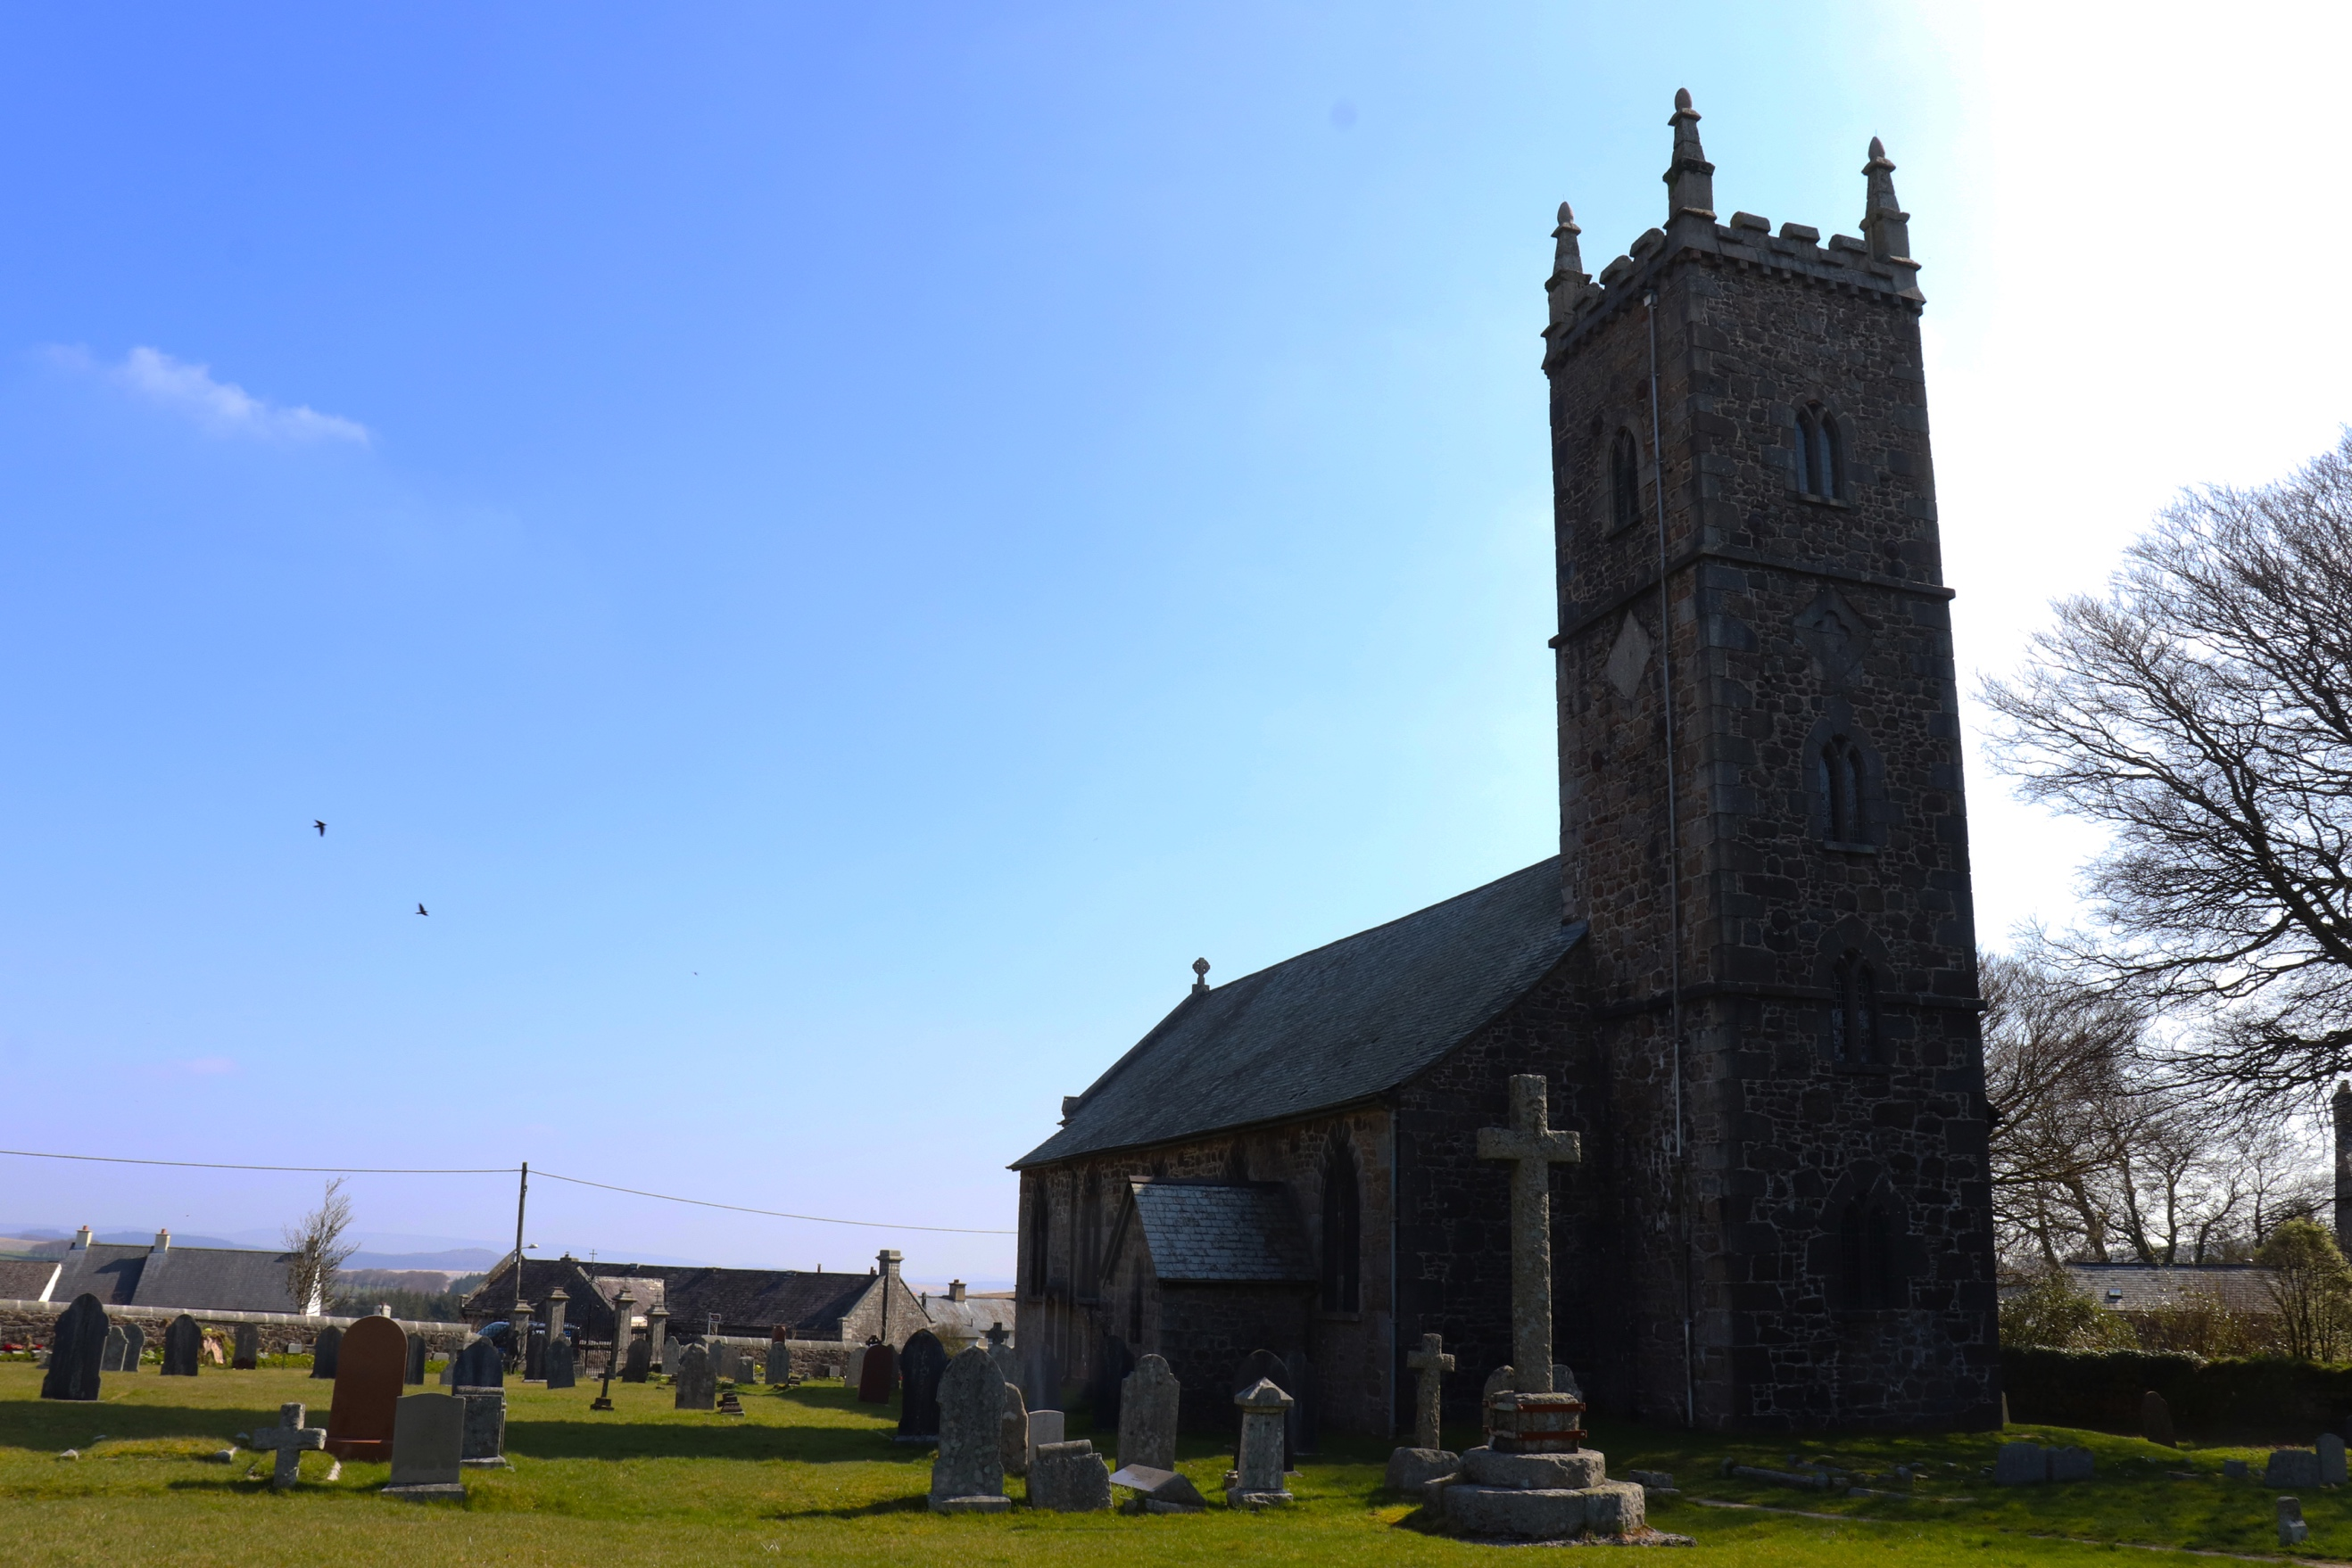
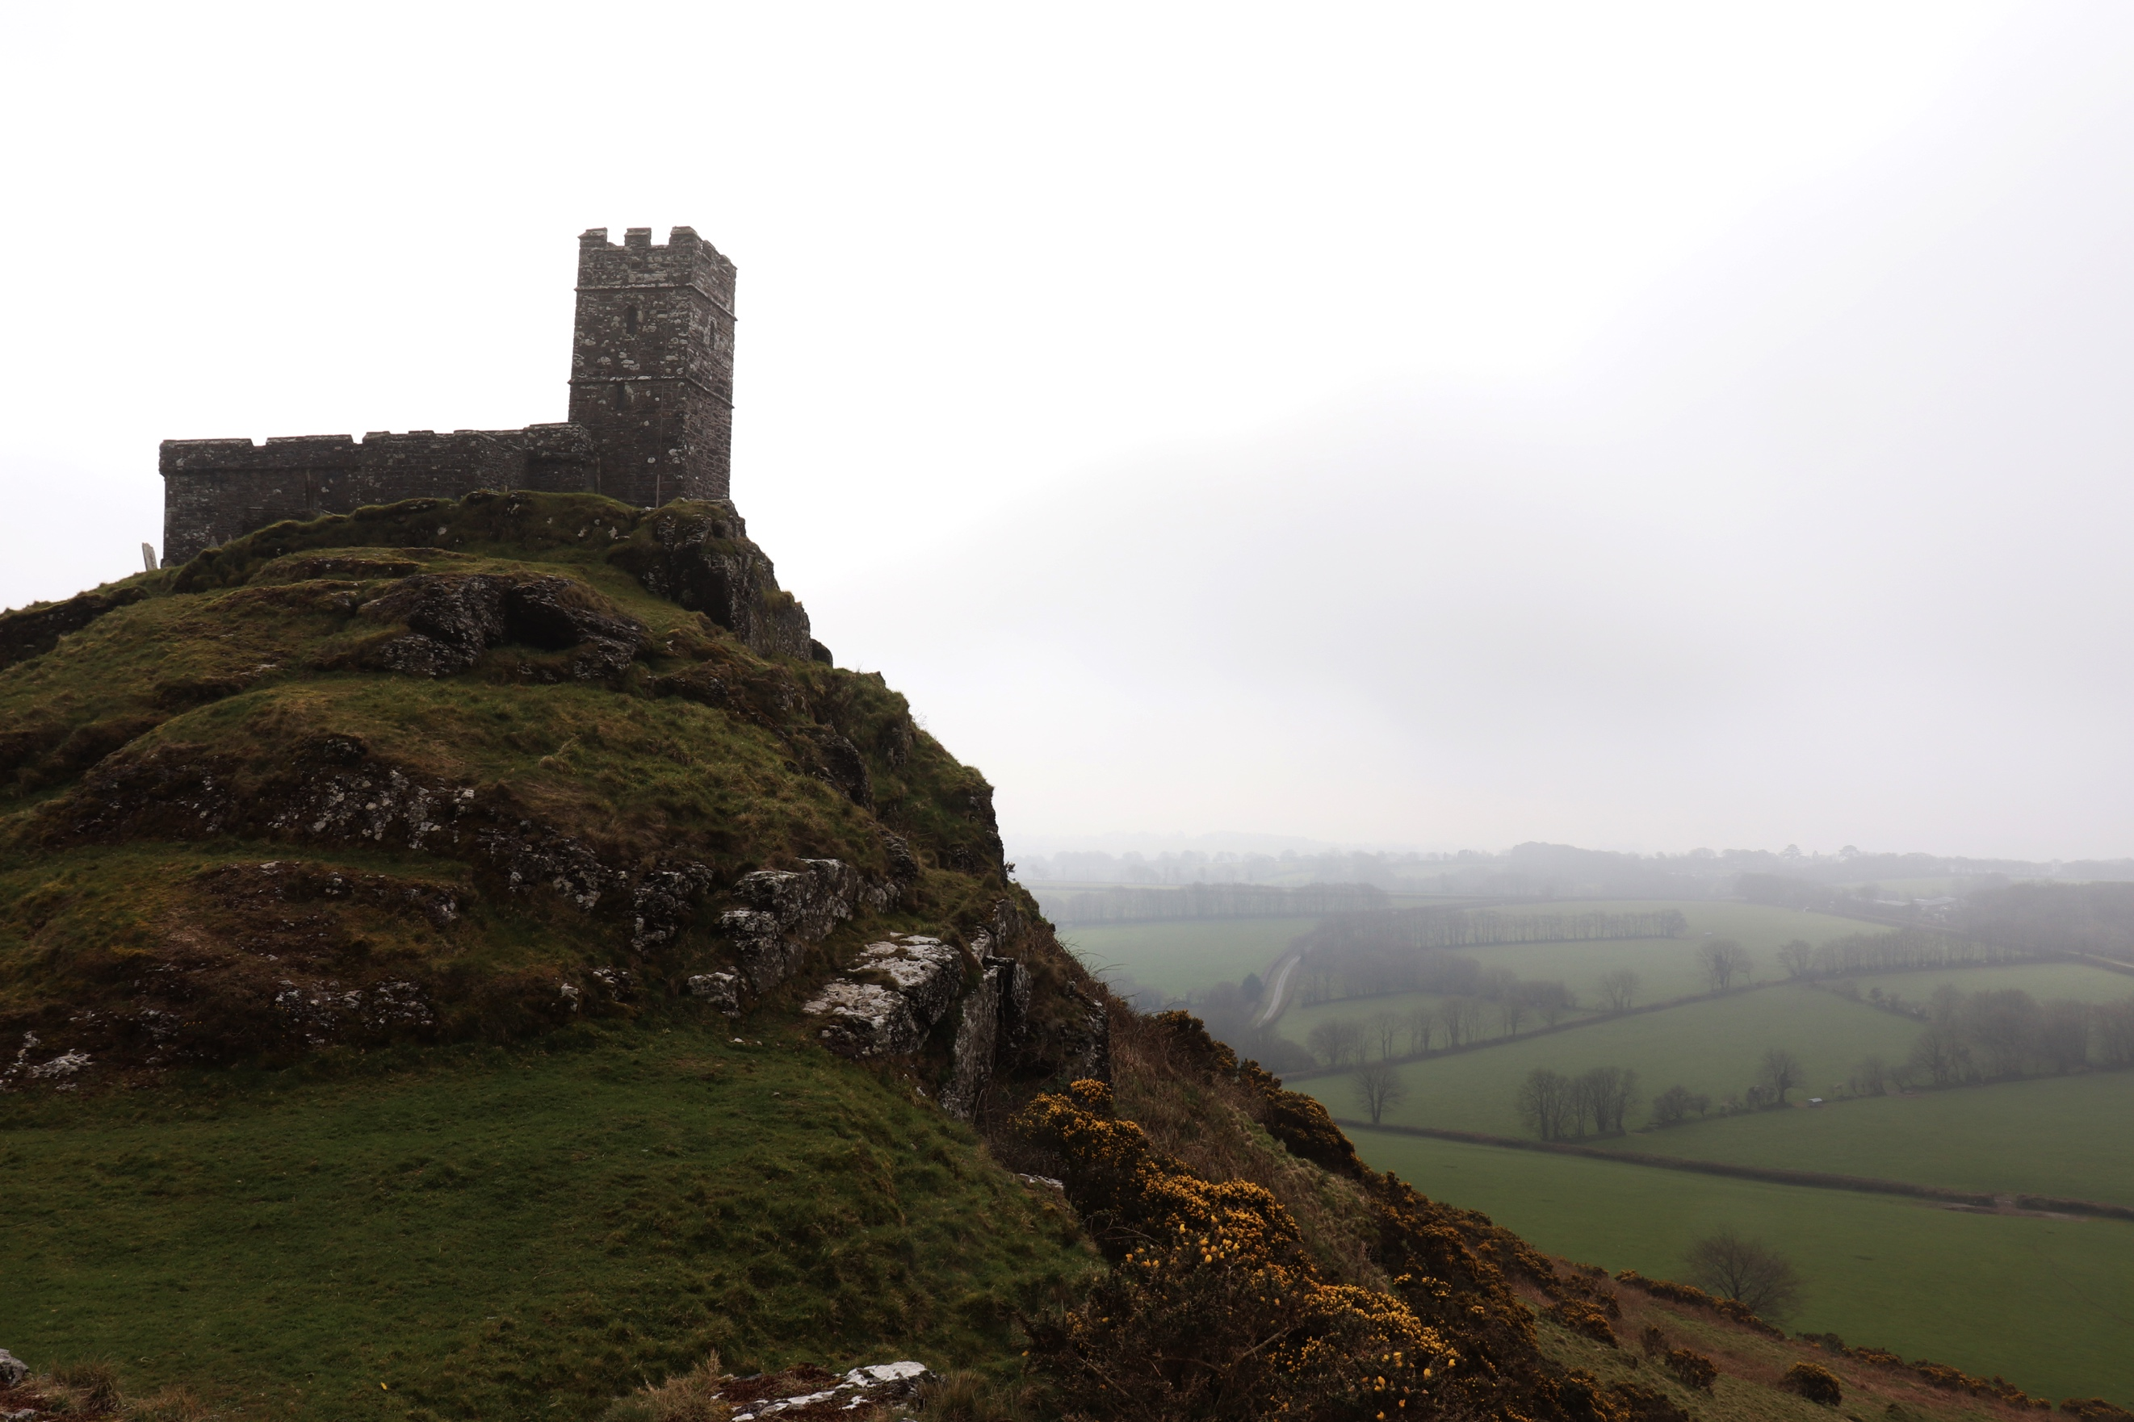
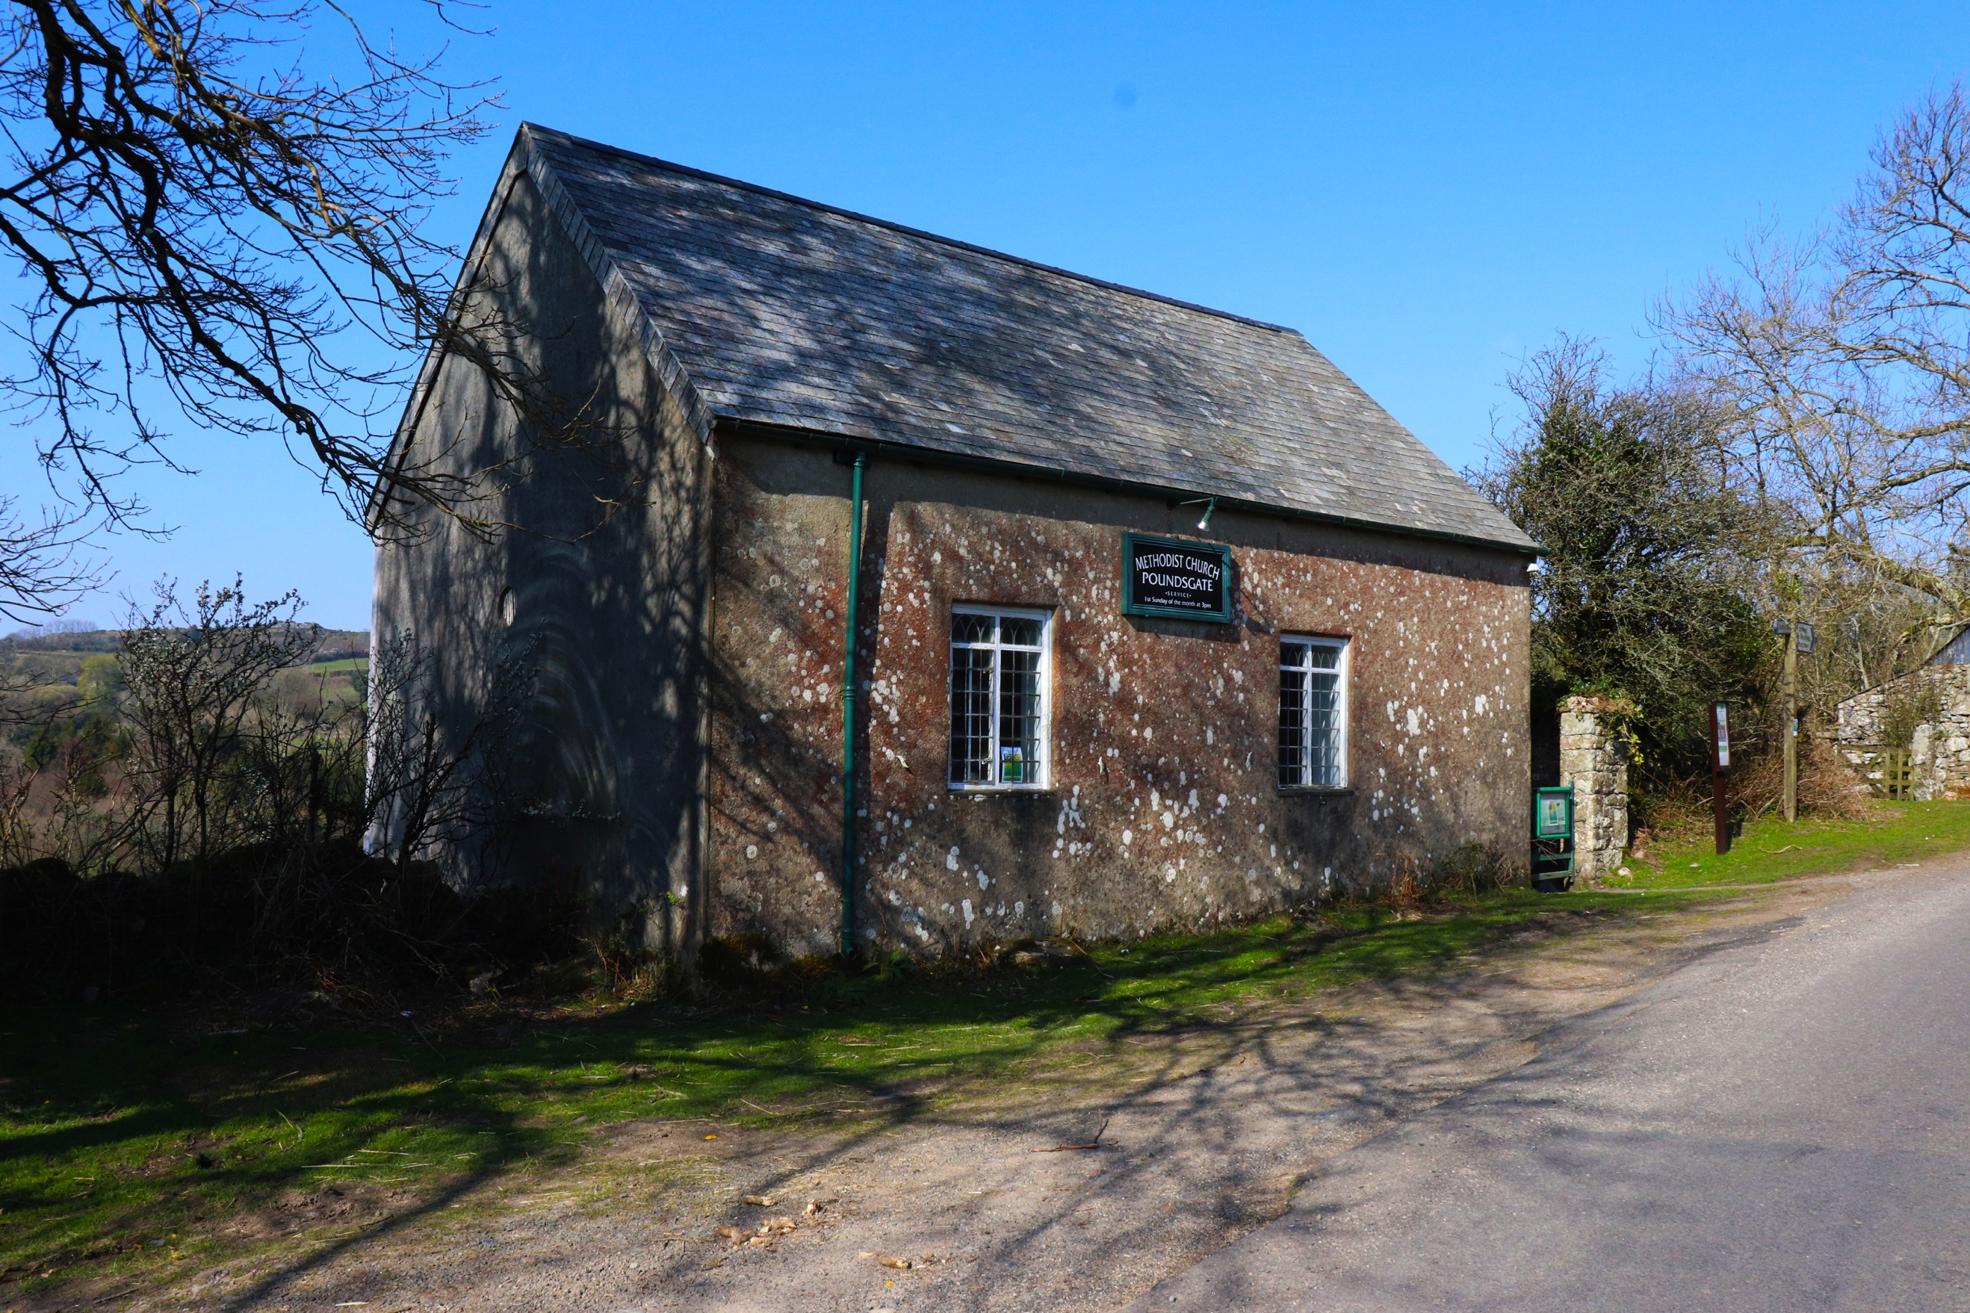
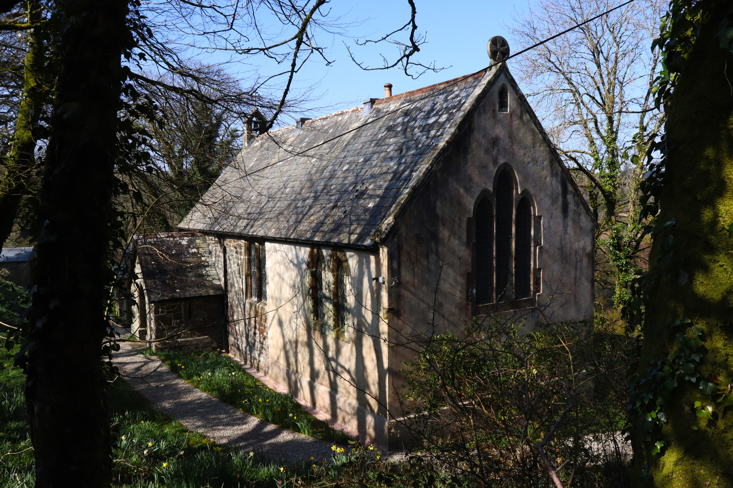
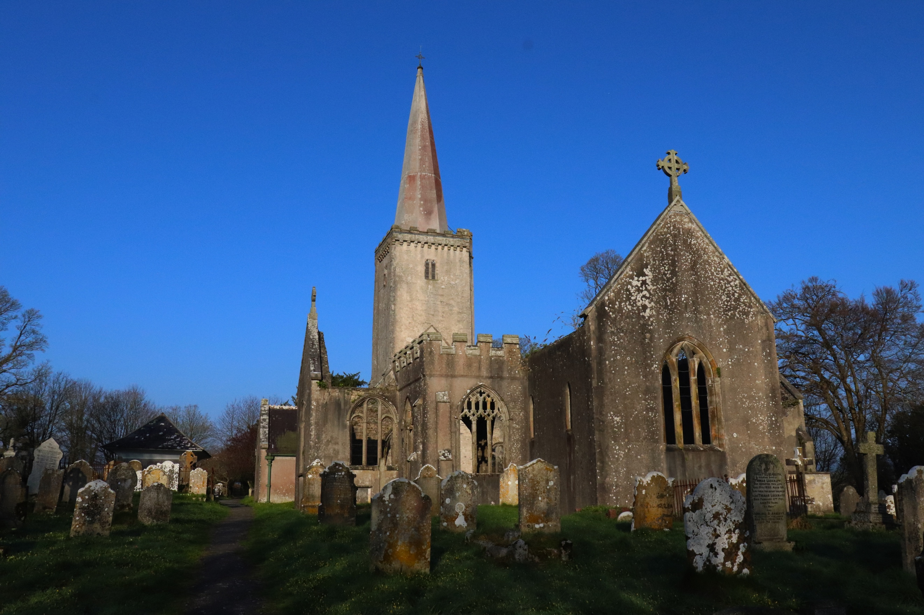
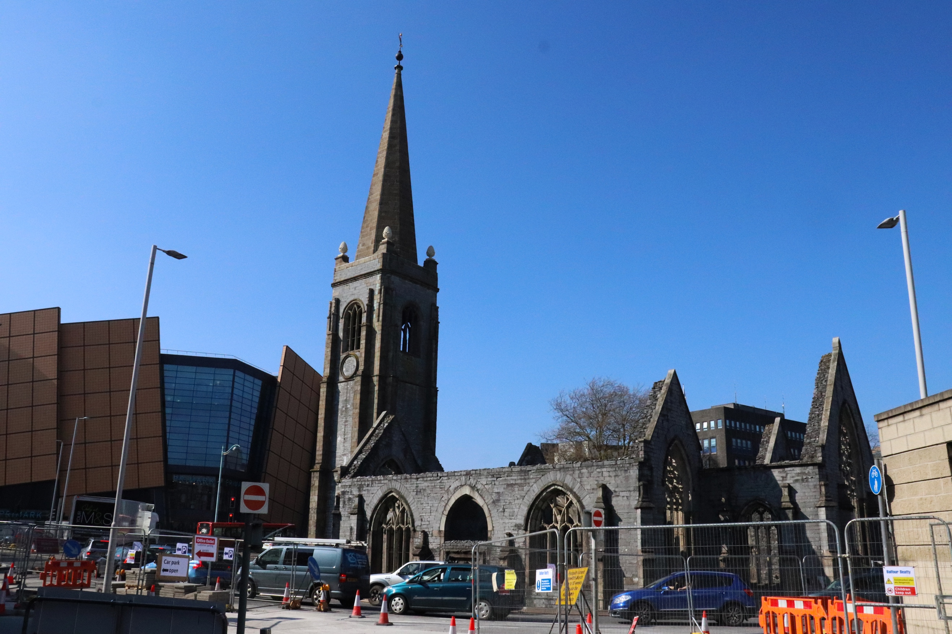
This collection is the second collection of Assignment 2, focusing on a collection of views. My first shoot was not up to the standard that it needed to be in order to clearly identify as a collection. This collection however, I feel is a better representation of a collection. This series of photographs focus on religious buildings, more specifically churches. When I shot this shoot, I shot modern, burnt out and amazing architectural buildings. The six images above are the 6 that I have chosen as my finals for this assignment. The shoot took me from my hometown Buckfastleigh, across the Moors to Tavistock and then down into Plymouth, where I ended my shoot with the fairly famous church, that sits in the middle of the roundabout next to Drake Circus called Charles Church. The texture of the churches seems to be rough, mainly because they are so old, and what materials they were made from. Each image has a different style foreground and background, as you might expect seeming they are in various locations. Image 1 has a graveyard surrounding the church, but not a very compact and busy grave. This might be because of the location. This church is situated on Dartmoor, at Princetown. This church goes by the name of Church of St Michael. Behind the church you can see a couple of rooftops of some houses which are over the road from the church.
In image 2, funnily and very strange, also called Church of St Michael is on the edge of Dartmoor on top of Brent Tor. This church overlooks the surrounding landscape and is a peaceful and beautiful church. As you can see from the surroundings, it is on top of a Tor, which you can see across the surrounding fields. Image 3 a smaller church on Dartmoor, A Methodist church, Poundsgate. This church is tiny and does not look like the other older fashion churches, it looks more like an ordinary building. But this church is surrounded by a quite road, and fields behind which you can see slightly. The 4th church looks really spectacular with its surroundings and one of my favourites, with all the overgrown bushes around it making it look very pretty and cosy. The 5th is a busy grave yard, this is Buckfastleigh’s church, situated in the heart of the town on a large hill, this church got burnt down many years ago, but still holds itself and looks really pretty. The last church which is in Plymouth is in the centre of Plymouth where it is very busy, and as you can see from the surroundings, probably the most diverse out of the lot, showing modern architecture, building works and cars. The church is in the centre of a very congested part of the city.
The colour of each of the images surrounding the church are vibrant and calm. It was a very sunny day when I did this shoot. I especially love the purple haze of the sky in image 1. Image 2 is the only one without blue sky, as it was overcast, very cloudy and windy when we went up the Tor. This almost makes the meeting between the sky and land over the background seem over exposed slightly, even though it is not. The buildings themselves are all very dark coloured, typically a colour of the church, and very bland.
Although I experimented with angles when out shooting, I didn’t try to get anything too fancy. Like the 26 gasoline stations, I did more of a point and shoot approach. This was from head height and taken from an angle that would mostly see the church 3D as this would allow the viewer to see the depth of the church and more of the church. All the churches come in different shapes and sizes and this is evident in my images.
I found it very hard whilst out shooting, as various problems occurred, such as the change in settings (accidently) and the glare of the sun. I feel that the images I have captured have been exposed to the best of my ability to avoid glare and over exposure. I followed the instructions of the brief by making sure my focal point was 18mm and my aperture was constantly the same throughout. The images sit more of a collection than my previous collection as this is more diverse and shows different locations, and buildings and angles etc. but same subject. Edward Ruscha was one of my main inspirations for this shoot as I feel his work clearly demonstrates a collection, therefore I feel mine has the same ingredients, but just different subject and places.

