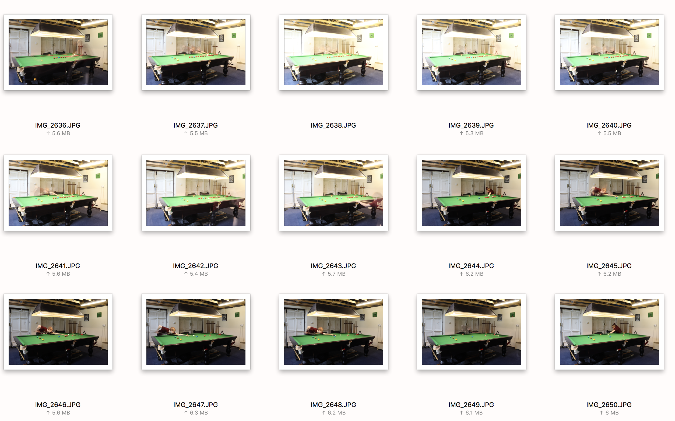

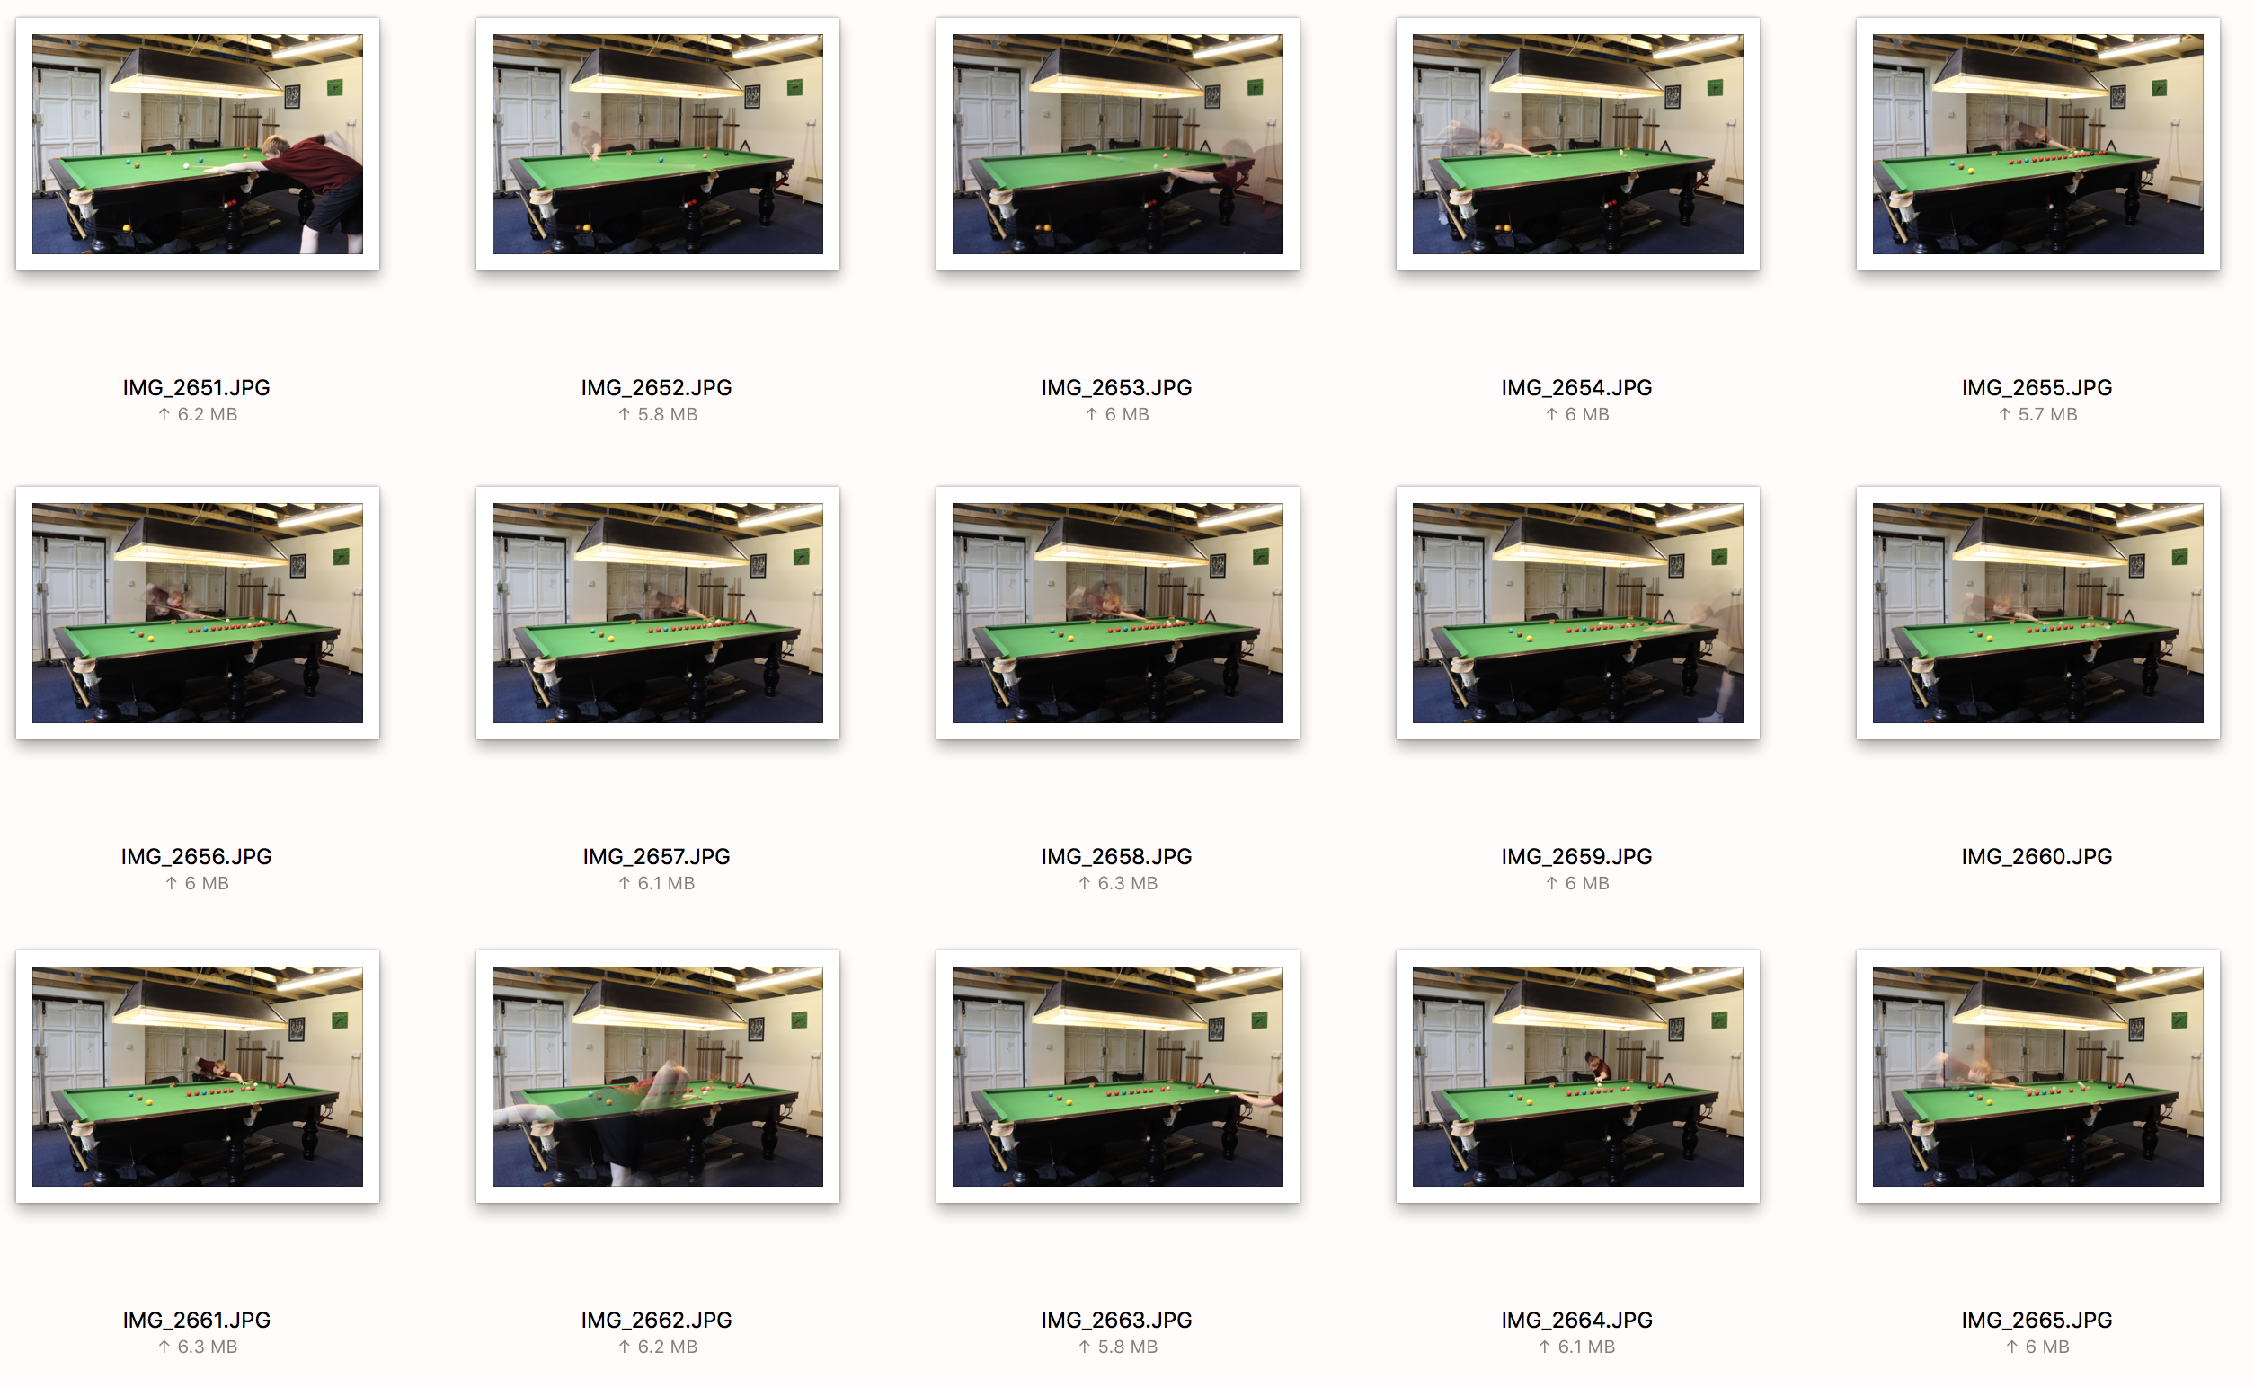

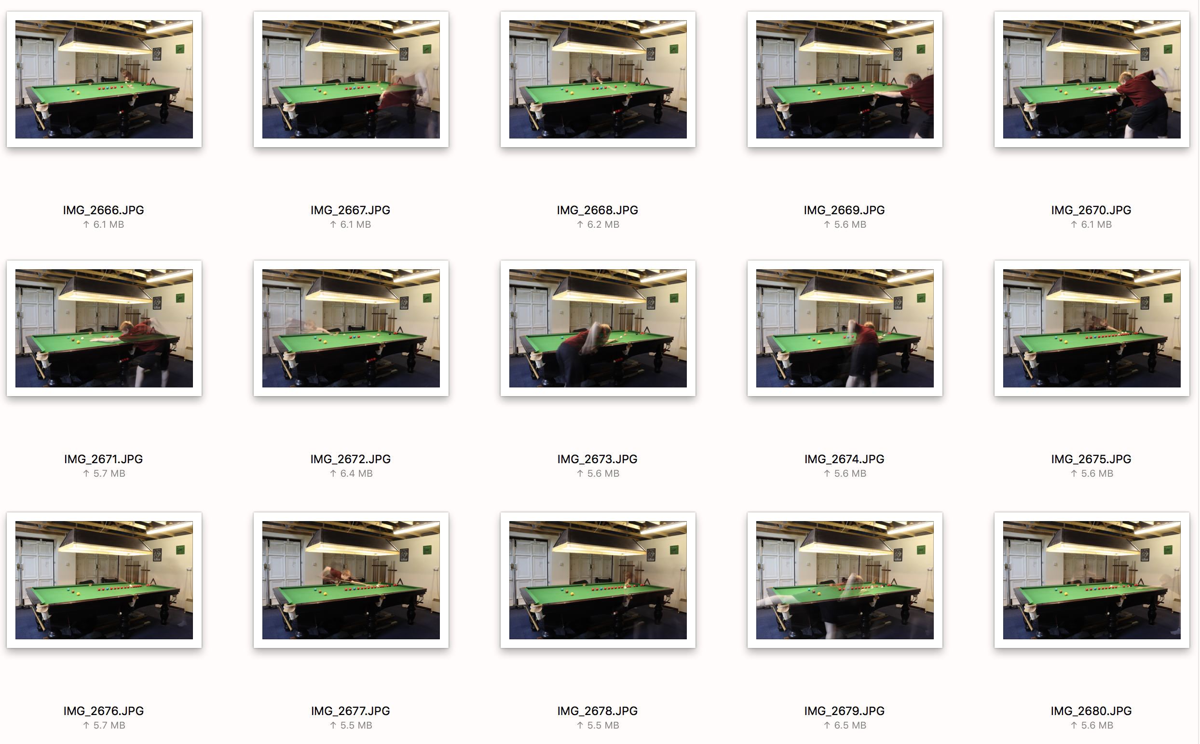

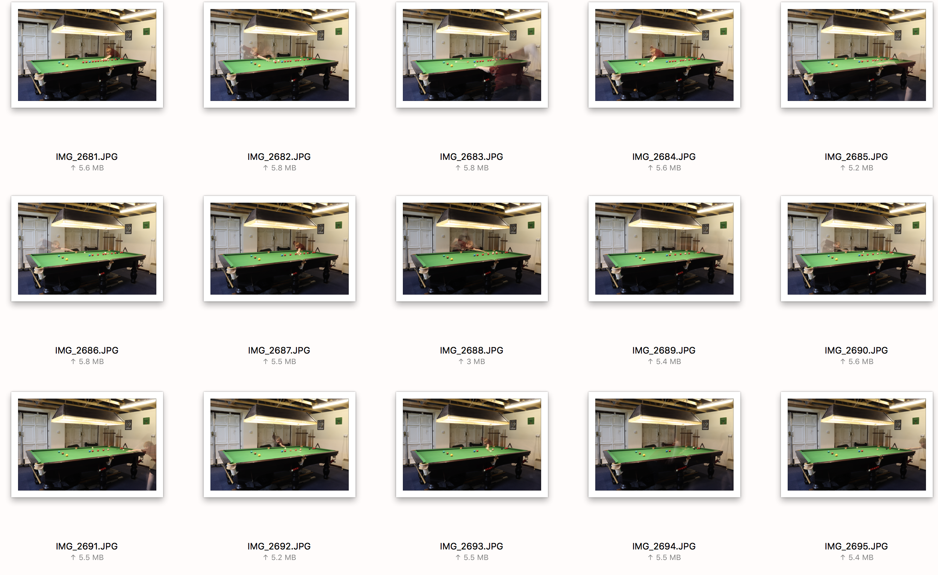

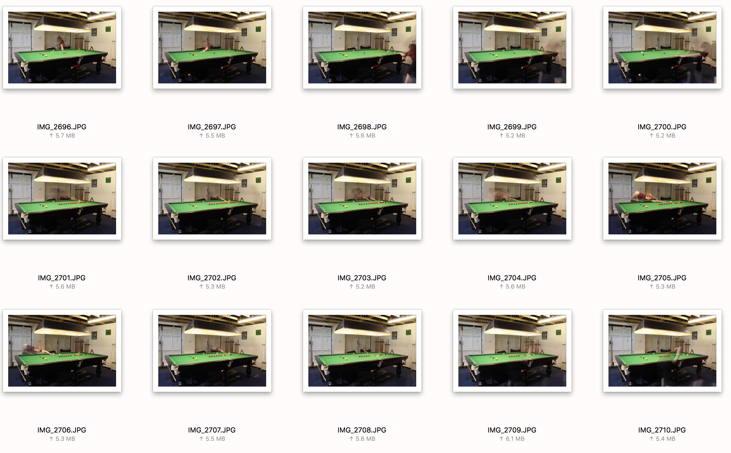
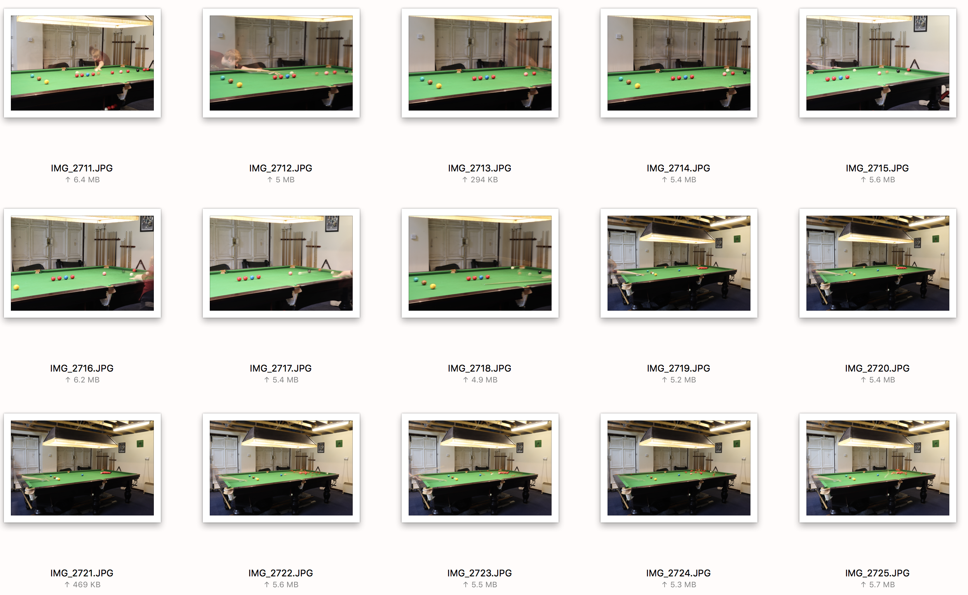

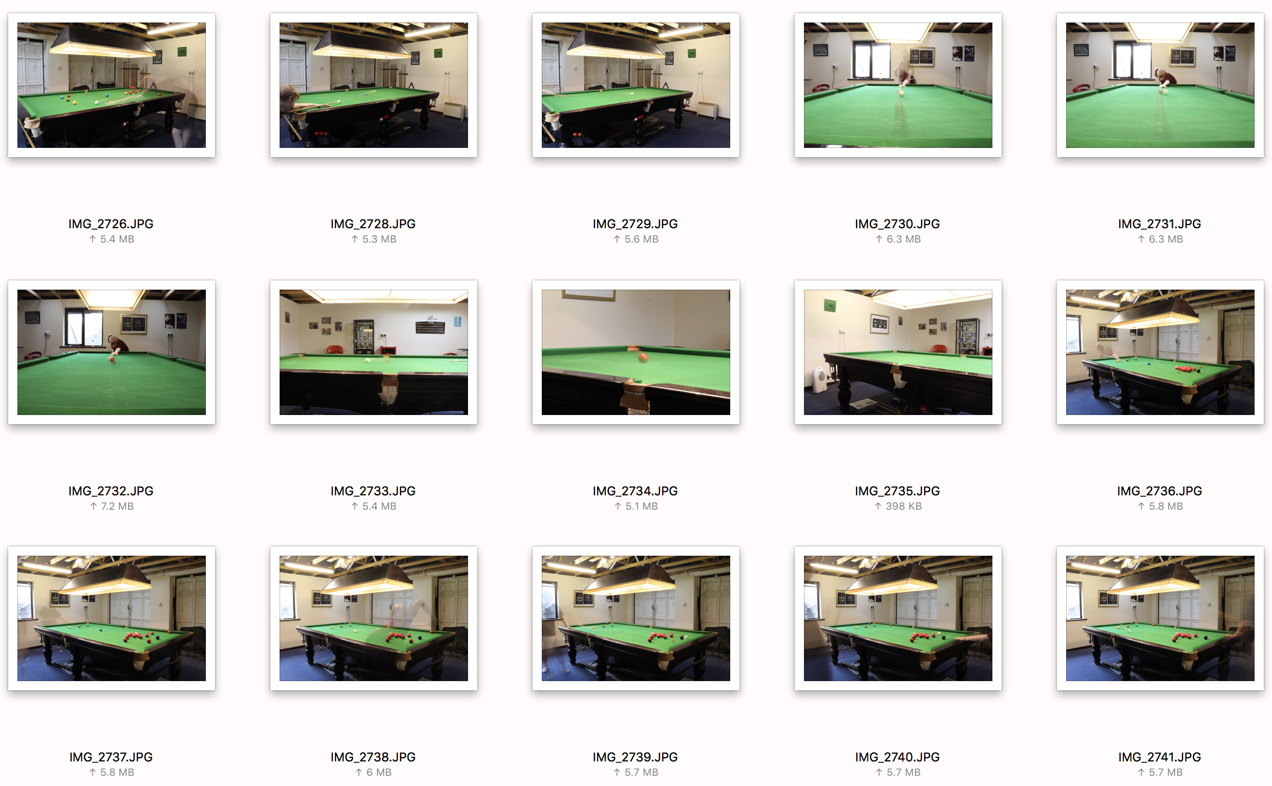
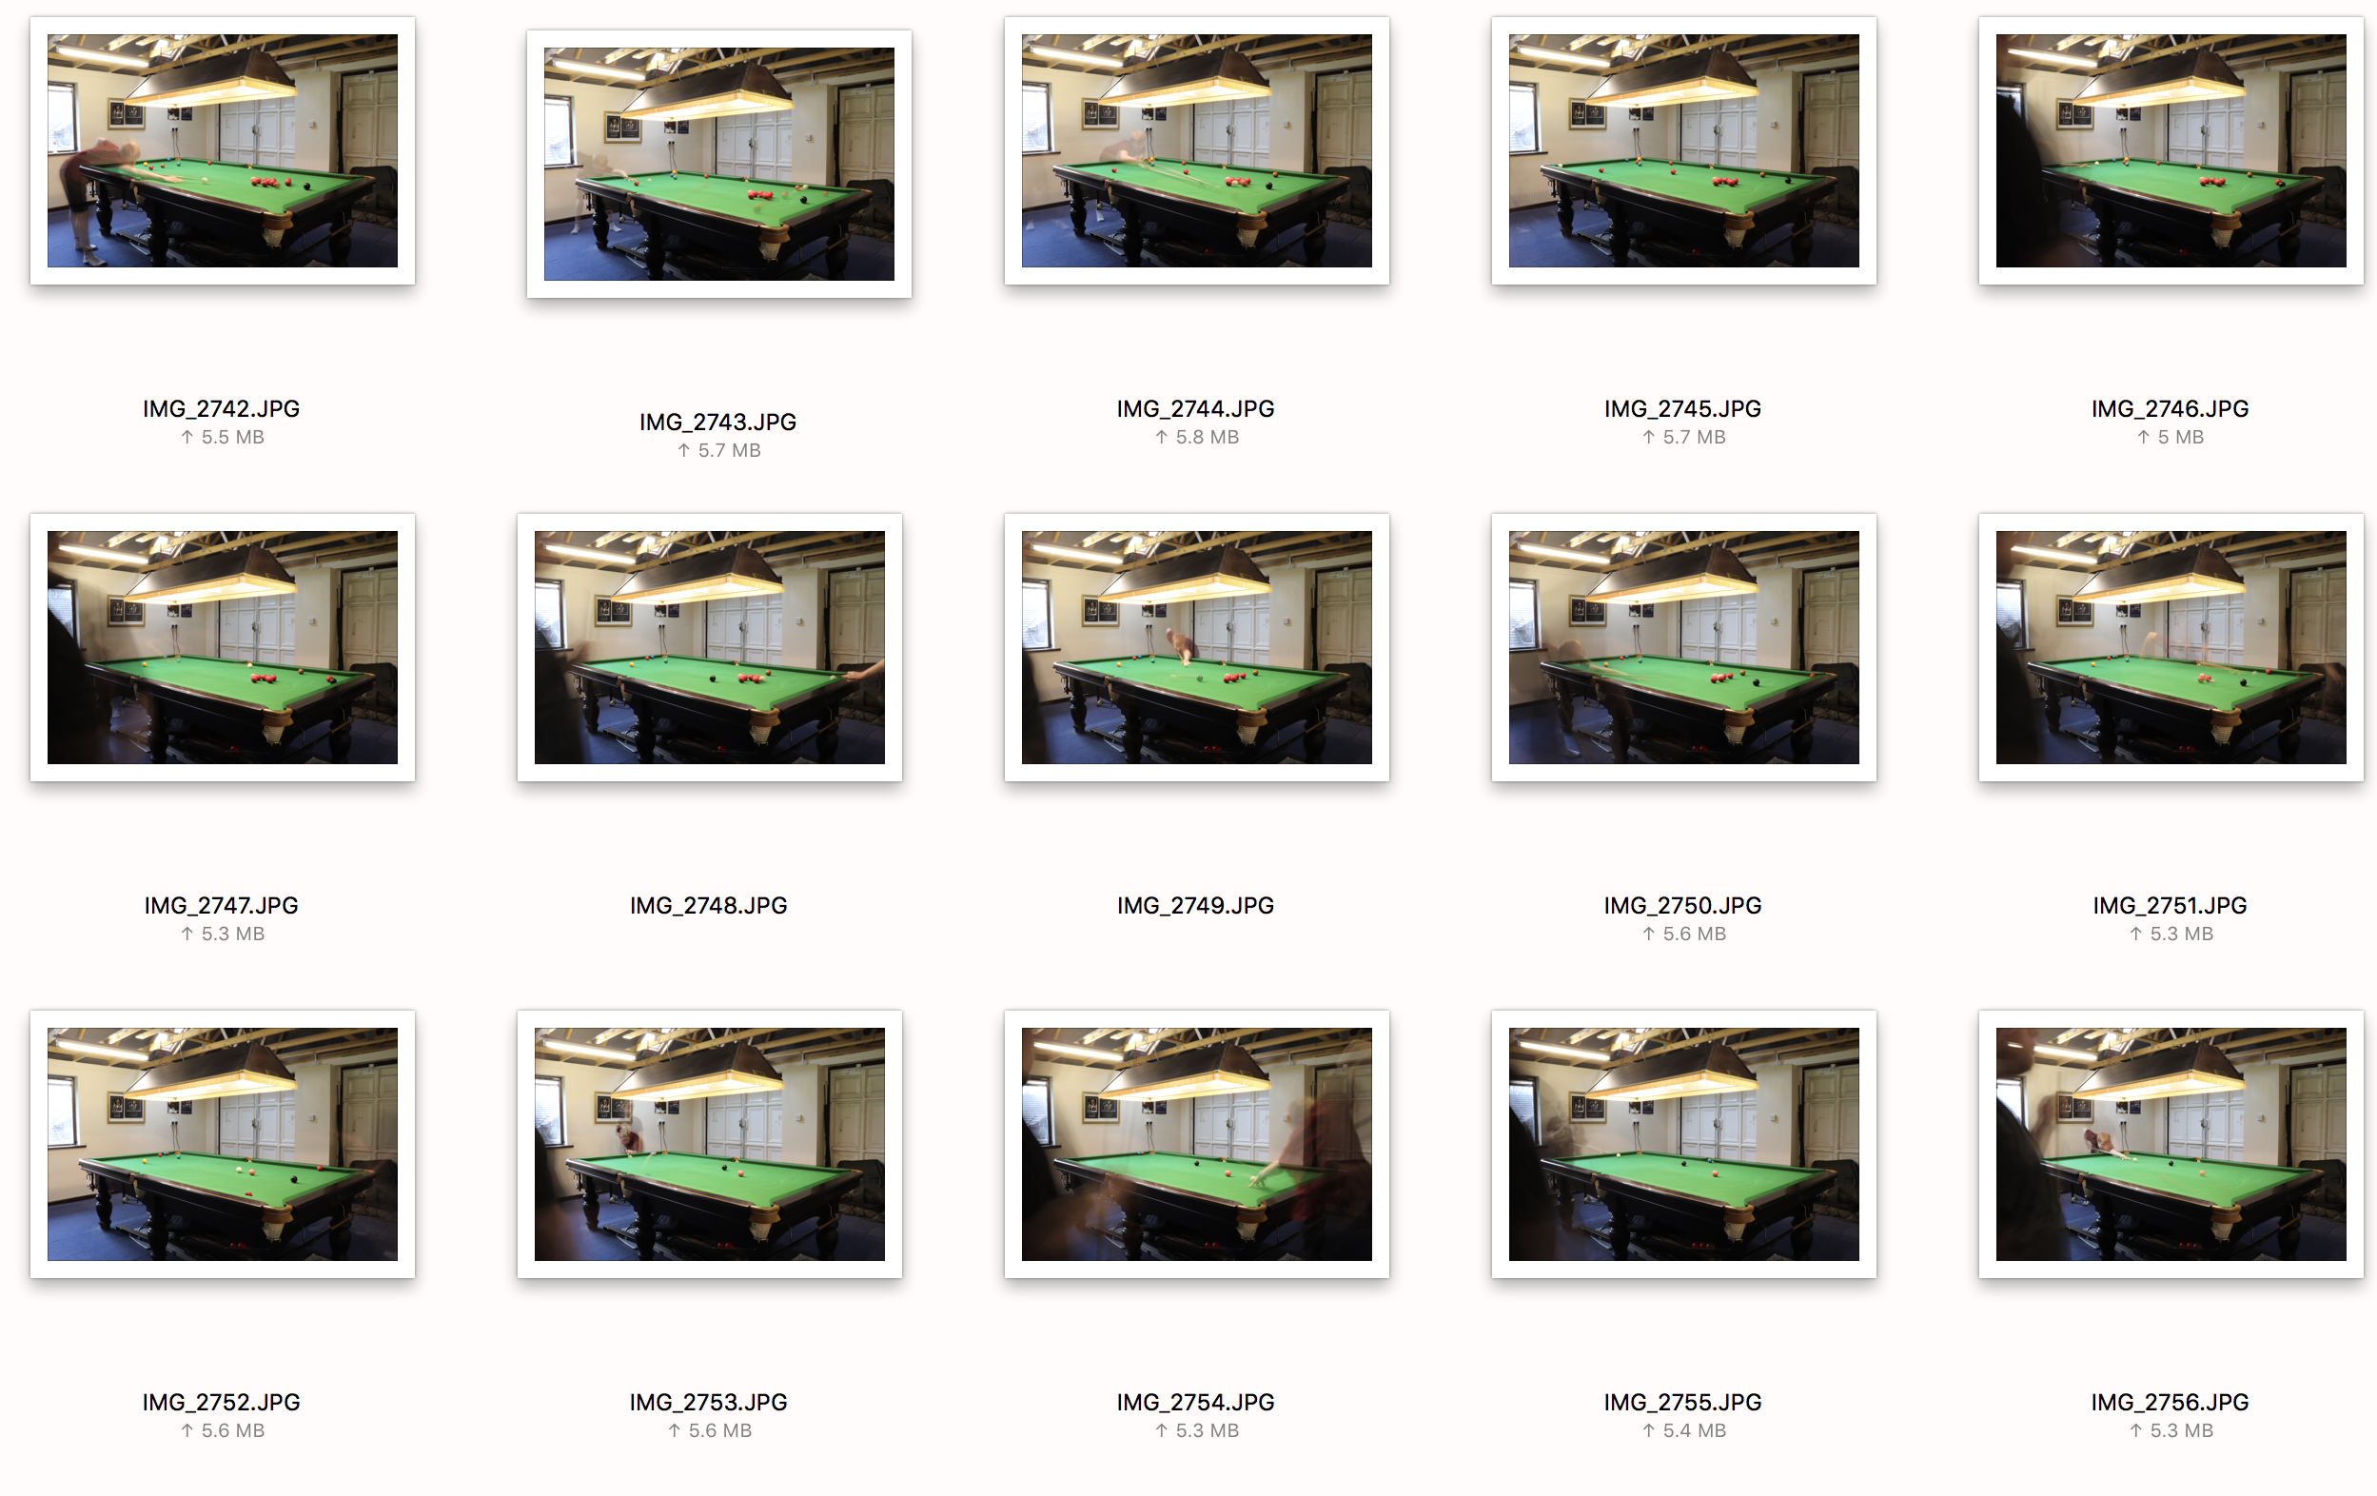
The reasoning behind why I have selected these images as my finals is because I feel that 3 images clearly show the theory behind this shoot with the slow shutter. The ones that made the cut is because they hold certain characteristics that make them stand out and demonstrate better than the other images what I wanted them to. I will talk more in depth in my annotations of the images. When selecting I thought they looked really good because of the balls and how they travel and the positioning of my brother and the balls. This shoot was a hard one to select from, as it was to take. This is because of the nature of the shoot and trying to capture it just right so that the outcome is noticeable and shows the balls technically ‘traveling through time’.

