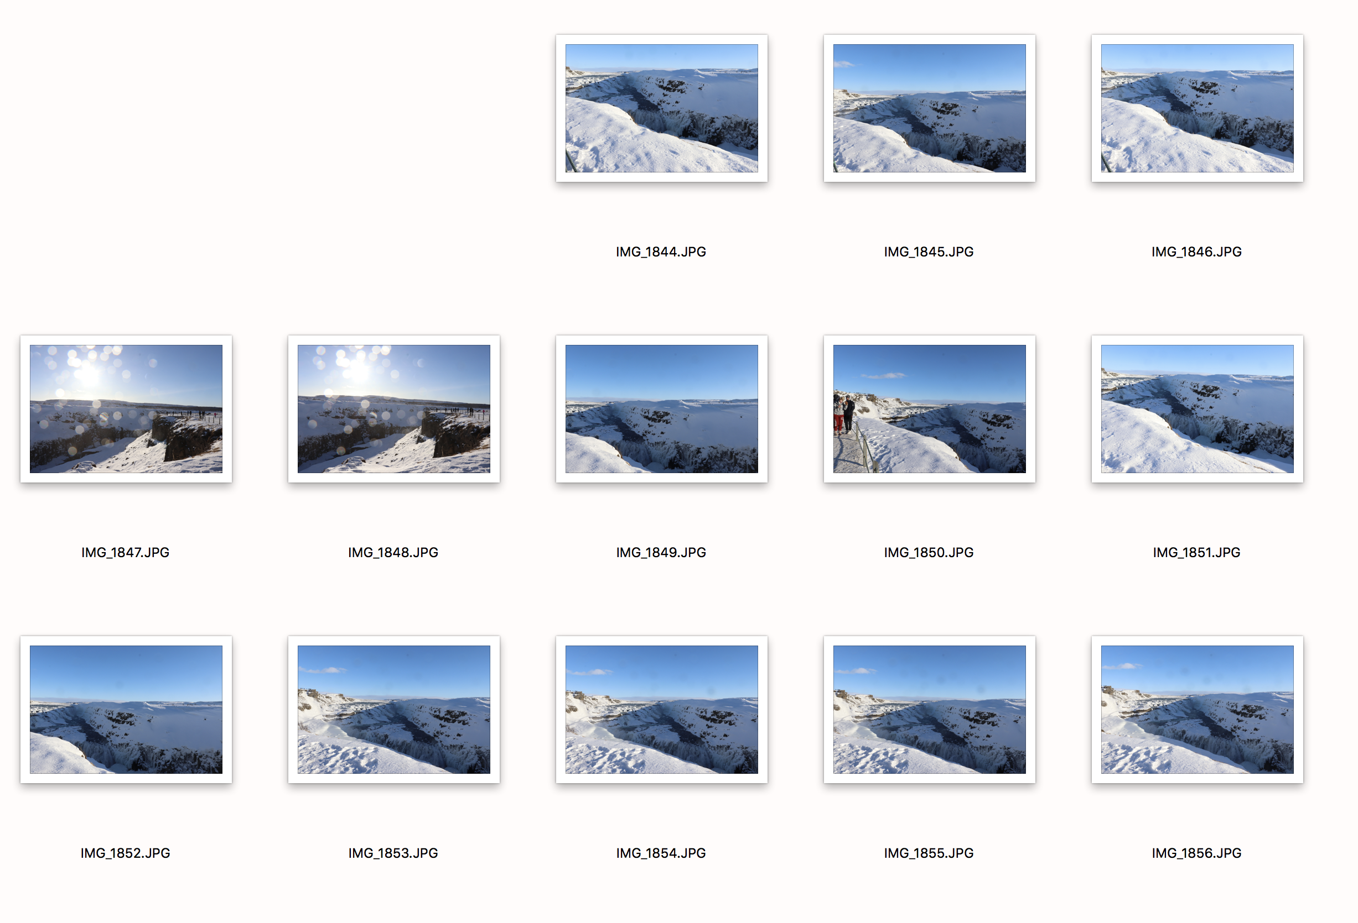
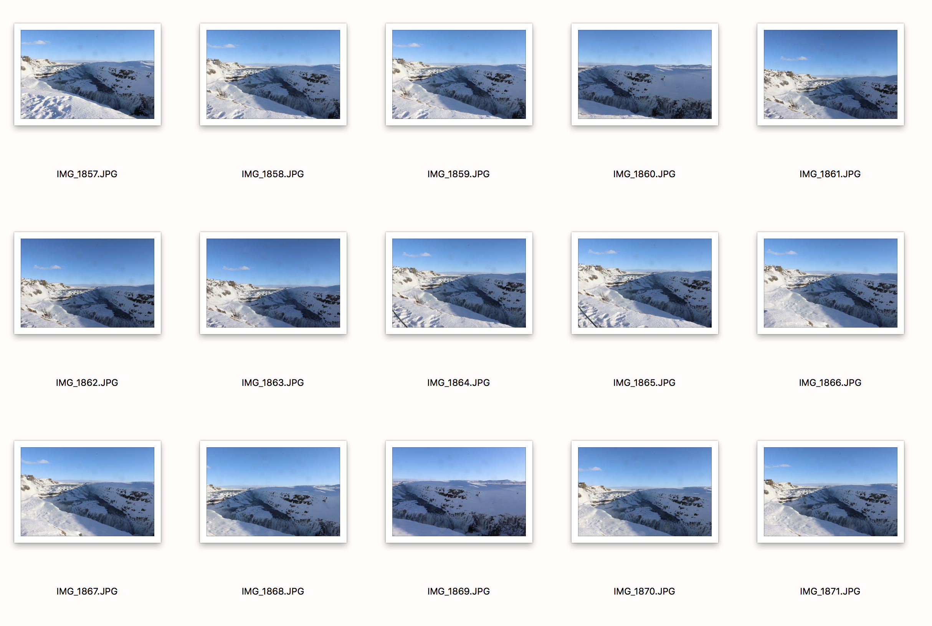
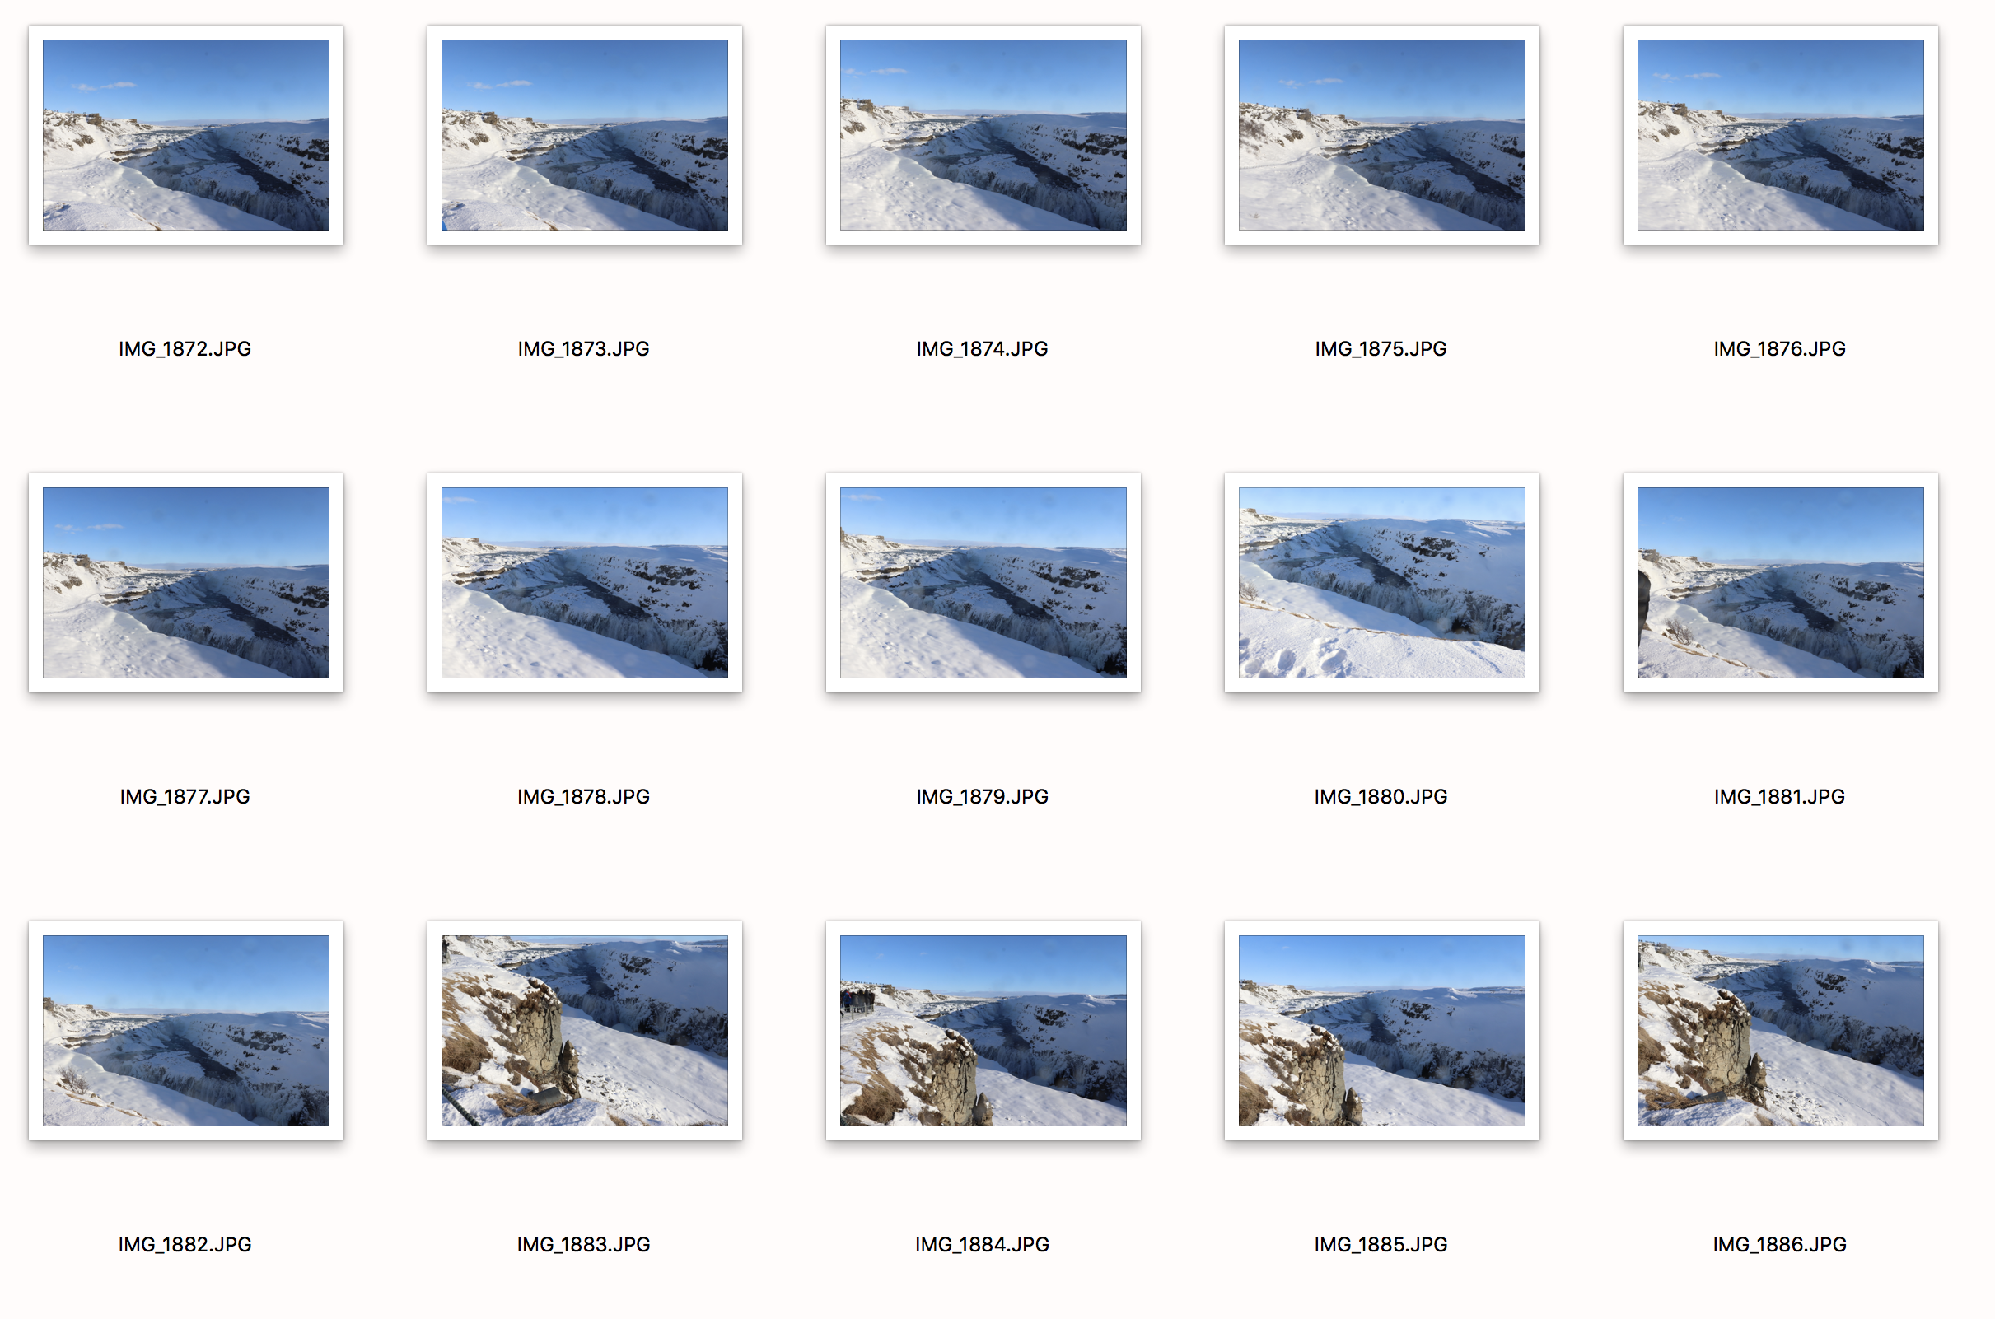
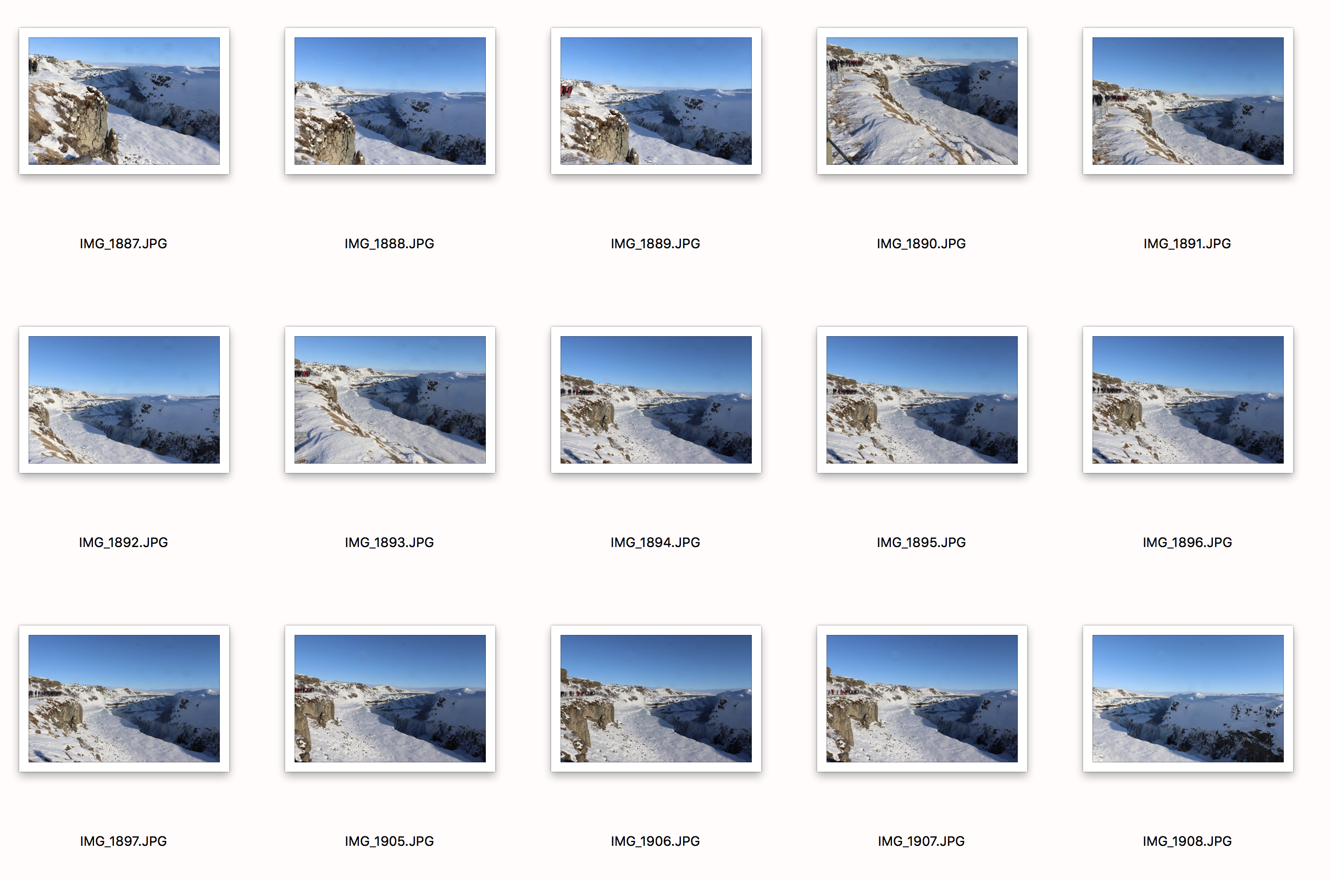
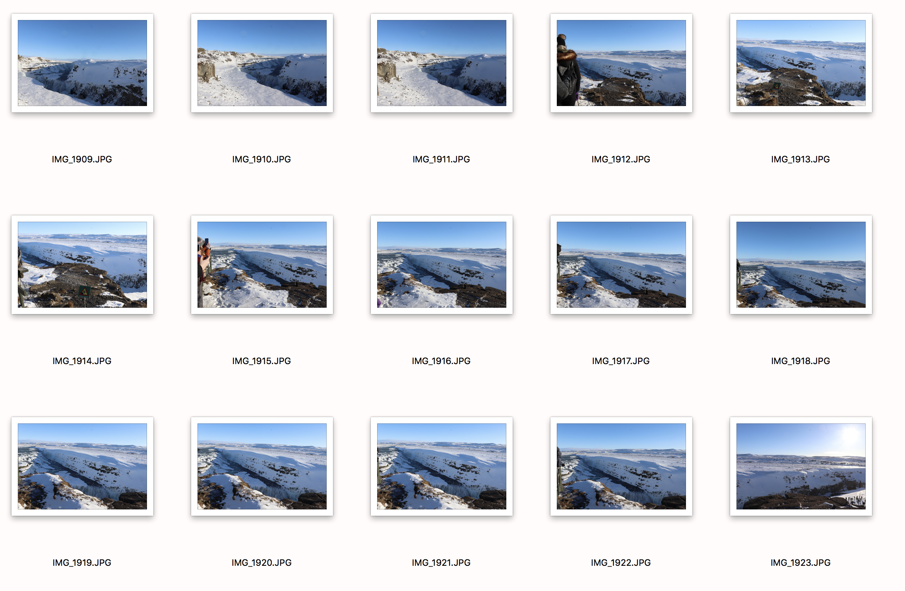

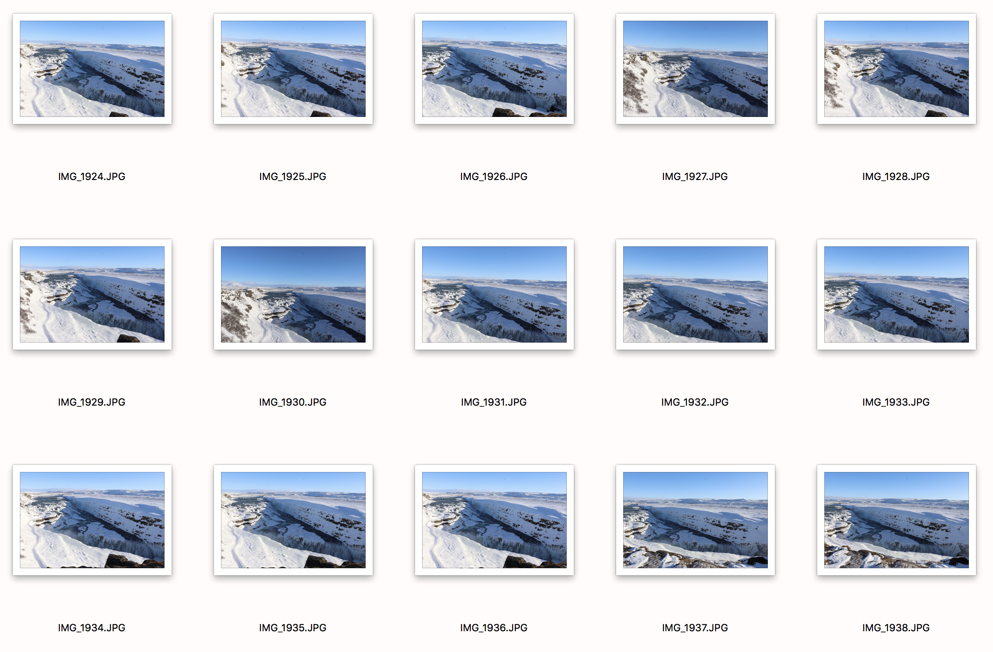

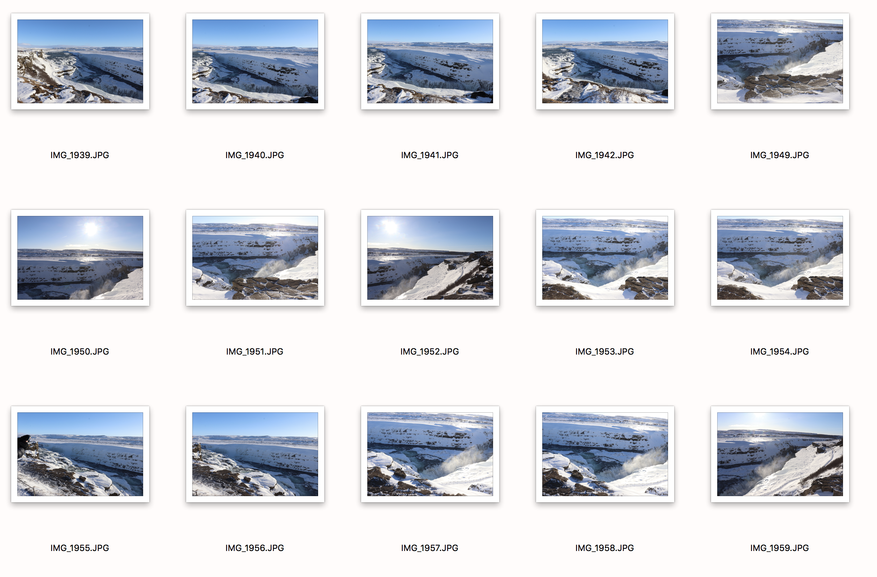

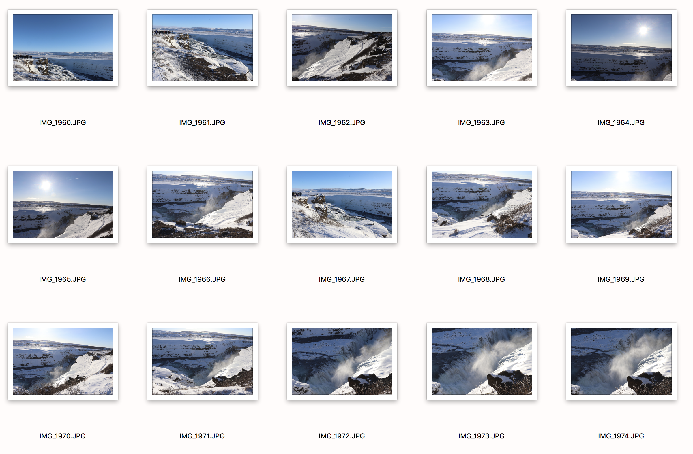

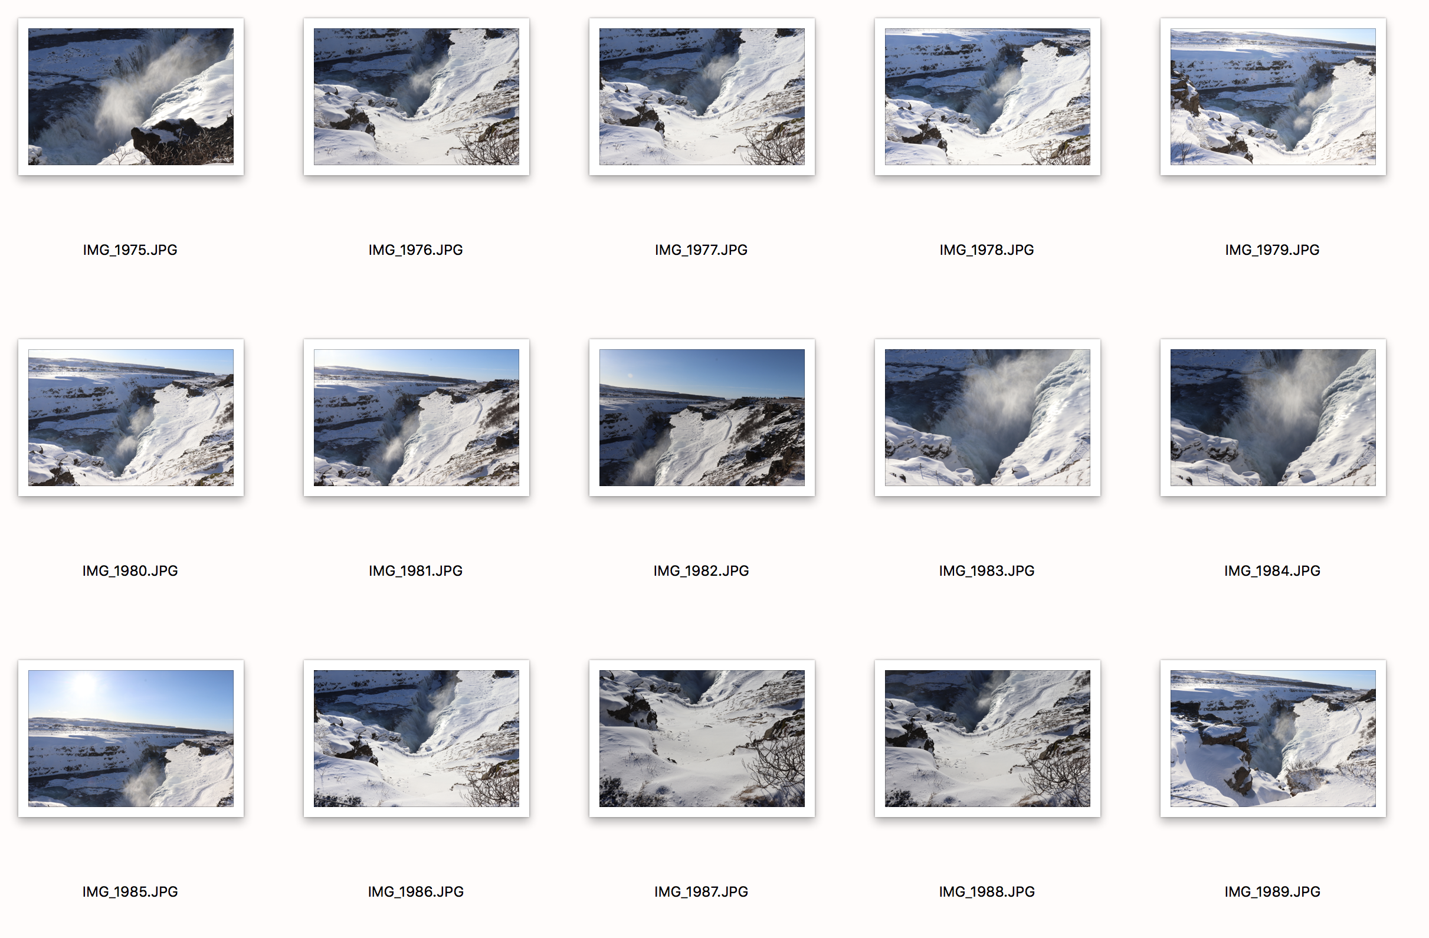

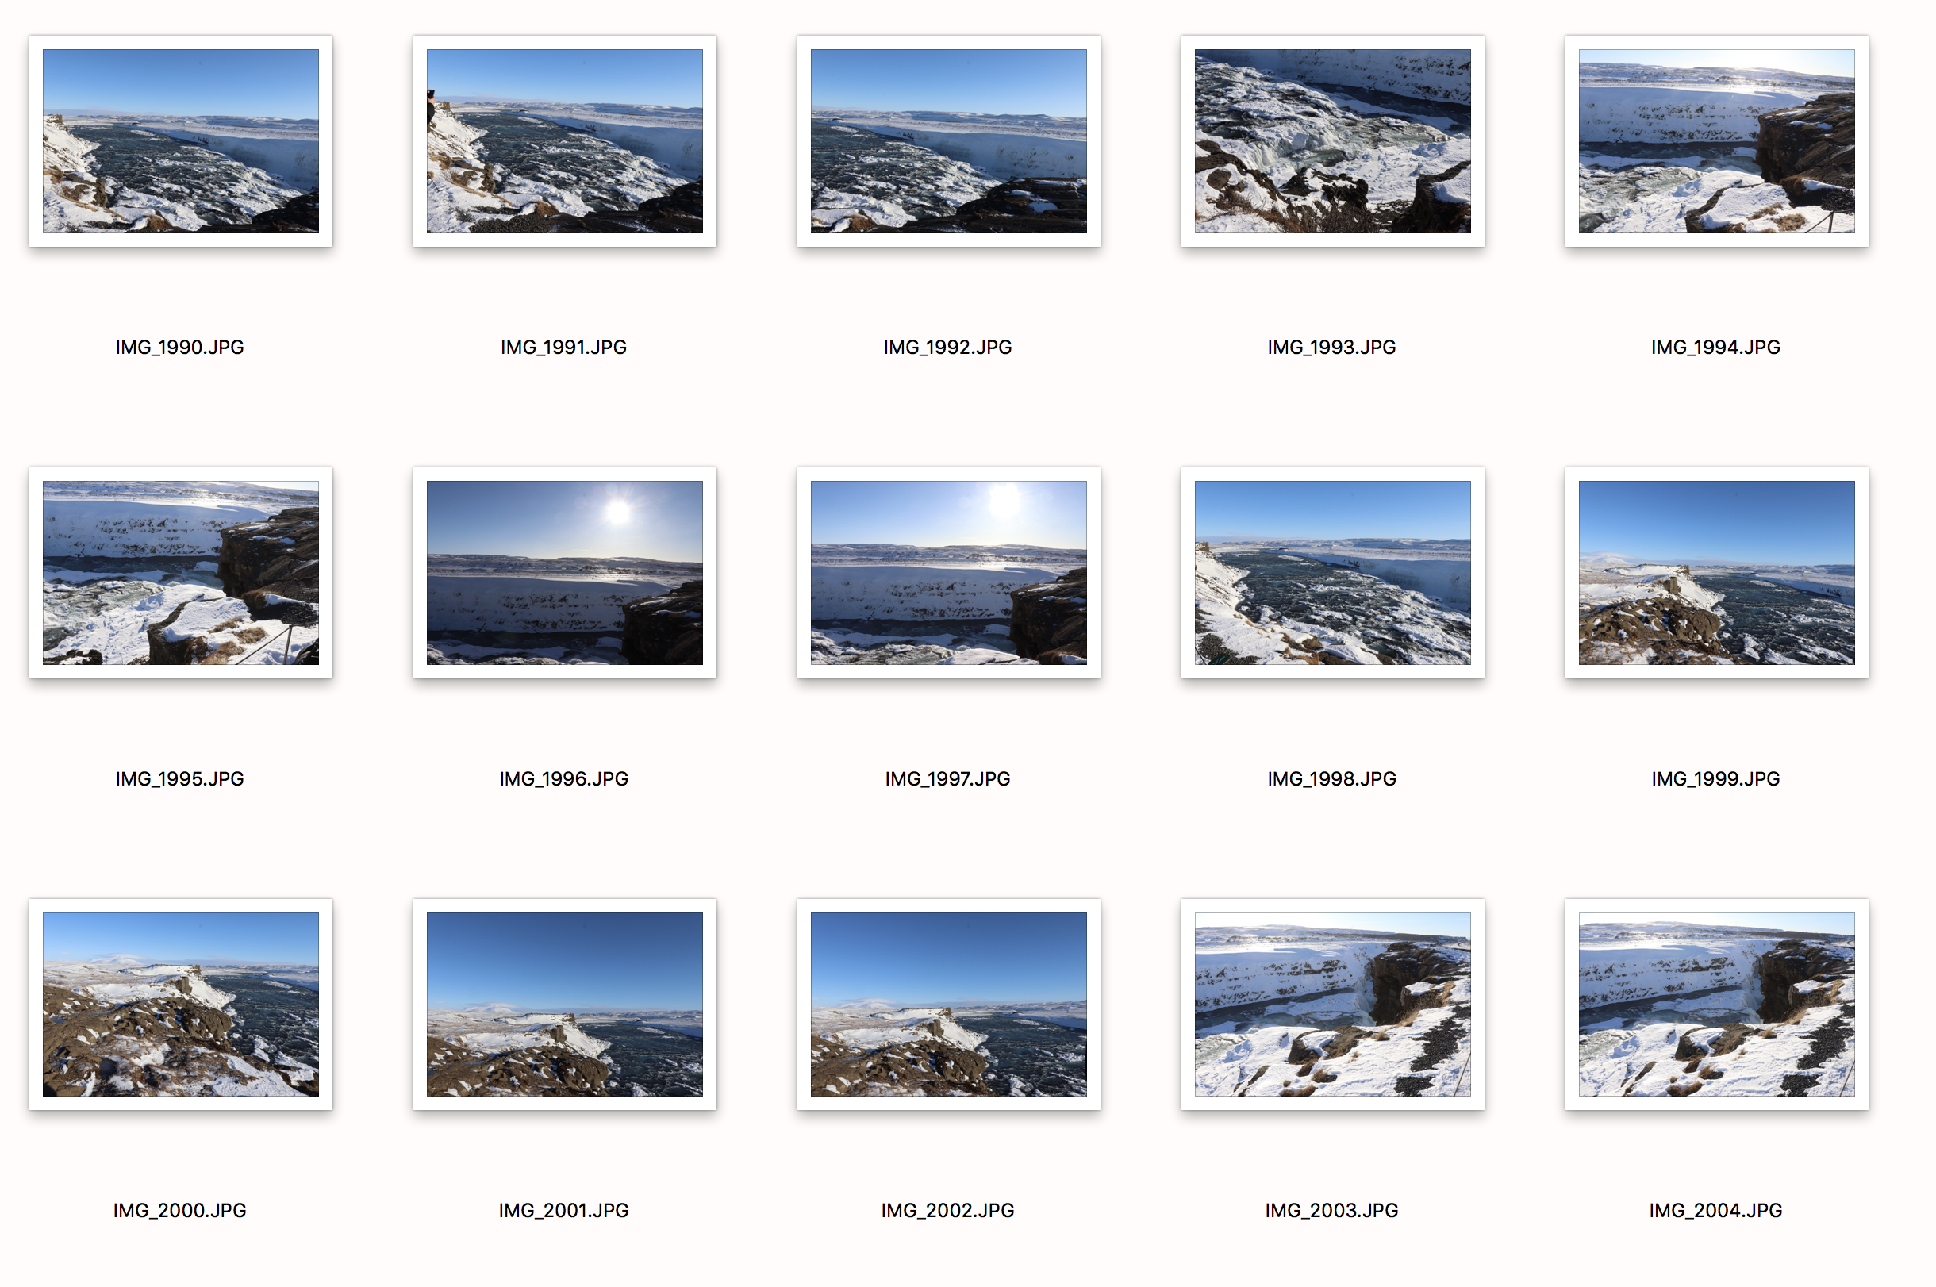
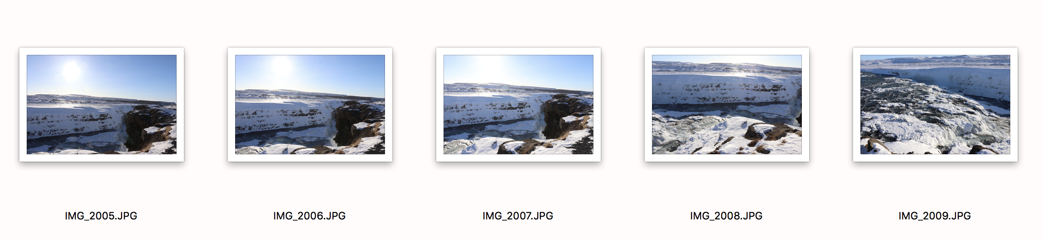

The reason I have chosen the images I have circled is because I feel that they are the best images that comply with the brief and help form a comfortable and good collection to enjoy looking at. This is not my main focus for the collection though. Here, I am specifically focusing on the same subject, but from various locations surrounding it. My reason for this collection is so that you can see what a landmark looks like from different locations. Because it is such a big waterfall, in each image you can clearly see that the images change slightly throughout, even though I am focusing on the same subject, using the same camera settings. When I write about my shoot, the text will complement the images so that it is easy to understand.

