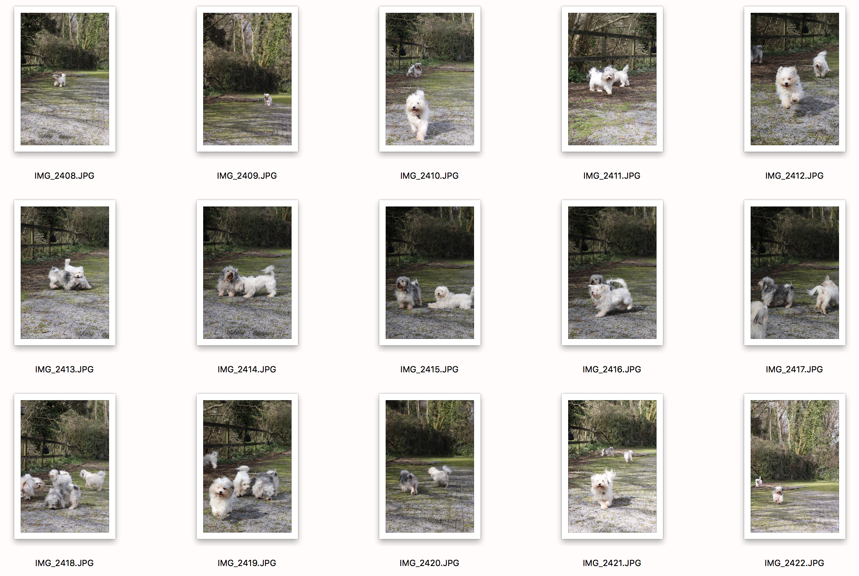
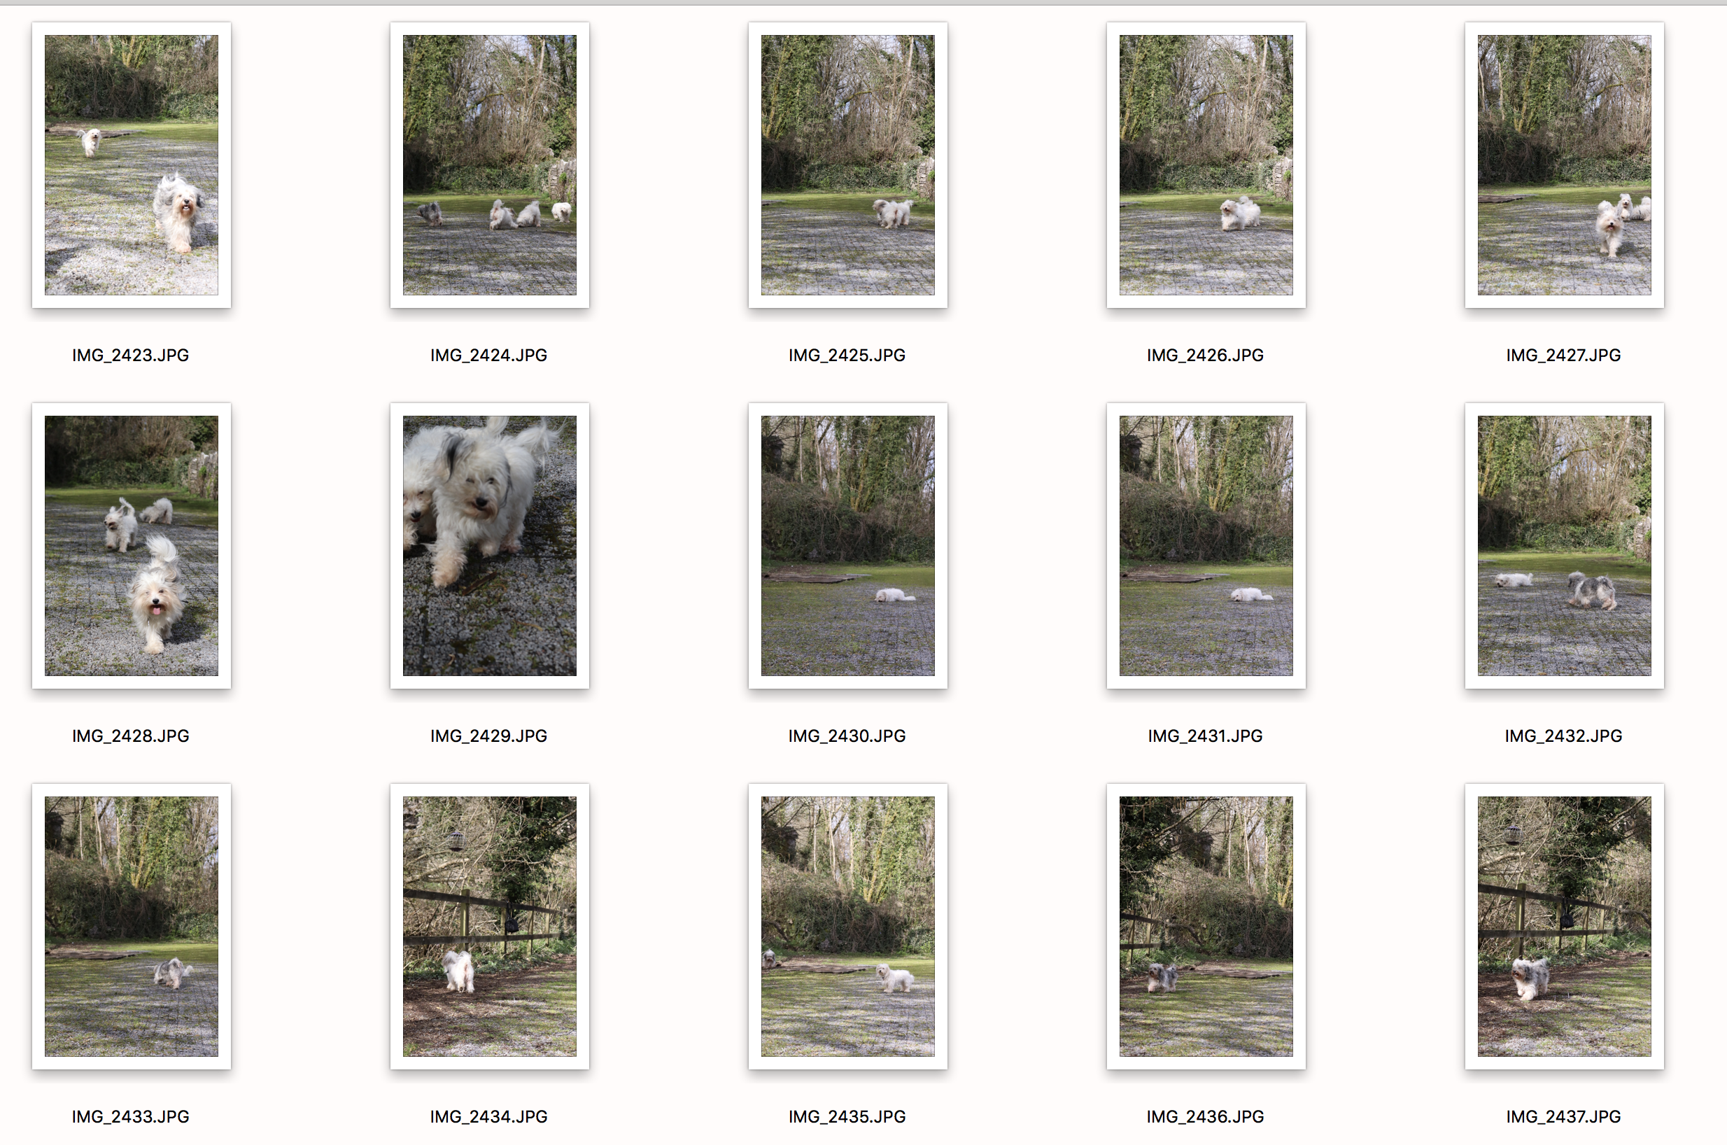
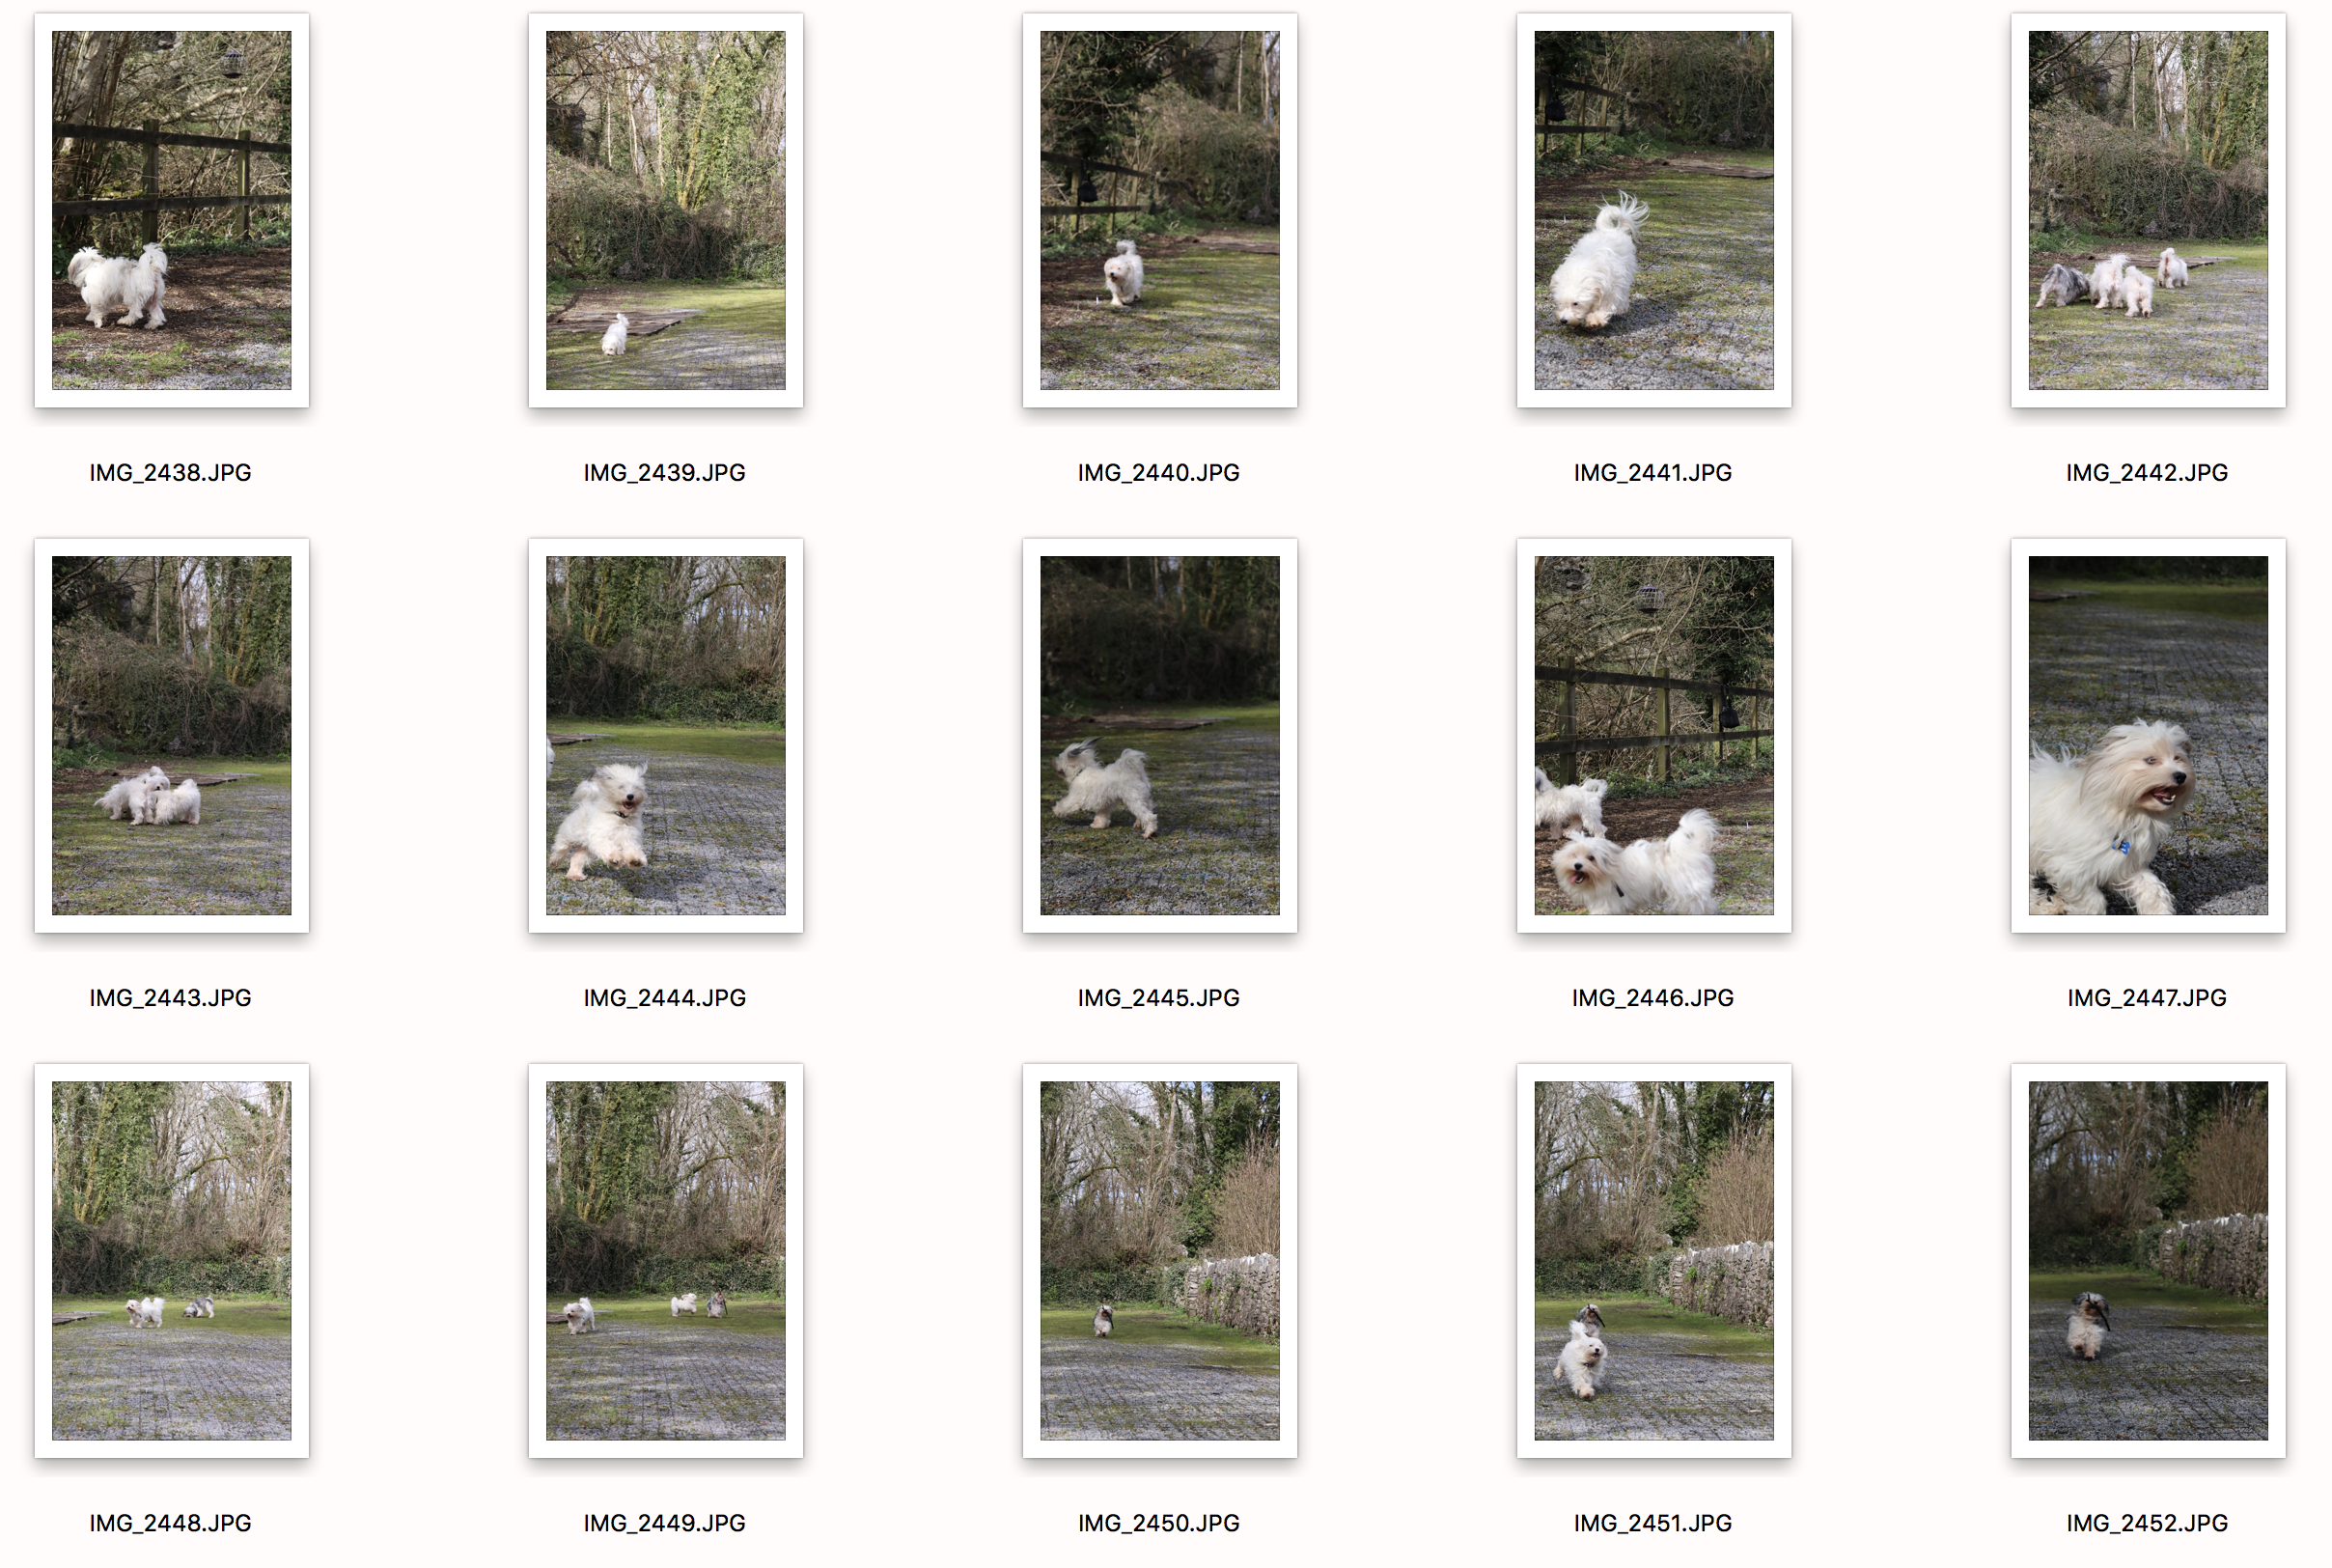
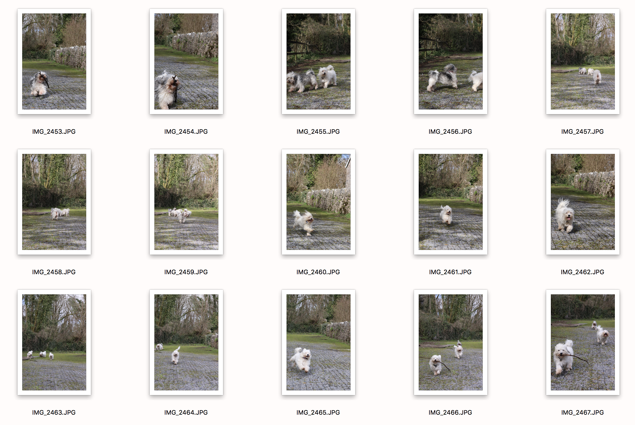
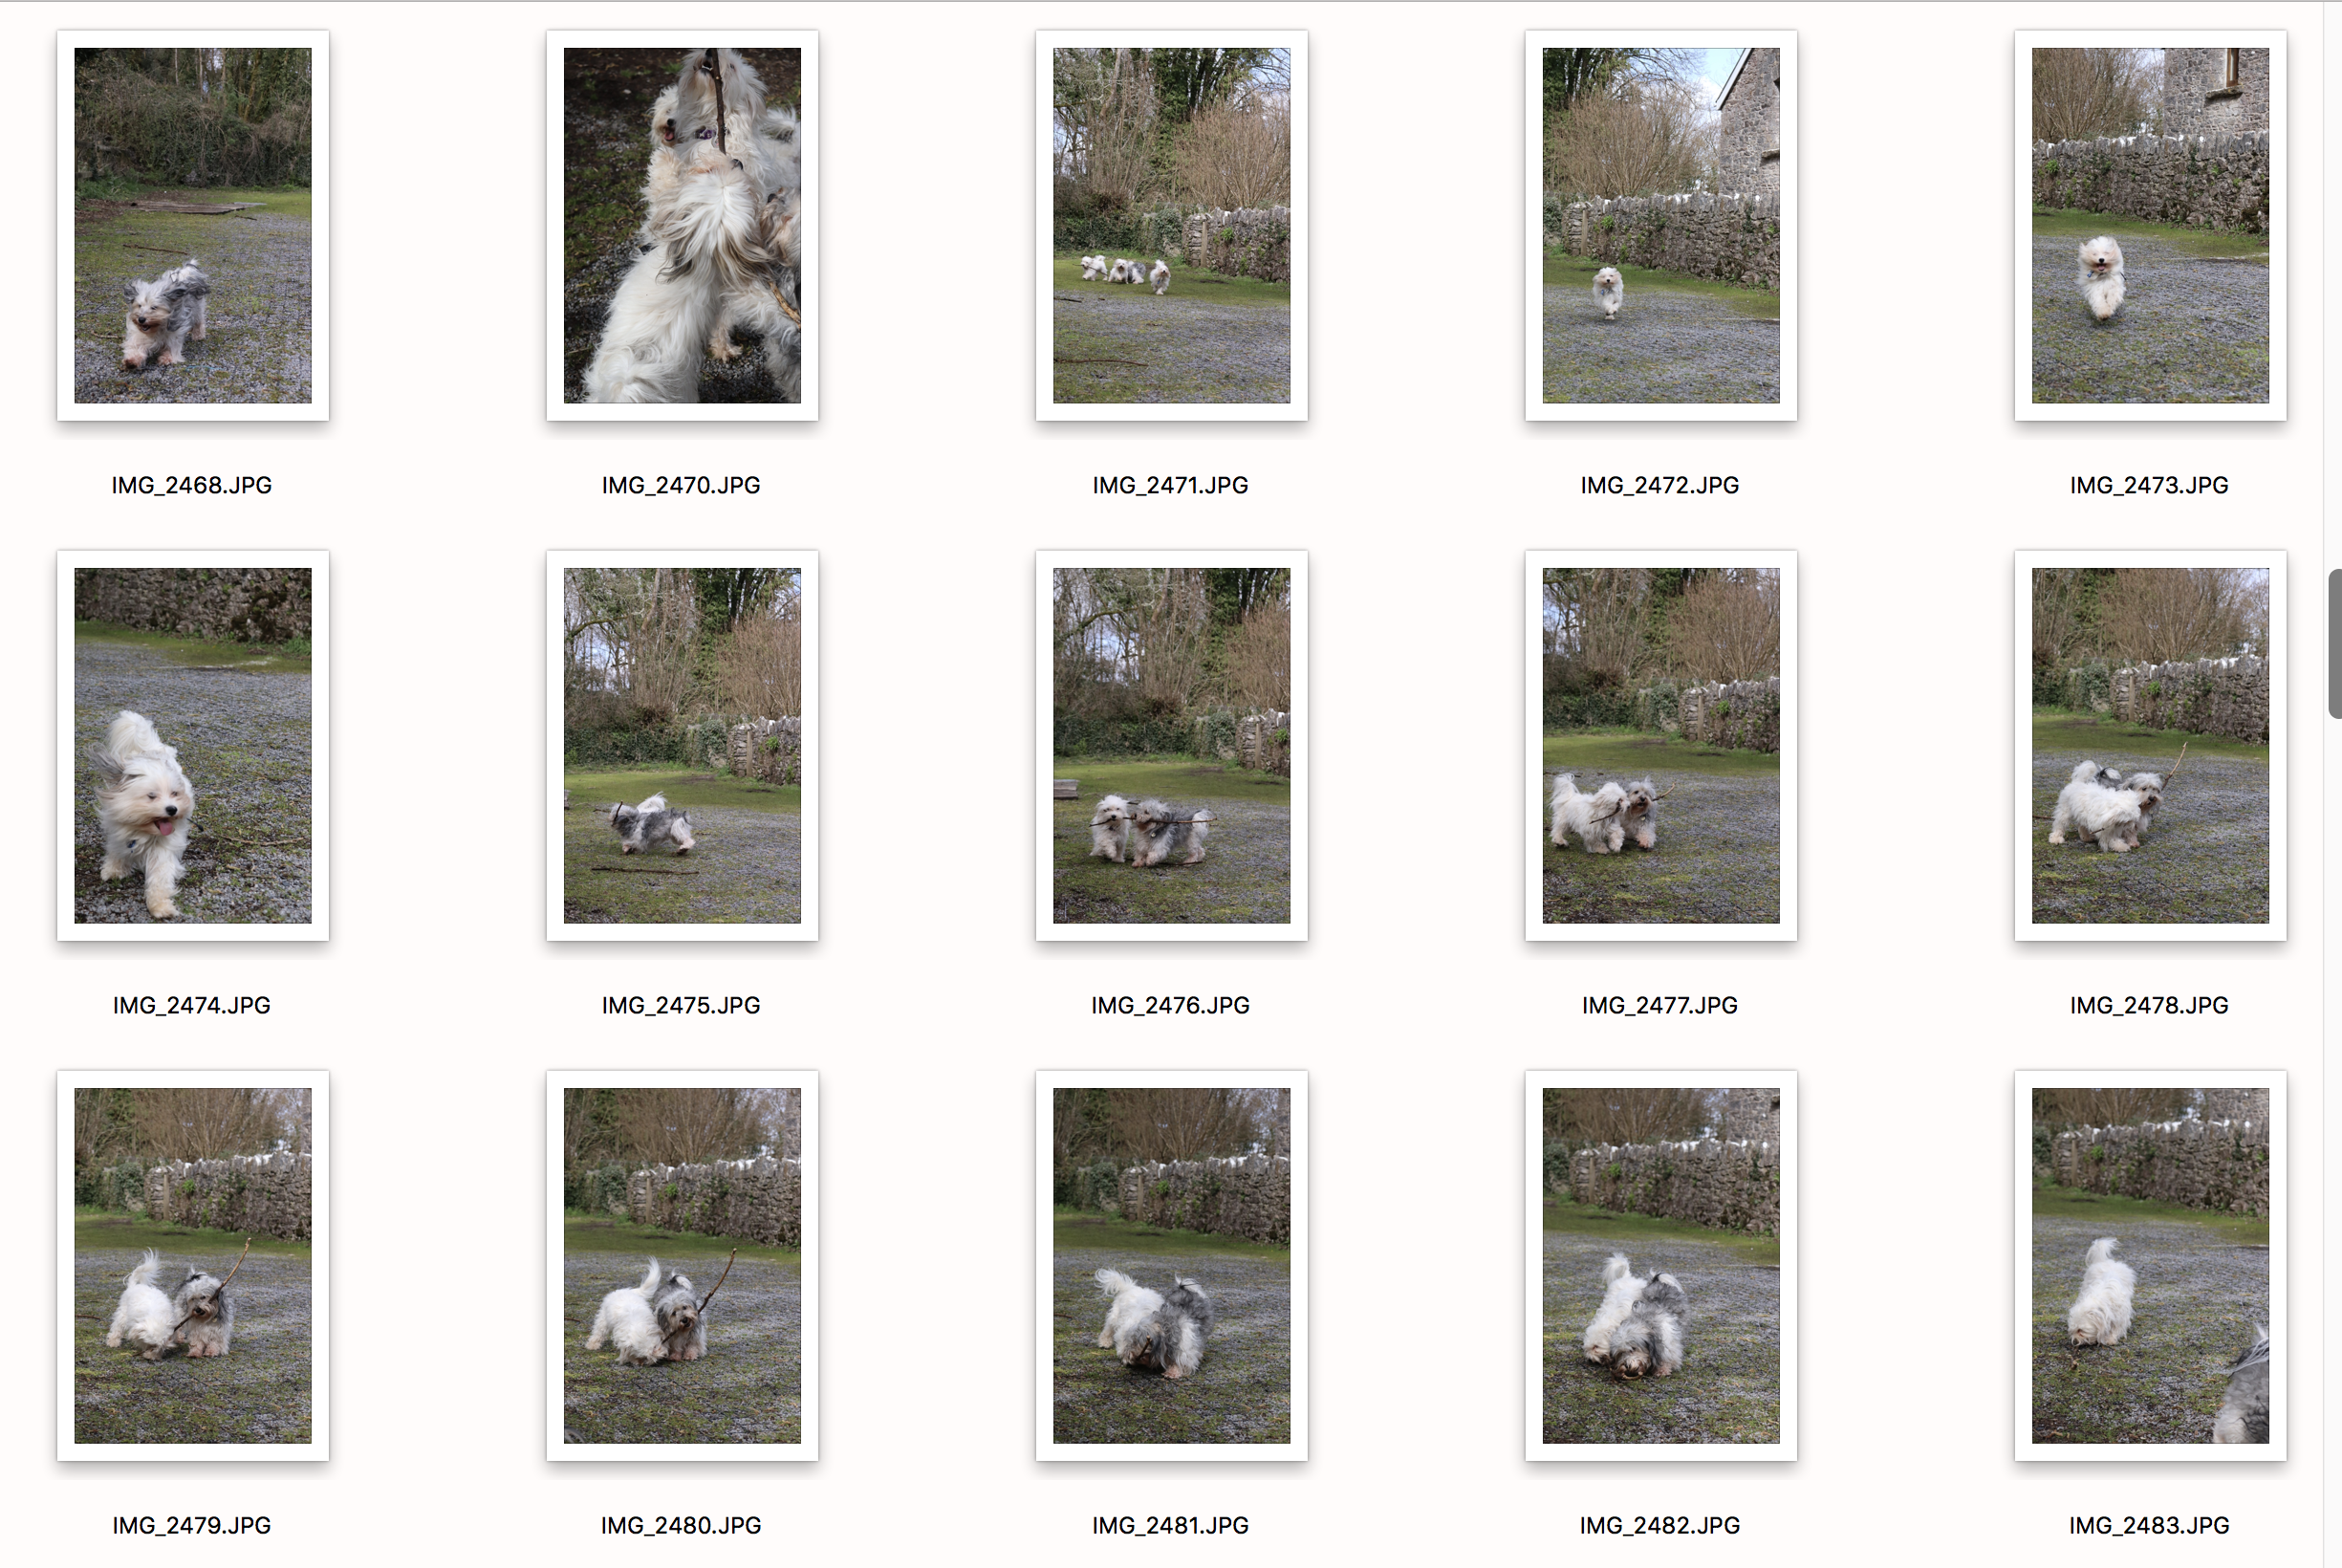
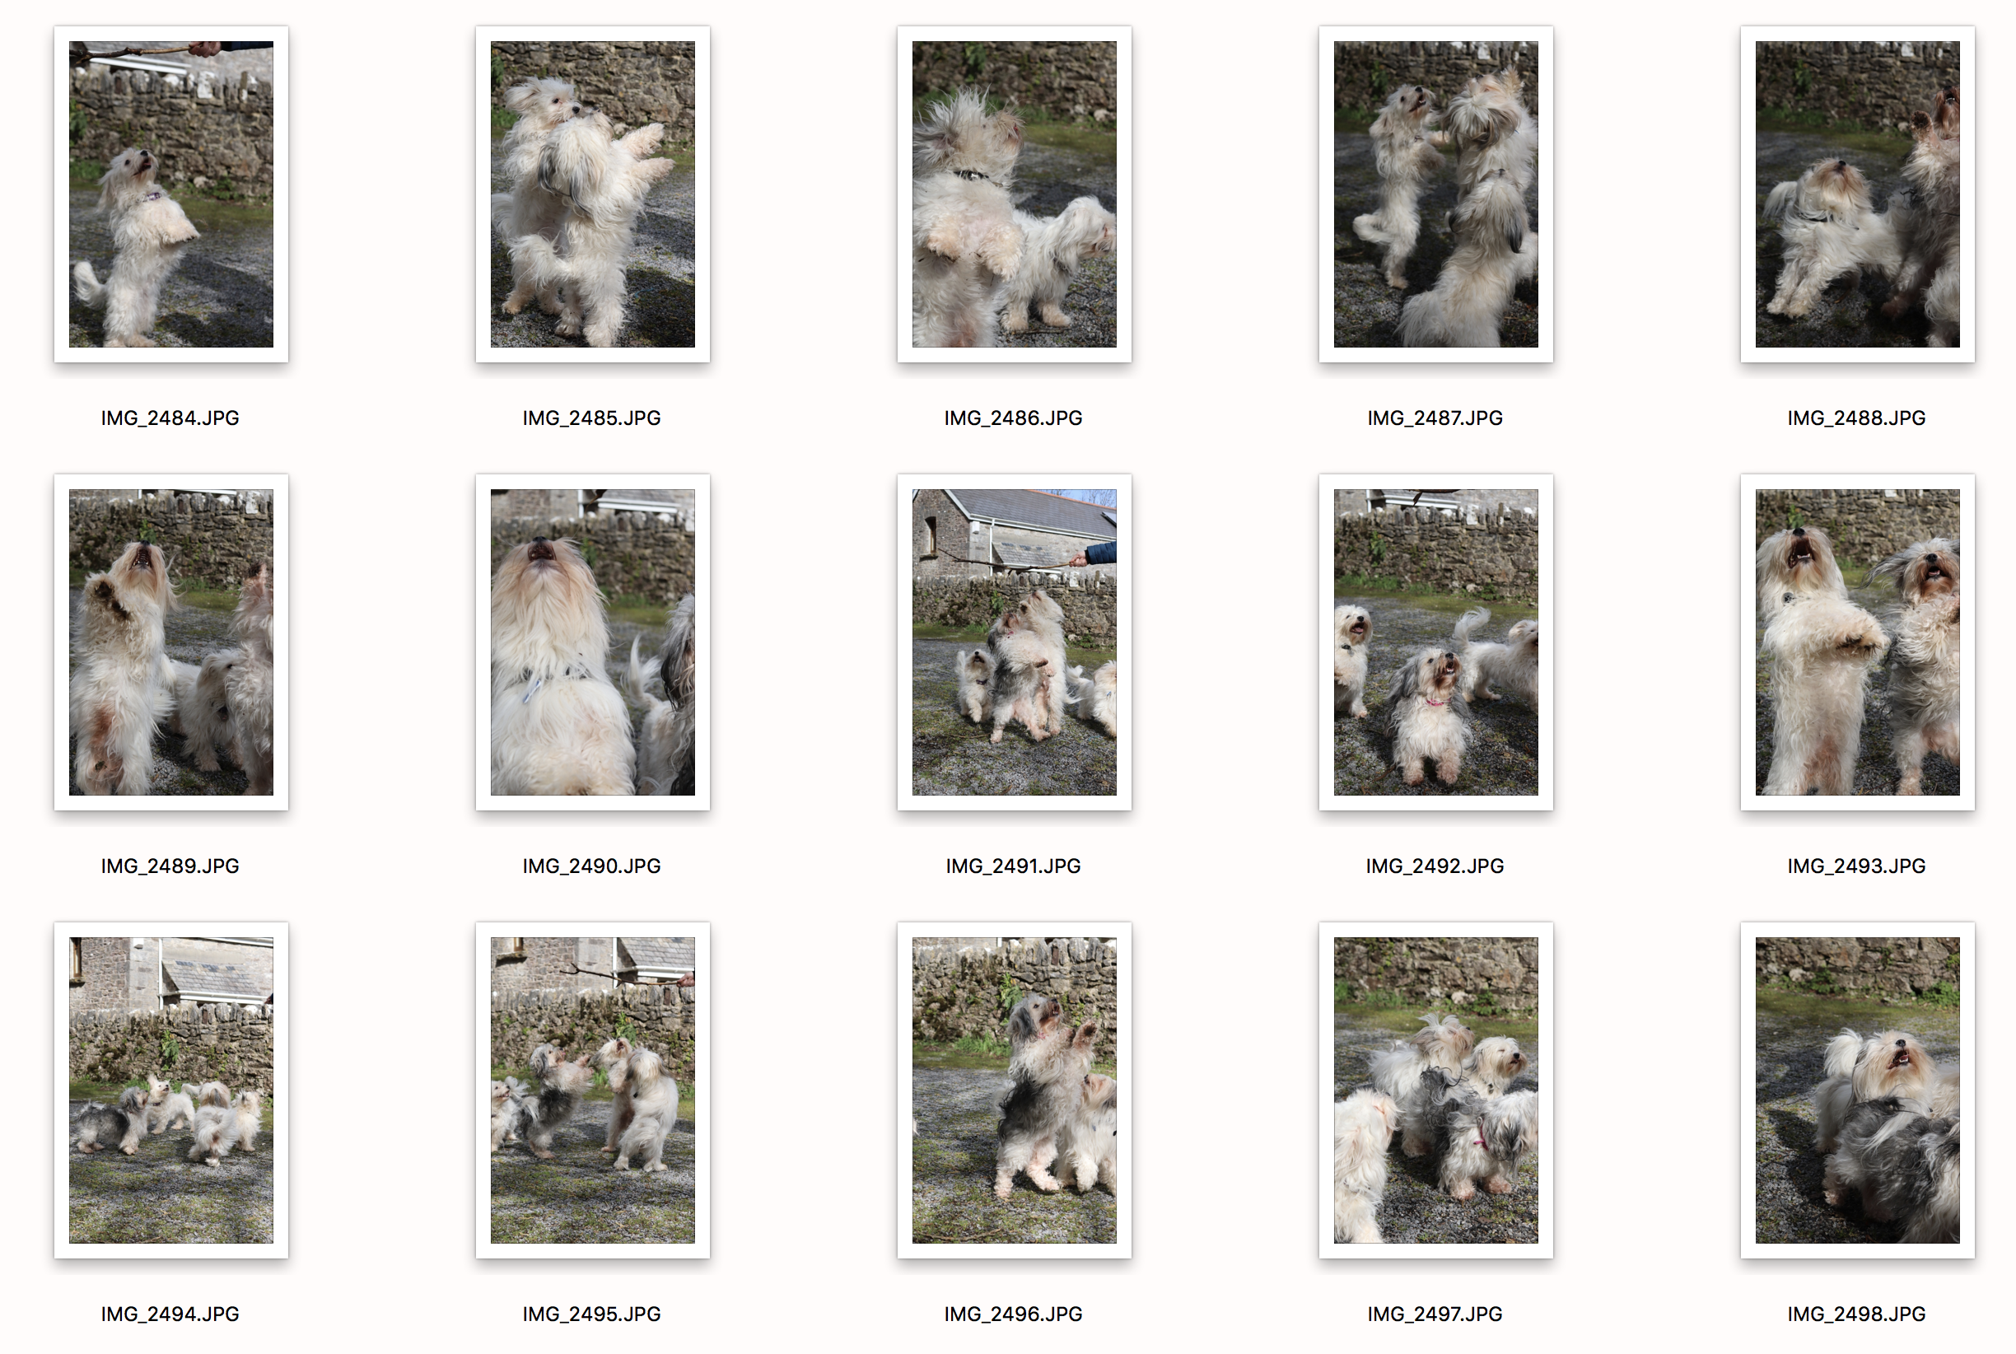
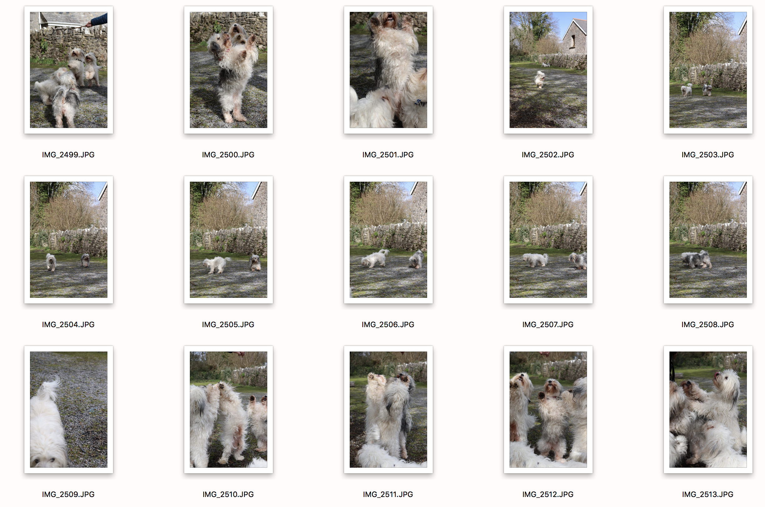
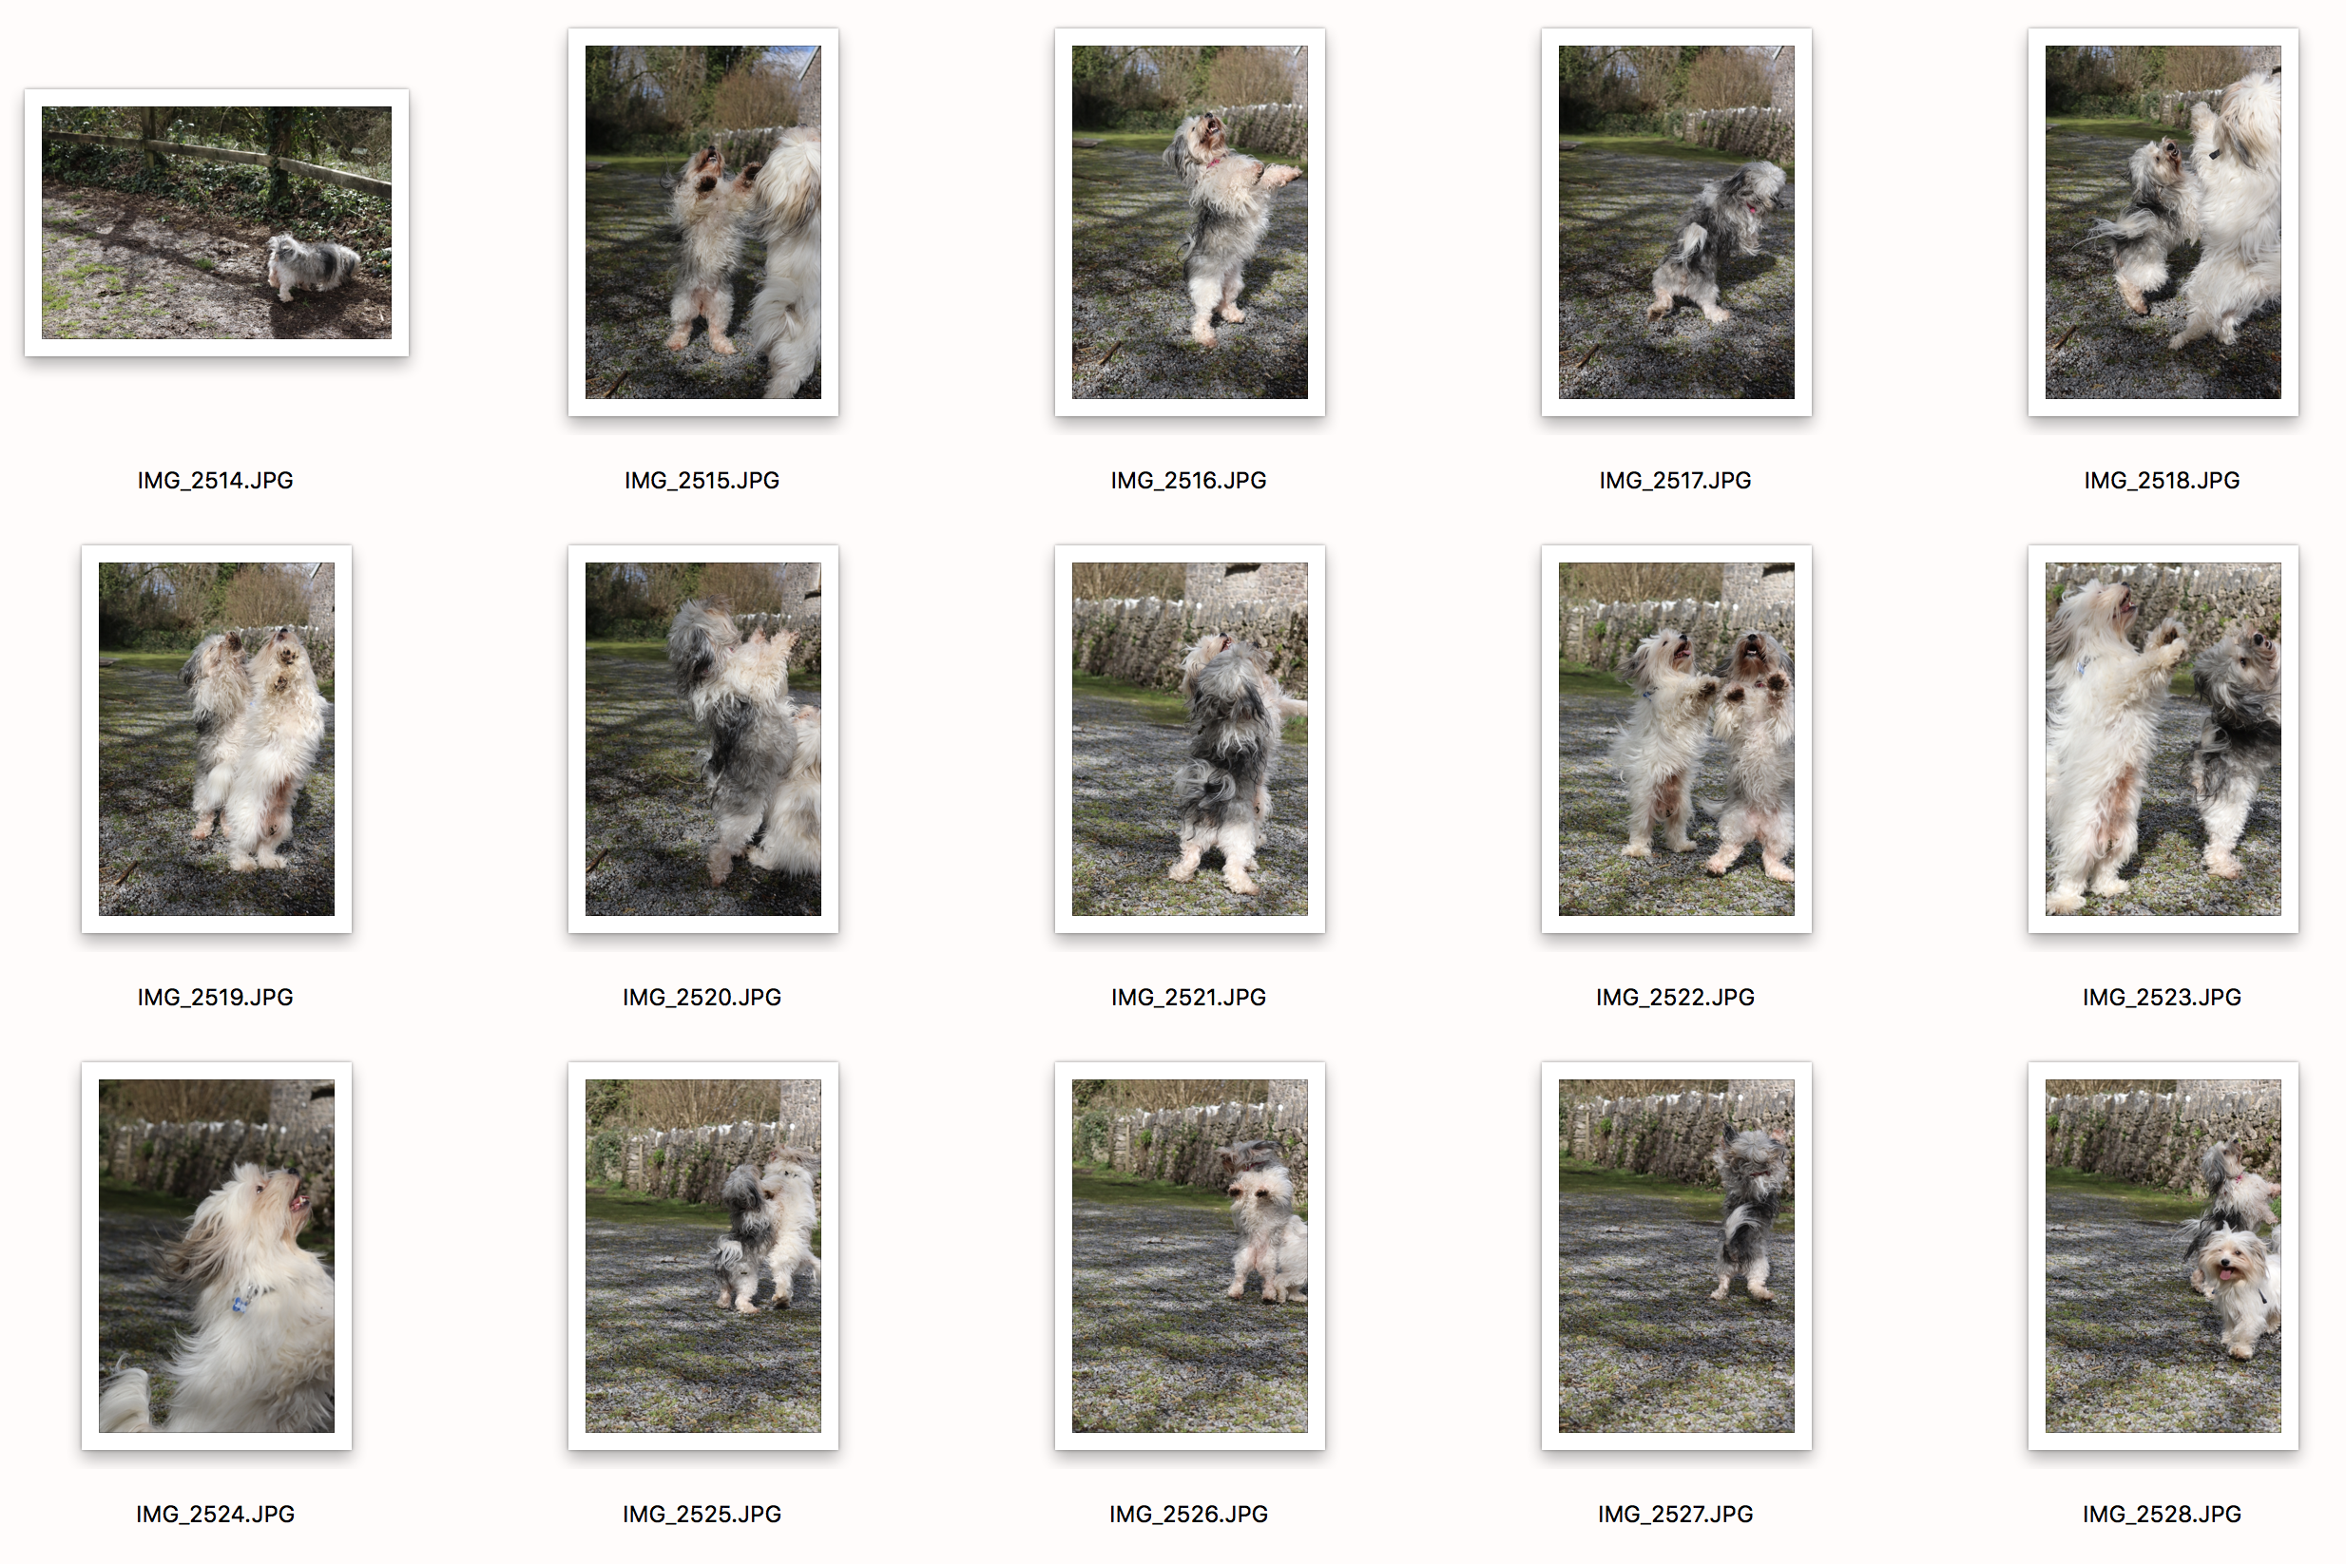
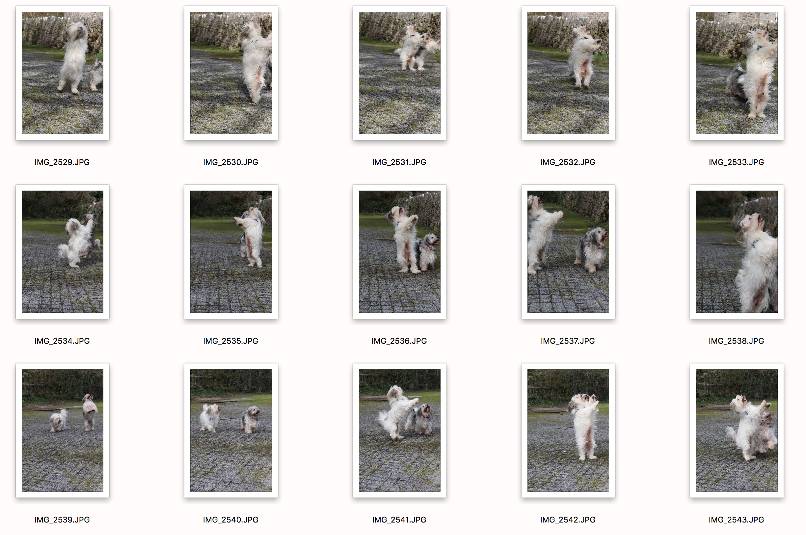
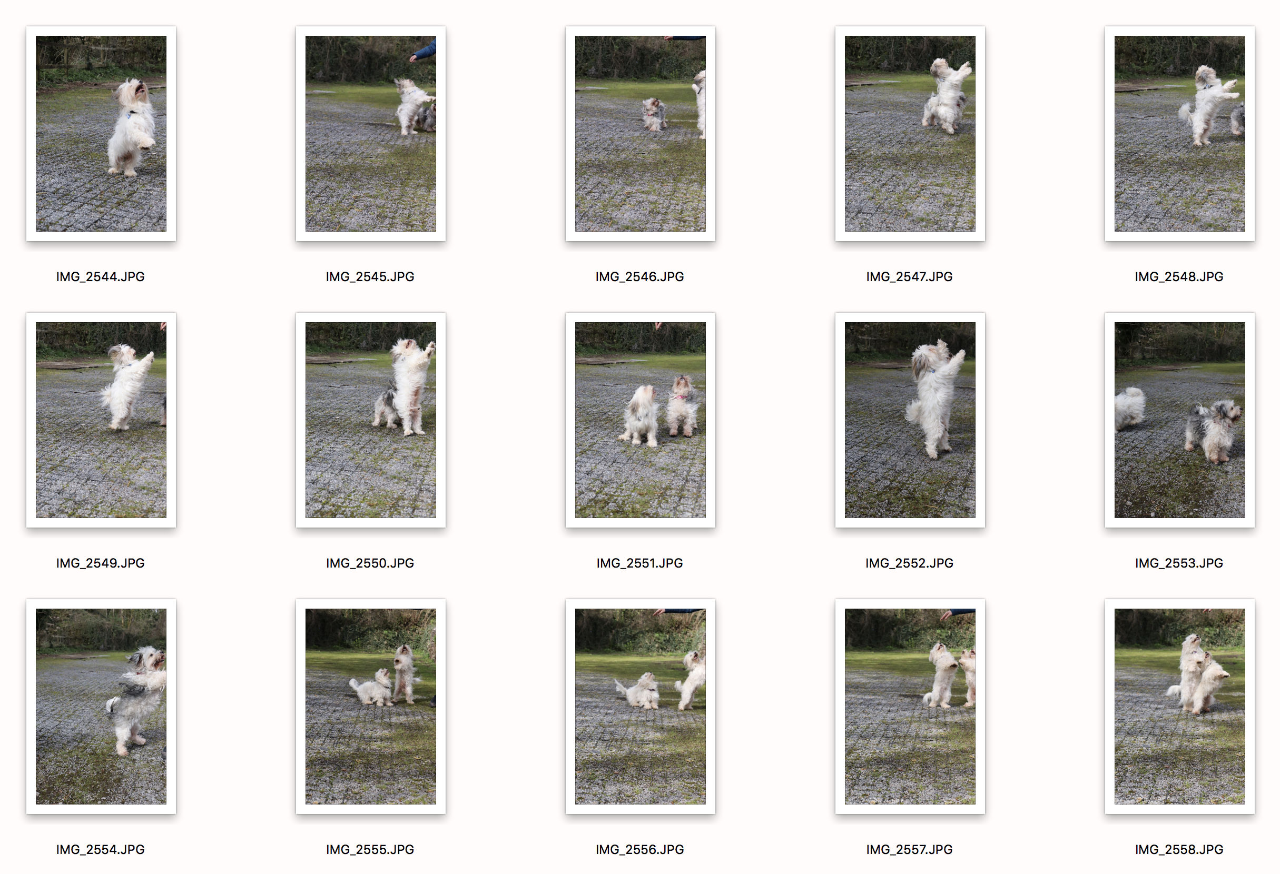
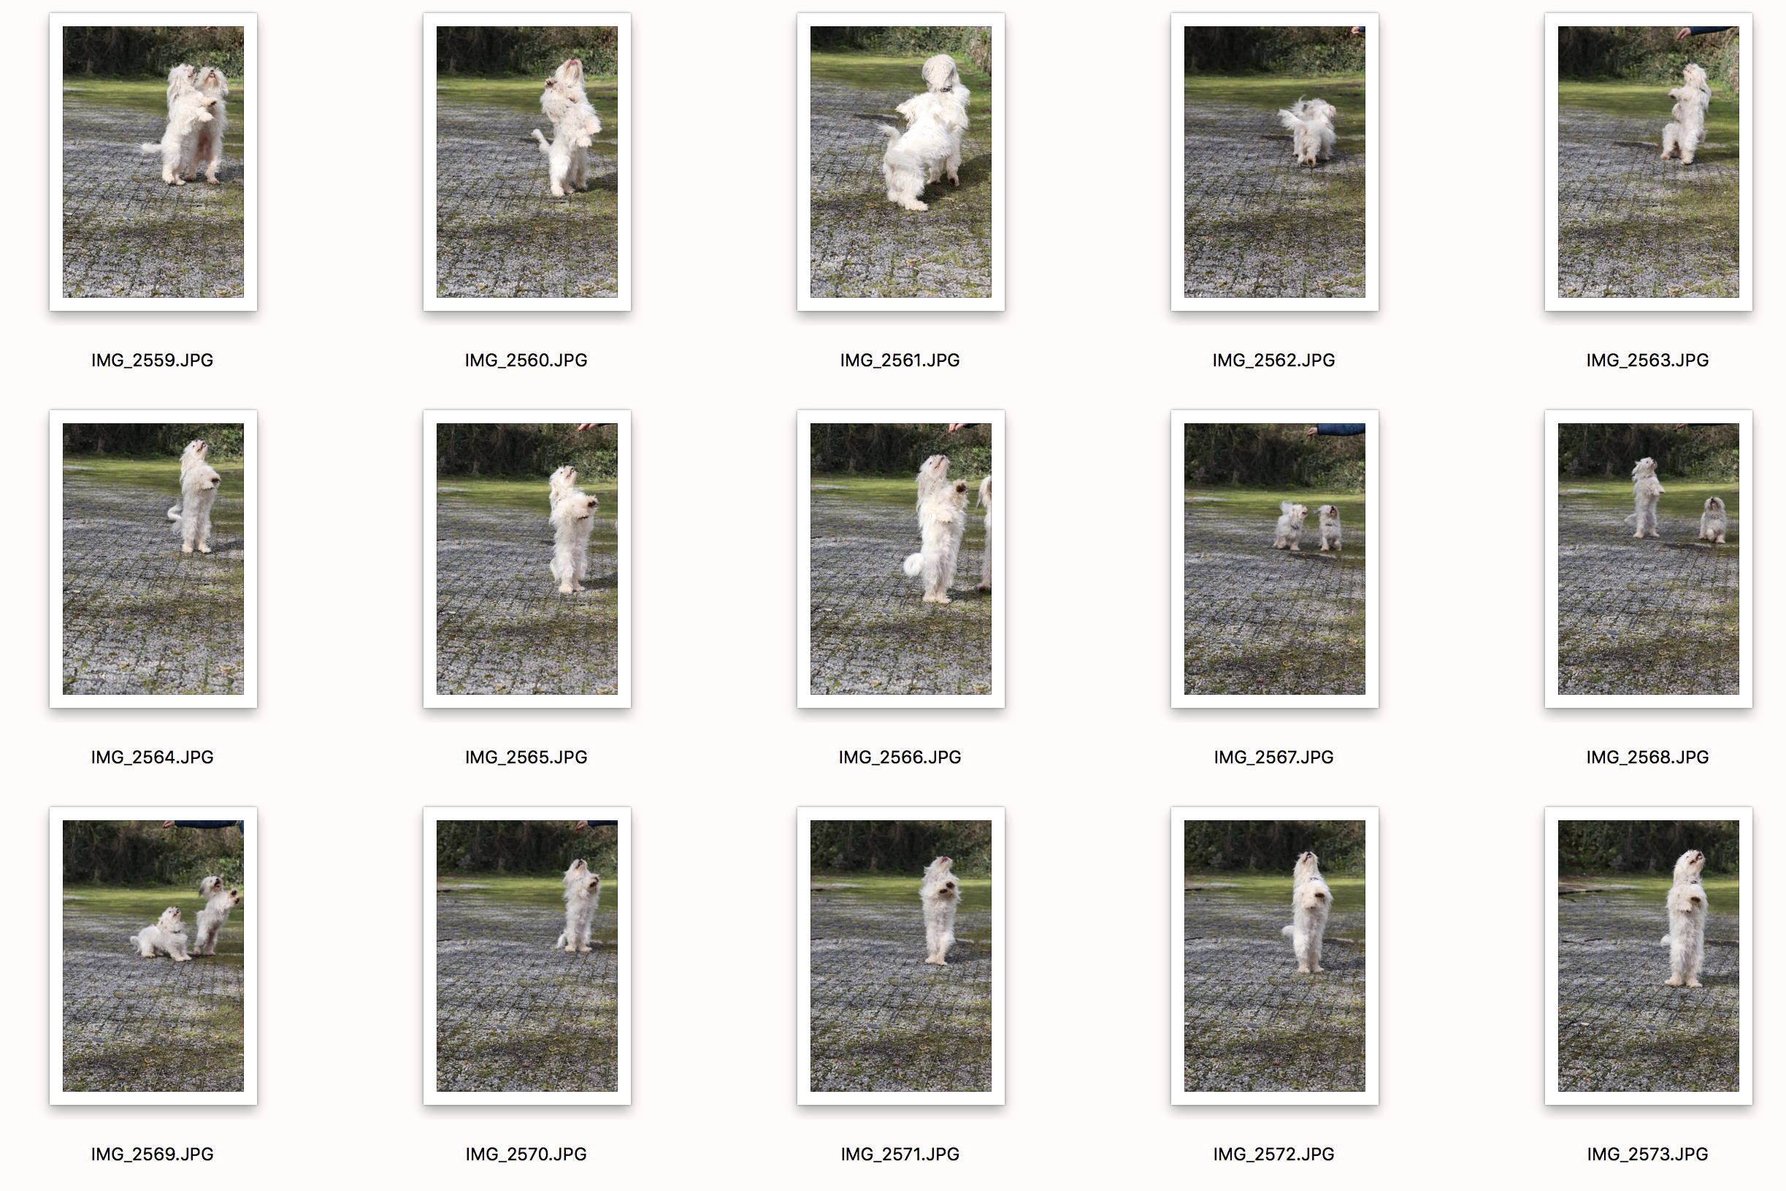
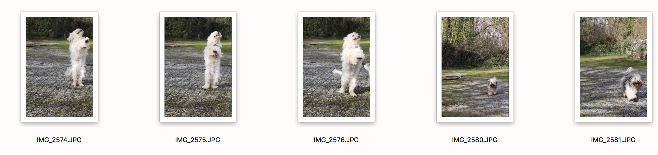
The images I have selected for this shoot is a series between mum and daughter and a selection that I feel compliments each other. Throughout the images they are trying to play with the same stick, resulting in a bit of a tug of war. Although the dogs don’t turn nasty on each other, both are trying to use their strength to take the stick from one another. This clearly demonstrates and altercation between the two and I feel represents movement. The movement isn’t really fast, but shows the dogs in action, playing. This scene would have happened quick enough that a fast shutter speed would have been needed to prevent blur and to capture the shots one after another in the that sequence. The sequence was captured within a minute, from first to last image. The reason I have not selected any of the other images is because they are not as good together and do not necessarily show one movement to the next, although some do show the dogs moving at a faster pace.

