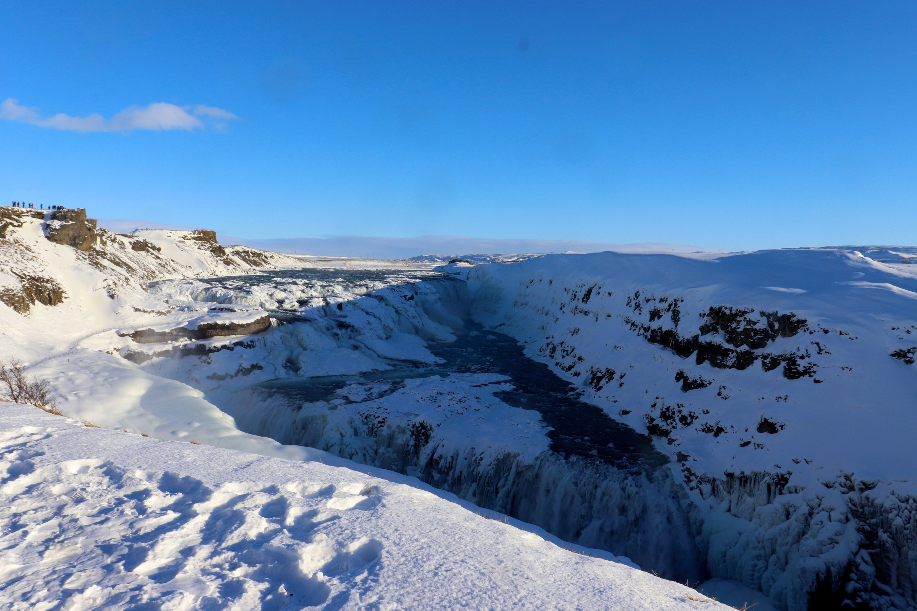
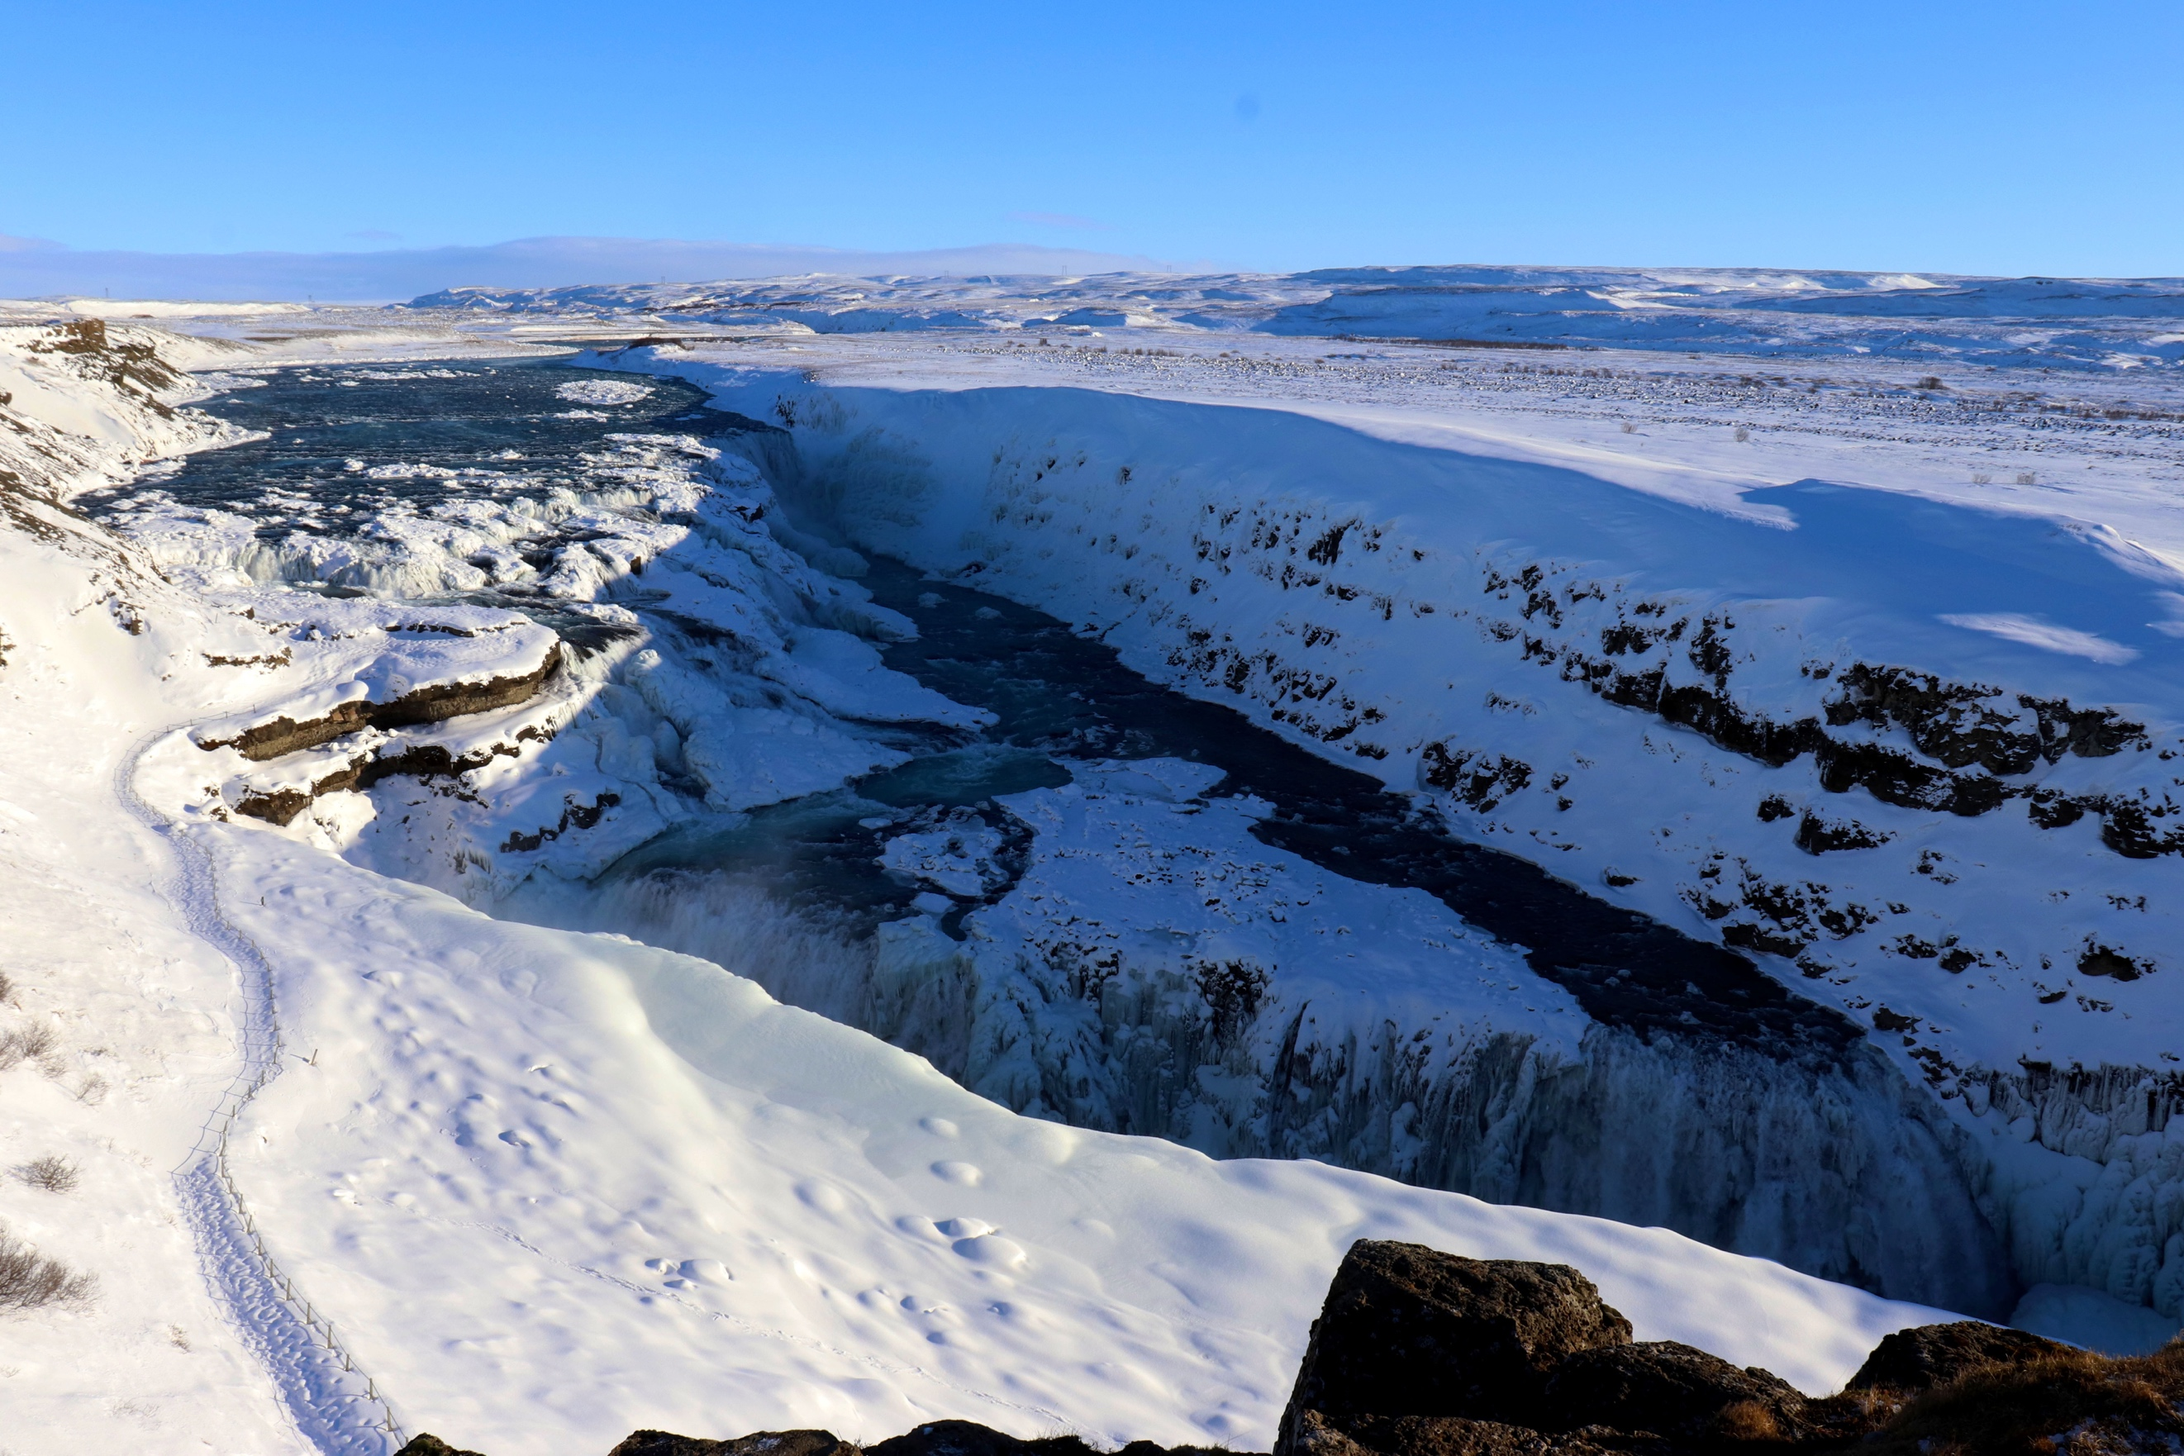
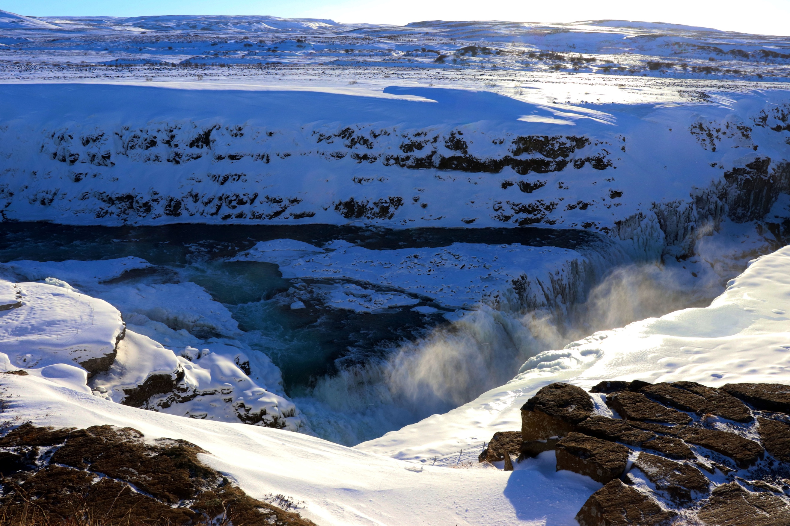
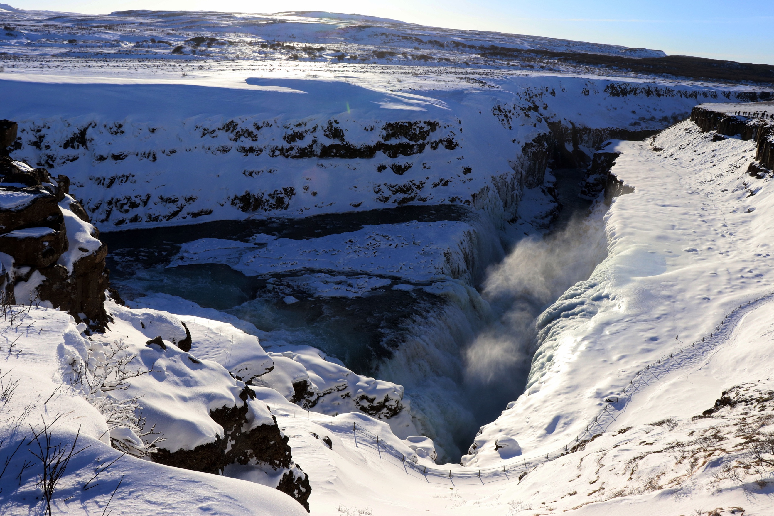
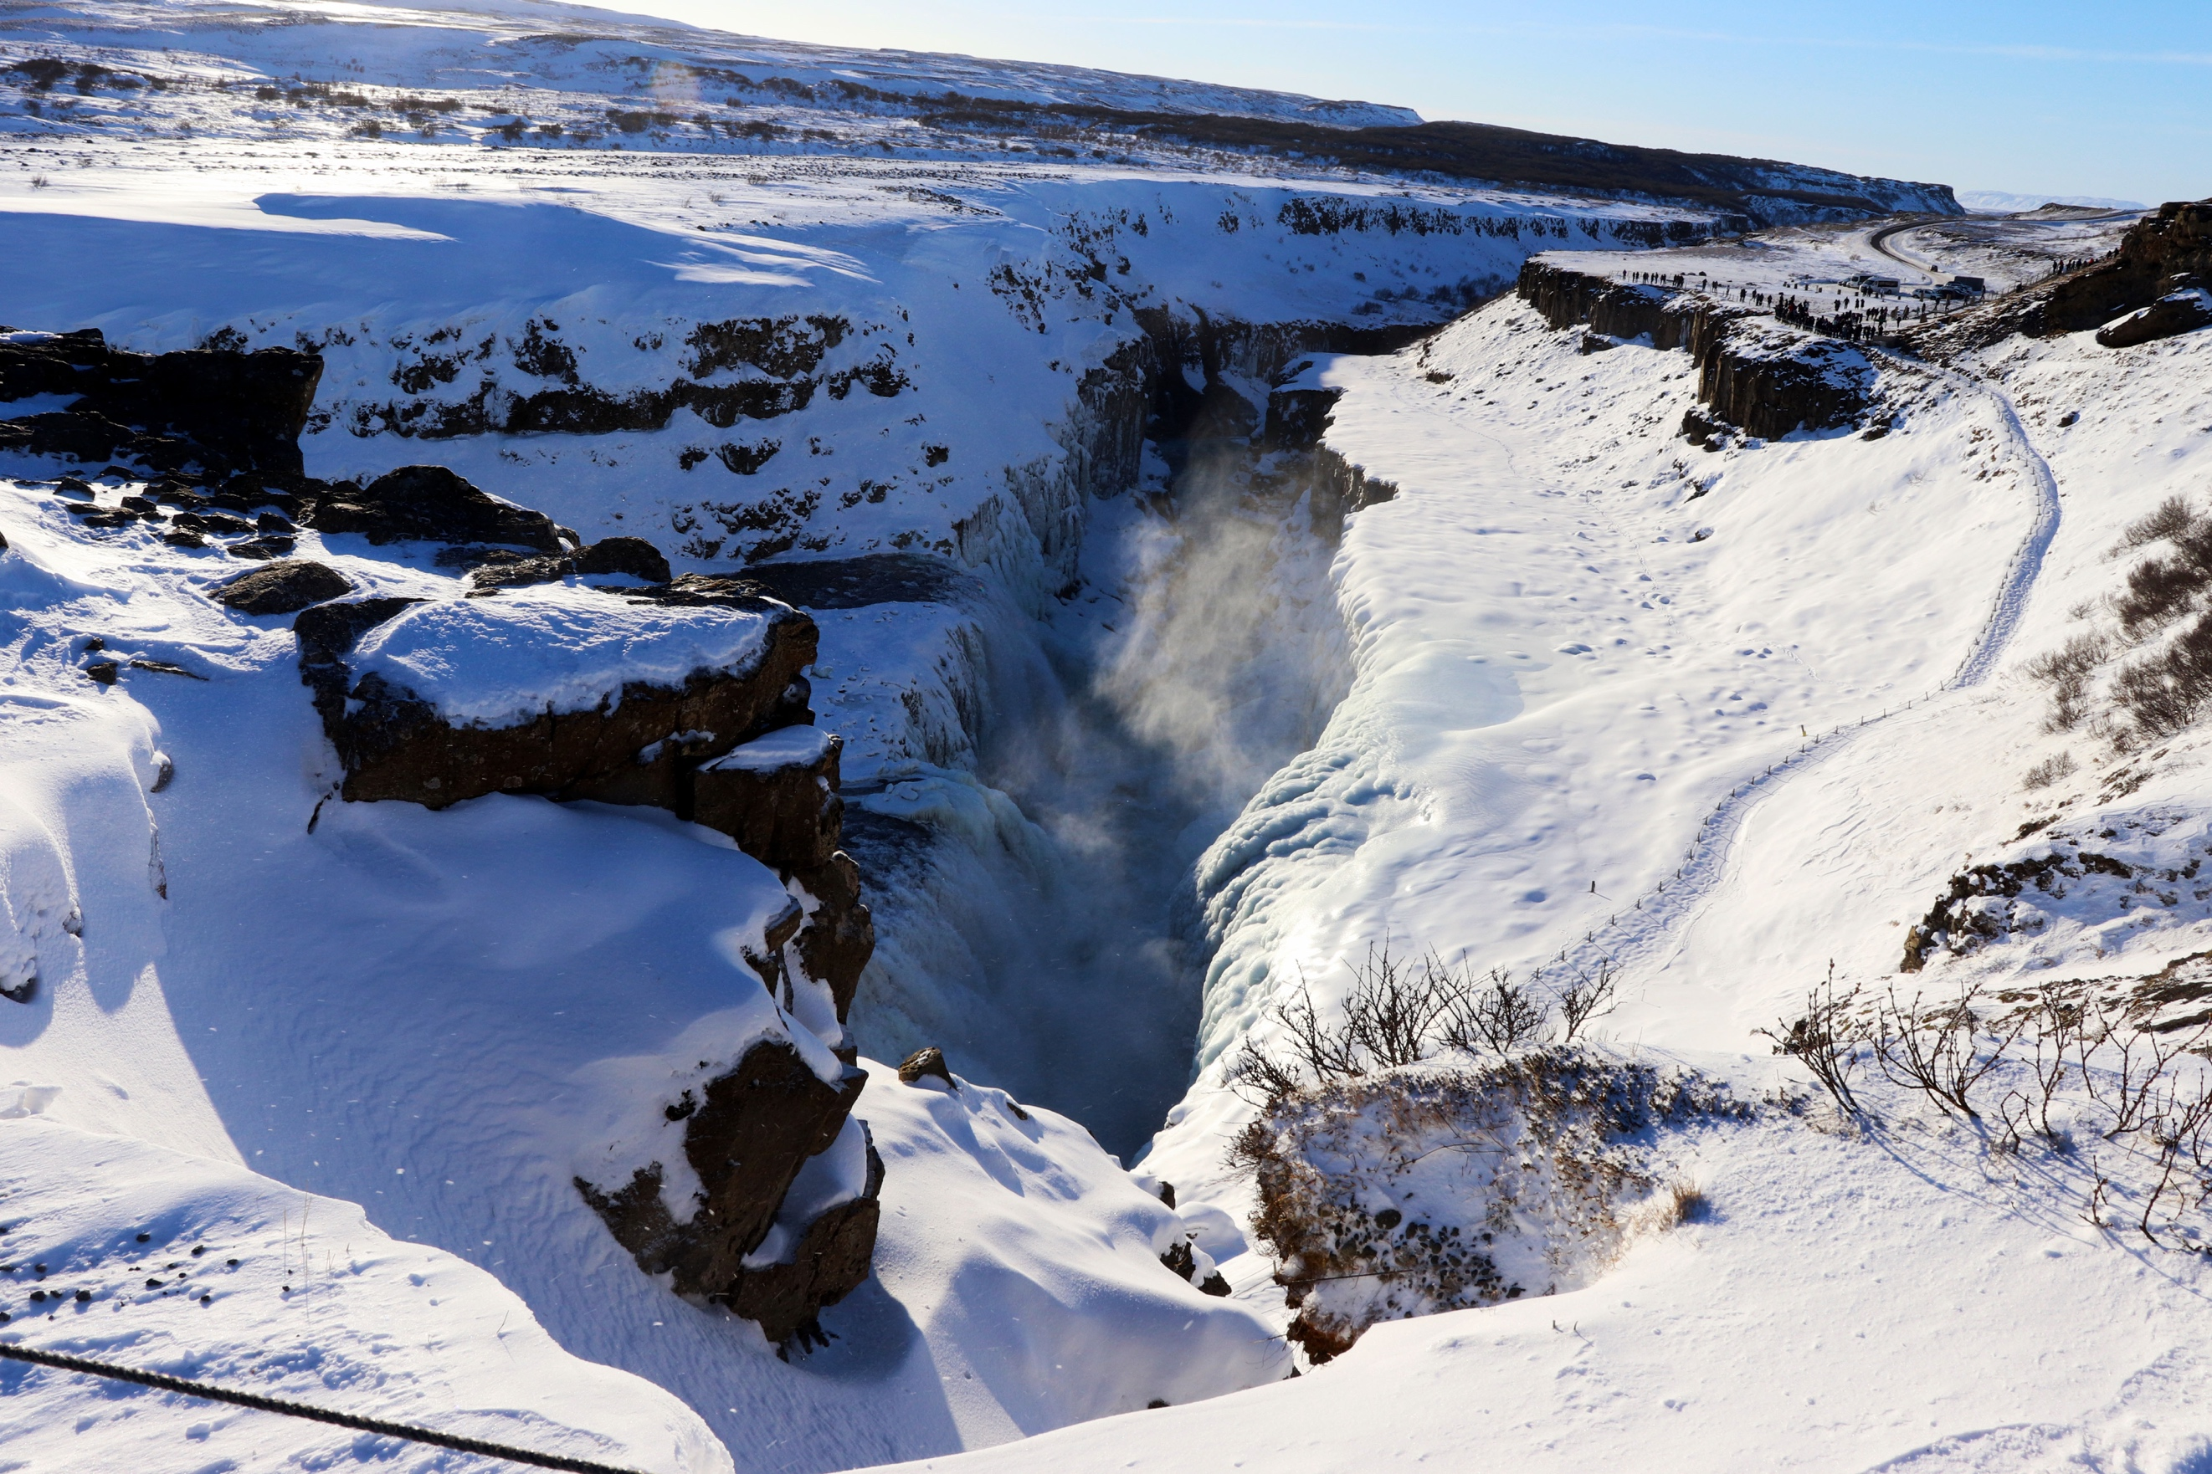
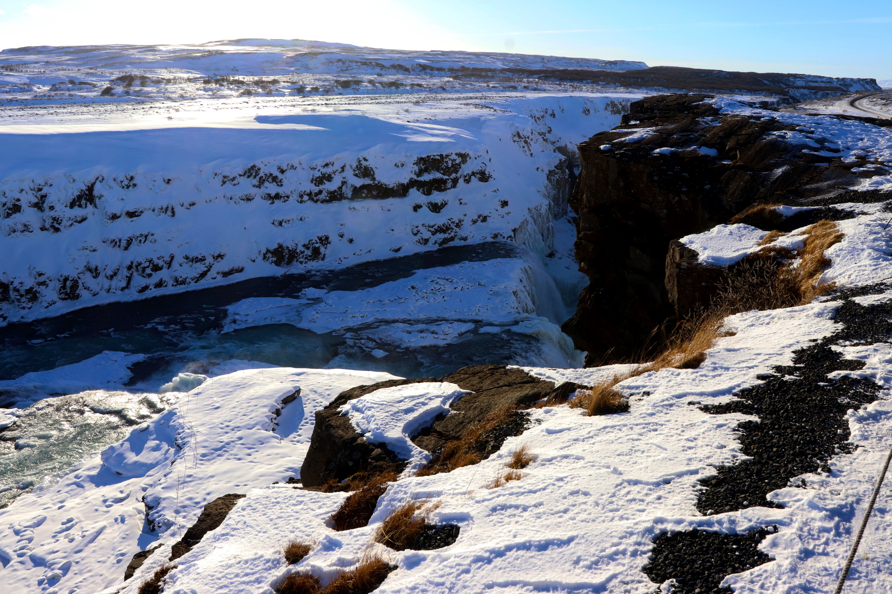
Above you can see my collection of images which represent the subject ‘Views’ in the brief. As instructed, all the images have kept the same focal length (18mm) with an aperture of 14 and the same view point, being the waterfall. I have also used the same shutter speed at 1/250. For this shoot, my camera was set on Manuel mode so I could make the most of the settings to my advantage for this shoot. I used my Canon 77D with my standard 18-55mm lens. Gullfoss Waterfall is breathe-taking just being there, and to see it covered in snow and partly iced up was certainly really cool. The series of photographs sit together as a collection simply because they are of the same landmark, just from different angles. My thinking behind the shoot was to do a lot of research before I left so that I could get a lot of inspiration whilst on my travels. I used Iceland for my assignment as I was out there for a week and was bound to come across a location that would be good for me to shoot for ‘Views’. Although this location is beautiful, beauty was not solely my purpose for this shoot, and in fact whilst I was out in Iceland I was not entirely sure what specifically I was going to shoot. When I arrived at this location on a tour, I saw it was the perfect opportunity.
I decided in quick succession that it would be beneficial if I was to focus on the same subject, but from different angles surrounding it. Of course, I couldn’t just get across the waterfall etc. I had to use where was accessible, but I decided to use the waterfall as the main focus. As you can see in each individual image, the images are all of a similar nature, but include and exclude certain subjects from each image. Not only that but the lighting is interesting throughout. In some images the waterfall is much more spectacular than other images, simply because of where I am. For a photographer, when shooting landscape, it is important that they manage to find the right location to shoot the subject. Therefore, I feel my series is an interesting collection as they all show the waterfall from different angles and locations and show a variety of surroundings, both in the background and the foreground.
When I did my research, I looked back at Fay Godwin, which uses landscape photography with a subject in the foreground in the majority of her images. One notably famous image is the one of the stone in the foreground and the landscape behind, which you can view on my website. Fay’s work helped inspire me to play around with the foreground and to include textures and different shaped objects before your eye is lead to the centre of the image.
Although not researched in depth for this assignment, but mentioned, Joel Meyerowitz was a name that has already popped into my head in the past for previous exercises. But again, he uses a similar technique to mine here, where he photographs the surrounding areas of a building from different parts of a city. Here, I have done the same but with a waterfall, which shows surroundings you cannot see in the other images. Finally, Edward Ruscha. His shoot on gas stations was very impressive and so I have looked at him in depth. How does gas stations and his photography relate to my collection? Well because I feel his work is taken from different locations also, with the same subject, just different location. I could have done a series of different waterfalls, but felt that I wanted to use more than one artist to inspire a unique and original collection for me to focus on.

The texture in the collection varies from image to image, some images have the rocks visible in the foreground, whereas some have snow. The snow gives the images a fresh and chilled look to the collection along with the water. Each foreground and background vary, despite being the same subject. This helps give each image it’s independence, but doesn’t necessarily mean separation from the collection, as the images have so much in common, and complement each other by viewing the same subject from different places. The images are made up of white, black/dark brown and blues.
The shadow moves in each image, even though it doesn’t. Only because I have moved, giving it a different effect in each one.

To make this series of images uniform, all contain similar ingredients throughout, but the ‘view’ changes slightly, to include and exclude certain aspects of the image. This is something that was looked into earlier in the course materials. I feel this is interesting as the slight change in positioning creates a whole new image, even if it is of the slightest change. Still making all the images sit together, without being the same, but of the same landmark.

