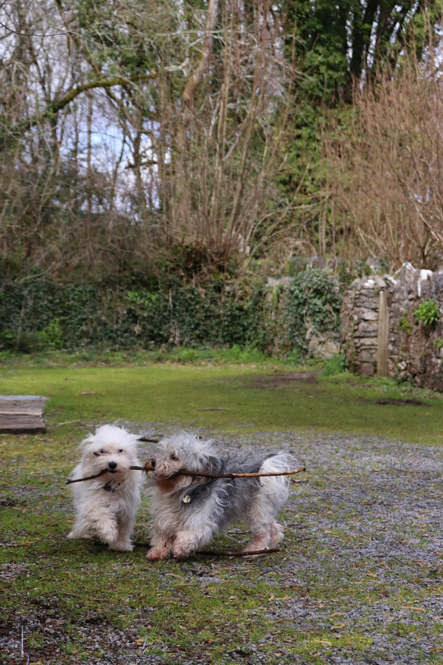

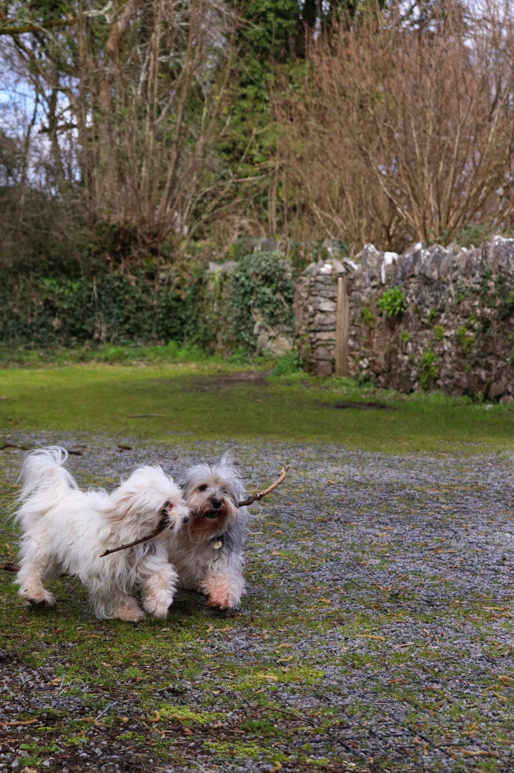

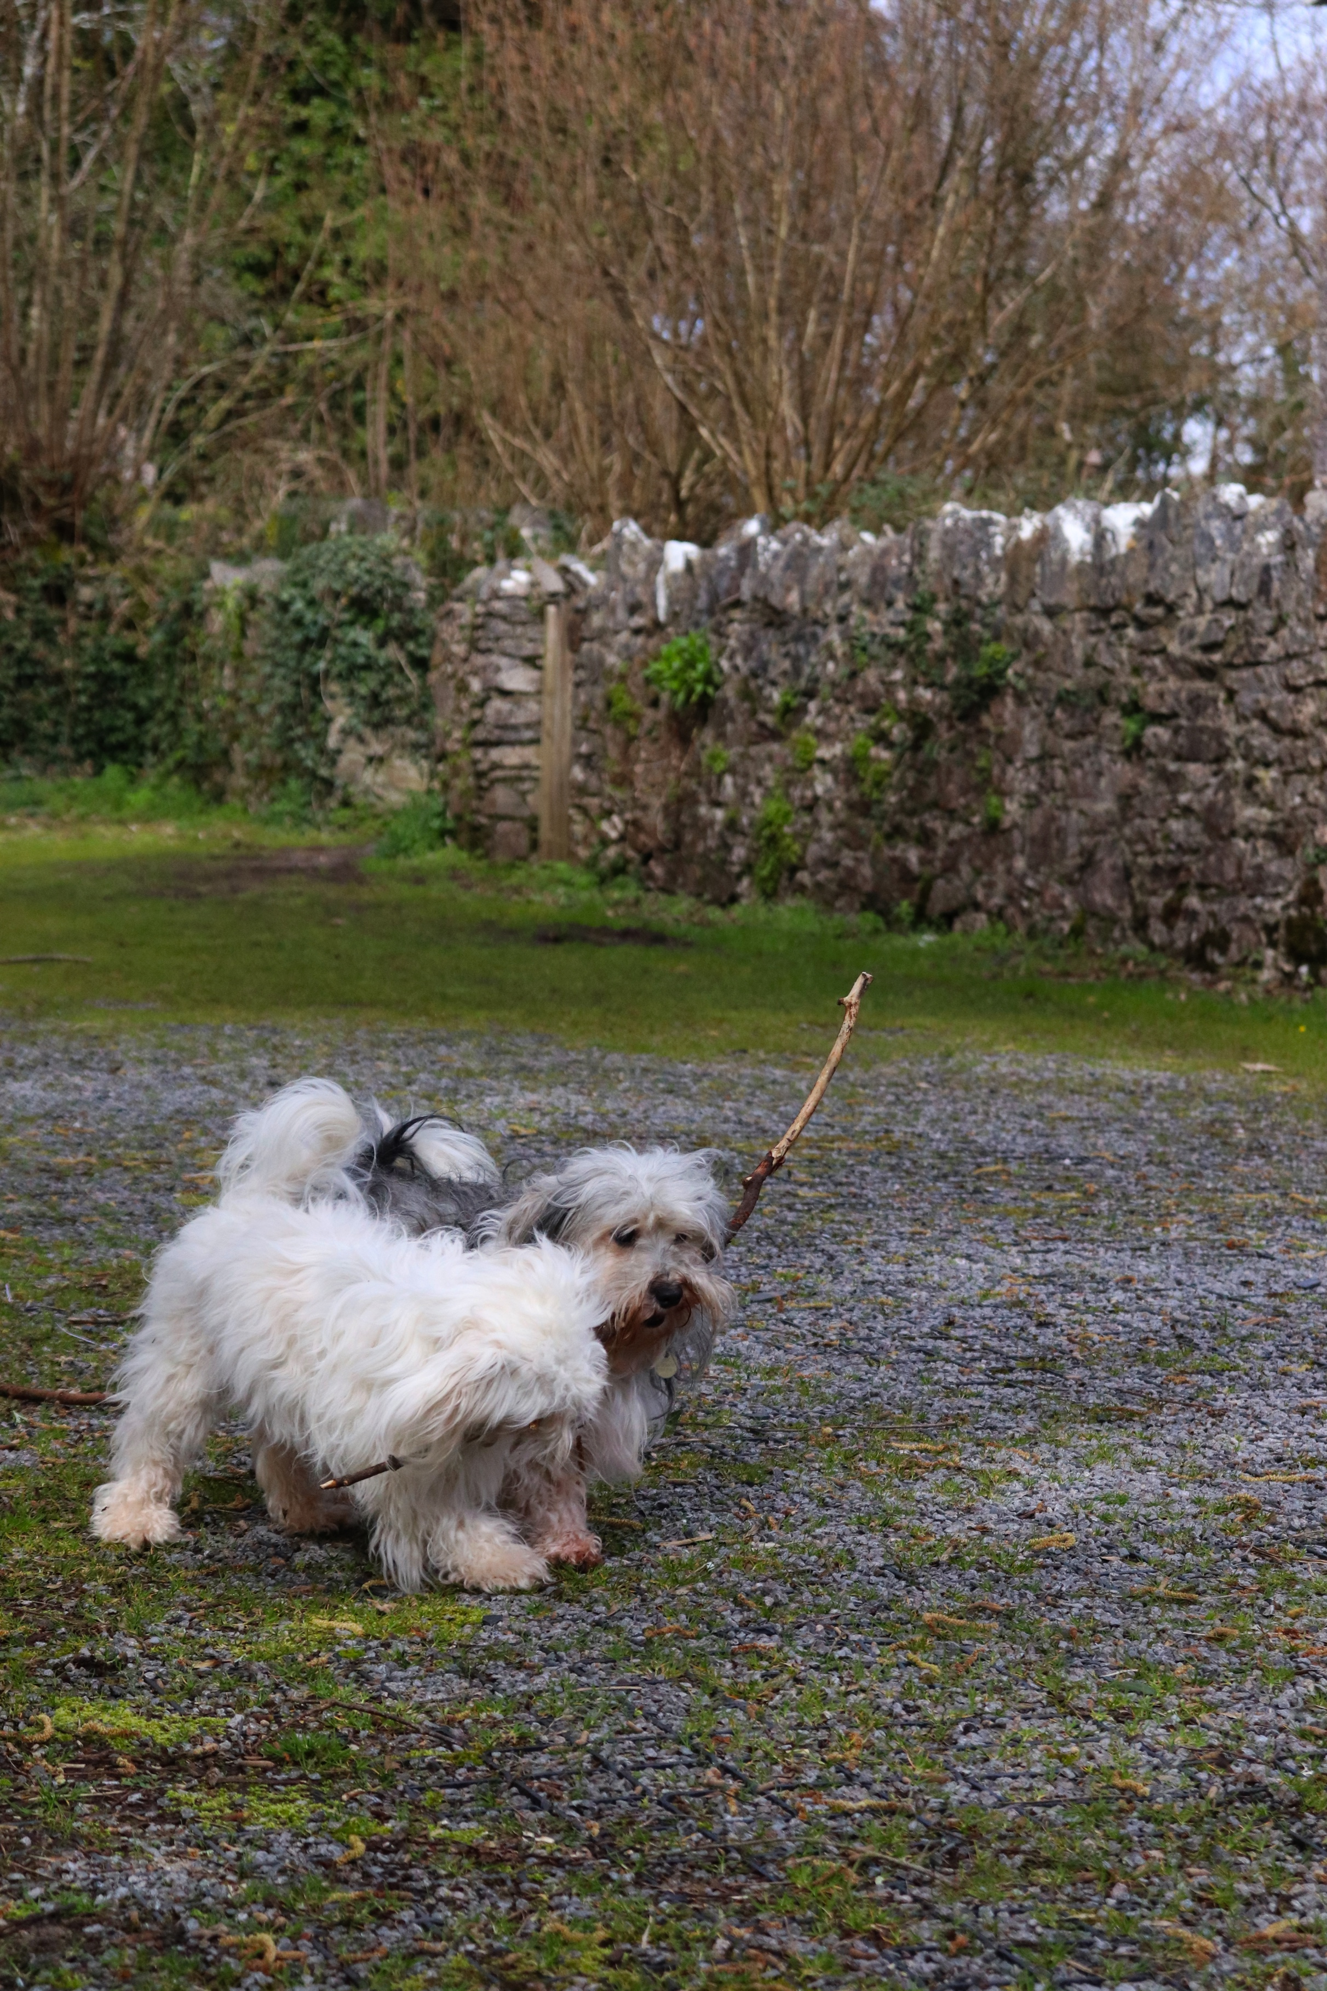

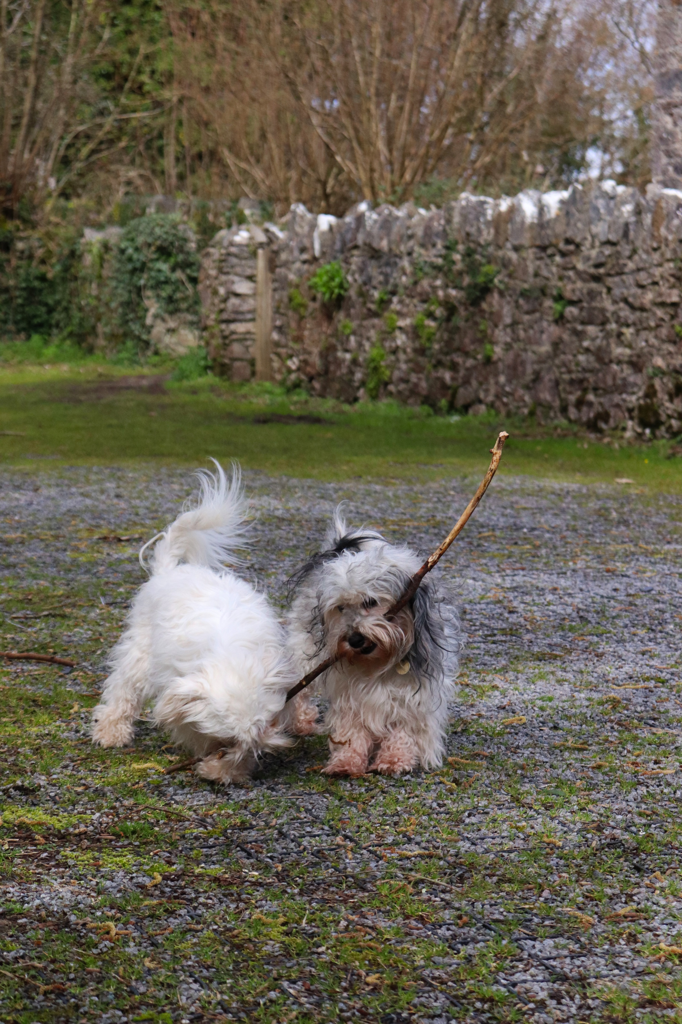

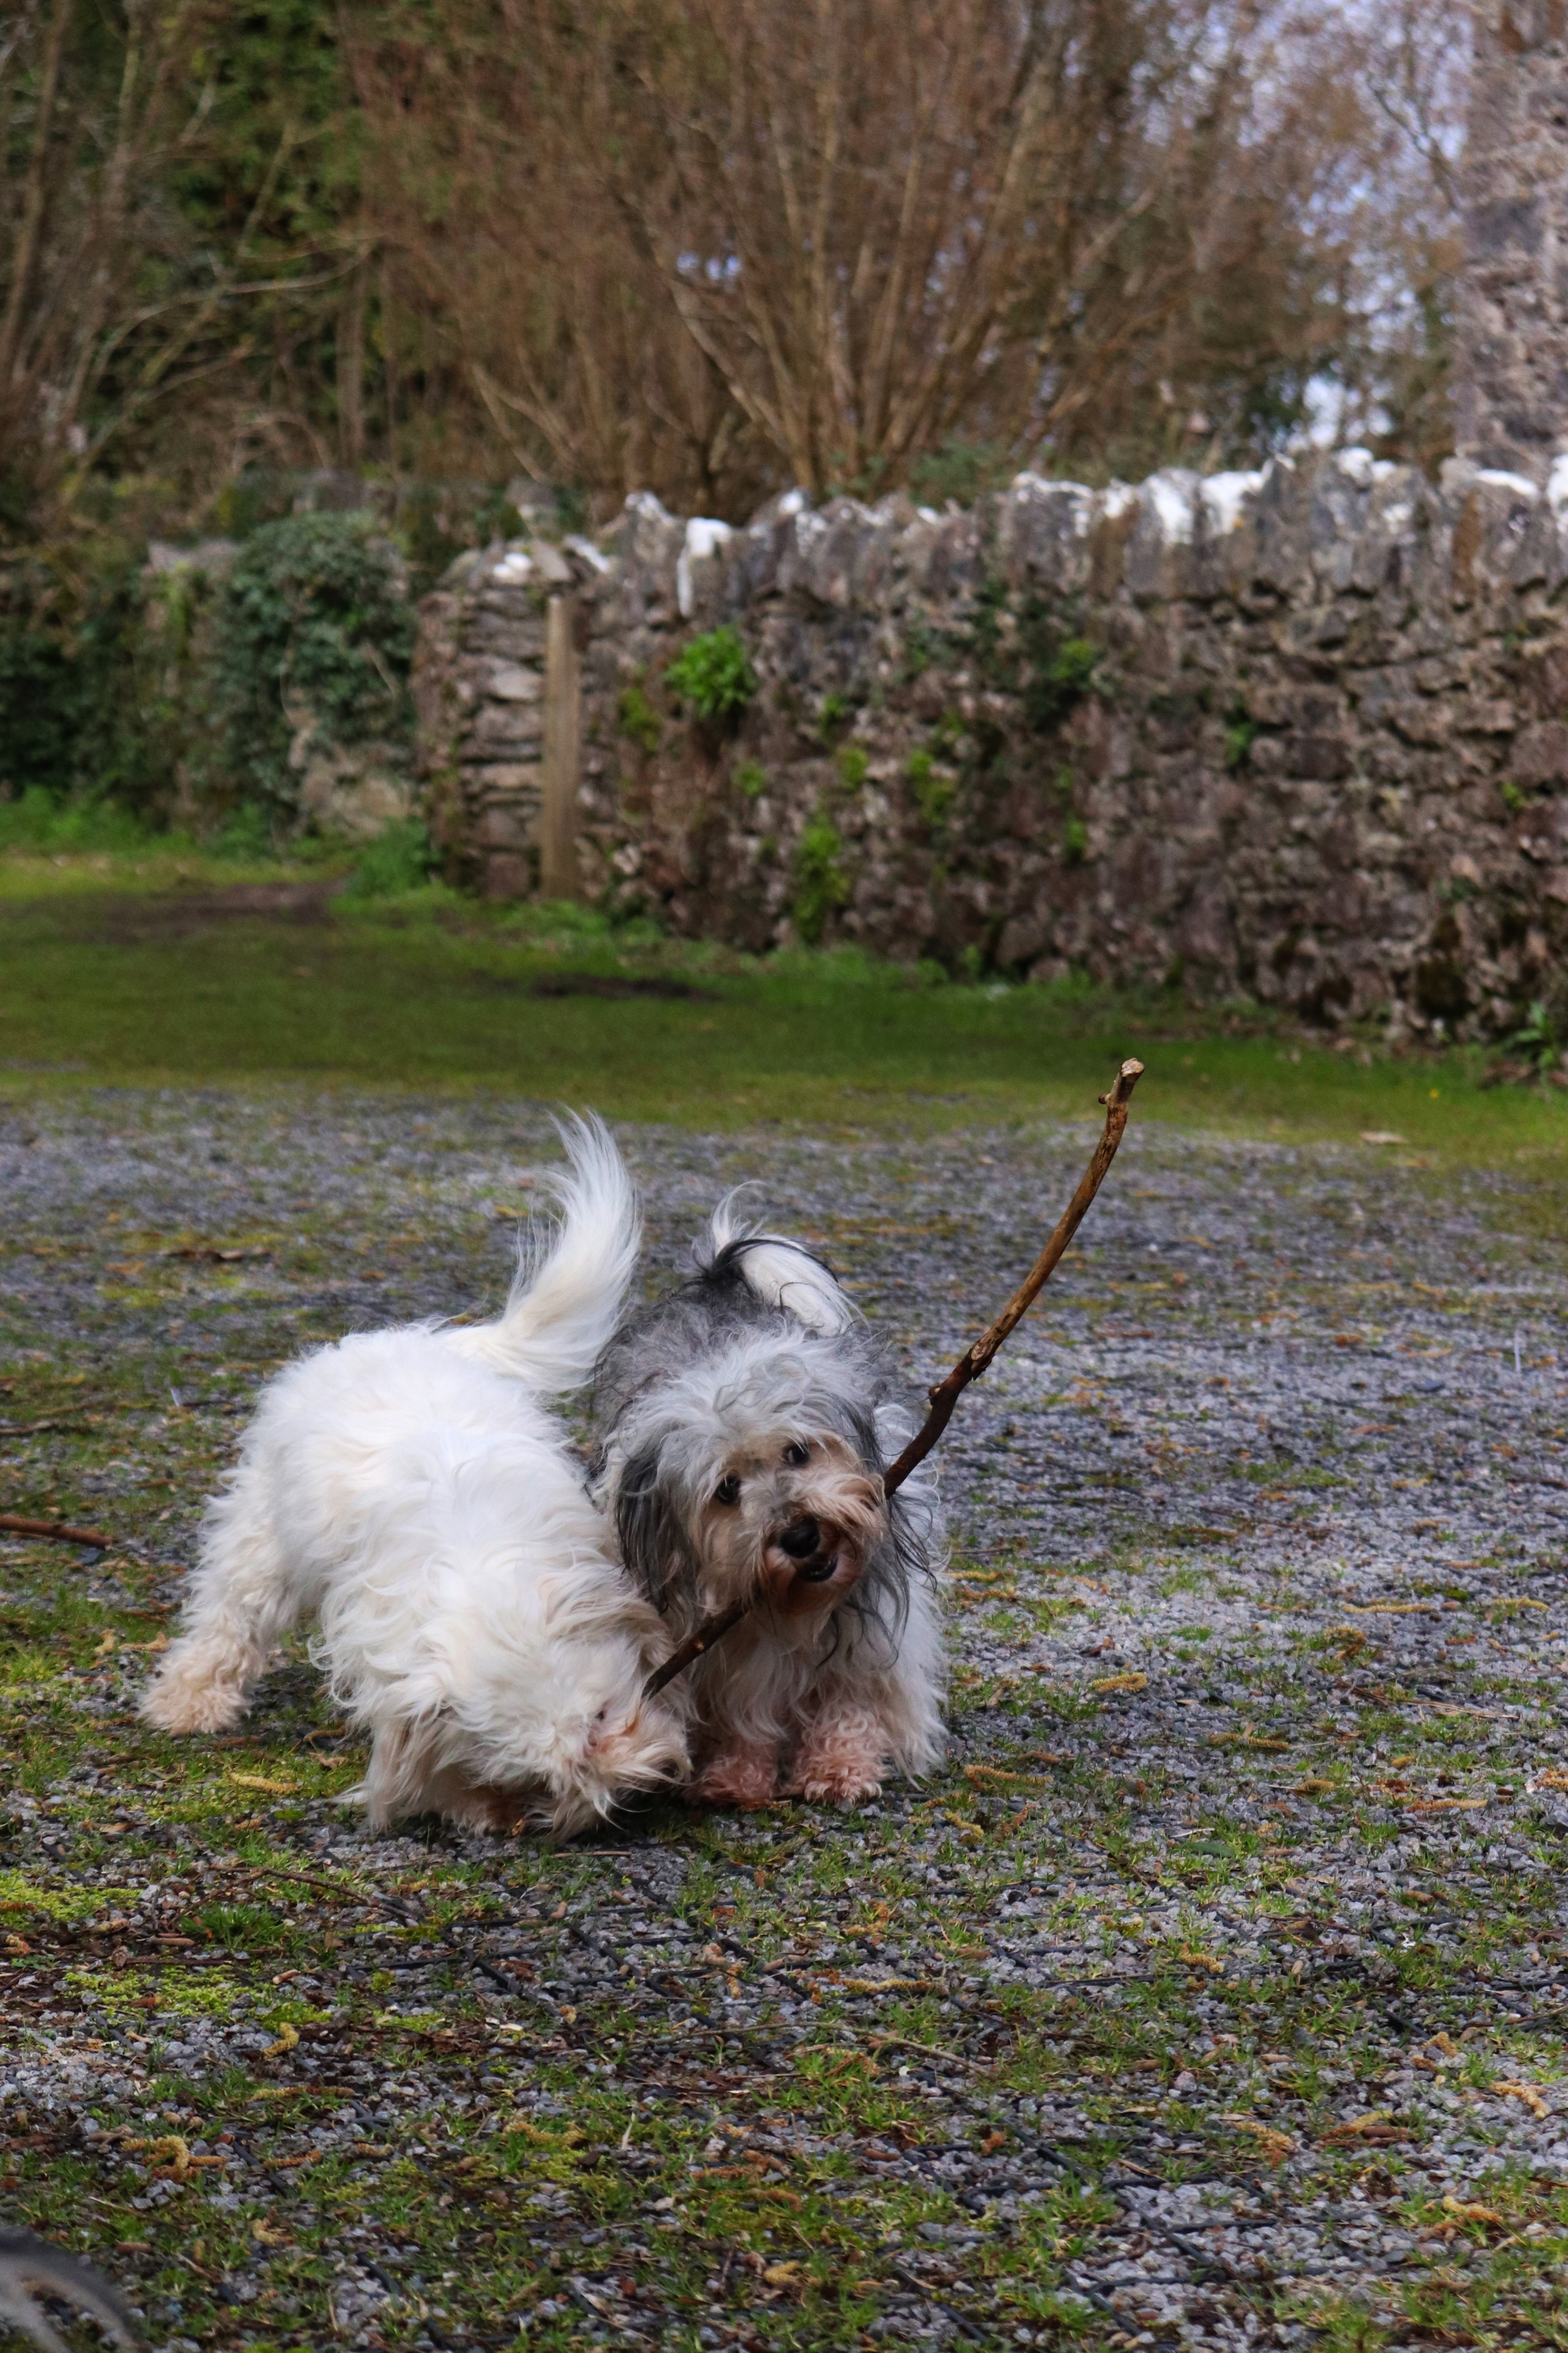

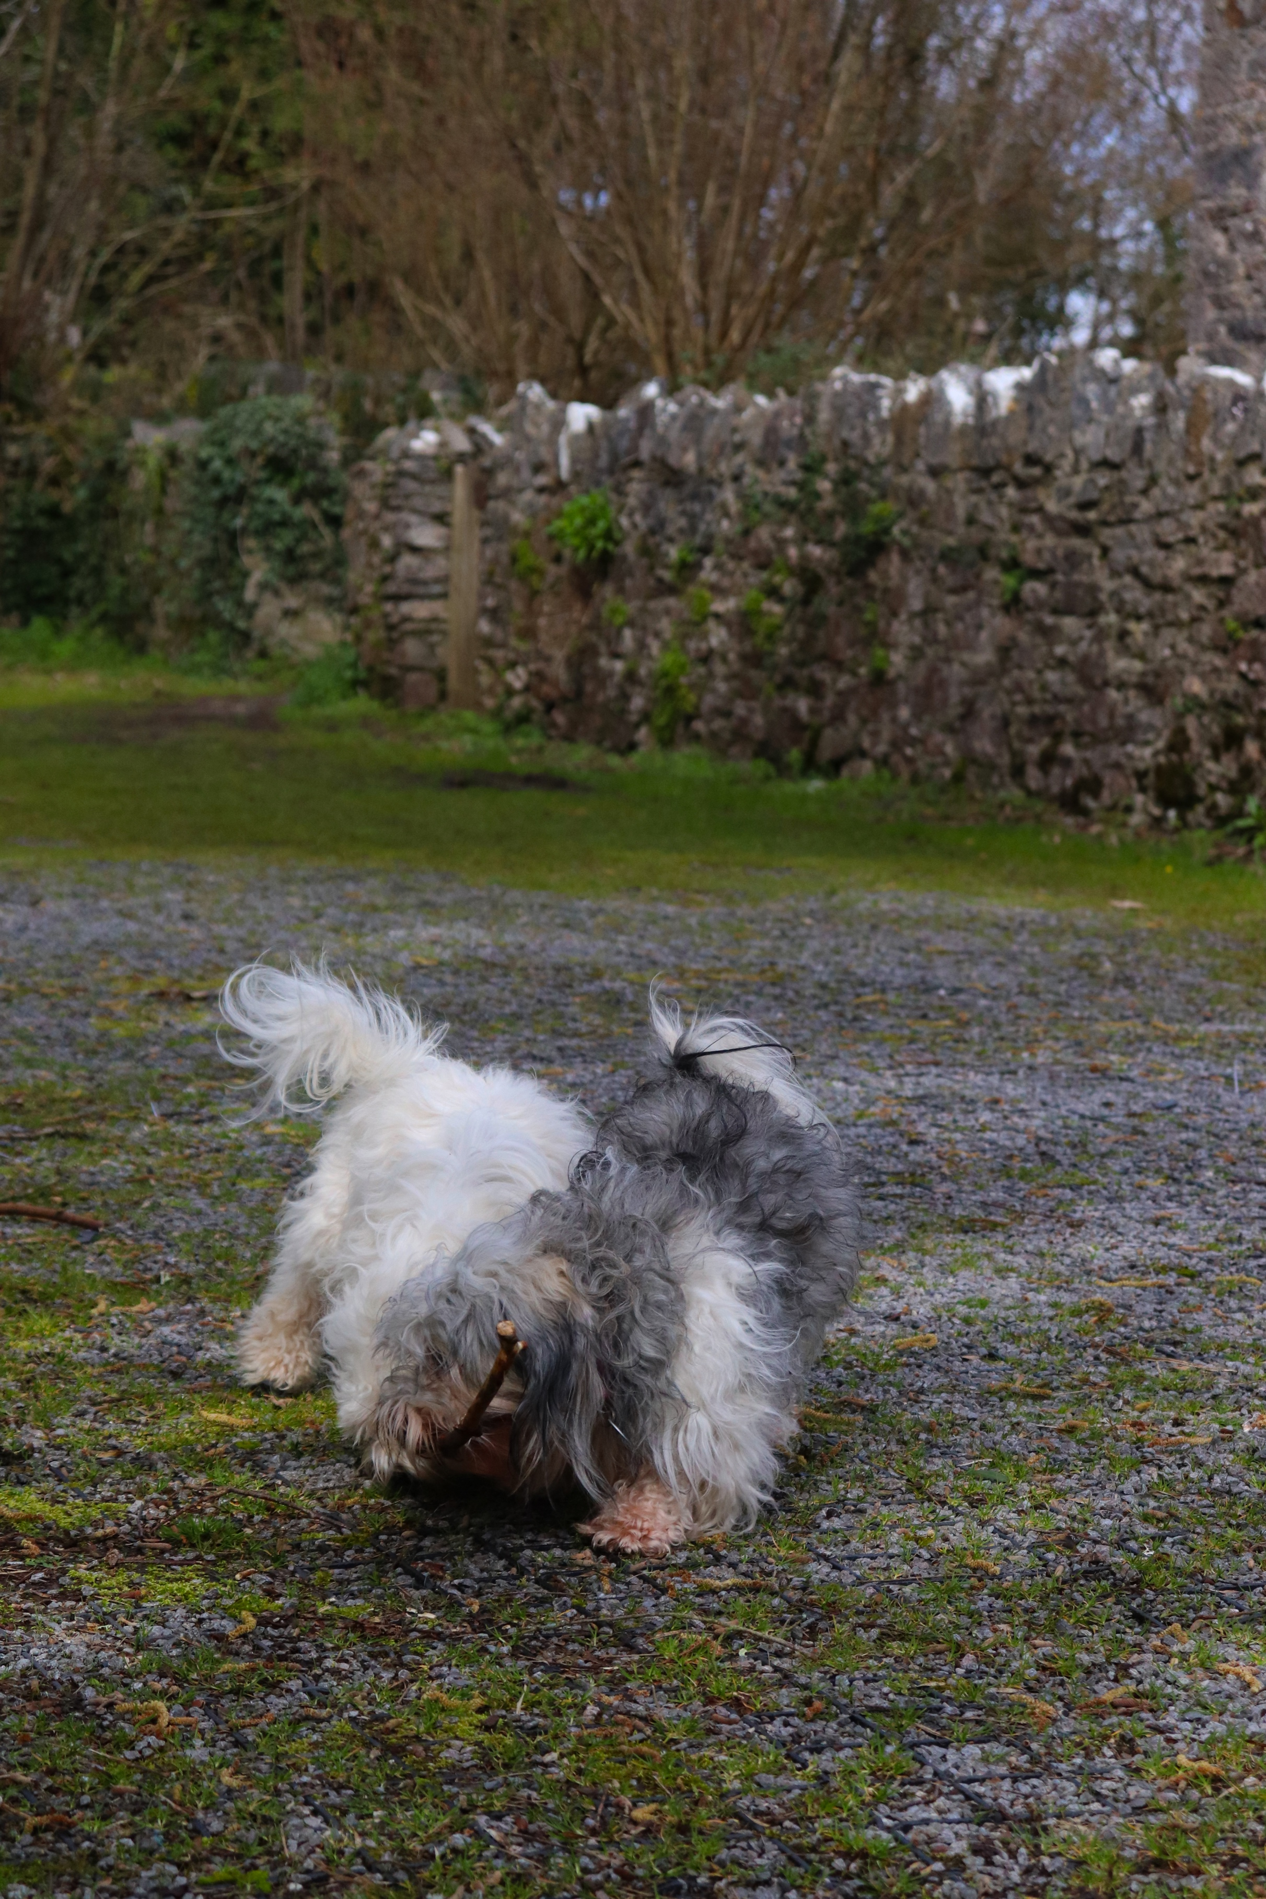

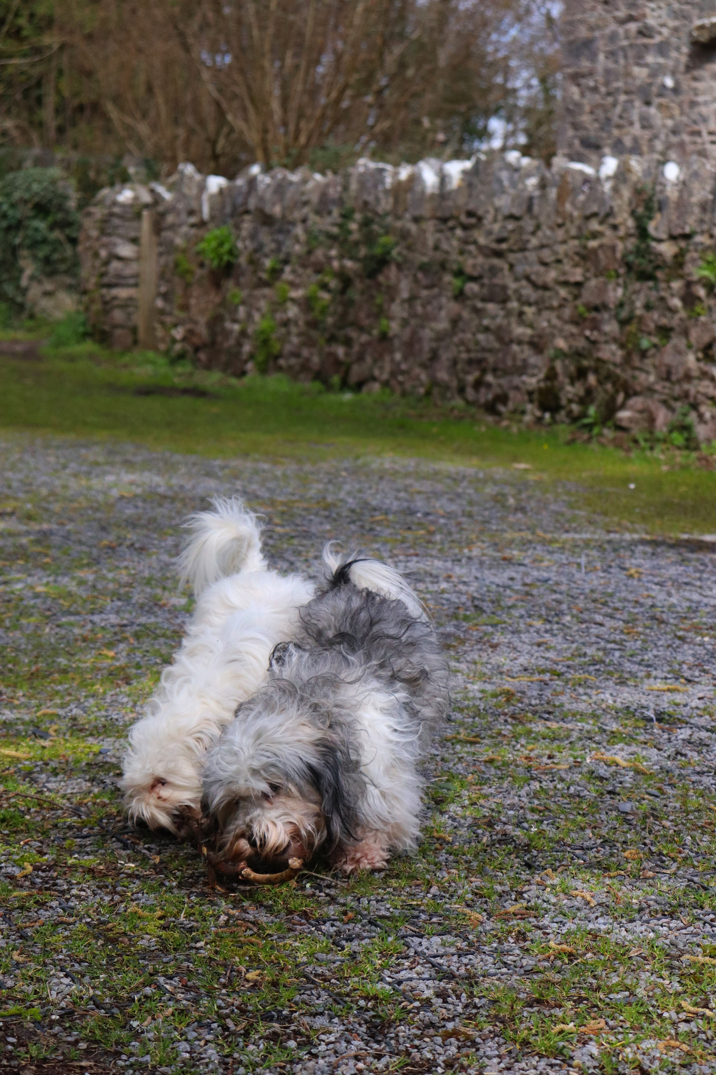

Above you can see the images I used for my finals from my shoot for movement. These images show a series of images of my two dogs, mother and daughter playing with a stick, trying to take it from each other. As you page through the images you can clearly see that there is movement as they try and take control of the stick so that they can play with it. Although it is not the fastest moving scene it was still a challenge to capture my dogs because they were always moving.
The texture of the series of images are soft, the foreground and midground are in focus throughout with the background (top of the image) blurred. This makes you focus on the subject much easier than it would be if this was not blurred. The framing of the images was hard in my opinion because the subjects were constantly moving when trying to shoot motion. I tried to apply previous knowledge by using rule of thirds and trying to secure good framing of the images. The colour throughout the images are vibrant and the backdrop is very simple with not much else going on. This makes you focus easily on the subjects. The angle I have taken this from is near level to the dogs, but just above their eye level. This gives the viewer the opportunity to see the dogs at a good height without being too high to see what they are doing, and not too low with too much ground in the foreground. For this shoot I made sure that the aperture was able to calculate automatically. I made sure that the shutter was on the highest for the majority of the shoot as this would capture motion at its fastest, and best.

My inspiration for this shoot came from the research I did on Eadweard Muybridge and his shoot on horses. When I was thinking what I could shoot, animals were one of my first thoughts, so I used my dogs, naturally playing with each other to show the viewer animals and family, acting naturally, using movement. I like how throughout the images, as you page through them, the movement changes the framing of the images and how the dogs move changing each image making it unique and showing different angles of the dogs as they tussle for the stick.
Movement throughout the series is important and is captured as if it was frozen and not showing movement as it is captured so fast with such a quick shutter speed.
In all, I like how the images sit together and how they represent movement throughout from the beginning to the end and how each snap is a frozen movement as they try to win the stick.

