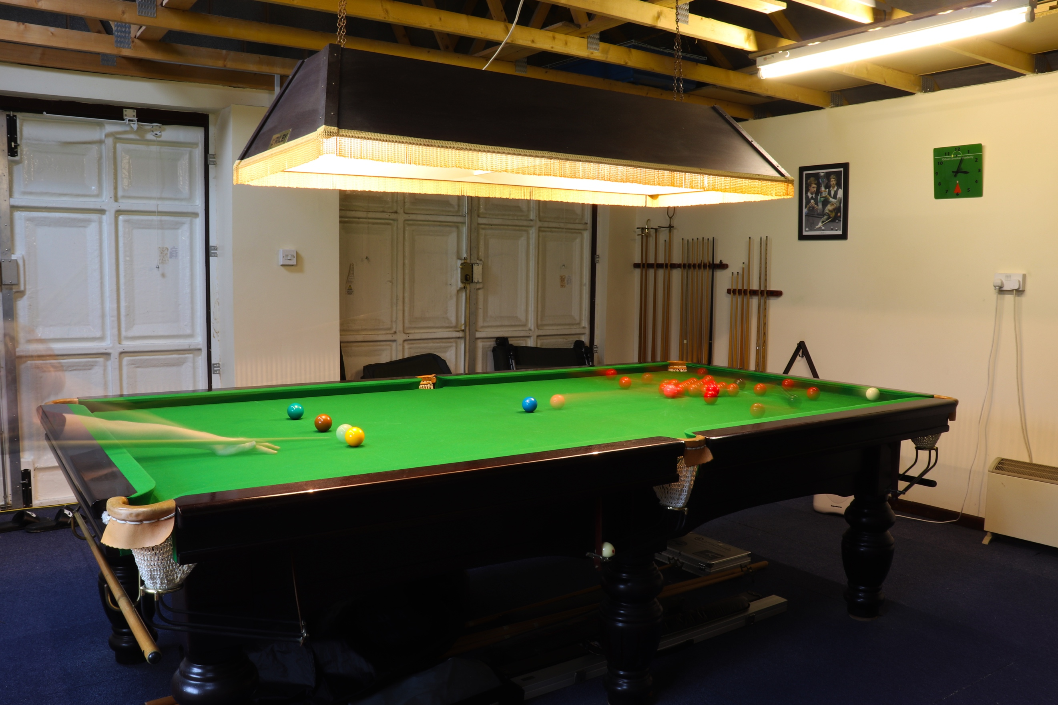
This is a shoot for ‘Trace’ and contains movement at slow shutter speed, causing blur. This series of images are of my brother, practicing. The colour of the balls is bold and simple, after being hit you can clearly still identify what colour is what. You can see as the balls have moved and I have taken the image, some have a streak behind them, as if they were moving super-fast. You can see where the black has moved to and the white in the image, it is almost as if there is two of them! When I planned this shoot, I was expecting a different outcome. I was expecting there to be a blur, but not clearly showing the same ball in a different location on the table which is really cool! For this image, I followed the instructions of the materials and put it to shutter priority where ultimately the shutter does what you ask it to, and the aperture is automatic. I did try the shutter for longer, but this didn’t come out as well as this image. This image is at the right shutter setting to capture movement, clearly without destroying the picture. Like woodman’s images, with some of the body still, and other parts moving, a few of the balls in this image are still because they haven’t been hit, and the others have a low opacity because they have moved, creating a ghost like effect.
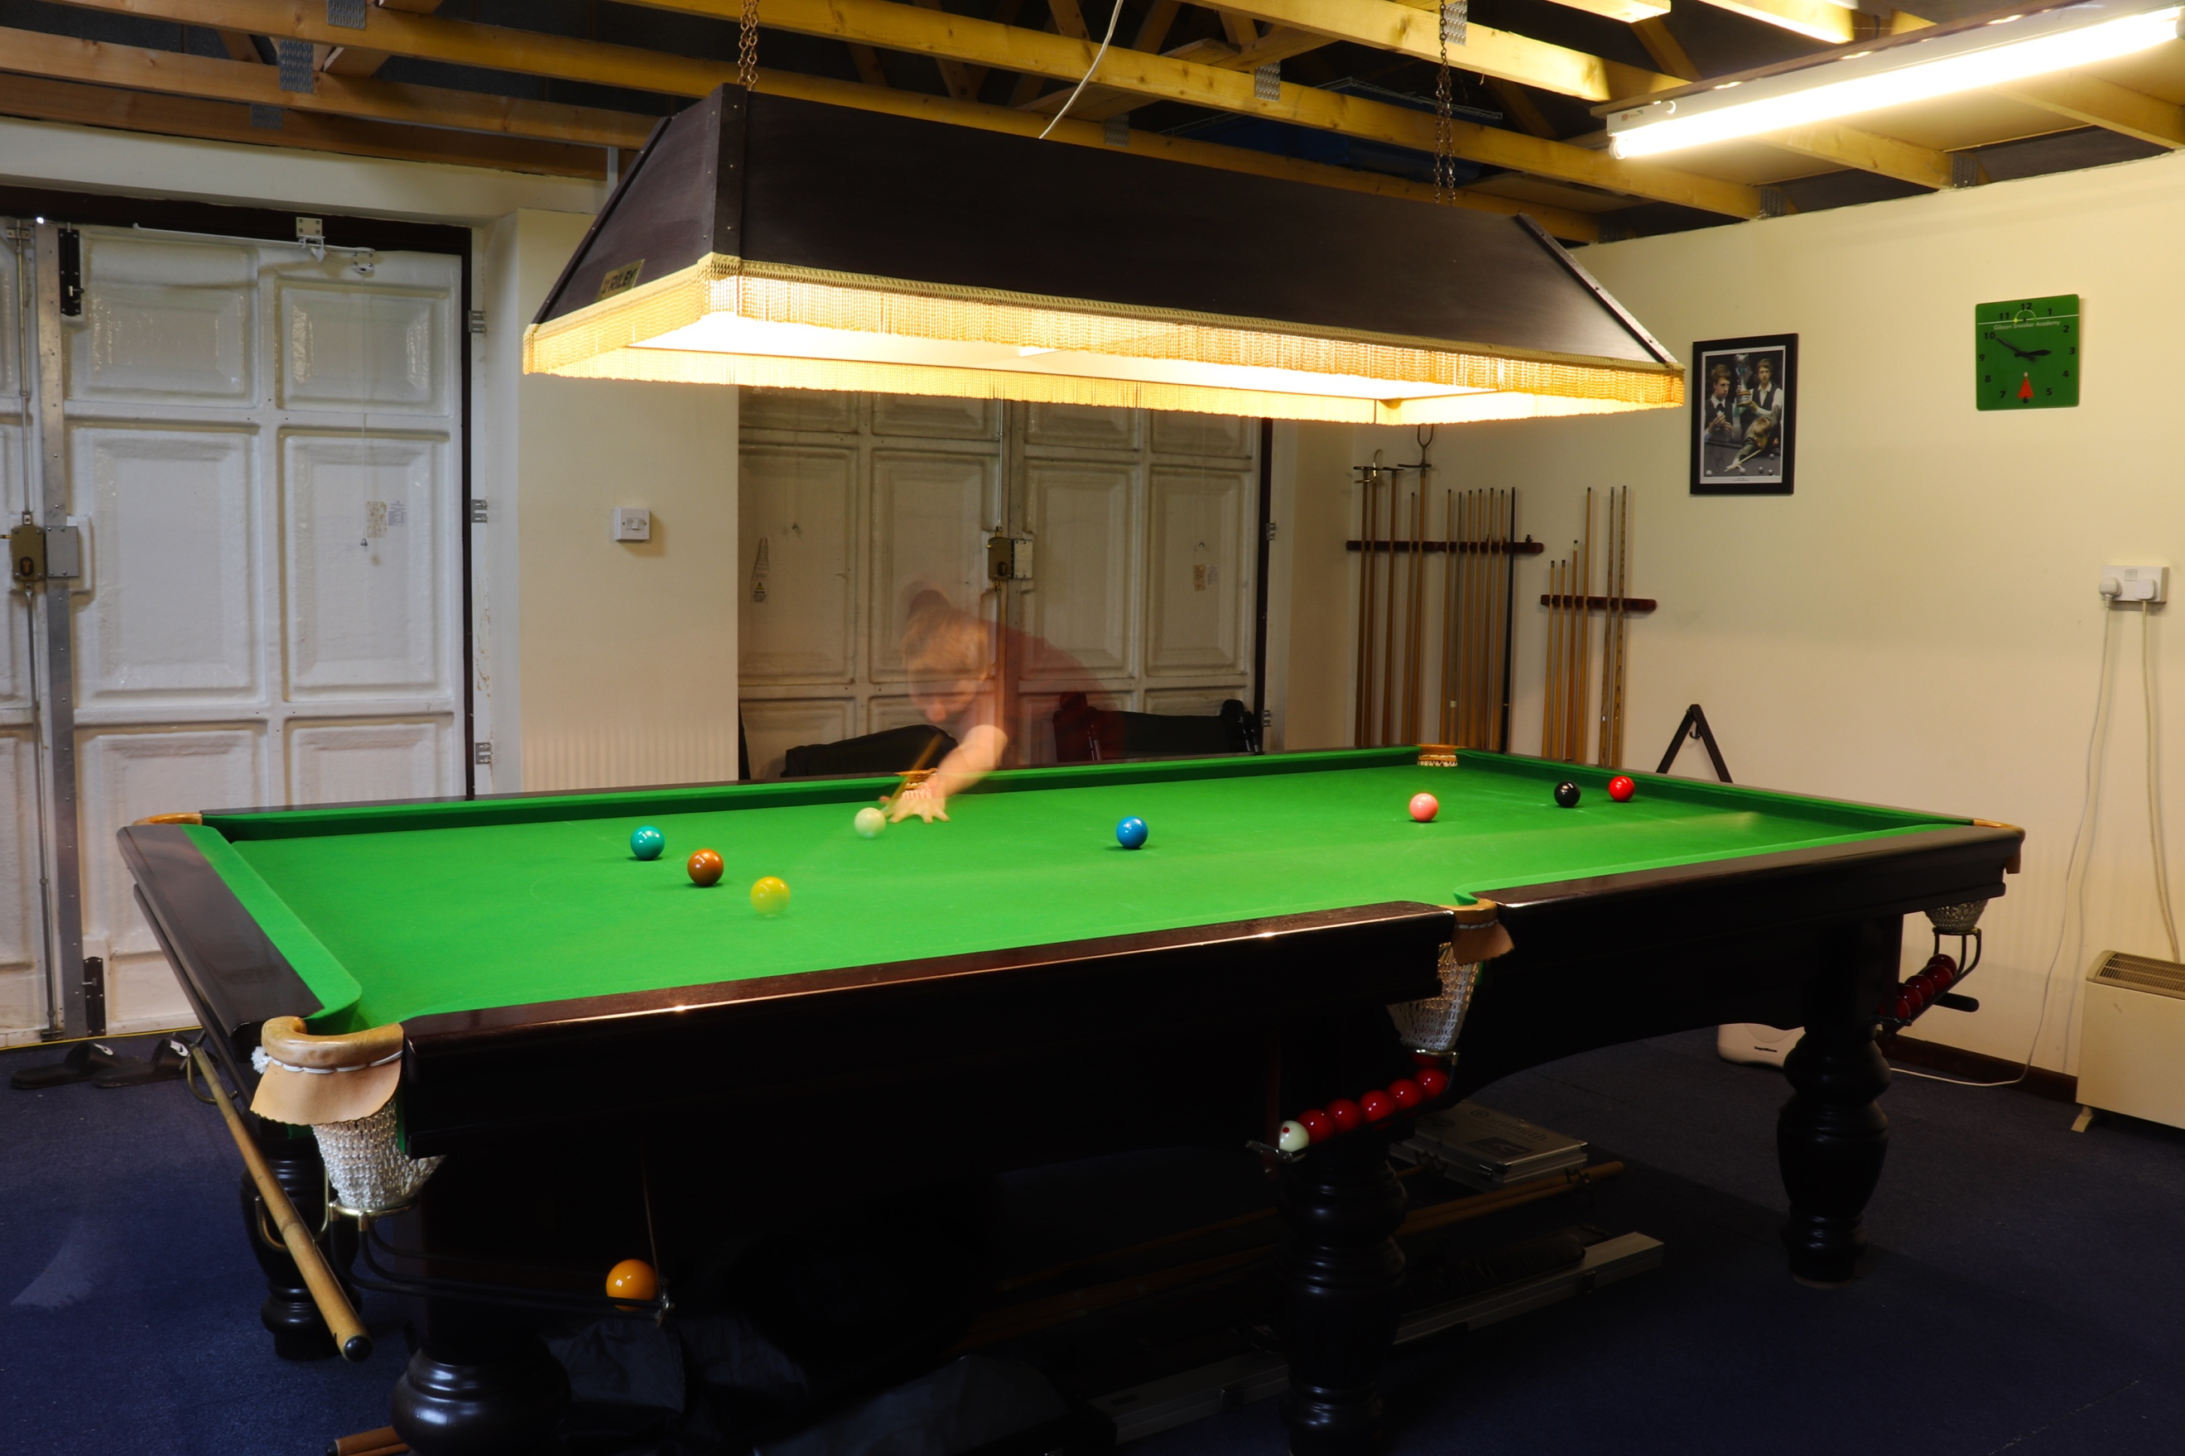
Like the first image, this one has been shot with the same point of view, for this I used my 18-55mm lens, at 18mm, and have used a tripod to steady the camera to make sure the shutter can work properly without camera wobble causing a shaky effect. This is my favourite image because as you look at the positioning of my brother and the yellow ball, you can see both are faded. But show no movement. If you look to the right down the table you can see a faint streak where the white has ended up after his shot has been taken. The yellow ball, you can clearly see in the pocket if you look down beneath the table! You can also see through my brother as well, like he is a ghost, and the shot is a ghost of what he has already done, which is pot the ball. If you look over to the left below the table also you can see a foot, which is my brothers, this looks rather strange and like a defect to the image, but the camera has managed to record this also after he has walked around there. The yellow has no streak to it and the camera has not recorded it. It is as if it has just appeared in the pocket, but as for his positioning in the image, it looks like he is just about to take the shot, even though the yellow is already in the pocket, it is as if he is lining up to take another shot.
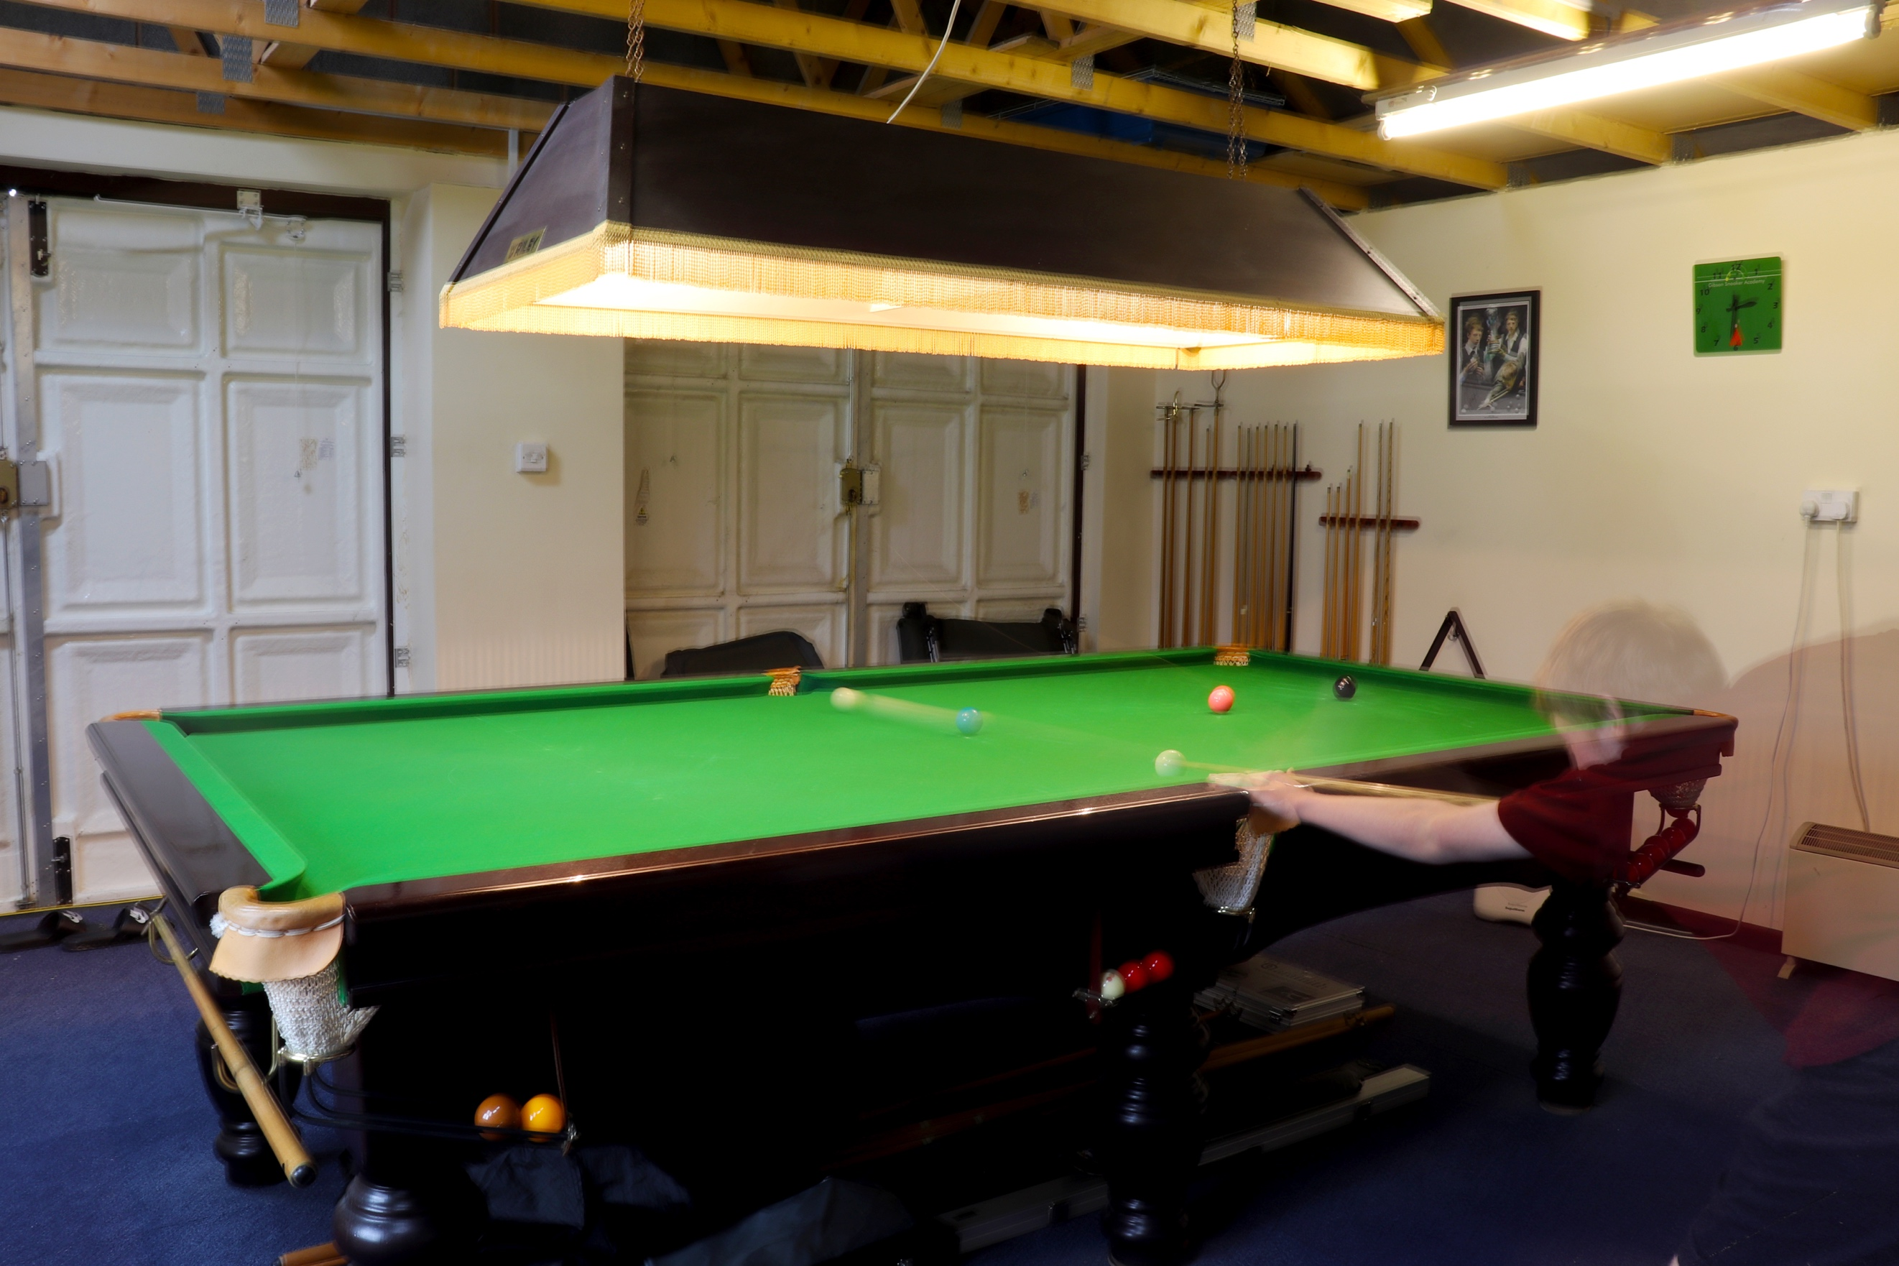
This is the third image in this shoot. This is where he has nearly cleared up and is on the blue. As he has taken his shot, you can see that the white has been hit at some power and looks like it has just gone straight through the blue! The blue looks like it hasn’t even moved, but he actually did pot it, balls can’t just go through one another. He looks like a ghost in this image too, just like the rest. I used the same settings and camera for this picture. As you can see there also looks like there is two whites again, showing traces of time from where it started at the beginning when the shutter opened, and where it recorded it at the end when the shutter closed.

