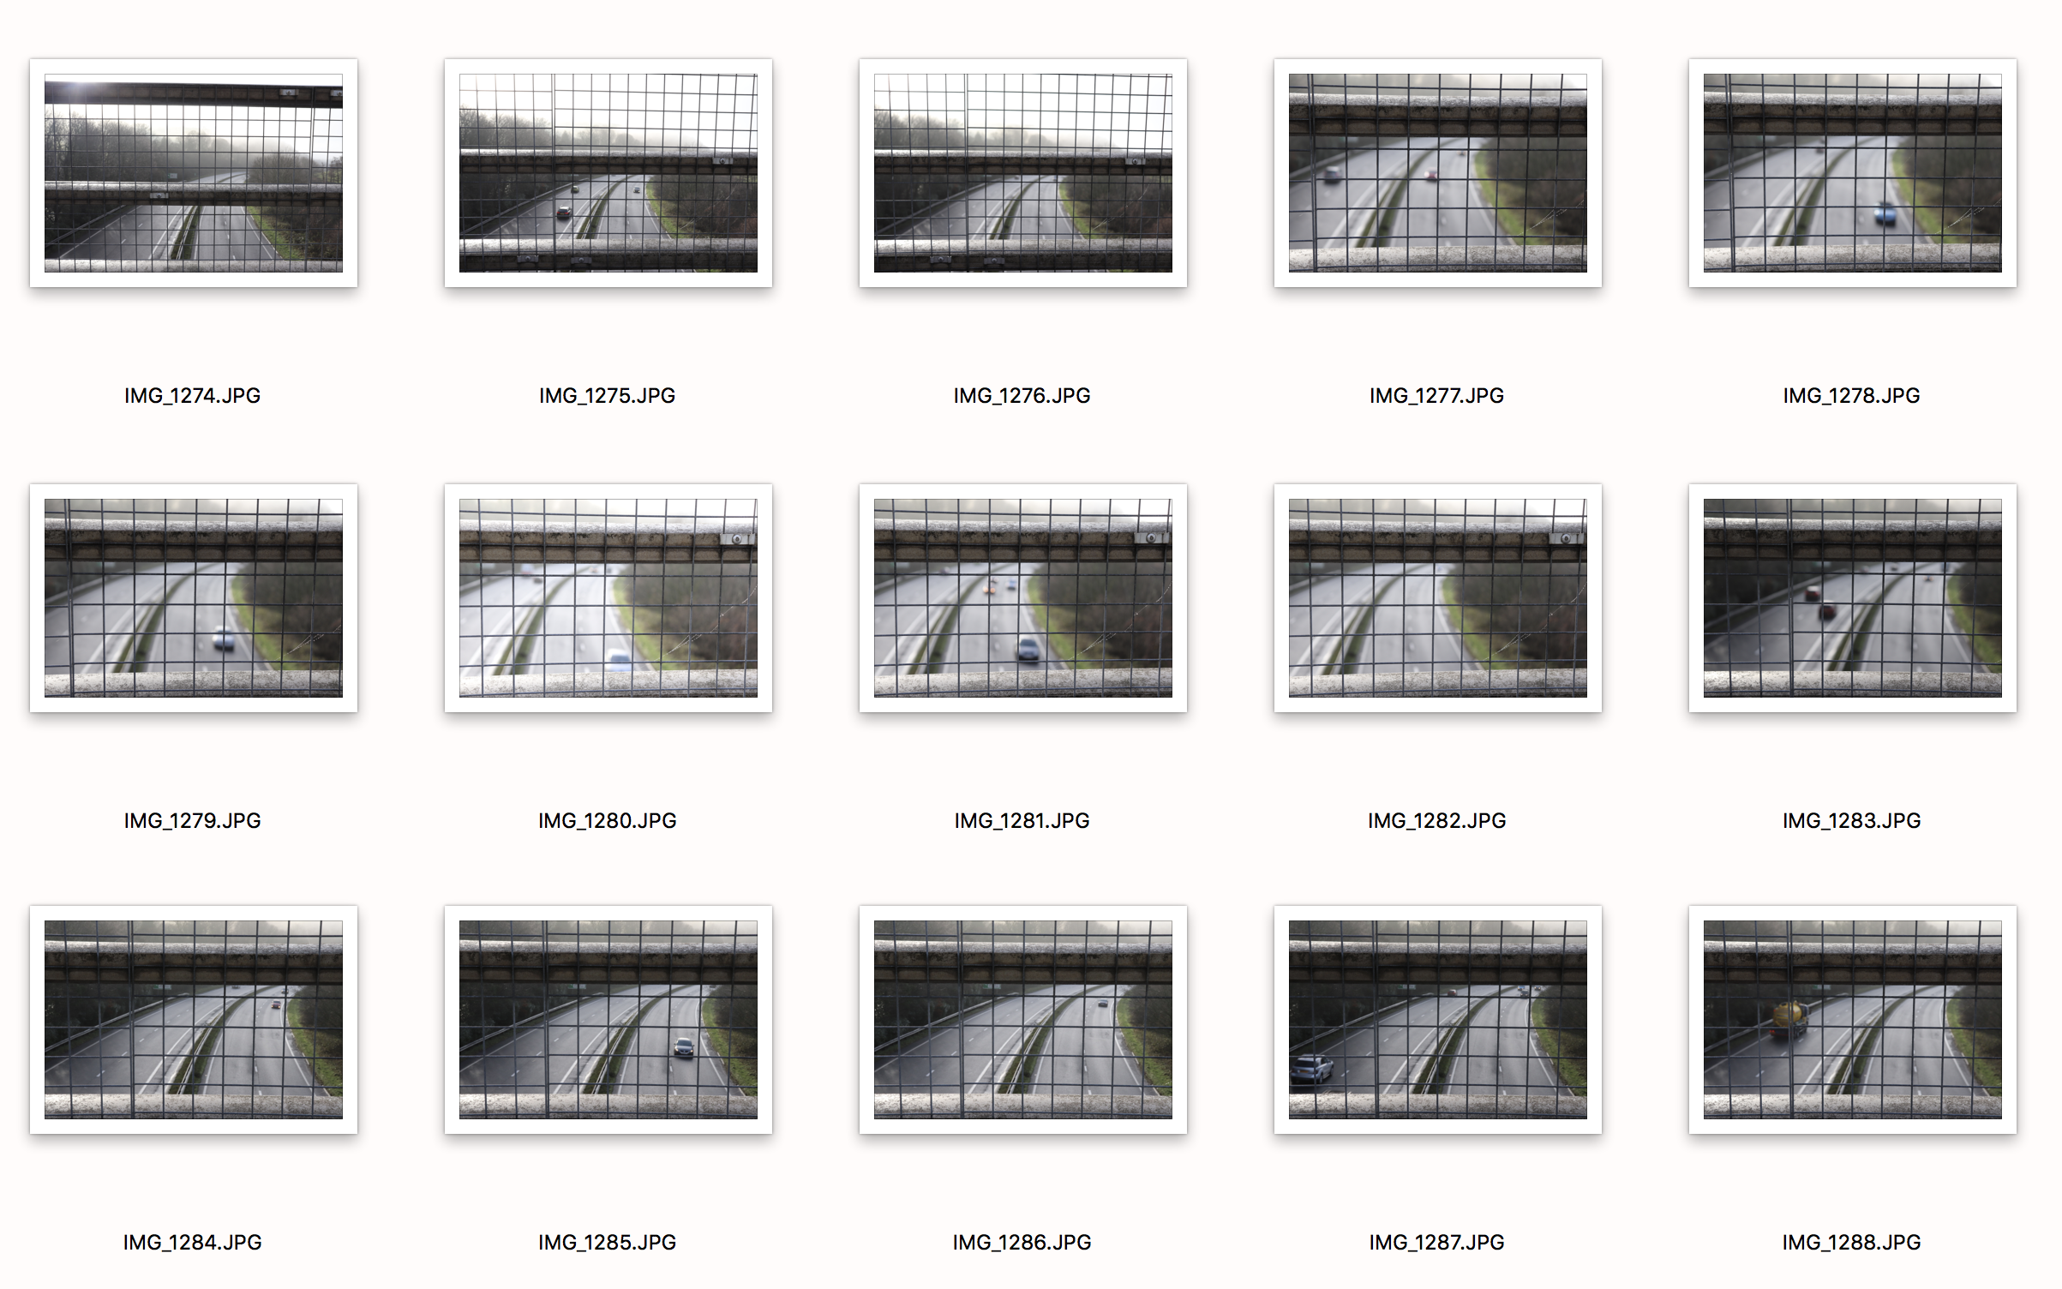

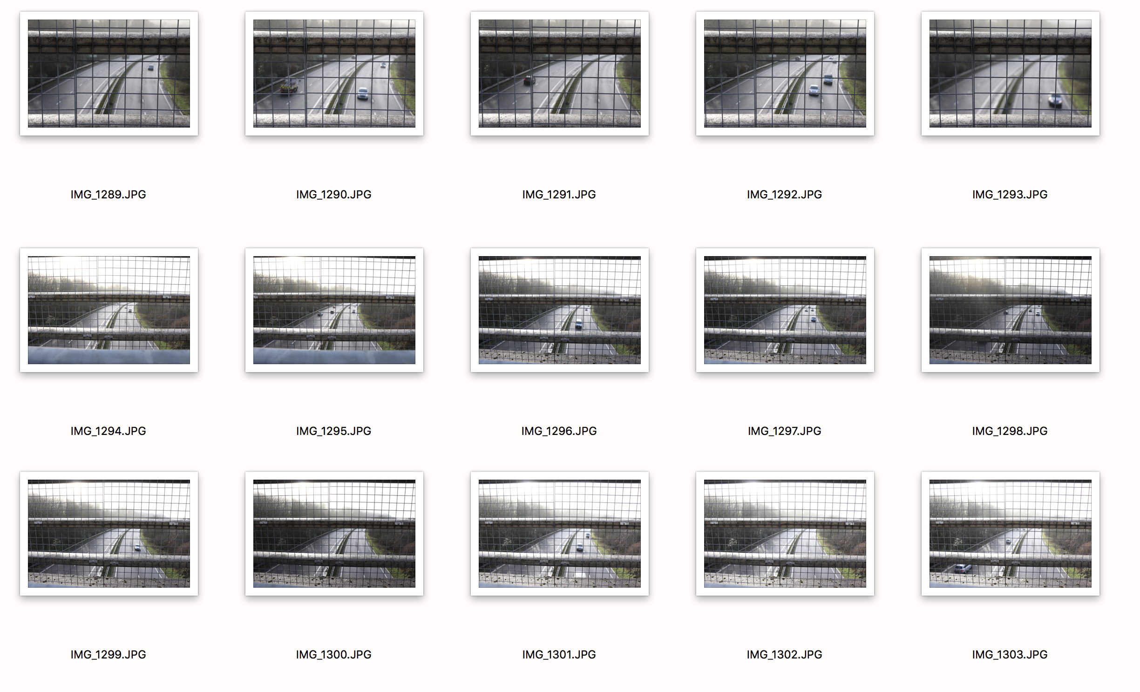

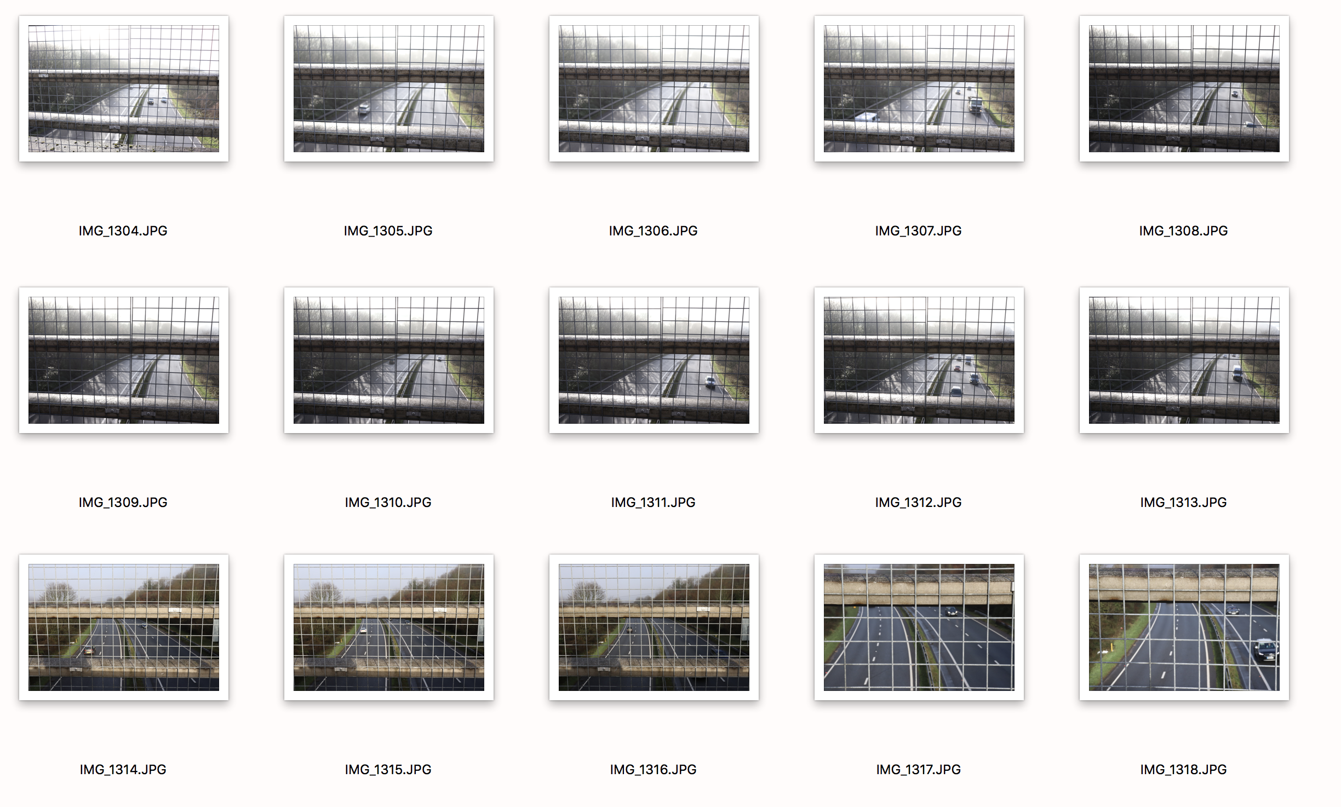

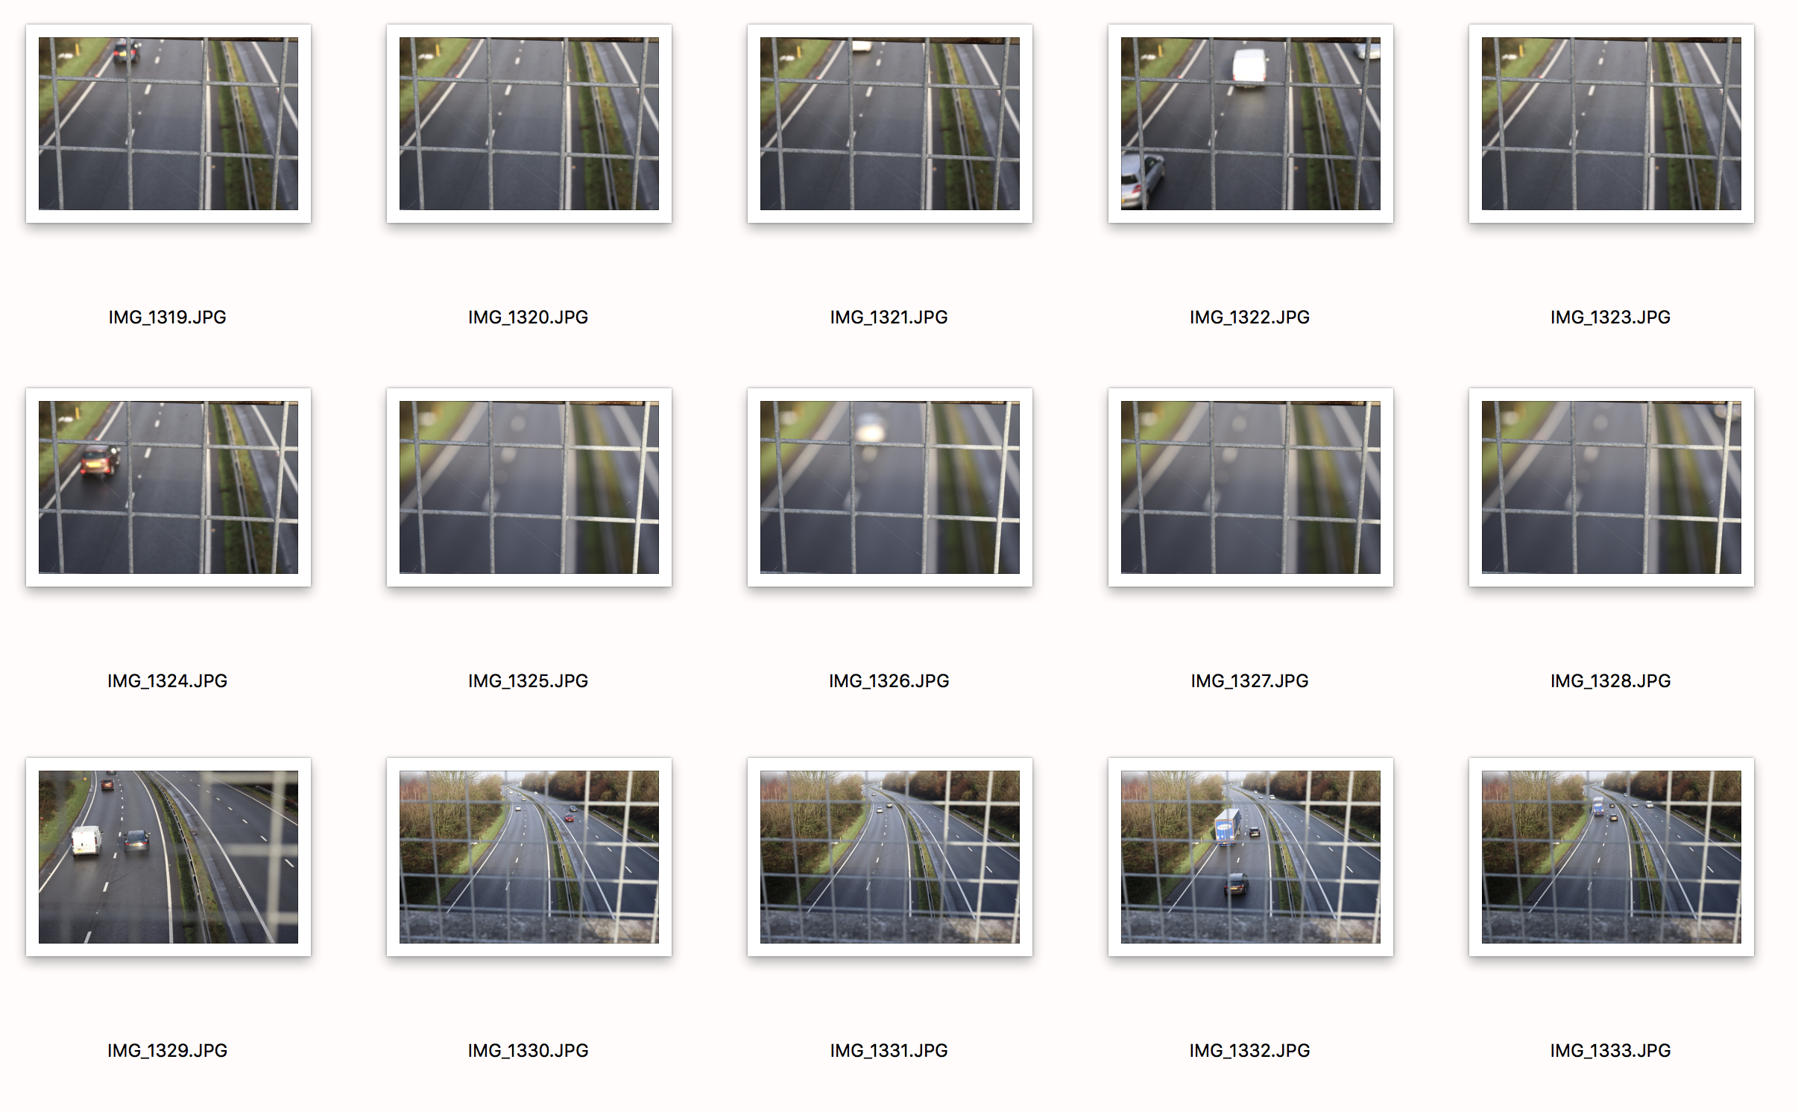

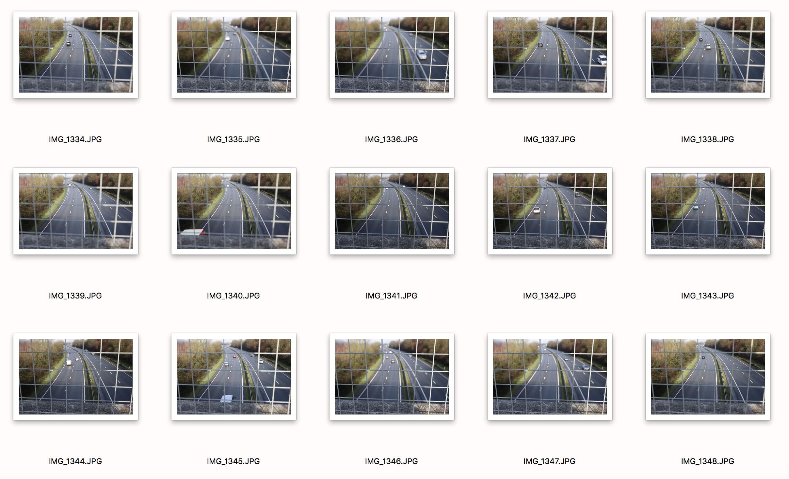

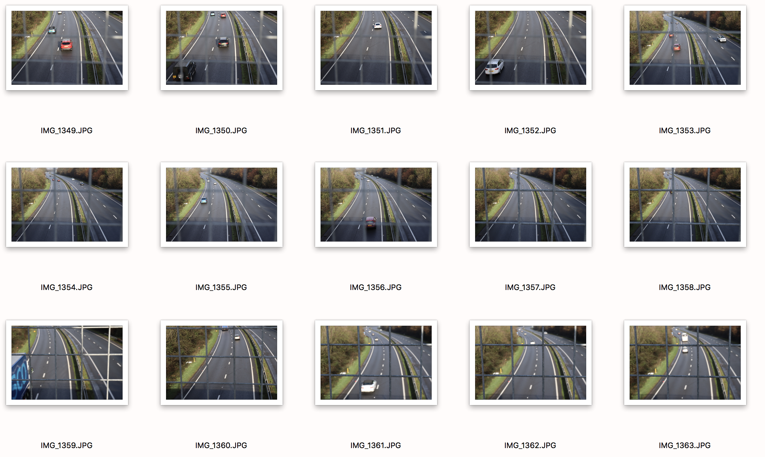

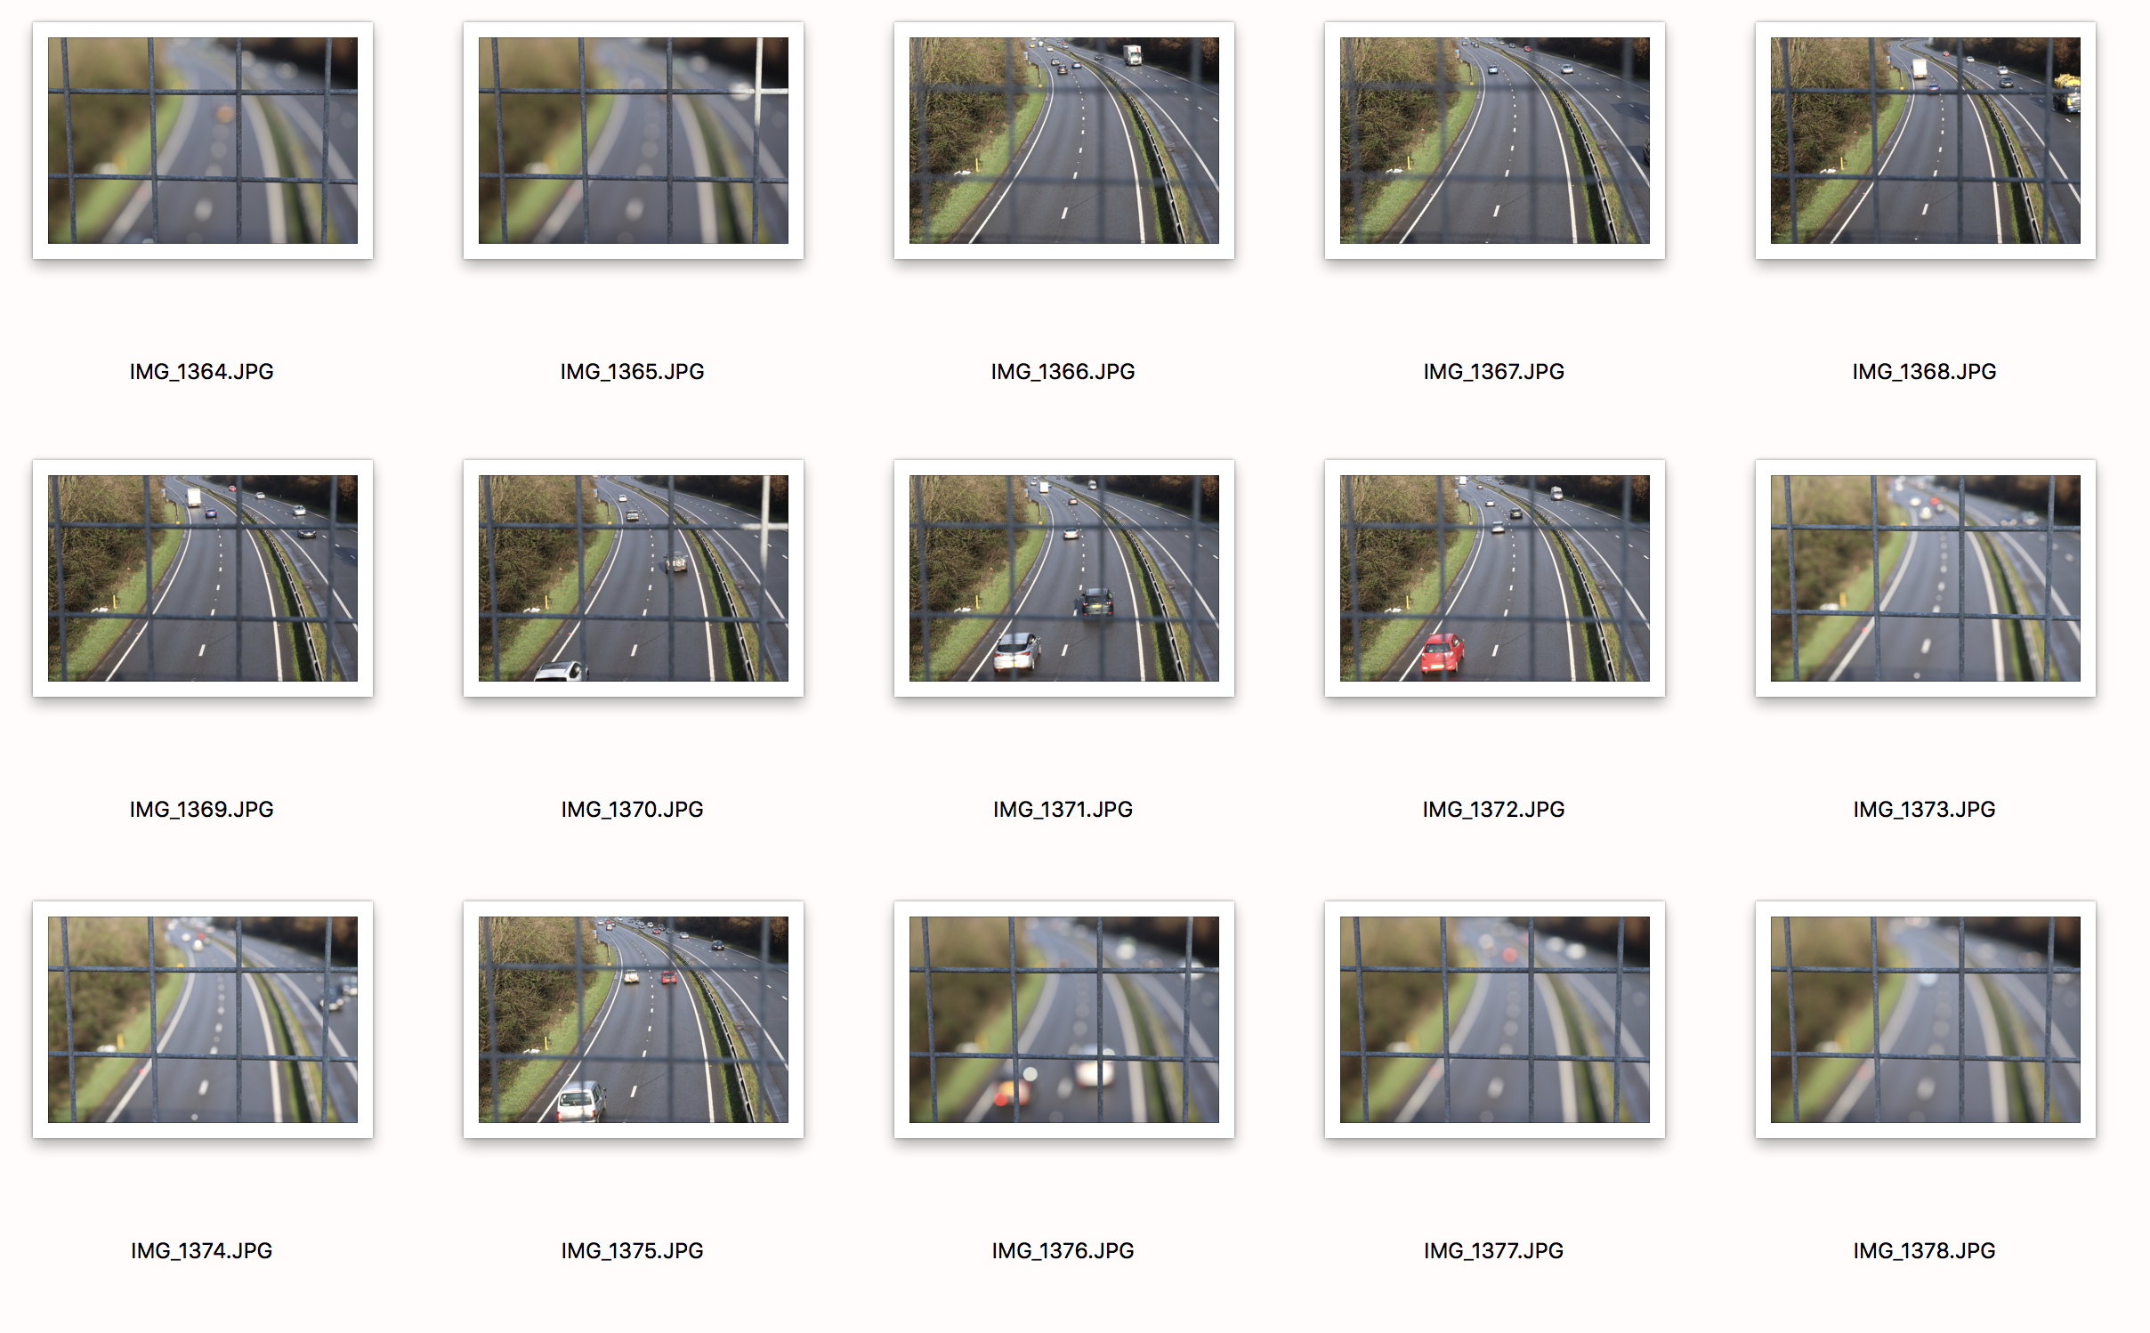

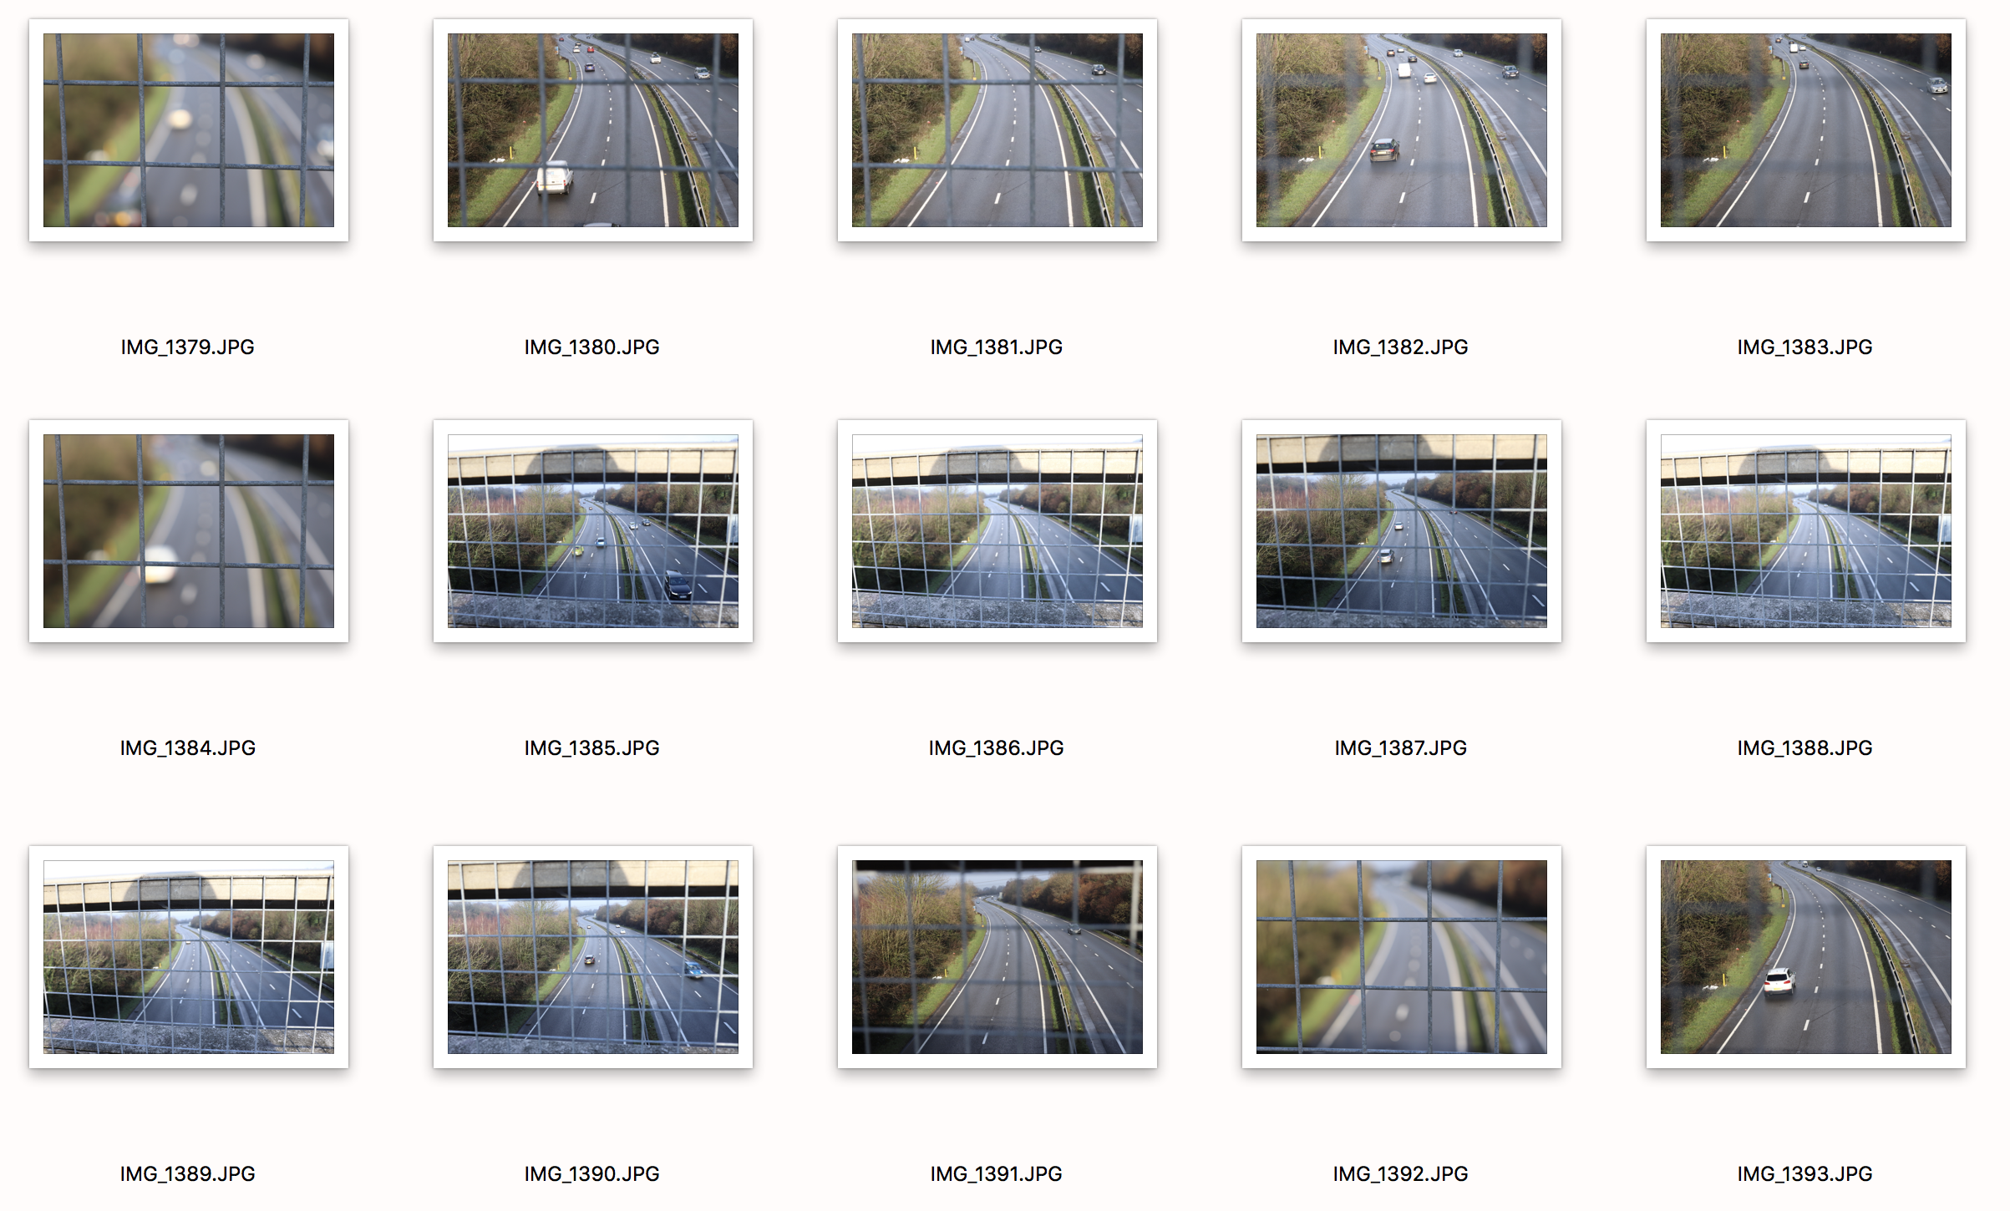

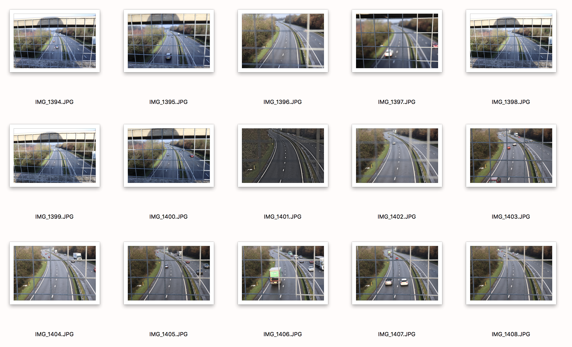

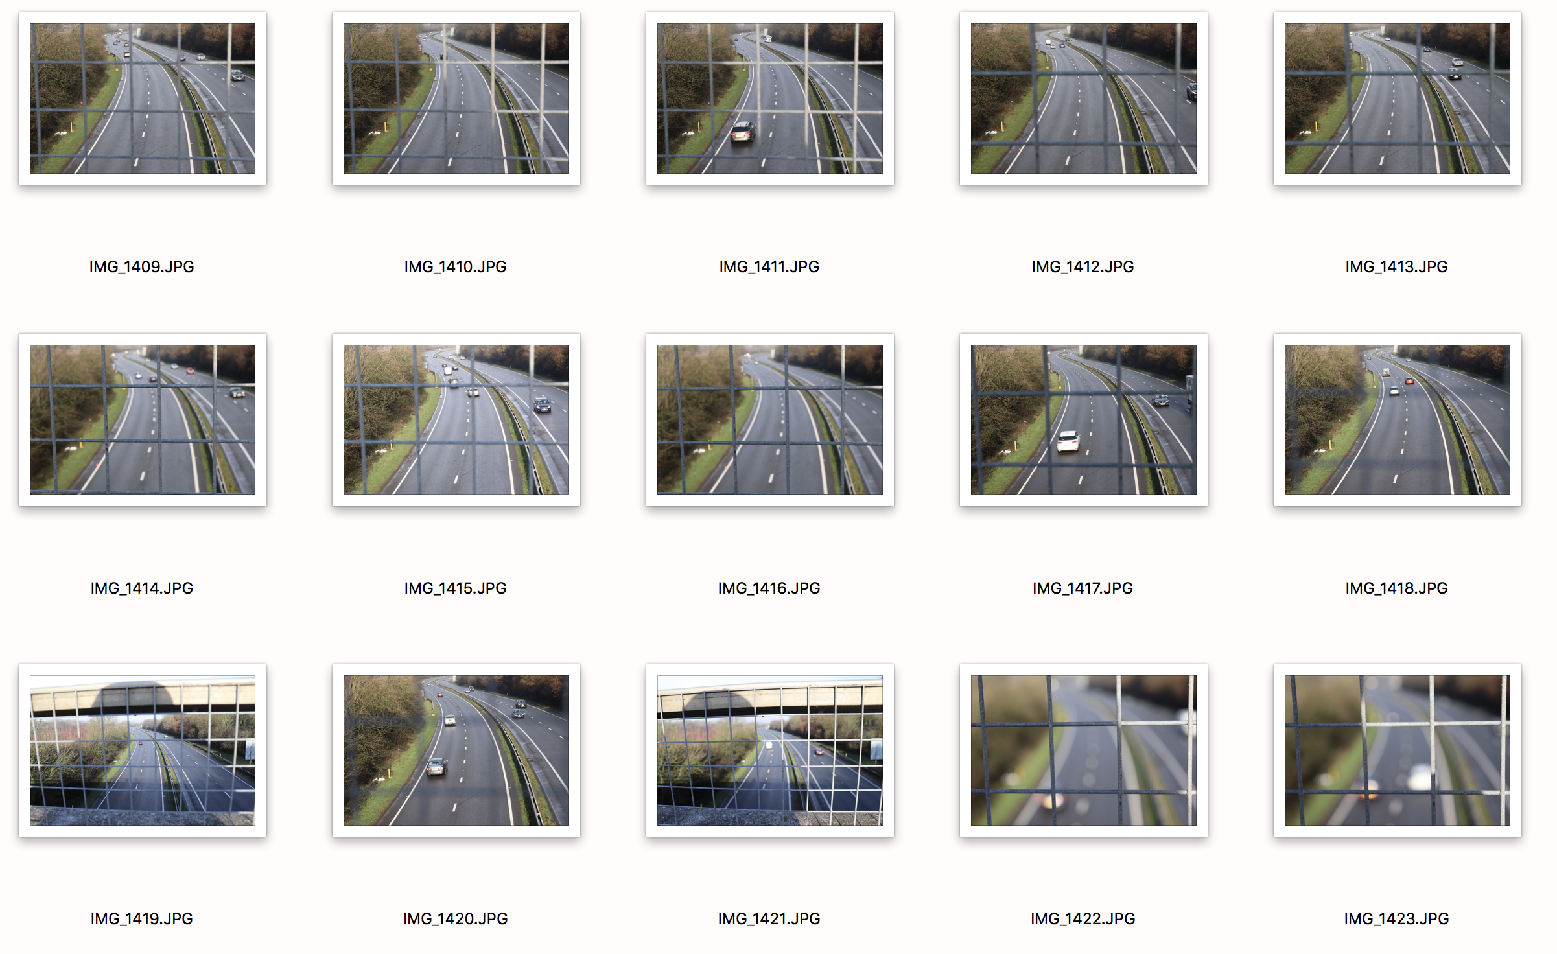

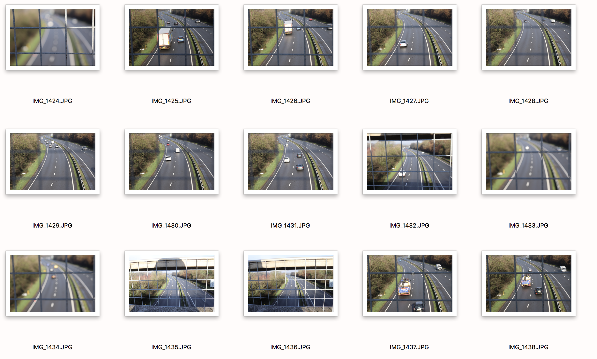

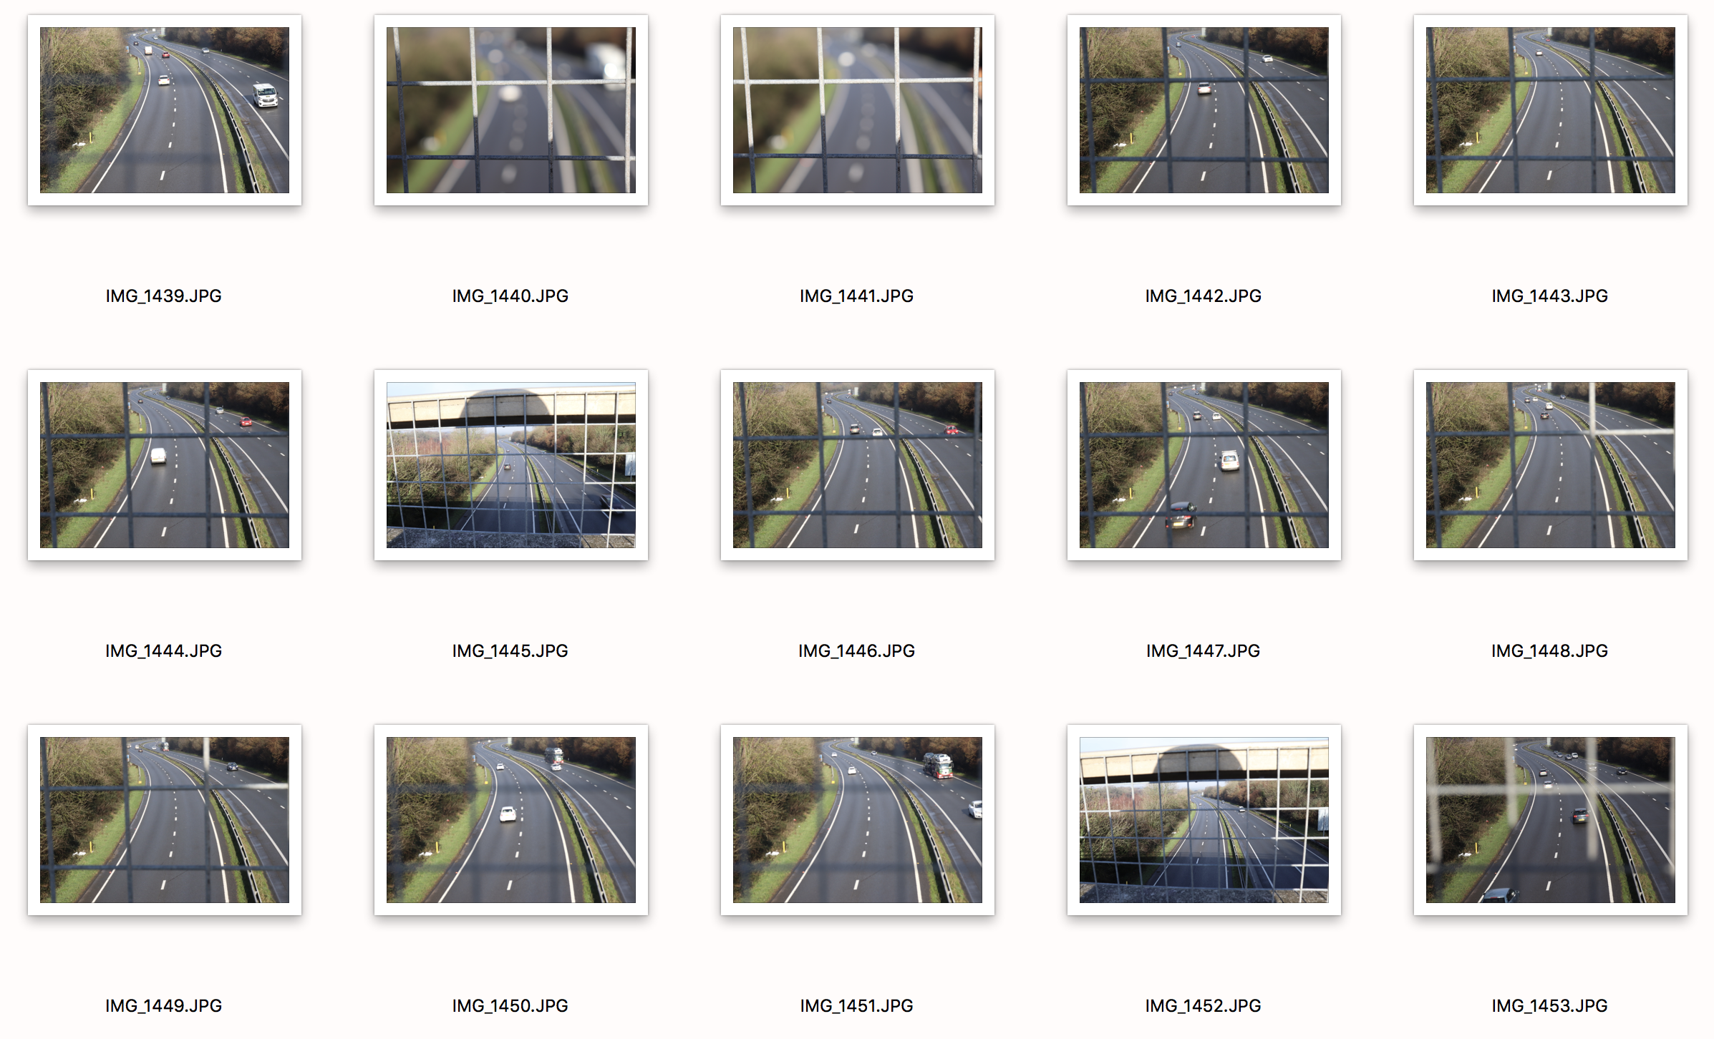

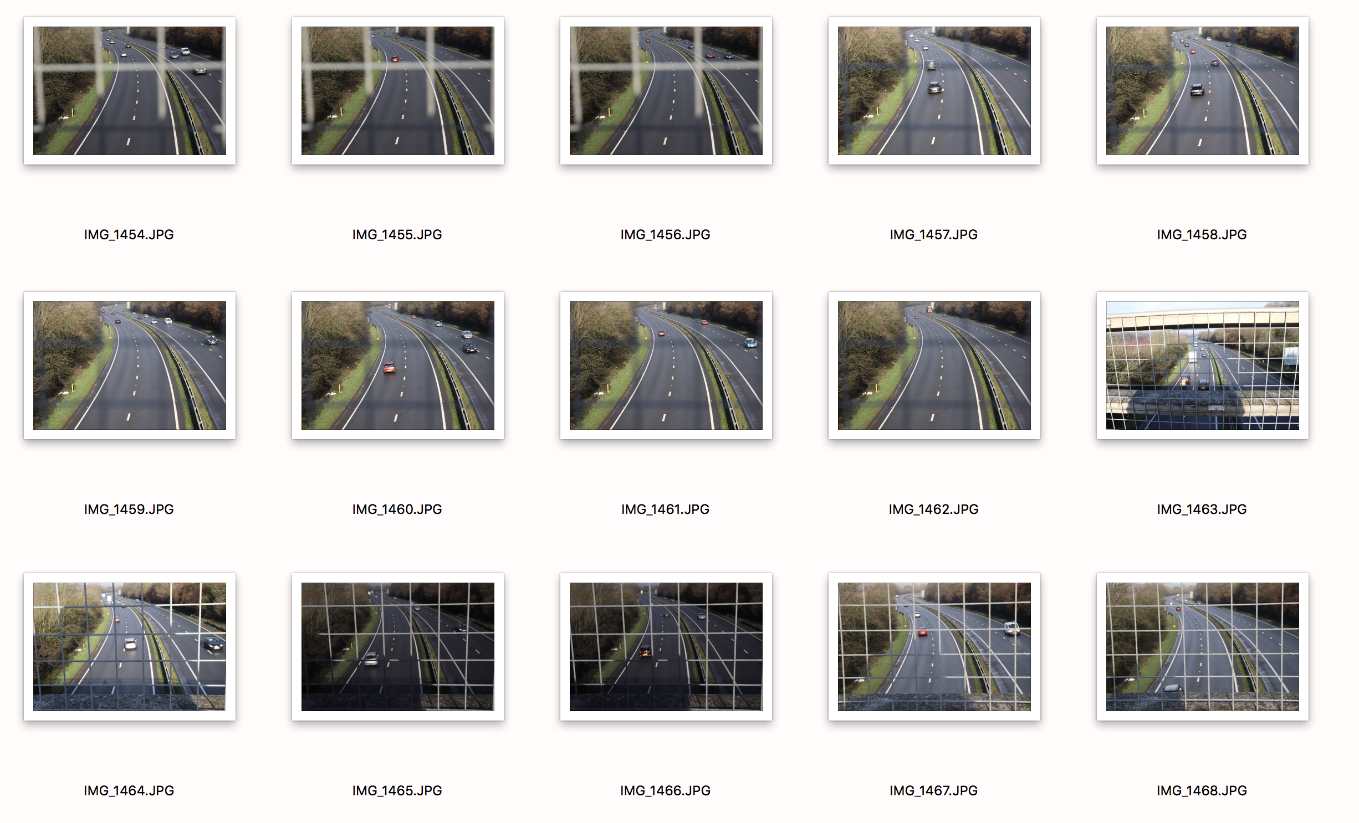

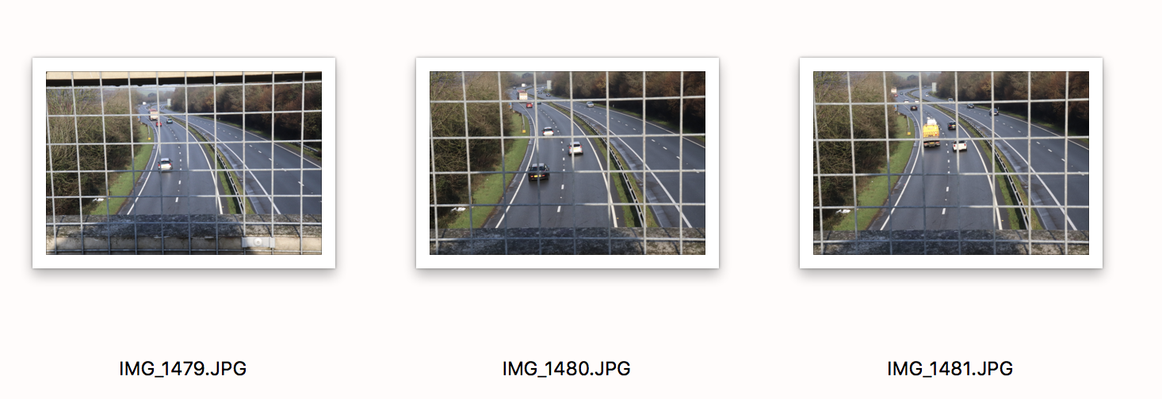
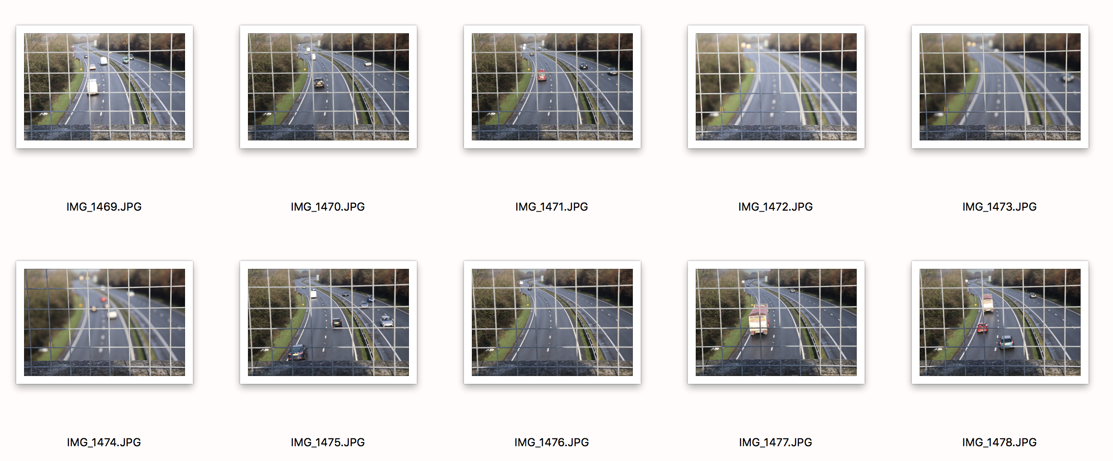

For this shoot I have taken many, many photos. The reason for this is because I feel I didn’t quite get the shots I wanted each time, and wanted a huge range of shots to look through so I could pick out the best. In the brief it says to do three images. Instead I have chosen five. My reasoning for this is because two of them come as a pair and these two images clearly represent the first part of the exercise. But this close in I couldn’t quite get the third shot. I could blur the background and keep the foreground in focus and I could blur the foreground and keep the background in focus. But could not seem to keep the whole field in focus from this close in. I tried on many occasions and in the end, I had to physically take a step back and do some other shots to include the image that captures the whole depth of field in focus. So therefore, I have chosen an extra three images, two the same as the first and one showing the second part of the exercise. I used an 18-55mm lens for this shoot, and shot a fair few images on aperture priority and tried various focal lengths but my camera was having none of it and found it really difficult to get a shot with all of the frame in focus. When I tried to focus using the shutter button it would either flick between the foreground and background and wouldn’t keep it in focus. I tried numerous other methods as well but found it hard to get a shot from that close in that kept it all in focus. In conclusion I wanted to include all images to show it from a range, one closer up and one further away, still focusing on the same thing, with also the third shot.

