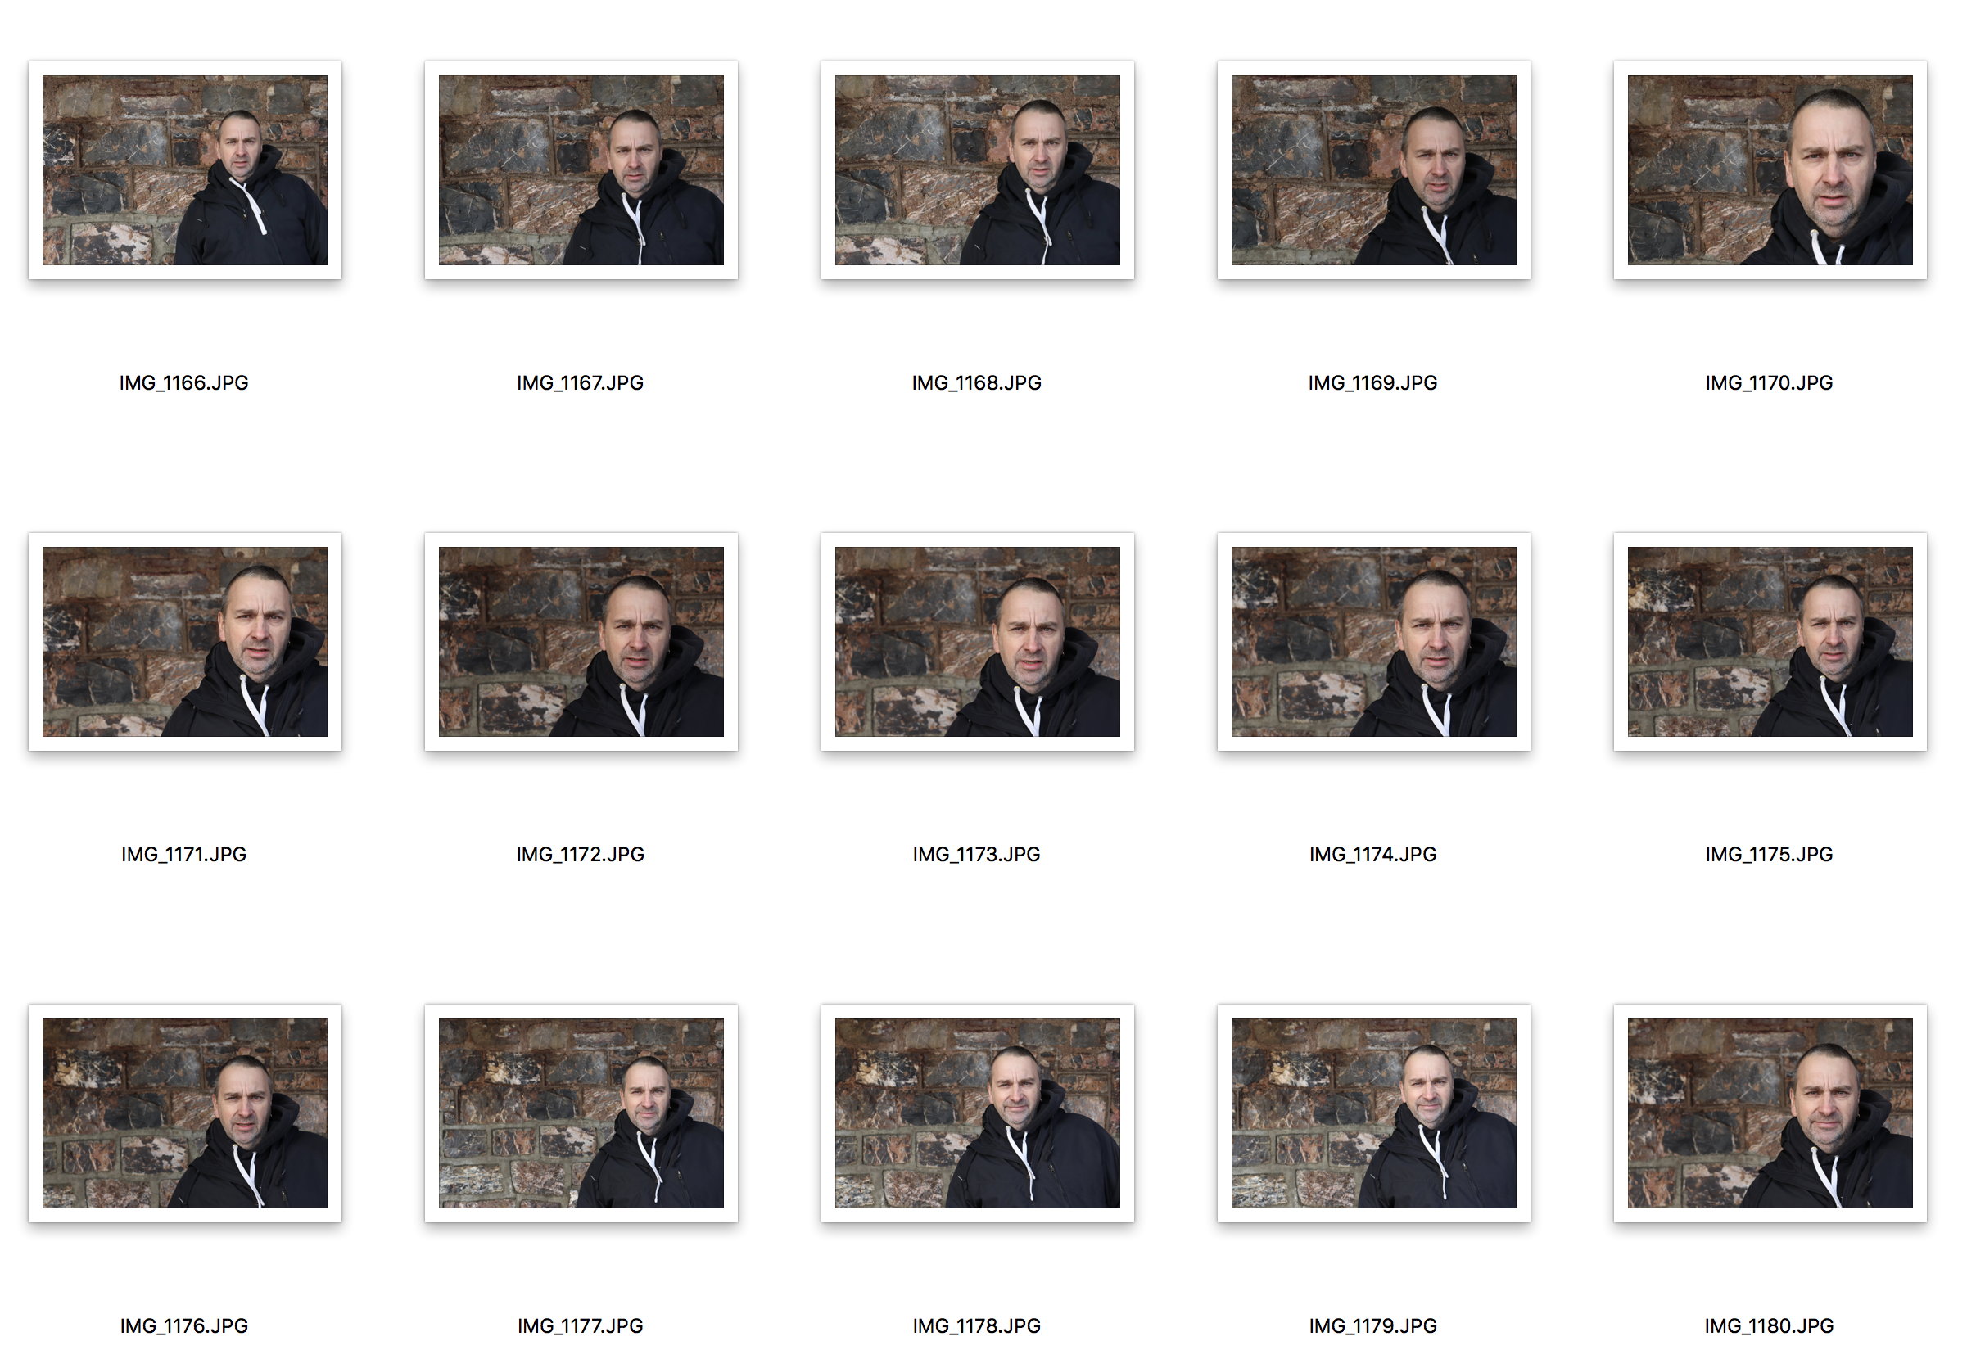
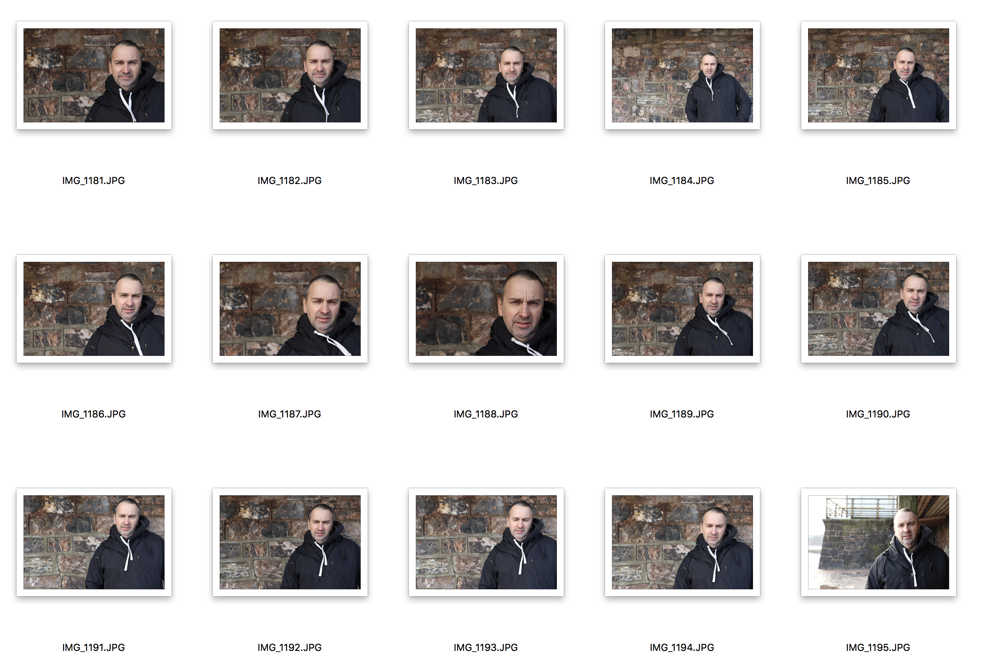
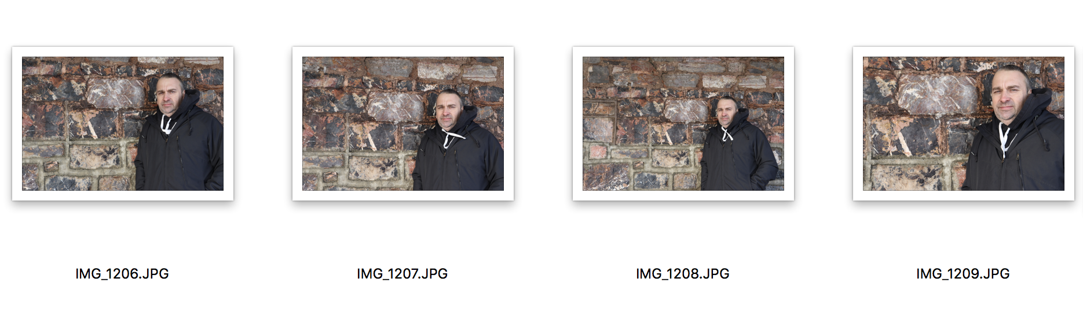
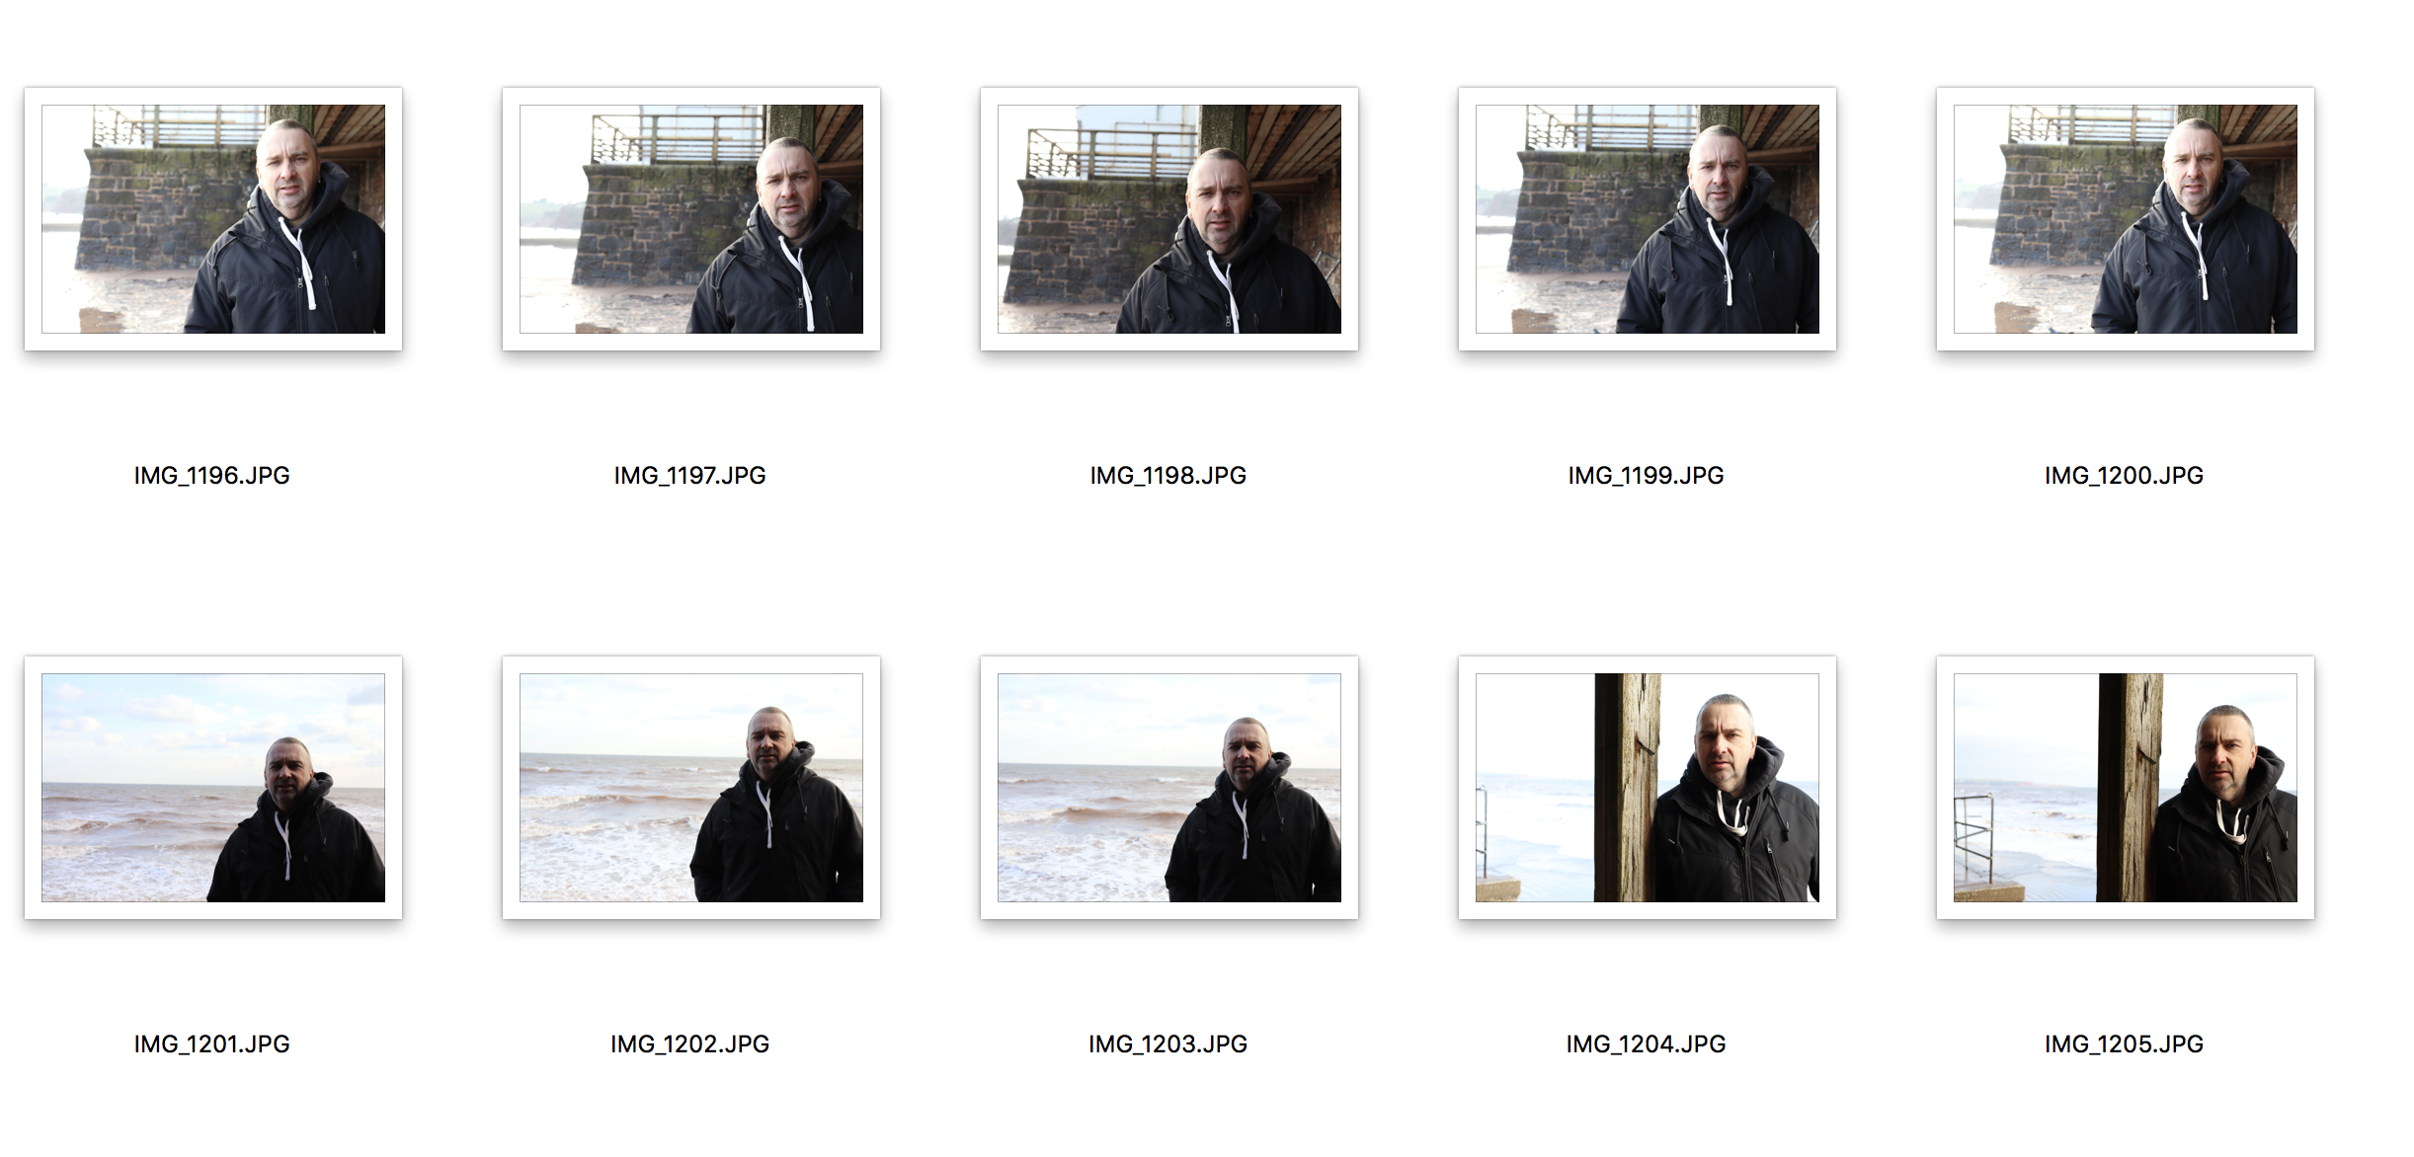

I found this shoot the hardest, and I managed to pick out a photo that I feel complies better than the rest of the images. I tried to get one with a plain background and at eye level. I know this is in the same location as the other shoots, but it is about technical ability and not about location. I read ahead and planned accordingly and as the saying goes two birds with one stone. I took advantage of this and instead of using extra fuel, money and time, I did the shoots in sequence and still managed to execute them as well as I could have. I found this shoot the hardest because I am too short compared with my dad and trying to use the rule of thirds grid as well on my camera and trying to get the framing dead on also was a challenge, though I thought I did well.

