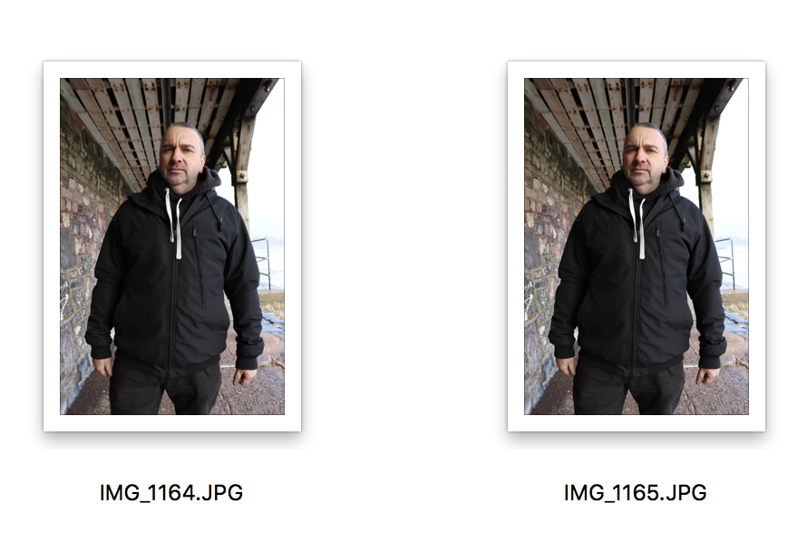
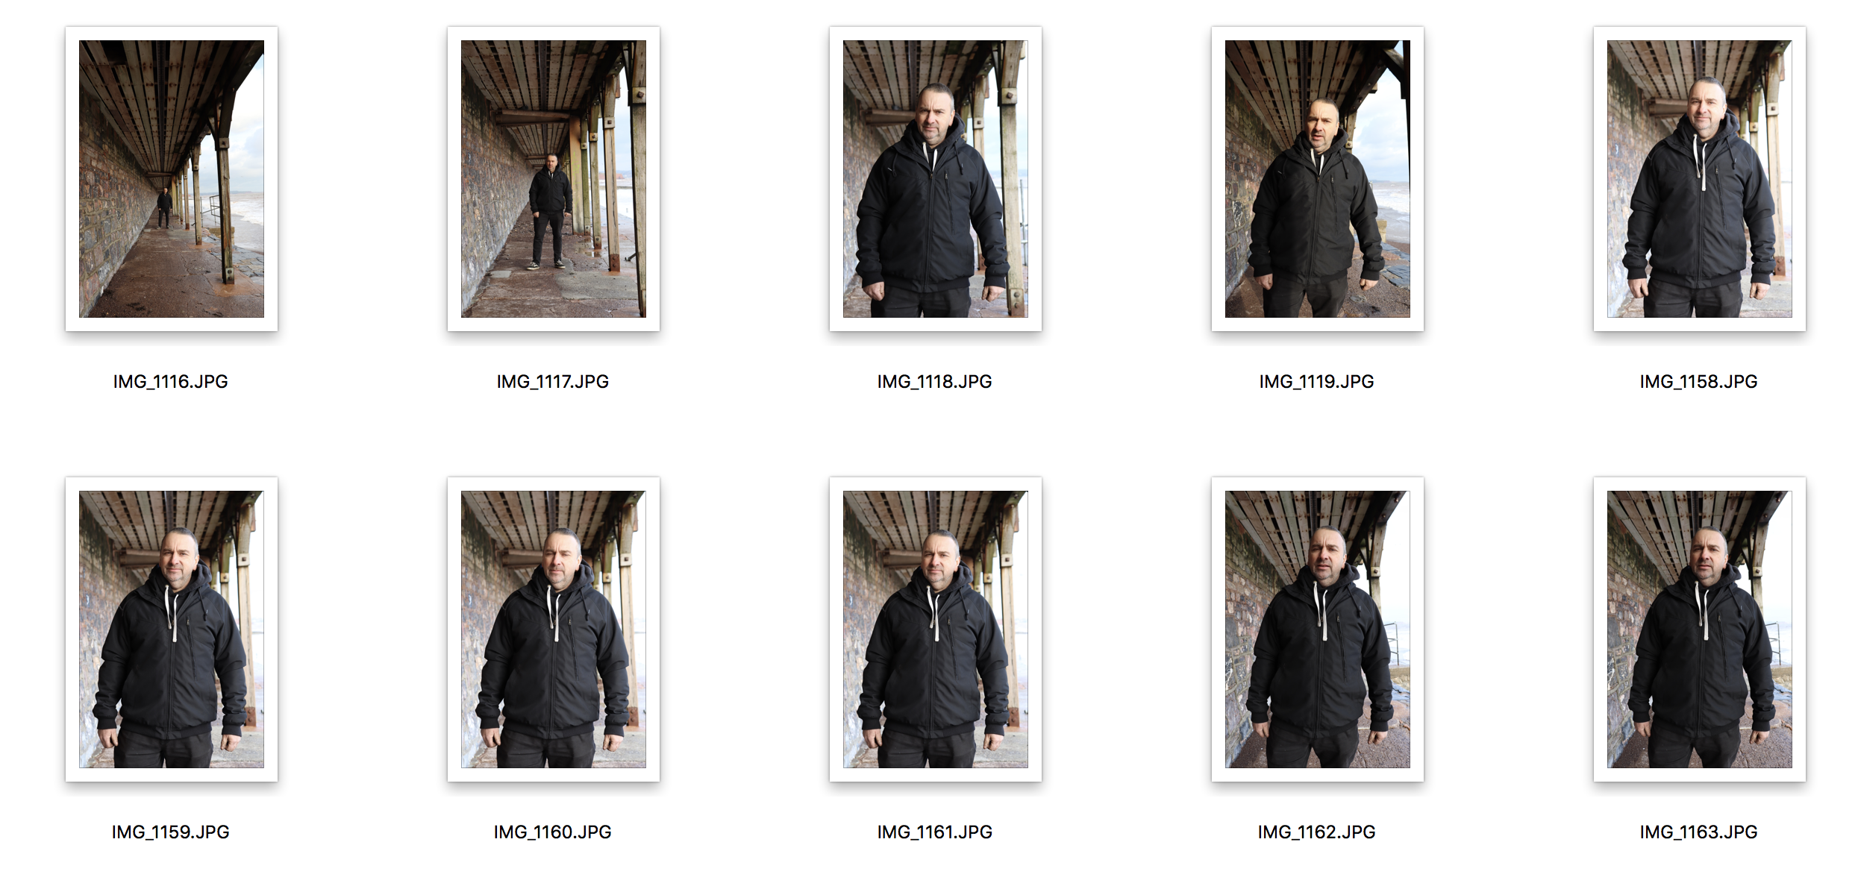
I shot this shoot at the same place as the ‘Zoom’ shoot as I thought it would be a really good location for it. The reason why there are not as many pictures as normal is because I felt I got the right shot for the brief within the shots I did and managed to demonstrate what was asked of me. I have chosen the circled images because I felt these were slightly better over the other ones due to closed eyes, or positioning.

