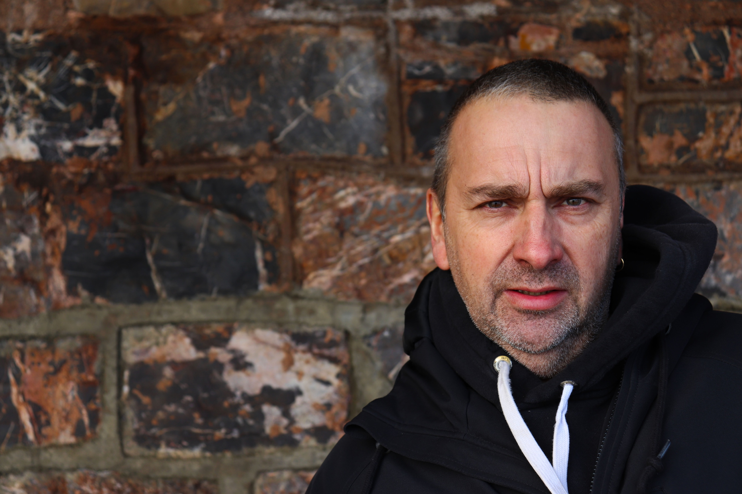
Here is my dad, who I have used as a model again. In this shot, the main focus is his eyes, and I have tried to capture him looking straight down the camera. I have positioned him off to the right and have used the rule of thirds to help with the positioning. Behind him is a stone wall which looks soft and vibrant as it has been blurred out to focus more on him. I have left enough room above his head and below so that his head is firmly in the image. As I am not very far out, the texture on his face is easy to see and the stubble of his beard seems rough. I have positioned his body towards me so that it doesn’t look weird. As if he is looking at me from a strange angle. Plus, I wanted the front of his face, not the side of his head. For this image, I used aperture priority and used my 18-55mm lens. I feel this links to my artist because I have gone for a head on shot, with a bland facial expression to really capture him in a natural position. I feel that he really compels against the background and stands out amongst it and doesn’t blend in because of the colours he is wearing.

