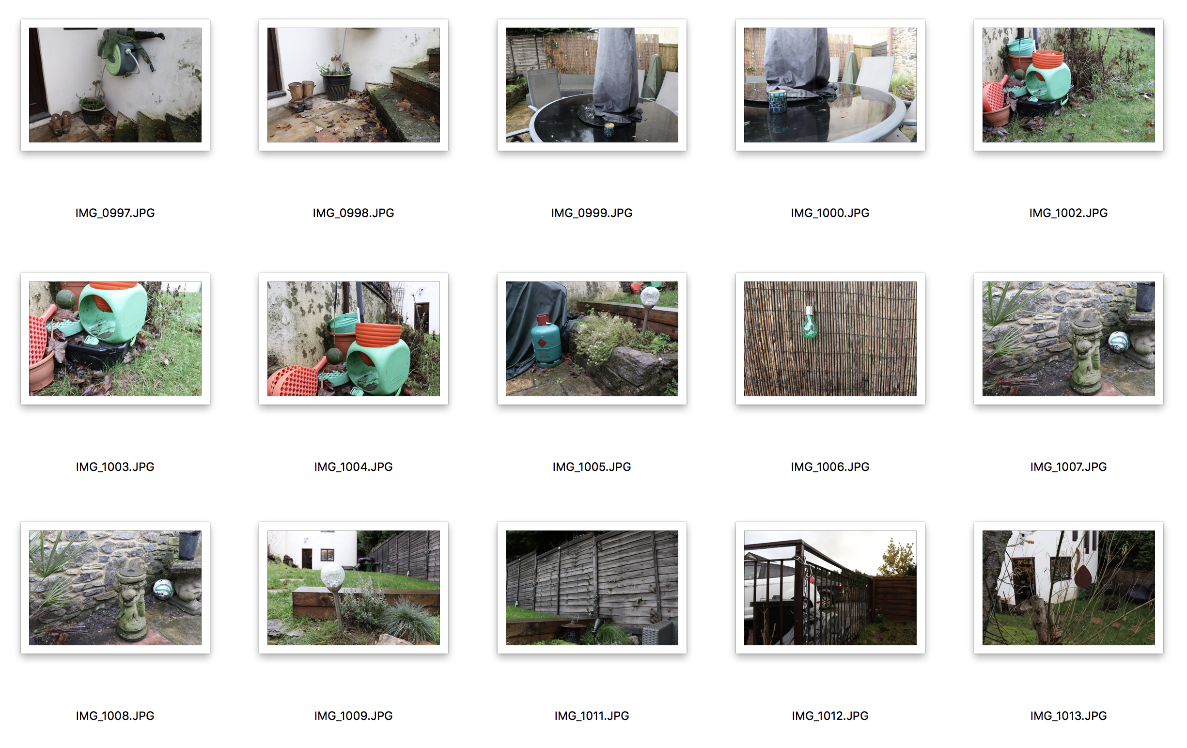

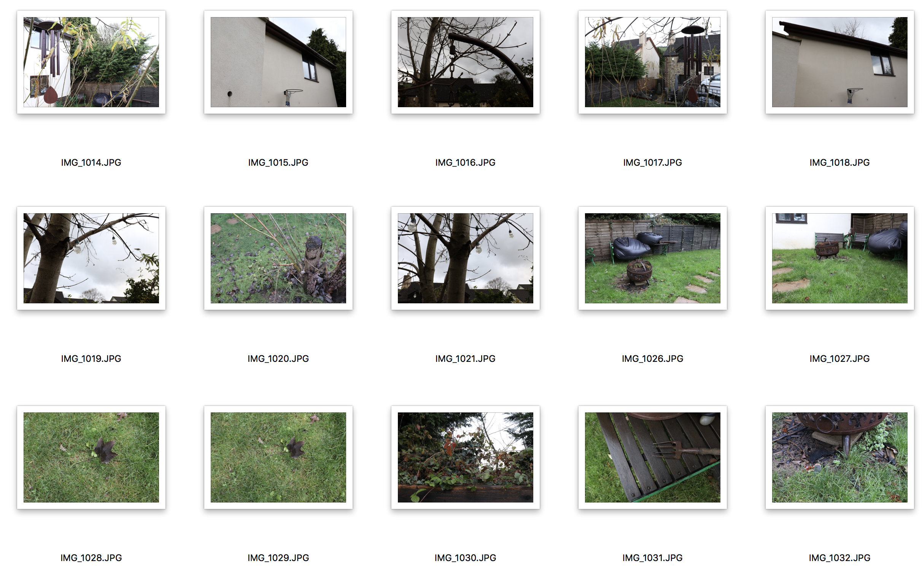

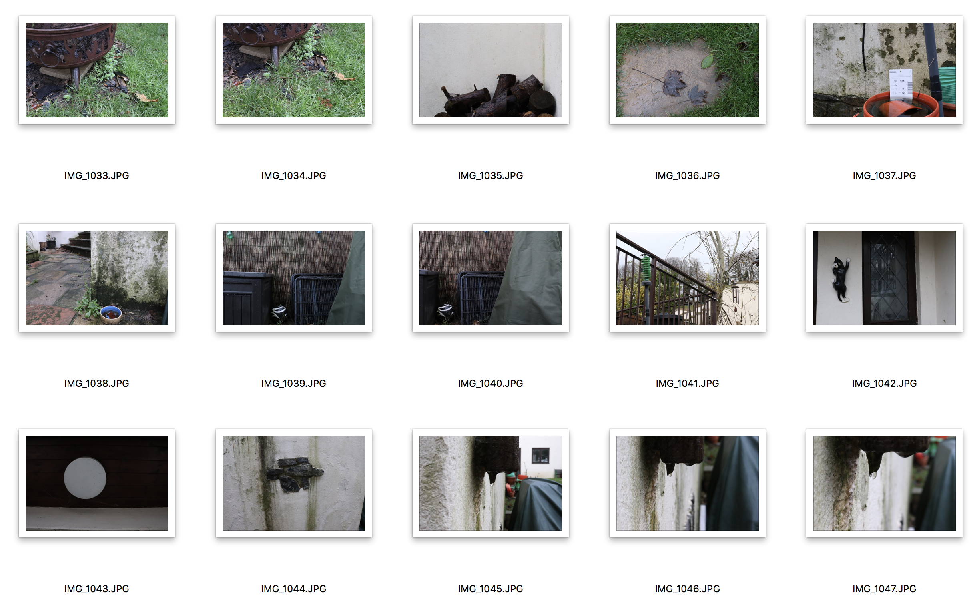

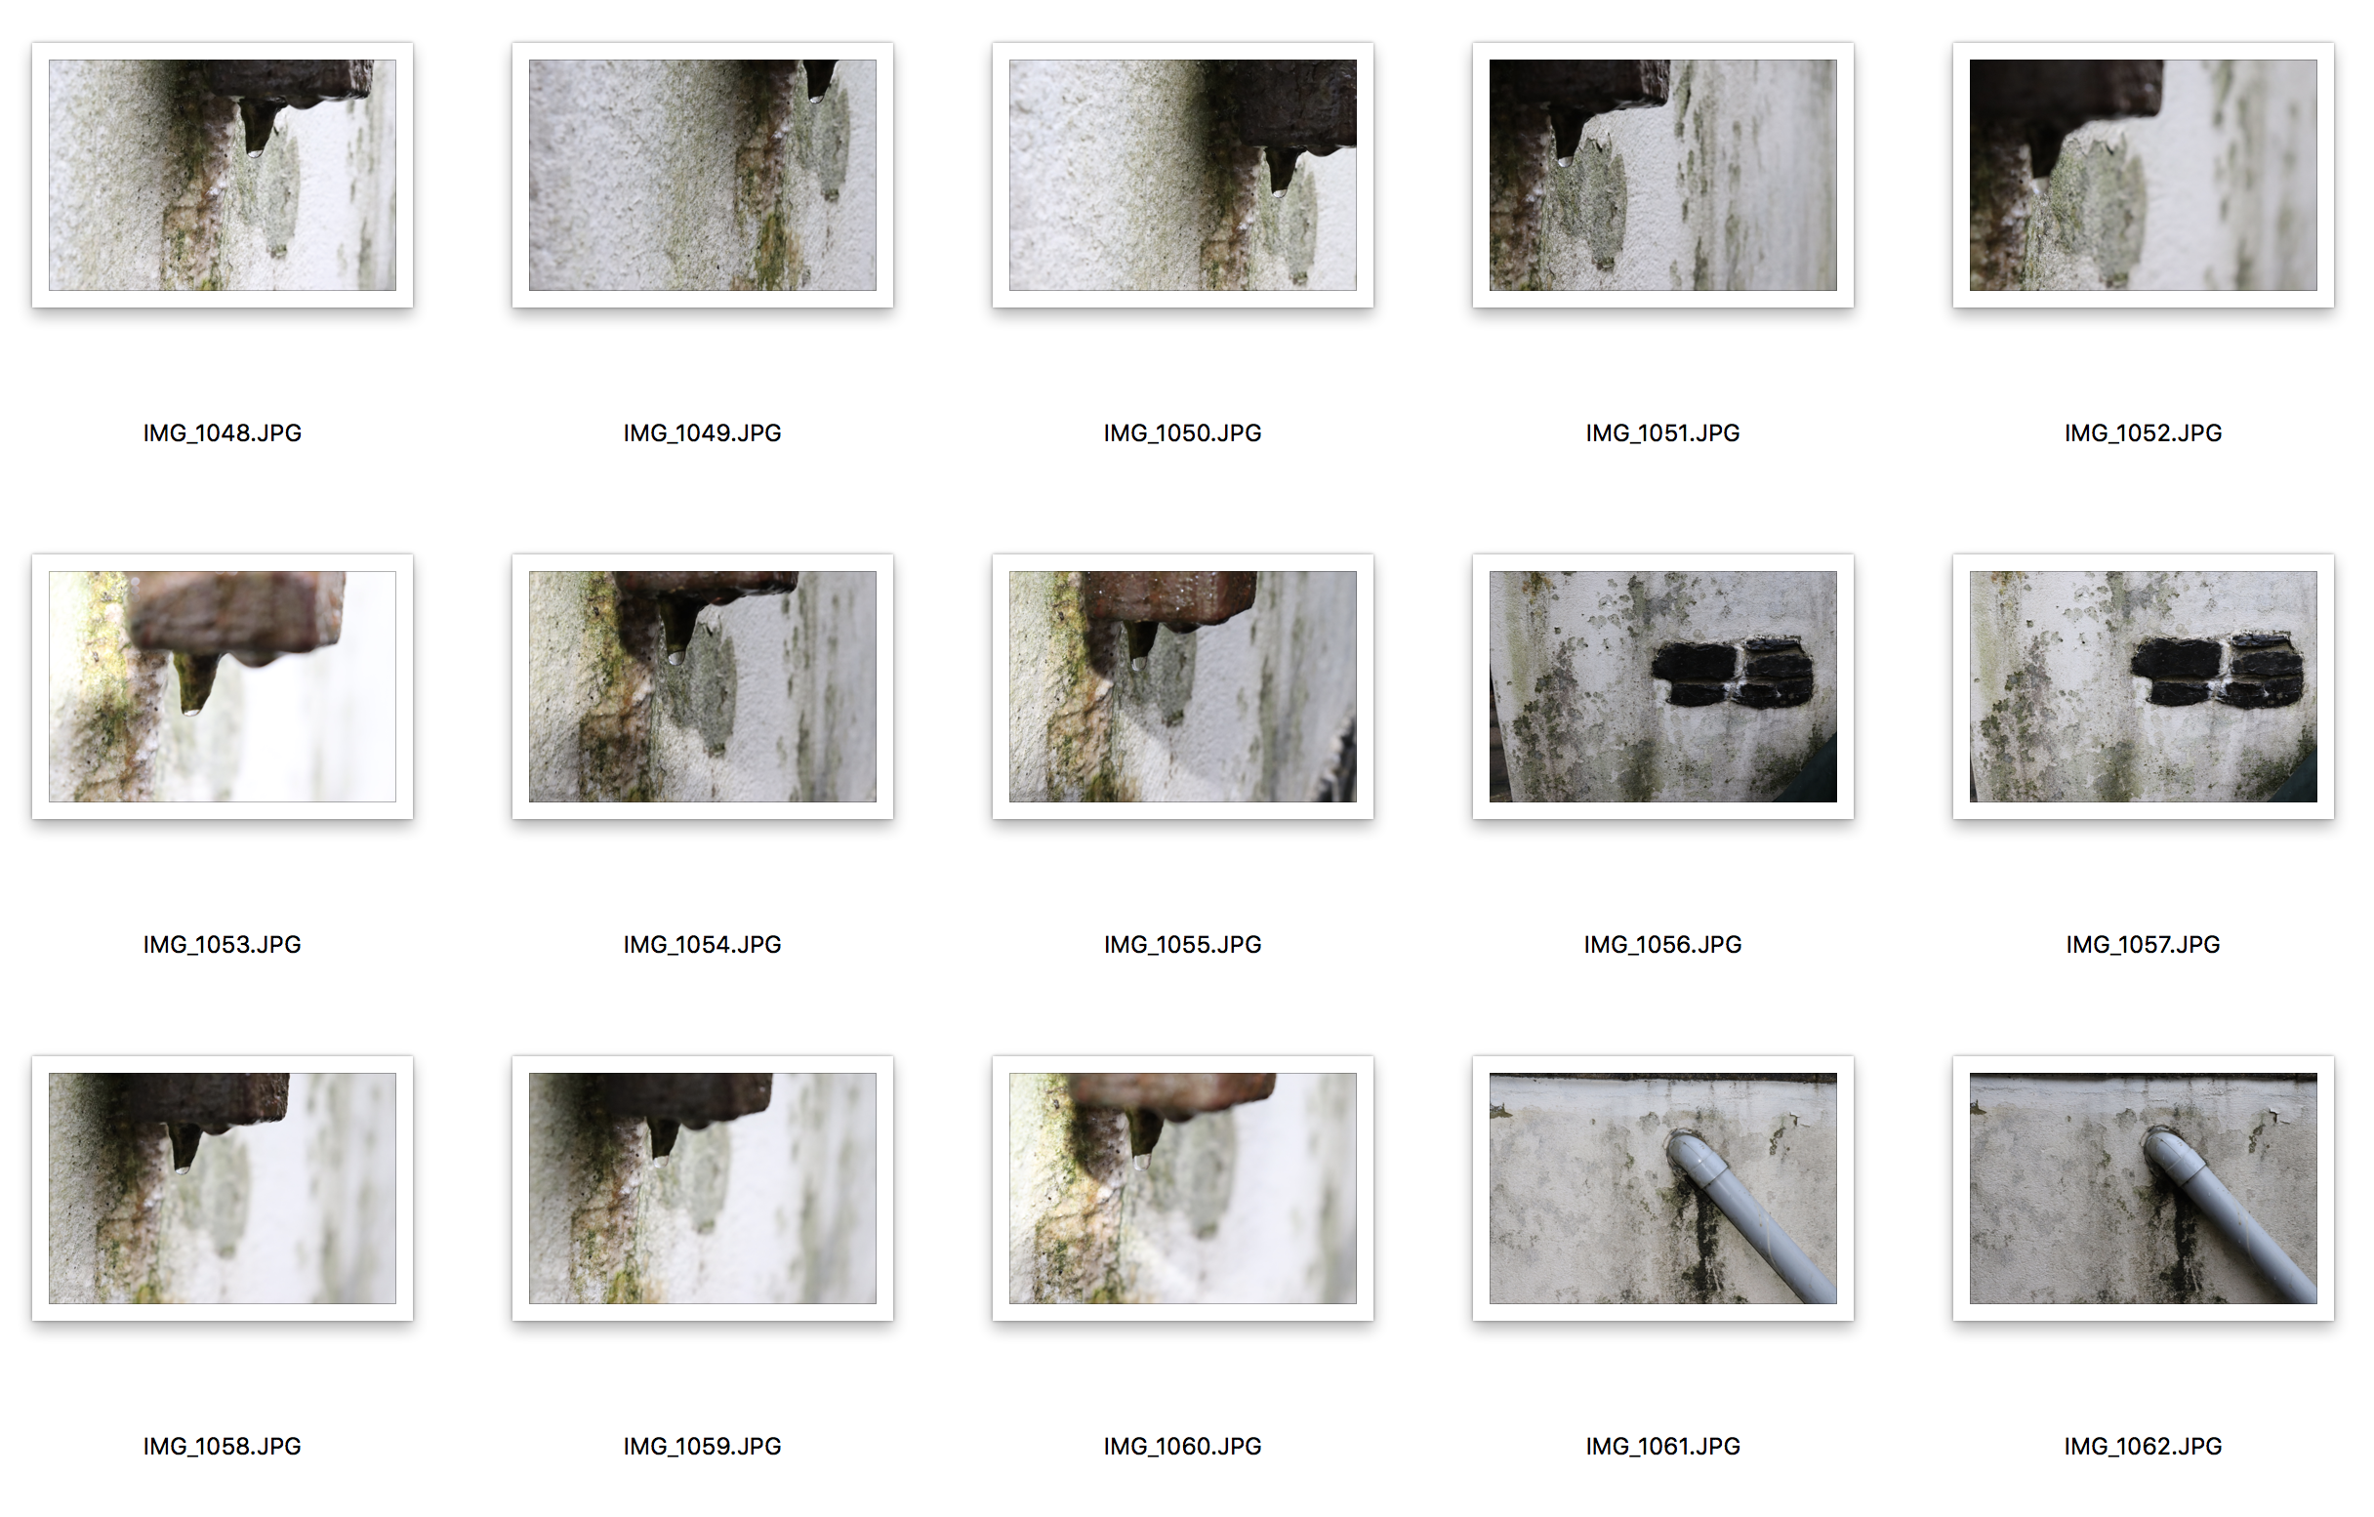

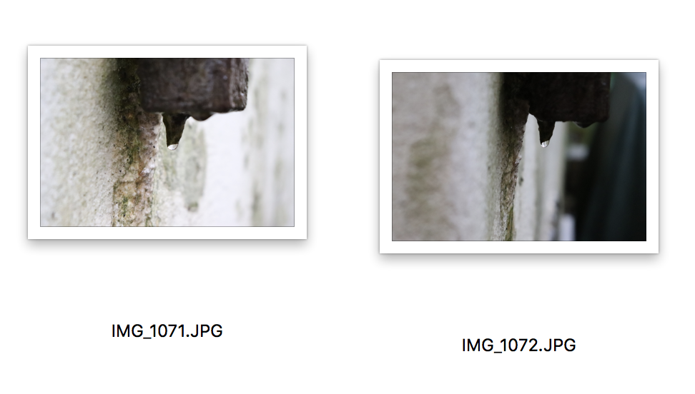
I have taken numerous pictures in my garden as you can see from the contact sheet. I used the viewfinder grid on my camera and placed the subject in different areas of the frame. I have selected the ones with the red circles around them as I feel that they are most compliant to the brief. My reason for this is because they have all used different squares on the gird (some of them used the same square but the majority didn’t) and also it also says in the brief about the photographs working together. I feel these images sit as a set because each of the subjects of the images seem to all be hanging objects, from water to lights. These all have that in common and feel they also work well by themselves as individual pictures as they all contain different texture and surroundings. Also, because of the weather they all have a very grotty and damp feel to them as well which helps group them.

