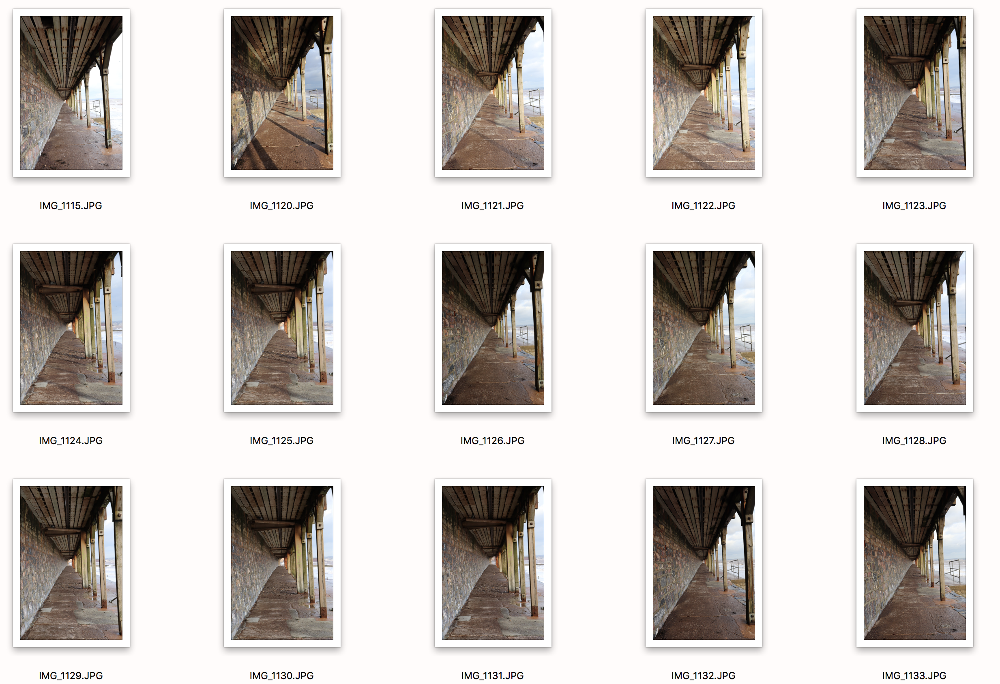

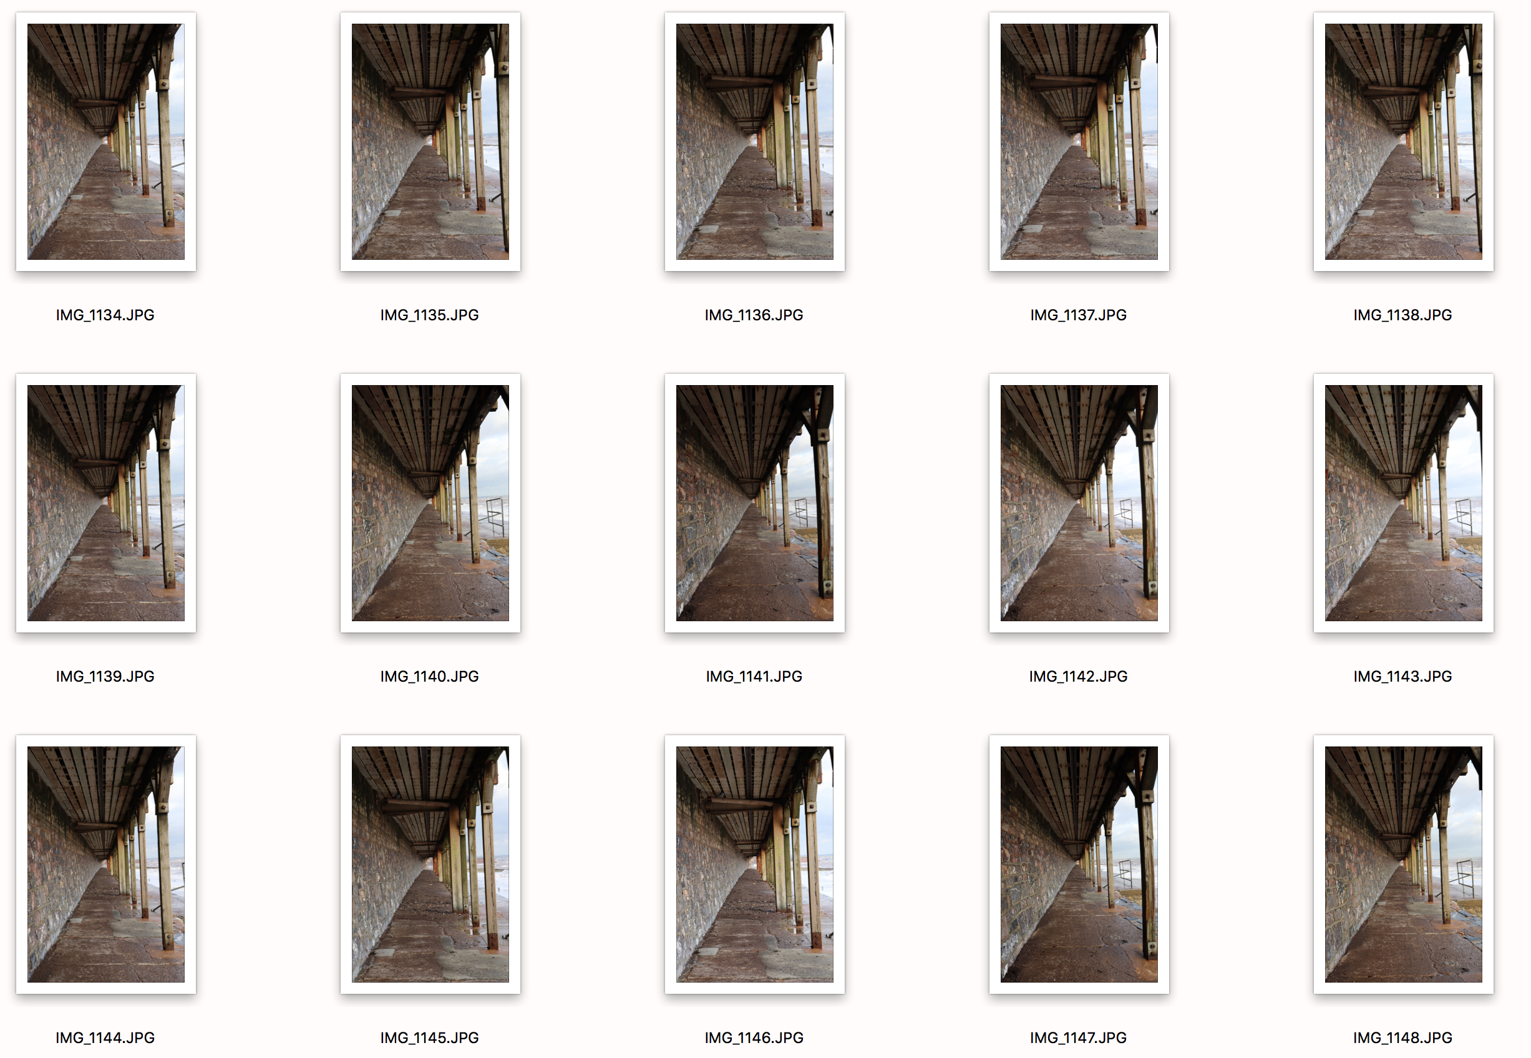

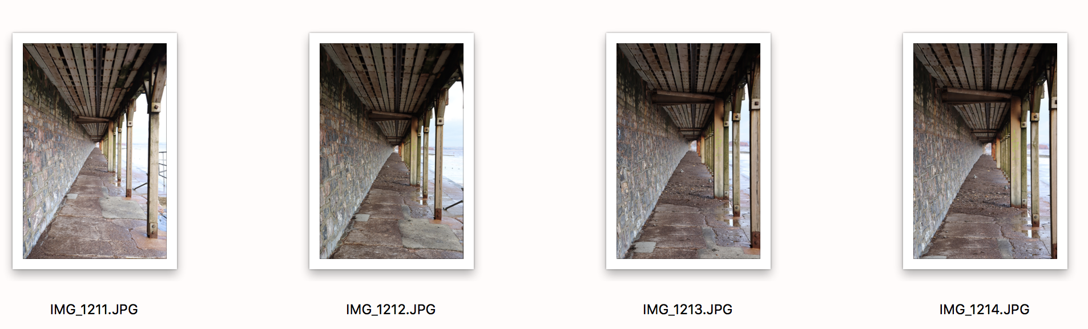
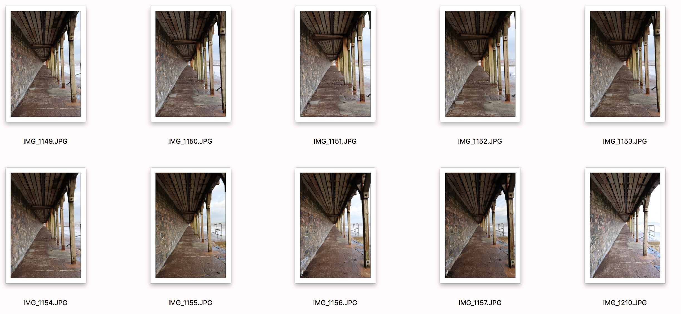

I have chosen the red circled photos because I felt they clearly demonstrated the brief and had good lighting and central positioning, which was what I intended after my research on Alfred Stieglitz. Most of the photos from this exercise look rather similar, so many of them could have been chosen, but for me I thought they were a tiny bit more central and clearly demonstrated the different lengths of zooming.

