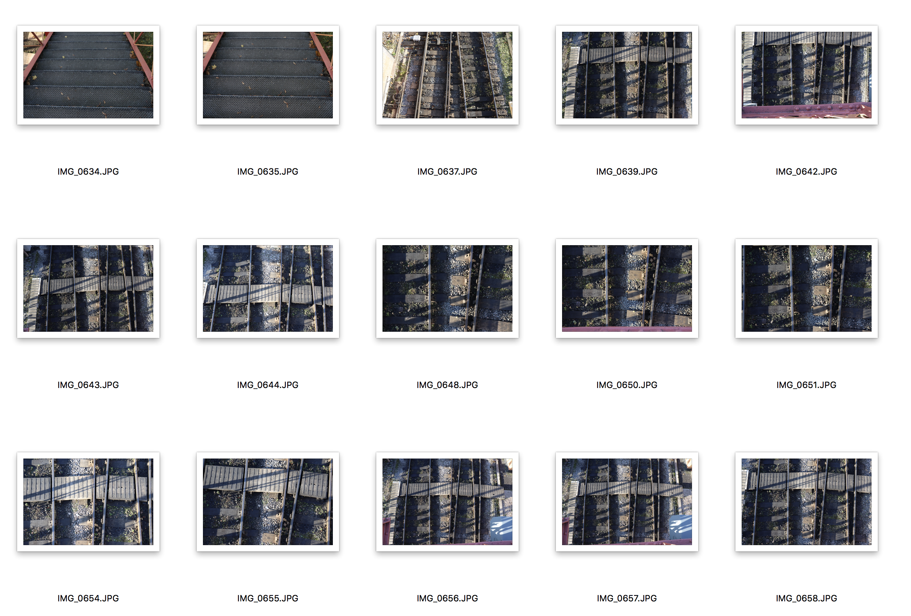
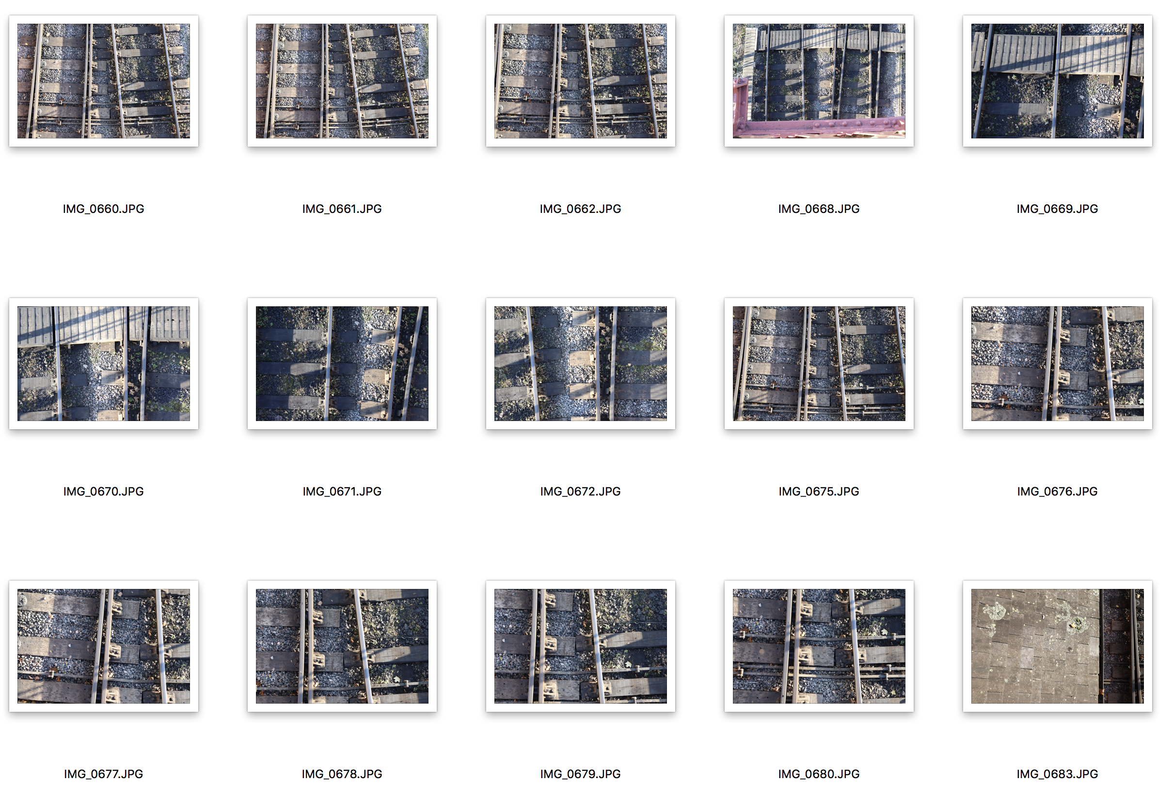
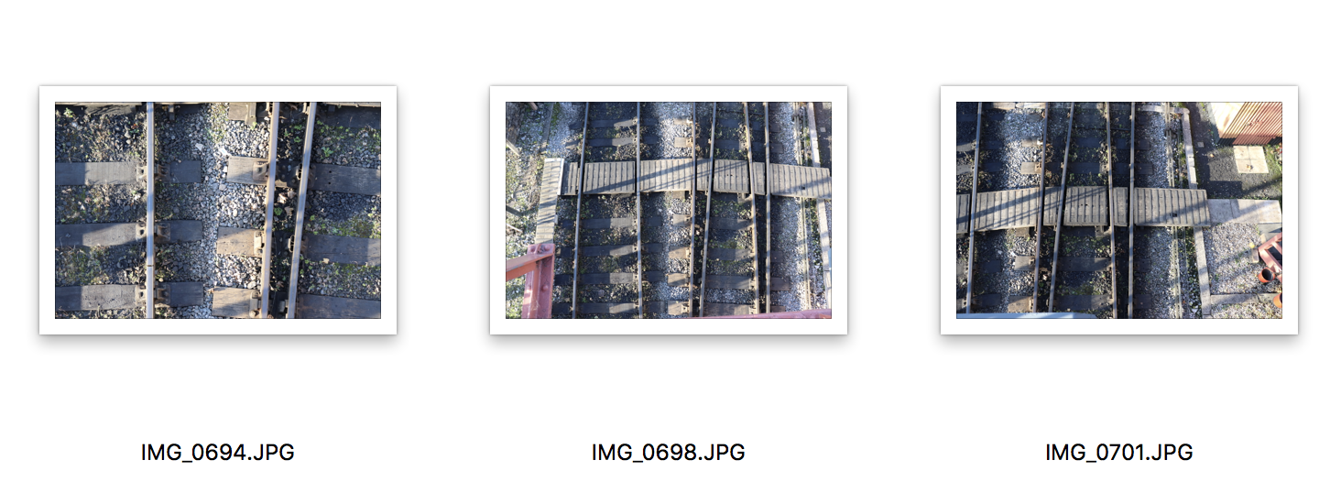
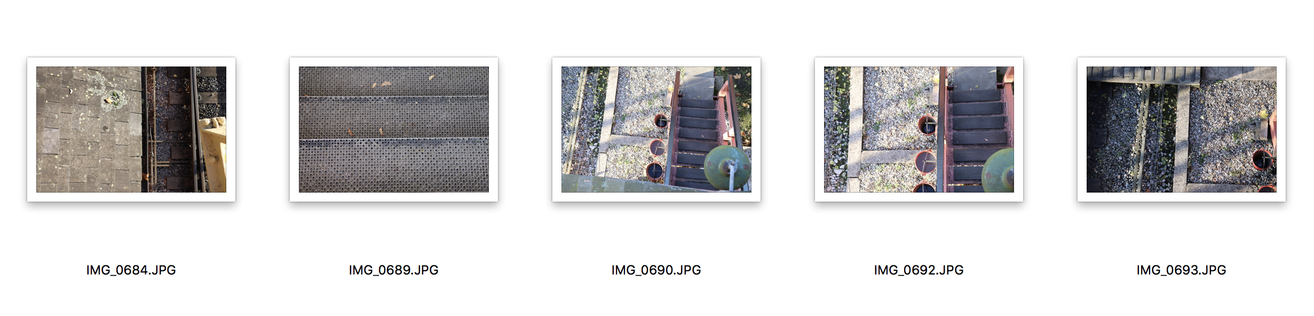
It took me a while to choose the images for this shoot. A lot of the images are similar, because most of them are taken of the same thing, in the same area. I wanted to choose a variety of track, which is why I chose one with the wooden boards in, one with the track bending in and one with the track parting. I tried all sorts of different angles to see what worked best. I tried taking abstract photographs from close in as well, which I feel came out surprisingly well. I chose the track shots over the stair shots and roof shots because they are more effective in terms of the brief. I also liked how the shadow came across the track as well, creating more lines.

