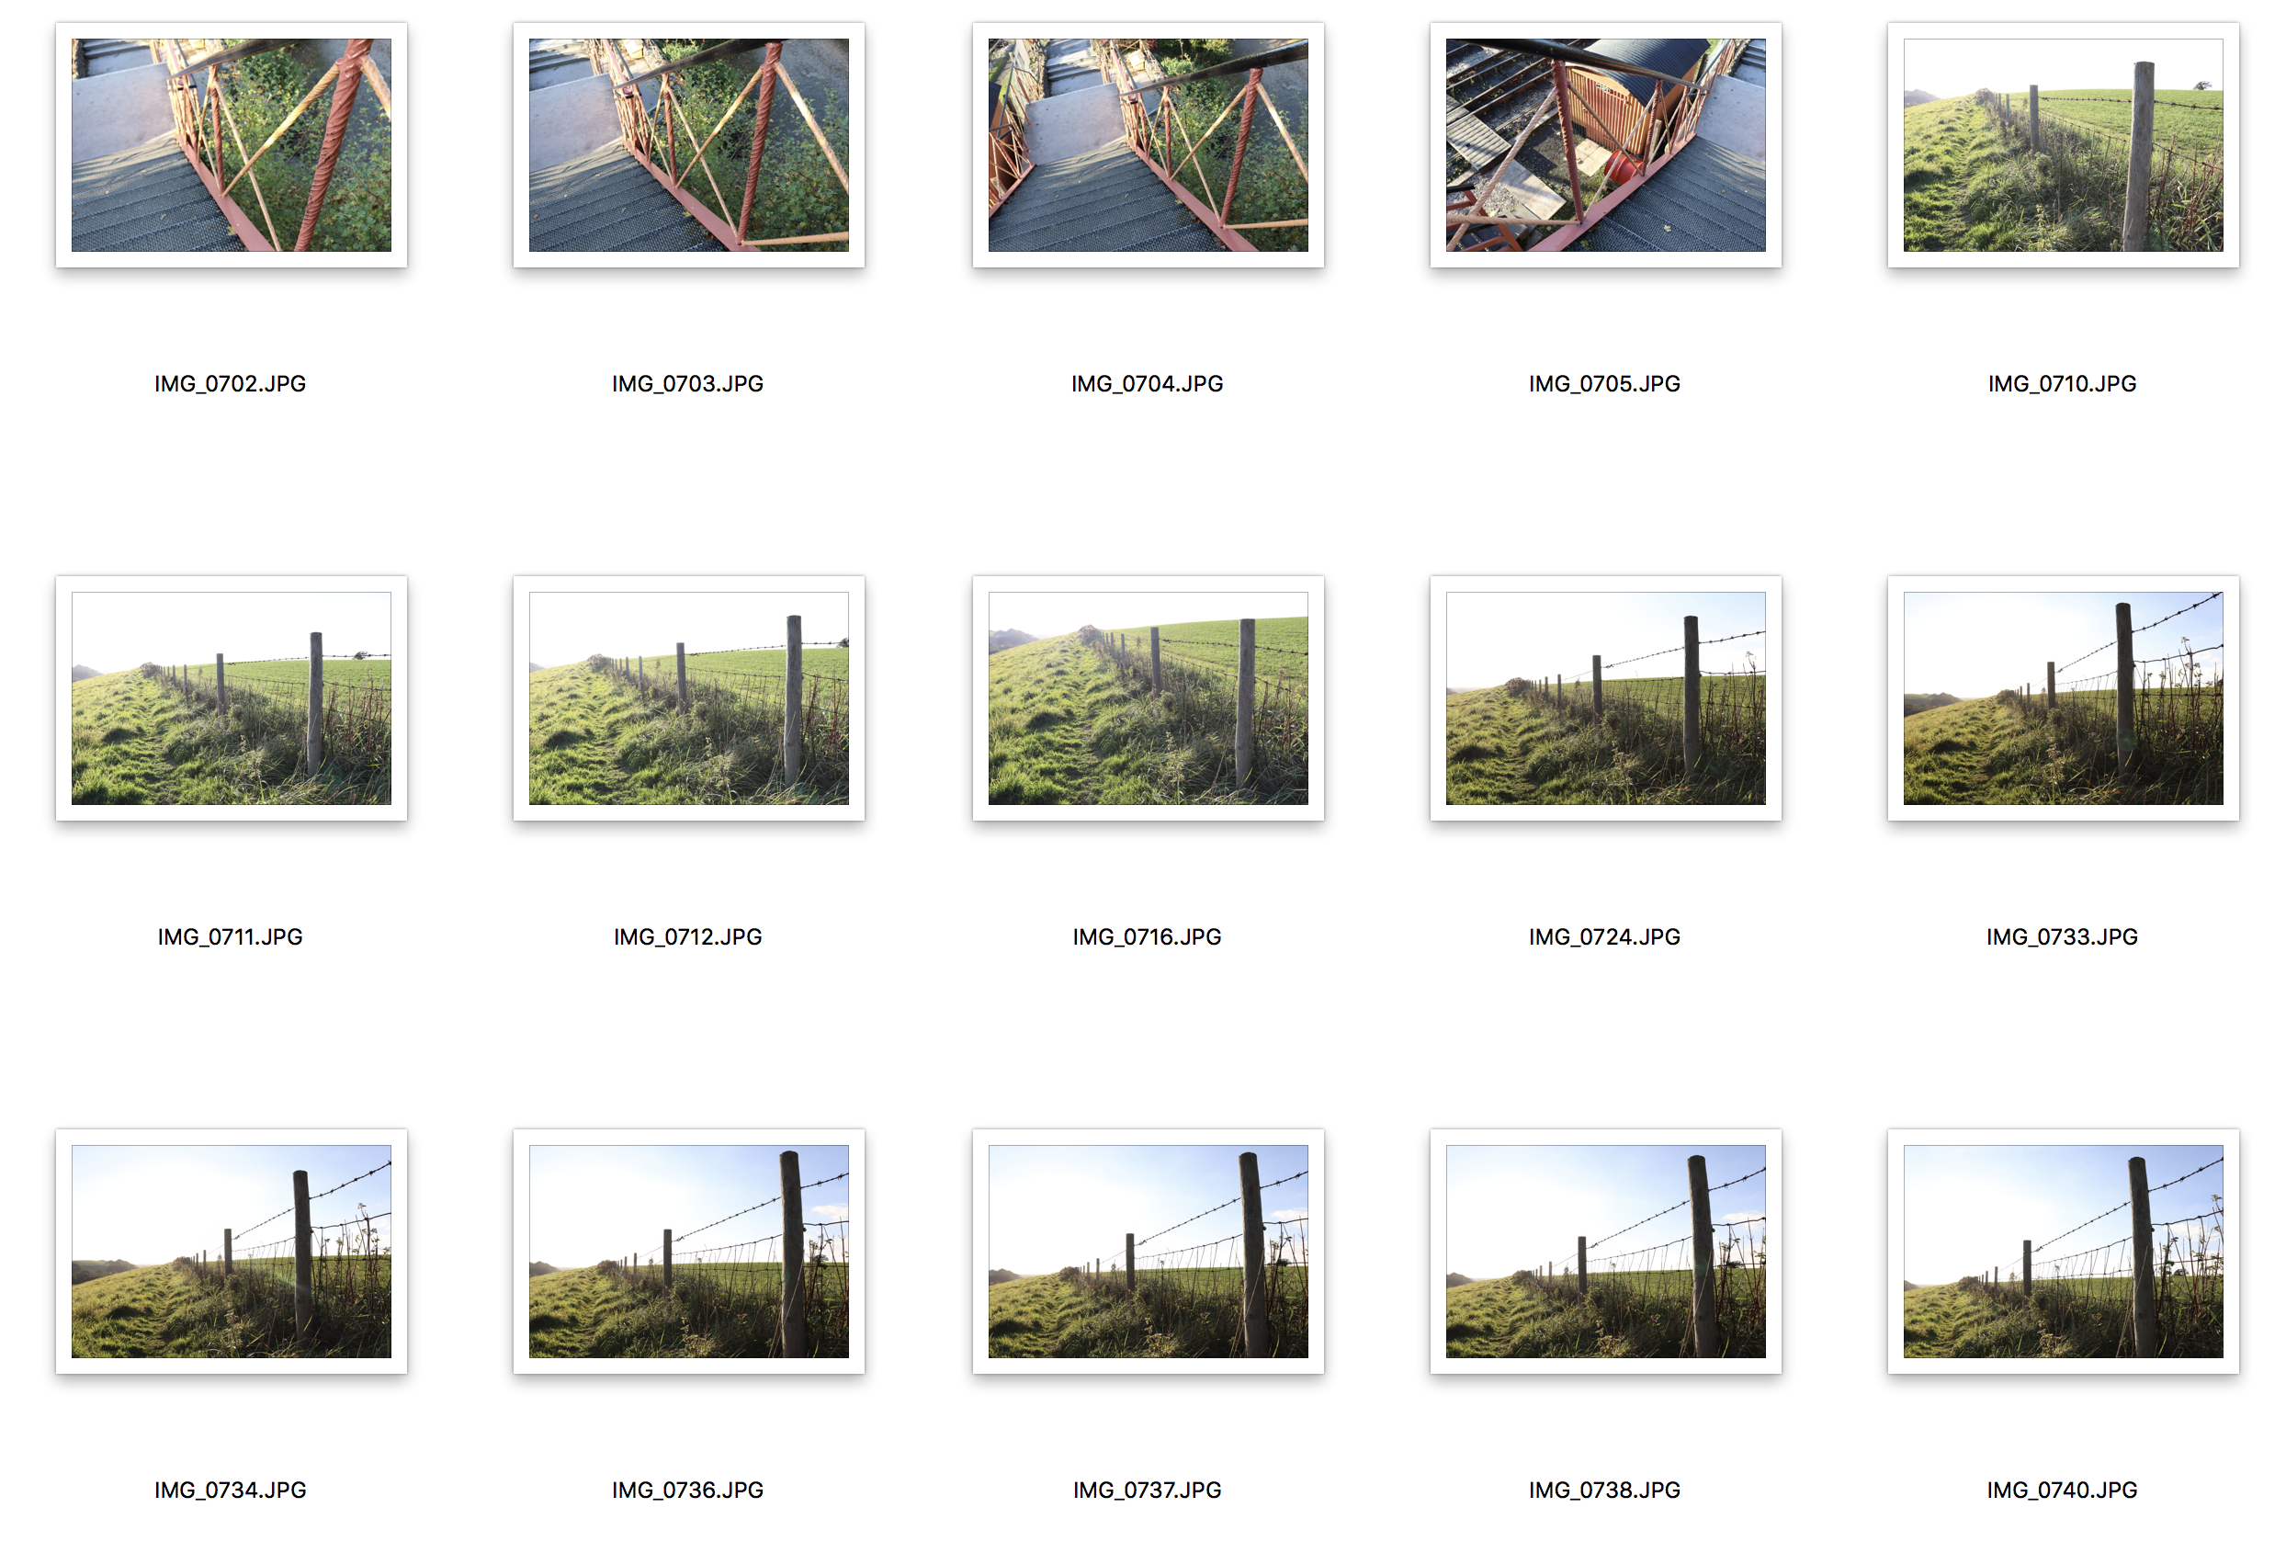
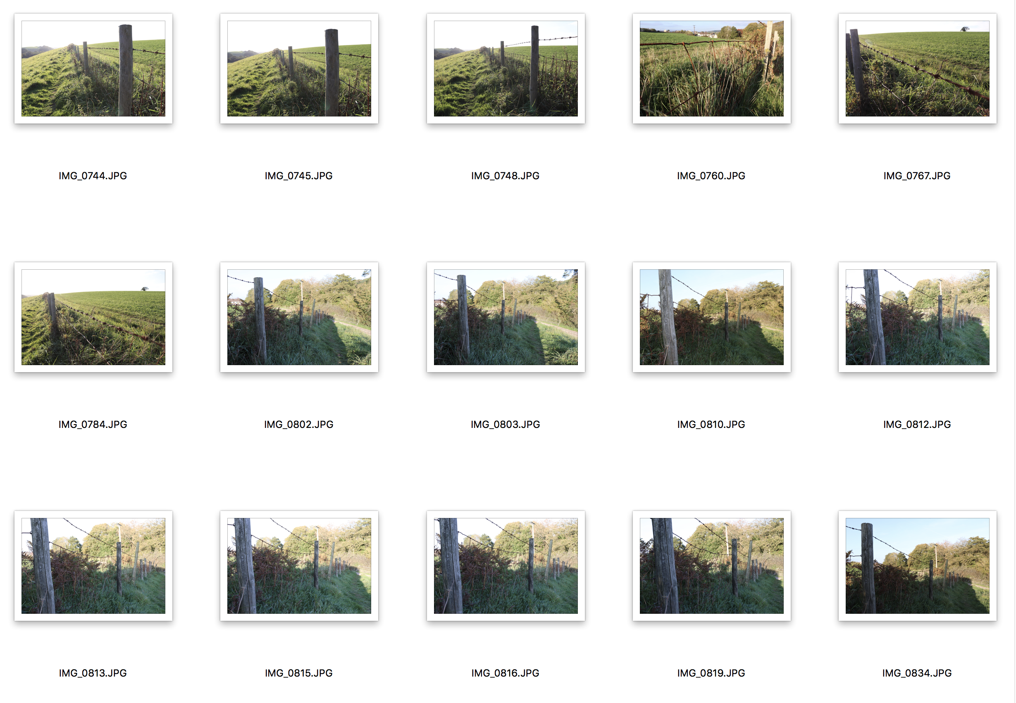
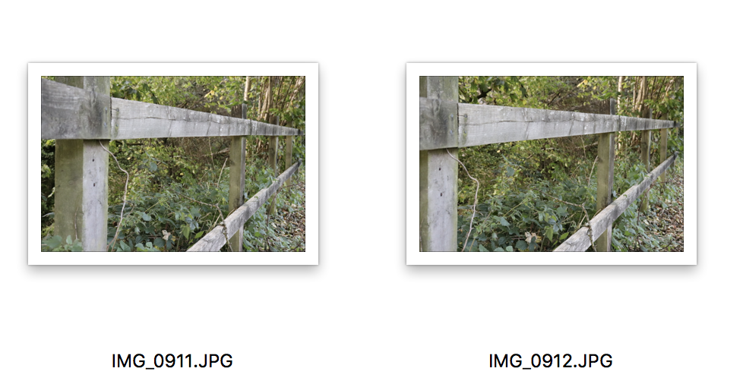
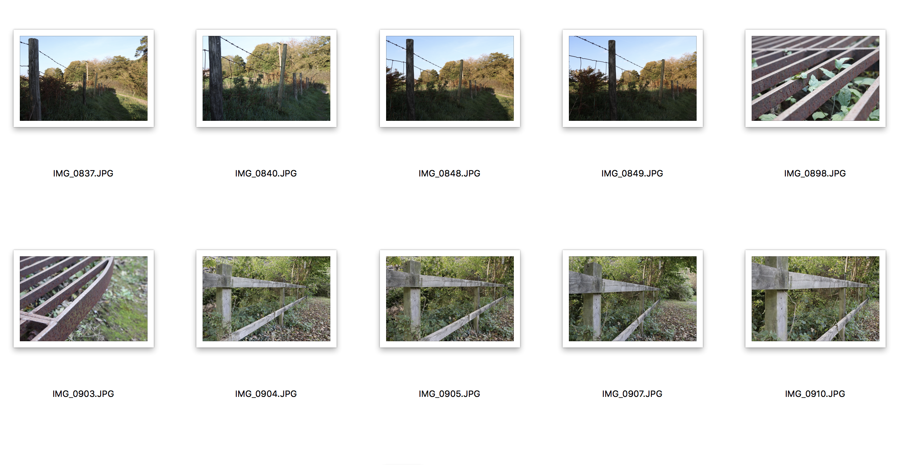

The reason I have selected the four circled images above is because I felt that they used slightly better angles than other images in the contact sheet and also, I feel that some images were either over exposed, or too dark or didn’t quite comply with the brief. In some of the images I tried to use flash and some images I tried to exclude something and include it in another. When debating which ones demonstrated compliance with the brief and also had good colour, framing etc, it helped lead to the decision of choosing these over others.

