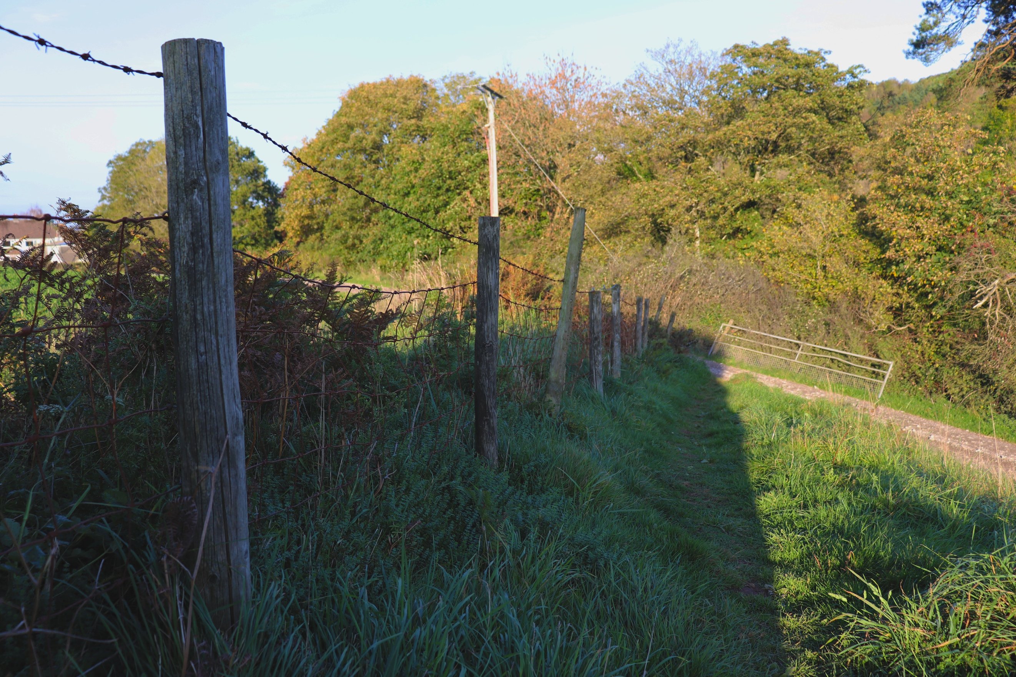
Here I have used a fence in a field to try and emulate Eugene Atget’s work in the brief. I feel that this photo does its job like it is intended to and it does draw your eye to the centre of the image, with no return, other than the point it starts at. The shadow also draws your eye into the picture and the background is just tree’s so you cannot see beyond the fence which gives an unconfutable feel. Also, you cannot see over the fence so much as there is just a field and plants behind it and this makes you think what is over there as you can just about see a building. The reason I have got down low is so that your eye can follow the fence along easier rather than taking a shot from higher up, this gives a better angle to follow with. There is a consistent pattern on the fence from the posts and wiring. I like the angle I have taken this from as I think it is from an angle which works the idea of this brief. If I was to shoot this image again, I would go when the sun wasn’t going down. This would then give me an idea of the shadow’s role within the photo and how affective the shadow is.

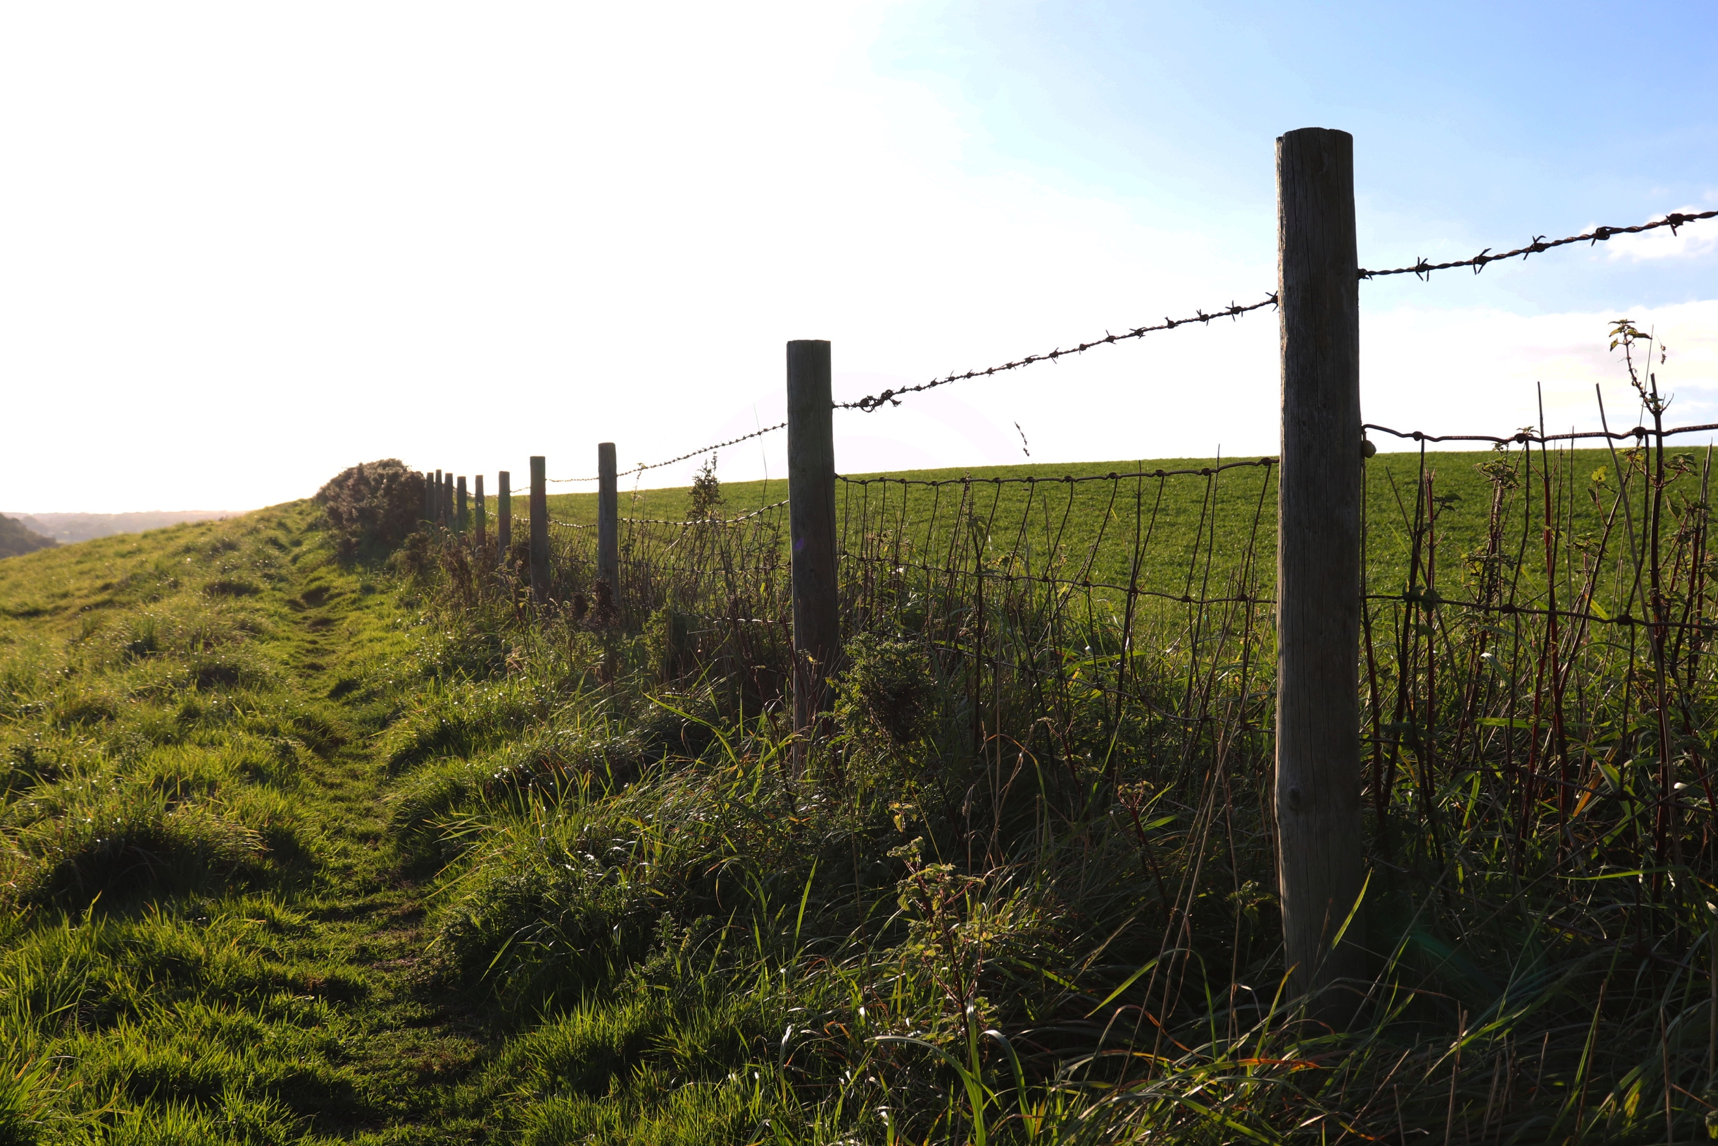
In this photograph, I have taken it further up the field from the opposite direction. As the sun was coming down it gave the image a warm glow as if it was summer, although it was cold. I dislike how the sun has made the top left of the picture so bright it is white. The fence in this photo leads your eye so far down that it goes into the bushes and it cannot go any further. I like how simple this image is with the colours and how the field divides the photo up from the ground to the skyline and how it meets with the bush if you follow the field from the right to the left. This makes the bush the main point as all lines lead to it which is unusual. If I was to shoot this shot again I would go when the sun was up higher in the sky, so it wouldn’t have such glare.
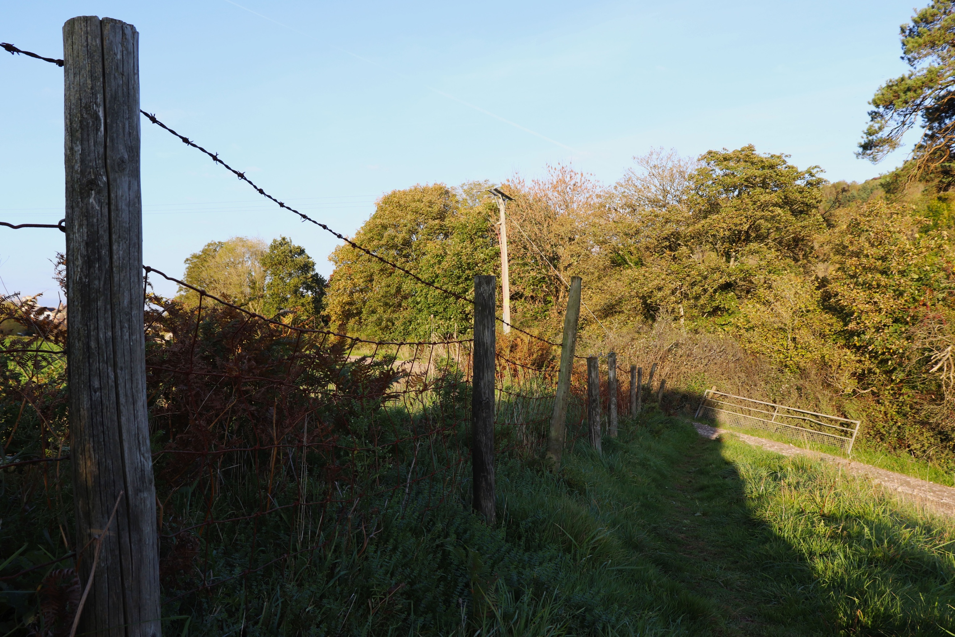
Being very similar to the first picture, you’re probably wondering why I put this one in. This is at a slightly different angle, closer up to the wooden pole which makes your eye start further over to the left. From this angle it is easier to see the texture of the wood and lines on the pole itself. You can also notice the wire further down the image too. The one thing I don’t like so much about this picture is how there is more sky in it because I have taken it looking slightly higher than the previous one. I have also realised that the bottom of the pole is cut off as well.
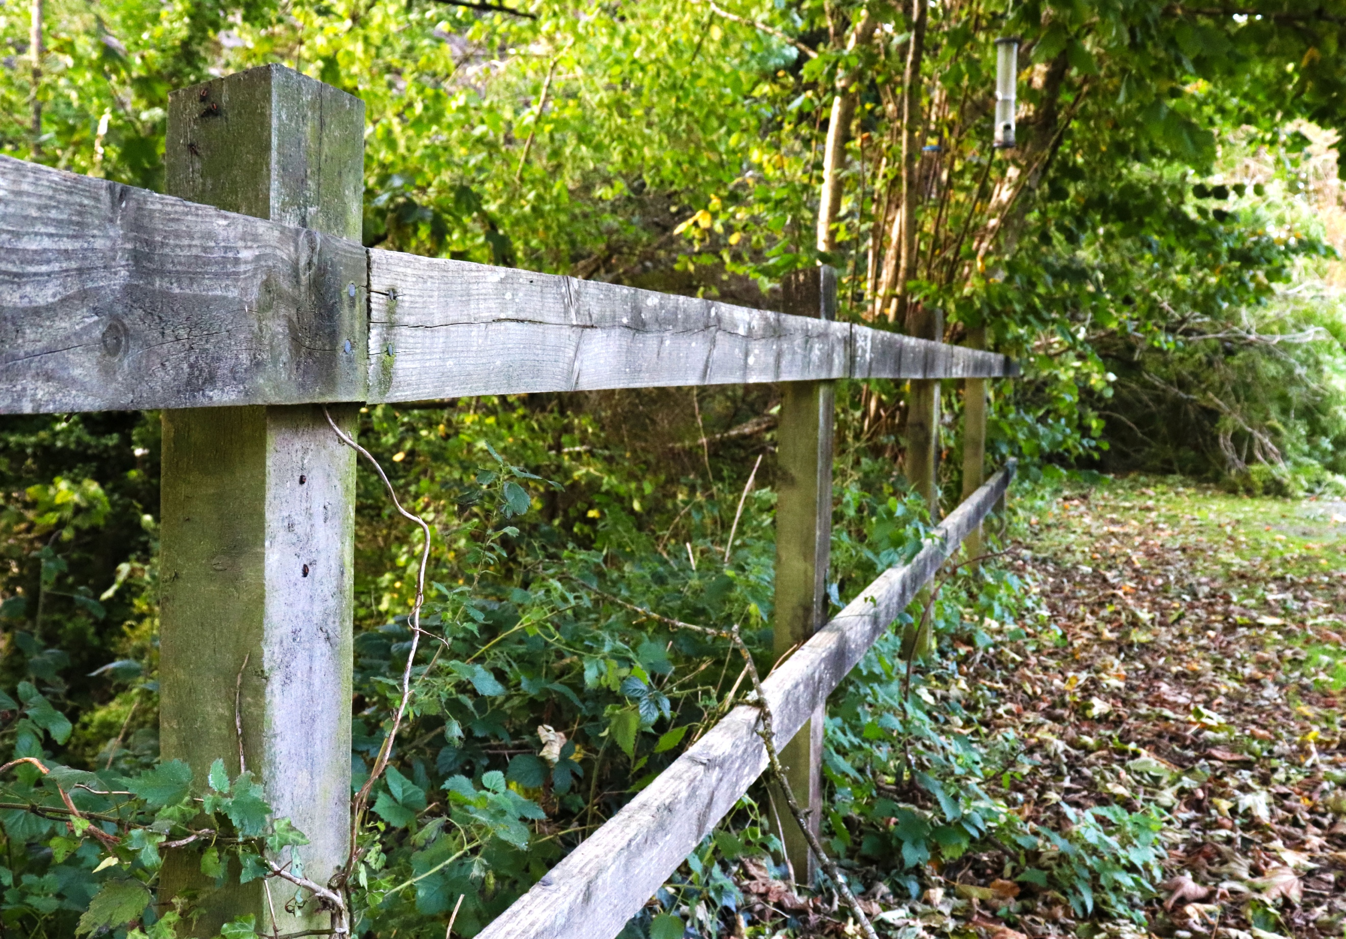
For my final annotation I have chosen a fence which I took a few photos of in a different location. This location seemed to be very overgrown as you can see from the twigs and leaves wrapping themselves around the fence. The fence seems to be discoloured and the further down the fence you look the darker the fence is. This makes it really stand out amongst the colours of the background as the colours in the background are bright and the fence is the opposite. I have positioned myself like the other photographs, close to the fence. The fence gives the impression that it is holding all the overgrown plantation back because as you can see through the fence it is all overgrown and on the other side, the side I am on its not. The fence has two lines, one higher and one lower and they both lead your eye into the image until you cannot see any further due to the overgrown tree which hides the rest of the fence.

