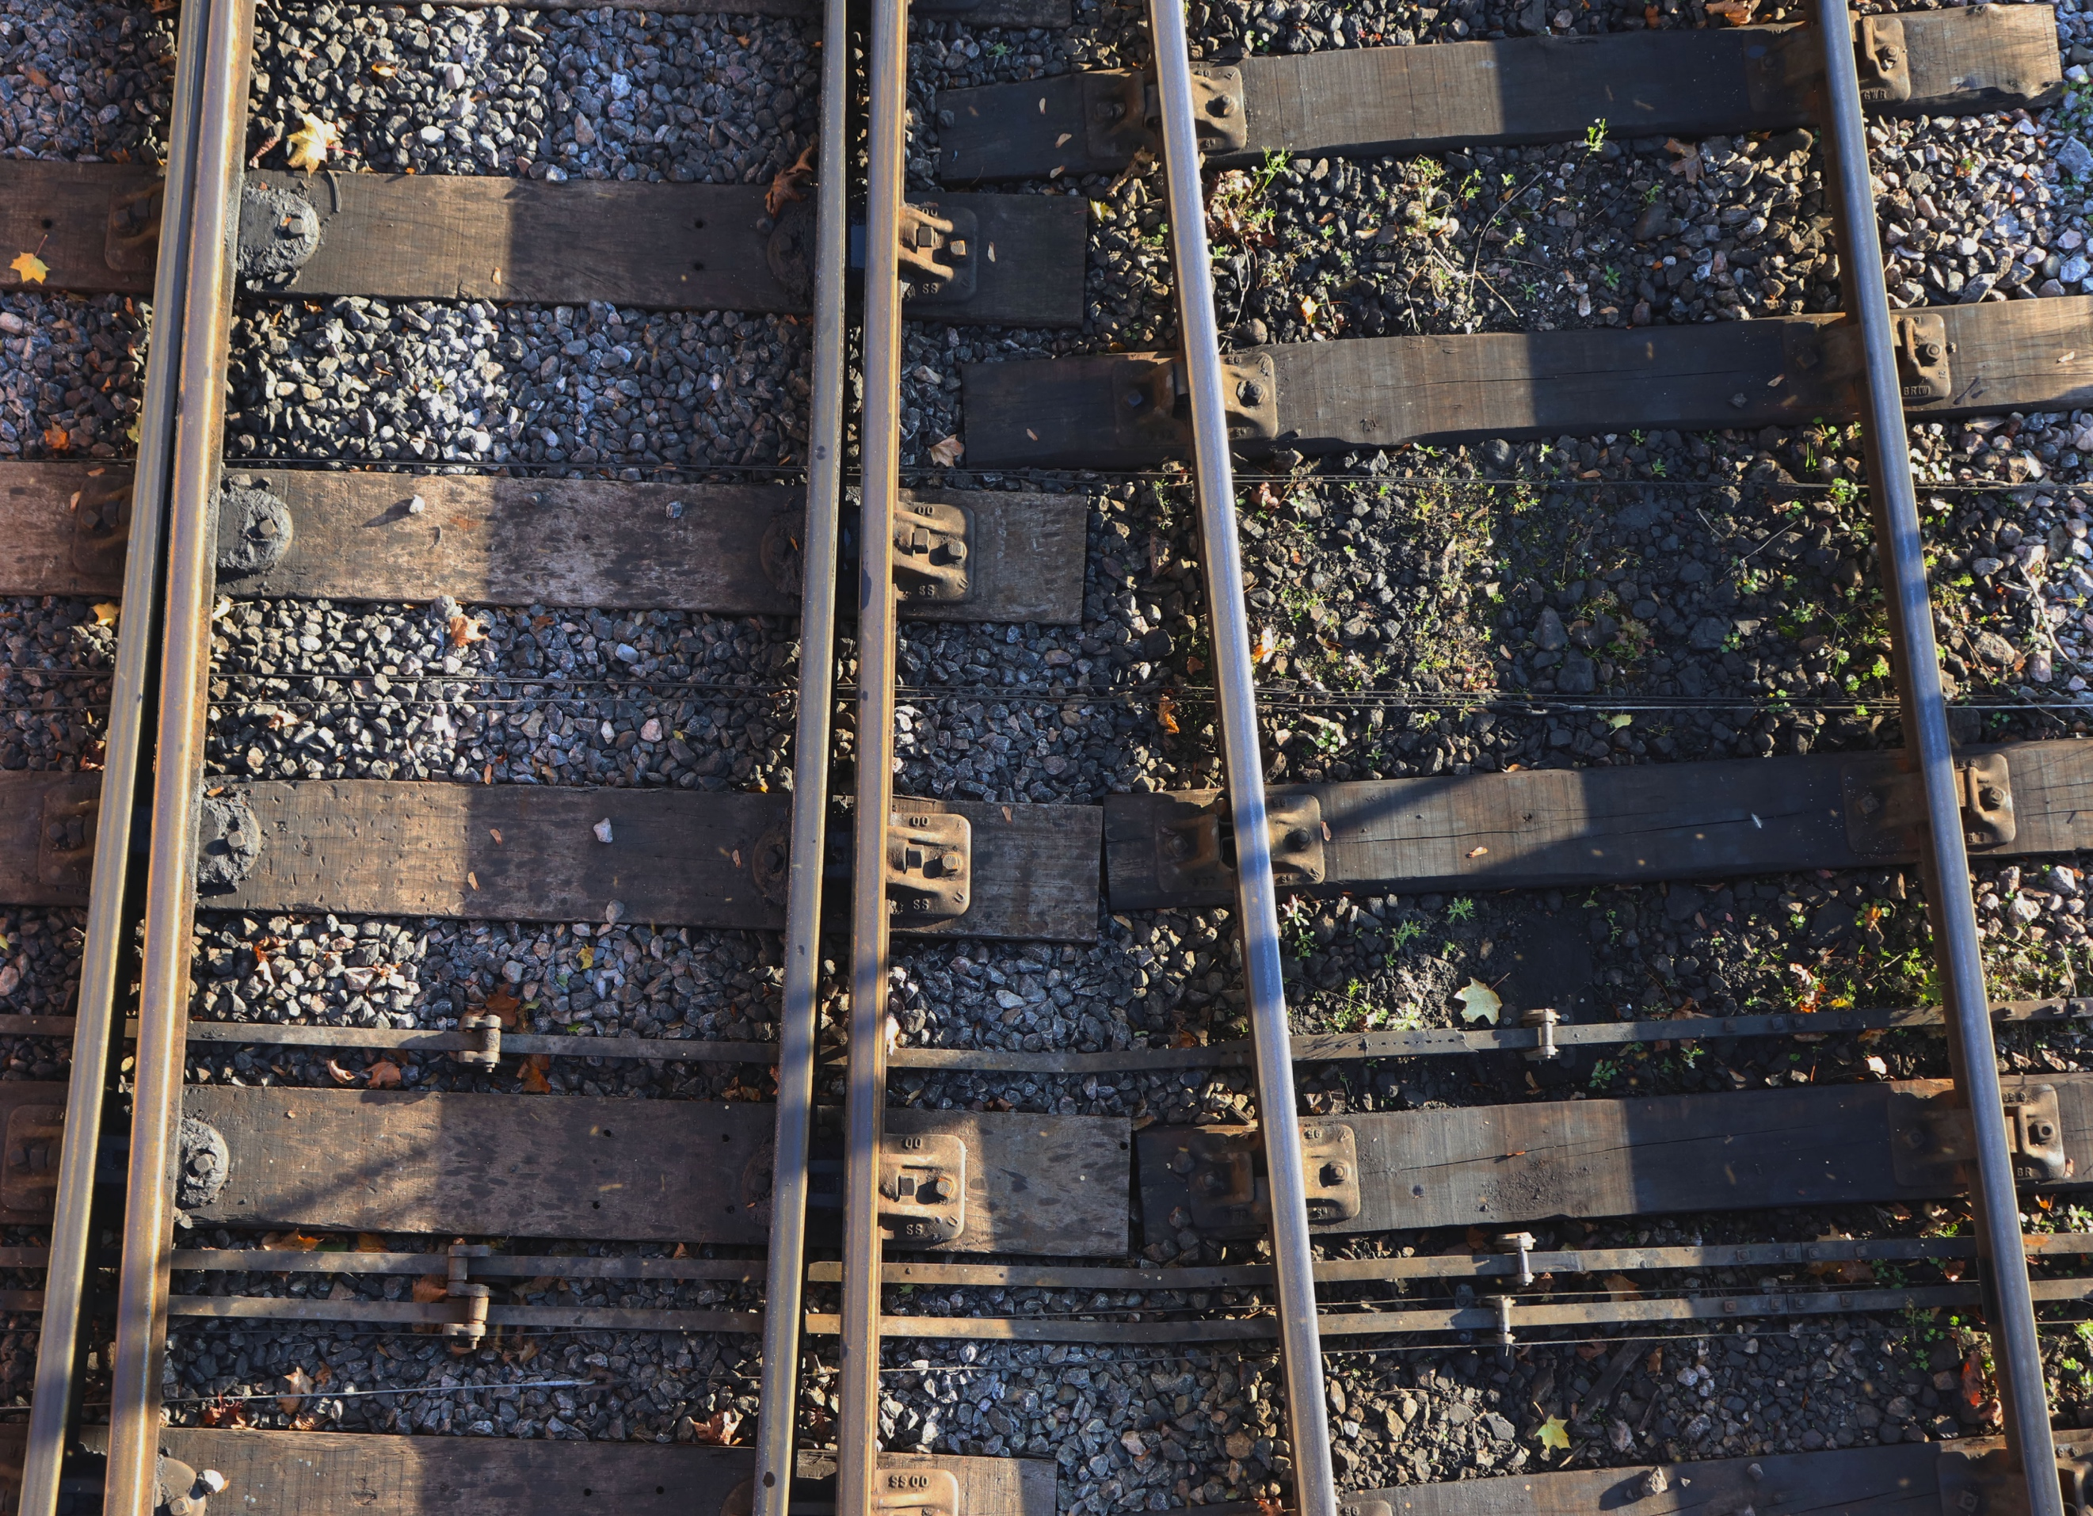
As you can see for this shoot I have taken it of the train tracks at the train station. I decided to do the tracks because I felt that there was pattern, symmetry and lines, the main focus for this exercise. The colour is very dark and bland because of the grey stones and bronze of the tracks, this gives it a very bold feel to the image. I have taken this angle from above as directed in the brief and as I am trying to emulate Moholy-Nagy’s work. I have tried to make everything seem flat. There are many patterns in this image from the planks of wood, to the rails themselves and the metal clamps. The sun was going down when I took this, which casted a shadow over the tracks giving it a variety of colour, as some parts of the track were lighter than other parts of the track. What I like about this picture is how the tracks run straight through the photo and how the planks are positioned. This could be improved by getting more of one track in than the other, making one track the central point of the frame.
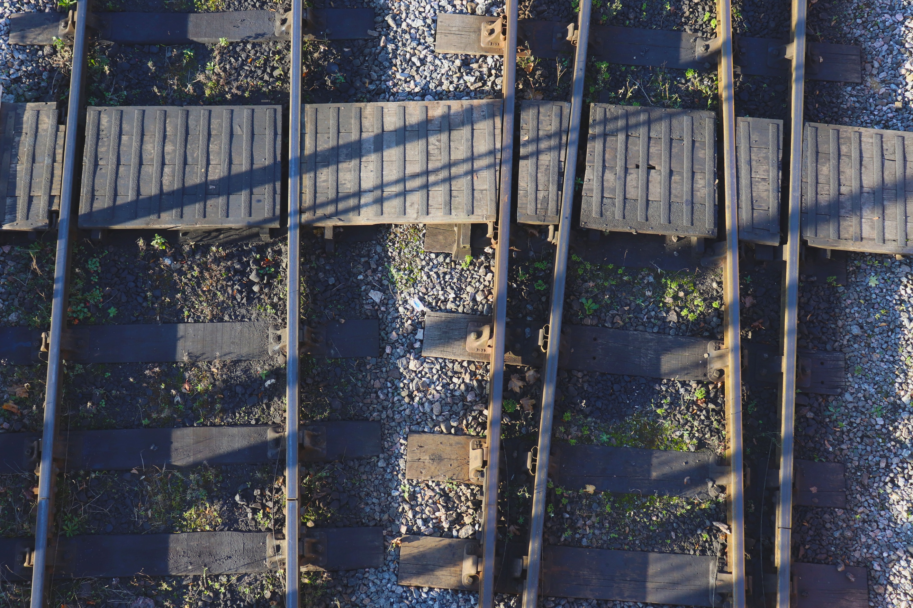
I have taken this one the other side of the bridge looking down on another section of the track, different from the first one. In this, you can see a plank of wood going across the top and this helps the image contain pattern. I like the way that the plank of wood going across the top has lines going one way and then the track below the lines are going the opposite way. Like the first annotation, this one still has all the other patterns in it. The shadow can be seen here to, like the first annotation and the same angle has been used. You can see that in this image the tracks seem to be getting further away from each other the further up you look, almost as if they’re parting to different destinations. This gives the viewer a sense of mystery as to where.
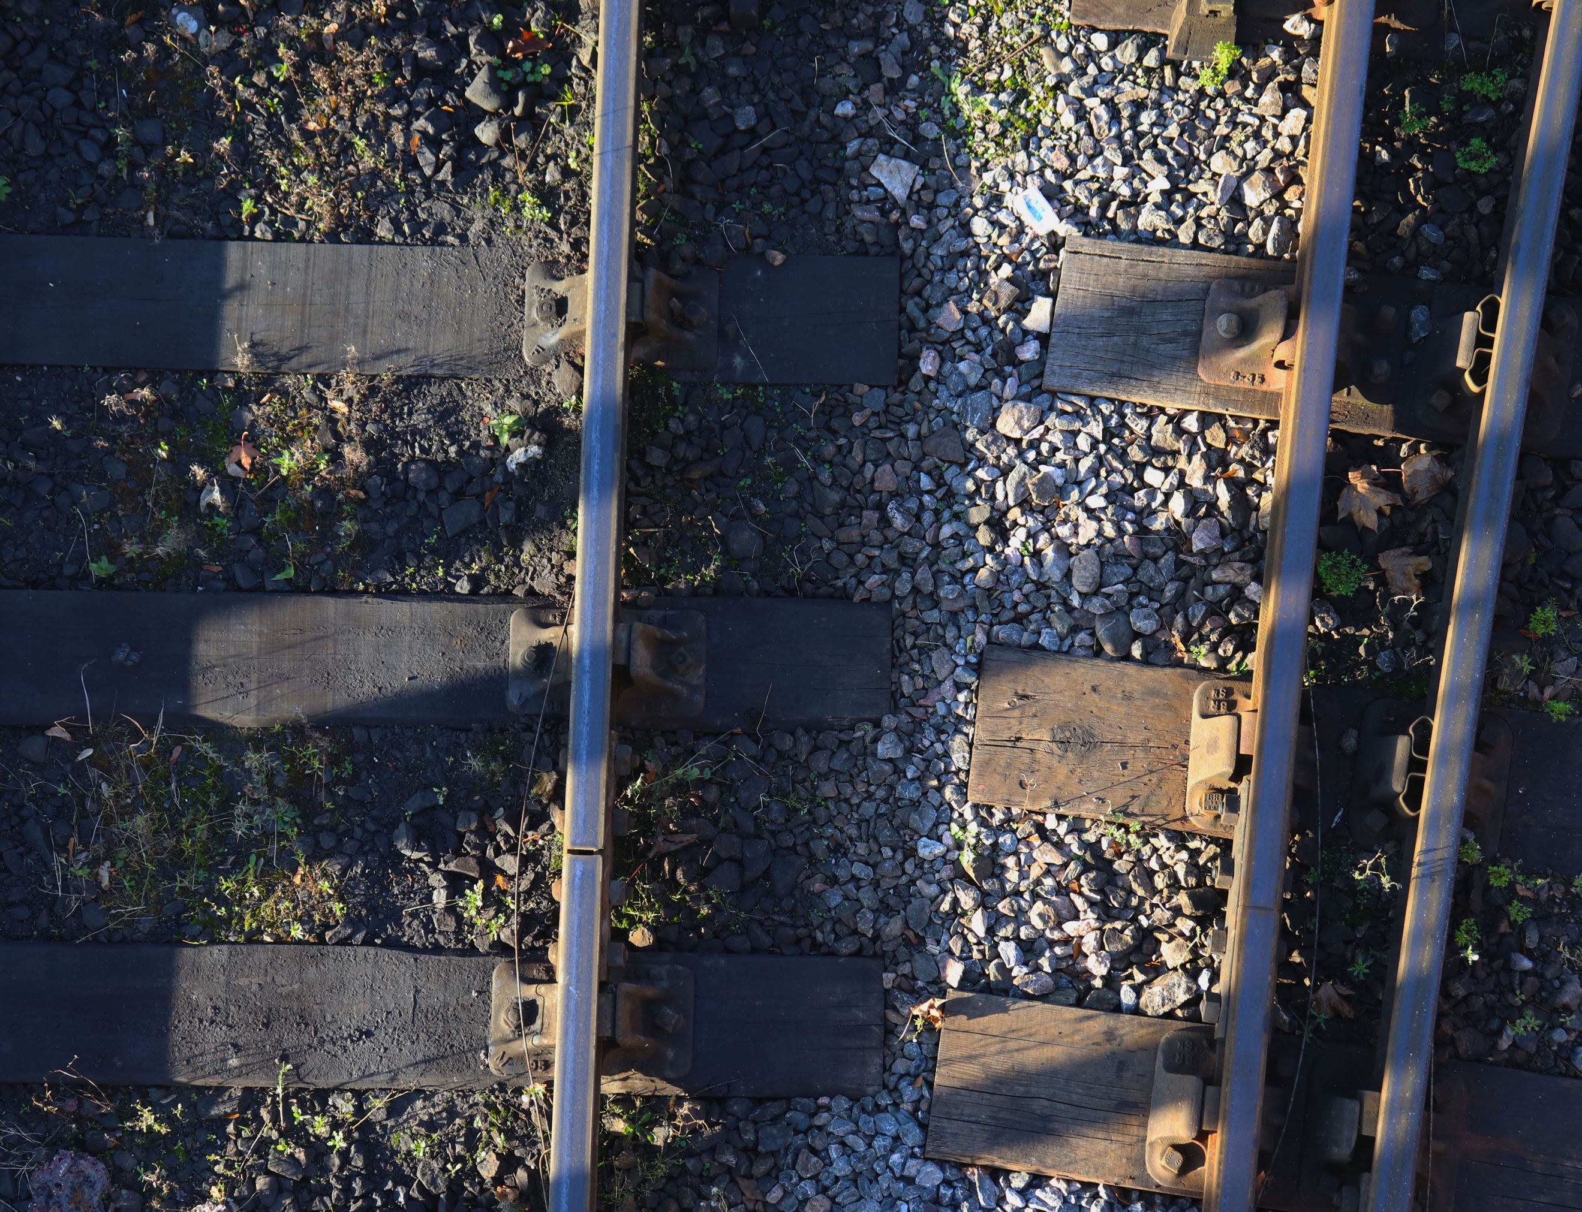
This image has been shot closer in, here I was focusing more on being abstract and trying to get an unusual image. You can really see the tracks parting as they leave the frame. It is unusual how one track is straight and one is bending off away. Because this has been taken further in, I feel that there is more texture in this image as the wood seems damp on the left and the tracks themselves seem hard and unforgiving. I have tried to execute a similar angle in this image as the first two, coming in from above, but because it is zoomed in, it is harder to tell what it is at first glance. I have deliberately framed this image so that the left track is more dominant than the right track instead of trying to be central. I like the framing of this image as it gives it an abstract feel to it. If I was going to shoot this again, a possibility is to do an even closer shot, to really focus on the texture.
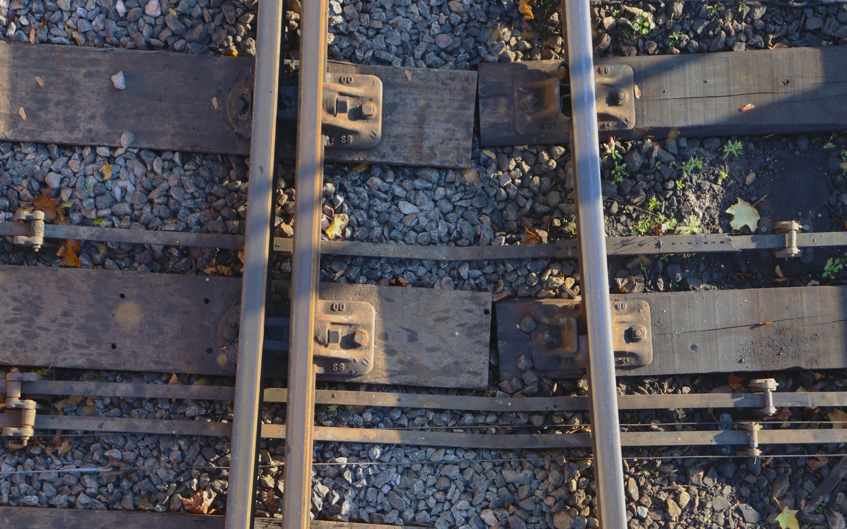
In this last photograph, I have also zoomed in close to the tracks and this has made it seem abstract. The colour in this image is gorgeous because of the sun shining off of the track giving it a strong bronze colour to it which looks unusual but interesting at the same time. In this photo, the stones seem to be a background for the tracks because there are so many of them and it seems like the tracks are just leant up against them, squashing them. There are many lines in this shot as you can see, some thicker than others and it makes the photo seem busy and your eye gets confused as to where to look as it goes all over the place. This certainly gives a more uncomfortable feel to the image over previous ones, especially as the shot is taken further in too, making it feel tense.

